Trinity Episcopal Church
In Sonoma for over 170 years

The Sunday of the Passion: Palm Sunday
Year A
Holy Eucharist II
March 29, 2026
10:00 AM In person and Online

Welcome to Trinity Episcopal, Sonoma. Whether you are passing through or looking for a church home, we are blessed by your presence and we invite you to worship with us fully – singing, praying and receiving communion- with your voice and heart. Everyone is welcome at Jesus’ Table, and everyone’s voice is needed to tell the Good News of God’s love in Christ. If you would like to learn more about The Episcopal Church, or how you can become a member of Trinity Church, please send us an email trinityepiscopalsonoma@comcast.net. We look forward to meeting you after the service where coffee and treats are served.
Notes on the Service Bulletin This service bulletin is a guide to the service. We use a variety of printed materials for the prayers, the scriptural readings and the hymns. The Readings for the week, including the Collect and Readings are found in this Bulletin. The service follows the liturgies that are found in the Book of Common Prayer (BCP). The BCP is the blue book found in the pew in front of you. The hymns come primarily from The 1982 Hymnal, also in the pew – the red book. Lift Every Voice and Sing (LEVAS) is another hymnal located in the pew rack. VF stands for Voices Found, another authorized hymnal. Sound Mate Assisted Hearing devices available at the back of the church on the Narthex Table.
For Visitors and Newcomers | Welcome! We are glad you have joined us today. If you are interested in a visit or call from the Priest-in-Charge, please sign our guest book on the Narthex* table to let her know you are visiting. Include your phone or email address. Narthex = wonderful old Latin word Episcopalians use for the entrance hall, traditionally at the western end of our churches.
Nursery Care | Children | Available during the 10:15 worship service by request. The nursery is located through the breezeway to the Education wing of the campus. Please ask an usher to show the way.
Coffee Hour Fellowship | Buttrum Hall or Courtyard, weather depending | Join us following the 10:00 AM worship service.
To access Trinity’s Guest WIFI: Password Rosepettal441 (case sensitive). We are glad you are here, and we invite you to enter fully into worship this morning.
All are welcome to make a gift and offering in thanksgiving to God; for the many blessings we have received. To take advantage of our electronic giving options, please follow the QR code with your capable electronic device, or visit https://onrealm.org/trinitysonoma/-/form/give/default Help us to make this a place where God’s grace is freely shared by all.

About this Service: Year C
Calendar of the Church Year
The calendar (BCP, pp. 15-33) orders the liturgical year of the Episcopal Church by identifying two cycles of feasts and holy days-one dependent upon the movable date of Easter Day and the other dependent upon the fixed date of Christmas, Dec. 25. Easter Day is the first Sunday after the full moon that falls on or after Mar. 21. The sequence of all Sundays in the church year is based on the date of Easter. Tables and rules for finding the date of Easter Day, and other movable feasts and holy days are provided by the BCP, pp. 880-885. The date of Easter determines the beginning of the season of Lent on Ash Wednesday and the date of Pentecost on the fiftieth day of the Easter season. The Sundays of Advent are always the four Sundays before Christmas Day. The church year begins on the first Sunday of Advent. The calendar also identifies and provides directions concerning the precedence and observance of principal feasts, Sundays, holy days (including Feasts of our Lord, other major feasts, and fasts), Days of Special Devotion, and Days of Optional Observance. The calendar lists dates for celebration of major feasts and lesser feasts by month and date. Appropriate Sunday Letters and Golden Numbers are also provided. (see BCP, pp. 880-881). The calendar also lists the titles of the seasons, Sundays, and major holy days observed in the Episcopal Church throughout the church year, including Advent season, Christmas season, Epiphany season, Lenten season, Holy Week, Easter season, the season after Pentecost, holy days, and National Days.
Notes on Sunday of the Passion – Maundy Thursday
Palm Sunday, which has been celebrated by Christians since at least the Fourth Century, marks the transition from our Lenten period of preparation into Holy Week. The concept of that transition defines this service: we begin with a remembrance of Jesus’ final entry into Jerusalem—a parade of welcome when people lined the road ahead of him with cloth and palm branches. When the Gospel is read, we’re asked to shift our attention to Jesus’ Last Supper and betrayal, where his path will finally lead: to his death on the cross.
The Episcopal tradition moves through the story of Easter slowly and deliberately. Holy Week culminates in what we call the Triduum: a three-part service that arcs from Maundy Thursday through Good Friday
and, finally, into the joy of Easter.
Today, at Trinity we being outside as our ancestors in faith who hailed Jesus’ entry into Jerusalem, gathering on the front porch for the Blessing of the Palms. Please deposit your personal items inside, in the pews, first, then return to the front porch for the Opening Liturgy, where The Gospel will be read and the palms blessed. We will process together from the front porch to our seats in the pews, singing the Processional Hymn ‘All Glory Laud and Honor’ and waving the blessed palms.
For those who prefer to remain inside for the first part of the Liturgy, we ask that you to sit in the Choir so you may hear the liturgy and participate. The church doors will remain open during the Liturgy of the Palms.
Prelude Steve Rubardt
Please stand at the entrance of the Church for the procession of the palms.
At the sound of the bell, please stand as you are able. The People respond when bold text appears.
The Liturgy of the Palms
Opening Acclamation BCP 270
Celebrant | Blessed is the King who comes in the name of the Lord.
People | Peace in heaven and glory in the highest.
Celebrant | Let us pray. Assist us mercifully with your help, O Lord God of our salvation, that we may enter with joy upon the contemplation of those mighty acts, whereby you have given us life and immortality; through Jesus Christ our Lord. Amen.
Processional Gospel Reading: Matthew 21:1-11
¹When [Jesus and his disciples] had come near Jerusalem and had reached Bethphage, at the Mount of Olives, Jesus sent two disciples, ²saying to them, “Go into the village ahead of you, and immediately you will find a donkey tied, and a colt with her; untie them and bring them to me. ³If anyone says anything to you, just say this, ‘The Lord needs them.’ And he will send them immediately.” ⁴This took place to fulfill what had been spoken through the prophet, saying,
⁵“Tell the daughter of Zion,
Look, your king is coming to you,
humble, and mounted on a donkey,
and on a colt, the foal of a donkey.”
⁶The disciples went and did as Jesus had directed them; ⁷they brought the donkey and the colt, and put their cloaks on them, and he sat on them. ⁸A very large crowd spread their cloaks on the road, and others cut branches from the trees and spread them on the road. ⁹The crowds that went ahead of him and that followed were shouting,
People: “Hosanna to the Son of David!
Blessed is the one who comes in the name of the Lord!
Hosanna in the highest heaven!”
¹⁰When he entered Jerusalem, the whole city was in turmoil, asking, “Who is this?” ¹¹The crowds were saying,
People: “This is the prophet Jesus from Nazareth in Galilee.”
Blessing of The Palms: BCP p. 271
Celebrant | The Lord be with you.
People | And also with you.
Celebrant | Let us give thanks to the Lord our God.
People | It is right to give him thanks and praise.
It is right to praise you, Almighty God, for the acts of love by which you have redeemed us through your Son Jesus Christ our Lord. On this day he entered the holy city of Jerusalem in triumph, and was proclaimed as King of kings by those who spread their garments and branches of palm along his way. Let these branches be for us signs of his victory, and grant that we who bear them in his name may ever hail him as our King, and follow him in the way that leads to eternal life; who lives and reigns in glory with you and the Holy Spirit, now and for ever. Amen.

Second Anthem (BCP p. 271)
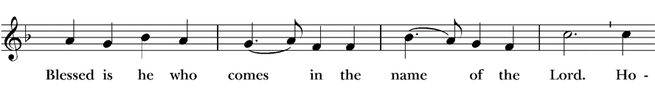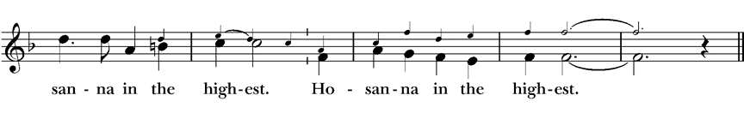
The Procession (BCP p. 271)
Celebrant | Let us go forth in peace.
People | In the name of Christ. Amen. (Wave branches)
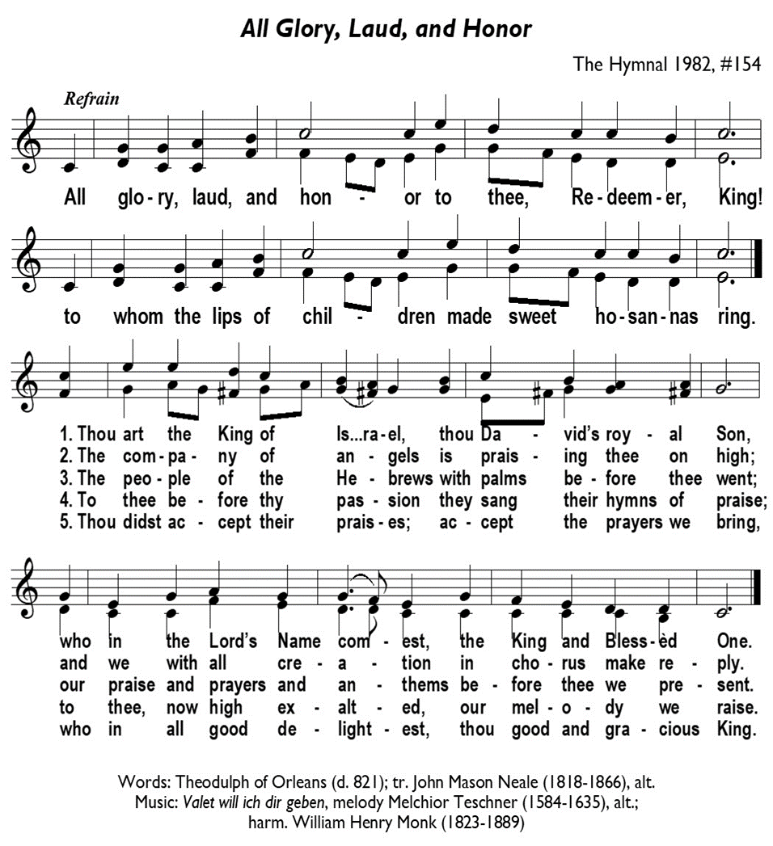
Processional Hymn All Glory, Laud, and Honor H-154 v 1,3,4 & 5
The Word of God
The Collect of the Day BCP 357
Celebrant | The Lord be with you.
People | And also with you.
Celebrant | Let us pray.
Almighty and everliving God, in your tender love for the human race you sent your Son our Savior Jesus Christ to take upon him our nature, and to suffer death upon the cross, giving us the example of his great humility: Mercifully grant that we may walk in the way of his suffering, and also share in his resurrection; through Jesus Christ our Lord, who lives and reigns with you and the Holy Spirit, one God, for ever and ever.
All Amen.
The Lessons
First Reading Isaiah 50:4-9a
Reader A Reading from the book of Isaiah.
⁴The Lord God has given me
the tongue of a teacher,
that I may know how to sustain
the weary with a word.
Morning by morning he wakens—
wakens my ear
to listen as those who are taught.
⁵The Lord God has opened my ear,
and I was not rebellious,
I did not turn backward.
⁶I gave my back to those who struck me,
and my cheeks to those who pulled out the beard;
I did not hide my face
from insult and spitting.
⁷The Lord God helps me;
therefore I have not been disgraced;
therefore I have set my face like flint,
and I know that I shall not be put to shame;
⁸he who vindicates me is near.
Who will contend with me?
Let us stand up together.
Who are my adversaries?
Let them confront me.
^{9a}It is the Lord God who helps me;
who will declare me guilty?
Reader | The Word of the Lord.
People | Thanks be to God.
The Psalm:  Psalm 31:9-16
Reader Our response to the reading is Psalm 31:9-16 which we will read responsively by half verse.
⁹Have mercy on me, O Lord, for I am in trouble; *
my eye is consumed with sorrow,
and also my throat and my belly.
¹⁰For my life is wasted with grief,
and my years with sighing; *
my strength fails me because of affliction,
and my bones are consumed.
¹¹I have become a reproach to all my enemies and even to my neighbors,
a dismay to those of my acquaintance; *
when they see me in the street they avoid me.
¹²I am forgotten like a dead man, out of mind; *
I am as useless as a broken pot.
¹³For I have heard the whispering of the crowd;
fear is all around; *
they put their heads together against me;
they plot to take my life.
¹⁴But as for me, I have trusted in you, O Lord. *
I have said, “You are my God.
¹⁵My times are in your hand; *
rescue me from the hand of my enemies,
and from those who persecute me.
¹⁶Make your face to shine upon your servant, *
and in your loving-kindness save me.”
The Second Reading  Philippians 2:5-11
Reader A Reading from Paul's letter to the Church in Philippi.
⁵Let the same mind be in you that was in Christ Jesus,
⁶who, though he was in the form of God,
did not regard equality with God
as something to be exploited,
⁷but emptied himself,
taking the form of a slave,
being born in human likeness.
And being found in human form,
⁸he humbled himself
and became obedient to the point of death—
even death on a cross.
⁹Therefore God also highly exalted him
and gave him the name
that is above every name,
¹⁰so that at the name of Jesus
every knee should bend,
in heaven and on earth and under the earth,
¹¹and every tongue should confess
that Jesus Christ is Lord,
to the glory of God the Father.
Reader | The Word of the Lord.
People | Thanks be to God.

Sequence Hymn How Bright Appears the Morning Star H 497 v 1
The Reading of Maundy Thursday/Passion: Matthew 26:14 – 27:66
Hear the passion of Our Lord Jesus Christ, according to Matthew.
Narrator: One of the twelve, who was called Judas Iscariot, went to the chief priests and said,
Judas: What will you give me if I betray him to you?”
Narrator: They paid him thirty pieces of silver. And from that moment he began to look for an opportunity to betray him. On the first day of Unleavened Bread the disciples came to Jesus, saying,
Disciple: “Where do you want us to make the preparations for you to eat the Passover?”
Narrator: Jesus said,
Jesus: Go into the city to a certain man, and say to him, ‘The Teacher says, “My time is near; I will keep the Passover at your house with my disciples.
Narrator: So the disciples did as Jesus had directed them, and they prepared the Passover meal. When it was evening, Jesus took his place with the twelve and while they were eating, he said,
Jesus: Truly I tell you, one of you will betray me.
Narrator: And they became greatly distressed and began to say to him one after another,
Disciple: Surely not I, Lord?
Narrator: Jesus answered,
Jesus: The one who has dipped his hand into the bowl with me will betray me. The Son of Man goes as it is written of him, but woe to that one by whom the Son of Man is betrayed! It would have been better for that one not to have been born.
Narrator: Judas, who betrayed him, said
Judas: Surely not I, Rabbi?
Narrator: Jesus replied,
Jesus: You have said so.
Narrator: While they were eating, Jesus took a loaf of bread, and after blessing it he broke it, gave it to the disciples, and said,
Jesus: Take, eat; this is my body.
Narrator: Then Jesus took a cup, and after giving thanks he gave it to them, saying,
Jesus: Drink from it, all of you; for this is my blood of the covenant, which is poured out for many for the forgiveness of sins. I tell you, I will never again drink of this fruit of the vine until that day when I drink it new with you in my Father’s kingdom.
Narrator: When they had sung the hymn, they went out to the Mount of Olives. Then Jesus said to them
Jesus: You will all become deserters because of me this night; for it is written, ‘I will strike the shepherd, and the sheep of the flock will be scattered.’ But after I am raised up, I will go ahead of you to Galilee.”
Narrator: Peter said to him,
Peter: Though all become deserters because of you, I will never desert you.
Narrator: Jesus said to him,
Jesus: Truly I tell you, this very night, before the cock crows, you will deny me three times.
Narrator: Peter said to him,
Peter: Even though I must die with you, I will not deny you.
Narrator: And so said all the disciples. Then Jesus went with them to a place called Gethsemane; and he said to his disciples,
Jesus: Sit here while I go over there and pray.
Narrator: He took with him Peter and the two sons of Zebedee and began to be grieved and agitated. Then he said to them,
Jesus: I am deeply grieved, even to death; remain here and stay awake with me.
Narrator: And going a little farther, he threw himself on the ground and prayed,
Jesus: My Father, if it is possible, let this cup pass from me; yet not what I want but what you want.
Narrator: Then he came to the disciples and found them sleeping; and he said to Peter,
Jesus: So, could you not stay awake with me one hour? Stay awake and pray that you may not come into the time of trial; the spirit indeed is willing, but the flesh is weak.
Narrator: Again he went away for the second time and prayed,
Jesus: My Father, if this cannot pass unless I drink it, your will be done.
Narrator: Again he came and found them sleeping, for their eyes were heavy. So leaving them again, he went away and prayed for the third time, saying the same words. Then he came to the disciples and said to them,
Jesus: Are you still sleeping and taking your rest? See, the hour is at hand, and the Son of Man is betrayed into the hands of sinners. Get up, let us be going. See, my betrayer is at hand.
Narrator: While he was still speaking, Judas, one of the twelve, arrived; with him was a large crowd with swords and clubs, from the chief priests and the elders of the people. Now the betrayer had given them a sign, saying,
Judas: The one I will kiss is the man; arrest him.
Narrator: At once he came up to Jesus and said,
Judas: Greetings, Rabbi!
Narrator: and kissed him. Jesus said to him,
Jesus: Friend, do what you are here to do.
Narrator: Then they came and laid hands on Jesus and arrested him. Suddenly, one of those with Jesus put his hand on his sword, drew it, and struck the slave of the high priest, cutting off his ear. Then Jesus said to him,
Jesus: Put your sword back into its place; for all who take the sword will perish by the sword. Do you think that I cannot appeal to my Father, and he will at once send me more than twelve legions of angels? But how then would the scriptures be fulfilled, which say it must happen in this way?
Narrator: At that hour Jesus said to the crowds,
Jesus: Have you come out with swords and clubs to arrest me as though I were a bandit? Day after day I sat in the temple teaching, and you did not arrest me. But all this has taken place, so that the scriptures of the prophets may be fulfilled.
Narrator: Then all the disciples deserted him and fled. Those who had arrested Jesus took him to Caiaphas the high priest, in whose house the scribes and the elders had gathered. But Peter was following him at a distance, as far as the courtyard of the high priest; and going inside, he sat with the guards in order to see how this would end. Now the chief priests and the whole council were looking for false testimony against Jesus so that they might put him to death, but they found none, though many false witnesses came forward. At last, two came forward and said,
Witness: This fellow said, ‘I am able to destroy the temple of God and to build it in three days.’
Narrator: The high priest stood up and said,
High Priest: Have you no answer? What is it that they testify against you?
Narrator: But Jesus was silent. Then the high priest said to him,
High Priest: I put you under oath before the living God, tell us if you are the Messiah, the Son of God.
Narrator: Jesus said to him,
Jesus: You have said so. But I tell you, from now on you will see the Son of Man seated at the right hand of Power and coming on the clouds of heaven.
Narrator: Then the high priest tore his clothes and said,
High Priest: He has blasphemed! Why do we still need witnesses? You have now heard his blasphemy. What is your verdict?
Narrator: They answered,
Chief Priest: He deserves death.
Narrator: Then they spat in his face and struck him; and some slapped him, saying,
Slapper: Prophesy to us, you Messiah! Who is it that struck you?
Narrator: Now Peter was sitting outside in the courtyard. A servant-girl came to him and said,
Servant Girl1: You also were with Jesus the Galilean.
Narrator: But he denied it before all of them, saying,
Peter: I do not know what you are talking about.
Narrator: When he went out to the porch, another servant-girl saw him, and she said to the bystanders,
Servant Girl 2: This man was with Jesus of Nazareth.
Narrator: Again he denied it with an oath,
Peter: I do not know the man.
Narrator: After a little while the bystanders came up and said to Peter,
Bystanders: Certainly you are also one of them, for your accent betrays you.
Narrator: Then Peter began to curse, and he swore an oath,
Peter: I do not know the man!
Narrator: At that moment the cock crowed. Then Peter remembered what Jesus had said.
Jesus: Before the cock crows, you will deny me three times.
Narrator: And he went out and wept bitterly. When morning came, all the chief priests and the elders of the people conferred together against Jesus in order to bring about his death. They bound him, led him away, and handed him over to Pilate the governor. When Judas, his betrayer, saw that Jesus was condemned, he repented and brought back the thirty pieces of silver to the chief priests and the elders. He said,
Judas: I have sinned by betraying innocent blood.
Narrator: But they said,
Chief Priest: What is that to us? See to it yourself.
Narrator: Throwing down the pieces of silver in the temple, Judas departed; and he went and hanged himself. But the chief priests, taking the pieces of silver, said,
Chief Priest: It is not lawful to put them into the treasury, since they are blood money.
Narrator: After conferring together, they used them to buy the potter’s field as a place to bury, foreigners. For this reason that field has been called the Field of Blood to this day. Then was fulfilled what had been spoken through the prophet Jeremiah:
Jeremiah: And they took the thirty pieces of silver, the price of the one on whom a price had been set, on whom some of the people of Israel had set a price, and they gave them for the potter’s field, as the Lord commanded me.
Narrator: Now Jesus stood before Pilot, the governor; and asked him,
Pilate: Are you the King of the Jews?
Narrator: Jesus said,
Jesus: You say so.
Narrator: But when he was accused by the chief priests and elders, Jesus did not answer. Then Pilate said to him,
Pilate: Do you not hear how many accusations they make against you?
Narrator: But Jesus gave him no answer, not even to a single charge, so that the governor was greatly amazed. Now at the festival the governor was accustomed to release a prisoner for the crowd, anyone whom they wanted. At that time they had a notorious prisoner, called Jesus Barabbas. So after they had gathered, Pilate said to them,
Pilate: Whom do you want me to release for you, Jesus Barabbas or Jesus who is called the Messiah?
Narrator: For he realized that it was out of jealousy that they had handed him over. While he was sitting on the judgment seat, his wife sent word to him,
Wife: Have nothing to do with that innocent man, for today I have suffered a great deal because of a dream about him.
Narrator: Now the chief priests and the elders persuaded the crowds to ask for Barabbas and to have Jesus killed. The governor again said to them,
Pilate: Which of the two do you want me to release for you?
Narrator: And they said,
Crowd: Barabbas.
Narrator: Pilate said to them,
Pilate: Then what should I do with Jesus who is called the Messiah?
Narrator: All of them said,
Crowd: Let him be crucified!
Narrator: Then he asked,
Pilate: Why, what evil has he done?
Narrator: But they shouted all the more,
Crowd: Let him be crucified!”
Narrator: So when Pilate saw that he could do nothing, but rather that a riot was beginning, he took some water and washed his hands before the crowd, saying,
Pilate: I am innocent of this man’s blood; see to it yourselves.
Narrator: Then the people as a whole answered,
Crowd: His blood be on us and on our children!
Narrator: So he released Barabbas for them; and after flogging Jesus, he handed him over to be crucified. Then the soldiers of the governor took Jesus into the governor’s headquarters, and they gathered the whole cohort around him. They stripped him and put a scarlet robe on him, and after twisting some thorns into a crown, they put it on his head. They put a reed in his right hand and knelt before him and mocked him, saying,
Soldiers: Hail, King of the Jews!
Narrator: They spat on him and took the reed and struck him on the head. After mocking him, they stripped him of the robe and put his own clothes on him. Then they led him away to crucify him. As they went out, they came upon a man from Cyrene named Simon; they compelled this man to carry his cross. And when they came to a place called Golgotha (which means Place of a Skull), they offered him wine to drink, mixed with gall; but when he tasted it, he would not drink it. And when they had crucified him, they divided his clothes among themselves by casting lots; then they sat down there and kept watch over him. Over his head they put the charge against him, which read, “This is Jesus, the King of the Jews.”
Then two bandits were crucified with him, one on his right and one on his left. Those who passed by derided him, shaking their heads and saying,
Passerbys: You who would destroy the temple and build it in three days, save yourself! If you are the Son of God, come down from the cross.
Narrator: In the same way the chief priests also, along with the scribes and elders, were mocking him, saying,
Chief Priest: He saved others; he cannot save himself. He is the King of Israel;
Scribes: let him come down from the cross now, and we will believe in him. He trusts in God; let God deliver him now, if he wants to; for he said, ‘I am God’s Son.’
Narrator: The bandits who were crucified with him also taunted him in the same way. From noon on, darkness came over the whole land until three in the afternoon. And about three o’clock Jesus cried with a loud voice,
Jesus: Eli, Eli, lema sabachthani?” that is, “My God, my God, why have you forsaken me?”
Narrator: When some of the bystanders heard it, they said,
Bystanders: This man is calling for Elijah.
Narrator: At once one of them ran and got a sponge, filled it with sour wine, put it on a stick, and gave it to him to drink. But the others said,
Others: Wait, let us see whether Elijah will come to save him.
Narrator: Then Jesus cried again with a loud voice and breathed his last. At that moment the curtain of the temple was torn in two, from top to bottom. The earth shook, and the rocks were split. The tombs also were opened, and many bodies of the saints who had fallen asleep were raised. After his resurrection they came out of the tombs and entered the holy city and appeared to many. Now when the centurion and those with him, who were keeping watch over Jesus, saw the earthquake and what took place, they were terrified and said,
Centurion: Truly this man was God’s Son!”
Narrator: Many women were also there, looking on from a distance; they had followed Jesus from Galilee and had provided for him. Among them were Mary Magdalene, and Mary the mother of James and Joseph, and the mother of the sons of Zebedee. When it was evening, there came a rich man from Arimathea, named Joseph, who was also a disciple of Jesus. He went to Pilate and asked for the body of Jesus; then Pilate ordered it to be given to him. So Joseph took the body and wrapped it in a clean linen cloth and laid it in his own new tomb, which he had hewn in the rock. He then rolled a great stone to the door of the tomb and went away. Mary Magdalene and the other Mary were there, sitting opposite the tomb. The next day, that is, after the day of Preparation, the chief priests and the Pharisees gathered before Pilate and said,
Chief Priest: Sir, we remember what that impostor said while he was still alive,
Pharisees: ‘After three days I will rise again.’ Therefore command the tomb to be made secure until the third day; otherwise his disciples may go and steal him away, and tell the people, ‘He has been raised from the dead,’ and the last deception would be worse than the first.
Narrator: Pilate said to them,
Pilate: You have a guard of soldiers; go, make it as secure as you can.”
Narrator: So they went with the guard and made the tomb secure by sealing the stone.
Sequence Hymn How Bright Appears the Morning Star H 497 v 2
The Sermon Pastor Cindy Beck
The Nicene Creed (BCP p. 358)
The Prayers of the People
Celebrant: The spirit indeed is willing, but the flesh is weak. So, let us cry out to our Lord, saying, “Crucified King, have mercy on us.”
Intercessor Have mercy on your Church, O Lord, for the times we have denied you. We have not been humble as you are humble. We have been unwilling to share the gospel with our friends and families.
In the Diocesan Cycle of Prayer, we pray for St Luke’s in Auburn and Grace Church in Fairfield.
In the Anglican Cycle of Prayer, we pray for The Anglican Church of Melanasia.
Crucified King,
Have mercy on us.
Have mercy on those who hold authority in the nations of the world, O Lord—especially those who are threatened by your message of love and justice. Have mercy on us for our silence and complicity.
Silence
Crucified King,
Have mercy on us.
Have mercy on those of us who are called to be stewards of your creation, O Lord. We have exploited and mistreated your masterpiece. Have mercy on us and teach us to love what you have called good, +___________________
Invite the congregation to add their thanksgivings, followed by silence
Crucified King,
Have mercy on us.
Have mercy on us, O Lord. Teach us to value what you value. Increase in us love for our neighbors.
Silence
Crucified King,
Have mercy on us.
Have mercy on all who are sick and suffering, O Lord. Strengthen those whose strength fails them. Comfort and care for those wasted with grief. Make your face to shine upon your servants ,+__________________________
Invite the congregation to add their petitions, followed by silence
Crucified King,
Have mercy on us.
Merciful Lord, you know the pain of death—even death on a cross. Have mercy on the dying and the dead. Bring them to the joy of everlasting life in you, +___________
Invite the congregation to add their petitions, followed by silence
Crucified King,
Have mercy on us.
Celebrant Blessed are you, O Lord our God, whose Son humbled himself and became obedient to the point of death. Receive the prayers we offer this day for all those in need in everyplace; through Jesus Christ our Lord.
Amen.
The Peace
Celebrant The peace of the Lord be always with you.
People And also with you.
Announcements
Birthdays, Anniversaries, Travelers (prayers found at back of bulletin)

The Holy Communion
The Offertory At the Offering, you’ll find a Pledge card in the Pew Rack for those who’d like to designate their financial donations to Trinity’s Pledging Income. For others, or a one-time gift, envelopes are in the pew racks as well as on the Narthex table or text TRINITYSONOMA" to 73256. Thank you!
Offertory Music
Steve Rubardt and Choir He will remember Me LEVAS 34
Doxology
The people stand while the offerings are presented and placed on the Altar.
Presider: Gracious God, as an offering of our thanksgiving and gratitude, we return to you a portion of what you have gifted us.
The Great Thanksgiving
Eucharistic Prayer B BCP 367
Celebrant | The Lord be with you.
People | And also with you.
Celebrant | Lift up your hearts.
People | We lift them to the Lord.
Celebrant | Let us give thanks to the Lord our God.
People | It is right to give him thanks and praise.
Proper Preface (BCP p. 367)
It is right, and a good and joyful thing, always and everywhere to give thanks to you, Father Almighty, Creator of heaven and earth.
Through Jesus Christ our Lord. For our sins he was lifted high upon the cross, that he might draw the whole world to himself; and, by his suffering and death, he became the source of eternal salvation for all who put their trust in him.
Therefore we praise you, joining our voices with Angels and Archangels and with all the company of heaven, who for ever sing this hymn to proclaim the glory of your Name:

Sanctus Holy Holy, Holy (Proulx) Hymnal S-125
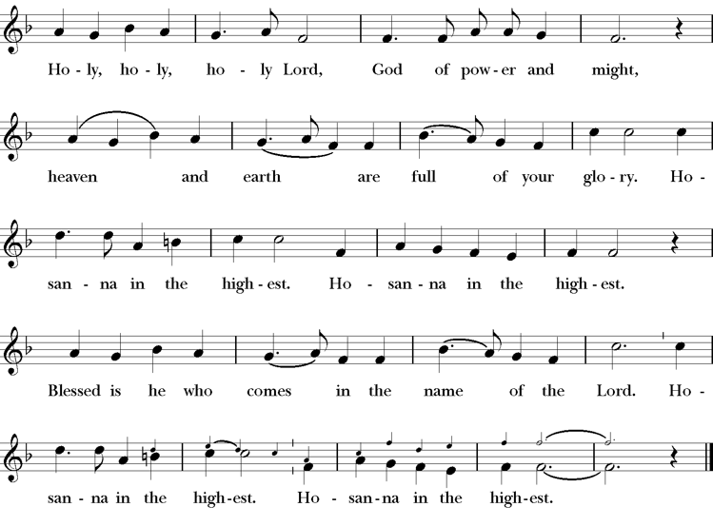
Presider Enduring God, as you sustained Jesus in hunger and thirst; through this meal strengthen us to keep our Lenten fast. Send your Holy Spirit upon us as we remember Jesus’ saving passion; transform our insatiable desires into hunger for the feast of this table. Send your Holy Spirit upon this bread and wine that they may be for us the body and blood of Christ; Who at supper with his disciples, took bread, gave you thanks, broke the bread, and gave it to them, saying “Take, eat: this is my body which is given for you; do this in remembrance of me.”
Presider After supper he took the cup of wine. Again he gave you thanks, and gave it to his disciples, saying, “Drink this, all of you: this is my blood of the new covenant which is shed for you and for many for the forgiveness of sins. Do this, as often as you drink it, in remembrance of me.”
Presider Great is the mystery of faith.
People Christ has died; Christ is risen; Christ will come again.
Presider Forgiving God, in this season of repentance, make your mercy sufficient for every need. Come to your children who are in their own wilderness and make their wanderings holy paths of learning your truth.
Come alongside your children who suffer in sin and give them the power to live as your beloved sons and daughters. Renew your church from the depths of your heart, where justice and mercy meet.
Infuse your church with Spirit and truth, walk with your beloved people as they seek security, companionship and freedom in your world, and fill your saints with the hope of eternal life, that all may come to praise your name, that all creation be stirred with the wonders of your grace.
Through Christ, with Christ, in Christ, in the unity of the Holy Spirit, all glory and honor are yours, almighty God, now and forever. AMEN.
The Lord’s Prayer
Presider As our Savior has taught us, we are bold to pray.
People Our Father, who art in heaven, hallowed be thy name. Thy Kingdom come, thy will be done, on earth as it is in heaven. Give us this day our daily bread. And forgive us our trespasses, as we forgive those who trespass against us. And lead us not into temptation, but deliver us from evil. For thine is the kingdom, the power and the glory, for ever and ever. Amen.
The Breaking of the Bread
The Presider breaks the consecrated bread in view of the assembly.
Presider Christ our Passover is sacrificed for us.
People Therefore let us keep the feast.
Invitation to Communion
Presider The gifts of God for the people of God. So come to this table you who have been here often and you who have not been here in a long time. Come, you who have tried to follow Jesus and you who have failed. You who are full of faith and full of doubt. Come, it is Christ himself who invites you to meet him here.
Sharing the Sacred Meal
This is Christ’s table and all are welcome and all are fed.
Communion Music Steve Rubardt & Choir If Thou but Trust H 635
Post-Communion Prayer BCP 365
The Blessing
The Recessional Hymn God is Love H 379
The Dismissal*
Celebrant | Let us go forth in the name of Christ.
People | Thanks be to God.
Postlude Steve Rubardt Please remain seated
SERVING TODAY
Celebrant and Preacher: Pastor Cindy Beck
Acolyte: Susie Hand
Lector: Barbara Feduska , Gerrilee Fisher
Intercessor: Alfred Escoffier
Worship Musician: Steve Rubardt
Choir Leader: Steve Rubardt
Choir: Liz Carpenter, Heather Dahlberg, Scott Sherman,
Patsy Gralow, Laurell Meredith, Mary Omodt, Barbara Feduska, Tara Anderson
Sunday School - Child Care: Wendy Aguilar Appt Only
Ushers: John Addeo
Tech Chaplain: Marcos Rendon
Altar Guild: Laurell Meredith , Mary Omodt
Hospitality : Lucy Maushardt
Altar Flowers are given to the glory of God by Altar Guild.
*Why no ‘Alleluias” printed in the bulletin? There are two different rubrics (or rules) that govern the use of Alleluia in worship, set by the Canons. One set of rubrics govern the use of Alleluia in music and in all of the liturgy except for the Dismissal. This rule says that we use Alleluia all the time except during the season of Lent. The other set of rubrics covers just the Dismissal and it says that we only use Alleluia in the Dismissal during the period from Easter Sunday through Pentecost, but not at any other time.
Prayers requested for these on Trinity’s long-term prayer list: Armando P, Georgia Bostedt, Muff Davey, John Eiler, Gerrilee Fisher, Claire Ginesi, Mary Griffin, David & Christine Hilt, Marie Lambert, Mark Mezzetta, Kelcey Omodt, Grizelda Ponce, Barry Reap, Blake W, Robert R, Melissa White, Ann Loveland Sherman, James Thomas, Rose Burns, Jennifer Gralow, Patsy Gralow, Steve Antenen, Sandra Leland, Karl, Michael Hardy, Michael Bean Land, Polly Moore, Sinat Liv, Will Maushardt, Sophia Piconi, Mike Smith.
Prayers for the Repose of soul: Tim Dowd , Susan Bassett, Joan Biersch, Linda Dowd, Christina Van Krugel, Mere Nagasau, Mary Goshert, Peggy Bell, Carolyn Caldwell, Van Z, Dolores Mae Seaberg Cole.
Contact Pastoral Care Chair, Lorena lorena.m.reinhardt@gmail.com to make any additions or to remove names from our Long-Term Prayer list.
April Announcements
Holy Week is this week! Good Friday service is April 3rd at 5PM with The Seven Last Words from the Cross. Easter Sunday is April 5th at 10AM.
Easter Flower Donations: Easter flower offering envelopes are now available in the narthex.
Envelopes may be placed in the collection plate, or you may mail them or drop them off at the parish office. Please make your donation by Wednesday, April 1st, and we’ll include the names of your loved ones you wish to remember or honor in our Easter Sunday bulletin.
Fellowship Coffee Hour Sign up - We encourage members to sign up to make coffee. Pastor Cindy is happy to demonstrate how easy this is. Please help us provide this hospitality for guests and members.
The February, March, April Forward Day by Day , a booklet of daily inspirational meditations is now available in the Church and the Office. We ask for a $2 donation.
Lectio Divina Bible Study is on Wednesday, at 11AM in the library. Lectio Divina, Latin for "divine reading," is a contemplative practice of scriptural reading, meditation, and prayer intended to promote communion with God. Unlike traditional Bible study that focuses on intellectual information, Lectio Divina emphasizes spiritual formation and personal intimacy with God.

Trinity Liturgical Ministry ROTA Next two weeks
Date | Celebrant | Ushers | Euch Min | Acolyte | Lector (s) | Intercessor | Altar Guild
April 5 | Cindy Beck | John Addeo | Bill Bonnet | Susie Hand | Bill Doyle , Bill Bonnet | Ann Kyser | Ann Kyser
April 12 | Cindy Beck | Marcia Derby |  | Arminda EIler | Barbara Feduska , John Eiler | Jane Hernandez | Marcia Derby , Mary Omodt

Schedule of Weekly Meetings and Services at Trinity Episcopal Sonoma
Day | Date | Time | Occasion | Location
Wednesday | April 1 | 11 AM | Bible Study | Library
Thursday | April 2 | 10:30 AM  5:30 PM | Mindfulness & Well Being  Alcoholics Anonymous | Library  Buttrum Hall
Saturday | April 4 | 8 AM | Centering Prayer | St. Luke’s Chapel
Saturday | April 4 | 2pm | Drawing Class | in Library
Sunday | April 5 | 10:15 AM | Holy Eucharist II | Sanctuary
Mon-Fri | Weekdays | 7AM-1PM | Sonoma Home Meals | Kitchen &Buttrum Hall
Mon-Fri | Weekdays | 9-2 | Sonoma Preschool Academy – School

Monthly Meetings at Trinity Episcopal Sonoma
Day | Date | Time | Meeting | Location | Contact
Tuesday | April 7 | 11 AM | Prayer Shawl Ministry | Library | Lorena Reinhardt lorena.m.reinhardt@gmail.com
TBD | TBD | 4:30 PM | Vestry | Library | Cindy Beck 916-955-9861

PRAYERS and BLESSINGS
For a Birthday
Watch over your child, O Lord as his/her days increase; bless and guide him/her wherever s/he may be. Strengthen them when s/he stands; comfort him/her when discouraged or sorrowful; raise him/her up if s/he fall; and in his/her heart may your peace which passes understanding abide all the days of his/her life; through Jesus Christ our Lord. Amen.
For an Anniversary
O God, you have so consecrated the covenant of marriage that it represents the spiritual unity between Christ and his Church: Send your blessing upon these your servants as they celebrate their anniversary, that they may continue to love, honor and cherish each other in faithfulness and patience, in wisdom and true godliness, that their home may be a haven of blessing and peace; through Jesus Christ our Lord, who lives and reigns with you and the Holy Spirit, one God, now and forever. Amen.
For Travelers
O God, our heavenly Father, whose glory fills the whole creation, and whose presence we find wherever we go; preserve those who travel; surround them with your loving care; protect them from every danger, and bring them in safety to their journey’s end; through Jesus Christ our Lord. Amen.
Sending our Eucharistic Visitors
Priest: In the name of this congregation, I send you forth bearing these holy gifts, the those to whom you go may share with us in the communion of Christ’s body and blood.
People: We who are many are one body, because we all share on bread, and one cup. Amen

