Trinity Episcopal Church
In Sonoma for over 170 years
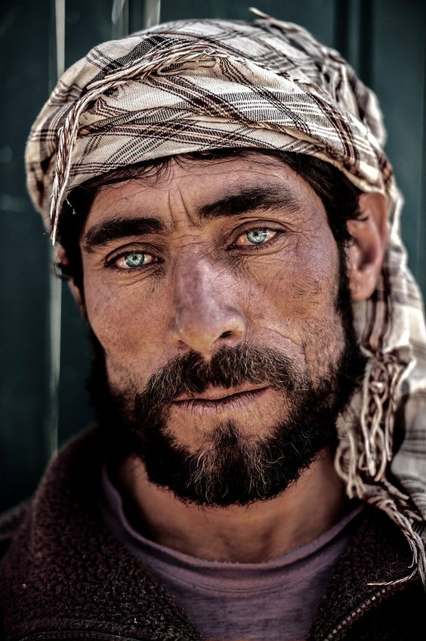
The Second Sunday of Advent
Advent 2 (Year A)
Holy Eucharist II
December 7 , 2025
10:00 AM In person and Online
Welcome to Trinity Episcopal, Sonoma!
Whether you have wandered in, are wondering about God or grew up in the church, or wherever you are in your journey...you are welcome here... We are blessed by your presence.
For Visitors and Newcomers:
Everyone is welcome to receive communion at the Lord’s table. Jesus gave this tangible reminder of God’s presence, love, and forgiveness for all. If you are interested in a visit or call from the Priest-in-Charge , please sign our guest book on the table at the entrance of the church, including an email or phone number.
Restrooms
A restroom is located outside the entrance of Buttrum Hall (the building across the courtyard) and another is located inside the hall to the right.
Coffee and Treats:
Following worship we have coffee and treats after service in Buttrum Hall. We hope it is a time to get to know you better.
To access Trinity’s Guest WIFI: Password Rosepettal441 (case sensitive).
We are glad you are here, and we invite you to enter fully into worship this morning.
December Announcements
Pledge Drive 2026 has begun, Trinity has mailed out the 2026 campaign letter, please return the form or contribute online via the Realm link. We appreciate each and every one of your contributions.
The Free Movie night series hosted by Trinity Episcopal in Sonoma, will be continuing this December, Wednesday 10th with “It’s a Wonderful Life”. Please join us at 6PM for the movie and engage in a conversation about the film afterward.
Fellowship Coffee Hour Sign up - We encourage members to sign up to make coffee. Pastor Cindy is happy to demonstrate how easy this is. Please help us provide this hospitality for guests and members.
The November, December, January Forward Day by Day , a booklet of daily inspirational meditations is now available in the Church and the Office. We ask for a $2 donation.
Christmas Eve Service will be at 3PM on December 24! Come celebrate the birth of our Lord!
This Advent 2025, starting on Sunday November 30th, join us on Sunday as Pastor Cindy breaks down the season of advent in a series of custom lessons crafted for our Parish
Please Donate! Chime in the joy of the Christmas season by decorating our Altar with the very gorgeous Poinsettia Plants. Whether to honor a special person or just sharing the season we welcome your donations. Please pick up a Flower Offering Envelope from the Welcome Table in the Narthex.
All are welcome to make a gift and offering in thanksgiving to God;
for the many blessings we have received. To take advantage of our electronic giving options, please follow the QR code with your capable electronic device, or visit https://onrealm.org/trinitysonoma/-/form/give/default Help us to make this a place where God’s grace is freely shared by all.
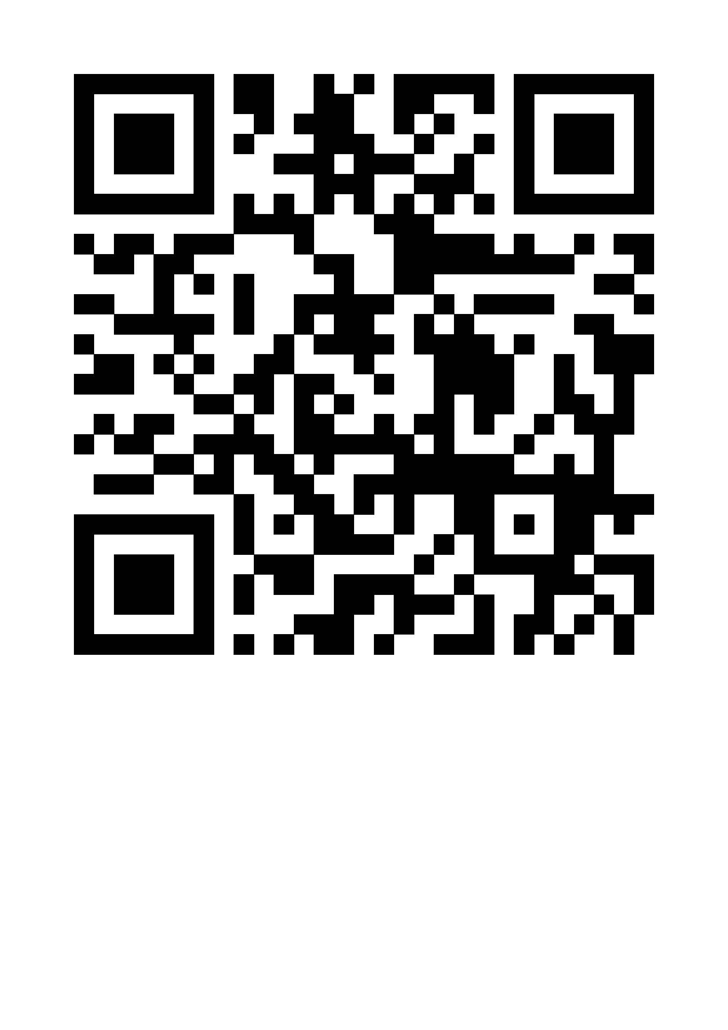

Prelude Steve Rubardt
Please stand for the Entrance Hymn.
At the sound of the bell, please stand as you are able. The People respond when bold text appears.

LIGHTING THE ADVENT CANDLE: In this season of Advent we reflect on Christ’s coming to be with us in the infant Jesus, how Christ comes to us daily as hope in the midst of fear, and how Christ will come again to bring fulfillment of God’s reign. May the light of this second candle remind us that we must not let our fear of the unknown stop us from moving forward as witnesses to God’s light in our lives. May our trust in your coming to us make us witnesses to your faithfulness.
The Word of God
Entrance Hymn Give to the Winds Your Fears
Opening Acclamation Isaiah 11:1-3. 12:2
Surely God is my salvation;
I will trust, and will not be afraid,
for the Lord God is my strength, and my might;
and has become my salvation.
A shoot shall come out from the stump of Jesse,
and a branch shall grow out of his roots.
The spirit of the Lord shall rest on him;
his delight shall be in the fear of the Lord.

Collect for Purity
All Long-expected God, we confess that we look at the world with fear of what might be. We see the brokenness of humanity that results in inequity among people, the fragility of the environment, and the increasing fears that blind us to your spirit among us. Awaken us to your advent among us, that we may abound in the hope you have promised. Amen.
Song of Praise Comfort, Comfort ye my People H 67
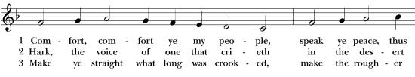
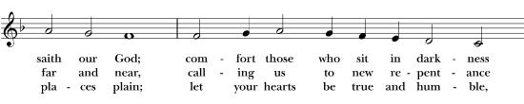
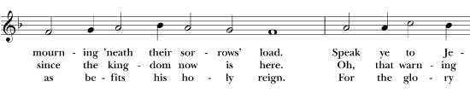
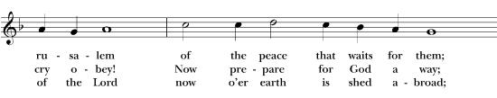
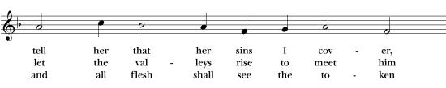
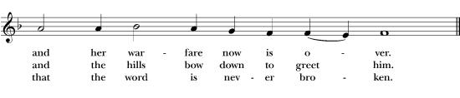
The Collect of the Day BCP 357
Celebrant | The Lord be with you.
People | And also with you.
Celebrant | Let us pray.
God who comes to us, we live in a world where not knowing what lies ahead seems to happen more frequently. We fear entering the unknowns in our personal lives. Fill us with the assurance of your presence in these times, confident in your faithful guidance through our Savior, Jesus Christ.
All Amen.
The Lessons
First Reading: Ecclesiastes 8:6 - 9a
Reader A Reading from the book of Ecclesiastes.
6 For every matter has its time and way, although the troubles of mortals lie heavy upon them. 7 Indeed, they do not know what is to be, for who can tell them how it will be? 8 No one has power over the wind to restrain the wind or power over the day of death; there is no discharge from the battle, nor does wickedness deliver those who practice it. 9 All this I observed, applying my mind to all that is done under the sun
Reader | The Word of the Lord.
People | Thanks be to God.

The Psalm: Psalm 25: 1-6, 8 -10
Reader Our response to the reading is Psalm 25: 1-6, 8 -10 which we will read responsively by half verse.
To you, O Lord, I lift up my soul.
² O my God, in you I trust;
do not let me be put to shame;
do not let my enemies exult over me.
³ Do not let those who wait for you be put to shame;
let them be ashamed who are wantonly treacherous.
⁴ Make me to know your ways, O Lord;
teach me your paths.
⁵ Lead me in your truth and teach me,
for you are the God of my salvation; for you I wait all day long.
⁶ Be mindful of your mercy, O Lord, and of your steadfast love,
for they have been from of old.
⁸ Good and upright is the Lord;
therefore he instructs sinners in the way.
⁹ He leads the humble in what is right
and teaches the humble his way.
¹⁰ All the paths of the Lord are steadfast love and faithfulness,
for those who keep his covenant and his decrees.
Sequence Hymn Once He came in a Blessing H 53 v 1 & 2
The Holy Gospel: 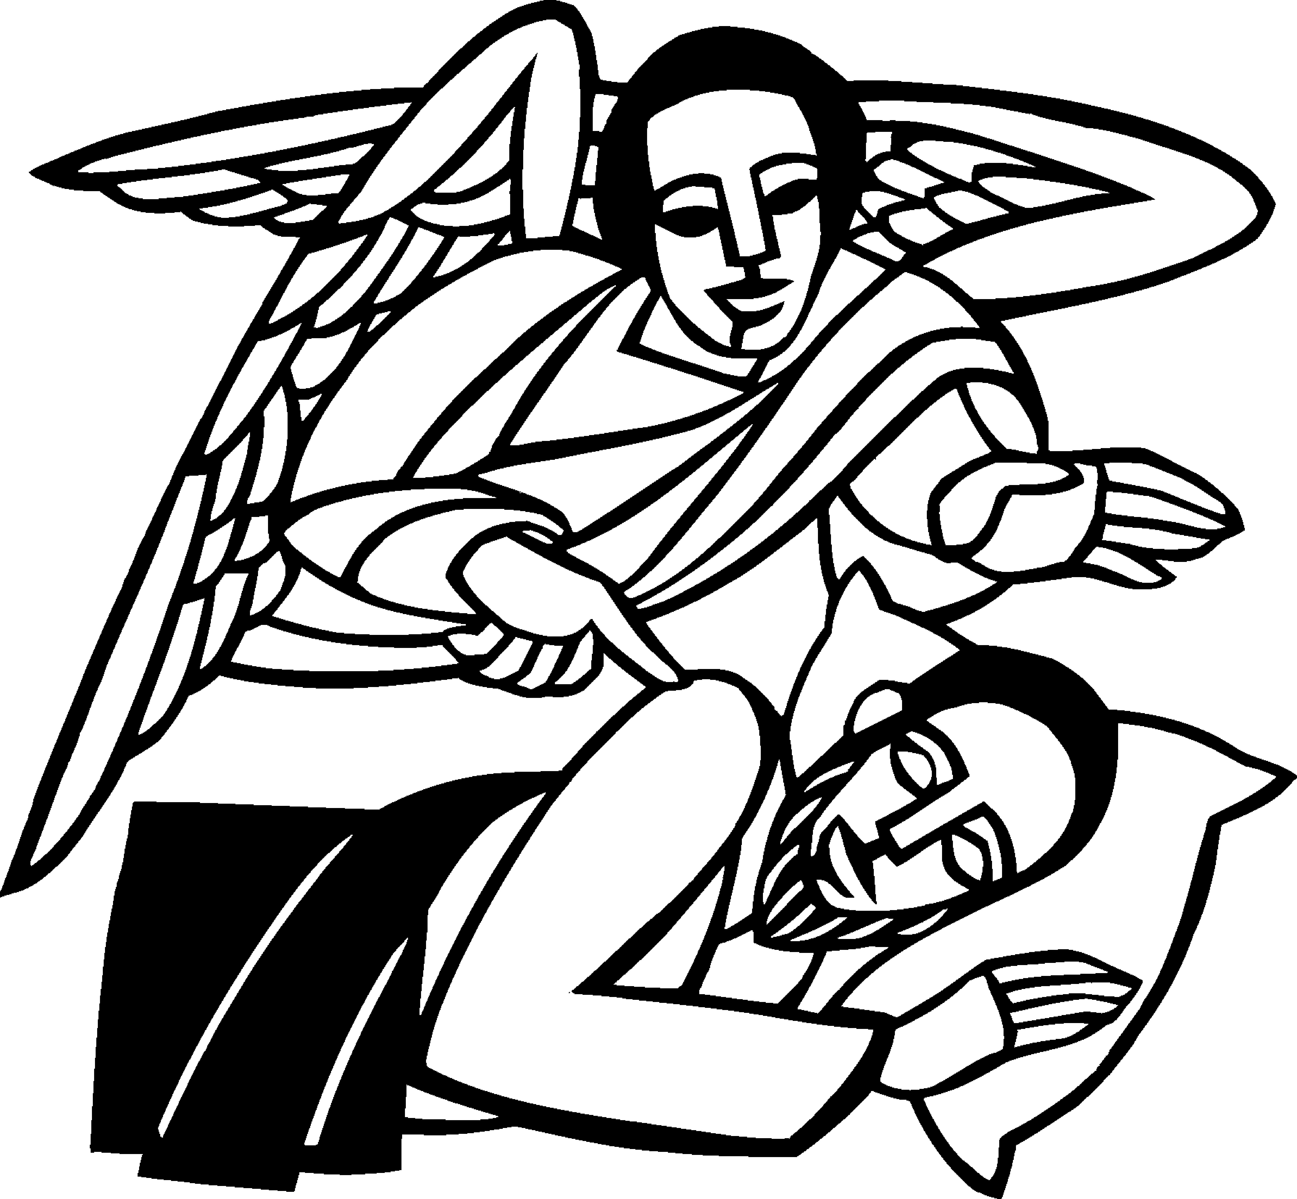 Matthew 1:18-24
Celebrant | The Holy Gospel of our Lord Jesus Christ according to Matthew.
People | Glory to you, Lord Christ.
¹⁸ Now the birth of Jesus the Messiah took place in this way. When his mother Mary had been engaged to Joseph, but before they lived together, she was found to be pregnant from the Holy Spirit. ¹⁹ Her husband Joseph, being a righteous man and unwilling to expose her to public disgrace, planned to divorce her quietly.²⁰ But just when he had resolved to do this, an angel of the Lord appeared to him in a dream and said, “Joseph, son of David, do not be afraid to take Mary as your wife, for the child conceived in her is from the Holy Spirit. ²¹ She will bear a son, and you are to name him Jesus, for he will save his people from their sins.”²² All this took place to fulfill what had been spoken by the Lord through the prophet:
²³ “Look, the virgin shall become pregnant and give birth to a son,
and they shall name him Emmanuel,” which means, “God is with us.”
²⁴ When Joseph awoke from sleep, he did as the angel of the Lord commanded him; he took her as his wife.
Celebrant | The Gospel of the Lord.
People | Praise to you, Lord Christ.
Sequence Hymn Once He came in a Blessing H 53 v 3 & 4
The Sermon Pastor Cindy Beck
The Apostles Creed (BCP p. 66)
The Prayers of the People
Celebrant: Friends, may the God of hope fill you with all joy and peace in believing. Let us come before the Lord praying, “Blessed are you, Lord God; May the earth be filled with your glory.”
Intercessor: Grant your Church, O God of encouragement, to live in harmony with one another, in accordance with Christ Jesus, so that we may glorify you with one voice. Make us a people of repentance and bless us with your Holy Spirit and fire.
In the Diocesan Cycle of Prayer, we pray for St. Luke’s in Woodland.
In the Anglican Cycle of Prayer, we pray for The Church of Bangladesh.
Silence
Blessed are you, Lord God;
May the earth be filled with your glory.
Grant this nation, O God of justice, the will to defend the needy and the poor. May we sincerely hope for that day when hurt and destruction are no more.
Silence
Blessed are you, Lord God;
May the earth be filled with your glory.
Grant your creation, O God of faithfulness, the hope of renewal. May we who are stewards of this earth, also live at peace with all you have created.
Silence
Blessed are you, Lord God;
May the earth be filled with your glory.
Grant this city, O God of understanding, prosperity. May all the people know and do justice. We ask that you teach us and our leaders the best ways to meet the needs of all our neighbors.
Invite the congregation to add their thanksgivings, followed by silence
Blessed are you, Lord God;
May the earth be filled with your glory.
Grant all the needy, O God of steadfast love, your mercy. Prove yourself to be a God of righteousness and faithfulness. To all their pain and suffering bring your healing and peace. And with your winnowing fork clear from their lives all the forces of oppression.
Invite the congregation to add their petitions, followed by silence
Blessed are you, Lord God;
May the earth be filled with your glory.
Grant to those who have died, O God of hope, eternal life in you. Bring the departed into your glorious dwelling where all their hope will be fulfilled in your Christ.
Invite the congregation to add their petitions, followed by silence
Blessed are you, Lord God;
May the earth be filled with your glory.
The Confession of Sin
Gracious Lord,
we confess our willingness to be loved
but also our reluctance to love.
We confess our readiness to accept your forgiving love
but also our own refusal to forgive.
We confess our eagerness to accept your redeeming love
but also our resistance to following you without question.
In this Advent time, forgive us the fears that keep us from responding as we should.
Come to us anew by your Spirit, and replace our fears with the confident hope in the promise of your Kingdom
Come Lord Jesus.
Amen.
The Peace
Celebrant The peace of the Lord be always with you.
People And also with you.
Announcements
Birthdays, Anniversaries, Travelers (prayers found at back of bulletin)

The Holy Communion
The Offertory At the Offering, you’ll find a Pledge card in the Pew Rack for those who’d like to designate their financial donations to Trinity’s Pledging Income. For others, or a one-time gift, envelopes are in the pew racks as well as on the Narthex table or text TRINITYSONOMA" to 73256. Thank you!
Offertory Music
Steve Rubardt and Choir Christmas Time is Here
Doxology
The people stand while the offerings are presented and placed on the Altar.
Presider: Gracious God, as an offering of our thanksgiving and gratitude, we return to you a portion of what you have gifted us.
The Great Thanksgiving
Eucharistic Prayer B BCP 367
Celebrant | The Lord be with you.
People | And also with you.
Celebrant | Lift up your hearts.
People | We lift them to the Lord.
Celebrant | Let us give thanks to the Lord our God.
People | It is right to give him thanks and praise.
Proper Preface (BCP p. 367)
It is right and a good and joyful thing, always and everywhere to give thanks to you, Father Almighty, Creator of heaven and earth.
We give you thanks, O God, for the goodness and love which you have made known to us in creation; in the calling of Israel to be your people; in your Word spoken through the prophets; and above all in the Word made flesh, Jesus, your Son.
For in these last days you sent him to be incarnate from the Virgin Mary, to be the Savior and redeemer of the world. In him you have delivered us from evil. In him you have brought us out of fear into hope; out of death into life.

Sanctus Holy Holy, Holy (Proulx) Hymnal S-125
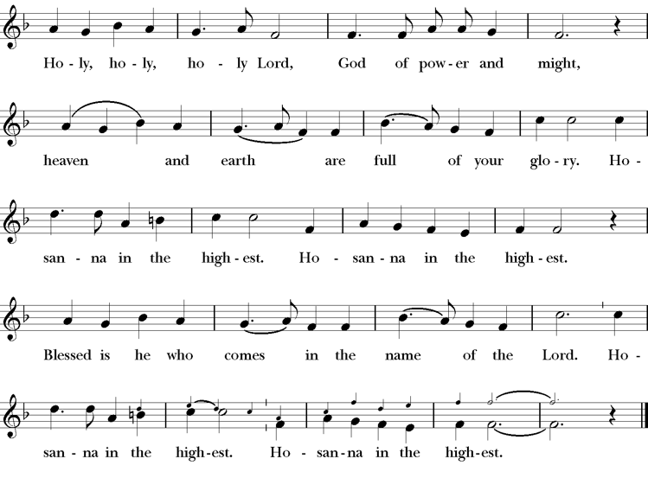
Words of Institution BCP 368
The Lord’s Prayer 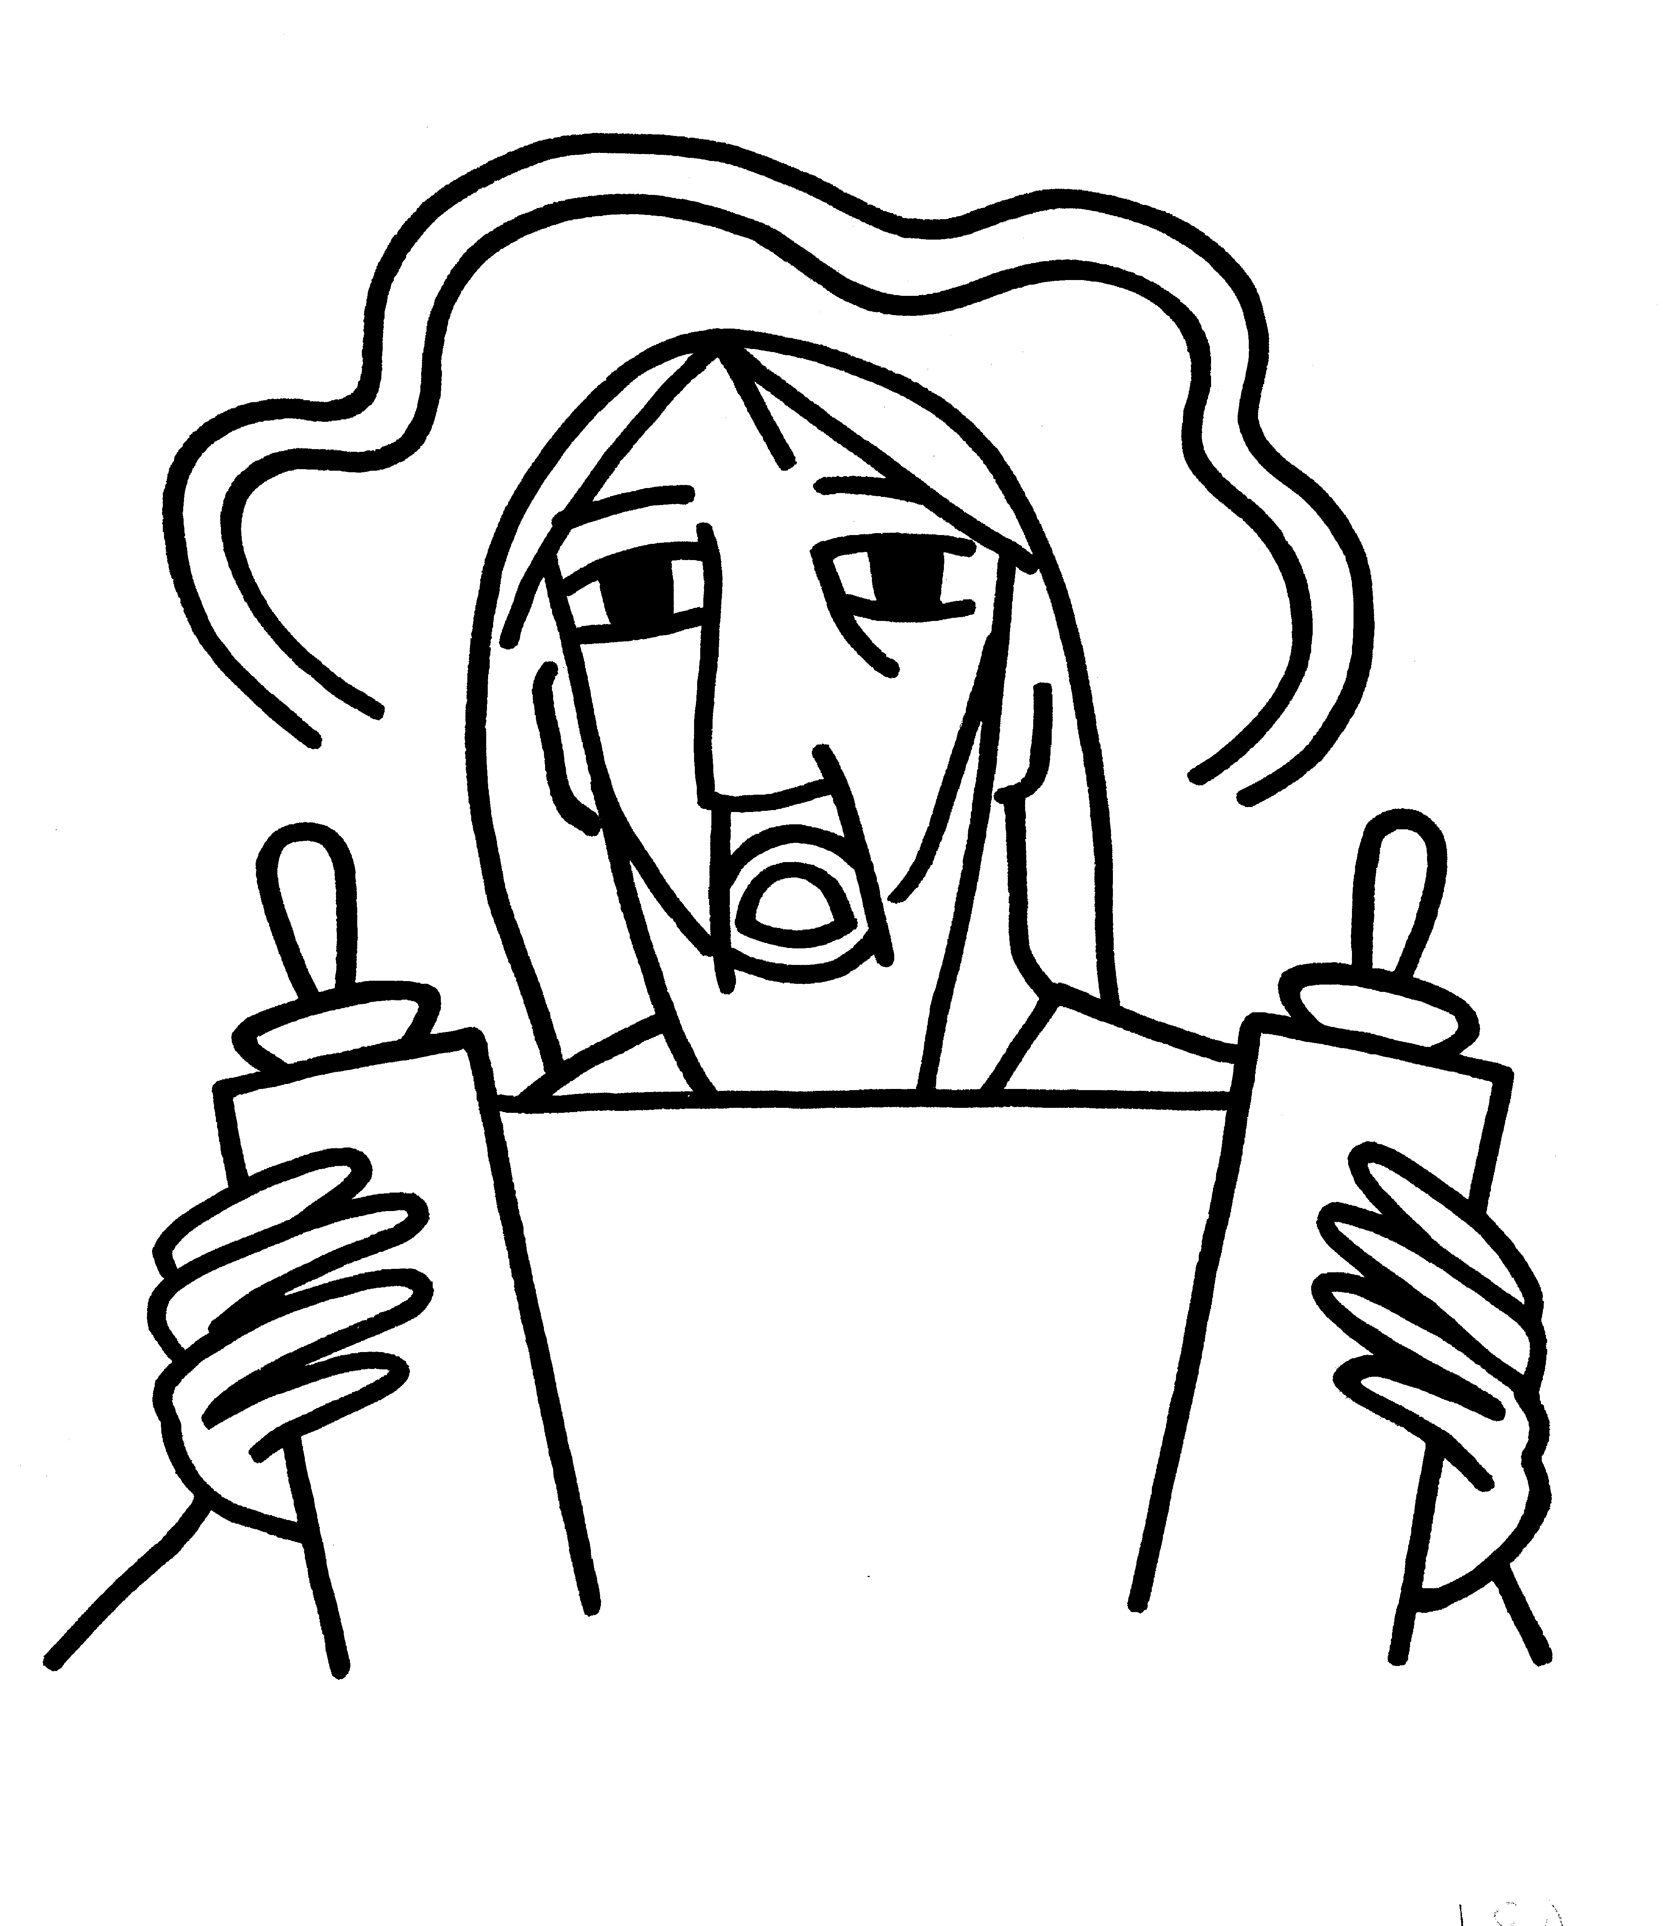 BCP 364
The Breaking of the Bread  BCP 364

Fraction Anthem

For the Bread Which you have Broken H 341
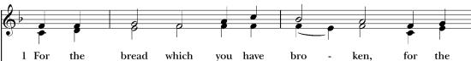
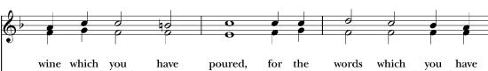
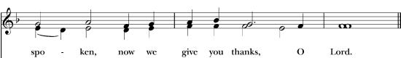
All are welcome at the Lord’s table to receive Holy Communion or a blessing. To receive Communion in your pew, please ask an usher to notify the ministers on your behalf. If you require a gluten-free wafer, please ask at the altar rail.

Communion Music Steve Rubardt & Choir
In the Bleak Midwinter H 112
Post-Communion Prayer
God our host, at this table you have fed us with joy and gladness.
Send us forth, eager to share the feast, welcome the stranger, and bear good fruit in the name of Jesus.
Amen.
The Blessing
God of endings and beginnings,
God in the darkness and the light,
God, our hope for the journey,
bless and keep you now and forever.
The Recessional Hymn If you but trust God to Guide you H 635
The Dismissal*
Celebrant | Fear not! Christ is coming soon.
People | Amen! Come, Lord Jesus!
Postlude Steve Rubardt
Please remain seated

SERVING TODAY
Celebrant and Preacher: Pastor Cindy Beck
Acolyte: Susie Hand
Lector: Lorena Reinhardt, Claire Ginesi
Intercessor: Barbara Feduska
Worship Musician: Steve Rubardt
Choir Leader: Steve Rubardt
Choir: Liz Carpenter, Heather Dahlberg, Scott Sherman, Lucy Maushardt, Patsy Gralow, Laurell Meredith, Mary Omodt, Barbara Feduska, Tara Anderson
Sunday School - Child Care: Wendy Aguilar Appt Only
Ushers: Marcia Derby
Tech Chaplain: Marcos Rendon
Altar Guild: Marcia Derby , Mary Omodt
Hospitality: Matt Dahlberg

Prayers requested for these on Trinity’s long-term prayer list: Baby Walker David, Armando P, Laura Basett, , Georgia Bostedt, Muff Davey, John Eiler, Gerrilee Fisher, Claire Ginesi, Mary Griffin, David & Christine Hilt, Dr. Tamer Keshen, Marie Lambert, Mark Mezzetta, Kelcey Omodt, Grizelda Ponce, Barry Reap, Blake W, Robert R, Ann Loveland Sherman, John Spooner, James Thomas, Rose Burns, Jennifer Gralow, Patsy Gralow, Steve Antenen, Van Z, Sandra Leland, John Forester, Stuart , Melissa White.
Prayers for the Repose of soul: Tim Dowd , Susan Bassett, Joan Biersch, Mere Nagasau, Christina Van Krugel, Linda Dowd, Peggy and John Bell, Denny Hoelter
Contact Pastoral Care Chair, Lorena lorena.m.reinhardt@gmail.com to make any additions or to remove names from our Long-Term Prayer list.

Calendar of the Church (Year A)
The calendar (BCP, pp. 15-33) orders the liturgical year of the Episcopal Church by identifying two cycles of feasts and holy days-one dependent upon the movable date of Easter Day and the other dependent upon the fixed date of Christmas, Dec. 25. Easter Day is the first Sunday after the full moon that falls on or after Mar. 21. The sequence of all Sundays in the church year is based on the date of Easter. Tables and rules for finding the date of Easter Day, and other movable feasts and holy days are provided by the BCP, pp. 880-885. The date of Easter determines the beginning of the season of Lent on Ash Wednesday and the date of Pentecost on the fiftieth day of the Easter season. The Sundays of Advent are always the four Sundays before Christmas Day. The church year begins on the first Sunday of Advent. The calendar also identifies and provides directions concerning the precedence and observance of principal feasts, Sundays, holy days (including Feasts of our Lord, other major feasts, and fasts), Days of Special Devotion, and Days of Optional Observance. The calendar lists dates for celebration of major feasts and lesser feasts by month and date. Appropriate Sunday Letters and Golden Numbers are also provided. (see BCP, pp. 880-881). The calendar also lists the titles of the seasons, Sundays, and major holy days observed in the Episcopal Church throughout the church year, including Advent season, Christmas season, Epiphany season, Lenten season, Holy Week, Easter season, the season after Pentecost, holy days, and National Days.
About this Service: Advent: Season of Expectation and Hope
The first season of the church year, beginning with the fourth Sunday before Christmas and continuing through the day before Christmas. The name is derived from a Latin word for “coming.” The season is a time of preparation and expectation for the coming celebration of our Lord's nativity, and for the final coming of Christ “in power and glory
Notes on the Advent Season Liturgy
Expectation, not penitence, is the major theme of in Advent. It is a season of preparation for the coming of Jesus Christ, both his coming in history to Bethlehem, celebrated at Christmas, and his coming in glory at the end of time to “to judge the living and the dead.,” to which Christians look forward. “The King shall come!” and “Rejoice!” are its watchwords. The great Advent figures who dominate the Scripture readings are Isaiah, John the Baptist, and the Virgin Mary.
The preparation is also distinct from getting ready for Christmas, in terms of planning and preparation for the ways we celebrate that feast with family or friends. The season of Advent. In our worship services should prepare us and our hearts for the renewed coming of Christ.
The Trinity Worship Ministry team has prepared our Advent celebrations with care to distinguish the four Sundays of Advent from other liturgical seasons.
First, our service will begin with the Lighting of the Advent candle. This will be followed by the Prelude, then the Entrance Hymn, which will be sung every Sunday of Advent. The Service Bulletin contains all the Prayers, Petitions, Lyrics and Scriptural readings. Hymn numbers are referenced for those who read music (1982 Hymnal found in the pew). We stand sit and kneel in this service, as you are able and comfortable.
Trinity Liturgical Ministry ROTA Next two weeks
Date | Celebrant | Ushers | Acolyte / EM | Lector (s) | Intercessor | Altar Guild
Dec 14 | Cindy Beck | John Addeo | Arminda Eiler | Gerrilee Fisher John Eiler | Alfred Escoffier | Susie Hand
Dec 21 | Cindy Beck | John Eiler | Arminda Eiler | Bill Doyle Barbara Feduska | Jane Hernandez | Liz Carpenter Laurell Meredith

Schedule of Weekly Meetings and Services at Trinity Episcopal Sonoma
Day | Date | Time | Occasion | Location
Wednesday | TBD | TBD | Bible Study | Library
Thursday | December 11 | 10:30 AM  5:30 PM | Mindfulness & Well Being  Alcoholics Anonymous | Library  Buttrum Hall
Saturday | December 13 | 8 AM | Centering Prayer | St. Luke’s Chapel
Sunday | December 14 | 10:15 AM | Holy Eucharist II | Sanctuary
Mon-Fri | Weekdays | 7AM-1PM | Sonoma Home Meals | Kitchen &Buttrum Hall
Mon-Fri | Weekdays | 9-2 | Sonoma Preschool Academy – School

Monthly Meetings at Trinity Episcopal Sonoma
Day | Date | Time | Meeting | Location | Contact
Tuesday | December 2 | 11 AM | Prayer Shawl Ministry | Library | Norah Collins 28norahe@gmail.com
Thursday | December 18 | 4:30 PM | Vestry | Library | Claire Ginesi cfgsonoma@gmail.com

PRAYERS and BLESSINGS
For a Birthday
Watch over your child, O Lord as his/her days increase; bless and guide him/her wherever s/he may be. Strengthen them when s/he stands; comfort him/her when discouraged or sorrowful; raise him/her up if s/he fall; and in his/her heart may your peace which passes understanding abide all the days of his/her life; through Jesus Christ our Lord. Amen.
For an Anniversary
O God, you have so consecrated the covenant of marriage that it represents the spiritual unity between Christ and his Church: Send your blessing upon these your servants as they celebrate their anniversary, that they may continue to love, honor and cherish each other in faithfulness and patience, in wisdom and true godliness, that their home may be a haven of blessing and peace; through Jesus Christ our Lord, who lives and reigns with you and the Holy Spirit, one God, now and forever. Amen.
For Travelers
O God, our heavenly Father, whose glory fills the whole creation, and whose presence we find wherever we go; preserve those who travel; surround them with your loving care; protect them from every danger, and bring them in safety to their journey’s end; through Jesus Christ our Lord. Amen.
Sending our Eucharistic Visitors
Priest: In the name of this congregation, I send you forth bearing these holy gifts, the those to whom you go may share with us in the communion of Christ’s body and blood.
People: We who are many are one body, because we all share on bread, and one cup. Amen

Trinity Episcopal Church
In Sonoma for over 170 years
275 East Spain Street
Sonoma, CA 95476
The Rt. Rev. Megan M. Traquair, Bishop
Diocese of Northern California
Pastor Cindy Beck, Interim
Steve Rubardt, Worship Music
Vestry
Claire Ginesi, Senior Warden
Bill Doyle, Junior Warden (Buildings, Grounds)
Bill Doyle (Stewardship)
Susie Hand
Heather Dahlberg
Sally Thornhill
Lorena Reinhardt (Pastoral Care)
Ministries
Prayer Shawl ,Norah Collins
Outreach, Jane Hernandez
Youth – Academic Tutoring, Karen Randall
Mindfulness & Well Being, Mary Omodt
Sunday School, Children, Wendy Aguilar

The Members of the Congregation are The Ministers of the Church

Administrative Office Hrs.
Monday Wednesday 9 A.M. – 2 PM; Thursday 10A.M.-2 P.M0
Sunday 9:30-11:30
Clergy Office Hours Wednesdays, Thursdays, by appointment

Emergency, sickness, please contact office: 707-938-4846

