**Trinity Episcopal Church**

In Sonoma for over 170 years

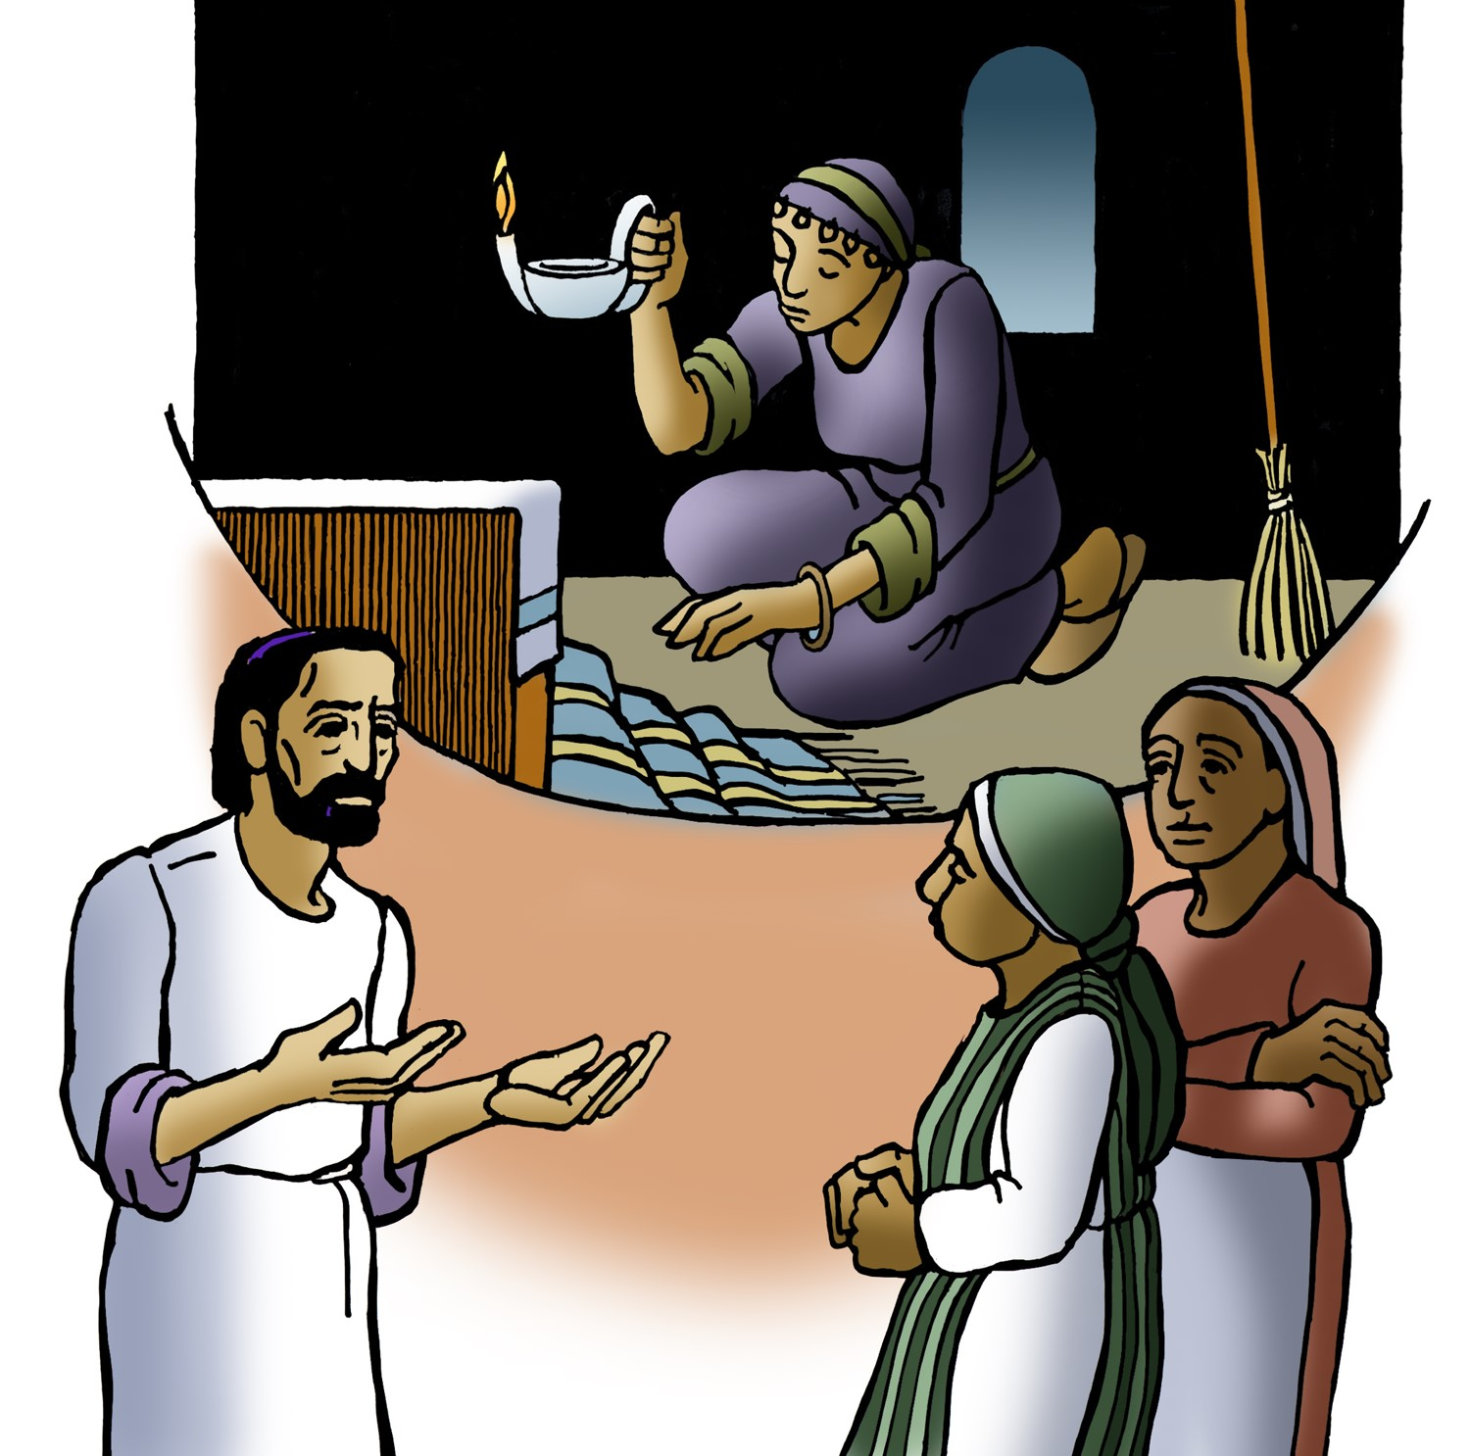

**The Fourteenth Sunday After Pentecost**

Proper 19 (Year C) **Holy Eucharist II**

September 14 , 2025

10:00 AM *In person and* [*Online*](https://www.youtube.com/@trinityepiscopalchurchsono8741)

***Welcome to Trinity Episcopal, Sonoma!***

Whether you have wandered in, are wondering about God or grew up in the church, or wherever you are in your journey...you are welcome here... We are blessed by your presence.

***For Visitors and Newcomers:***

Everyone is welcome to receive communion at the Lord’s table. Jesus gave this tangible reminder of God’s presence, love, and forgiveness for all. If you are interested in a visit or call from the Priest-in-Charge , please sign our guest book on the table at the entrance of the church, including an email or phone number.

***Restrooms***

A restroom is located outside the entrance of Buttrum Hall (the building across the courtyard) and another is located inside the hall to the right.

***Coffee and Treats:***

Following worship we have coffee and treats after service in Buttrum Hall. We hope it is a time to get to know you better.

***To access Trinity’s Guest WIFI: Password Rosepettal441 (case sensitive).***

We are glad you are here, and we invite you to enter fully into worship this morning.

**August Announcements**

**Pastor Cindy continues her 8 week bible study on Wednesday at 11 am.**

called "Together by Grace: Bible Conversations in Matthew." With guided conversations and open-ended questions, participants are invited to share thoughts, experiences and similarities with the biblical stories. Ten participant books have arrived! If there is interest in an evening group, please let Pastor Cindy know.

**The Free Movie night series** hosted by Trinity Episcopal in Sonoma, will be returning this September, Wednesday 17th with ‘The Truman Show”. Please join us at 6PM for the movie and engage with the parish in the post film discussion.

**September 9, 2025 marks the 5th anniversary** of the City of Sonoma declaring September 9 to be "Norah Collins Day."  Nora was nominated for this recognition due to her faithful ministry of making and distributing prayer shawls to comfort people in times of sorrow, illness, bereavement, and more.  We at Trinity are grateful for Nora's continued ministry of creating and distributing prayer shawls.

***Small Group Gatherings (What to Expect) -*** These Small Group Gatherings are times of conversation about our lives at Trinity Episcopal. Each group will share stories and ideas about our experiences at Trinity, what struggles Trinity faces, what resources Trinity has, etc. Questions such as “Why do you come to Trinity?” “What is Trinity’s purpose?” may be raised. Each group will follow a behavioral covenant on how we will listen and respond to one another and how we ourselves will speak.

There are still spaces left on:

Wednesday, Sept. 24 from 2 – 3:30 at Liz Carpenter’s home

Thursday, Sept. 25 from 3 – 4:30 at Heather Dahlberg’s home

Wednesday, October 1 from 10:30 – noon at Mandy Birkbeck’s home in Napa

Sign up after worship on the table outside the church or contact the office

at 707-938-4846.

***Fellowship Coffee Hour Sign up***

We encourage members to sign up to make coffee. Pastor Cindy is happy to demonstrate how easy this is. Please help us provide this hospitality for guests and members.

***The August, September, October Forward Day by Day ,***

a booklet of daily inspirational meditations is now available in the Church and the Office. We ask for a $2 donation.

***All are welcome to make a gift and offering in thanksgiving to God*;**

for the many blessings we have received. To take advantage of our electronic giving options, please follow the QR code with your capable electronic device, or visit <https://onrealm.org/trinitysonoma/-/form/give/default> Help us to make this a place where God’s grace is freely shared by all.

**Please wish Father Jim Thomas a Happy Birthday** (September 12), Trinity Episcopal in Sonoma is forever in your gratitude.





**Prelude** Steve Rubardt

*Please stand for the Entrance Hymn.*

*At the sound of the bell, please stand as you are able. The People respond when bold text appears.*

The Word of God

**Entrance Hymn *The God of Abraham Praise*** H 401

**Opening Acclamation** BCP 319

|  |  |
| --- | --- |
| *Celebrant* | Blessed be God: Father, Son, and Holy Spirit. |
| ***People*** | **And blessed be his kingdom, now and for ever. Amen.** |

**Collect for Purity**

***All* Almighty God, to you all hearts are open, all desires known, and from you no secrets are hid: Cleanse the thoughts of our hearts by the inspiration of your Holy Spirit, that we may perfectly love you, and worthily magnify your holy Name; through Christ our Lord. *Amen.***

**Song of Praise Gloria BCP 356/Hymnal S-280**

***All*** Glory to God in the highest,

and peace to his people on earth.

Lord God, heavenly King,

almighty God and Father,

we worship you, we give you thanks,

we praise you for your glory.

Lord Jesus Christ, only Son of the Father,

Lord God, Lamb of God,

you take away the sin of the world:

have mercy on us;

you are seated at the right hand of the Father:

receive our prayer.

For you alone are the Holy One,

you alone are the Lord,

you alone are the Most High,

Jesus Christ,

with the Holy Spirit,

in the glory of God the Father. Amen.

**The Collect of the Day** BCP 357

|  |  |
| --- | --- |
| Celebrant | The Lord be with you. |
| ***People*** | **And also with you.** |
| Celebrant | Let us pray. |

O God, because without you we are not able to please you mercifully grant that your Holy Spirit may in all things direct and rule our hearts; through Jesus Christ our Lord, who lives and reigns with you and the Holy Spirit, one God, now and for ever.

***All* Amen.**

**The Lessons**

**First Reading:  Exodus 32:7-14**

*Reader* A Reading from the book of Exodus.

7The Lord said to Moses, “Go down at once! Your people, whom you brought up out of the land of Egypt, have acted perversely; 8they have been quick to turn aside from the way that I commanded them; they have cast for themselves an image of a calf, and have worshiped it and sacrificed to it, and said, ‘These are your gods, O Israel, who brought you up out of the land of Egypt!’ ” 9The Lord said to Moses, “I have seen this people, how stiff-necked they are. 10Now let me alone, so that my wrath may burn hot against them and I may consume them; and of you I will make a great nation.”  
  11But Moses implored the Lord his God, and said, “O Lord, why does your wrath burn hot against your people, whom you brought out of the land of Egypt with great power and with a mighty hand? 12Why should the Egyptians say, ‘It was with evil intent that he brought them out to kill them in the mountains, and to consume them from the face of the earth’? Turn from your fierce wrath; change your mind and do not bring disaster on your people. 13Remember Abraham, Isaac, and Israel, your servants, how you swore to them by your own self, saying to them, ‘I will multiply your descendants like the stars of heaven, and all this land that I have promised I will give to your descendants, and they shall inherit it forever.’ ” 14And the Lord changed his mind about the disaster that he planned to bring on his people.

|  |  |
| --- | --- |
| *Reader* | The Word of the Lord. |
| ***People*** | **Thanks be to God.** |



**The Psalm: Psalm 51:1-11**

*Reader* Our response to the reading is Psalm 51:1-11which we will read responsively by half verse.

1Have mercy on me, O God, according to your loving-kindness; *  
   **in your great compassion blot out my offenses.**  
  2Wash me through and through from my wickedness, *  
   **and cleanse me from my sin.**  
  3For I know my transgressions, *  
   **and my sin is ever before me.**  
  4Against you only have I sinned *  
   **and done what is evil in your sight.**  
  5And so you are justified when you speak *  
   **and upright in your judgment.**  
  6Indeed, I have been wicked from my birth, *  
   **a sinner from my mother’s womb.**  
  7For behold, you look for truth deep within me, *  
   **and will make me understand wisdom secretly.**  
  8Purge me from my sin, and I shall be pure; *  
   **wash me, and I shall be clean indeed.**  
  9Make me hear of joy and gladness, *  
   **that the body you have broken may rejoice.**  
  10Hide your face from my sins, *  
   **and blot out all my iniquities.**  
  11Create in me a clean heart, O God, *  
   **and renew a right spirit within me.**

**Second Reading:  1 Timothy 1:12-17**

*Reader*A Reading from Paul's First letter to Timothy.

12I am grateful to Christ Jesus our Lord, who has strengthened me, because he judged me faithful and appointed me to his service, 13even though I was formerly a blasphemer, a persecutor, and a man of violence. But I received mercy because I had acted ignorantly in unbelief, 14and the grace of our Lord overflowed for me with the faith and love that are in Christ Jesus. 15The saying is sure and worthy of full acceptance, that Christ Jesus came into the world to save sinners—of whom I am the foremost. 16But for that very reason I received mercy, so that in me, as the foremost, Jesus Christ might display the utmost patience, making me an example to those who would come to believe in him for eternal life. 17To the King of the ages, immortal, invisible, the only God, be honor and glory forever and ever. Amen.

|  |  |
| --- | --- |
| *Reader* | The Word of the Lord. |
| ***People*** | **Thanks be to God.** |

**Sequence Hymn**  ***The King of Love my Shepherd is*** H 645 v 1 & 3



**The Holy Gospel:  Luke 15:1-10**

|  |  |
| --- | --- |
| Celebrant | The Holy Gospel of our Lord Jesus Christ according to Luke. |
| ***People*** | **Glory to you, Lord Christ.** |

1Now all the tax collectors and sinners were coming near to listen to [Jesus.] 2And the Pharisees and the scribes were grumbling and saying, “This fellow welcomes sinners and eats with them.”  
  3So he told them this parable: 4“Which one of you, having a hundred sheep and losing one of them, does not leave the ninety-nine in the wilderness and go after the one that is lost until he finds it? 5When he has found it, he lays it on his shoulders and rejoices. 6And when he comes home, he calls together his friends and neighbors, saying to them, ‘Rejoice with me, for I have found my sheep that was lost.’ 7Just so, I tell you, there will be more joy in heaven over one sinner who repents than over ninety-nine righteous persons who need no repentance.  
  8“Or what woman having ten silver coins, if she loses one of them, does not light a lamp, sweep the house, and search carefully until she finds it? 9When she has found it, she calls together her friends and neighbors, saying, ‘Rejoice with me, for I have found the coin that I had lost.’ 10Just so, I tell you, there is joy in the presence of the angels of God over one sinner who repents.”

|  |  |
| --- | --- |
| *Celebrant* | The Gospel of the Lord. |
| ***People*** | **Praise to you, Lord Christ.** |

**Sequence Hymn  *The King of Love my Shepherd is*** H 645 v 5 & 6

**The Sermon**  Cindy Beck

**The Nicene Creed** (BCP p. 358)

**The Prayers of the People**

Celebrant: Let us pray for the Church and for the World. Grant Almighty God, that all who confess your name may be united in truth, live together in love and reveal your glory in the world.

Intercessor: Father, we pray for your holy Catholic Church.

**That we all may be one.**

In the Diocesan Cycle of Prayer, we pray for Trinity Church in Sutter Creek.

In the Anglican Cycle of Prayer, we pray for The Anglican Church of South America. Grant that every member of the Church may truly and humbly serve you.

**That your Name may be glorified by all people.**

We pray for *N.* our Presiding Bishop, for our bishop, *N.*, for all the clergy of this parish; for all bishops, priests and deacons.

**That they may be faithful ministers of your Word and Sacraments and that they may guide their parishioners with your light and love.**

We pray for *N.* our President, for Congress and our state legislature, for the Supreme Court and for all courts; for all who govern and seek to govern in our nation and the nations of the world.

**That they will seek your justice and your will in their service.**

Give us grace to do your will in all that we undertake.

**That our works may find favor in your sight.**

Praise God for all those in whom Christ has been honored. As we *remember*/*anticipate* the anniversary of 9/11, we give thanks for all first responders, ministers, chaplains and civil servants who have honored you with their lives while responding to disasters, civil unrest, and terrorist attacks.

**That we too may have grace to glorify Christ when we respond to those in need in our own day.**

Have compassion on all who suffer from illness, bereavement and brokenness.

*Invite the congregation to add their petitions, followed by silence*

**That they may be delivered from their distress.**

We praise you for all your saints who have entered in eternal joy.

*Invite the congregation to add their petitions, followed by silence*

**That we may also come to share in your heavenly kingdom.**

Let us pray for own needs and those of others, silently or aloud.

*(Silence. The People may add their own petitions.)*

*Presider*

Lord of creation whose glory is around and within us: open our eyes to your wonders, that we may serve you with reverence and know your peace in our lives. To you we give glory, Father, Son and Holy Spirit now and forever.

**Amen.**

**The Confession of Sin**  BCP 359

**The Peace**

Celebrant The peace of the Lord be always with you.

***People* And also with you.**

**Announcements**

Birthdays, Anniversaries, Travelers (prayers found at back of bulletin)



The Holy Communion

**The Offertory** *At the Offering, you’ll find a Pledge card in the Pew Rack for those who’d like to designate their financial donations to Trinity’s Pledging Income. For others, or a one-time gift, envelopes are in the pew racks as well as on the Narthex table or text TRINITYSONOMA" to 73256. Thank you!*

**Offertory Music**

Steve Rubardt and Choir There’s a Sweet, Sweet Spirit LEVAS 120

**Doxology**

The people stand while the offerings are presented and placed on the Altar.

Presider: Gracious God, as an offering of our thanksgiving and gratitude, we return to you a portion of what you have gifted us.

**The Great Thanksgiving**

Eucharistic Prayer B BCP 367

|  |  |
| --- | --- |
| Celebrant | The Lord be with you. |
| **People** | **And also with you.** |
| Celebrant | Lift up your hearts. |
| **People** | **We lift them to the Lord.** |
| Celebrant | Let us give thanks to the Lord our God. |
| **People** | **It is right to give him thanks and praise.** |

**Proper Preface (BCP p. 367)**

It is right, and a good and joyful thing, always and everywhere to give thanks to you, Father Almighty, Creator of heaven and earth.

For you are the source of light and life; you made us in your image, and called us to new life in Jesus Christ our Lord.

Therefore we praise you, joining our voices with Angels and Archangels and with all the company of heaven, who for ever sing this hymn to proclaim the glory of your Name:



**Sanctus Holy Holy, Holy (Proulx)**  Hymnal S-125

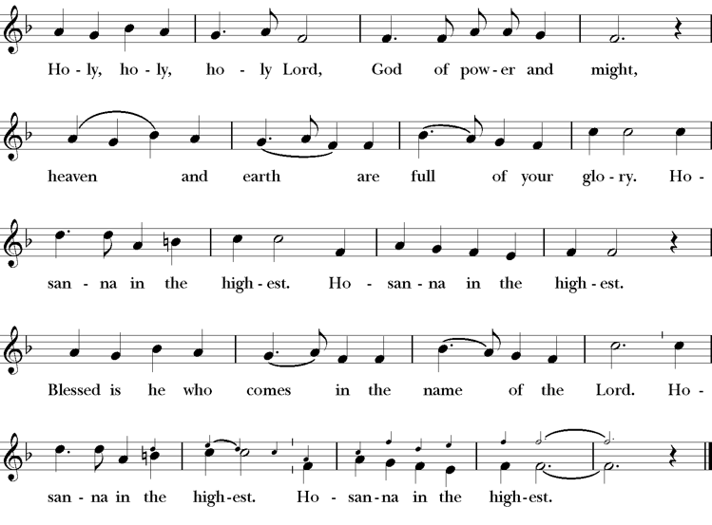

**The Lord’s Prayer** BCP 336

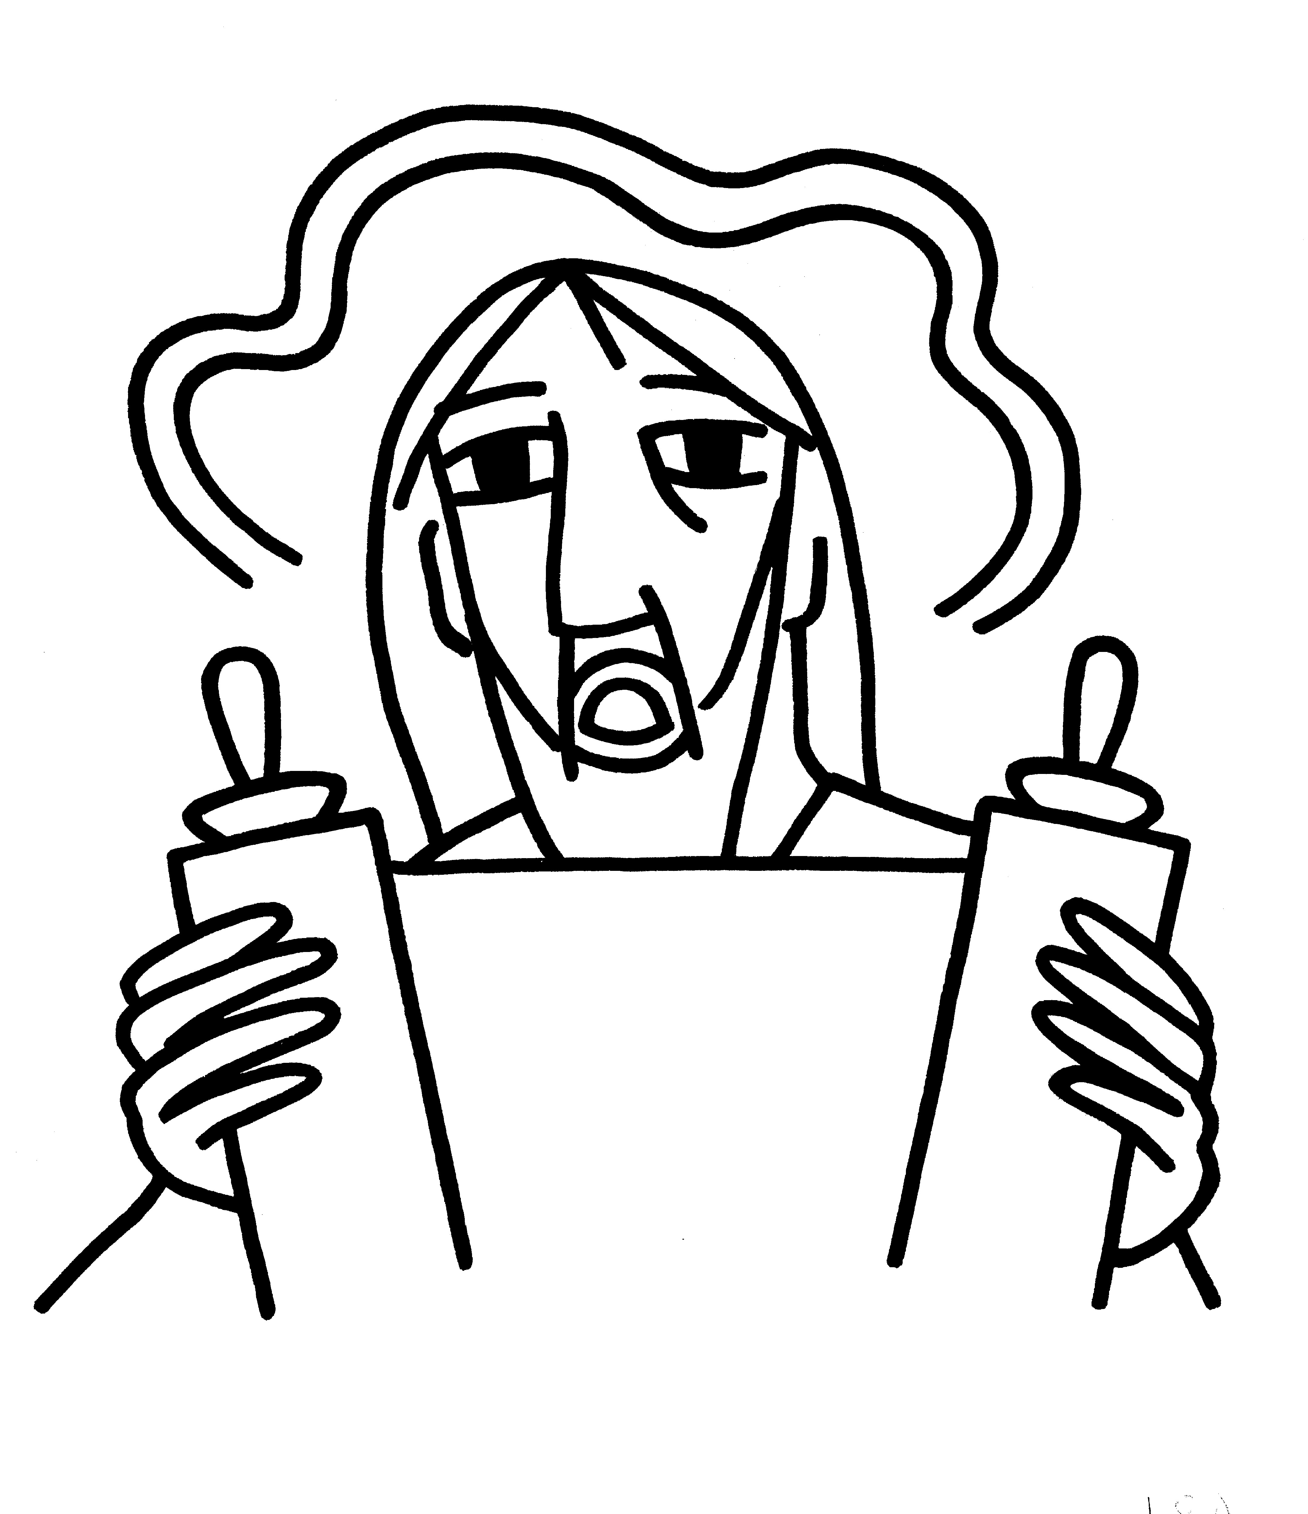

**The Breaking of the Bread** BCP 364



**Fraction Anthem** S-154

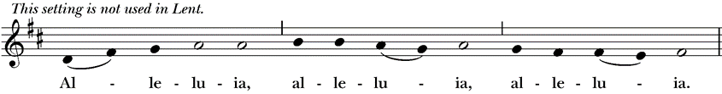

Click to get the full file (S 154 Christ our Passover (Hurd) 2 (Staff).tif):  (Staff)Click to get the full file (S 154 Christ our Passover (Hurd) 3 (Staff).tif):  (Staff)

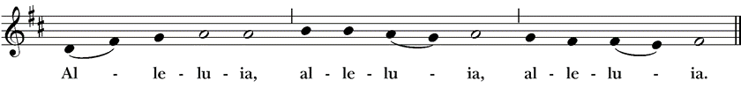

*All are welcome at the Lord’s table to receive Holy Communion or a blessing. To receive Communion in your pew, please ask an usher to notify the ministers on your behalf. If you require a gluten-free wafer, please ask at the altar rail.*

**Communion Music Steve Rubardt & Choir**

***Now the Silence*** H 333

**Post-Communion Prayer** BCP 365

**The Blessing**

**The Recessional Hymn *Take my Life*** H 707

**The Dismissal\***

|  |  |
| --- | --- |
| *Celebrant* | Let us go forth in the name of Christ. |
| ***People*** | **Thanks be to God.** |

**Postlude** Steve Rubardt

*Please remain seated*

**SERVING TODAY**

**Celebrant and Preacher:** Cindy Beck

**Eucharistic Minister:** Arminda Eiler

**Acolyte:** Susie Hand

**Lector:**  Ann Kyser , Gerrilee Fisher

**Intercessor:** Barbara Feduska

**Worship Musician**: Steve Rubardt

**Choir Leader:** Steve Rubardt

**Choir**: Liz Carpenter, Heather Dahlberg, Scott Sherman, Lucy Maushardt, Patsy Gralow, Laurell Meredith, Mary Omodt, Barbara Feduska, Tara Anderson

**Sunday School - Child Care:**Wendy Aguilar Appt Only

**Ushers**: John Eiler , Barbara Feduska

**Tech Chaplain**: Marcos Rendon

**Altar Guild**: Ann Kyser

**Hospitality**: Jane Hernandez

**Counters:** TBD

Altar Flowers are given to the glory of God by Altar Guild.

*\*Why no ‘Alleluias” printed in the bulletin? There are two different rubrics (or rules) that govern the use of Alleluia in worship, set by the Canons. One set of rubrics govern the use of Alleluia in music and in all of the liturgy except for the Dismissal. This rule says that we use Alleluia all the time except during the season of Lent. The other set of rubrics covers just the Dismissal and it says that we only use Alleluia in the Dismissal during the period from Easter Sunday through Pentecost, but not at any other time.*

**Prayers requested for these on Trinity’s long-term prayer list**: Baby Walker David, Armando P, Laura Basett, Peggy & John Bell, Georgia Bostedt, Muff Davey, Linda Dowd, John Eiler, Gerrilee Fisher, Claire Ginesi, Mary Griffin, David & Christine Hilt, Dr. Tamer Keshen, Marie Lambert, Mark Mezzetta, Kelcey Omodt, Grizelda Ponce, Barry Reap, Blake W, Robert R, Ann Loveland Sherman, John Spooner, James Thomas, Rose Burns, Jennifer Gralow, Patsy Gralow, Denny Hoelter, Steve Antenen, Van Z, Sandra Leland, John Forester, Stuart , Melissa White.

**Prayers for the Repose of soul:** Tim Dowd , Susan Bassett, Joan Biersch, Mere Nagasau, Christina Van Krugel

Contact Pastoral Care Chair, Lorena [lorena.m.reinhardt@gmail.com](mailto:lorena.m.reinhardt@gmail.com) to make any additions or to remove names from our Long-Term Prayer list.

**About this Service**: **Year C**

**Calendar of the Church Year**

The calendar (BCP, pp. 15-33) orders the liturgical year of the Episcopal Church by identifying two cycles of feasts and holy days-one dependent upon the movable date of Easter Day and the other dependent upon the fixed date of Christmas, Dec. 25. Easter Day is the first Sunday after the full moon that falls on or after Mar. 21. The sequence of all Sundays in the church year is based on the date of Easter. Tables and rules for finding the date of Easter Day, and other movable feasts and holy days are provided by the BCP, pp. 880-885. The date of Easter determines the beginning of the season of Lent on Ash Wednesday and the date of Pentecost on the fiftieth day of the Easter season. The Sundays of Advent are always the four Sundays before Christmas Day. The church year begins on the first Sunday of Advent. The calendar also identifies and provides directions concerning the precedence and observance of principal feasts, Sundays, holy days (including Feasts of our Lord, other major feasts, and fasts), Days of Special Devotion, and Days of Optional Observance. The calendar lists dates for celebration of major feasts and lesser feasts by month and date. Appropriate Sunday Letters and Golden Numbers are also provided. (see BCP, pp. 880-881). The calendar also lists the titles of the seasons, Sundays, and major holy days observed in the Episcopal Church throughout the church year, including Advent season, Christmas season, Epiphany season, Lenten season, Holy Week, Easter season, the season after Pentecost, holy days, and National Days.

**About this Service: The Season after Pentecost**

Our current liturgical season, the Season after Pentecost, is by far the longest of the Episcopal church year. It begins the day after Pentecost and ends the day before the First Sunday of Advent. Since the date of Easter changes every year—and the Day of Pentecost is always 50 days after Easter—the length of the season varies as well, ranging from 24-29 weeks in length. This season is sometimes called Ordinary Time, a phrase borrowed from the Roman Catholic Church. A common practice among Episcopal churches is to change the appropriate liturgical elements at the start of each new season. Often these changes are directed by the Book of Common Prayer, such as the acclamations named for use in the Lenten and Easter seasons. However, liturgical leaders also decide which Prayers of the People, Eucharistic Prayer, blessing, and dismissal are used in services.



**Trinity Liturgical Ministry ROTA Next two weeks**

|  |  |  |  |  |  |  |  |
| --- | --- | --- | --- | --- | --- | --- | --- |
| **Date** | **Celebrant** | **Ushers** | **Euch Min** | **Acolyte** | **Lector (s)** | **Intercessor** | **Altar Guild** |
| September 21 | Cindy Beck | Jane Hernandez Barbara Feduska | Susie Hand | Arminda Eiler | Bill Doyle John Eiler | Lorena Reinhardt | Laurell Meredith Liz Carpenter |
| September 28 | Cindy Beck | John Eiler Marcia Derby | Arminda Eiler | Susie Hand | Barbara Feduska Gerrilee Fisher | Ann Kyser | Ann Kyser |

**Schedule of Weekly Meetings and Services at Trinity Episcopal Sonoma**

|  |  |  |  |  |
| --- | --- | --- | --- | --- |
| **Day** | **Date** | **Time** | **Occasion** | **Location** |
| Wednesday | September 17 | 11 AM | Bible Study | Library |
| Thursday | September 18 | 10:30 AM  5:30 PM | Mindfulness & Well Being  Alcoholics Anonymous | Library  Buttrum Hall |
| Saturday | September 20 | 8 AM | Centering Prayer | St. Luke’s Chapel |
| Sunday | September 21 | 10:15 AM | Holy Eucharist II | Sanctuary |
| Mon-Fri | Weekdays | 7AM-1PM | Sonoma Home Meals | Kitchen &Buttrum Hall |
| 9-2 | **Sonoma Preschool Academy – School** | |

**Monthly Meetings at Trinity Episcopal Sonoma**

|  |  |  |  |  |  |
| --- | --- | --- | --- | --- | --- |
| Day | Date | Time | Meeting | Location | Contact |
| Tuesday | September 2 | 11 AM | Prayer Shawl Ministry | Library | Norah Collins [28norahe@gmail.com](mailto:28norahe@gmail.com) |
| Thursday | September 25 | 4:30 PM | Vestry | Library | Claire Ginesi [cfgsonoma@gmail.com](mailto:cfgsonoma@gmail.com) |

**PRAYERS and BLESSINGS**

**For a Birthday**

Watch over your child, O Lord as his/her days increase; bless and guide him/her wherever s/he may be. Strengthen them when s/he stands; comfort him/her when discouraged or sorrowful; raise him/her up if s/he fall; and in his/her heart may your peace which passes understanding abide all the days of his/her life; through Jesus Christ our Lord. ***Amen.***

**For an Anniversary**

O God, you have so consecrated the covenant of marriage that it represents the spiritual unity between Christ and his Church: Send your blessing upon these your servants as they celebrate their anniversary, that they may continue to love, honor and cherish each other in faithfulness and patience, in wisdom and true godliness, that their home may be a haven of blessing and peace; through Jesus Christ our Lord, who lives and reigns with you and the Holy Spirit, one God, now and forever. ***Amen.***

**For Travelers**

O God, our heavenly Father, whose glory fills the whole creation, and whose presence we find wherever we go; preserve those who travel; surround them with your loving care; protect them from every danger, and bring them in safety to their journey’s end; through Jesus Christ our Lord. ***Amen***.

**Sending our Eucharistic Visitors**

**Priest**: In the name of this congregation, I send you forth bearing these holy gifts, the those to whom you go may share with us in the communion of Christ’s body and blood.

**People**: *We who are many are one body, because we all share on bread, and one cup.* ***Amen***

|  |
| --- |
|   *In Sonoma for over 170 years*  275 East Spain Street  Sonoma, CA 95476 |
| The Rt. Rev. Megan M. Traquair, Bishop  Diocese of Northern California  Pastor Cindy Beck, Interim  Steve Rubardt, Worship Music  **Vestry**  Claire Ginesi, Senior Warden  Bill Doyle, Junior Warden (Buildings, Grounds)  Bill Doyle (Stewardship)  Susie Hand  Heather Dahlberg  Sally Thornhill  Lorena Reinhardt (Pastoral Care)  **Ministries**  Prayer Shawl ,Norah Collins  Outreach, Jane Hernandez  Youth – Academic Tutoring, Karen Randall  Mindfulness & Well Being, Mary Omodt  Sunday School, Children, Wendy Aguilar  The Members of the Congregation are The Ministers of the Church  Administrative Office Hrs.  Monday Wednesday 9 A.M. – 2 PM; Thursday 10A.M.-2 P.M0  Sunday 9:30-11:30  Clergy Office Hours Wednesdays, Thursdays, by appointment  Emergency, sickness, please contact office: 707-938-4846 |