Trinity Episcopal Church
Cultivating God’s Loving Spirit in each of us
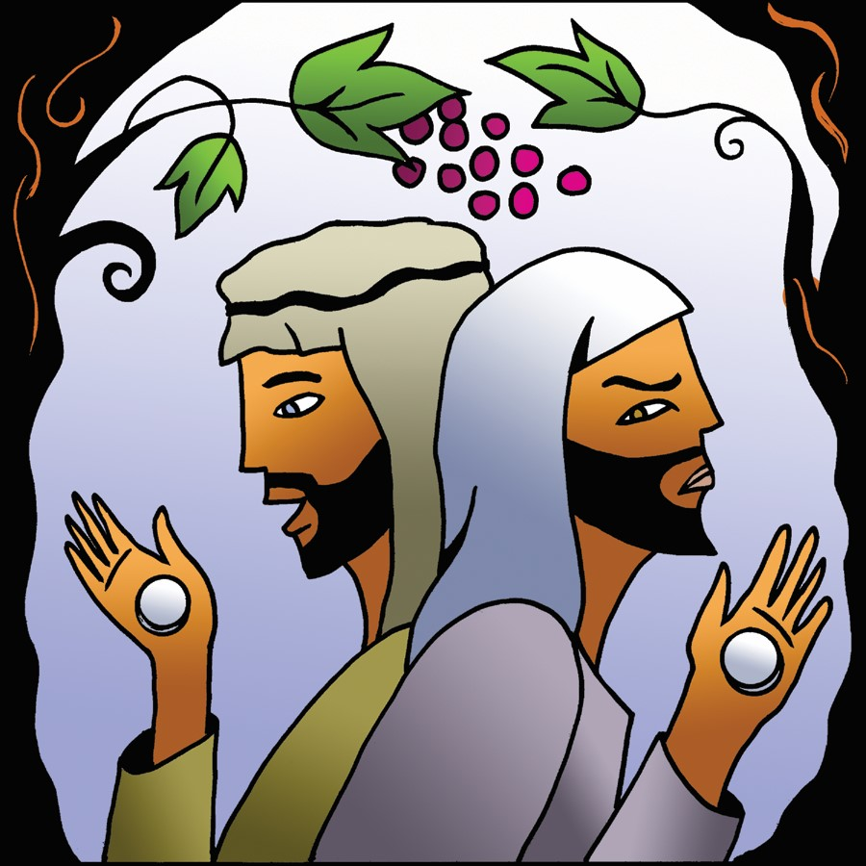
Proper 20
Year A
Holy Eucharist II
September 20, 2026
10:00 AM In person and Online

Welcome to Trinity Episcopal, Sonoma. Whether you are passing through or looking for a church home, we are blessed by your presence and we invite you to worship with us fully – singing, praying and receiving communion- with your voice and heart. Please sign our guestbook at the back of the church, including your email.
If you would like to learn more about The Episcopal Church, please send us an email trinityepiscopalsonoma@comcast.net. We look forward to meeting you after the service where coffee and treats are served.

All are welcome to make a gift and offering in thanksgiving to God; for the many blessings we have received. To take advantage of our electronic giving options, please follow the QR code with your capable electronic device, or visit https://onrealm.org/trinitysonoma/-/form/give/default
September Announcements
Fellowship Coffee Hour Sign up – Fellowship follows the service! We meet in the hall or courtyard. We’d love to visit with you.
Thank you to everyone who donated food for A Simple Gesture, your gift helps people have a meal! Our next pick up will be in November!
Movie Night at Trinity will continue in October, at 6PM in Buttram Hall. Stay tuned for more information on date and movie selection. There will be snacks and refreshements during the post film discussion.
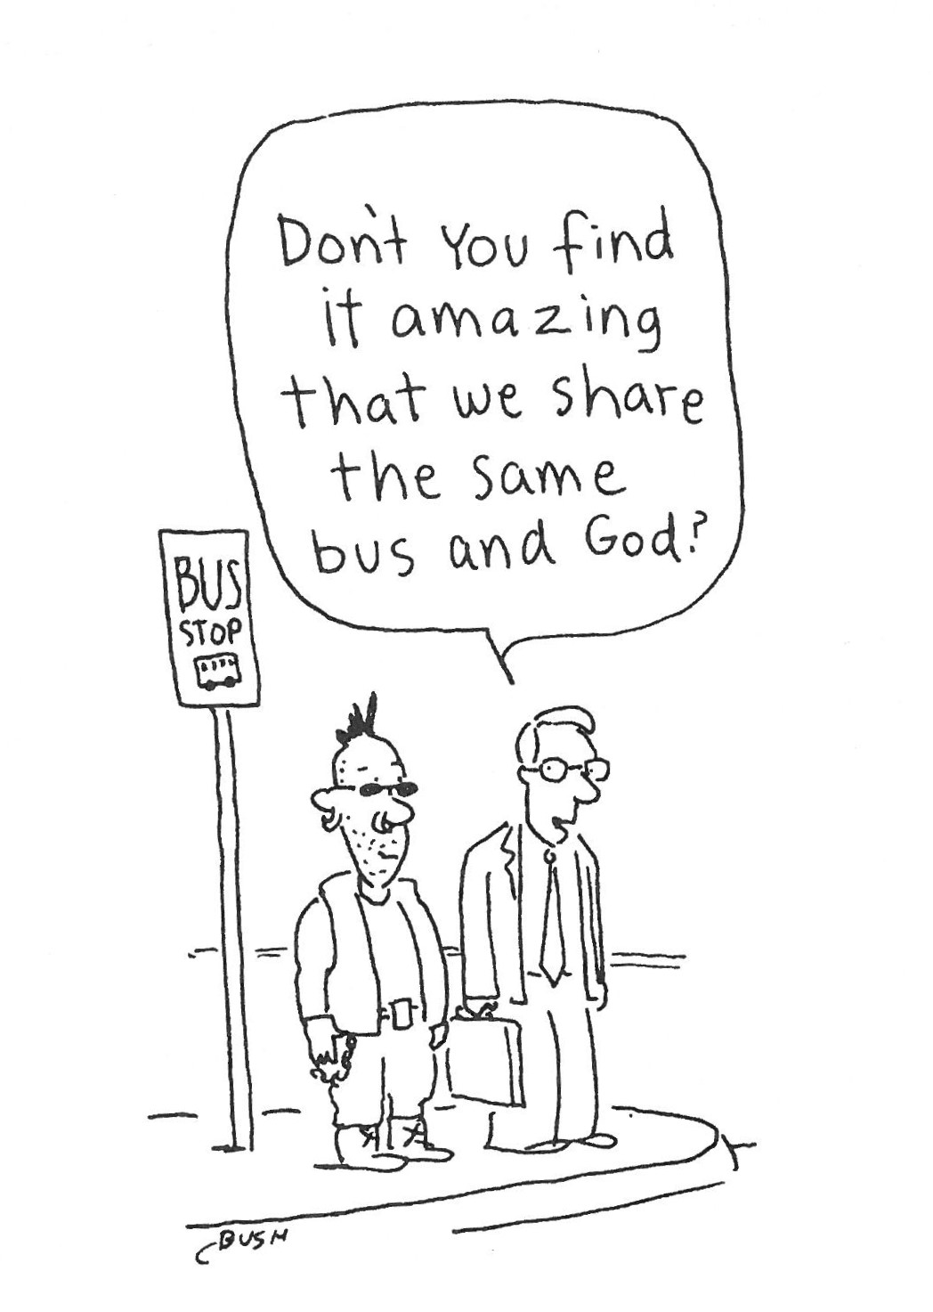
Prelude Steve Rubardt
Please stand for the Entrance Hymn.
At the sound of the bell, please stand as you are able. The People respond when bold text appears.
The Word of God
Entrance Hymn Glorious Things of Thee are Spoken H 523
Opening Acclamation BCP 319
Celebrant | Blessed be God: Father, Son, and Holy Spirit.
People | And blessed be his kingdom, now and for ever. Amen.
Collect for Purity
All Almighty God, to you all hearts are open, all desires known, and from you no secrets are hid: Cleanse the thoughts of our hearts by the inspiration of your Holy Spirit, that we may perfectly love you, and worthily magnify your holy Name; through Christ our Lord. Amen.
Song of Praise Glory to God Hymn S-280 is sung, all standing
Glory to God in the highest,
and peace to his people on earth.
Lord God, heavenly King,
almighty God and Father,
we worship you, we give you thanks,
we praise you for your glory.
Lord Jesus Christ, only Son of the Father,
Lord God, Lamb of God,
you take away the sin of the world:
have mercy on us;
you are seated at the right hand of the Father:
receive our prayer.
For you alone are the Holy One,
you alone are the Lord,
you alone are the Most High,
Jesus Christ,
with the Holy Spirit,
in the glory of God the Father. Amen.
The Collect of the Day BCP 357
Celebrant | The Lord be with you.
People | And also with you.
Celebrant | Let us pray.
Grant us, Lord, not to be anxious about earthly things, but to love things heavenly; and even now, while we are placed among things that are passing away, to hold fast to those that shall endure; through Jesus Christ our Lord, who lives and reigns with you and the Holy Spirit, one God, for ever and ever.
All Amen.

The Lessons
First Reading: Jonah 3:10--4:11
Reader A Reading from the book of Jonah.
¹⁰When God saw what [the people of Ninevah] did, how they turned from their evil ways, God changed his mind about the calamity that he had said he would bring upon them; and he did not do it.
^{4:1}But this was very displeasing to Jonah, and he became angry. ²He prayed to the Lord and said, “O Lord! Is not this what I said while I was still in my own country? That is why I fled to Tarshish at the beginning; for I knew that you are a gracious God and merciful, slow to anger, and abounding in steadfast love, and ready to relent from punishing. ³And now, O Lord, please take my life from me, for it is better for me to die than to live.” ⁴And the Lord said, “Is it right for you to be angry?” ⁵Then Jonah went out of the city and sat down east of the city, and made a booth for himself there. He sat under it in the shade, waiting to see what would become of the city.
⁶The Lord God appointed a bush, and made it come up over Jonah, to give shade over his head, to save him from his discomfort; so Jonah was very happy about the bush. ⁷But when dawn came up the next day, God appointed a worm that attacked the bush, so that it withered. ⁸When the sun rose, God prepared a sultry east wind, and the sun beat down on the head of Jonah so that he was faint and asked that he might die. He said, “It is better for me to die than to live.”
⁹But God said to Jonah, “Is it right for you to be angry about the bush?” And he said, “Yes, angry enough to die.” ¹⁰Then the Lord said, “You are concerned about the bush, for which you did not labor and which you did not grow; it came into being in a night and perished in a night. ¹¹And should I not be concerned about Nineveh, that great city, in which there are more than a hundred and twenty thousand persons who do not know their right hand from their left, and also many animals?”
Reader | The Word of the Lord.
People | Thanks be to God.
The Psalm: Psalm 145:1-8
Reader We will read Psalm 145:1-8, responsively by half verse.
¹I will exalt you, O God my King, *
and bless your Name for ever and ever.
²Every day will I bless you *
and praise your Name for ever and ever.
³Great is the Lord and greatly to be praised; *
there is no end to his greatness.
⁴One generation shall praise your works to another *
and shall declare your power.
⁵I will ponder the glorious splendor of your majesty *
and all your marvelous works.
⁶They shall speak of the might of your wondrous acts, *
and I will tell of your greatness.
⁷They shall publish the remembrance of your great goodness; *
they shall sing of your righteous deeds.
⁸The Lord is gracious and full of compassion, *
slow to anger and of great kindness.
Second Reading: Philippians 1:21-30
Reader A Reading from Paul's letter to the Church in Philippi.
²¹To me, living is Christ and dying is gain. ²²If I am to live in the flesh, that means fruitful labor for me; and I do not know which I prefer. ²³I am hard pressed between the two: my desire is to depart and be with Christ, for that is far better; ²⁴but to remain in the flesh is more necessary for you. ²⁵Since I am convinced of this, I know that I will remain and continue with all of you for your progress and joy in faith, ²⁶so that I may share abundantly in your boasting in Christ Jesus when I come to you again.
²⁷Only, live your life in a manner worthy of the gospel of Christ, so that, whether I come and see you or am absent and hear about you, I will know that you are standing firm in one spirit, striving side by side with one mind for the faith of the gospel, ²⁸and are in no way intimidated by your opponents. For them this is evidence of their destruction, but of your salvation. And this is God’s doing. ²⁹For he has graciously granted you the privilege not only of believing in Christ, but of suffering for him as well—³⁰since you are having the same struggle that you saw I had and now hear that I still have.
Reader | The Word of the Lord.
People | Thanks be to God.
Sequence Hymn O Master, Let me Walk with Thee H 660 v 1 & 2
The Holy Gospel: Matthew 20:1-16
Celebrant | The Holy Gospel of our Lord Jesus Christ according to Matthew.
People | Glory to you, Lord Christ.
[Jesus said,] ¹“The kingdom of heaven is like a landowner who went out early in the morning to hire laborers for his vineyard. ²After agreeing with the laborers for the usual daily wage, he sent them into his vineyard. ³When he went out about nine o’clock, he saw others standing idle in the marketplace; ⁴and he said to them, ‘You also go into the vineyard, and I will pay you whatever is right.’ So they went. ⁵When he went out again about noon and about three o’clock, he did the same. ⁶And about five o’clock he went out and found others standing around; and he said to them, ‘Why are you standing here idle all day?’ ⁷They said to him, ‘Because no one has hired us.’ He said to them, ‘You also go into the vineyard.’ ⁸When evening came, the owner of the vineyard said to his manager, ‘Call the laborers and give them their pay, beginning with the last and then going to the first.’ ⁹When those hired about five o’clock came, each of them received the usual daily wage. ¹⁰Now when the first came, they thought they would receive more; but each of them also received the usual daily wage. ¹¹And when they received it, they grumbled against the landowner, ¹²saying, ‘These last worked only one hour, and you have made them equal to us who have borne the burden of the day and the scorching heat.’ ¹³But he replied to one of them, ‘Friend, I am doing you no wrong; did you not agree with me for the usual daily wage? ¹⁴Take what belongs to you and go; I choose to give to this last the same as I give to you. ¹⁵Am I not allowed to do what I choose with what belongs to me? Or are you envious because I am generous?’ ¹⁶So the last will be first, and the first will be last.”
Celebrant | The Gospel of the Lord.
People | Praise to you, Lord Christ.
Sequence Hymn O Master, Let me Walk with Thee H 660 v 3 & 4
Sermon Pastor Cindy Beck
The Nicene Creed (BCP p. 358)
We believe in one God, the Father, the Almighty, maker of heaven and earth, of all that is, seen and unseen.
We believe in one Lord, Jesus Christ, the only Son of God, eternally begotten of the Father, God from God, Light from Light, true God from true God, begotten, not made, of one Being with the Father. Through him all things were made. For us and for our salvation he came down from heaven: by the Power of the Holy Spirit he became incarnate from the Virgin Mary, and was made man. For our sake he was crucified under Pontius Pilate; he suffered death and was buried. On the third day he rose again in accordance with the Scriptures; he ascended into heaven and is seated at the right hand of the Father. He will come again in glory to judge the living and the dead, and his kingdom will have no end.
We believe in the Holy Spirit, the Lord, the giver of life, who proceeds from the Father and the Son. With the Father and the Son he is worshipped and glorified. He has spoken through the Prophets. We believe in one holy catholic and apostolic Church. We acknowledge one baptism for the forgiveness of sins. We look for the resurrection of the dead, and the life of the world to come. Amen.

The Prayers of the People
Celebrant: Let us offer prayers for all who labor in the vineyard of the Lord and for all in every danger and need.
Intercessor: For this holy gathering, and for the people of God in every place.
In the Diocesan Cycle of Prayer, we pray for St Francis in Fortuna.
In the Anglican Cycle of Prayer, we pray for The Anglican Church of Australia.
Silence
Lord, have mercy.
For the Universal Church, its members and our mission in the world; for this congregation, for our parish clergy, for our bishop, N., and for N., our Presiding Bishop.
Silence
Lord, have mercy.
For all peoples and their leaders, for N. our President, N. our Governor, and N. our Mayor, for all candidates for office, and for justice, mercy, and peace in the world.
Silence
Lord, have mercy.
For all who work for daily wages, and for their employers and managers. For all those seeking a just wage and full employment, +_________________.
Invite the congregation to add their thanksgivings, followed by silence
Lord , have mercy.
For abundant fruits of the earth, and for safety from violent storms.
Silence
Lord, have mercy.
For the sick and the suffering, travelers and the victims of war, prisoners and refugees, and the dying and dead, +______________.
Invite the congregation to add their petitions, followed by silence
Lord, we are in need of your mercy;
Lord, have mercy.
For our city and those who live in it, and for our families, companions, and all those we love.
Silence
Lord, have mercy.
For any additional prayers and thanksgivings you’d like to name now, in silence or aloud.
Silence
Lord , have mercy.
Celebrant Gracious and merciful God, who honors the last as well as the first, hear the prayers we offer this day and welcome your people into your kingdom; through Jesus Christ our Lord.
Amen.
Confession of Sin BCP 359
Most merciful God, we confess that we have sinned against you in thought, word and deed, by what we have done, and by what we have left undone.
We have not loved you with our whole heart; we have not loved our neighbors as ourselves. We are truly sorry and we humbly repent.
For the sake of your Son Jesus Christ, have mercy on us and forgive us; that we may delight in your will, and walk in your ways, to the glory of your Name. Amen.

The Peace
Celebrant The peace of the Lord be always with you.
People And also with you.
Announcements
Birthdays, Anniversaries, Travelers (prayers found at back of bulletin)
The Holy Communion
The Offertory At the Offering, you’ll find a Pledge card in the Pew Rack for those who’d like to designate their financial donations to Trinity’s Pledging Income. For others, or a one-time gift, envelopes are in the pew racks as well as on the Narthex table or text TRINITYSONOMA" to 73256. Thank you!
Offertory Music
Steve Rubardt and Choir This Little Light of Mine LEVAS 221
Doxology
Praise God, from whom all blessings flow;
Praise Him, all creatures here below;
Praise Him above, ye heav'nly host;
Praise Father, Son, and Holy Ghost.
Amen.
The people stand while the offerings are presented and placed on the Altar.
Presider: Gracious God, as an offering of our thanksgiving and gratitude, we return to you a portion of what you have gifted us.
The Great Thanksgiving
Eucharistic Prayer B BCP 367
Celebrant | The Lord be with you.
People | And also with you.
Celebrant | Lift up your hearts.
People | We lift them to the Lord.
Celebrant | Let us give thanks to the Lord our God.
People | It is right to give him thanks and praise.
Proper Preface (BCP p. 367)
It is right, and a good and joyful thing, always and everywhere to give thanks to you, Father Almighty, Creator of heaven and earth.
For you are the source of light and life; you made us in your image, and called us to new life in Jesus Christ our Lord.
Therefore we praise you, joining our voices with Angels and Archangels and with all the company of heaven, who for ever sing this hymn to proclaim the glory of your Name:
Sanctus Holy Holy, Holy (Proulx) Hymnal S-125
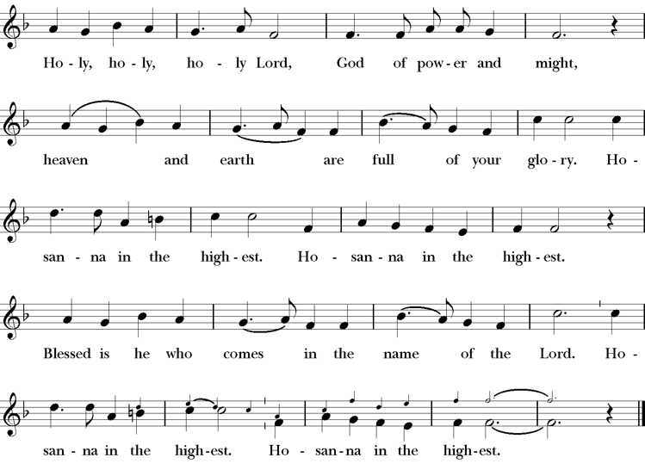
Presider Holy and gracious Father: In your infinite love you made us for yourself; and, when we had fallen into sin and become subject to evil and death, you, in your mercy, sent Jesus Christ, your only and eternal Son, to share our human nature, to live and die as one of us, to reconcile us to you, the God and Father of all.
He stretched out his arms upon the cross, and offered himself, in obedience to your will, a perfect sacrifice for the whole world.
On the night he was handed over to suffering and death, our Lord Jesus Christ took bread; and when he had given thanks to you, he broke it, and gave it to his disciples, and said, “Take, eat: This is my Body, which is given for you. Do this for the remembrance of me”
After supper he took the cup of wine; and when he had given thanks, he gave it to them, saying, “Drink this, all of you: this is my blood of the new covenant which is shed for you and for many for the forgiveness of sins. Whenever you drink it, do this for the remembrance of me.”
Presider Therefore we proclaim the mystery of faith.
People Christ has died; Christ is risen; Christ will come again.
Presider We celebrate the memorial of our redemption, O Father, in this sacrifice of praise and thanksgiving. Recalling his death, resurrection, and ascension, we offer you these gifts.
Sanctify them by your Holy Spirit to be for your people the Body and Blood of your Son, the holy food and drink of new and unending life in him. Sanctify us also that we may faithfully receive this holy Sacrament, and serve you in unity, constancy, and peace; and at last day bring us with all your saints into the joy of your eternal kingdom.
All this we ask through your Son Jesus Christ. By him, and with him, and in him, in the unity of the Holy Spirit all honor and glory is yours, Almighty Father, now and for ever.
Amen.
The Lord’s Prayer
Presider As our Savior has taught us, we are bold to pray.
People Our Father, who art in heaven, hallowed be thy name. Thy Kingdom come, thy will be done, on earth as it is in heaven. Give us this day our daily bread. And forgive us our trespasses, as we forgive those who trespass against us. And lead us not into temptation, but deliver us from evil. For thine is the kingdom, the power and the glory, for ever and ever. Amen.

The Breaking of the Bread
The Presider breaks the consecrated bread in view of the assembly.
Presider The Gifts of God for the people of God.
People Therefore let us keep the feast. Alleluia

Invitation to Communion
Presider Come to this table you who have been here often and you who have not been here in a long time. Come, you who have tried to follow Jesus and you who have failed. You who are full of faith and full of doubt. Come, it is Christ himself who invites you to meet him here.
Sharing the Sacred Meal
This is Christ’s table and all are welcome and all are fed.
Communion Music The Lord’s Prayer LEVAS 264
Post-Communion Prayer BCP 365
The Blessing
The Recessional Hymn For all the Saints H 287 v 1 - 4
The Dismissal*
Celebrant | Let us go forth in the name of Christ.
People | Thanks be to God.
Postlude Steve Rubardt Please remain seated

SERVING TODAY
Celebrant & Preacher: Pastor Cindy Beck
Acolyte: Susie Hand
Lector: Claire Ginesi , Lorena Reinhardt
Intercessor: Bill Doyle
Worship Musician: Steve Rubardt
Choir Leader: Steve Rubardt
Choir: Liz Carpenter, Heather Dahlberg, Scott Sherman, Patsy Gralow, Laurell Meredith, Mary Omodt, Barbara Feduska, Tara Anderson, Carol Heffer, Don McMahon
Sunday School - Child Care: Wendy Aguilar Appt Only
Ushers: Alfred Escoffier
Tech Chaplain: Marcos Rendon
Altar Guild: Laurell Meredith , Liz Carpenter
Hospitality : Lisa Coleman
Flowers: In Honor of Dennis Meredith
Altar Flowers today are created by Laurell Meredith
Prayers requested for these on Trinity’s long-term prayer list: Armando P, Georgia Bostedt, John Eiler, Gerrilee Fisher, Claire Ginesi, Mary Griffin, David & Christine Hilt, Mark Mezzetta, Kelcey Omodt, Grizelda Ponce, Barry Reap, Blake W, Robert R, Melissa White, Ann Loveland Sherman, James Thomas, Rose Burns, Jennifer Gralow, Patsy Gralow, Steve Antenen, Sandra Leland, Karl, Michael Hardy, Michael Bean Land, Polly Moore, Sinat Liv, Will Maushardt, Sophia Piconi, Mike Smith, Jean Maffoli.
Prayers for the Repose of soul: Tim Dowd , Susan Bassett, Joan Biersch, Linda Dowd, Christina Van Krugel, Mere Nagasau, Mary Goshert, Peggy Bell, Carolyn Caldwell, Van Z, Dolores Mae Seaberg Cole, Muff Davey, Giancarlo Cestarollo.
Contact Pastoral Care Chair, Lorena lorena.m.reinhardt@gmail.com to make any additions or to remove names from our Long-Term Prayer list.
Notes on the Service Bulletin This service bulletin is a guide to the service. We use a variety of printed materials for the prayers, the scriptural readings and the hymns. The Readings for the week, including the Collect and Readings are found in this Bulletin. The service follows the liturgies that are found in the Book of Common Prayer (BCP). The BCP is the blue book found in the pew in front of you. The hymns come primarily from The 1982 Hymnal, also in the pew – the red book. Lift Every Voice and Sing (LEVAS) is another hymnal located in the pew rack. VF stands for Voices Found, another authorized hymnal. Sound Mate Assisted Hearing devices available at the back of the church on the Narthex Table.

Trinity Liturgical Ministry ROTA Next two weeks
Date | Celebrant | Ushers | Acolyte | Lector (s) | Intercessor | Altar Guild
9/27 | TBD | John Addeo | Arminda Eiler | Jane Hernandez , John Eiler | Barbara Feduska | Marcia Derby , Mary Omodt
10/4 | Cindy Beck | TBD | TBD | TBD | TBD | TBD
Schedule of Weekly Meetings and Services at Trinity Episcopal Sonoma
Day | Date | Time | Occasion | Location
Wednesday | September 23 | 11 AM | Bible Study | Library
Thursday | September 24 | 10:30 AM  5:30 PM | Mindfulness & Well Being  Alcoholics Anonymous | Library  Buttrum Hall
Saturday | September 26 | 8 AM | Centering Prayer | St. Luke’s Chapel
Sunday | September 27 | 10:00 AM | Holy Eucharist II | Sanctuary
Mon-Fri | Weekdays | 7AM-1PM | Sonoma Home Meals | Kitchen &Buttrum Hall
Mon-Fri | Weekdays | 9-2 | Sonoma Preschool Academy – School

Monthly Meetings at Trinity Episcopal Sonoma
Day | Date | Time | Meeting | Location | Contact
Tuesday | October 6 | 11 AM | Prayer Shawl Ministry | Library | Lorena Reinhardt lorena.m.reinhardt@gmail.com
Thursday | TBD | TBD | Vestry | Library | Cindy Beck 916-955-9861

PRAYERS and BLESSINGS
For a Birthday
Watch over your child, O Lord as his/her days increase; bless and guide him/her wherever s/he may be. Strengthen them when s/he stands; comfort him/her when discouraged or sorrowful; raise him/her up if s/he fall; and in his/her heart may your peace which passes understanding abide all the days of his/her life; through Jesus Christ our Lord. Amen.
For an Anniversary
O God, you have so consecrated the covenant of marriage that it represents the spiritual unity between Christ and his Church: Send your blessing upon these your servants as they celebrate their anniversary, that they may continue to love, honor and cherish each other in faithfulness and patience, in wisdom and true godliness, that their home may be a haven of blessing and peace; through Jesus Christ our Lord, who lives and reigns with you and the Holy Spirit, one God, now and forever. Amen.
For Travelers
O God, our heavenly Father, whose glory fills the whole creation, and whose presence we find wherever we go; preserve those who travel; surround them with your loving care; protect them from every danger, and bring them in safety to their journey’s end; through Jesus Christ our Lord. Amen.
Sending our Eucharistic Visitors
Priest: In the name of this congregation, I send you forth bearing these holy gifts, the those to whom you go may share with us in the communion of Christ’s body and blood.
People: We who are many are one body, because we all share on bread, and one cup. Amen.
Trinity Episcopal Church
In Sonoma for over 170 years
275 East Spain Street
Sonoma, CA 95476
The Rt. Rev. Megan M. Traquair, Bishop
Diocese of Northern California
Pastor Cindy Beck, Interim
Steve Rubardt, Worship Music
Vestry
Bill Doyle, Senior Warden & Stewardship
Susie Hand
Heather Dahlberg
Sally Zimmerman
Lorena Reinhardt (Pastoral Care)
Luke Bohanan
Mandy Birkbeck
Ministries
Prayer Shawl, Lorena Reinhardt
Outreach, Jane Hernandez
Mindfulness & Well Being, Mary Omodt
Sunday School, Children, Wendy Aguilar

The Members of the Congregation are The Ministers of the Church

Administrative Office Hrs.
Monday Wednesday 9 A.M. – 2 PM; Thursday 10A.M.-2 P.M0
Sunday 9:30-11:30
Clergy Office Hours Wednesdays, Thursdays, by appointment

Emergency, sickness, please contact office: 707-938-4846

