Trinity Episcopal Church
In Sonoma for over 170 years
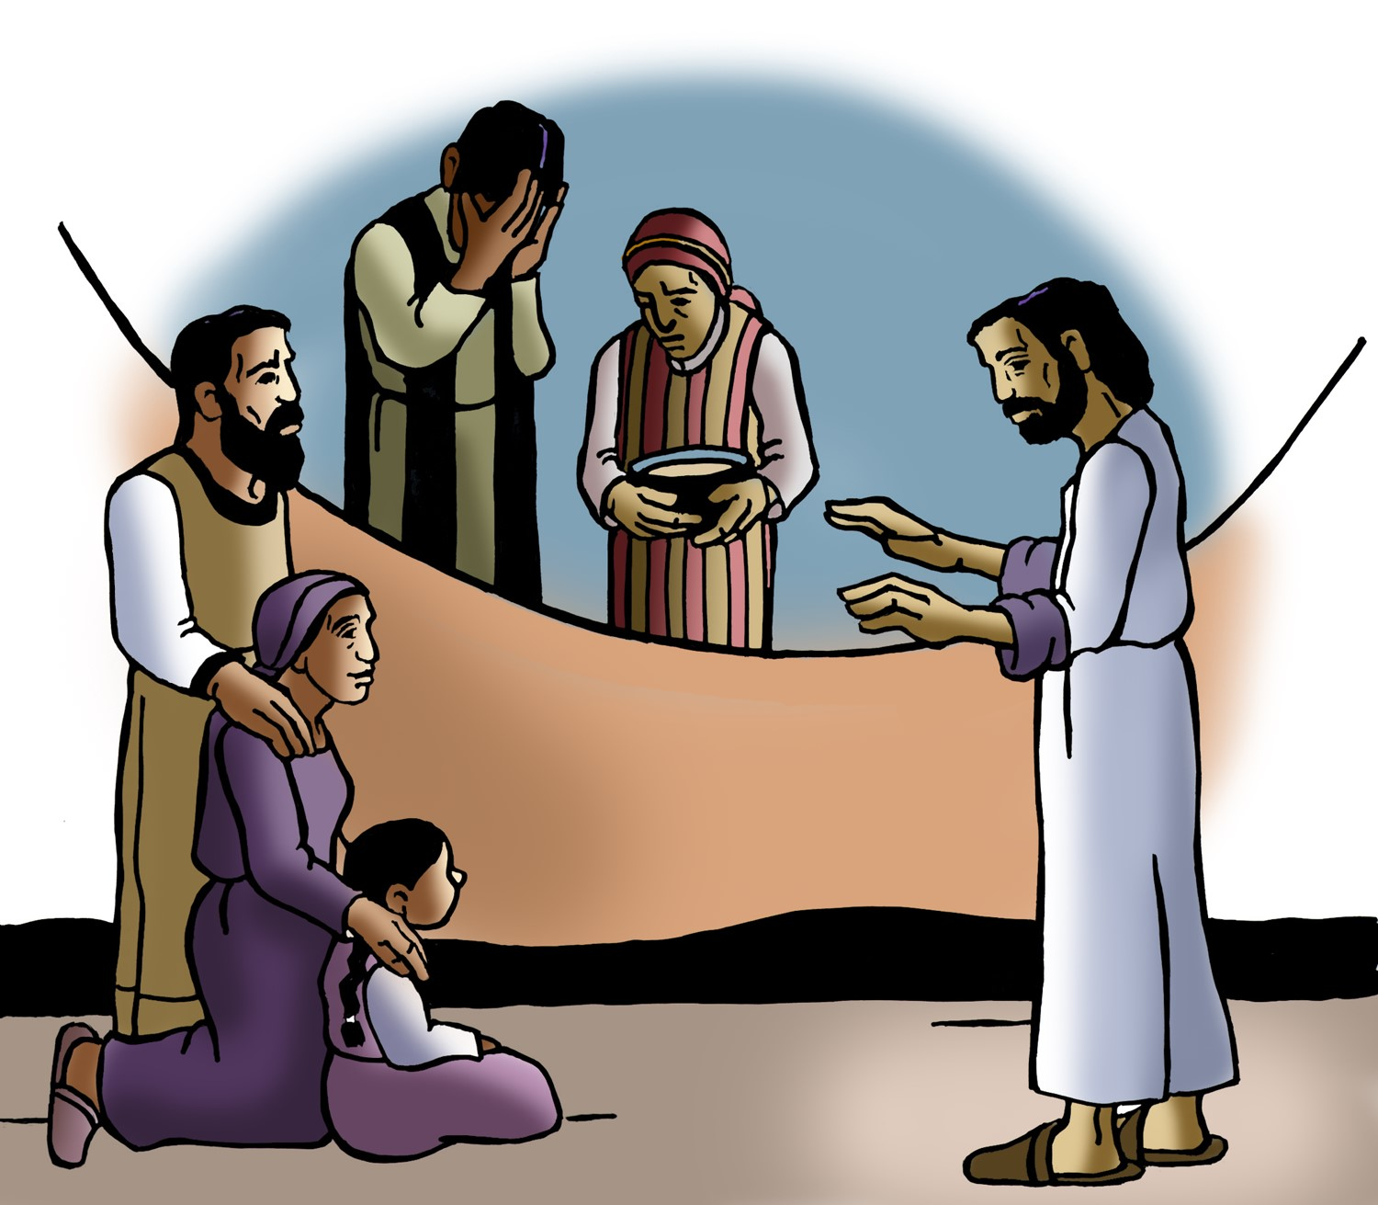
All Saints’ Sunday
Proper 26 (Year C)
Holy Eucharist II
November 2 , 2025
10:00 AM In person and Online

Welcome to Trinity Episcopal, Sonoma!
Whether you have wandered in, are wondering about God or grew up in the church, or wherever you are in your journey...you are welcome here... We are blessed by your presence.
For Visitors and Newcomers:
Everyone is welcome to receive communion at the Lord’s table. Jesus gave this tangible reminder of God’s presence, love, and forgiveness for all. If you are interested in a visit or call from the Priest-in-Charge , please sign our guest book on the table at the entrance of the church, including an email or phone number.
Restrooms
A restroom is located outside the entrance of Buttrum Hall (the building across the courtyard) and another is located inside the hall to the right.
Coffee and Treats:
Following worship we have coffee and treats after service in Buttrum Hall. We hope it is a time to get to know you better.
To access Trinity’s Guest WIFI: Password Rosepettal441 (case sensitive).
We are glad you are here, and we invite you to enter fully into worship this morning.
October Announcements
Pastor Cindy would like to know if there is interest in an Adult Education time either following Sunday worship or an early evening time. Guided conversations, open-ended questions, participants are invited to share thoughts, experiences and similarities with the biblical stories. If you have suggestions on a class you’d like Pastor Cindy to lead next, please contact the office 707-938-4846 or speak with her directly.
Small is Beautiful: The Quest to Save the Valley of the Moon, local film will be shown at St. Patrick’s Episcopal in Kenwood on Nov 2nd at 4PM. If you’d like to discuss the proposed future development in your community please join.
The Free Movie night series hosted by Trinity Episcopal in Sonoma, will be continuing this November, Wednesday 12th with “Jack & Diane Something’s Gotta Give”. Please join us at 6PM for the movie and engage with in a conversation about the film afterward.
Fellowship Coffee Hour Sign up
We encourage members to sign up to make coffee. Pastor Cindy is happy to demonstrate how easy this is. Please help us provide this hospitality for guests and members.
McGill University Doctoral Student, Collin Miller plays a concert of organ masterpieces on Friday, Nov. 14. Admission is free. The performance takes place at 6 p.m. at St. Paul’s Episcopal Church in Healdsburg.
The August, September, October Forward Day by Day ,
a booklet of daily inspirational meditations is now available in the Church and the Office. We ask for a $2 donation.
A Festival Eucharist led by Bishop Megan Traquair with prayers of thanksgiving for the Saints of Grace past, present, and future will be on Nov 1st at Grace Episcopal Church in St Helena from 2pm to 8pm. The evening will include musical stylings of the Jazz@7 VocalEnsemble. The entire diocesan community is welcome to help us celebrate Grace turning 150 years young!
All are welcome to make a gift and offering in thanksgiving to God;
for the many blessings we have received. To take advantage of our electronic giving options, please follow the QR code with your capable electronic device, or visit https://onrealm.org/trinitysonoma/-/form/give/default Help us to make this a place where God’s grace is freely shared by all.


Prelude Steve Rubardt
Please stand for the Entrance Hymn.
At the sound of the bell, please stand as you are able. The People respond when bold text appears.
The Word of God
Entrance Hymn The God of Abraham Praise H401
Opening Acclamation BCP 319
Celebrant | Blessed be God: Father, Son, and Holy Spirit.
People | And blessed be his kingdom, now and for ever. Amen.
Collect for Purity
All Almighty God, to you all hearts are open, all desires known, and from you no secrets are hid: Cleanse the thoughts of our hearts by the inspiration of your Holy Spirit, that we may perfectly love you, and worthily magnify your holy Name; through Christ our Lord. Amen.
Song of Praise Gloria BCP 356/Hymnal S-280
All Glory to God in the highest,
and peace to his people on earth.
Lord God, heavenly King,
almighty God and Father,
we worship you, we give you thanks,
we praise you for your glory.
Lord Jesus Christ, only Son of the Father,
Lord God, Lamb of God,
you take away the sin of the world:
have mercy on us;
you are seated at the right hand of the Father:
receive our prayer.
For you alone are the Holy One,
you alone are the Lord,
you alone are the Most High,
Jesus Christ,
with the Holy Spirit,
in the glory of God the Father. Amen.
The Collect of the Day BCP 357
Celebrant | The Lord be with you.
People | And also with you.
Celebrant | Let us pray.
Almighty and everlasting God, increase in us the gifts of faith, hope, and charity; and, that we may obtain what you promise, make us love what you command; through Jesus Christ our Lord, who lives and reigns with you and the Holy Spirit, one God, for ever and ever.
All Amen.
The Lessons
First Reading: Daniel 7:1-3, 15-18
Reader A Reading from the book of Daniel.
¹In the first year of King Belshazzar of Babylon, Daniel had a dream and visions of his head as he lay in bed. Then he wrote down the dream: ²I, Daniel, saw in my vision by night the four winds of heaven stirring up the great sea, ³and four great beasts came up out of the sea, different from one another.
¹⁵As for me, Daniel, my spirit was troubled within me, and the visions of my head terrified me. ¹⁶I approached one of the attendants to ask him the truth concerning all this. So he said that he would disclose to me the interpretation of the matter: ¹⁷“As for these four great beasts, four kings shall arise out of the earth. ¹⁸But the holy ones of the Most High shall receive the kingdom and possess the kingdom forever—forever and ever.”

Reader | The Word of the Lord.
People | Thanks be to God.


The Psalm: Psalm 149
Reader Our response to the reading is Psalm 84:1-6 which we will read responsively by half verse.
¹Hallelujah!
Sing to the Lord a new song; *
sing his praise in the congregation of the faithful.
²Let Israel rejoice in his Maker; *
let the children of Zion be joyful in their King.
³Let them praise his Name in the dance; *
let them sing praise to him with timbrel and harp.
⁴For the Lord takes pleasure in his people *
and adorns the poor with victory.
⁵Let the faithful rejoice in triumph; *
let them be joyful on their beds.
⁶Let the praises of God be in their throat *
and a two-edged sword in their hand;
⁷To wreak vengeance on the nations *
and punishment on the peoples;
⁸To bind their kings in chains *
and their nobles with links of iron;
⁹To inflict on them the judgment decreed; *
this is glory for all his faithful people.
Hallelujah!
Second Reading: Ephesians 1:11-23
Reader A Reading from Paul's letter to the Church in Ephesus.
¹¹In Christ we have also obtained an inheritance, having been destined according to the purpose of him who accomplishes all things according to his counsel and will, ¹²so that we, who were the first to set our hope on Christ, might live for the praise of his glory. ¹³In him you also, when you had heard the word of truth, the gospel of your salvation, and had believed in him, were marked with the seal of the promised Holy Spirit; ¹⁴this is the pledge of our inheritance toward redemption as God’s own people, to the praise of his glory.
¹⁵I have heard of your faith in the Lord Jesus and your love toward all the saints, and for this reason ¹⁶I do not cease to give thanks for you as I remember you in my prayers. ¹⁷I pray that the God of our Lord Jesus Christ, the Father of glory, may give you a spirit of wisdom and revelation as you come to know him, ¹⁸so that, with the eyes of your heart enlightened, you may know what is the hope to which he has called you, what are the riches of his glorious inheritance among the saints, ¹⁹and what is the immeasurable greatness of his power for us who believe, according to the working of his great power. ²⁰God put this power to work in Christ when he raised him from the dead and seated him at his right hand in the heavenly places, ²¹far above all rule and authority and power and dominion, and above every name that is named, not only in this age but also in the age to come. ²²And he has put all things under his feet and has made him the head over all things for the church, ²³which is his body, the fullness of him who fills all in all.

Reader | The Word of the Lord.
People | Thanks be to God.
Sequence Hymn Blest are the Pure in Heart H 656 v 1 & 2
The Holy Gospel: Luke 6:20-31
Celebrant | The Holy Gospel of our Lord Jesus Christ according to Luke.
People | Glory to you, Lord Christ.
²⁰[Jesus] looked up at his disciples and said:
“Blessed are you who are poor,
for yours is the kingdom of God.
²¹“Blessed are you who are hungry now,
for you will be filled.
“Blessed are you who weep now,
for you will laugh.
²²“Blessed are you when people hate you, and when they exclude you, revile you, and defame you on account of the Son of Man. ²³Rejoice in that day and leap for joy, for surely your reward is great in heaven; for that is what their ancestors did to the prophets.
²⁴“But woe to you who are rich,
for you have received your consolation.
²⁵“Woe to you who are full now,
for you will be hungry.
“Woe to you who are laughing now,
for you will mourn and weep.
²⁶“Woe to you when all speak well of you, for that is what their ancestors did to the false prophets.
²⁷“But I say to you that listen, Love your enemies, do good to those who hate you, ²⁸bless those who curse you, pray for those who abuse you. ²⁹If anyone strikes you on the cheek, offer the other also; and from anyone who takes away your coat do not withhold even your shirt. ³⁰Give to everyone who begs from you; and if anyone takes away your goods, do not ask for them again. ³¹Do to others as you would have them do to you.”

Celebrant | The Gospel of the Lord.
People | Praise to you, Lord Christ.
Sequence Hymn Blest are the Pure in Heart H 656 v 3 & 4
The Sermon Cindy Beck
All Saints Litany
The Prayers of the People
Celebrant: The Lord takes great pleasure in us. God cares for us and hears our prayers. So let us pray: “We offer our prayers; Our hope is set on you, O Christ.”
Intercessor: Bless your Church, O Lord. Increase our faith in you. Increase our love for one another. Increase in us a spirit of wisdom.
In the Diocesan Cycle of Prayer, we pray for St. John the Evangelist in Chico.
In the Anglican Cycle of Prayer, we pray of the Province of West Africa.
Silence
We offer our prayers;
Our hope is set on you, O Christ.
Bless the human family, O Lord. Bless the poor. Bless the hungry. Bless those who now weep.
Silence
We offer our prayers;
Our hope is set on you, O Christ.
Bless this good creation, O Lord. All things were made through you and by your resurrection they are given new life. We thank you that you are already making all things new.
Invite the congregation to add thanksgivings, followed by Silence
We offer our prayers;
Our hope is set on you, O Christ.
Bless this city, O Lord. May we be known as a generous people—doing to our neighbors as we would have them do to us.
Silence
We offer our prayers;
Our hope is set on you, O Christ.
Bless those in need, O Lord. You adorn the poor with victory; you fill those who are hungry. Make happy those for whom we pray.
Invite the congregation to add their petitions, followed by Silence
We offer our prayers;
Our hope is set on you, O Christ.
Bless the saints who now rest from their labors, O Lord. Give to them the kingdom of God as a possession—for ever and ever.
Invite the congregation to add their petitions, followed by Silence
We offer our prayers;
Our hope is set on you, O Christ.
The Confession of Sin BCP 359

The Peace
Celebrant The peace of the Lord be always with you.
People And also with you.
Announcements
Birthdays, Anniversaries, Travelers (prayers found at back of bulletin)

The Holy Communion
The Offertory At the Offering, you’ll find a Pledge card in the Pew Rack for those who’d like to designate their financial donations to Trinity’s Pledging Income. For others, or a one-time gift, envelopes are in the pew racks as well as on the Narthex table or text TRINITYSONOMA" to 73256. Thank you!

Offertory Music
Steve Rubardt and Choir What a Wonderful World
Doxology
The people stand while the offerings are presented and placed on the Altar.
Presider: Gracious God, as an offering of our thanksgiving and gratitude, we return to you a portion of what you have gifted us.
The Great Thanksgiving
Eucharistic Prayer B BCP 367
Celebrant | The Lord be with you.
People | And also with you.
Celebrant | Lift up your hearts.
People | We lift them to the Lord.
Celebrant | Let us give thanks to the Lord our God.
People | It is right to give him thanks and praise.

Proper Preface (BCP p. 367)
It is right, and a good and joyful thing, always and everywhere to give thanks to you, Father Almighty, Creator of heaven and earth.
For in the multitude of your saints, you have surrounded us with a great cloud of witnesses, that we might rejoice in their fellowship, and run with endurance the race that is set before us; and, together with them, receive the crown of glory that never fades away.
Therefore we praise you, joining our voices with Angels and Archangels and with all the company of heaven, who for ever sing this hymn to proclaim the glory of your Name:

Sanctus Holy Holy, Holy (Proulx) Hymnal S-125
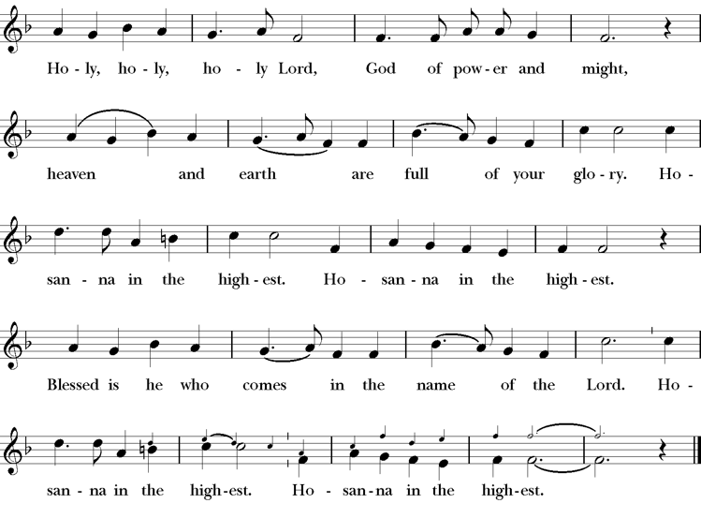
Words of Institution BCP 368
The Lord’s Prayer 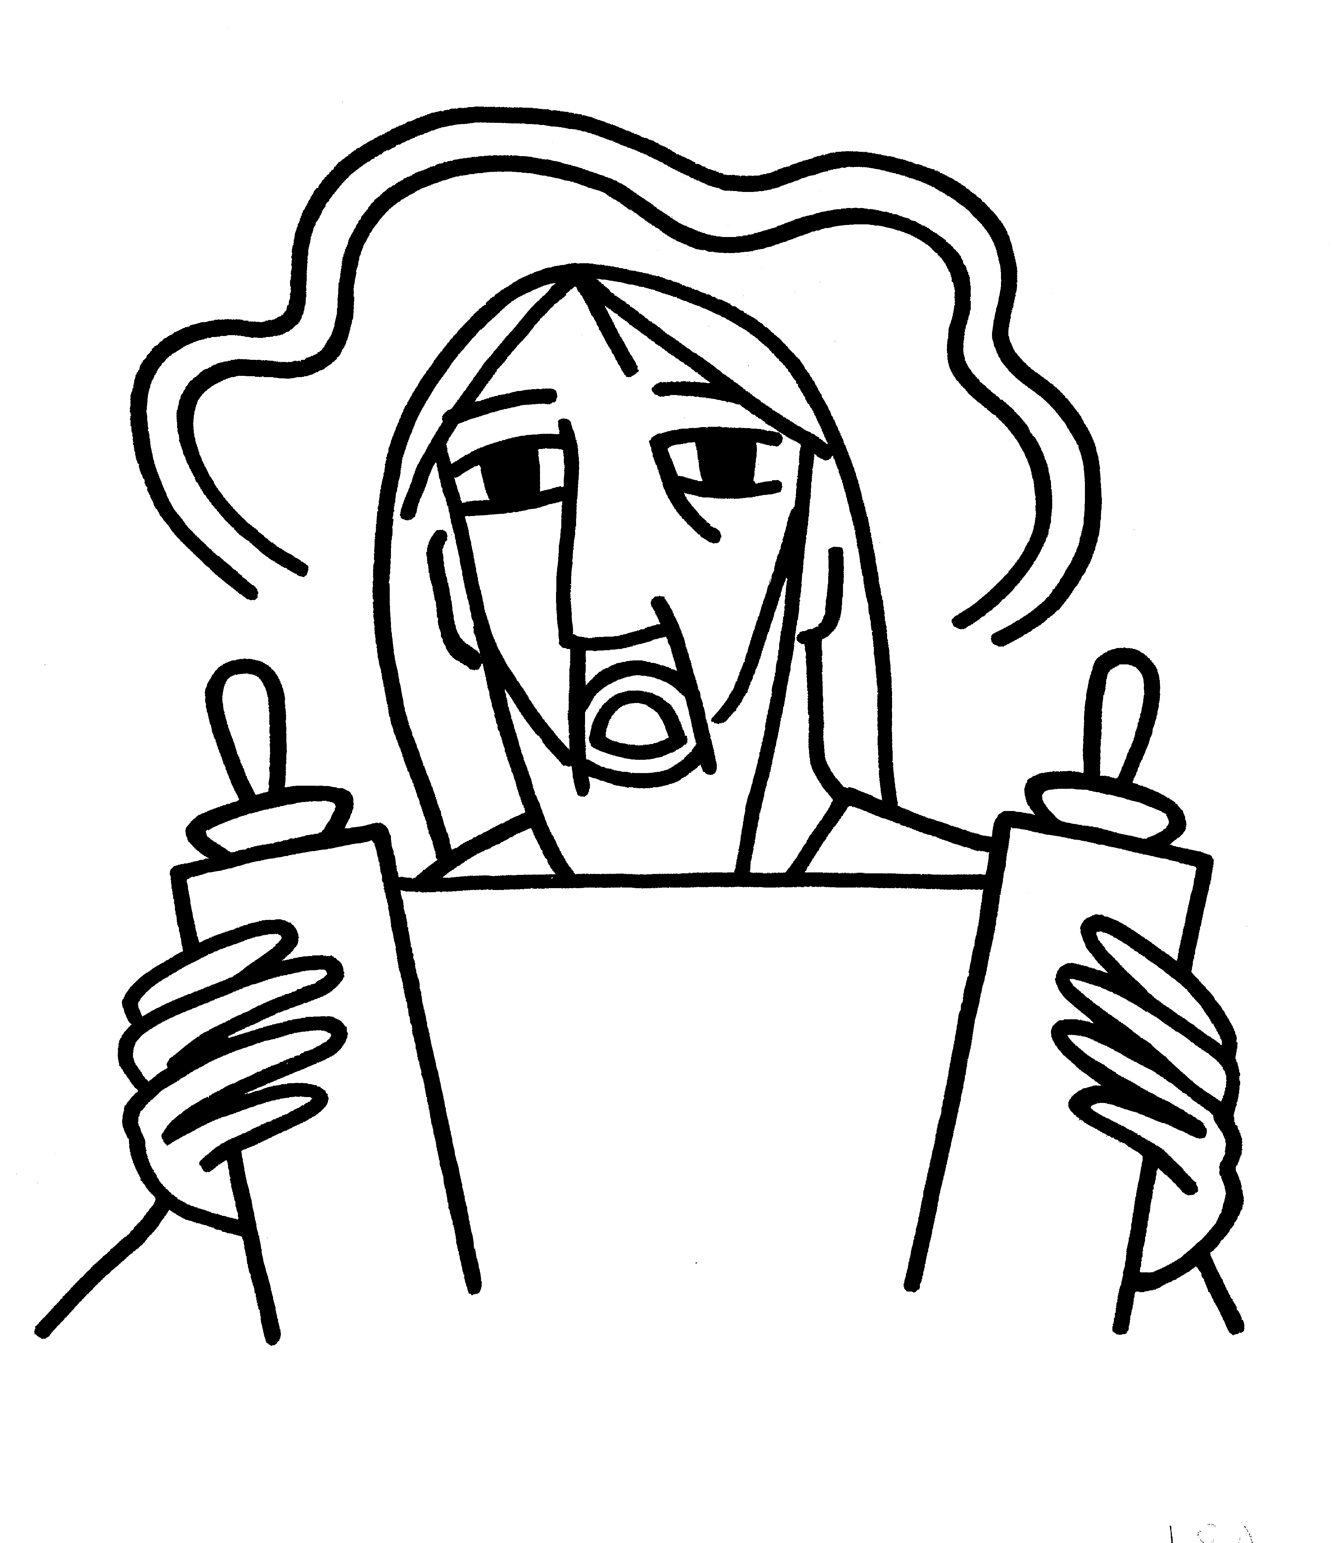 BCP 364
The Breaking of the Bread  BCP 364

Fraction Anthem S-154
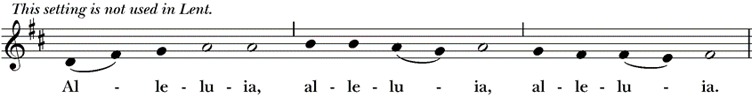
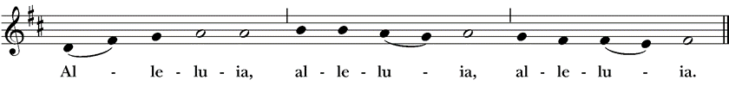
All are welcome at the Lord’s table to receive Holy Communion or a blessing. To receive Communion in your pew, please ask an usher to notify the ministers on your behalf. If you require a gluten-free wafer, please ask at the altar rail.
Communion Music Steve Rubardt & Choir
Baptized in Water LEVAS 121
Post-Communion Prayer BCP 365
The Blessing
The Recessional Hymn Come Thou Font of Every Blessing LEVAS 111
The Dismissal*
Celebrant | Let us go forth in the name of Christ.
People | Thanks be to God.
Postlude Steve Rubardt
Please remain seated
SERVING TODAY
Celebrant and Preacher: Cindy Beck
Eucharistic Minister: Bill Bonnet
Acolyte: Susie Hand
Lector: Lorena Reinhardt , Douglas Griffin
Intercessor: Claire Ginesi
Worship Musician: Steve Rubardt
Choir Leader: Steve Rubardt
Choir: Liz Carpenter, Heather Dahlberg, Scott Sherman, Lucy Maushardt, Patsy Gralow, Laurell Meredith, Mary Omodt, Barbara Feduska, Tara Anderson
Sunday School - Child Care: Wendy Aguilar Appt Only
Ushers: Jane Hernandez
Tech Chaplain: Marcos Rendon
Altar Guild: Laurell Meredith , Elizabeth Carpenter
Hospitality: Lorena Reinhardt
Altar Flowers are given to the glory of God by Altar Guild.

Prayers requested for these on Trinity’s long-term prayer list: Baby Walker David, Armando P, Laura Basett, , Georgia Bostedt, Muff Davey, John Eiler, Gerrilee Fisher, Claire Ginesi, Mary Griffin, David & Christine Hilt, Dr. Tamer Keshen, Marie Lambert, Mark Mezzetta, Kelcey Omodt, Grizelda Ponce, Barry Reap, Blake W, Robert R, Ann Loveland Sherman, John Spooner, James Thomas, Rose Burns, Jennifer Gralow, Patsy Gralow, Denny Hoelter, Steve Antenen, Van Z, Sandra Leland, John Forester, Stuart , Melissa White.
Prayers for the Repose of soul: Tim Dowd , Susan Bassett, Joan Biersch, Mere Nagasau, Christina Van Krugel, Linda Dowd, Peggy and John Bell
Contact Pastoral Care Chair, Lorena lorena.m.reinhardt@gmail.com to make any additions or to remove names from our Long-Term Prayer list.

About this Service: Year C
Calendar of the Church Year
The calendar (BCP, pp. 15-33) orders the liturgical year of the Episcopal Church by identifying two cycles of feasts and holy days-one dependent upon the movable date of Easter Day and the other dependent upon the fixed date of Christmas, Dec. 25. Easter Day is the first Sunday after the full moon that falls on or after Mar. 21. The sequence of all Sundays in the church year is based on the date of Easter. Tables and rules for finding the date of Easter Day, and other movable feasts and holy days are provided by the BCP, pp. 880-885. The date of Easter determines the beginning of the season of Lent on Ash Wednesday and the date of Pentecost on the fiftieth day of the Easter season. The Sundays of Advent are always the four Sundays before Christmas Day. The church year begins on the first Sunday of Advent. The calendar also identifies and provides directions concerning the precedence and observance of principal feasts, Sundays, holy days (including Feasts of our Lord, other major feasts, and fasts), Days of Special Devotion, and Days of Optional Observance. The calendar lists dates for celebration of major feasts and lesser feasts by month and date. Appropriate Sunday Letters and Golden Numbers are also provided. (see BCP, pp. 880-881). The calendar also lists the titles of the seasons, Sundays, and major holy days observed in the Episcopal Church throughout the church year, including Advent season, Christmas season, Epiphany season, Lenten season, Holy Week, Easter season, the season after Pentecost, holy days, and National Days.

About this Service: The Season after Pentecost
Our current liturgical season, the Season after Pentecost, is by far the longest of the Episcopal church year. It begins the day after Pentecost and ends the day before the First Sunday of Advent. Since the date of Easter changes every year—and the Day of Pentecost is always 50 days after Easter—the length of the season varies as well, ranging from 24-29 weeks in length. This season is sometimes called Ordinary Time, a phrase borrowed from the Roman Catholic Church. A common practice among Episcopal churches is to change the appropriate liturgical elements at the start of each new season. Often these changes are directed by the Book of Common Prayer, such as the acclamations named for use in the Lenten and Easter seasons. However, liturgical leaders also decide which Prayers of the People, Eucharistic Prayer, blessing, and dismissal are used in services.


Trinity Liturgical Ministry ROTA Next two weeks

Date | Celebrant | Ushers | Euch Min | Acolyte | Lector (s) | Intercessor | Altar Guild
Nov 9 | TBD | Marcia Derby | Bill Bonnet | Arminda Eiler | Gerrilee FIsher John Eiler | Alfred Escoffier | Marcia Derby Mary Omodt
Nov 16 | Cindy Beck | John Eiler | Bill Bonnett | Arminda Eiler | Douglas Griffin Bill Doyle | Ann Kyser | Ann Kyser

Schedule of Weekly Meetings and Services at Trinity Episcopal Sonoma

Day | Date | Time | Occasion | Location
Wednesday | November 5 | 11 AM | Bible Study | Library
Thursday | November 6 | 10:30 AM  5:30 PM | Mindfulness & Well Being  Alcoholics Anonymous | Library  Buttrum Hall
Saturday | November 8 | 8 AM | Centering Prayer | St. Luke’s Chapel
Sunday | November 9 | 10:15 AM | Holy Eucharist II | Sanctuary
Mon-Fri | Weekdays | 7AM-1PM | Sonoma Home Meals | Kitchen &Buttrum Hall
Mon-Fri | Weekdays | 9-2 | Sonoma Preschool Academy – School

Monthly Meetings at Trinity Episcopal Sonoma

Day | Date | Time | Meeting | Location | Contact
Tuesday | November 4 | 11 AM | Prayer Shawl Ministry | Library | Norah Collins 28norahe@gmail.com
Thursday | November 20 | 4:30 PM | Vestry | Library | Claire Ginesi cfgsonoma@gmail.com

PRAYERS and BLESSINGS
For a Birthday
Watch over your child, O Lord as his/her days increase; bless and guide him/her wherever s/he may be. Strengthen them when s/he stands; comfort him/her when discouraged or sorrowful; raise him/her up if s/he fall; and in his/her heart may your peace which passes understanding abide all the days of his/her life; through Jesus Christ our Lord. Amen.
For an Anniversary
O God, you have so consecrated the covenant of marriage that it represents the spiritual unity between Christ and his Church: Send your blessing upon these your servants as they celebrate their anniversary, that they may continue to love, honor and cherish each other in faithfulness and patience, in wisdom and true godliness, that their home may be a haven of blessing and peace; through Jesus Christ our Lord, who lives and reigns with you and the Holy Spirit, one God, now and forever. Amen.
For Travelers
O God, our heavenly Father, whose glory fills the whole creation, and whose presence we find wherever we go; preserve those who travel; surround them with your loving care; protect them from every danger, and bring them in safety to their journey’s end; through Jesus Christ our Lord. Amen.
Sending our Eucharistic Visitors
Priest: In the name of this congregation, I send you forth bearing these holy gifts, the those to whom you go may share with us in the communion of Christ’s body and blood.
People: We who are many are one body, because we all share on bread, and one cup. Amen

Trinity Episcopal Church
In Sonoma for over 170 years
275 East Spain Street
Sonoma, CA 95476
The Rt. Rev. Megan M. Traquair, Bishop
Diocese of Northern California
Pastor Cindy Beck, Interim
Steve Rubardt, Worship Music
Vestry
Claire Ginesi, Senior Warden
Bill Doyle, Junior Warden (Buildings, Grounds)
Bill Doyle (Stewardship)
Susie Hand
Heather Dahlberg
Sally Thornhill
Lorena Reinhardt (Pastoral Care)
Ministries
Prayer Shawl ,Norah Collins
Outreach, Jane Hernandez
Youth – Academic Tutoring, Karen Randall
Mindfulness & Well Being, Mary Omodt
Sunday School, Children, Wendy Aguilar

The Members of the Congregation are The Ministers of the Church

Administrative Office Hrs.
Monday Wednesday 9 A.M. – 2 PM; Thursday 10A.M.-2 P.M0
Sunday 9:30-11:30
Clergy Office Hours Wednesdays, Thursdays, by appointment

Emergency, sickness, please contact office: 707-938-4846

