Trinity Episcopal Church
In Sonoma for over 170 years

The Fourth Sunday after the Epiphany
Epiphany 4 (Year A)
Holy Eucharist II
February 1, 2026
10:00 AM In person and Online
Welcome to Trinity Episcopal, Sonoma!
Whether you have wandered in, are wondering about God or grew up in the church, or wherever you are in your journey...you are welcome here... We are blessed by your presence.
For Visitors and Newcomers:
Everyone is welcome to receive communion at the Lord’s table. Jesus gave this tangible reminder of God’s presence, love, and forgiveness for all. If you are interested in a visit or call from the Priest-in-Charge , please sign our guest book on the table at the entrance of the church, including an email or phone number.
Restrooms
A restroom is located outside the entrance of Buttrum Hall (the building across the courtyard) and another is located inside the hall to the right.
Coffee and Treats:
Following worship we have coffee and treats after service in Buttrum Hall. We hope it is a time to get to know you better.
To access Trinity’s Guest WIFI: Password Rosepettal441 (case sensitive).
We are glad you are here, and we invite you to enter fully into worship this morning.
February Announcements
Fellowship Coffee Hour Sign up - We encourage members to sign up to make coffee. Pastor Cindy is happy to demonstrate how easy this is. Please help us provide this hospitality for guests and members.
The February, March, April Forward Day by Day , a booklet of daily inspirational meditations is now available in the Church and the Office. We ask for a $2 donation.
Next month, St. Pauls in Healdsburg organ concert series will feature John Karl Hirten, Director of Music at St. John's Episcopal in Ross, CA. John will play pieces by J. S. Bach, Milhaud, Bruhns, Hewitt as well as one of his own compositions! The performance will be held in the church on Sunday, February 15 at 5:00 pm. Admission is free.
Movie Night Wednesday, February 11 @ 6PM. Our movie is "The Mortal Storm" starring Jimmy Stewart, Margaret Sullivan and Robert Young. The film shows the impact on Germans, focusing on the family and friends of a Non-Aryan Professor, after Hitler becomes chancellor of Germany and gains unlimited power. Discussion and food will follow.
Lectio Divina Bible Study starts Wednesday, February 4th at 10:30AM in the library. Lectio Divina, Latin for "divine reading," is a contemplative practice of scriptural reading, meditation, and prayer intended to promote communion with God. Unlike traditional Bible study that focuses on intellectual information, Lectio Divina emphasizes spiritual formation and personal intimacy with God.
Welcome to our new Vestry members! Mandy Birkbeck, Susie Hand, Sally Zimmerman and Luke Bohanan; prayerfully let their names go forward and were elected to Trinity's Vestry. Keep them and the vestry in prayer as we begin a new year of serving God through leadership at Trinity.
All are welcome to make a gift and offering in thanksgiving to God;
for the many blessings we have received. To take advantage of our electronic giving options, please follow the QR code with your capable electronic device, or visit https://onrealm.org/trinitysonoma/-/form/give/default Help us to make this a place where God’s grace is freely shared by all.

Prelude Steve Rubardt
Please stand for the Entrance Hymn.
At the sound of the bell, please stand as you are able. The People respond when bold text appears.
The Word of God
Entrance Hymn All Praise to Thee H 477
Opening Acclamation (BCP p. 355)
The people standing, the Celebrant says
 | Blessed be God: Father, Son, and Holy Spirit.
People | And blessed be his kingdom, now and for ever. Amen.
Collect for Purity
All Almighty God, to you all hearts are open, all desires known, and from you no secrets are hid: Cleanse the thoughts of our hearts by the inspiration of your Holy Spirit, that we may perfectly love you, and worthily magnify your holy Name; through Christ our Lord. Amen.
Song of Praise Gloria BCP 356/Hymnal S-280
All Glory to God in the highest,
and peace to his people on earth.
Lord God, heavenly King,
almighty God and Father,
we worship you, we give you thanks,
we praise you for your glory.
Lord Jesus Christ, only Son of the Father,
Lord God, Lamb of God,
you take away the sin of the world:
have mercy on us;
you are seated at the right hand of the Father:
receive our prayer.
For you alone are the Holy One,
you alone are the Lord,
you alone are the Most High,
Jesus Christ,
with the Holy Spirit,
in the glory of God the Father. Amen.
The Collect of the Day BCP 357
Celebrant | The Lord be with you.
People | And also with you.
Celebrant | Let us pray.
Almighty and everlasting God, you govern all things both in heaven and on earth: Mercifully hear the supplications of your people, and in our time grant us your peace; through Jesus Christ our Lord, who lives and reigns with you and the Holy Spirit, one God, for ever and ever.
All Amen.
The Lessons
First Reading: Micah 6:1-8
Reader A Reading from the book of the prophet Micah.
¹Hear what the Lord says:
“Rise, plead your case before the mountains,
and let the hills hear your voice.
²Hear, you mountains, the controversy of the Lord,
and you enduring foundations of the earth;
for the Lord has a controversy with his people,
and he will contend with Israel.”
³“O my people, what have I done to you?
In what have I wearied you? Answer me!
⁴For I brought you up from the land of Egypt,
and redeemed you from the house of slavery;
and I sent before you Moses,
Aaron, and Miriam.
⁵O my people, remember now what King Balak of Moab devised,
what Balaam son of Beor answered him,
and what happened from Shittim to Gilgal,
that you may know the saving acts of the Lord.”
⁶“With what shall I come before the Lord,
and bow myself before God on high?
Shall I come before him with burnt offerings,
with calves a year old?
⁷Will the Lord be pleased with thousands of rams,
with ten thousands of rivers of oil?
Shall I give my firstborn for my transgression,
the fruit of my body for the sin of my soul?”
⁸He has told you, O mortal, what is good;
and what does the Lord require of you
but to do justice, and to love kindness,
and to walk humbly with your God?
Reader | The Word of the Lord.
People | Thanks be to God.
The Psalm: Psalm 15
Reader We will read Psalm 15, responsively by half verse.
¹Lord, who may dwell in your tabernacle? *
who may abide upon your holy hill?
²Whoever leads a blameless life and does what is right, *
who speaks the truth from his heart.
³There is no guile upon his tongue;
he does no evil to his friend; *
he does not heap contempt upon his neighbor.
⁴In his sight the wicked is rejected, *
but he honors those who fear the Lord.
⁵He has sworn to do no wrong *
and does not take back his word.
⁶He does not give his money in hope of gain, *
nor does he take a bribe against the innocent.
⁷Whoever does these things *
shall never be overthrown.
The Second Reading 1 Corinthians 1:18-31
Reader A Reading from Paul's First letter to the Church in Corinth.
¹⁸The message about the cross is foolishness to those who are perishing, but to us who are being saved it is the power of God. ¹⁹For it is written,
“I will destroy the wisdom of the wise,
and the discernment of the discerning I will thwart.”
²⁰Where is the one who is wise? Where is the scribe? Where is the debater of this age? Has not God made foolish the wisdom of the world? ²¹For since, in the wisdom of God, the world did not know God through wisdom, God decided, through the foolishness of our proclamation, to save those who believe. ²²For Jews demand signs and Greeks desire wisdom, ²³but we proclaim Christ crucified, a stumbling block to Jews and foolishness to Gentiles, ²⁴but to those who are the called, both Jews and Greeks, Christ the power of God and the wisdom of God. ²⁵For God’s foolishness is wiser than human wisdom, and God’s weakness is stronger than human strength.
²⁶Consider your own call, brothers and sisters: not many of you were wise by human standards, not many were powerful, not many were of noble birth. ²⁷But God chose what is foolish in the world to shame the wise; God chose what is weak in the world to shame the strong; ²⁸God chose what is low and despised in the world, things that are not, to reduce to nothing things that are, ²⁹so that no one might boast in the presence of God. ³⁰He is the source of your life in Christ Jesus, who became for us wisdom from God, and righteousness and sanctification and redemption, ³¹in order that, as it is written, “Let the one who boasts, boast in the Lord.”
Reader | The Word of the Lord.
People | Thanks be to God.
Sequence Hymn Lord make Us Servants of your Peace H 593 v 1 & 2

The Holy Gospel: Matthew 5:1-12
Celebrant | The Holy Gospel of our Lord Jesus Christ according to Matthew.
People | Glory to you, Lord Christ.
¹When Jesus saw the crowds, he went up the mountain; and after he sat down, his disciples came to him. ²Then he began to speak, and taught them, saying:
³“Blessed are the poor in spirit, for theirs is the kingdom of heaven.
⁴“Blessed are those who mourn, for they will be comforted.
⁵“Blessed are the meek, for they will inherit the earth.
⁶“Blessed are those who hunger and thirst for righteousness, for they will be filled.
⁷“Blessed are the merciful, for they will receive mercy.
⁸“Blessed are the pure in heart, for they will see God.
⁹“Blessed are the peacemakers, for they will be called children of God.
¹⁰“Blessed are those who are persecuted for righteousness’ sake, for theirs is the kingdom of heaven.
¹¹“Blessed are you when people revile you and persecute you and utter all kinds of evil against you falsely on my account. ¹²Rejoice and be glad, for your reward is great in heaven, for in the same way they persecuted the prophets who were before you.”
Celebrant | The Gospel of the Lord.
People | Praise to you, Lord Christ.
Sequence Hymn Lord make us Servants of your Peace H 593 v 3,4 & 5
The Sermon Pastor Cindy Beck
The Nicene Creed (BCP p. 358)
The Prayers of the People
Celebrant: God’s foolishness is wiser than human wisdom, and God’s weakness is stronger than human strength. So let us pray to the Lord, saying, “For your blessing and guidance, we give you thanks.”
Intercessor: God, bless your Church. May our souls hunger and thirst for righteousness. Give us the grace to do those things you require of us: to do justice, and to love kindness, and to walk humbly with you.
In the Diocesan Cycle of Prayer, we pray for Christ the King in Quincy.
In the Anglican Cycle of Prayer, we pray for The Church of England.
Silence
For your blessing and guidance,
We give you thanks.
God, bless the people of this and every nation. You make foolish the wisdom of the world; we pray that our leaders find their wisdom in you. Teach us to be merciful and open us to receive mercy from others.
Silence
For your blessing and guidance,
We give you thanks.
God, bless your creation. Your mighty, creative voice echoes through the mountains. We offer back to you all the many gifts that spring forth from this earth, +_____________________________
Invite the congregation to add their thanksgivings, followed by silence
For your blessing and guidance,
We give you thanks.
God, bless our local community. May we be a people who do no evil to our friends, who heap no contempt upon our neighbors.
Silence
For your blessing and guidance,
We give you thanks.
God, bless the poor in spirit with the inheritance of your kingdom. You choose what is weak in this world to shame the strong. Be the source of life for all those suffering and sick. +___________________________
Invite the congregation to add their petitions, followed by silence
For your blessing and guidance,
We give you thanks.
God, bless the dying and the dead, +_______________ May their reward be great in heaven. Give to those who now mourn the blessing of your comfort.
Invite the congregation to add their petitions, followed by silence
For your blessing and guidance,
We give you thanks.
The Confession of Sin
Most merciful God,
we confess that we have sinned against you
in thought, word, and deed,
by what we have done,
and by what we have left undone.
We have not loved you with our whole heart;
we have not loved our neighbors as ourselves.
We are truly sorry and we humbly repent.
For the sake of your Son Jesus Christ,
have mercy on us and forgive us;
that we may delight in your will,
and walk in your ways,
to the glory of your Name. Amen.
The Peace
Celebrant The peace of the Lord be always with you.
People And also with you.
Announcements
Birthdays, Anniversaries, Travelers (prayers found at back of bulletin)

The Holy Communion
The Offertory At the Offering, you’ll find a Pledge card in the Pew Rack for those who’d like to designate their financial donations to Trinity’s Pledging Income. For others, or a one-time gift, envelopes are in the pew racks as well as on the Narthex table or text TRINITYSONOMA" to 73256. Thank you!
Offertory Music
Steve Rubardt & Choir Somewhere
Doxology
The people stand while the offerings are presented and placed on the Altar.
Presider: Gracious God, as an offering of our thanksgiving and gratitude, we return to you a portion of what you have gifted us.
The Great Thanksgiving
Eucharistic Prayer B BCP 367
Celebrant | The Lord be with you.
People | And also with you.
Celebrant | Lift up your hearts.
People | We lift them to the Lord.
Celebrant | Let us give thanks to the Lord our God.
People | It is right to give him thanks and praise.
Proper Preface (BCP p. 367)
It is right, and a good and joyful thing, always and everywhere to give thanks to you, Father Almighty, Creator of heaven and earth.
Because in the mystery of the Word made flesh, you have caused a new light to shine in our hearts, to give the knowledge of your glory in the face of your Son Jesus Christ our Lord.
Therefore we praise you, joining our voices with Angels and Archangels and with all the company of heaven, who for ever sing this hymn to proclaim the glory of your Name:
Sanctus Holy Holy, Holy (Proulx) Hymnal S-125
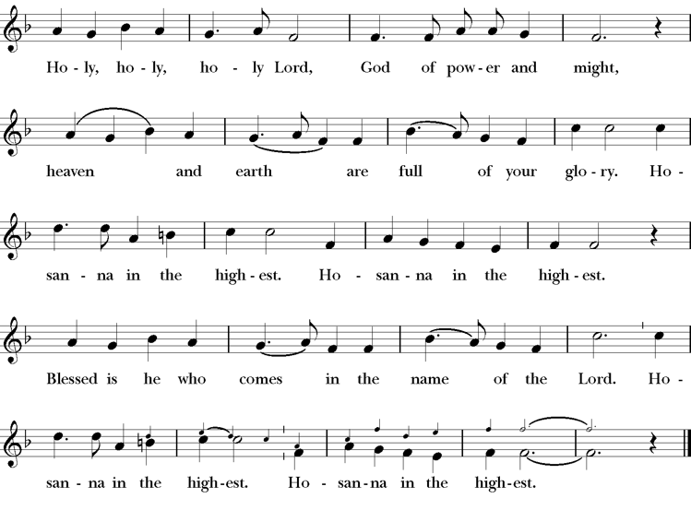
Words of Institution BCP 368
The Lord’s Prayer 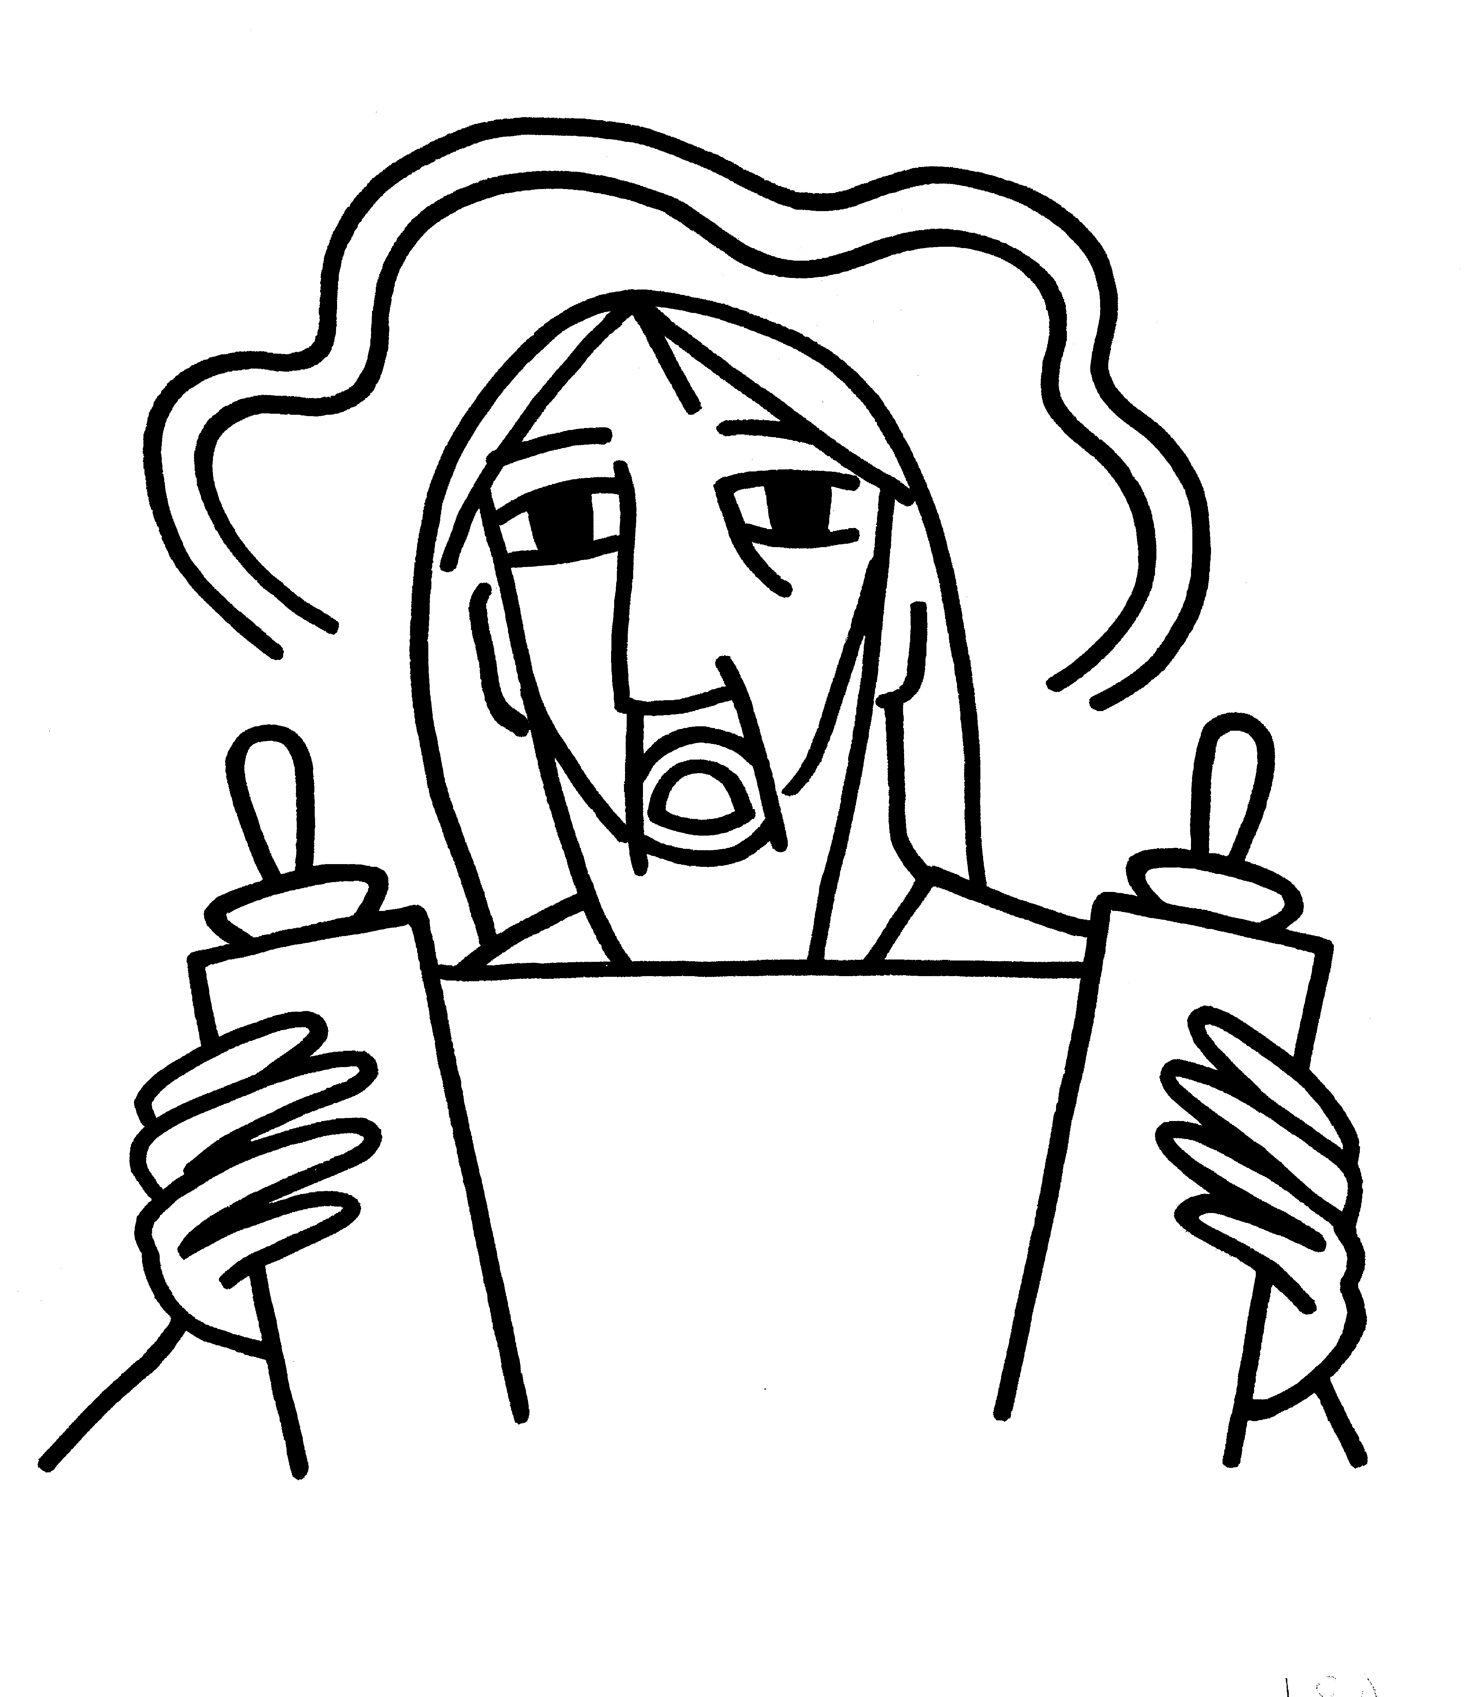 BCP 364
The Breaking of the Bread  BCP 364
Fraction Anthem S-154
All are welcome at the Lord’s table to receive Holy Communion or a blessing. To receive Communion in your pew, please ask an usher to notify the ministers on your behalf. If you require a gluten-free wafer, please ask at the altar rail.
Communion Music Steve Rubardt & Choir
Let all Mortal Flesh keep Silence H 324
Post-Communion Prayer
Eternal God, heavenly Father,
you have graciously accepted us as living members
of your Son our Savior Jesus Christ,
and you have fed us with spiritual food
in the Sacrament of his Body and Blood.
Send us now into the world in peace,
and grant us strength and courage
to love and serve you
with gladness and singleness of heart;
through Christ our Lord. Amen.
Amen.
Blessing (BCP p. 366)
The blessing of God Almighty, the Father, the Son, and the Holy Spirit, be upon you and remain with you for ever.
Amen.
The Recessional Hymn Just a Closer Walk with Thee LEVAS 72
Dismissal (BCP p. 366)
 | Let us go forth in the name of Christ.
People | Thanks be to God.
Postlude Steve Rubardt
Please remain seated
SERVING TODAY
Celebrant and Preacher: Pastor Cindy Beck
Acolyte: Susie Hand
Lector: Lorena Reinhardt , Ann Kyser
Intercessor: Barbara Feduska
Worship Musician: Steve Rubardt
Choir Leader: Steve Rubardt
Choir: Liz Carpenter, Heather Dahlberg, Scott Sherman, Lucy Maushardt, Patsy Gralow, Laurell Meredith, Mary Omodt, Barbara Feduska, Tara Anderson
Sunday School - Child Care: Wendy Aguilar Appt Only
Ushers: John Addeo
Tech Chaplain: Marcos Rendon
Altar Guild: Ann Kyser
Hospitality:

Prayers requested for these on Trinity’s long-term prayer list: Baby Walker David, Armando P, Laura Basett, , Georgia Bostedt, Muff Davey, John Eiler, Gerrilee Fisher, Claire Ginesi, Mary Griffin, David & Christine Hilt, Dr. Tamer Keshen, Marie Lambert, Mark Mezzetta, Kelcey Omodt, Grizelda Ponce, Barry Reap, Blake W, Robert R, Ann Loveland Sherman, John Spooner, James Thomas, Rose Burns, Jennifer Gralow, Patsy Gralow, Steve Antenen, Sandra Leland, John Forester, Stuart , Melissa White.
Prayers for the Repose of soul: Tim Dowd , Susan Bassett, Joan Biersch, Mere Nagasau, Christina Van Krugel, Linda Dowd, Peggy and John Bell, Denny Hoelter, Van Z
Contact Pastoral Care Chair, Lorena lorena.m.reinhardt@gmail.com to make any additions or to remove names from our Long-Term Prayer list.

Calendar of the Church Year
The calendar (BCP, pp. 15-33) orders the liturgical year of the Episcopal Church by identifying two cycles of feasts and holy days-one dependent upon the movable date of Easter Day and the other dependent upon the fixed date of Christmas, Dec. 25. Easter Day is the first Sunday after the full moon that falls on or after Mar. 21. The sequence of all Sundays in the church year is based on the date of Easter. Tables and rules for finding the date of Easter Day, and other movable feasts and holy days are provided by the BCP, pp. 880-885. The date of Easter determines the beginning of the season of Lent on Ash Wednesday and the date of Pentecost on the fiftieth day of the Easter season. The Sundays of Advent are always the four Sundays before Christmas Day. The church year begins on the first Sunday of Advent. The calendar also identifies and provides directions concerning the precedence and observance of principal feasts, Sundays, holy days (including Feasts of our Lord, other major feasts, and fasts), Days of Special Devotion, and Days of Optional Observance. The calendar lists dates for celebration of major feasts and lesser feasts by month and date. Appropriate Sunday Letters and Golden Numbers are also provided. (see BCP, pp. 880-881). The calendar also lists the titles of the seasons, Sundays, and major holy days observed in the Episcopal Church throughout the church year, including Advent season, Christmas season, Epiphany season, Lenten season, Holy Week, Easter season, the season after Pentecost, holy days, and National Days.
Notes on the Epiphany Season Liturgy
In the weeks after Epiphany, other events in Jesus’ ministry are celebrated, events such as his first miracle, changing water into wine; his first healing; his calling of the disciples; his first preaching. These events reveal him as God’s Son and help us explore more deeply the unlimited extent of his love and our role—as the members of his Body—in revealing him to the world.
The liturgical texts for this period are very expressive of its meaning and embody many of the symbols, both biblical and cultural, which came to be part of the season:

Trinity Liturgical Ministry ROTA Next two weeks
Date | Celebrant | Ushers | Acolyte / EM | Lector (s) | Intercessor | Altar Guild
Feb 8 | Cindy Beck | Marcia Derby | Arminda Eiler | Gerrilee Fisher , John Eiler | Alfred Escoffier | Marcia Derby Mary Omodt
Feb 15 | Cindy Beck | Alfred Escoffier | Susie Hand | Ann Kyser, Lorena Reinhardt | Barbara Feduska | Susie Hand

Schedule of Weekly Meetings and Services at Trinity Episcopal Sonoma
Day | Date | Time | Occasion | Location
Wednesday | January 28 | 10:30 AM | Bible Study | Library
Thursday | January 29 | 10:30 AM  5:30 PM | Mindfulness & Well Being  Alcoholics Anonymous | Library  Buttrum Hall
Saturday | Jan 31 | 8 AM | Centering Prayer | St. Luke’s Chapel
Sunday | Feb 1 | 10:15 AM | Holy Eucharist II | Sanctuary
Mon-Fri | Weekdays | 7AM-1PM | Sonoma Home Meals | Kitchen &Buttrum Hall
Mon-Fri | Weekdays | 9-2 | Sonoma Preschool Academy – School
Monthly Meetings at Trinity Episcopal Sonoma
Day | Date | Time | Meeting | Location | Contact
Tuesday | TBD | 11 AM | Prayer Shawl Ministry | Library | Norah Collins 28norahe@gmail.com
Thursday | TBD | 4:30 PM | Vestry | Library | Claire Ginesi cfgsonoma@gmail.com

PRAYERS and BLESSINGS
For a Birthday
Watch over your child, O Lord as his/her days increase; bless and guide him/her wherever s/he may be. Strengthen them when s/he stands; comfort him/her when discouraged or sorrowful; raise him/her up if s/he fall; and in his/her heart may your peace which passes understanding abide all the days of his/her life; through Jesus Christ our Lord. Amen.
For an Anniversary
O God, you have so consecrated the covenant of marriage that it represents the spiritual unity between Christ and his Church: Send your blessing upon these your servants as they celebrate their anniversary, that they may continue to love, honor and cherish each other in faithfulness and patience, in wisdom and true godliness, that their home may be a haven of blessing and peace; through Jesus Christ our Lord, who lives and reigns with you and the Holy Spirit, one God, now and forever. Amen.
For Travelers
O God, our heavenly Father, whose glory fills the whole creation, and whose presence we find wherever we go; preserve those who travel; surround them with your loving care; protect them from every danger, and bring them in safety to their journey’s end; through Jesus Christ our Lord. Amen.
Sending our Eucharistic Visitors
Priest: In the name of this congregation, I send you forth bearing these holy gifts, the those to whom you go may share with us in the communion of Christ’s body and blood.
People: We who are many are one body, because we all share on bread, and one cup. Amen

Trinity Episcopal Church
In Sonoma for over 170 years
275 East Spain Street
Sonoma, CA 95476
The Rt. Rev. Megan M. Traquair, Bishop
Diocese of Northern California
Pastor Cindy Beck, Interim
Steve Rubardt, Worship Music
Vestry
Bill Doyle, Junior Warden (Buildings, Grounds)
Bill Doyle (Stewardship)
Susie Hand
Heather Dahlberg
Lorena Reinhardt (Pastoral Care)
Ministries
Prayer Shawl ,Norah Collins
Outreach, Jane Hernandez
Youth – Academic Tutoring, Karen Randall
Mindfulness & Well Being, Mary Omodt
Sunday School, Children, Wendy Aguilar

The Members of the Congregation are The Ministers of the Church

Administrative Office Hrs.
Monday Wednesday 9 A.M. – 2 PM; Thursday 10A.M.-2 P.M0
Sunday 9:30-11:30
Clergy Office Hours Wednesdays, Thursdays, by appointment

Emergency, sickness, please contact office: 707-938-4846

