

An Order for
the Celebration of
The Holy Eucharist
For the 1st Sunday of Lent
February 22, 2026
Welcome! Beinvenido! Karibu!
Scattered in the world we gather together as God's people in worship. We bring the fragments of our lives to be healed and made whole in Christ as we gather in community.
Worship lies at the heart of the Christian life. It is in worship that we express our theology and define our identity. It is through encountering God within worship that we are formed and transformed as God’s people. One of the glories of the Episcopal/Anglican Church is its liturgical worship. Liturgy refers to the patterns, forms, words and actions through which public worship is conducted.
As we gather, we bring our diverse gifts: gifts of music, dance, prophecy, teaching, preaching, and friendship. We present these gifts in the form of our most precious offering to God, our very selves, that all that we do may be for God’s glory in the unity of Christ’s church.
See end of bulletin for information and announcements for Trinity Episcopal Sonoma.
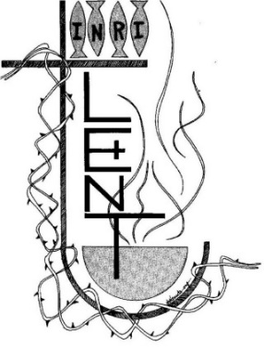
About the Season of Lent

Early Christians observed “a season of penitence and fasting” in preparation for the Paschal feast, or Pascha (Easter). The season now known as Lent, from an Old English word meaning “spring,” the time of lengthening days, has a long history. Lent was especially important for converts to the faith who were preparing for baptism, and for those guilty of notorious sins who were being restored to the Christian assembly. In the western church, the forty days of Lent extend from Ash Wednesday through Holy Saturday, omitting Sundays. The last three days of Lent are the sacred Triduum of Maundy Thursday, Good Friday, and Holy Saturday. Today, Lent has reacquired its significance as the final preparation of adult candidates for baptism. Joining with them, all Christians are invited “to the observance of a holy Lent, by self-examination and repentance; by prayer, fasting, and self-denial; and by reading and meditating on God’s holy Word.”

About the Holy Eucharist
“When God finds us, there is always a celebration. In the Eucharist, we gather to celebrate God finding us in Jesus Christ. If you’re feeling lost, when you come to receive Jesus in bread and wine, ask to be found. If you know what it is to have been found by God, when you come to receive Jesus in bread and wine, give thanks – thanks to the one who came looking for you, and found you.”
-Br. Geoffrey Tristram
Society of Saint John the Evangelist
In the Episcopal Church the Holy Eucharist is the sacrament of Christ's body and blood, and the principal act of Christian worship. The term is from the Greek, "thanksgiving." Jesus instituted the Eucharist "on the night when he was betrayed." At the Last Supper he shared the Bread and cup of Wine at a sacred meal with his disciples. He identified the Bread with his body and the Wine with his blood of the new covenant. Jesus commanded his disciples to "do this" in remembrance of Jesus.
For Episcopalians, the Holy Eucharist becomes the very Real Presence of Christ, his Body and Blood, the ordinary made also extraordinary, sacred by Jesus' own words and by the Holy Spirit.
In the Episcopal Church, we seek to adapt ancient liturgy for today. If you grew up in a less formal church, worship may feel pretty traditional. If you grew up in a formal church, our worship may deconstruct that formality, and ask you to pray using more modern words, or sing new songs. We seek to balance tradition and culture in our worship. When we hold the tension well between the ancient and the modern, the Holy Eucharist comes alive.
Opening Hymn
We begin by praising God through song and prayer.
Now Let Us all, With One Accord H 147
The Penitential Rite
Our worship begins with the Acclamation and Penitential Rite.
Presider Blessed be the God of our salvation.
People Who bears our burdens and forgives our sin.
Presider Jesus said, "The first commandment is this: Hear, O Israel: The Lord our God is the only Lord. Love the Lord your God with all your heart, with all your soul, with all your mind, and with all your strength. The second is this: Love your neighbor as yourself. There is no other commandment greater than these." -Mark 12:29-31

The Confession
As we enter in to worship we ask God’s forgiveness for things done and things left undone and things done on our behalf so that we may be reconciled to each other and to God.
Presider Let us confess our sins against God and our neighbor.
Silence is kept for a time.
Presider Most holy and merciful God: We confess to you and to one another, and to the whole communion of saints in heaven and on earth, that we have sinned by our own fault in thought, word, and deed; by what we have done, and by what we have left undone.
People We have not loved you with our whole heart, and mind, and strength. We have not loved our neighbors as ourselves. We have not forgiven others, as we have been forgiven.

Presider Our past unfaithfulness: the pride, hypocrisy, and impatience of our lives,
People We confess to you, O God.
Presider Our self-indulgence, and our exploitation of other people, our anger at our own frustration, and our envy of those more fortunate than ourselves,
People We confess to you, O God.
Presider For all false judgments, for uncharitable thoughts toward our neighbors, and for our prejudice and contempt toward those who differ from us,
People Accept our repentance, O God.
Presider For our waste and pollution of your creation, and our lack of concern for those who come after us,
People Accept our repentance, O God.
Presider Restore us, good Lord, and let your anger depart from us;
People Favorably hear us, for your mercy is great.

declaration of pardon & forgiveness
Presider The Eternal God forgives you and frees you from your sins, heals and strengthens you by the Holy Spirit, and raises you to new life in Christ Jesus our Lord. Amen

Song of Penance: Trisagion (Sung)
When the Trisagion is sung, it is repeated three times.
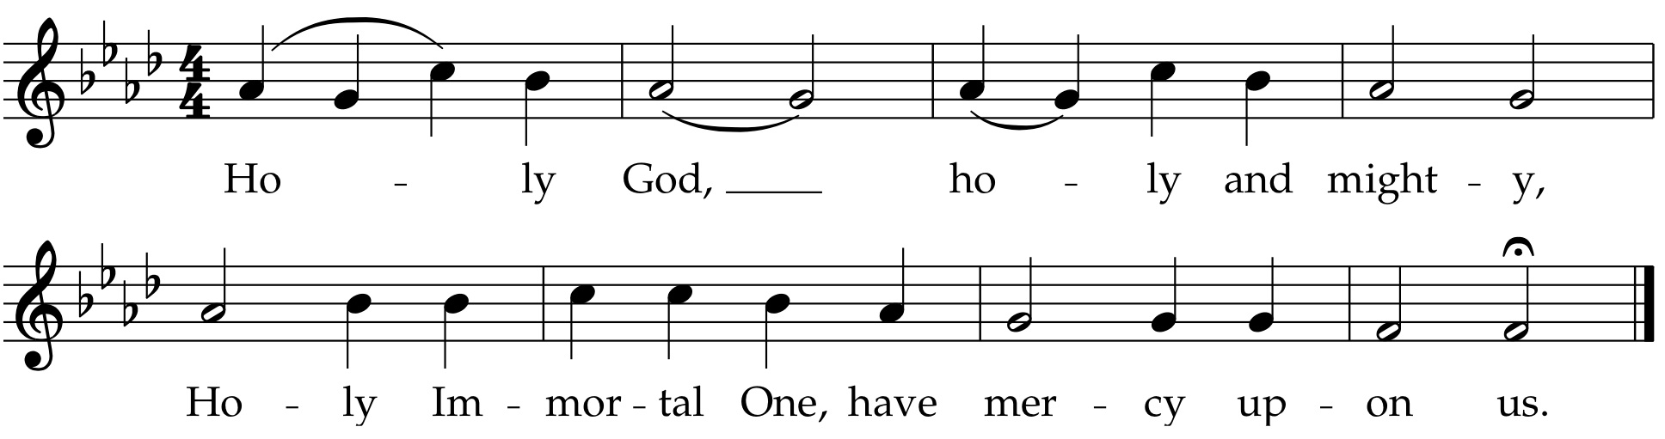
Collect of the Day
The collect is written to go along with both the season of the church year and the readings for the day. It summarizes the attributes of God as revealed in the scripture for the day.
Presider The Lord be with you.
People And also with you.
Presider Let us pray.
Lord Jesus, you taught your disciples that you must undergo great suffering and be killed before rising again; grant us the strength and wisdom to be your followers and to take up our cross to follow you, this day and always.
Amen.
We hear the sacred stories
We hear the stories of the experience of God from our spiritual ancestors. Reading and commenting on scripture goes back to the earliest services of Christianity. Following the pattern of Jewish synagogue worship, readings follow a set pattern for what will be read when.
The First Reading Genesis 2:15-17; 3:1-7
The people sit.
A Reading from the book of Genesis.
¹⁵The Lord God took the man and put him in the garden of Eden to till it and keep it. ¹⁶And the Lord God commanded the man, “You may freely eat of every tree of the garden; ¹⁷but of the tree of the knowledge of good and evil you shall not eat, for in the day that you eat of it you shall die.”
^{3:1}Now the serpent was more crafty than any other wild animal that the Lord God had made. He said to the woman, “Did God say, ‘You shall not eat from any tree in the garden’?” ²The woman said to the serpent, “We may eat of the fruit of the trees in the garden; ³but God said, ‘You shall not eat of the fruit of the tree that is in the middle of the garden, nor shall you touch it, or you shall die.’ ” ⁴But the serpent said to the woman, “You will not die; ⁵for God knows that when you eat of it your eyes will be opened, and you will be like God, knowing good and evil.” ⁶So when the woman saw that the tree was good for food, and that it was a delight to the eyes, and that the tree was to be desired to make one wise, she took of its fruit and ate; and she also gave some to her husband, who was with her, and he ate. ⁷Then the eyes of both were opened, and they knew that they were naked; and they sewed fig leaves together and made loincloths for themselves.
Reader Hear what the Holy Spirit is saying to God’s people.
People Thanks be to God.
The Psalm of the Day Psalm 32
The psalms are a part of the poetry of the Hebrew people. They express joy and sadness, loneliness and thanksgiving as part of the human longing to be united with God.
Reader We will read Psalm 2, responsively by half verse.
¹Happy are they whose transgressions are forgiven, *
and whose sin is put away!
²Happy are they to whom the Lord imputes no guilt, *
and in whose spirit there is no guile!
³While I held my tongue, my bones withered away, *
because of my groaning all day long.
⁴For your hand was heavy upon me day and night; *
my moisture was dried up as in the heat of summer.
⁵Then I acknowledged my sin to you, *
and did not conceal my guilt.
⁶I said, “I will confess my transgressions to the Lord.” *
Then you forgave me the guilt of my sin.
⁷Therefore all the faithful will make their prayers to you in time of trouble; *
when the great waters overflow, they shall not reach them.
⁸You are my hiding-place;
you preserve me from trouble; *
you surround me with shouts of deliverance.
⁹“I will instruct you and teach you in the way that you should go; *
I will guide you with my eye.
¹⁰Do not be like horse or mule, which have no understanding; *
who must be fitted with bit and bridle,
or else they will not stay near you.”
¹¹Great are the tribulations of the wicked; *
but mercy embraces those who trust in the Lord.
¹²Be glad, you righteous, and rejoice in the Lord; *
shout for joy, all who are true of heart.

The Second Reading Romans 5:12-19
A Reading from Paul's letter to the Church in Rome.
¹²Just as sin came into the world through one man, and death came through sin, and so death spread to all because all have sinned—¹³sin was indeed in the world before the law, but sin is not reckoned when there is no law. ¹⁴Yet death exercised dominion from Adam to Moses, even over those whose sins were not like the transgression of Adam, who is a type of the one who was to come.
¹⁵But the free gift is not like the trespass. For if the many died through the one man’s trespass, much more surely have the grace of God and the free gift in the grace of the one man, Jesus Christ, abounded for the many. ¹⁶And the free gift is not like the effect of the one man’s sin. For the judgment following one trespass brought condemnation, but the free gift following many trespasses brings justification. ¹⁷If, because of the one man’s trespass, death exercised dominion through that one, much more surely will those who receive the abundance of grace and the free gift of righteousness exercise dominion in life through the one man, Jesus Christ.
¹⁸Therefore just as one man’s trespass led to condemnation for all, so one man’s act of righteousness leads to justification and life for all. ¹⁹For just as by the one man’s disobedience the many were made sinners, so by the one man’s obedience the many will be made righteous.
Reader Hear what the Holy Spirit is saying to the church.
People Thanks be to God.
Preparing to Hear the Gospel
We rise in body or in spirit for the Gospel reading to show the particular importance we place on Jesus’ words and actions.
Sequence Hymn
Lord, Who throughout H 142 vs 1-3
The Proclamation of the Gospel
Presider The Holy Gospel of our Savior Jesus Christ according to Matthew.
People Glory to you, O Christ.
¹[After Jesus was baptized, he] was led up by the Spirit into the wilderness to be tempted by the devil.²He fasted forty days and forty nights, and afterwards he was famished. ³The tempter came and said to him, “If you are the Son of God, command these stones to become loaves of bread.” ⁴But he answered, “It is written,
‘One does not live by bread alone,
but by every word that comes from the mouth of God.’ ”
⁵Then the devil took him to the holy city and placed him on the pinnacle of the temple, ⁶saying to him, “If you are the Son of God, throw yourself down; for it is written,
‘He will command his angels concerning you,’
and ‘On their hands they will bear you up,
so that you will not dash your foot against a stone.’ ”
⁷Jesus said to him, “Again it is written, ‘Do not put the Lord your God to the test.’ ”
⁸Again, the devil took him to a very high mountain and showed him all the kingdoms of the world and their splendor; ⁹and he said to him, “All these I will give you, if you will fall down and worship me.” ¹⁰Jesus said to him, “Away with you, Satan! for it is written,
‘Worship the Lord your God,
and serve only him.’ ”
¹¹Then the devil left him, and suddenly angels came and waited on him.
Presider The Gospel of the Lord.
People Praise to you, O Christ.
Sequence Hymn
Lord, Who throughout H 142 vs 4-5
The Sermon
We remain seated for the sermon. Having someone comment on the scriptures read goes back to the earliest days of Christianity and to the Jewish Synagogue worship which preceded it.
The Affirmation of Faith
Since the Sixth Century, the Church has recited either the Nicene Creed or the Apostle’s Creed at the Eucharist. The word creed comes from the Latin credo for “I believe” or “I lend my heart to.”
The Nicene Creed
Presider We affirm our faith in the One, Holy and Living God.
People We believe in one God, the Father, the Almighty, maker of heaven and earth, of all that is, seen and unseen.
People We believe in one Lord, Jesus Christ, the only Son of God, eternally begotten of the Father, God from God, Light from Light, true God from true God, begotten, not made, of one Being with the Father. Through him all things were made. For us and for our salvation he came down from heaven: by the power of the Holy Spirit he became incarnate from the Virgin Mary, and was made man. For our sake he was crucified under Pontius Pilate; he suffered death and was buried. On the third day he rose again in accordance with the Scriptures; he ascended into heaven and is seated at the right hand of the Father. He will come again in glory to judge the living and the dead, and his kingdom will have no end.
People We believe in the Holy Spirit, the Lord, the giver of life, who proceeds from the Father and the Son. With the Father and the Son he is worshiped and glorified. He has spoken through the Prophets. We believe in one holy catholic and apostolic Church. We acknowledge one baptism for the forgiveness of sins. We look for the resurrection of the dead, and the life of the world to come. Amen.

The Prayers of the People
Prayer changes people. Prayer is not about changing God, but about changing us more into the likeness of God. Collectively and individually we offer the hopes and desires of our hearts to God.
Presider: We do not live by bread alone, but by every word that comes from the mouth of God. Let us pray to the source of our sustenance, saying, “God, our hiding place, preserve us from trouble.”
Intercessor: Great God, you have called your people to worship and serve you alone. Instill in us such a singleness of heart that we might perfectly trust you to meet our needs.
God, our hiding place,
People: Preserve us from trouble.
Intercessor: Great God, we live among many temptations. Free the people of this nation, and this world, from all sinful desires that draw us from the love of God.
God, our hiding place,
People: Preserve us from trouble.
Great Creator, you have surrounded us with blessings; you provide enough to meet our needs. And yet, we strive and scheme for more, always more. Have mercy on us. God, our hiding place,
People: Preserve us from trouble.
Intercessor: O Lord, we pray for those bound by addiction, those for whom temptation is a constant threat. Set the captive free. Satisfy their cravings with abundant grace.
(Invite the congregation to add their petitions)
God, our hiding place,
People: Preserve us from trouble.
Intercessor: Be with the sick and suffering, Great Healer. Be for them a hiding place; preserve them from trouble; surround them with shouts of deliverance.
(Invite the congregation to add their petitions)
God, our hiding place,
People: Preserve us from trouble.
Intercessor: Through the righteousness of Jesus our Christ, give new and abundant life to all. Justify the dying and the dead. Keep them in your strong hands for ever.
God, our hiding place,
People: Preserve us from trouble.
Presider: Lord Jesus, you proclaimed the Good News in Galilee, saying that the time is fulfilled and the kingdom of God has come near; grant us the strength and wisdom to repent and believe in the Good News, this day and always.
People: Amen.
The Exchange of the Peace
As we enter the most sacred portion of our worship, we exchange a sign of God’s promised peace. There are no set words to use in greeting each other, but “Peace be with you,” “God’s peace,” and “Shalom” are all commonly used.
Presider The Peace of Christ be always with you.
People And also with you.
Presider Let us offer each other a sign of Christ's peace.
We are a community of reconciliation and peace; therefore, we greet each other with a sign of our desire for peace.
Welcome & Announcements
Community announcements, notices, prayers, and celebrations may be offered at this time.
Gathering at Christ's Table
Having been nourished from the richness of God's love in sacred story and reconciled to each other through prayer and peace, we gather at Christ's table to offer ourselves to be transformed for service in the world.
The Offertory
The gifts of bread, wine, money and other gifts are brought to the Presider as an offering to God as a reminder of Christ's sacrificial love and life. Once the Holy Table or Altar is prepared the Presider and people give thanks to God for the many gifts we have been given.
Offertory Hymn:
You who Dwell WLP 810
Doxology
The people stand while the offerings are presented and placed on the Altar.
Presider: Gracious God, as an offering of our thanksgiving and gratitude, we return to you a portion of what you have gifted us.
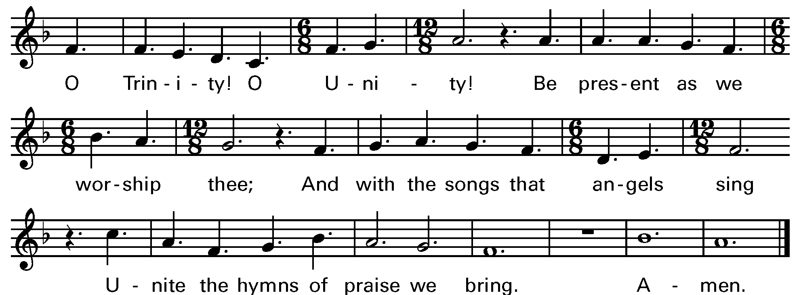

Music: OLD HUNDREDTH
The Great Thanksgiving
The Eucharistic Prayer, or Great Thanksgiving, is the prayer of the Church to invite Christ to be present in the elements of bread and wine. Now we come to the second act in the drama with the Liturgy of the Table. It is based on Jewish Fellowship meals, particularly the Passover observance. But this second half of the service is not communion in and of itself. It is the whole service, both acts of the drama, that make up the Eucharist.
Eucharistic Prayer for Lent
Presider The Lord be with you.
People And also with you.
Presider Lift up your hearts.
People We lift them to the Lord.
Presider Let us give thanks to the Lord our God.
People It is right to give thanks and praise.
Presider Blessed are you, God of everlasting covenant, for your promises are steadfast and your provision is sure. Through the forty years of your people’s desert wanderings you were constant in fire and cloud; with manna and mercy you sustained every step. You made Jesus’ temptation of forty days a theater of truth where your Word stood strong.
In every age you have shaped your people through times of wilderness and wandering, of temptation and trial, and brought them into the land of promise and the life of covenant.

And so we give you humble thanks for your forgiveness and our new life, with angels and archangels and the company of heaven, singing your unending praise.

Sanctus Holy Holy, Holy (Proulx) Hymnal S-125
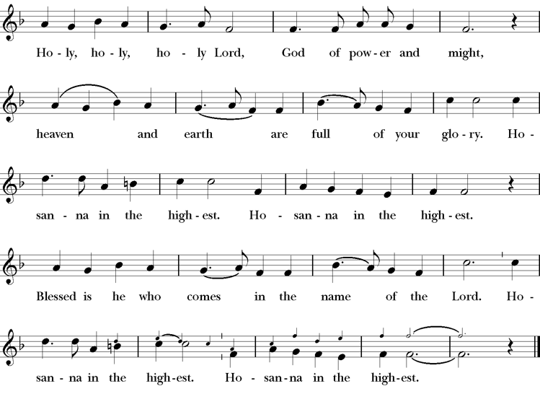
Presider Enduring God, as you sustained Jesus in hunger and thirst; through this meal strengthen us to keep our Lenten fast. Send your Holy Spirit upon us as we remember Jesus’ saving passion; transform our insatiable desires into hunger for the feast of this table. Send your Holy Spirit upon this bread and wine that they may be for us the body and blood of Christ;
Who at supper with his disciples, took bread, gave you thanks, broke the bread, and gave it to them, saying “Take, eat: this is my body which is given for you; do this in remembrance of me.”
Presider After supper he took the cup of wine. Again he gave you thanks, and gave it to his disciples, saying, “Drink this, all of you: this is my blood of the new covenant which is shed for you and for many for the forgiveness of sins. Do this, as often as you drink it, in remembrance of me.”
Presider Great is the mystery of faith.
People Christ has died; Christ is risen; Christ will come again.
Presider Forgiving God, in this season of repentance, make your mercy sufficient for every need. Come to your children who are in their own wilderness and make their wanderings holy paths of learning your truth.
Presider Come alongside your children who suffer in sin and give them the power to live as your beloved sons and daughters. Renew your church from the depths of your heart, where justice and mercy meet.
Presider Infuse your church with Spirit and truth, walk with your beloved people as they seek security, companionship and freedom in your world, and fill your saints with the hope of eternal life, that all may come to praise your name, that all creation be stirred with the wonders of your grace.
Presider Through Christ, with Christ, in Christ, in the unity of the Holy Spirit, all glory and honor are yours, almighty God, now and forever. AMEN.
The Lord’s Prayer
The link between our daily bread and the spiritual food we receive in the Eucharist is an ancient connection. In the Lord’s Prayer we ask for daily bread, meaning the things we need to get through each day. But as a part of that, the bread also symbolizes God’s presence.
Presider As our Savior has taught us, we are bold to pray.
People Our Father, who art in heaven, hallowed be thy name. Thy Kingdom come, thy will be done, on earth as it is in heaven. Give us this day our daily bread. And forgive us our trespasses, as we forgive those who trespass against us. And lead us not into temptation, but deliver us from evil. For thine is the kingdom, the power and the glory, for ever and ever. Amen.
The Breaking of the Bread
The Presider breaks the consecrated bread in view of the assembly.
Presider Christ our Passover is sacrificed for us.
People Therefore let us keep the feast.
Invitation to Communion
We partake in the Eucharist and are spiritually nourished, but it is not for our benefit alone. Communion enables us to return to the world with renewed vigor for proclaiming the Gospel in our words and in our lives. In the Eucharist, Christ’s presence both nourishes us and challenges us.
Presider The gifts of God for the people of God. So come to this table you who have been here often and you who have not been here in a long time. Come, you who have tried to follow Jesus and you who have failed. You who are full of faith and full of doubt. Come, it is Christ himself who invites you to meet him here.
Sharing the Sacred Meal
This is Christ’s table and all are welcome and all are fed.
Communion Hymn: Ave Verum
Post Communion Prayer
Presider God is with you.
People And also with you.
Presider Together, let us pray.
People Eternal God, you have renewed us with the living bread from heaven; by it you nourish our faith, increase our hope, and strengthen our love: teach us always to hunger for him who is the true and living bread, and enable us to live lives grounded in service to you and to one another; through Jesus Christ our Lord. Amen.
The Lenten Prayer over the People
The Presider prays over the people as a reminder of God’s extravagant love and invites us to go into the world to be God’s blessing.
Presider Bow down your hearts before the Lord our God. Grant, most merciful Lord, to your faithful people pardon and peace, that they may be cleansed from all their sins, and serve you with a quiet mind; through Christ our Lord. Amen.
Closing Hymn
We begin and end our time of worship by praising God through song and prayer.
Great is thy Faithfulness LEVAS 189
Dismissal
As the celebration ends, we are charged to “Go in Peace to love and serve the Lord.” The Eucharist is therefore not an exclusive gathering that separates us from the world, but a challenge to reach out beyond our own church to the world around us.
Presider Our worship is ended. Our service in the world begins. Go into the world to love what God loves. Go in Peace to love and serve the Lord.
People Thanks be to God.

Thank you for worshiping with us today.
We hope to see you again soon
as we offer Christ’s unfenced love to the world.

SERVING TODAY
Celebrant and Preacher: Rev Mary Claugus
Acolyte: Arminda Eiler
Lector: Gerrilee FIsher , John Eiler
Intercessor: Claire Ginesi
Worship Musician: Steve Rubardt
Choir Leader: Steve Rubardt
Choir: Liz Carpenter, Heather Dahlberg, Scott Sherman, Lucy Maushardt, Patsy Gralow, Laurell Meredith, Mary Omodt, Barbara Feduska, Tara Anderson
Sunday School - Child Care: Wendy Aguilar Appt Only
Ushers: John Eiler
Tech Chaplain: Marcos Rendon
Altar Guild: Laurell Meredith , Liz Carpenter
Hospitality: Claire Ginesi
Trinity Liturgical Ministry ROTA Next two weeks
Date | Celebrant | Ushers | Acolyte / EM | Lector (s) | Intercessor | Altar Guild
March 1 | Cindy Beck | Marcia Derby | Susie Hand | Bill Doyle , Claire Ginesi | Lorena Reinhardt | Marcia Derby, Liz Carpenter
March 8 | Cindy Beck | John Addeo | Arminda Eiler | Ann Kyser , John Eiler | Alfred Escoffier | Ann Kyser
Schedule of Weekly Meetings and Services at Trinity Episcopal Sonoma
Day | Date | Time | Occasion | Location
Wednesday | February 25 | 11 AM | Bible Study | Library
Thursday | February 16 | 10:30 AM  5:30 PM | Mindfulness & Well Being  Alcoholics Anonymous | Library  Buttrum Hall
Saturday | February 28 | 8 AM | Centering Prayer | St. Luke’s Chapel
Sunday | March 1 | 10:15 AM | Holy Eucharist II | Sanctuary
Mon-Fri | Weekdays | 7AM-1PM | Sonoma Home Meals | Kitchen &Buttrum Hall
Mon-Fri | Weekdays | 9-2 | Sonoma Preschool Academy – School
Monthly Meetings at Trinity Episcopal Sonoma
Day | Date | Time | Meeting | Location | Contact
Tuesday | TBD | 11 AM | Prayer Shawl Ministry | Library | Lorena Reinhardt
Thursday | TBD | 4:30 PM | Vestry | Library | Cindy Beck
PRAYERS and BLESSINGS
For a Birthday
Watch over your child, O Lord as his/her days increase; bless and guide him/her wherever s/he may be. Strengthen them when s/he stands; comfort him/her when discouraged or sorrowful; raise him/her up if s/he fall; and in his/her heart may your peace which passes understanding abide all the days of his/her life; through Jesus Christ our Lord. Amen.
For an Anniversary
O God, you have so consecrated the covenant of marriage that it represents the spiritual unity between Christ and his Church: Send your blessing upon these your servants as they celebrate their anniversary, that they may continue to love, honor and cherish each other in faithfulness and patience, in wisdom and true godliness, that their home may be a haven of blessing and peace; through Jesus Christ our Lord, who lives and reigns with you and the Holy Spirit, one God, now and forever. Amen.
For Travelers
O God, our heavenly Father, whose glory fills the whole creation, and whose presence we find wherever we go; preserve those who travel; surround them with your loving care; protect them from every danger, and bring them in safety to their journey’s end; through Jesus Christ our Lord. Amen.
Sending our Eucharistic Visitors
Priest: In the name of this congregation, I send you forth bearing these holy gifts, the those to whom you go may share with us in the communion of Christ’s body and blood.
People: We who are many are one body, because we all share on bread, and one cup. Amen

February Announcements
2025 End of Year Giving Statements have been generated and will begin to be sent out. If you need another copy let the office know.
Fellowship Coffee Hour Sign up - We encourage members to sign up to make coffee. Pastor Cindy is happy to demonstrate how easy this is. Please help us provide this hospitality for guests and members.
The February, March, April Forward Day by Day , a booklet of daily inspirational meditations is now available in the Church and the Office. We ask for a $2 donation.
Soup Suppers Start next Wednesday, at 5PM in Buttram Hall. Please sign up for either soup or bread during fellowship hour!
Lectio Divina Bible Study is on Wednesday, at 11AM in the library. Lectio Divina, Latin for "divine reading," is a contemplative practice of scriptural reading, meditation, and prayer intended to promote communion with God. Unlike traditional Bible study that focuses on intellectual information, Lectio Divina emphasizes spiritual formation and personal intimacy with God.
All are welcome to make a gift and offering in thanksgiving to God; for the many blessings we have received. To take advantage of our electronic giving options, please follow the QR code with your capable electronic device, or visit https://onrealm.org/trinitysonoma/-/form/give/default Help us to make this a place where God’s grace is freely shared by all.

Big Thank you to Rev. Mary Claugus for presiding and preaching at Trinity this morning. Mary retired from St. Michaels Episcopal Church in Carmichael.

