Trinity Episcopal Church
In Sonoma for over 170 years
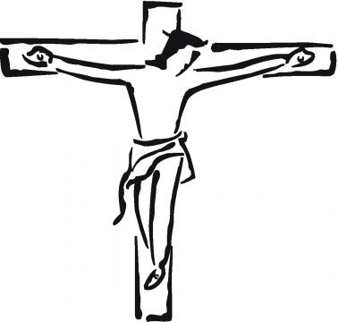
Good Friday
Year C
April 3, 2026
5:00 PM In person

For Visitors and Newcomers: Welcome! We are glad you have joined us today. If you are interested in a visit or call from the Priest-in-Charge, please sign our guest book on the Narthex* table to let her know you are visiting. Include your phone or email address. Narthex = wonderful old Latin word Episcopalians use for the entrance hall, traditionally at the western end of our churches.
To access Trinity’s Guest WIFI: Password Rosepettal441 (case sensitive). We are glad you are here, and we invite you to enter fully into worship this morning.
All are welcome to make a gift and offering in thanksgiving to God; for the many blessings we have received. To take advantage of our electronic giving options, please follow the QR code with your capable electronic device, or visit https://onrealm.org/trinitysonoma/-/form/give/default Help us to make this a place where God’s grace is freely shared by all.

About this Service: Year A
Notes on Good Friday
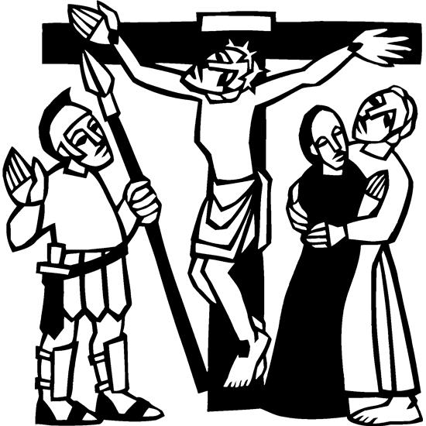
Good Friday is a day of somber reflection and remembrance of Jesus' sacrifice on the cross, emphasizing the love and grace of God despite the suffering. While it marks the crucifixion, it is also seen as a prelude to the joy of Easter Sunday, celebrating Christ's victory over death. Our service tonight seeks to hear Jesus’ last seven phrases as they may have been experienced by those watching his crucifixion.

CALL TO WORSHIP:
Isaiah 53:4-6
Leader: Surely he took up our infirmities and carried our sorrows,
Congregation: yet we considered him stricken by God, smitten by him, and afflicted.
L: But he was pierced for our transgressions, he was crushed for our iniquities;
C: the punishment that brought us peace was upon him, and by his wounds we are healed.
L: All we, like sheep, have gone astray, each of us has turned to his own way;
C: and the Lord has laid on him the iniquity of us all.

Litany of Remembrance
L: Let us remember Jesus: who, though rich, became poor and dwelt among us, who was mighty indeed, healing the sick and the troubled, who, as a teacher to his disciples, was their companion and servant.
C: May we ever be grateful for Jesus the Christ and what he has done for us.
L: Let us remember Jesus who prayed for the forgiveness of those who rejected him, who loved all people, and prayed for them, even if they denied and rejected him who hated sin because he knew the cost of pride and selfishness, of cruelty and hatred, both to people and to God.
C: May we ever be grateful for Jesus the Christ and what he has done for us.
L: Let us remember Jesus, who humbled himself, obedient unto the cross. God has exalted him who has redeemed us from the bondage of sin and given us new freedom.
C: May we ever be grateful for Jesus the Christ and what he has done and continues to do for us.
The First Word:

“Father, forgive them, for they do not
know what they are doing.”
Luke 23:34

REFLECTION
Silence
PRAYER
L: Let us pray. Almighty God,
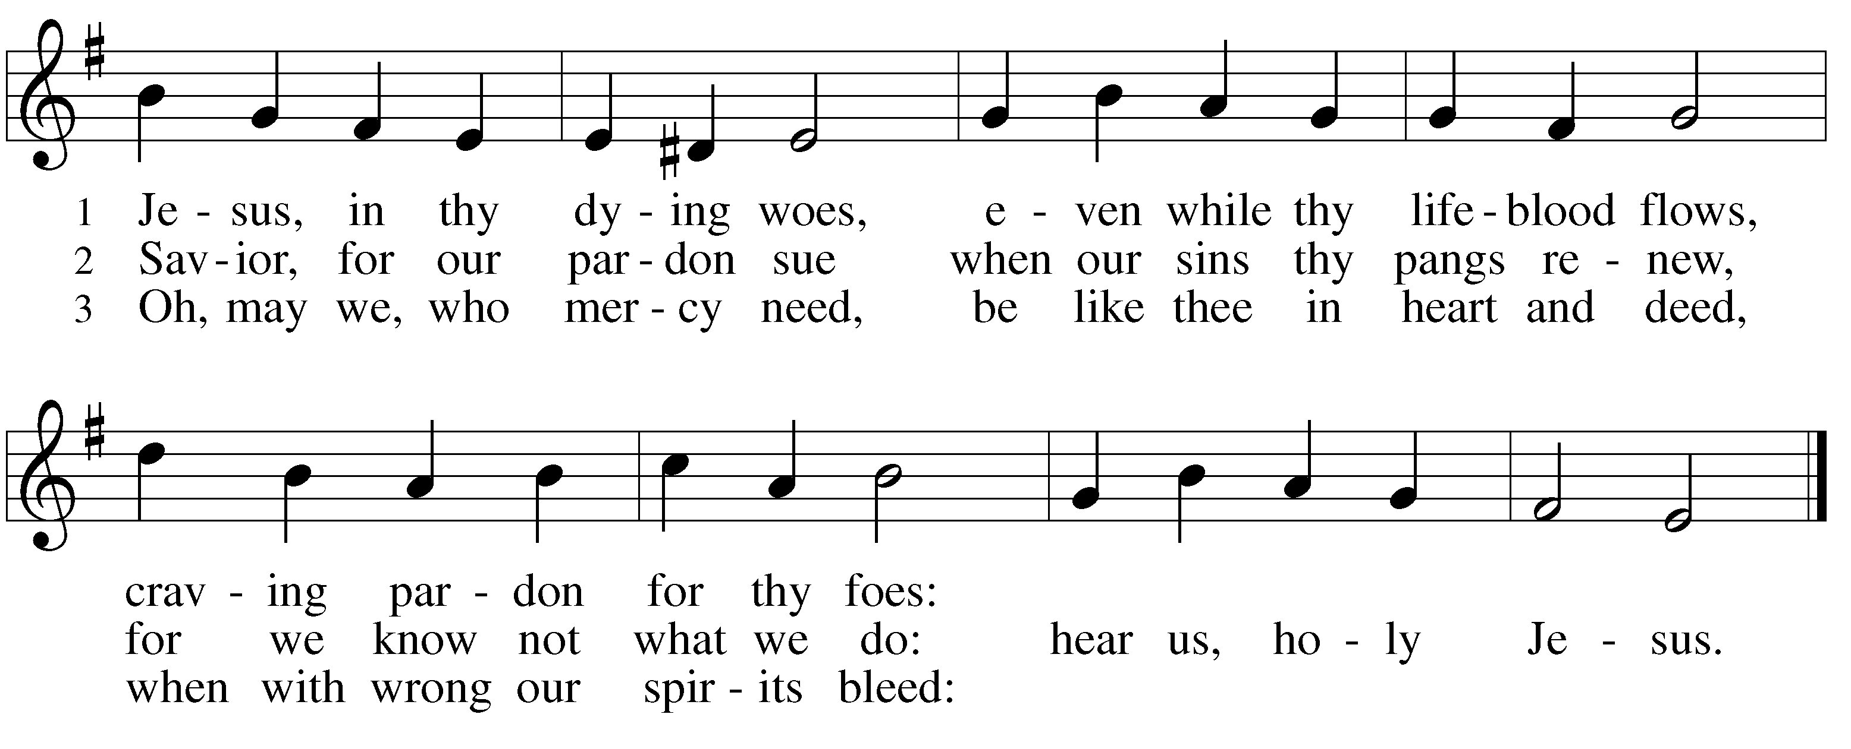
C: to whom your crucified Son prayed for the forgiveness of those who did not know what they were doing, grant that we too may be included in that prayer. Whether we sin out of ignorance or intention, be merciful to us and grant us your acceptance and peace, in the name of Jesus Christ, our suffering Savior. Amen.

The First Candle is Extinguished
The Second Word:

“Truly I tell you, "Today you will be with me in paradise.”
Luke 23:43

REFLECTION
Silence

PRAYER
L: O Lord Jesus Christ,
C: in your agony you showed compassion to a man who recognized his sinfulness and your holiness. You have him the gift of eternal life. We thank you for that same indescribable gift to us. Help us to show such compassion to the lost so that they may to dwell in paradise with you. In your holy name we pray. Amen.
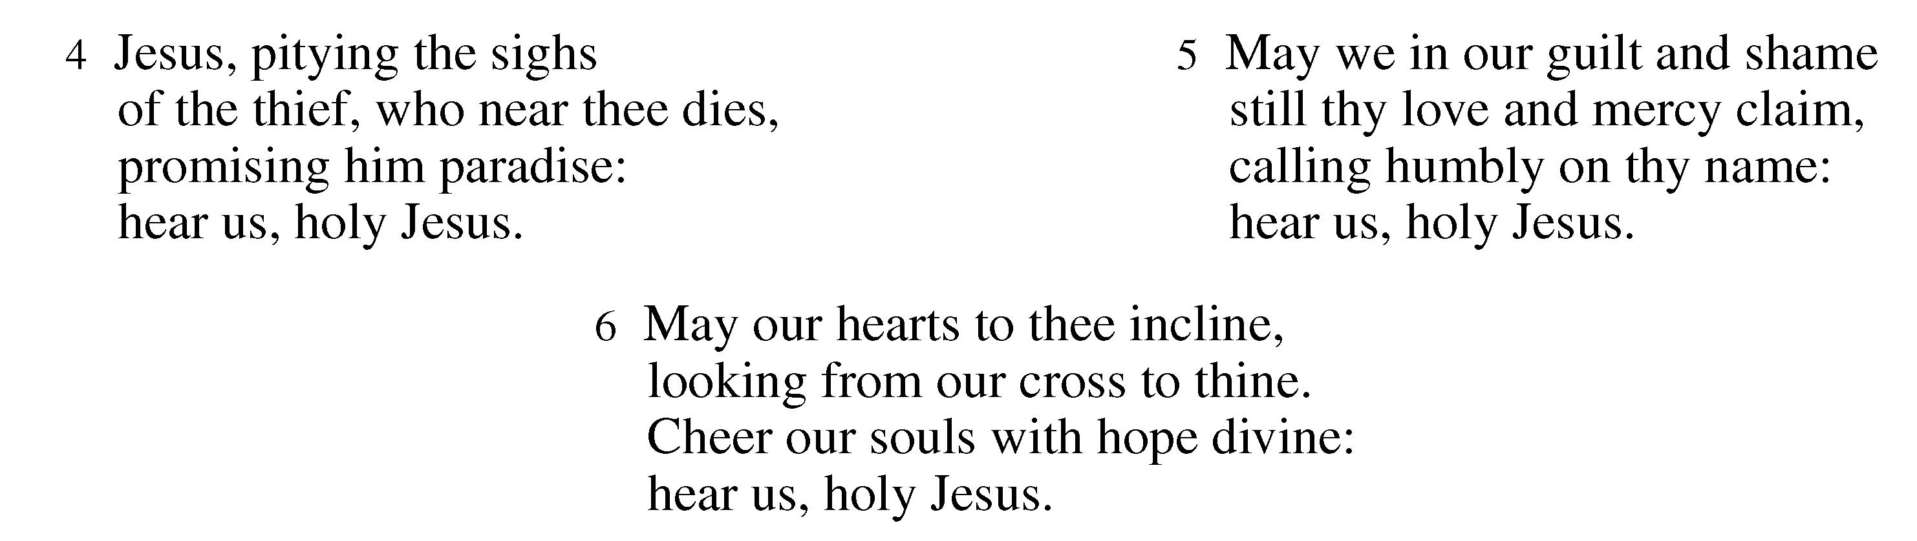

The Second Candle is Extinguished
The Third Word:

“Woman, here is your son,” . . . “Here is your mother.”
John 19:26-27

REFLECTION
Silence

PRAYER
L: Let us pray. O blessed Savior,
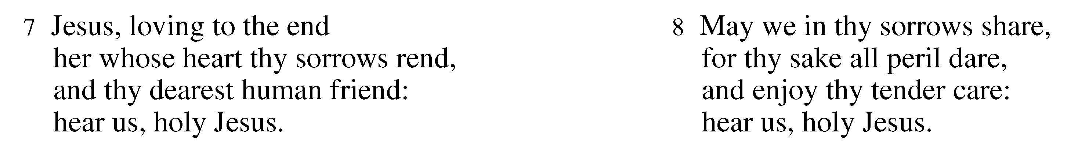
C: who in your hours of greatest suffering expression compassion for your mother and made arrangements for her care, grant that we who seek to follow your example may show our concern for the needs of others, reaching out to provide for those who suffer in our human family. Hear this prayer for mercy's sake. Amen.
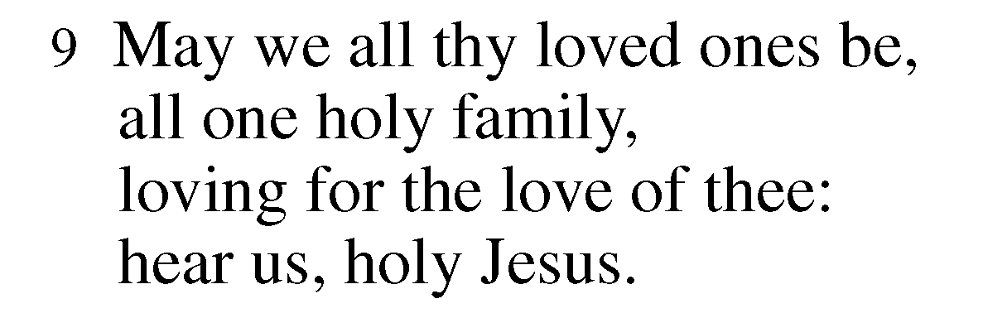

The Third Candle is Extinguished
The Fourth Word

“My God, my God, why have you forsaken me?”

Matthew 27:46

REFLECTION

Silence

PRAYER
L: Almighty God,
C: who forsook your Son upon the Cross showing the world your judgment upon human sin and guilt, grant us, upon hearing his cry, the grace to know and believe that we will never be forsaken, that he is present with us even to the end of the age. For the sake of Jesus Christ who bore our sins on the cross. Amen.
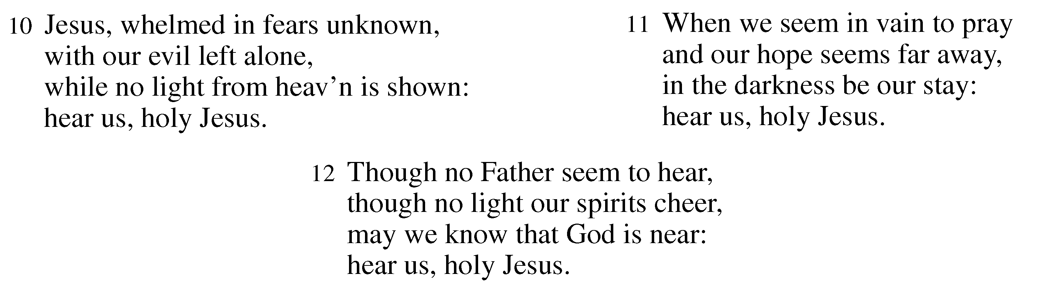

The Fourth Candle is Extinguished
THE FIFTH WORD

"I am thirsty."
John 19:28

REFLECTION
Silence

PRAYER
L: O blessed Savior,
C: whose lips were dry and whose throat was parched, grant us the water of life that we who thirst after righteousness may find it quenched by your love and mercy, leading us to bring this same relief to others. Amen.
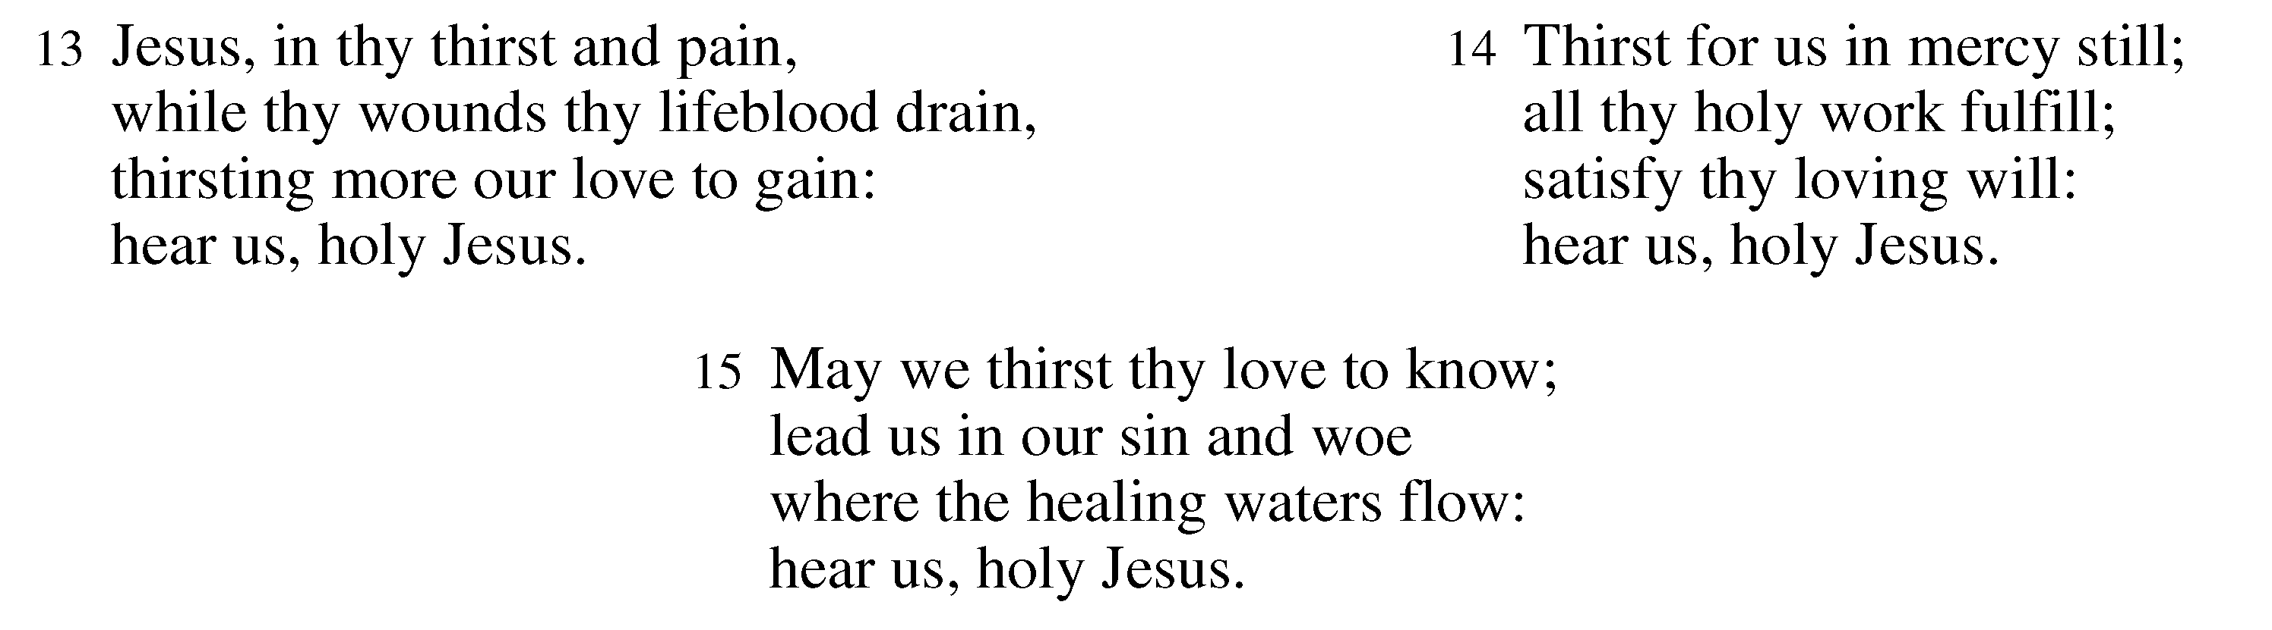

The Fifth Candle is Extinguished
The Sixth Word

"It is finished."
John 19:30

REFLECTION
Silence

PRAYER
L: O Lord Jesus Christ,
C: who finished the work that you were sent to do, enable us by your Holy Spirit to be faithful to our call. Grant us strength bear our crosses and endure our sufferings, even unto death. Enable us to live and love so faithfully that we also become good news to the world, joining your witness, O Jesus, in whose name we pray. Amen.

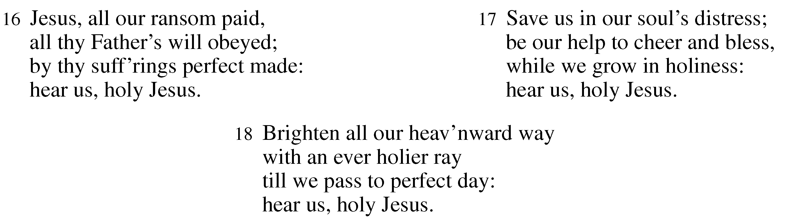

The Sixth Candle is Extinguished

The Seventh Word

"Father, into your hands I commit my spirit."
Luke 23:46

REFLECTION
Silence

PRAYER
L: Heavenly Father,
C: into whose hands your Son Jesus Christ commended his spirit, grant that we too, following his example, may in all of life and at the moment of our death entrust our lives into your faithful hands of love. In the name of Jesus who gave his life for us all. Amen

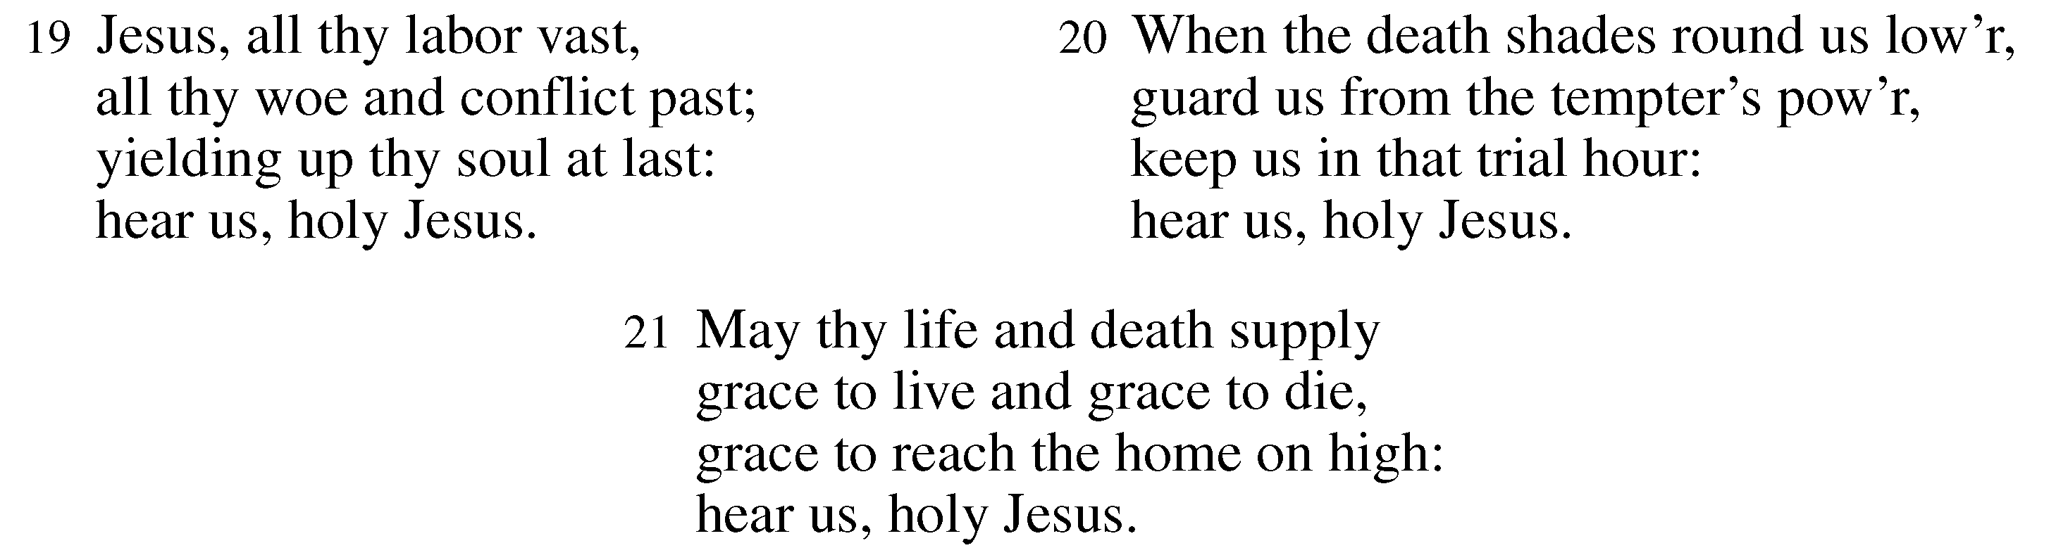

The Seventh Candle is Extinguished

After a moment of meditation, the congregation is asked
to leave in silence. If you have an offering, it may be left in
the plate provided at the doors.

SERVING TONIGHT

Presider: Pastor Cindy Beck
Reader 1st Word: Ann Kyser
Reader 2nd Word: Scott Sherman
Reader 3rd Word: Barbara Feduska
Reader 4th Word: John Eiler
Reader 5th Word: Ann Kyser
Reader 6th Word: Bill Bonnet
Reader 7th Word: Lorena Reinhardt
Worship Musician: Steve Rubardt
Tech Chaplain: Marcos Rendon

Please join us as we celebrate
Christ’s victory over death
this Easter Sunday,
April 5th at 10:00 am

