Trinity Episcopal Church
In Sonoma for over 170 years
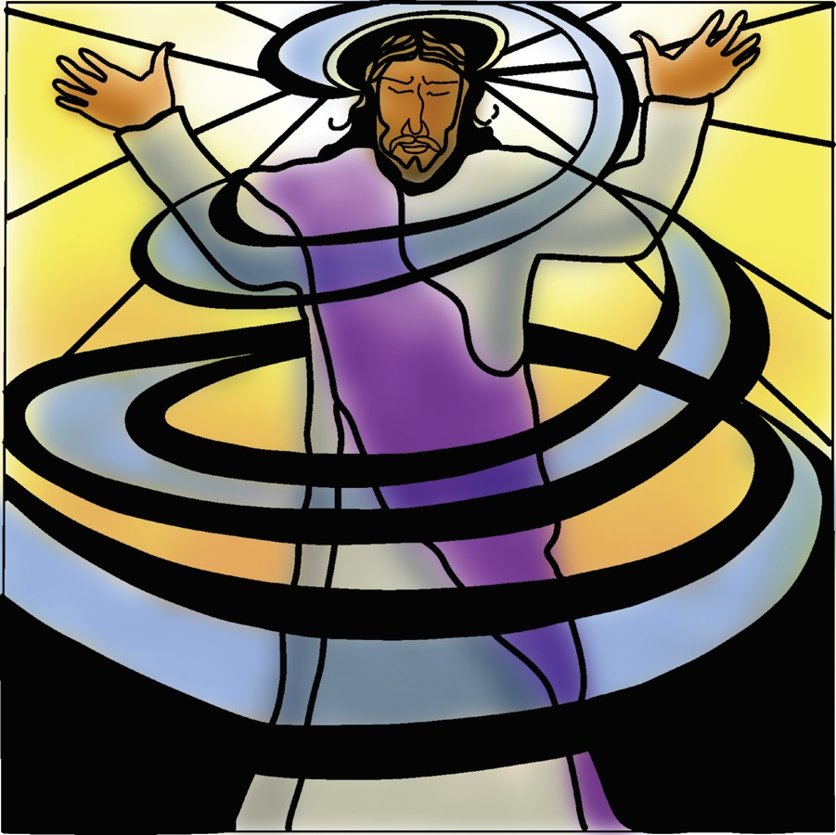
Ascension Sunday
Year A
Holy Eucharist II
May 17, 2026
10:00 AM In person and Online

May Announcements
Fellowship Coffee Hour Sign up - We encourage members to sign up to make coffee. Pastor Cindy is happy to demonstrate how easy this is. Please help us provide this hospitality for guests and members.
Movie Night at Trinity will continue on Wednesday June 17th. Join us for “Inside Out” at 6PM in Buttrum Hall. Stay for the snacks and post film discussion.
The May, June, July Forward Day by Day , a booklet of daily inspirational meditations is now available in the Church and the Office.
Lectio Divina Bible Study is on Wednesday, at 11AM in the library. Lectio Divina, Latin for "divine reading," is a contemplative practice of scriptural reading, meditation, and prayer intended to promote communion with God. Unlike traditional Bible study that focuses on intellectual information, Lectio Divina emphasizes spiritual formation and personal intimacy with God.
The Congregational Vitality Assessment has closed (April 22nd). Pastor Cindy will present the results at the Congregational meeting.
Save the date!: Congregational Retreat on May 16, 2026 from 9:00 AM to 12:30!
Trinity Episcopal donated 8 full bags to A simple Gesture this month! It was picked up on Saturday May 2nd. Your contributions are appreciated. The next pick up date will be on July 11th. Check expiration dates on your items and please no glass containers!!
St. Stephen's Episcopal, Sebastopol invites us to participate in a Gay Pride March on Saturday, June 6, 2026.
They are registered as part of a contingent called Episcopal Churches of Sonoma County. Those who’d like to walk in the Parade need to be in place at 10:30 a.m. at the intersection of 4th Street and Brookwood in Santa Rosa; look for the Episcopal Church banner. All the Episcopal parishes together will have a booth at the festival, with the opportunity to engage with festival goers and share that all are welcome in the Episcopal Church.
The festival will be in Courthouse Square in downtown Santa Rosa from 12:00 pm to 5:00 pm, welcoming everyone and supporting the LGBTQIA+ community.
Attending this joyful and peaceful parade is one way to let others know that they are welcome in the congregations of the local Episcopal Church. For more information, contact Deacon Kate at at deacon@ststephenssebastopol.org
Prelude Steve Rubardt
Please stand for the Entrance Hymn.
At the sound of the bell, please stand as you are able. The People respond when bold text appears.
The Word of God
Entrance Hymn How Bright Appears the Morning Star H 497
Opening Acclamation BCP 319
Celebrant | Alleluia. Christ is risen.
People | The Lord is risen indeed. Alleluia.
Collect for Purity
All Almighty God, to you all hearts are open, all desires known, and from you no secrets are hid: Cleanse the thoughts of our hearts by the inspiration of your Holy Spirit, that we may perfectly love you, and worthily magnify your holy Name; through Christ our Lord. Amen.
Song of Praise Glory to God Hymn S-280 is sung, all standing
Glory to God in the highest,
and peace to his people on earth.
Lord God, heavenly King,
almighty God and Father,
we worship you, we give you thanks,
we praise you for your glory.
Lord Jesus Christ, only Son of the Father,
Lord God, Lamb of God,
you take away the sin of the world:
have mercy on us;
you are seated at the right hand of the Father:
receive our prayer.
For you alone are the Holy One,
you alone are the Lord,
you alone are the Most High,
Jesus Christ,
with the Holy Spirit,
in the glory of God the Father. Amen.
The Collect of the Day BCP 357
Celebrant | The Lord be with you.
People | And also with you.
Celebrant | Let us pray.
Almighty God, whose blessed Son our Savior Jesus Christ ascended far above all heavens that he might fill all things: Mercifully give us faith to perceive that, according to his promise, he abides with his Church on earth, even to the end of the ages; through Jesus Christ our Lord, who lives and reigns with you and the Holy Spirit, one God, in glory everlasting. All Amen.
The Lessons
First Reading: Acts 1:1-11
Reader A Reading from the Acts of the Apostles.
¹In the first book, Theophilus, I wrote about all that Jesus did and taught from the beginning ²until the day when he was taken up to heaven, after giving instructions through the Holy Spirit to the apostles whom he had chosen. ³After his suffering he presented himself alive to them by many convincing proofs, appearing to them during forty days and speaking about the kingdom of God. ⁴While staying with them, he ordered them not to leave Jerusalem, but to wait there for the promise of the Father. “This,” he said, “is what you have heard from me; ⁵for John baptized with water, but you will be baptized with the Holy Spirit not many days from now.”
⁶So when they had come together, they asked him, “Lord, is this the time when you will restore the kingdom to Israel?” ⁷He replied, “It is not for you to know the times or periods that the Father has set by his own authority. ⁸But you will receive power when the Holy Spirit has come upon you; and you will be my witnesses in Jerusalem, in all Judea and Samaria, and to the ends of the earth.” ⁹When he had said this, as they were watching, he was lifted up, and a cloud took him out of their sight. ¹⁰While he was going and they were gazing up toward heaven, suddenly two men in white robes stood by them. ¹¹They said, “Men of Galilee, why do you stand looking up toward heaven? This Jesus, who has been taken up from you into heaven, will come in the same way as you saw him go into heaven.”
Reader | The Word of the Lord.
People | Thanks be to God.
The Psalm: Psalm 47
Reader Our response to the reading is Psalm 47, which we will read responsively by half verse.
¹Clap your hands, all you peoples; *
shout to God with a cry of joy.
²For the Lord Most High is to be feared; *
he is the great King over all the earth.
³He subdues the peoples under us, *
and the nations under our feet.
⁴He chooses our inheritance for us, *
the pride of Jacob whom he loves.
⁵God has gone up with a shout, *
the Lord with the sound of the ram’s-horn.
⁶Sing praises to God, sing praises; *
sing praises to our King, sing praises.
⁷For God is King of all the earth; *
sing praises with all your skill.
⁸God reigns over the nations; *
God sits upon his holy throne.
⁹The nobles of the peoples have gathered together *
with the people of the God of Abraham.
¹⁰The rulers of the earth belong to God, *
and he is highly exalted.

Second Reading: Ephesians 1:15-23
Reader A Reading from Paul's letter to the Church in Ephesus.
¹⁵I have heard of your faith in the Lord Jesus and your love toward all the saints, and for this reason ¹⁶I do not cease to give thanks for you as I remember you in my prayers. ¹⁷I pray that the God of our Lord Jesus Christ, the Father of glory, may give you a spirit of wisdom and revelation as you come to know him, ¹⁸so that, with the eyes of your heart enlightened, you may know what is the hope to which he has called you, what are the riches of his glorious inheritance among the saints, ¹⁹and what is the immeasurable greatness of his power for us who believe, according to the working of his great power. ²⁰God put this power to work in Christ when he raised him from the dead and seated him at his right hand in the heavenly places, ²¹far above all rule and authority and power and dominion, and above every name that is named, not only in this age but also in the age to come. ²²And he has put all things under his feet and has made him the head over all things for the church, ²³which is his body, the fullness of him who fills all in all.
Reader | The Word of the Lord.
People | Thanks be to God.


Sequence Hymn O Spirit of Life H 505 v 1 & 2
The Holy Gospel: Luke 24:44-53
Celebrant | The Holy Gospel of our Lord Jesus Christ according to Luke.
People | Glory to you, Lord Christ.
⁴⁴[Jesus said to his disciples,] “These are my words that I spoke to you while I was still with you—that everything written about me in the law of Moses, the prophets, and the psalms must be fulfilled.”⁴⁵Then he opened their minds to understand the scriptures, ⁴⁶and he said to them, “Thus it is written, that the Messiah is to suffer and to rise from the dead on the third day, ⁴⁷and that repentance and forgiveness of sins is to be proclaimed in his name to all nations, beginning from Jerusalem. ⁴⁸You are witnesses of these things. ⁴⁹And see, I am sending upon you what my Father promised; so stay here in the city until you have been clothed with power from on high.”
⁵⁰Then he led them out as far as Bethany, and, lifting up his hands, he blessed them. ⁵¹While he was blessing them, he withdrew from them and was carried up into heaven. ⁵²And they worshiped him, and returned to Jerusalem with great joy; ⁵³and they were continually in the temple blessing God.
Celebrant | The Gospel of the Lord.
People | Praise to you, Lord Christ.
Sequence Hymn O Spirit of Life H 505 v 3 & 4
Sermon Pastor Cindy Beck
The Nicene Creed (BCP p. 358)
The Prayers of the People
Celebrant: Come, let us pray with thanksgiving to him who ascended with great triumph to God’s heavenly kingdom, responding to each petition by saying, “Hear us, Ascended Lord.”
Intercessor Open our minds to understand the truth of holy scripture, fashioning our lives to proclaim its saving message, and bearing witness to the power of forgiveness and mercy; for this we pray.
In the Diocesan Cycle of Prayer, we pray for Holy Trinity in Ukiah.
In the Anglican Cycle of Prayer, we pray for The Diocese of Western New York.
For this we pray;
Hear us, ascended Lord.
Turn our hearts toward your will, that we may choose new life, receive the grace of your forgiveness, and bear witness to your loving and sacrificial hope.
Silence
For this we pray;
Hear us, ascended Lord.
In thanksgiving for the faith of the apostles, whose devotion to Jesus inspires our holy and life-giving commitment to proclaim his message today, +________.
Invite the congregation to add their thanksgivings, followed by silence
For this we pray;
Hear us, ascended Lord.
Move the leaders of Church and government to guide us into a simplicity of living, discovering our worth through virtuous living, and leaving behind the false promises of the world’s wealth;.
Silence
For this we pray;
Hear us, ascended Lord.
Send us into places of poverty and despair, that we may feed the hungry, comfort those who are ill, be present to the lonely, offer hope to the downtrodden, and reveal the healing power of the Risen and Ascended Christ,+___________________.
Invite the congregation to add their petitions, followed by silence
For this we pray;
Hear us, ascended Lord.
Give us faith to perceive that Christ dwells with his Church on earth and prepares for us a heavenly mansion, especially remembering today ____________ and all who have died,+___________________.
Invite the congregation to add their petitions, followed by silence
For this we pray;
Hear us, ascended Lord.
Celebrant With the freedom of an enlightened heart, we join in the inheritance of the saints as we continue our prayers and thanksgivings.
Amen.
The Peace
Celebrant The peace of the Lord be always with you.
People And also with you.
Announcements
Birthdays, Anniversaries, Travelers (prayers found at back of bulletin)

The Holy Communion
The Offertory At the Offering, you’ll find a Pledge card in the Pew Rack for those who’d like to designate their financial donations to Trinity’s Pledging Income. For others, or a one-time gift, envelopes are in the pew racks as well as on the Narthex table or text TRINITYSONOMA" to 73256. Thank you!
Offertory Music
Steve Rubardt and Choir Life Every Voice and Sing LEVAS 1
Doxology
The people stand while the offerings are presented and placed on the Altar.
Presider: Gracious God, as an offering of our thanksgiving and gratitude, we return to you a portion of what you have gifted us.
The Great Thanksgiving
Eucharistic Prayer B BCP 367
Celebrant | The Lord be with you.
People | And also with you.
Celebrant | Lift up your hearts.
People | We lift them to the Lord.
Celebrant | Let us give thanks to the Lord our God.
People | It is right to give him thanks and praise.
Proper Preface (BCP p. 367)
It is right, and a good and joyful thing, always and everywhere to give thanks to you, Father Almighty, Creator of heaven and earth.
But chiefly are we bound to praise you for the glorious resurrection of your Son Jesus Christ our Lord; for he is the true Paschal Lamb, who was sacrificed for us, and has taken away the sin of the world. By his death he has destroyed death, and by his rising to life again he has won for us everlasting life.
Therefore we praise you, joining our voices with Angels and Archangels and with all the company of heaven, who for ever sing this hymn to proclaim the glory of your Name:
Sanctus Holy Holy, Holy (Proulx) Hymnal S-125
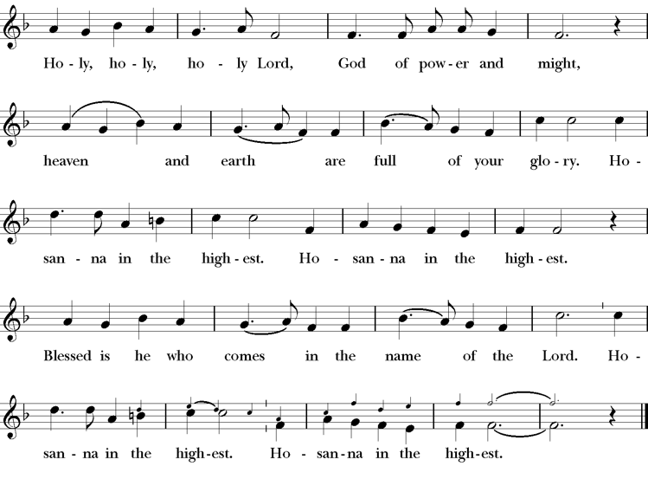
Presider Holy and gracious Father: In your infinite love you made us for yourself; and, when we had fallen into sin and become subject to evil and death, you, in your mercy, sent Jesus Christ, your only and eternal Son, to share our human nature, to live and die as one of us, to reconcile us to you, the God and Father of all.
He stretched out his arms upon the cross, and offered himself, in obedience to your will, a perfect sacrifice for the whole world.
On the night he was handed over to suffering and death, our Lord Jesus Christ took bread; and when he had given thanks to you, he broke it, and gave it to his disciples, and said, “Take, eat: This is my Body, which is given for you. Do this for the remembrance of me”
After supper he took the cup of wine; and when he had given thanks, he gave it to them, saying, “Drink this, all of you: this is my blood of the new covenant which is shed for you and for many for the forgiveness of sins. Whenever you drink it, do this for the remembrance of me.”
Presider Therefore we proclaim the mystery of faith:.
People Christ has died; Christ is risen; Christ will come again.
Presider We celebrate the memorial of our redemption, O Father, in this sacrifice of praise and thanksgiving. Recalling his death, resurrection, and ascension, we offer you these gifts.
Sanctify them by your Holy Spirit to be for your people the Body and Blood of your Son, the holy food and drink of new and unending life in him. Sanctify us also that we may faithfully receive this holy Sacrament, and serve you in unity, constancy, and peace; and at last day bring us with all your saints into the joy of your eternal kingdom.
All this we ask through your Son Jesus Christ. By him, and with him, and in him, in the unity of the Holy Spirit all honor and glory is yours, Almighty Father, now and for ever.
Amen.

The Lord’s Prayer
Presider As our Savior has taught us, we are bold to pray.
People Our Father, who art in heaven, hallowed be thy name. Thy Kingdom come, thy will be done, on earth as it is in heaven. Give us this day our daily bread. And forgive us our trespasses, as we forgive those who trespass against us. And lead us not into temptation, but deliver us from evil. For thine is the kingdom, the power and the glory, for ever and ever. Amen.
The Breaking of the Bread
The Presider breaks the consecrated bread in view of the assembly.
Presider The Gifts of God for the people of God.
People Therefore let us keep the feast. Alleluia
Invitation to Communion
Presider Come to this table you who have been here often and you who have not been here in a long time. Come, you who have tried to follow Jesus and you who have failed. You who are full of faith and full of doubt. Come, it is Christ himself who invites you to meet him here.
Sharing the Sacred Meal
This is Christ’s table and all are welcome and all are fed.
Communion Music Baptized in Water LEVAS 121
Post-Communion Prayer BCP 365
The Blessing
The Recessional Hymn Alleluia! Sing to Jesus H 461
The Dismissal*
Celebrant | Let us go forth in the name of Christ.
People | Thanks be to God.
Postlude Steve Rubardt Please remain seated



SERVING TODAY
Celebrant & Preacher: Pastor Cindy Beck
Acolyte: Susie Hand
Lector: Bill Doyle , Lorena Reinhardt
Intercessor: Barbara Feduska
Worship Musician: Steve Rubardt
Choir Leader: Steve Rubardt
Choir: Liz Carpenter, Heather Dahlberg, Scott Sherman,
Patsy Gralow, Laurell Meredith, Mary Omodt, Barbara Feduska, Tara Anderson
Sunday School - Child Care: Wendy Aguilar Appt Only
Ushers: Alfred Escoffier
Tech Chaplain: Marcos Rendon
Altar Guild: Susie Hand
Hospitality :
Altar Flowers are given to the glory of God by Altar Guild.
*Why no ‘Alleluias” printed in the bulletin? There are two different rubrics (or rules) that govern the use of Alleluia in worship, set by the Canons. One set of rubrics govern the use of Alleluia in music and in all of the liturgy except for the Dismissal. This rule says that we use Alleluia all the time except during the season of Lent. The other set of rubrics covers just the Dismissal and it says that we only use Alleluia in the Dismissal during the period from Easter Sunday through Pentecost, but not at any other time.

Prayers requested for these on Trinity’s long-term prayer list: Armando P, Georgia Bostedt, Muff Davey, John Eiler, Gerrilee Fisher, Claire Ginesi, Mary Griffin, David & Christine Hilt, Marie Lambert, Mark Mezzetta, Kelcey Omodt, Grizelda Ponce, Barry Reap, Blake W, Robert R, Melissa White, Ann Loveland Sherman, James Thomas, Rose Burns, Jennifer Gralow, Patsy Gralow, Steve Antenen, Sandra Leland, Karl, Michael Hardy, Michael Bean Land, Polly Moore, Sinat Liv, Will Maushardt, Sophia Piconi, Mike Smith.
Prayers for the Repose of soul: Tim Dowd , Susan Bassett, Joan Biersch, Linda Dowd, Christina Van Krugel, Mere Nagasau, Mary Goshert, Peggy Bell, Carolyn Caldwell, Van Z, Dolores Mae Seaberg Cole.
Contact Pastoral Care Chair, Lorena lorena.m.reinhardt@gmail.com to make any additions or to remove names from our Long-Term Prayer list.
Welcome to Trinity Episcopal, Sonoma. Whether you are passing through or looking for a church home, we are blessed by your presence and we invite you to worship with us fully – singing, praying and receiving communion- with your voice and heart. Everyone is welcome at Jesus’ Table, and everyone’s voice is needed to tell the Good News of God’s love in Christ. If you would like to learn more about The Episcopal Church, or how you can become a member of Trinity Church, please send us an email trinityepiscopalsonoma@comcast.net. We look forward to meeting you after the service where coffee and treats are served.
Notes on the Service Bulletin This service bulletin is a guide to the service. We use a variety of printed materials for the prayers, the scriptural readings and the hymns. The Readings for the week, including the Collect and Readings are found in this Bulletin. The service follows the liturgies that are found in the Book of Common Prayer (BCP). The BCP is the blue book found in the pew in front of you. The hymns come primarily from The 1982 Hymnal, also in the pew – the red book. Lift Every Voice and Sing (LEVAS) is another hymnal located in the pew rack. VF stands for Voices Found, another authorized hymnal. Sound Mate Assisted Hearing devices available at the back of the church on the Narthex Table.
For Visitors and Newcomers | Welcome! We are glad you have joined us today. If you are interested in a visit or call from the Priest-in-Charge, please sign our guest book on the Narthex* table to let her know you are visiting. Include your phone or email address. Narthex = wonderful old Latin word Episcopalians use for the entrance hall, traditionally at the western end of our churches.
Nursery Care | Children | Available during the 10:00 worship service by request. The nursery is located through the breezeway to the Education wing of the campus. Please ask an usher to show the way.
Sunday School available by appointment, Please contact Trinity Office at least one week in advance.
Coffee Hour Fellowship | Buttrum Hall or Courtyard, weather depending | Join us following the 10:00 AM worship service.
To access Trinity’s Guest WIFI: Password Rosepettal441 (case sensitive). We are glad you are here, and we invite you to enter fully into worship this morning.
All are welcome to make a gift and offering in thanksgiving to God; for the many blessings we have received. To take advantage of our electronic giving options, please follow the QR code with your capable electronic device, or visit https://onrealm.org/trinitysonoma/-/form/give/default Help us to make this a place where God’s grace is freely shared by all.

About this Service: Year A
Calendar of the Church Year
The calendar (BCP, pp. 15-33) orders the liturgical year of the Episcopal Church by identifying two cycles of feasts and holy days-one dependent upon the movable date of Easter Day and the other dependent upon the fixed date of Christmas, Dec. 25. Easter Day is the first Sunday after the full moon that falls on or after Mar. 21. The sequence of all Sundays in the church year is based on the date of Easter. Tables and rules for finding the date of Easter Day, and other movable feasts and holy days are provided by the BCP, pp. 880-885. The date of Easter determines the beginning of the season of Lent on Ash Wednesday and the date of Pentecost on the fiftieth day of the Easter season. The Sundays of Advent are always the four Sundays before Christmas Day. The church year begins on the first Sunday of Advent. The calendar also identifies and provides directions concerning the precedence and observance of principal feasts, Sundays, holy days (including Feasts of our Lord, other major feasts, and fasts), Days of Special Devotion, and Days of Optional Observance. The calendar lists dates for celebration of major feasts and lesser feasts by month and date. Appropriate Sunday Letters and Golden Numbers are also provided. (see BCP, pp. 880-881). The calendar also lists the titles of the seasons, Sundays, and major holy days observed in the Episcopal Church throughout the church year, including Advent season, Christmas season, Epiphany season, Lenten season, Holy Week, Easter season, the season after Pentecost, holy days, and National Days.
About this Service: Eastertide
Eastertide in the Episcopal Church is the "Great Fifty Days" of celebration from Easter Day to Pentecost, marking the resurrection and ascension of Jesus. It is a period of joy featuring white/gold vestments, the burning of the Paschal Candle, and the return of the "Alleluia" in worship.
Eastertide ends on the Day of Pentecost, which celebrates when the Holy Spirit descended on the disciples in the form of tongues of fire. The word Pentecost means “fiftieth day” in Greek.

Trinity Liturgical Ministry ROTA Next two weeks
Date | Celebrant | Ushers | Acolyte | Lector (s) | Intercessor | Altar Guild
May 24 | Cindy Beck | Marcia Derby | Arminda Eiler | Lorena Reinhardt , John Eiler | Claire Ginesi | Marcia Derby , Mary Omodt
May 31 | Cindy Beck | John Addeo | Arminda Eiler | Bill Doyle , Gerrilee Fisher | Jane Hernandez | Liz Carpenter , Laurell Meredith

Schedule of Weekly Meetings and Services at Trinity Episcopal Sonoma
Day | Date | Time | Occasion | Location
Wednesday | May 20 | 11 AM | Bible Study | Library
Thursday | May 21 | 10:30 AM  5:30 PM | Mindfulness & Well Being  Alcoholics Anonymous | Library  Buttrum Hall
Saturday | May 23 | 8 AM | Centering Prayer | St. Luke’s Chapel
Saturday | May 23 | 2pm | Drawing Class | in Library
Sunday | May 24 | 10:15 AM | Holy Eucharist II | Sanctuary
Mon-Fri | Weekdays | 7AM-1PM | Sonoma Home Meals | Kitchen &Buttrum Hall
Mon-Fri | Weekdays | 9-2 | Sonoma Preschool Academy – School

Monthly Meetings at Trinity Episcopal Sonoma
Day | Date | Time | Meeting | Location | Contact
Tuesday | May 5 | 11 AM | Prayer Shawl Ministry | Library | Lorena Reinhardt lorena.m.reinhardt@gmail.com
Thursday | May 7 | 4:30 PM | Vestry | Library | Cindy Beck 916-955-9861

PRAYERS and BLESSINGS
For a Birthday
Watch over your child, O Lord as his/her days increase; bless and guide him/her wherever s/he may be. Strengthen them when s/he stands; comfort him/her when discouraged or sorrowful; raise him/her up if s/he fall; and in his/her heart may your peace which passes understanding abide all the days of his/her life; through Jesus Christ our Lord. Amen.
For an Anniversary
O God, you have so consecrated the covenant of marriage that it represents the spiritual unity between Christ and his Church: Send your blessing upon these your servants as they celebrate their anniversary, that they may continue to love, honor and cherish each other in faithfulness and patience, in wisdom and true godliness, that their home may be a haven of blessing and peace; through Jesus Christ our Lord, who lives and reigns with you and the Holy Spirit, one God, now and forever. Amen.
For Travelers
O God, our heavenly Father, whose glory fills the whole creation, and whose presence we find wherever we go; preserve those who travel; surround them with your loving care; protect them from every danger, and bring them in safety to their journey’s end; through Jesus Christ our Lord. Amen.
Sending our Eucharistic Visitors
Priest: In the name of this congregation, I send you forth bearing these holy gifts, the those to whom you go may share with us in the communion of Christ’s body and blood.
People: We who are many are one body, because we all share on bread, and one cup. Amen

