Trinity Episcopal Church
Cultivating God’s Loving Spirit in each of us
Proper 19
Year A
Holy Eucharist II
September 13, 2026
10:00 AM In person and Online
Welcome to Trinity Episcopal, Sonoma. Whether you are passing through or looking for a church home, we are blessed by your presence and we invite you to worship with us fully – singing, praying and receiving communion- with your voice and heart. Please sign our guestbook at the back of the church, including your email.
If you would like to learn more about The Episcopal Church, please send us an email trinityepiscopalsonoma@comcast.net. We look forward to meeting you after the service where coffee and treats are served.
Did you know that....
...that Trinity's Little Free Library is up? Thanks to Mary Omodt, John Addeo, and Alan Cobb.
...that our free Movie Night is this Thursday at 6pm? The movie is "Legally Blond."
...91 Popes are buried under St. Peter's Basilica in Rome?

All are welcome to make a gift and offering in thanksgiving to God; for the many blessings we have received. To take advantage of our electronic giving options, please follow the QR code with your capable electronic device, or visit https://onrealm.org/trinitysonoma/-/form/give/default
September Announcements
Fellowship Coffee Hour Sign up – Fellowship follows the service! We meet in the hall or courtyard. We’d love to visit with you.
Thank you to everyone who donated food for A Simple Gesture, your gift helps people have a meal! Our next pick up will be in November!
Movie Night at Trinity will continue on Wednesday Sept 16th. Join us for “Legally Blonde”, at 6PM in Buttram Hall. Stay for the snacks and post film discussion.
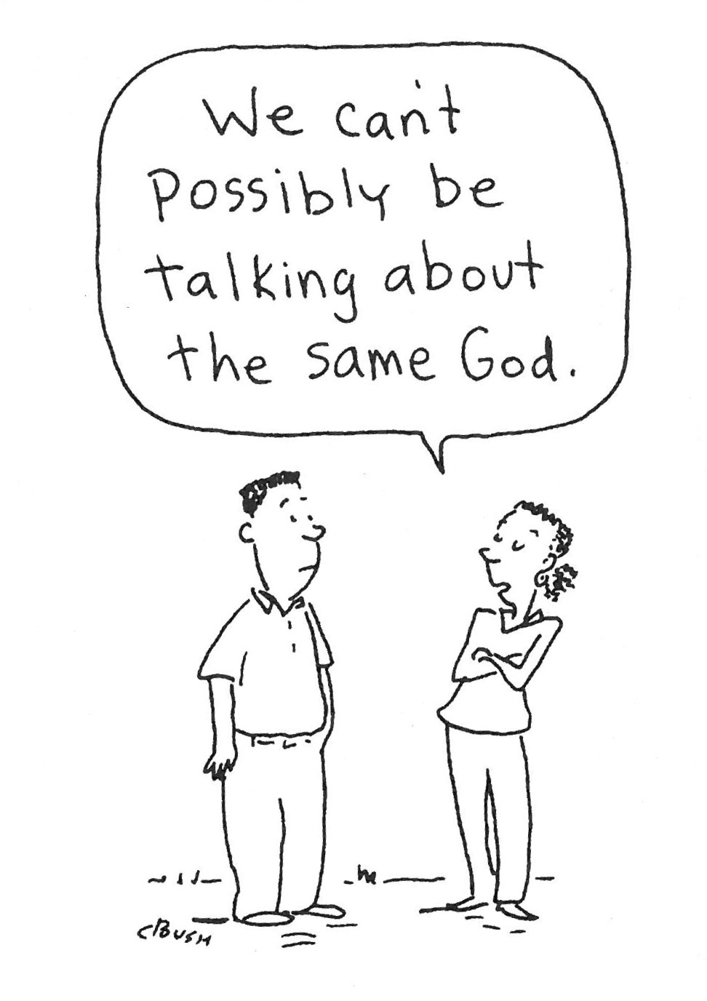
Prelude Steve Rubardt
Please stand for the Entrance Hymn.
At the sound of the bell, please stand as you are able. The People respond when bold text appears.
The Word of God
Entrance Hymn Joyful, Joyful we Adore thee H 376
Opening Acclamation BCP 319
Celebrant | Blessed be God: Father, Son, and Holy Spirit.
People | And blessed be his kingdom, now and for ever. Amen.
Collect for Purity
All Almighty God, to you all hearts are open, all desires known, and from you no secrets are hid: Cleanse the thoughts of our hearts by the inspiration of your Holy Spirit, that we may perfectly love you, and worthily magnify your holy Name; through Christ our Lord. Amen.
Song of Praise Glory to God Hymn S-280 is sung, all standing
Glory to God in the highest,
and peace to his people on earth.
Lord God, heavenly King,
almighty God and Father,
we worship you, we give you thanks,
we praise you for your glory.
Lord Jesus Christ, only Son of the Father,
Lord God, Lamb of God,
you take away the sin of the world:
have mercy on us;
you are seated at the right hand of the Father:
receive our prayer.
For you alone are the Holy One,
you alone are the Lord,
you alone are the Most High,
Jesus Christ,
with the Holy Spirit,
in the glory of God the Father. Amen.
The Collect of the Day BCP 357
Celebrant | The Lord be with you.
People | And also with you.
Celebrant | Let us pray.
O God, because without you we are not able to please you mercifully grant that your Holy Spirit may in all things direct and rule our hearts; through Jesus Christ our Lord, who lives and reigns with you and the Holy Spirit, one God, now and for ever.
All Amen.
The Lessons
First Reading: Genesis 50:15-21
Reader A Reading from the book of Genesis.
¹⁵Realizing that their father was dead, Joseph’s brothers said, “What if Joseph still bears a grudge against us and pays us back in full for all the wrong that we did to him?” ¹⁶So they approached Joseph, saying, “Your father gave this instruction before he died, ¹⁷‘Say to Joseph: I beg you, forgive the crime of your brothers and the wrong they did in harming you.’ Now therefore please forgive the crime of the servants of the God of your father.” Joseph wept when they spoke to him. ¹⁸Then his brothers also wept, fell down before him, and said, “We are here as your slaves.” ¹⁹But Joseph said to them, “Do not be afraid! Am I in the place of God? ²⁰Even though you intended to do harm to me, God intended it for good, in order to preserve a numerous people, as he is doing today. ²¹So have no fear; I myself will provide for you and your little ones.” In this way he reassured them, speaking kindly to them.

Reader | The Word of the Lord.
People | Thanks be to God.
The Psalm: Psalm 103:[1-7] 8-13
Reader We will read Psalm 103:[1-7] 8-13, responsively by half verse.
¹Bless the Lord, O my soul, *
and all that is within me, bless his holy Name.
²Bless the Lord, O my soul, *
and forget not all his benefits.
³He forgives all your sins *
and heals all your infirmities;
⁴He redeems your life from the grave *
and crowns you with mercy and loving-kindness;
⁵He satisfies you with good things, *
and your youth is renewed like an eagle’s.
⁶The Lord executes righteousness *
and judgment for all who are oppressed.
⁷He made his ways known to Moses *
and his works to the children of Israel.
⁸The Lord is full of compassion and mercy, *
slow to anger and of great kindness.
⁹He will not always accuse us, *
nor will he keep his anger for ever.
¹⁰He has not dealt with us according to our sins, *
nor rewarded us according to our wickedness.
¹¹For as the heavens are high above the earth, *
so is his mercy great upon those who fear him.
¹²As far as the east is from the west, *
so far has he removed our sins from us.
¹³As a father cares for his children, *
so does the Lord care for those who fear him.
Second Reading: Romans 14:1-12
Reader A Reading from Paul's letter to the Church in Rome.
¹Welcome those who are weak in faith, but not for the purpose of quarreling over opinions. ²Some believe in eating anything, while the weak eat only vegetables. ³Those who eat must not despise those who abstain, and those who abstain must not pass judgment on those who eat; for God has welcomed them. ⁴Who are you to pass judgment on servants of another? It is before their own lord that they stand or fall. And they will be upheld, for the Lord is able to make them stand.
⁵Some judge one day to be better than another, while others judge all days to be alike. Let all be fully convinced in their own minds. ⁶Those who observe the day, observe it in honor of the Lord. Also those who eat, eat in honor of the Lord, since they give thanks to God; while those who abstain, abstain in honor of the Lord and give thanks to God.
⁷We do not live to ourselves, and we do not die to ourselves. ⁸If we live, we live to the Lord, and if we die, we die to the Lord; so then, whether we live or whether we die, we are the Lord’s. ⁹For to this end Christ died and lived again, so that he might be Lord of both the dead and the living.
¹⁰Why do you pass judgment on your brother or sister? Or you, why do you despise your brother or sister? For we will all stand before the judgment seat of God. ¹¹For it is written,
“As I live, says the Lord, every knee shall bow to me,
and every tongue shall give praise to God.”
¹²So then, each of us will be accountable to God.

Reader | The Word of the Lord.
People | Thanks be to God.

Sequence Hymn Creator of the Stars of Night H 60 v 1-3
The Holy Gospel: Matthew 18:21-35
Celebrant | The Holy Gospel of our Lord Jesus Christ according to Matthew.
People | Glory to you, Lord Christ.
²¹Peter came and said to [Jesus], “Lord, if another member of the church sins against me, how often should I forgive? As many as seven times?” ²²Jesus said to him, “Not seven times, but, I tell you, seventy-seven times.
²³“For this reason the kingdom of heaven may be compared to a king who wished to settle accounts with his slaves. ²⁴When he began the reckoning, one who owed him ten thousand talents was brought to him; ²⁵and, as he could not pay, his lord ordered him to be sold, together with his wife and children and all his possessions, and payment to be made. ²⁶So the slave fell on his knees before him, saying, ‘Have patience with me, and I will pay you everything.’ ²⁷And out of pity for him, the lord of that slave released him and forgave him the debt. ²⁸But that same slave, as he went out, came upon one of his fellow slaves who owed him a hundred denarii; and seizing him by the throat, he said, ‘Pay what you owe.’ ²⁹Then his fellow slave fell down and pleaded with him, ‘Have patience with me, and I will pay you.’ ³⁰But he refused; then he went and threw him into prison until he would pay the debt. ³¹When his fellow slaves saw what had happened, they were greatly distressed, and they went and reported to their lord all that had taken place. ³²Then his lord summoned him and said to him, ‘You wicked slave! I forgave you all that debt because you pleaded with me. ³³Should you not have had mercy on your fellow slave, as I had mercy on you?’ ³⁴And in anger his lord handed him over to be tortured until he would pay his entire debt. ³⁵So my heavenly Father will also do to every one of you, if you do not forgive your brother or sister from your heart.”

Celebrant | The Gospel of the Lord.
People | Praise to you, Lord Christ.
Sequence Hymn Creator of the Stars of Night H 60 v 4-6
Sermon Pastor Cindy Beck
The Nicene Creed (BCP p. 358)
We believe in one God, the Father, the Almighty, maker of heaven and earth, of all that is, seen and unseen.
We believe in one Lord, Jesus Christ, the only Son of God, eternally begotten of the Father, God from God, Light from Light, true God from true God, begotten, not made, of one Being with the Father. Through him all things were made. For us and for our salvation he came down from heaven: by the Power of the Holy Spirit he became incarnate from the Virgin Mary, and was made man. For our sake he was crucified under Pontius Pilate; he suffered death and was buried. On the third day he rose again in accordance with the Scriptures; he ascended into heaven and is seated at the right hand of the Father. He will come again in glory to judge the living and the dead, and his kingdom will have no end.
We believe in the Holy Spirit, the Lord, the giver of life, who proceeds from the Father and the Son. With the Father and the Son he is worshipped and glorified. He has spoken through the Prophets. We believe in one holy catholic and apostolic Church. We acknowledge one baptism for the forgiveness of sins. We look for the resurrection of the dead, and the life of the world to come. Amen.

The Prayers of the People
Celebrant: Each of us is finally accountable to God. So let us pray, saying, “Lord, we are in need of your mercy; have patience with us.”
Intercessor: We acknowledge that we all sin against our siblings in Christ. Forgive us even as we forgive each other. Help us to be merciful to each other in the Church.
In the Diocesan Cycle of Prayer, we pray for Trinity Church in Sutter Creek.
In the Anglican Cycle of Prayer, we pray for The Anglican Church in Aotearoa, New Zealand and Polynesia.
Lord, we are in need of your mercy;
Have patience with us
We acknowledge that we desire to repay violence with violence. Open our hearts to forgive even those who commit evil acts towards us and those we love. Help us to live mercifully in our world.
Silence
Lord, we are in need of your mercy;
Have patience with us
We acknowledge we do not always appreciate the diversity of your creation. Teach us to live in peace with each other and with your creation. Help us to live mercifully with our world, +_________________.
Invite the congregation to add their thanksgivings, followed by silence
Lord, we are in need of your mercy;
Have patience with us
We acknowledge that we do not love our neighbors as you love us. Forgive us for placing ourselves as judge over others when judgment belongs to you alone. Help us to accept the great mercy you choose to show others.
Silence
Lord, we are in need of your mercy;
Have patience with us
We pray for those whose lives are broken by evil. Because of your mercy we believe that whatever befalls them, they belong to you; you care for the brokenhearted. Help us to share your love with all those who are hurting, +______________.
Invite the congregation to add their petitions, followed by silence
Lord, we are in need of your mercy;
Have patience with us
We remember those who died in violence. We remember those men and women of the armed services, innocent bystanders, first responders, and even those we have called enemies. The dead belong to you, O Lord. Even as we seek your mercy for ourselves, judge all those who have died with mercy, +___________________.
Invite the congregation to add their petitions, followed by silence
Lord, we are in need of your mercy;
Have patience with us
I invite any other prayers of intercession or thanksgiving, silently or aloud.
Lord, we are in need of your mercy;
Have patience with us
Celebrant Almighty and eternal God, ruler of all things in heaven and earth: Mercifully accept the prayers of your people, and strengthen us to do your will; through Jesus Christ our Lord.
Amen.
Confession of Sin BCP 359
Most merciful God, we confess that we have sinned against you in thought, word and deed, by what we have done, and by what we have left undone.
We have not loved you with our whole heart; we have not loved our neighbors as ourselves. We are truly sorry and we humbly repent.
For the sake of your Son Jesus Christ, have mercy on us and forgive us; that we may delight in your will, and walk in your ways, to the glory of your Name. Amen.
The Peace
Celebrant The peace of the Lord be always with you.
People And also with you.
Announcements
Birthdays, Anniversaries, Travelers (prayers found at back of bulletin)
The Holy Communion
The Offertory At the Offering, you’ll find a Pledge card in the Pew Rack for those who’d like to designate their financial donations to Trinity’s Pledging Income. For others, or a one-time gift, envelopes are in the pew racks as well as on the Narthex table or text TRINITYSONOMA" to 73256. Thank you!
Offertory Music
Steve Rubardt and Choir Go Down Moses LEVAS 228
Doxology
Praise God, from whom all blessings flow;
Praise Him, all creatures here below;
Praise Him above, ye heav'nly host;
Praise Father, Son, and Holy Ghost.
Amen.
The people stand while the offerings are presented and placed on the Altar.
Presider: Gracious God, as an offering of our thanksgiving and gratitude, we return to you a portion of what you have gifted us.
The Great Thanksgiving
Eucharistic Prayer B BCP 367
Celebrant | The Lord be with you.
People | And also with you.
Celebrant | Lift up your hearts.
People | We lift them to the Lord.
Celebrant | Let us give thanks to the Lord our God.
People | It is right to give him thanks and praise.
Proper Preface (BCP p. 367)
It is right, and a good and joyful thing, always and everywhere to give thanks to you, Father Almighty, Creator of heaven and earth.
For you are the source of light and life; you made us in your image, and called us to new life in Jesus Christ our Lord.
Therefore we praise you, joining our voices with Angels and Archangels and with all the company of heaven, who for ever sing this hymn to proclaim the glory of your Name:
Sanctus Holy Holy, Holy (Proulx) Hymnal S-125
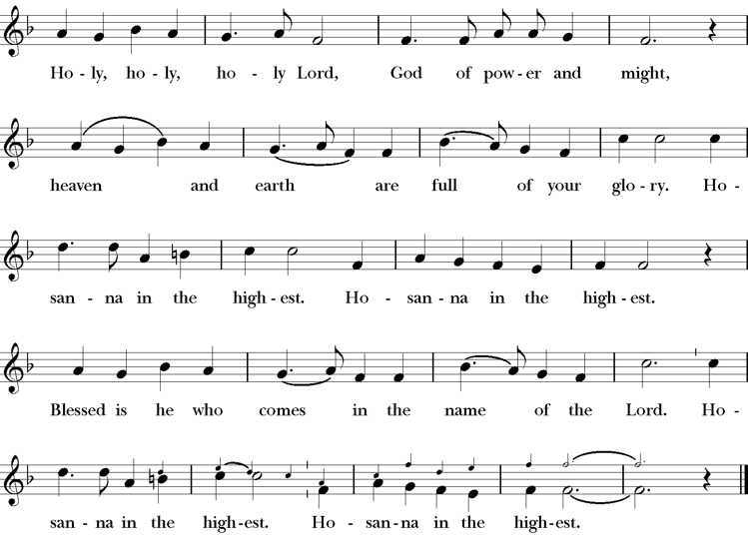
Presider Holy and gracious Father: In your infinite love you made us for yourself; and, when we had fallen into sin and become subject to evil and death, you, in your mercy, sent Jesus Christ, your only and eternal Son, to share our human nature, to live and die as one of us, to reconcile us to you, the God and Father of all.
He stretched out his arms upon the cross, and offered himself, in obedience to your will, a perfect sacrifice for the whole world.
On the night he was handed over to suffering and death, our Lord Jesus Christ took bread; and when he had given thanks to you, he broke it, and gave it to his disciples, and said, “Take, eat: This is my Body, which is given for you. Do this for the remembrance of me”
After supper he took the cup of wine; and when he had given thanks, he gave it to them, saying, “Drink this, all of you: this is my blood of the new covenant which is shed for you and for many for the forgiveness of sins. Whenever you drink it, do this for the remembrance of me.”
Presider Therefore we proclaim the mystery of faith:.
People Christ has died; Christ is risen; Christ will come again.
Presider We celebrate the memorial of our redemption, O Father, in this sacrifice of praise and thanksgiving. Recalling his death, resurrection, and ascension, we offer you these gifts.
Sanctify them by your Holy Spirit to be for your people the Body and Blood of your Son, the holy food and drink of new and unending life in him. Sanctify us also that we may faithfully receive this holy Sacrament, and serve you in unity, constancy, and peace; and at last day bring us with all your saints into the joy of your eternal kingdom.
All this we ask through your Son Jesus Christ. By him, and with him, and in him, in the unity of the Holy Spirit all honor and glory is yours, Almighty Father, now and for ever.
Amen.
The Lord’s Prayer
Presider As our Savior has taught us, we are bold to pray.
People Our Father, who art in heaven, hallowed be thy name. Thy Kingdom come, thy will be done, on earth as it is in heaven. Give us this day our daily bread. And forgive us our trespasses, as we forgive those who trespass against us. And lead us not into temptation, but deliver us from evil. For thine is the kingdom, the power and the glory, for ever and ever. Amen.

The Breaking of the Bread
The Presider breaks the consecrated bread in view of the assembly.
Presider The Gifts of God for the people of God.
People Therefore let us keep the feast. Alleluia

Invitation to Communion
Presider Come to this table you who have been here often and you who have not been here in a long time. Come, you who have tried to follow Jesus and you who have failed. You who are full of faith and full of doubt. Come, it is Christ himself who invites you to meet him here.
Sharing the Sacred Meal
This is Christ’s table and all are welcome and all are fed.
Communion Music We the Lord’s People H 51
Post-Communion Prayer BCP 365
The Blessing
The Recessional Hymn All Things Bright and Beautiful H 405
The Dismissal*
Celebrant | Let us go forth in the name of Christ.
People | Thanks be to God.
Postlude Steve Rubardt Please remain seated
SERVING TODAY
Celebrant & Preacher: Pastor Cindy Beck
Acolyte: Claire Ginesi
Lector: Lorena Reinhardt , Gerrilee Fischer
Intercessor: Alfred Escoffier
Worship Musician: Steve Rubardt
Choir Leader: Steve Rubardt
Choir: Liz Carpenter, Heather Dahlberg, Scott Sherman, Patsy Gralow, Laurell Meredith, Mary Omodt, Barbara Feduska, Tara Anderson, Carol Heffer, Don McMahon
Sunday School - Child Care: Wendy Aguilar Appt Only
Ushers: Marcia Derby
Tech Chaplain: Marcos Rendon
Altar Guild: Marcia Derby , Mary Omodt
Hospitality : Sally Zimmerman , Claire Ginesi , Scott Sherman
Flowers: In Honor of Giancarlo Cestarollo
Altar Flowers today are created by Marianne Uhl

Prayers requested for these on Trinity’s long-term prayer list: Armando P, Georgia Bostedt, John Eiler, Gerrilee Fisher, Claire Ginesi, Mary Griffin, David & Christine Hilt, Mark Mezzetta, Kelcey Omodt, Grizelda Ponce, Barry Reap, Blake W, Robert R, Melissa White, Ann Loveland Sherman, James Thomas, Rose Burns, Jennifer Gralow, Patsy Gralow, Steve Antenen, Sandra Leland, Karl, Michael Hardy, Michael Bean Land, Polly Moore, Sinat Liv, Will Maushardt, Sophia Piconi, Mike Smith, Jean Maffoli.
Prayers for the Repose of soul: Tim Dowd , Susan Bassett, Joan Biersch, Linda Dowd, Christina Van Krugel, Mere Nagasau, Mary Goshert, Peggy Bell, Carolyn Caldwell, Van Z, Dolores Mae Seaberg Cole, Muff Davey, Giancarlo Cestarollo.
Contact Pastoral Care Chair, Lorena lorena.m.reinhardt@gmail.com to make any additions or to remove names from our Long-Term Prayer list.
Notes on the Service Bulletin This service bulletin is a guide to the service. We use a variety of printed materials for the prayers, the scriptural readings and the hymns. The Readings for the week, including the Collect and Readings are found in this Bulletin. The service follows the liturgies that are found in the Book of Common Prayer (BCP). The BCP is the blue book found in the pew in front of you. The hymns come primarily from The 1982 Hymnal, also in the pew – the red book. Lift Every Voice and Sing (LEVAS) is another hymnal located in the pew rack. VF stands for Voices Found, another authorized hymnal. Sound Mate Assisted Hearing devices available at the back of the church on the Narthex Table.

Trinity Liturgical Ministry ROTA Next two weeks
Date | Celebrant | Ushers | Acolyte | Lector (s) | Intercessor | Altar Guild
9/20 | TBD | Alfred Escoffier | Susie Hand | Claire Ginesi, Lorena Reinhardt | Bill Doyle | Laurell Meredith , Liz Carpenter
9/27 | Cindy Beck | John Addeo | Arminda Eiler | Jane Hernandez , John Eiler | Barbara Feduska | Marcia Derby , Mary Omodt
Schedule of Weekly Meetings and Services at Trinity Episcopal Sonoma
Day | Date | Time | Occasion | Location
Wednesday | September 16 | 11 AM | Bible Study | Library
Thursday | September 17 | 10:30 AM  5:30 PM | Mindfulness & Well Being  Alcoholics Anonymous | Library  Buttrum Hall
Saturday | September 19 | 8 AM | Centering Prayer | St. Luke’s Chapel
Sunday | September 20 | 10:00 AM | Holy Eucharist II | Sanctuary
Mon-Fri | Weekdays | 7AM-1PM | Sonoma Home Meals | Kitchen &Buttrum Hall
Mon-Fri | Weekdays | 9-2 | Sonoma Preschool Academy – School

Monthly Meetings at Trinity Episcopal Sonoma
Day | Date | Time | Meeting | Location | Contact
Tuesday | September 1 | 11 AM | Prayer Shawl Ministry | Library | Lorena Reinhardt lorena.m.reinhardt@gmail.com
Thursday | TBD | TBD | Vestry | Library | Cindy Beck 916-955-9861



PRAYERS and BLESSINGS
For a Birthday
Watch over your child, O Lord as his/her days increase; bless and guide him/her wherever s/he may be. Strengthen them when s/he stands; comfort him/her when discouraged or sorrowful; raise him/her up if s/he fall; and in his/her heart may your peace which passes understanding abide all the days of his/her life; through Jesus Christ our Lord. Amen.
For an Anniversary
O God, you have so consecrated the covenant of marriage that it represents the spiritual unity between Christ and his Church: Send your blessing upon these your servants as they celebrate their anniversary, that they may continue to love, honor and cherish each other in faithfulness and patience, in wisdom and true godliness, that their home may be a haven of blessing and peace; through Jesus Christ our Lord, who lives and reigns with you and the Holy Spirit, one God, now and forever. Amen.
For Travelers
O God, our heavenly Father, whose glory fills the whole creation, and whose presence we find wherever we go; preserve those who travel; surround them with your loving care; protect them from every danger, and bring them in safety to their journey’s end; through Jesus Christ our Lord. Amen.
Sending our Eucharistic Visitors
Priest: In the name of this congregation, I send you forth bearing these holy gifts, the those to whom you go may share with us in the communion of Christ’s body and blood.
People: We who are many are one body, because we all share on bread, and one cup. Amen.
Trinity Episcopal Church
In Sonoma for over 170 years
275 East Spain Street
Sonoma, CA 95476
The Rt. Rev. Megan M. Traquair, Bishop
Diocese of Northern California
Pastor Cindy Beck, Interim
Steve Rubardt, Worship Music
Vestry
Bill Doyle, Senior Warden & Stewardship
Susie Hand
Heather Dahlberg
Sally Zimmerman
Lorena Reinhardt (Pastoral Care)
Luke Bohanan
Mandy Birkbeck
Ministries
Prayer Shawl, Lorena Reinhardt
Outreach, Jane Hernandez
Mindfulness & Well Being, Mary Omodt
Sunday School, Children, Wendy Aguilar

The Members of the Congregation are The Ministers of the Church

Administrative Office Hrs.
Monday Wednesday 9 A.M. – 2 PM; Thursday 10A.M.-2 P.M0
Sunday 9:30-11:30
Clergy Office Hours Wednesdays, Thursdays, by appointment

Emergency, sickness, please contact office: 707-938-4846

