

An Order for
the Celebration of
The Holy Eucharist
For the 3rd Sunday of Lent
March 8, 2026
Welcome! Beinvenido! Karibu!
Scattered in the world we gather together as God's people in worship. We bring the fragments of our lives to be healed and made whole in Christ as we gather in community.
Worship lies at the heart of the Christian life. It is in worship that we express our theology and define our identity. It is through encountering God within worship that we are formed and transformed as God’s people. One of the glories of the Episcopal/Anglican Church is its liturgical worship. Liturgy refers to the patterns, forms, words and actions through which public worship is conducted.
As we gather, we bring our diverse gifts: gifts of music, dance, prophecy, teaching, preaching, and friendship. We present these gifts in the form of our most precious offering to God, our very selves, that all that we do may be for God’s glory in the unity of Christ’s church.
See end of bulletin for information and announcements for Trinity Episcopal Sonoma.
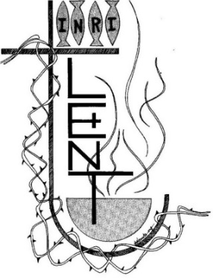
About the Season of Lent

Early Christians observed “a season of penitence and fasting” in preparation for the Paschal feast, or Pascha (Easter). The season now known as Lent, from an Old English word meaning “spring,” the time of lengthening days, has a long history. Lent was especially important for converts to the faith who were preparing for baptism, and for those guilty of notorious sins who were being restored to the Christian assembly. In the western church, the forty days of Lent extend from Ash Wednesday through Holy Saturday, omitting Sundays. The last three days of Lent are the sacred Triduum of Maundy Thursday, Good Friday, and Holy Saturday. Today, Lent has reacquired its significance as the final preparation of adult candidates for baptism. Joining with them, all Christians are invited “to the observance of a holy Lent, by self-examination and repentance; by prayer, fasting, and self-denial; and by reading and meditating on God’s holy Word.”

About the Holy Eucharist
“When God finds us, there is always a celebration. In the Eucharist, we gather to celebrate God finding us in Jesus Christ. If you’re feeling lost, when you come to receive Jesus in bread and wine, ask to be found. If you know what it is to have been found by God, when you come to receive Jesus in bread and wine, give thanks – thanks to the one who came looking for you, and found you.”
-Br. Geoffrey Tristram Society of Saint John the Evangelist
In the Episcopal Church the Holy Eucharist is the sacrament of Christ's body and blood, and the principal act of Christian worship. The term is from the Greek, "thanksgiving." Jesus instituted the Eucharist "on the night when he was betrayed." At the Last Supper he shared the Bread and cup of Wine at a sacred meal with his disciples. He identified the Bread with his body and the Wine with his blood of the new covenant. Jesus commanded his disciples to "do this" in remembrance of Jesus.
For Episcopalians, the Holy Eucharist becomes the very Real Presence of Christ, his Body and Blood, the ordinary made also extraordinary, sacred by Jesus' own words and by the Holy Spirit.
In the Episcopal Church, we seek to adapt ancient liturgy for today. If you grew up in a less formal church, worship may feel pretty traditional. If you grew up in a formal church, our worship may deconstruct that formality, and ask you to pray using more modern words, or sing new songs. We seek to balance tradition and culture in our worship. When we hold the tension well between the ancient and the modern, the Holy Eucharist comes alive.
Opening Hymn
We begin by praising God through song and prayer.
Just As I Am H 693
The Penitential Rite
Our worship begins with the Acclamation and Penitential Rite.
Presider Blessed be the God of our salvation.
People Who bears our burdens and forgives our sin.
Presider Jesus said, "The first commandment is this: Hear, O Israel: The Lord our God is the only Lord. Love the Lord your God with all your heart, with all your soul, with all your mind, and with all your strength. The second is this: Love your neighbor as yourself. There is no other commandment greater than these." -Mark 12:29-31

The Confession
As we enter in to worship we ask God’s forgiveness for things done and things left undone and things done on our behalf so that we may be reconciled to each other and to God.
Presider Let us confess our sins against God and our neighbor.
Silence is kept for a time.
Presider Most holy and merciful God: We confess to you and to one another, and to the whole communion of saints in heaven and on earth, that we have sinned by our own fault in thought, word, and deed; by what we have done, and by what we have left undone.
People We have not loved you with our whole heart, and mind, and strength. We have not loved our neighbors as ourselves. We have not forgiven others, as we have been forgiven.

Presider Our past unfaithfulness: the pride, hypocrisy, and impatience of our lives,
People We confess to you, O God.
Presider Our self-indulgence, and our exploitation of other people, our anger at our own frustration, and our envy of those more fortunate than ourselves,
People We confess to you, O God.
Presider For all false judgments, for uncharitable thoughts toward our neighbors, and for our prejudice and contempt toward those who differ from us,
People Accept our repentance, O God.
Presider For our waste and pollution of your creation, and our lack of concern for those who come after us,
People Accept our repentance, O God.
Presider Restore us, good Lord, and let your anger depart from us;
People Favorably hear us, for your mercy is great.

declaration of pardon & forgiveness
Presider The Eternal God forgives you and frees you from your sins, heals and strengthens you by the Holy Spirit, and raises you to new life in Christ Jesus our Lord. Amen

Song of Penance: Trisagion (Sung)
When the Trisagion is sung, it is repeated three times.
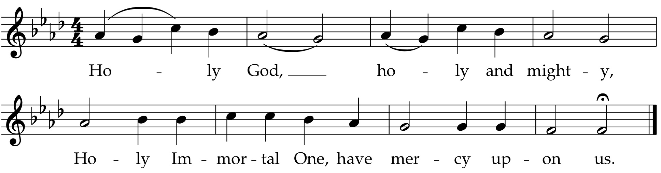
Collect of the Day
The collect is written to go along with both the season of the church year and the readings for the day. It summarizes the attributes of God as revealed in the scripture for the day.
Presider The Lord be with you.
People And also with you.
Presider Let us pray.
Lord Jesus, it was your will that your Father’s House would be a place
of prayer for all people; grant us the strength and wisdom to be a
people consumed with prayer and zeal for you, this day and
always.
Amen.
We hear the sacred stories
We hear the stories of the experience of God from our spiritual ancestors. Reading and commenting on scripture goes back to the earliest services of Christianity. Following the pattern of Jewish synagogue worship, readings follow a set pattern for what will be read when.
The First Reading Exodus 17:1-7
The people sit.
A Reading from the book of Exodus.
¹From the wilderness of Sin the whole congregation of the Israelites journeyed by stages, as the Lord commanded. They camped at Rephidim, but there was no water for the people to drink. ²The people quarreled with Moses, and said, “Give us water to drink.” Moses said to them, “Why do you quarrel with me? Why do you test the Lord?” ³But the people thirsted there for water; and the people complained against Moses and said, “Why did you bring us out of Egypt, to kill us and our children and livestock with thirst?” ⁴So Moses cried out to the Lord, “What shall I do with this people? They are almost ready to stone me.” ⁵The Lord said to Moses, “Go on ahead of the people, and take some of the elders of Israel with you; take in your hand the staff with which you struck the Nile, and go. ⁶I will be standing there in front of you on the rock at Horeb. Strike the rock, and water will come out of it, so that the people may drink.” Moses did so, in the sight of the elders of Israel. ⁷He called the place Massah and Meribah, because the Israelites quarreled and tested the Lord, saying, “Is the Lord among us or not?”
Reader Hear what the Holy Spirit is saying to God’s people.
People Thanks be to God.

The Psalm of the Day Psalm 95
The psalms are a part of the poetry of the Hebrew people. They express joy and sadness, loneliness and thanksgiving as part of the human longing to be united with God.
Reader We will read Psalm 95, responsively by half verse.
¹Come, let us sing to the Lord; *
let us shout for joy to the Rock of our salvation.
²Let us come before his presence with thanksgiving *
and raise a loud shout to him with psalms.
³For the Lord is a great God, *
and a great King above all gods.
⁴In his hand are the caverns of the earth, *
and the heights of the hills are his also.
⁵The sea is his, for he made it, *
and his hands have molded the dry land.
⁶Come, let us bow down, and bend the knee, *
and kneel before the Lord our Maker.
⁷For he is our God,
and we are the people of his pasture and the sheep of his hand. *
Oh, that today you would hearken to his voice!
⁸Harden not your hearts,
as your forebears did in the wilderness, *
at Meribah, and on that day at Massah,
when they tempted me.
⁹They put me to the test, *
though they had seen my works.
¹⁰Forty years long I detested that generation and said, *
“This people are wayward in their hearts;
they do not know my ways.”
¹¹So I swore in my wrath, *
“They shall not enter into my rest.”

The Second Reading Romans 5:1-11
A Reading from Paul's letter to the Church in Rome.
¹Since we are justified by faith, we have peace with God through our Lord Jesus Christ, ²through whom we have obtained access to this grace in which we stand; and we boast in our hope of sharing the glory of God. ³And not only that, but we also boast in our sufferings, knowing that suffering produces endurance, ⁴and endurance produces character, and character produces hope, ⁵and hope does not disappoint us, because God’s love has been poured into our hearts through the Holy Spirit that has been given to us.
⁶For while we were still weak, at the right time Christ died for the ungodly. ⁷Indeed, rarely will anyone die for a righteous person—though perhaps for a good person someone might actually dare to die. ⁸But God proves his love for us in that while we still were sinners Christ died for us. ⁹Much more surely then, now that we have been justified by his blood, will we be saved through him from the wrath of God. ¹⁰For if while we were enemies, we were reconciled to God through the death of his Son, much more surely, having been reconciled, will we be saved by his life. ¹¹But more than that, we even boast in God through our Lord Jesus Christ, through whom we have now received reconciliation.
Reader Hear what the Holy Spirit is saying to the church.
People Thanks be to God.
Preparing to Hear the Gospel
We rise in body or in spirit for the Gospel reading to show the particular importance we place on Jesus’ words and actions.
Sequence Hymn
As Longs the Deer for Cooling H 658 v 1 & 2
The Proclamation of the Gospel John 4:5-42
Presider The Holy Gospel of our Savior Jesus Christ according to John.
People Glory to you, O Christ.
⁵[Jesus] came to a Samaritan city called Sychar, near the plot of ground that Jacob had given to his son Joseph.⁶Jacob’s well was there, and Jesus, tired out by his journey, was sitting by the well. It was about noon.
⁷A Samaritan woman came to draw water, and Jesus said to her, “Give me a drink.” ⁸(His disciples had gone to the city to buy food.) ⁹The Samaritan woman said to him, “How is it that you, a Jew, ask a drink of me, a woman of Samaria?” (Jews do not share things in common with Samaritans.) ¹⁰Jesus answered her, “If you knew the gift of God, and who it is that is saying to you, ‘Give me a drink,’ you would have asked him, and he would have given you living water.” ¹¹The woman said to him, “Sir, you have no bucket, and the well is deep. Where do you get that living water? ¹²Are you greater than our ancestor Jacob, who gave us the well, and with his sons and his flocks drank from it?” ¹³Jesus said to her, “Everyone who drinks of this water will be thirsty again, ¹⁴but those who drink of the water that I will give them will never be thirsty. The water that I will give will become in them a spring of water gushing up to eternal life.” ¹⁵The woman said to him, “Sir, give me this water, so that I may never be thirsty or have to keep coming here to draw water.”
¹⁶Jesus said to her, “Go, call your husband, and come back.” ¹⁷The woman answered him, “I have no husband.” Jesus said to her, “You are right in saying, ‘I have no husband’; ¹⁸for you have had five husbands, and the one you have now is not your husband. What you have said is true!” ¹⁹The woman said to him, “Sir, I see that you are a prophet. ²⁰Our ancestors worshiped on this mountain, but you say that the place where people must worship is in Jerusalem.” ²¹Jesus said to her, “Woman, believe me, the hour is coming when you will worship the Father neither on this mountain nor in Jerusalem. ²²You worship what you do not know; we worship what we know, for salvation is from the Jews. ²³But the hour is coming, and is now here, when the true worshipers will worship the Father in spirit and truth, for the Father seeks such as these to worship him. ²⁴God is spirit, and those who worship him must worship in spirit and truth.” ²⁵The woman said to him, “I know that Messiah is coming” (who is called Christ). “When he comes, he will proclaim all things to us.” ²⁶Jesus said to her, “I am he, the one who is speaking to you.”
²⁷Just then his disciples came. They were astonished that he was speaking with a woman, but no one said, “What do you want?” or, “Why are you speaking with her?” ²⁸Then the woman left her water jar and went back to the city. She said to the people, ²⁹“Come and see a man who told me everything I have ever done! He cannot be the Messiah, can he?” ³⁰They left the city and were on their way to him.
³¹Meanwhile the disciples were urging him, “Rabbi, eat something.” ³²But he said to them, “I have food to eat that you do not know about.” ³³So the disciples said to one another, “Surely no one has brought him something to eat?” ³⁴Jesus said to them, “My food is to do the will of him who sent me and to complete his work. ³⁵Do you not say, ‘Four months more, then comes the harvest’? But I tell you, look around you, and see how the fields are ripe for harvesting. ³⁶The reaper is already receiving wages and is gathering fruit for eternal life, so that sower and reaper may rejoice together. ³⁷For here the saying holds true, ‘One sows and another reaps.’ ³⁸I sent you to reap that for which you did not labor. Others have labored, and you have entered into their labor.”
³⁹Many Samaritans from that city believed in him because of the woman’s testimony, “He told me everything I have ever done.” ⁴⁰So when the Samaritans came to him, they asked him to stay with them; and he stayed there two days. ⁴¹And many more believed because of his word. ⁴²They said to the woman, “It is no longer because of what you said that we believe, for we have heard for ourselves, and we know that this is truly the Savior of the world.”
Presider The Gospel of the Lord.
People Praise to you, O Christ.
Sequence Hymn
As Longs the Deer for Cooling H 658 v 3 & 4
The Sermon
We remain seated for the sermon. Having someone comment on the scriptures read goes back to the earliest days of Christianity and to the Jewish Synagogue worship which preceded it.
The Affirmation of Faith
Since the Sixth Century, the Church has recited either the Nicene Creed or the Apostle’s Creed at the Eucharist. The word creed comes from the Latin credo for “I believe” or “I lend my heart to.”
The Nicene Creed
Presider We affirm our faith in the One, Holy and Living God.
People We believe in one God, the Father, the Almighty, maker of heaven and earth, of all that is, seen and unseen.
People We believe in one Lord, Jesus Christ, the only Son of God, eternally begotten of the Father, God from God, Light from Light, true God from true God, begotten, not made, of one Being with the Father. Through him all things were made. For us and for our salvation he came down from heaven: by the power of the Holy Spirit he became incarnate from the Virgin Mary, and was made man. For our sake he was crucified under Pontius Pilate; he suffered death and was buried. On the third day he rose again in accordance with the Scriptures; he ascended into heaven and is seated at the right hand of the Father. He will come again in glory to judge the living and the dead, and his kingdom will have no end.
People We believe in the Holy Spirit, the Lord, the giver of life, who proceeds from the Father and the Son. With the Father and the Son he is worshiped and glorified. He has spoken through the Prophets. We believe in one holy catholic and apostolic Church. We acknowledge one baptism for the forgiveness of sins. We look for the resurrection of the dead, and the life of the world to come. Amen.

The Prayers of the People
Prayer changes people. Prayer is not about changing God, but about changing us more into the likeness of God. Collectively and individually we offer the hopes and desires of our hearts to God.
Presider: Come, let us bow down, and bend the knee, and kneel before the Lord our Maker. With thankful hearts, let us pray to the Lord saying, “Great God and King, hear our prayer.”
Intercessor: Lord, give us eyes to see that the fields are ripe for harvesting. May the Church reap what has been sown by our forebears and sow the seeds that will bring forth the fruit of the future,+______
Invite the congregation to add their thanksgivings, followed by silence
Great God and King,
People: Hear our Prayer.
Intercessor: Lord, reveal the strength of your love to those around the world who are asking, “Is the Lord among us or not?” We pray for comfort and peace for all people.
Silence
Great God and King,
People: Hear our prayer.
Lord, you hold the caverns of the earth and the heights of the hills; your hands have formed the seas and the dry land. Bless and keep your creation.
Silence
Great God and King,
People: Hear our prayer.
Intercessor: Lord, where there is suffering in our city, produce endurance; where there is endurance, produce character; where there is character, produce hope. And where we place our hope in you, let us not be disappointed.
Silence
Great God and King,
People: Hear our prayer.
Intercessor: Lord, we pray for those who are sick or suffering. Give them that living water that comes only through your Son Jesus Christ, that their needs may be met and all their thirsts quenched, +_______
Invite the congregation to add their thanksgivings, followed by silence
Great God and King,
People: Hear our prayer.
Intercessor: Lord, we pray for the dying and the dead. We pray in the assurance that all have been reconciled to you through the death of your Son and saved by his new life,+_____________________
Invite the congregation to add their petitions, followed by silence
Great God and King,
People: Hear our prayer.
Presider: Keep this your family, Lord, with your never-failing mercy, that
relying solely on the help of your heavenly grace, they may be
upheld by your divine protection; through Christ our Lord.
Lord, bless us,
People: Amen.
The Exchange of the Peace
As we enter the most sacred portion of our worship, we exchange a sign of God’s promised peace. There are no set words to use in greeting each other, but “Peace be with you,” “God’s peace,” and “Shalom” are all commonly used.
Presider The Peace of Christ be always with you.
People And also with you.
Presider Let us offer each other a sign of Christ's peace.
We are a community of reconciliation and peace; therefore, we greet each other with a sign of our desire for peace.
Welcome & Announcements
Community announcements, notices, prayers, and celebrations may be offered at this time.
Gathering at Christ's Table
Having been nourished from the richness of God's love in sacred story and reconciled to each other through prayer and peace, we gather at Christ's table to offer ourselves to be transformed for service in the world.
The Offertory
The gifts of bread, wine, money and other gifts are brought to the Presider as an offering to God as a reminder of Christ's sacrificial love and life. Once the Holy Table or Altar is prepared the Presider and people give thanks to God for the many gifts we have been given.
Offertory Hymn:
The Lord’s Prayer LEVAS 264
Doxology
The people stand while the offerings are presented and placed on the Altar.
Presider: Gracious God, as an offering of our thanksgiving and gratitude, we return to you a portion of what you have gifted us.
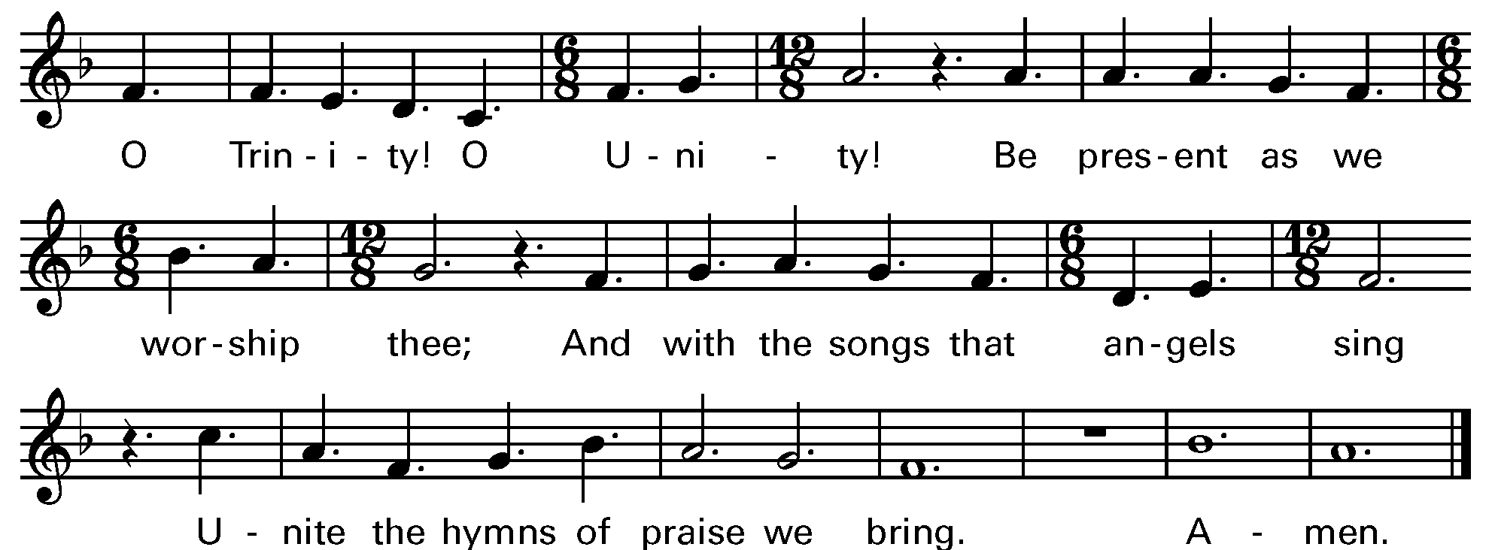

Music: OLD HUNDREDTH
The Great Thanksgiving
The Eucharistic Prayer, or Great Thanksgiving, is the prayer of the Church to invite Christ to be present in the elements of bread and wine. Now we come to the second act in the drama with the Liturgy of the Table. It is based on Jewish Fellowship meals, particularly the Passover observance. But this second half of the service is not communion in and of itself. It is the whole service, both acts of the drama, that make up the Eucharist.
Eucharistic Prayer for Lent
Presider The Lord be with you.
People And also with you.
Presider Lift up your hearts.
People We lift them to the Lord.
Presider Let us give thanks to the Lord our God.
People It is right to give thanks and praise.
Presider Blessed are you, God of everlasting covenant, for your promises are steadfast and your provision is sure. Through the forty years of your people’s desert wanderings you were constant in fire and cloud; with manna and mercy you sustained every step. You made Jesus’ temptation of forty days a theater of truth where your Word stood strong.
In every age you have shaped your people through times of wilderness and wandering, of temptation and trial, and brought them into the land of promise and the life of covenant.

And so we give you humble thanks for your forgiveness and our new life, with angels and archangels and the company of heaven, singing your unending praise.

Sanctus Holy Holy, Holy (Proulx) Hymnal S-125
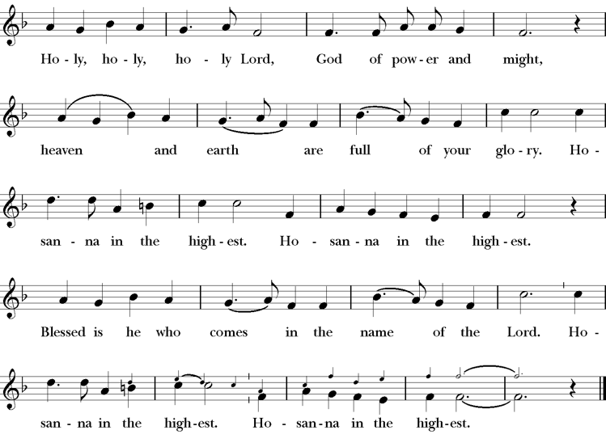
Presider Enduring God, as you sustained Jesus in hunger and thirst; through this meal strengthen us to keep our Lenten fast. Send your Holy Spirit upon us as we remember Jesus’ saving passion; transform our insatiable desires into hunger for the feast of this table. Send your Holy Spirit upon this bread and wine that they may be for us the body and blood of Christ;
Who at supper with his disciples, took bread, gave you thanks, broke the bread, and gave it to them, saying “Take, eat: this is my body which is given for you; do this in remembrance of me.”
Presider After supper he took the cup of wine. Again he gave you thanks, and gave it to his disciples, saying, “Drink this, all of you: this is my blood of the new covenant which is shed for you and for many for the forgiveness of sins. Do this, as often as you drink it, in remembrance of me.”
Presider Great is the mystery of faith.
People Christ has died; Christ is risen; Christ will come again.
Presider Forgiving God, in this season of repentance, make your mercy sufficient for every need. Come to your children who are in their own wilderness and make their wanderings holy paths of learning your truth.
Presider Come alongside your children who suffer in sin and give them the power to live as your beloved sons and daughters. Renew your church from the depths of your heart, where justice and mercy meet.
Presider Infuse your church with Spirit and truth, walk with your beloved people as they seek security, companionship and freedom in your world, and fill your saints with the hope of eternal life, that all may come to praise your name, that all creation be stirred with the wonders of your grace.
Presider Through Christ, with Christ, in Christ, in the unity of the Holy Spirit, all glory and honor are yours, almighty God, now and forever. AMEN.
The Lord’s Prayer
The link between our daily bread and the spiritual food we receive in the Eucharist is an ancient connection. In the Lord’s Prayer we ask for daily bread, meaning the things we need to get through each day. But as a part of that, the bread also symbolizes God’s presence.
Presider As our Savior has taught us, we are bold to pray.
People Our Father, who art in heaven, hallowed be thy name. Thy Kingdom come, thy will be done, on earth as it is in heaven. Give us this day our daily bread. And forgive us our trespasses, as we forgive those who trespass against us. And lead us not into temptation, but deliver us from evil. For thine is the kingdom, the power and the glory, for ever and ever. Amen.
The Breaking of the Bread
The Presider breaks the consecrated bread in view of the assembly.
Presider Christ our Passover is sacrificed for us.
People Therefore let us keep the feast.
Invitation to Communion
We partake in the Eucharist and are spiritually nourished, but it is not for our benefit alone. Communion enables us to return to the world with renewed vigor for proclaiming the Gospel in our words and in our lives. In the Eucharist, Christ’s presence both nourishes us and challenges us.
Presider The gifts of God for the people of God. So come to this table you who have been here often and you who have not been here in a long time. Come, you who have tried to follow Jesus and you who have failed. You who are full of faith and full of doubt. Come, it is Christ himself who invites you to meet him here.
Sharing the Sacred Meal
This is Christ’s table and all are welcome and all are fed.
Communion Hymn: Jesus, All my Gladness H 701
Post Communion Prayer
Presider God is with you.
People And also with you.
Presider Together, let us pray.
People Eternal God, you have renewed us with the living bread from heaven; by it you nourish our faith, increase our hope, and strengthen our love: teach us always to hunger for him who is the true and living bread, and enable us to live lives grounded in service to you and to one another; through Jesus Christ our Lord. Amen.
The Lenten Prayer over the People
The Presider prays over the people as a reminder of God’s extravagant love and invites us to go into the world to be God’s blessing.
Presider Bow down your hearts before the Lord our God. Grant, most merciful Lord, to your faithful people pardon and peace, that they may be cleansed from all their sins, and serve you with a quiet mind; through Christ our Lord. Amen.
Closing Hymn
We begin and end our time of worship by praising God through song and prayer.
Near The Cross LEVAS 29
Dismissal
As the celebration ends, we are charged to “Go in Peace to love and serve the Lord.” The Eucharist is therefore not an exclusive gathering that separates us from the world, but a challenge to reach out beyond our own church to the world around us.
Presider Our worship is ended. Our service in the world begins. Go into the world to love what God loves. Go in Peace to love and serve the Lord.
People Thanks be to God.

Thank you for worshiping with us today.
We hope to see you again soon
as we offer Christ’s unfenced love to the world.


SERVING TODAY
Celebrant and Preacher: Cindy Beck
Acolyte: Arminda Eiler
Lector: Barbara Feduska , John Eiler
Intercessor: Alfred Escoffier
Worship Musician: Steve Rubardt
Choir Leader: Steve Rubardt
Choir: Liz Carpenter, Heather Dahlberg, Scott Sherman, Lucy Maushardt, Patsy Gralow, Laurell Meredith, Mary Omodt, Barbara Feduska, Tara Anderson
Sunday School - Child Care: Wendy Aguilar Appt Only
Ushers: John Addeo
Tech Chaplain: Marcos Rendon
Altar Guild: Ann Kyser
Hospitality: Matthew Dahlberg

Trinity Liturgical Ministry ROTA Next two weeks
Date | Celebrant | Ushers | Acolyte / EM | Lector (s) | Intercessor | Altar Guild
March 15 | Cindy Beck | Alfred Escoffier | Susie Hand | Gerrilee Fisher , Lorena Reinhardt | Barbara Feduska | Susie Hand
March 22 | TBD | John Eiler | Arminda Eiler | Ann Kyser , Bill Doyle | Claire Ginesi | Ann Kyser

Schedule of Weekly Meetings and Services at Trinity Episcopal Sonoma
Day | Date | Time | Occasion | Location
Wednesday | March 11 | 11 AM | Bible Study | Library
Thursday | March 12 | 10:30 AM  5:30 PM | Mindfulness & Well Being  Alcoholics Anonymous | Library  Buttrum Hall
Saturday | March 14 | 8 AM | Centering Prayer | St. Luke’s Chapel
Sunday | March 15 | 10:15 AM | Holy Eucharist II | Sanctuary
Mon-Fri | Weekdays | 7AM-1PM | Sonoma Home Meals | Kitchen &Buttrum Hall
Mon-Fri | Weekdays | 9-2 | Sonoma Preschool Academy – School
Monthly Meetings at Trinity Episcopal Sonoma
Day | Date | Time | Meeting | Location | Contact
Tuesday | March 3 | 11 AM | Prayer Shawl Ministry | TBD | Lorena Reinhardt (415)488-3674
Thursday | TBD | 4:30 PM | Vestry | Library | Cindy Beck cbeck6012@gmail.com

PRAYERS and BLESSINGS
For a Birthday
Watch over your child, O Lord as his/her days increase; bless and guide him/her wherever s/he may be. Strengthen them when s/he stands; comfort him/her when discouraged or sorrowful; raise him/her up if s/he fall; and in his/her heart may your peace which passes understanding abide all the days of his/her life; through Jesus Christ our Lord. Amen.
For an Anniversary
O God, you have so consecrated the covenant of marriage that it represents the spiritual unity between Christ and his Church: Send your blessing upon these your servants as they celebrate their anniversary, that they may continue to love, honor and cherish each other in faithfulness and patience, in wisdom and true godliness, that their home may be a haven of blessing and peace; through Jesus Christ our Lord, who lives and reigns with you and the Holy Spirit, one God, now and forever. Amen.
For Travelers
O God, our heavenly Father, whose glory fills the whole creation, and whose presence we find wherever we go; preserve those who travel; surround them with your loving care; protect them from every danger, and bring them in safety to their journey’s end; through Jesus Christ our Lord. Amen.
Sending our Eucharistic Visitors
Priest: In the name of this congregation, I send you forth bearing these holy gifts, the those to whom you go may share with us in the communion of Christ’s body and blood.
People: We who are many are one body, because we all share on bread, and one cup. Amen

March Announcements
Rev. Dr. Stephen Hassett, Missioner for Congregational Vitality of the Northern Episcopal Diocese, will be visiting Trinity Episcopal Church next Sunday, March 15th. He will preach in the service and following worship, would like to visit with us during coffee hour. Please plan to be here to welcome him!!!
2025 End of Year Giving Statements have been sent out. If you need another copy, let the office know.
Fellowship Coffee Hour Sign up - We encourage members to sign up to make coffee. Pastor Cindy is happy to demonstrate how easy this is. Please help us provide this hospitality for guests and members.
The February, March, April Forward Day by Day , a booklet of daily inspirational meditations is now available in the Church and the Office. We ask for a $2 donation.
Soup Suppers have started on Wednesdays, at 5PM in Buttram Hall. Please sign up for either soup or bread during fellowship hour!
Movie Night Wednesday, March 18th @ 6PM. Our movie is "12 Angry Men" starring Henry Fonda. “Bias. Anger. Fear. WELCOME TO DEMOCRACY IN A LOCKED ROOM.” Discussion and food will follow.
This month, St Paul’s in Healdsburg organ concert series will feature a Choral Evensong. It will be a traditional Choral Evensong celebrating the workers of charity Vincent De Paul, Priest, and Louise De Marillac, Monastic. It will feature Preces & Responses by Richard Ayleward, Evening Service by Sir John Stainer and Stainer’s popular anthem, God So Loved the World. Also some hymns and organ voluntaries.
The performance will be held in the church on Sunday, March 15 at 5:00 pm. Admission is free.
The Lenten Quiet day for our Russian River Deanery will be at St Patrick’s Kenwood on March 21. The event starts at 1pm and goes till 5pm. Register Now at: https://form.jotform.com/norcalepiscopal/lenten-quiet-days-registration
St. Andrew Presbyterian Church (16290 Arnold Dr., Sonoma) is sponsoring a Rise Against Hunger Mission Project in the Fellowship Hall on Saturday, March 21 from 1:30pm-3:30pm. All are welcome to join!
Lectio Divina Bible Study is on Wednesday, at 11AM in the library. Lectio Divina, Latin for "divine reading," is a contemplative practice of scriptural reading, meditation, and prayer intended to promote communion with God. Unlike traditional Bible study that focuses on intellectual information, Lectio Divina emphasizes spiritual formation and personal intimacy with God.
All are welcome to make a gift and offering in thanksgiving to God; for the many blessings we have received. To take advantage of our electronic giving options, please follow the QR code with your capable electronic device, or visit https://onrealm.org/trinitysonoma/-/form/give/default Help us to make this a place where God’s grace is freely shared by all.

