Trinity Episcopal Church
Cultivating God’s Loving Spirit in Each of Us
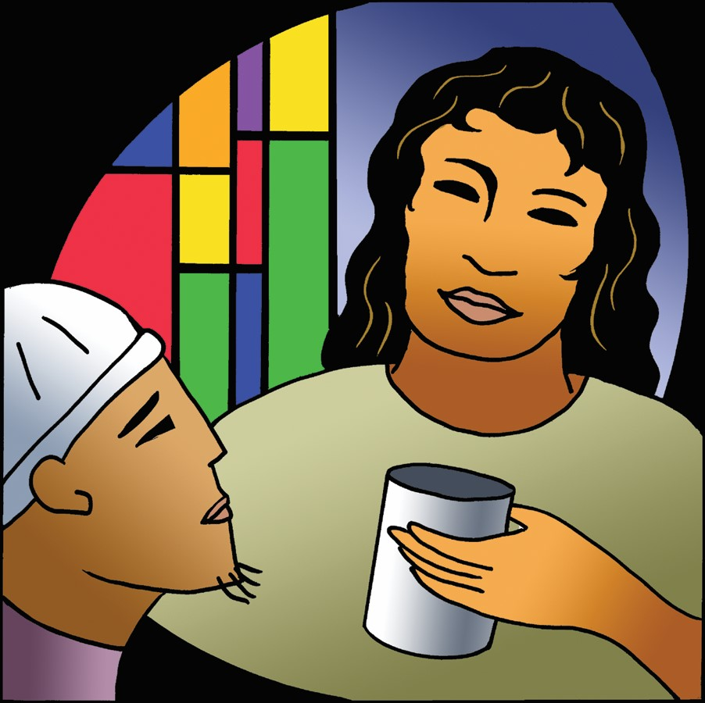
Proper 25
Year A
Holy Eucharist II
October 25, 2026
10:00 AM In person and Online
Welcome to Trinity Episcopal, Sonoma. Whether you are passing through or looking for a church home, we are blessed by your presence and we invite you to worship with us fully – singing, praying and receiving communion- with your voice and heart. Please sign our guestbook at the back of the church, including your email.
If you would like to learn more about The Episcopal Church, please send us an email trinityepiscopalsonoma@comcast.net. We look forward to meeting you after the service where coffee and treats are served.

All are welcome to make a gift and offering in thanksgiving to God; for the many blessings we have received. To take advantage of our electronic giving options, please follow the QR code with your capable electronic device, or visit https://onrealm.org/trinitysonoma/-/form/give/default
October Announcements
Fellowship Coffee Hour Sign up – Fellowship follows the service! We meet in the hall or courtyard. We’d love to visit with you.
Thank you to everyone who donated food for A Simple Gesture, your gift helps people have a meal! Our next pick up will be in November!
Movie Night at Trinity will continue on Novmeber 18th, at 6PM in Buttram Hall. We will be showing “Paper Moon”. There will be snacks and refreshements during the post film discussion.

Prelude Steve Rubardt
Please stand for the Entrance Hymn.
At the sound of the bell, please stand as you are able. The People respond when bold text appears.
The Word of God
Entrance Hymn The God of Abraham Praise H 401
Opening Acclamation BCP 319
Celebrant | Blessed be God: Father, Son, and Holy Spirit.
People | And blessed be his kingdom, now and for ever. Amen.
Collect for Purity
All Almighty God, to you all hearts are open, all desires known, and from you no secrets are hid: Cleanse the thoughts of our hearts by the inspiration of your Holy Spirit, that we may perfectly love you, and worthily magnify your holy Name; through Christ our Lord. Amen.
Song of Praise Glory to God Hymn S-280 is sung, all standing
Glory to God in the highest,
and peace to his people on earth.
Lord God, heavenly King,
almighty God and Father,
we worship you, we give you thanks,
we praise you for your glory.
Lord Jesus Christ, only Son of the Father,
Lord God, Lamb of God,
you take away the sin of the world:
have mercy on us;
you are seated at the right hand of the Father:
receive our prayer.
For you alone are the Holy One,
you alone are the Lord,
you alone are the Most High,
Jesus Christ,
with the Holy Spirit,
in the glory of God the Father. Amen.
The Collect of the Day BCP 357
Celebrant | The Lord be with you.
People | And also with you.
Celebrant | Let us pray.
Almighty and everlasting God, increase in us the gifts of faith, hope, and charity; and, that we may obtain what you promise, make us love what you command; through Jesus Christ our Lord, who lives and reigns with you and the Holy Spirit, one God, for ever and ever.
All Amen.
The Lessons
First Reading: Leviticus 19:1-2, 15-18
Reader A Reading from the book of Leviticus.
¹The Lord spoke to Moses, saying:
²Speak to all the congregation of the people of Israel and say to them: You shall be holy, for I the Lord your God am holy.
¹⁵You shall not render an unjust judgment; you shall not be partial to the poor or defer to the great: with justice you shall judge your neighbor. ¹⁶You shall not go around as a slanderer among your people, and you shall not profit by the blood of your neighbor: I am the Lord.
¹⁷You shall not hate in your heart anyone of your kin; you shall reprove your neighbor, or you will incur guilt yourself. ¹⁸You shall not take vengeance or bear a grudge against any of your people, but you shall love your neighbor as yourself: I am the Lord.
Reader | The Word of the Lord.
People | Thanks be to God.
The Psalm: Psalm 1
Reader We will read Psalm 1, responsively by half verse.
¹Happy are they who have not walked in the counsel of the wicked, *
nor lingered in the way of sinners,
nor sat in the seats of the scornful!
²Their delight is in the law of the Lord, *
and they meditate on his law day and night.
³They are like trees planted by streams of water,
bearing fruit in due season, with leaves that do not wither; *
everything they do shall prosper.
⁴It is not so with the wicked; *
they are like chaff which the wind blows away.
⁵Therefore the wicked shall not stand upright when judgment comes, *
nor the sinner in the council of the righteous.
⁶For the Lord knows the way of the righteous, *
but the way of the wicked is doomed.

Second Reading: 1 Thessalonians 2:1-8
Reader A Reading from Paul's First letter to the Church in Thessalonika.
¹You yourselves know, brothers and sisters, that our coming to you was not in vain, ²but though we had already suffered and been shamefully mistreated at Philippi, as you know, we had courage in our God to declare to you the gospel of God in spite of great opposition. ³For our appeal does not spring from deceit or impure motives or trickery, ⁴but just as we have been approved by God to be entrusted with the message of the gospel, even so we speak, not to please mortals, but to please God who tests our hearts. ⁵As you know and as God is our witness, we never came with words of flattery or with a pretext for greed; ⁶nor did we seek praise from mortals, whether from you or from others, ⁷though we might have made demands as apostles of Christ. But we were gentle among you, like a nurse tenderly caring for her own children. ⁸So deeply do we care for you that we are determined to share with you not only the gospel of God but also our own selves, because you have become very dear to us.
Reader | The Word of the Lord.
People | Thanks be to God.
Sequence Hymn Come with us, O Bless’d Jesus H 336 v 1 & 2
The Holy Gospel: Matthew 22:34-46
Celebrant | The Holy Gospel of our Lord Jesus Christ according to Matthew.
People | Glory to you, Lord Christ.
³⁴When the Pharisees heard that [Jesus] had silenced the Sadducees, they gathered together, ³⁵and one of them, a lawyer, asked him a question to test him. ³⁶“Teacher, which commandment in the law is the greatest?” ³⁷He said to him, “ “You shall love the Lord your God with all your heart, and with all your soul, and with all your mind.’ ³⁸This is the greatest and first commandment. ³⁹And a second is like it: ‘You shall love your neighbor as yourself.’ ⁴⁰On these two commandments hang all the law and the prophets.”
⁴¹Now while the Pharisees were gathered together, Jesus asked them this question: ⁴²“What do you think of the Messiah? Whose son is he?” They said to him, “The son of David.” ⁴³He said to them, “How is it then that David by the Spirit calls him Lord, saying,
⁴⁴‘The Lord said to my Lord,
“Sit at my right hand,
until I put your enemies under your feet”’?
⁴⁵If David thus calls him Lord, how can he be his son?” ⁴⁶No one was able to give him an answer, nor from that day did anyone dare to ask him any more questions.
Celebrant | The Gospel of the Lord.
People | Praise to you, Lord Christ.
Sequence Hymn Come with Us, O Bless’d Jesus H 336 v 3


Sermon Pastor Cindy Beck
The Nicene Creed (BCP p. 358)
We believe in one God, the Father, the Almighty, maker of heaven and earth, of all that is, seen and unseen.
We believe in one Lord, Jesus Christ, the only Son of God, eternally begotten of the Father, God from God, Light from Light, true God from true God, begotten, not made, of one Being with the Father. Through him all things were made. For us and for our salvation he came down from heaven: by the Power of the Holy Spirit he became incarnate from the Virgin Mary, and was made man. For our sake he was crucified under Pontius Pilate; he suffered death and was buried. On the third day he rose again in accordance with the Scriptures; he ascended into heaven and is seated at the right hand of the Father. He will come again in glory to judge the living and the dead, and his kingdom will have no end.
We believe in the Holy Spirit, the Lord, the giver of life, who proceeds from the Father and the Son. With the Father and the Son he is worshipped and glorified. He has spoken through the Prophets. We believe in one holy catholic and apostolic Church. We acknowledge one baptism for the forgiveness of sins. We look for the resurrection of the dead, and the life of the world to come. Amen.

The Prayers of the People
Celebrant: O Lord, who is our refuge from age to age, hear our prayers.
Intercessor: In the Diocesan Cycle of Prayer, we pray for St. James in Lincoln.
In the Anglican Cycle of Prayer, we pray for The Church of the Province of Central Africa.
O God, hear us.
For those preparing for Holy Baptism; for N. our Presiding Bishop, for N. our bishop, for our parish clergy; for this holy gathering and for the people of God in every place.
Silence
O God, hear us.
For N. our President, N. our Governor, and N. our Mayor; for our courts and legislatures; for mercy, justice, and peace among all peoples.
Silence
O God, hear us.
For good weather, abundant fruits of the earth, and peaceful times, +_____________.
Invite the congregation to add their thanksgivings, followed by silence
O God, hear us.
For our communities and our neighbors near and far; for our families, companions, and all those we love.
Silence
O god, hear us.
For orphans and widows, the sick and the suffering, for travelers, strangers, and all with heavy burdens, +______________.
Invite the congregation to add their petitions, followed by silence
O God, hear us.
For our deliverance from all affliction, strife, and need.
Silence
O God, hear us.
For those who rest in Christ and for all the dead, we pray, +__________.
Invite the congregation to add their petitions, followed by silence
O God, hear us.
Celebrant Almighty God, whose gifts of blessing and grace have no end, write in our hearts your joy and zeal to tell the story of our faith by our words, by our deeds, and by offering all that you have given us: our lives, our gifts, our resources. Grant us also a portion of your never-ending generosity, that we may proclaim your love and mercy to the world around us through our parish community; through Jesus Christ our Lord and Savior. Amen.
Confession of Sin BCP 359
Most merciful God, we confess that we have sinned against you in thought, word and deed, by what we have done, and by what we have left undone.
We have not loved you with our whole heart; we have not loved our neighbors as ourselves. We are truly sorry and we humbly repent.
For the sake of your Son Jesus Christ, have mercy on us and forgive us; that we may delight in your will, and walk in your ways, to the glory of your Name. Amen.

The Peace
Celebrant The peace of the Lord be always with you.
People And also with you.

Announcements
Birthdays, Anniversaries, Travelers (prayers found at back of bulletin)
The Holy Communion
The Offertory At the Offering, you’ll find a Pledge card in the Pew Rack for those who’d like to designate their financial donations to Trinity’s Pledging Income. For others, or a one-time gift, envelopes are in the pew racks as well as on the Narthex table or text TRINITYSONOMA" to 73256. Thank you!
Offertory Music
Steve Rubardt and Choir Bridge over Troubled Water
Doxology
Praise God, from whom all blessings flow;
Praise Him, all creatures here below;
Praise Him above, ye heav'nly host;
Praise Father, Son, and Holy Ghost.
Amen.
The people stand while the offerings are presented and placed on the Altar.
Presider: Gracious God, as an offering of our thanksgiving and gratitude, we return to you a portion of what you have gifted us.
The Great Thanksgiving
Eucharistic Prayer B BCP 367
Celebrant | The Lord be with you.
People | And also with you.
Celebrant | Lift up your hearts.
People | We lift them to the Lord.
Celebrant | Let us give thanks to the Lord our God.
People | It is right to give him thanks and praise.
Proper Preface (BCP p. 367)
It is right, and a good and joyful thing, always and everywhere to give thanks to you, Father Almighty, Creator of heaven and earth.
For you are the source of light and life; you made us in your image, and called us to new life in Jesus Christ our Lord.
Therefore we praise you, joining our voices with Angels and Archangels and with all the company of heaven, who for ever sing this hymn to proclaim the glory of your Name:
Sanctus Holy Holy, Holy (Proulx) Hymnal S-125
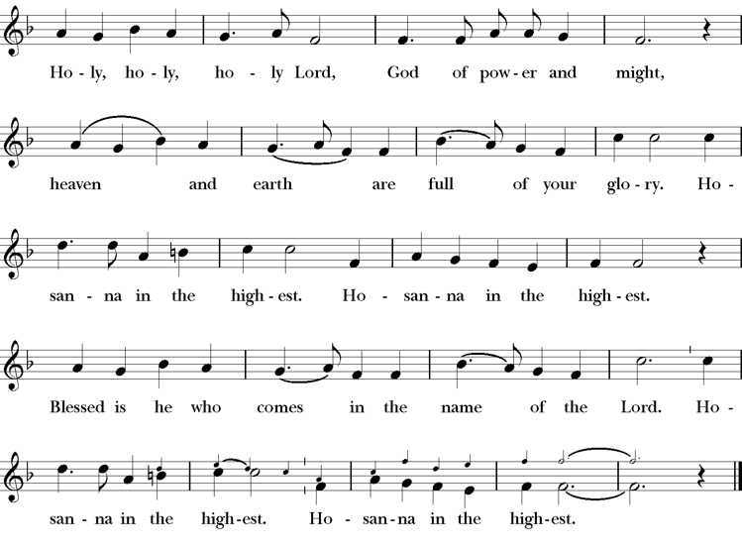
Presider Holy and gracious Father: In your infinite love you made us for yourself; and, when we had fallen into sin and become subject to evil and death, you, in your mercy, sent Jesus Christ, your only and eternal Son, to share our human nature, to live and die as one of us, to reconcile us to you, the God and Father of all.
He stretched out his arms upon the cross, and offered himself, in obedience to your will, a perfect sacrifice for the whole world.
On the night he was handed over to suffering and death, our Lord Jesus Christ took bread; and when he had given thanks to you, he broke it, and gave it to his disciples, and said, “Take, eat: This is my Body, which is given for you. Do this for the remembrance of me”
After supper he took the cup of wine; and when he had given thanks, he gave it to them, saying, “Drink this, all of you: this is my blood of the new covenant which is shed for you and for many for the forgiveness of sins. Whenever you drink it, do this for the remembrance of me.”
Presider Therefore we proclaim the mystery of faith.
People Christ has died; Christ is risen; Christ will come again.
Presider We celebrate the memorial of our redemption, O Father, in this sacrifice of praise and thanksgiving. Recalling his death, resurrection, and ascension, we offer you these gifts.
Sanctify them by your Holy Spirit to be for your people the Body and Blood of your Son, the holy food and drink of new and unending life in him. Sanctify us also that we may faithfully receive this holy Sacrament, and serve you in unity, constancy, and peace; and at last day bring us with all your saints into the joy of your eternal kingdom.
All this we ask through your Son Jesus Christ. By him, and with him, and in him, in the unity of the Holy Spirit all honor and glory is yours, Almighty Father, now and for ever.
Amen.

The Lord’s Prayer
Presider As our Savior has taught us, we are bold to pray.
People Our Father, who art in heaven, hallowed be thy name. Thy Kingdom come, thy will be done, on earth as it is in heaven. Give us this day our daily bread. And forgive us our trespasses, as we forgive those who trespass against us. And lead us not into temptation, but deliver us from evil. For thine is the kingdom, the power and the glory, for ever and ever. Amen.

The Breaking of the Bread
The Presider breaks the consecrated bread in view of the assembly.
Presider The Gifts of God for the people of God.
People Therefore let us keep the feast. Alleluia

Invitation to Communion
Presider This is the Lord’s table. The Lord Jesus invites us to share this joyful feast.
Sharing the Sacred Meal
This is Christ’s table and all are welcome and all are fed.
Communion Music Jesu, Jesu LEVAS 74
Post-Communion Prayer BCP 365
The Blessing
The Recessional Hymn Great is thy Faithfulness LEVAS 189
The Dismissal*
Celebrant | Let us go forth in the name of Christ.
People | Thanks be to God.
Postlude Steve Rubardt Please remain seated

SERVING TODAY
Celebrant & Preacher: Rev LA King
Acolyte: Arminda Eiler
Lector: Jane Hernandez , John Eiler
Intercessor: Barbara Feduska
Worship Musician: Steve Rubardt
Choir Leader: Steve Rubardt
Choir: Liz Carpenter, Heather Dahlberg, Scott Sherman, Patsy Gralow, Laurell Meredith, Mary Omodt, Barbara Feduska, Tara Anderson, Carol Heffler, Don McMahon
Sunday School - Child Care: Wendy Aguilar
Ushers: Alfred Escoffier
Tech Chaplain: Marcos Rendon
Altar Guild: Laurell Meredith , Liz Carpenter
Hospitality :
Altar Flowers today are arranged by Liz Carpenter & Barbara Addeo

Prayers requested for these on Trinity’s long-term prayer list: Armando P, Georgia Bostedt, John Eiler, Gerrilee Fisher, Claire Ginesi, Mary Griffin, David & Christine Hilt, Mark Mezzetta, Kelcey Omodt, Grizelda Ponce, Barry Reap, Blake W, Robert R, Melissa White, Ann Loveland Sherman, James Thomas, Rose Burns, Jennifer Gralow, Patsy Gralow, Steve Antenen, Sandra Leland, Karl, Michael Hardy, Michael Bean Land, Polly Moore, Sinat Liv, Will Maushardt, Sophia Piconi, Mike Smith, Jean Maffoli.
Prayers for the Repose of soul: Tim Dowd , Susan Bassett, Joan Biersch, Linda Dowd, Christina Van Krugel, Mere Nagasau, Mary Goshert, Peggy Bell, Carolyn Caldwell, Van Z, Dolores Mae Seaberg Cole, Muff Davey, Giancarlo Cestarollo.
Contact Pastoral Care Chair, Lorena lorena.m.reinhardt@gmail.com to make any additions or to remove names from our Long-Term Prayer list.
Notes on the Service Bulletin This service bulletin is a guide to the service. We use a variety of printed materials for the prayers, the scriptural readings and the hymns. The Readings for the week, including the Collect and Readings are found in this Bulletin. The service follows the liturgies that are found in the Book of Common Prayer (BCP). The BCP is the blue book found in the pew in front of you. The hymns come primarily from The 1982 Hymnal, also in the pew – the red book. Lift Every Voice and Sing (LEVAS) is another hymnal located in the pew rack. VF stands for Voices Found, another authorized hymnal. Sound Mate Assisted Hearing devices available at the back of the church on the Narthex Table.

Trinity Liturgical Ministry ROTA Next two weeks
Date | Celebrant | Ushers | Acolyte | Lector (s) | Intercessor | Altar Guild
11/1 | Cindy Beck | John Addeo | Arminda Eiler | Bill Doyle , John Eiler | Douglas Griffin | Susie Hand
11/8 | Cindy Beck | Alfred Escoffier | Claire Ginesi | Barbara Feduska , Gerrilee Fischer | Jane Hernandez | Mary Omodt

Schedule of Weekly Meetings and Services at Trinity Episcopal Sonoma
Day | Date | Time | Occasion | Location
Wednesday | October 28 | 11 AM | Bible Study | Library
Thursday | October 29 | 10:30 AM  5:30 PM | Mindfulness & Well Being  Alcoholics Anonymous | Library  Buttrum Hall
Saturday | October 31 | 8 AM | Centering Prayer | St. Luke’s Chapel
Sunday | November 1 | 10:00 AM | Holy Eucharist II | Sanctuary
Mon-Fri | Weekdays | 7AM-1PM | Sonoma Home Meals | Kitchen &Buttrum Hall
Mon-Fri | Weekdays | 9-2 | Sonoma Preschool Academy – School

Monthly Meetings at Trinity Episcopal Sonoma
Day | Date | Time | Meeting | Location | Contact
Tuesday | November 3 | 11 AM | Prayer Shawl Ministry | Library | Lorena Reinhardt lorena.m.reinhardt@gmail.com
Thursday | TBD | TBD | Vestry | Library | Cindy Beck 916-955-9861



PRAYERS and BLESSINGS
For a Birthday
Watch over your child, O Lord as his/her days increase; bless and guide him/her wherever s/he may be. Strengthen them when s/he stands; comfort him/her when discouraged or sorrowful; raise him/her up if s/he fall; and in his/her heart may your peace which passes understanding abide all the days of his/her life; through Jesus Christ our Lord. Amen.
For an Anniversary
O God, you have so consecrated the covenant of marriage that it represents the spiritual unity between Christ and his Church: Send your blessing upon these your servants as they celebrate their anniversary, that they may continue to love, honor and cherish each other in faithfulness and patience, in wisdom and true godliness, that their home may be a haven of blessing and peace; through Jesus Christ our Lord, who lives and reigns with you and the Holy Spirit, one God, now and forever. Amen.
For Travelers
O God, our heavenly Father, whose glory fills the whole creation, and whose presence we find wherever we go; preserve those who travel; surround them with your loving care; protect them from every danger, and bring them in safety to their journey’s end; through Jesus Christ our Lord. Amen.
Sending our Eucharistic Visitors
Priest: In the name of this congregation, I send you forth bearing these holy gifts, the those to whom you go may share with us in the communion of Christ’s body and blood.
People: We who are many are one body, because we all share on bread, and one cup. Amen.

Trinity Episcopal Church
In Sonoma for over 170 years
275 East Spain Street
Sonoma, CA 95476
The Rt. Rev. Megan M. Traquair, Bishop
Diocese of Northern California
Pastor Cindy Beck, Interim
Steve Rubardt, Worship Music
Vestry
Bill Doyle, Senior Warden & Stewardship
Susie Hand
Heather Dahlberg
Sally Zimmerman
Lorena Reinhardt (Pastoral Care)
Luke Bohanan
Mandy Birkbeck
Ministries
Prayer Shawl, Lorena Reinhardt
Outreach, Jane Hernandez
Mindfulness & Well Being, Mary Omodt
Sunday School, Children, Wendy Aguilar

The Members of the Congregation are The Ministers of the Church

Administrative Office Hrs.
Monday Wednesday 9 A.M. – 2 PM; Thursday 10A.M.-2 P.M0
Sunday 9:30-11:30
Clergy Office Hours Wednesdays, Thursdays, by appointment

Emergency, sickness, please contact office: 707-938-4846

