Trinity Episcopal Church
In Sonoma for over 170 years
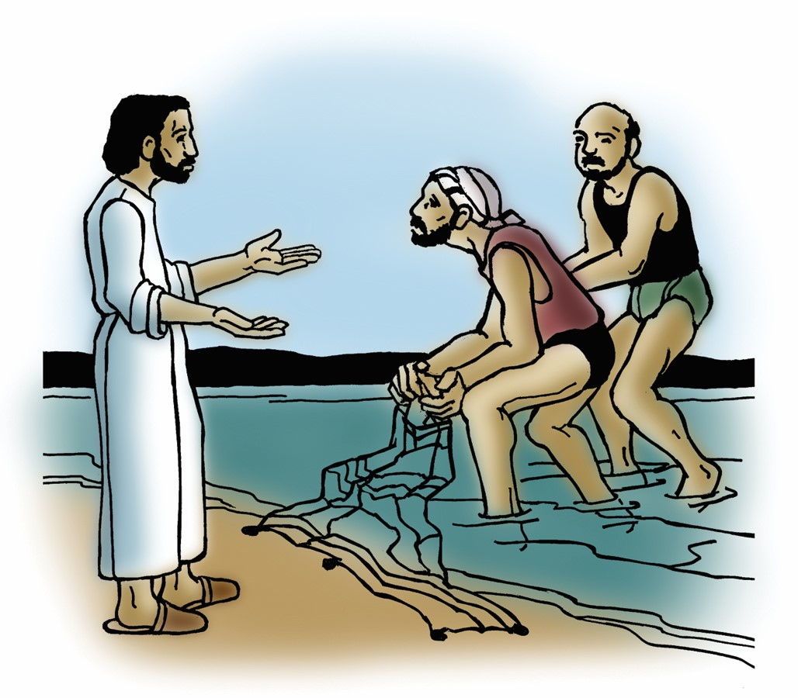
The Third Sunday after the Epiphany
Epiphany 3 (Year A)
Holy Eucharist II
January 25, 2026
10:00 AM In person and Online
Welcome to Trinity Episcopal, Sonoma!
Whether you have wandered in, are wondering about God or grew up in the church, or wherever you are in your journey...you are welcome here... We are blessed by your presence.
For Visitors and Newcomers:
Everyone is welcome to receive communion at the Lord’s table. Jesus gave this tangible reminder of God’s presence, love, and forgiveness for all. If you are interested in a visit or call from the Priest-in-Charge , please sign our guest book on the table at the entrance of the church, including an email or phone number.
Restrooms
A restroom is located outside the entrance of Buttrum Hall (the building across the courtyard) and another is located inside the hall to the right.
Coffee and Treats:
Following worship we have coffee and treats after service in Buttrum Hall. We hope it is a time to get to know you better.
To access Trinity’s Guest WIFI: Password Rosepettal441 (case sensitive).
We are glad you are here, and we invite you to enter fully into worship this morning.
January Announcements
Trinity’s annual meeting is today after Sunday’s Service.
Fellowship Coffee Hour Sign up - We encourage members to sign up to make coffee. Pastor Cindy is happy to demonstrate how easy this is. Please help us provide this hospitality for guests and members.
The February, March, April Forward Day by Day , a booklet of daily inspirational meditations is now available in the Church and the Office. We ask for a $2 donation.
Congregational Vitality Assessment (CVA): This online tool is designed to help a congregation diagnose its 1) Vitality and Sustainability 2) Identify its strengths and weaknesses and 3) Develop/Prioritize strategies to address them. It does this by measuring how effectively a congregation is carrying out 11 vital areas of congregational functioning such as: Vision, Mission, & Discernment; Lay Engagement & Empowerment; Change Readiness; Spiritual Life; Outreach; and Stewardship. Once we receive the link from the Diocese, we will provide you with the information on how to fill out the survey.
Prayer Shawl Ministry: When Norah Collins came to Trinity Episcopal, she introduced us to the gift of Prayer Shawl Ministry. Norah was recognized for this effort by the City of Sonoma who named September 9, 2020, Norah Collins Day. Prayer Shawls are handmade by members of Trinity Episcopal to be given to someone to whom you want to give comfort, warmth, blessings and more. Wearing them, the recipients are surrounded by the blessings of Trinity Episcopal. Request forms for a shawl can be found in the purple folder in the library. Please fill one out and someone will get back to you with a shawl. Written requests allow us to follow up with recipients on their needs. Thank you.
Lectio Divina Bible Study starts Wednesday, February 4th at 10:30AM in the library. Lectio Divina, Latin for "divine reading," is a contemplative practice of scriptural reading, meditation, and prayer intended to promote communion with God. Unlike traditional Bible study that focuses on intellectual information, Lectio Divina emphasizes spiritual formation and personal intimacy with God.
Pastor Cindy is considering another study to be held either after worship or early evening based on the book "The Bible With and Without Jesus." Amy-Jill Levine and Marc Zvi Brettler take readers on a guided tour of the most popular Hebrew Bible passages quoted in the New Testament to show what the texts meant in their original contexts and then how Jews and Christians, over time, understood those same texts. More information to come as to time and location.
All are welcome to make a gift and offering in thanksgiving to God;
for the many blessings we have received. To take advantage of our electronic giving options, please follow the QR code with your capable electronic device, or visit https://onrealm.org/trinitysonoma/-/form/give/default Help us to make this a place where God’s grace is freely shared by all.


Prelude Steve Rubardt
Please stand for the Entrance Hymn.
At the sound of the bell, please stand as you are able. The People respond when bold text appears.
The Word of God
Entrance Hymn Spread, o Spread, Thou Mighty Word H 530
Opening Acclamation (BCP p. 355)
The people standing, the Celebrant says
 | Blessed be God: Father, Son, and Holy Spirit.
People | And blessed be his kingdom, now and for ever. Amen.
Collect for Purity
All Almighty God, to you all hearts are open, all desires known, and from you no secrets are hid: Cleanse the thoughts of our hearts by the inspiration of your Holy Spirit, that we may perfectly love you, and worthily magnify your holy Name; through Christ our Lord. Amen.
Song of Praise Gloria BCP 356/Hymnal S-280
All Glory to God in the highest,
and peace to his people on earth.
Lord God, heavenly King,
almighty God and Father,
we worship you, we give you thanks,
we praise you for your glory.
Lord Jesus Christ, only Son of the Father,
Lord God, Lamb of God,
you take away the sin of the world:
have mercy on us;
you are seated at the right hand of the Father:
receive our prayer.
For you alone are the Holy One,
you alone are the Lord,
you alone are the Most High,
Jesus Christ,
with the Holy Spirit,
in the glory of God the Father. Amen.
The Collect of the Day BCP 357
Celebrant | The Lord be with you.
People | And also with you.
Celebrant | Let us pray.
Give us grace, O Lord, to answer readily the call of our Savior Jesus Christ and proclaim to all people the Good News of his salvation, that we and the whole world may perceive the glory of his marvelous works; who lives and reigns with you and the Holy Spirit, one God, for ever and ever.
All Amen.
The Lessons
First Reading: Isaiah 9:1-4
Reader A Reading from the book of the prophet Isaiah.
¹There will be no gloom for those who were in anguish. In the former time he brought into contempt the land of Zebulun and the land of Naphtali, but in the latter time he will make glorious the way of the sea, the land beyond the Jordan, Galilee of the nations.
²The people who walked in darkness
have seen a great light;
those who lived in a land of deep darkness—
on them light has shined.
³You have multiplied the nation,
you have increased its joy;
they rejoice before you
as with joy at the harvest,
as people exult when dividing plunder.
⁴For the yoke of their burden,
and the bar across their shoulders,
the rod of their oppressor,
you have broken as on the day of Midian.
Reader | The Word of the Lord.
People | Thanks be to God.
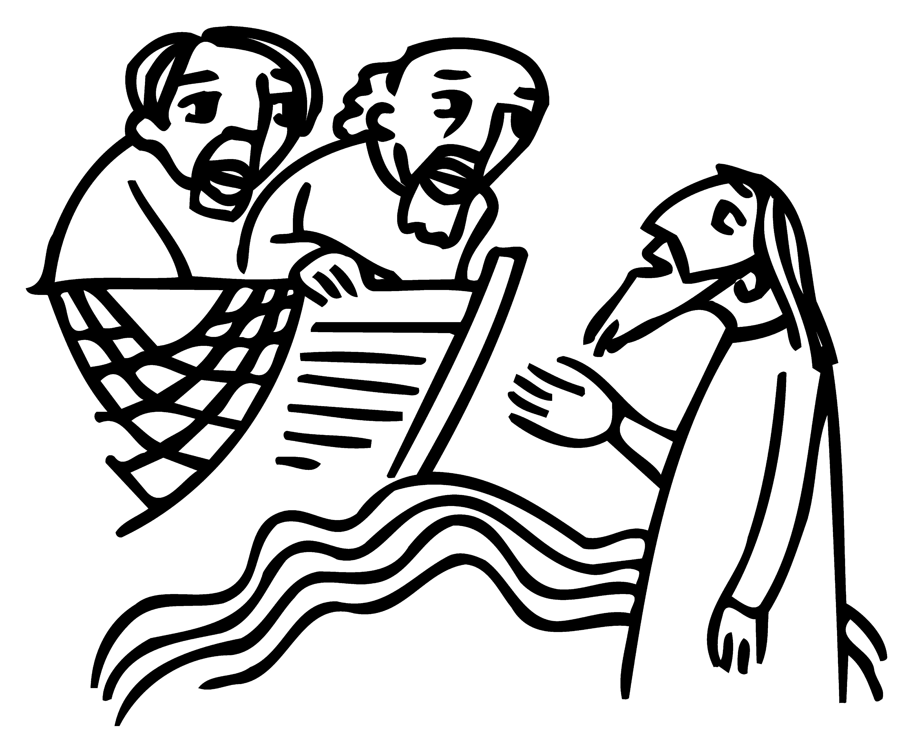
The Psalm: Psalm 27:1, 5-13
Reader We will read Psalm 27:1, 5-13, responsively by half verse.
¹The Lord is my light and my salvation;
whom then shall I fear? *
the Lord is the strength of my life;
of whom then shall I be afraid?
⁵One thing have I asked of the Lord;
one thing I seek; *
that I may dwell in the house of the Lord all the days of my life;
⁶To behold the fair beauty of the Lord *
and to seek him in his temple.
⁷For in the day of trouble he shall keep me safe in his shelter; *
he shall hide me in the secrecy of his dwelling
and set me high upon a rock.
⁸Even now he lifts up my head *
above my enemies round about me.
⁹Therefore I will offer in his dwelling an oblation
with sounds of great gladness; *
I will sing and make music to the Lord.
¹⁰Hearken to my voice, O Lord, when I call; *
have mercy on me and answer me.
¹¹You speak in my heart and say, “Seek my face.” *
Your face, Lord, will I seek.
¹²Hide not your face from me, *
nor turn away your servant in displeasure.
¹³You have been my helper;
cast me not away; *
do not forsake me, O God of my salvation.
The Second Reading 1 Corinthians 1:10-18
Reader A Reading from Paul's First letter to the Church in Corinth.
¹⁰Now I appeal to you, brothers and sisters, by the name of our Lord Jesus Christ, that all of you be in agreement and that there be no divisions among you, but that you be united in the same mind and the same purpose. ¹¹For it has been reported to me by Chloe’s people that there are quarrels among you, my brothers and sisters. ¹²What I mean is that each of you says, “I belong to Paul,” or “I belong to Apollos,” or “I belong to Cephas,” or “I belong to Christ.” ¹³Has Christ been divided? Was Paul crucified for you? Or were you baptized in the name of Paul? ¹⁴I thank God that I baptized none of you except Crispus and Gaius, ¹⁵so that no one can say that you were baptized in my name. ¹⁶(I did baptize also the household of Stephanas; beyond that, I do not know whether I baptized anyone else.) ¹⁷For Christ did not send me to baptize but to proclaim the gospel, and not with eloquent wisdom, so that the cross of Christ might not be emptied of its power.
¹⁸For the message about the cross is foolishness to those who are perishing, but to us who are being saved it is the power of God.
Reader | The Word of the Lord.
People | Thanks be to God.
Sequence Hymn The People who in Darkness Walked H 126 v 1-3
The Holy Gospel: Matthew 4:12-23
Celebrant | The Holy Gospel of our Lord Jesus Christ according to Matthew.
People | Glory to you, Lord Christ.
¹²Now when Jesus heard that John had been arrested, he withdrew to Galilee. ¹³He left Nazareth and made his home in Capernaum by the sea, in the territory of Zebulun and Naphtali, ¹⁴so that what had been spoken through the prophet Isaiah might be fulfilled:
¹⁵“Land of Zebulun, land of Naphtali,
on the road by the sea, across the Jordan, Galilee of the Gentiles—
¹⁶the people who sat in darkness
have seen a great light,
and for those who sat in the region and shadow of death
light has dawned.”
¹⁷From that time Jesus began to proclaim, “Repent, for the kingdom of heaven has come near.”
¹⁸As he walked by the Sea of Galilee, he saw two brothers, Simon, who is called Peter, and Andrew his brother, casting a net into the sea—for they were fishermen. ¹⁹And he said to them, “Follow me, and I will make you fish for people.” ²⁰Immediately they left their nets and followed him. ²¹As he went from there, he saw two other brothers, James son of Zebedee and his brother John, in the boat with their father Zebedee, mending their nets, and he called them. ²²Immediately they left the boat and their father, and followed him.
²³Jesus went throughout Galilee, teaching in their synagogues and proclaiming the good news of the kingdom and curing every disease and every sickness among the people.
Celebrant | The Gospel of the Lord.
People | Praise to you, Lord Christ.
Sequence Hymn The People who in Darkness Walked H 126 v 4-5
The Sermon Pastor Cindy Beck
The Nicene Creed (BCP p. 358)
The Prayers of the People
Celebrant: Friends, it is the Lord who speaks in our hearts, who says, “Seek my face.” With humble hearts let us come before the Lord saying, “When we call, O Lord, Hearken to our voice.”
Intercessor: God, help your Church. Heal her divisions. Increase her joy. Unite her members that we might have a common purpose: to proclaim the gospel.
In the Diocesan Cycle of Prayer, we pray for Christ Church in Eureka and St. Mary’s in Napa.
In the Anglican Cycle of Prayer, we pray for The Iglesia Anglicana de Chile.
Silence
When we call, O Lord,
Hearken to our voice.
God, help this nation and the world. Where there are heavy burdens, where oppression reigns, show the strength of your arm and set your people free. May the coming of your kingdom be ever nearer.
Silence
When we call, O Lord,
Hearken to our voice.
God, help your creation. You make glorious the way of the sea; you bring us joy at the harvest. Teach us to live in harmony with all you have made, +__________
Invite the congregation to add their thanksgivings, followed by silence
When we call, O Lord,
Hearken to our voice.
God, help our local community. May your great light drive away all of the shadows that darken our region. Even now lift up the heads of the downcast.
Silence
When we call, O Lord,
Hearken to our voice.
God, help the sick and suffering, +_______________ Do not forsake them but show yourself to be the strength of their lives and their salvation. May Jesus be the healer of every disease and sickness among the people.
Invite the congregation to add their petitions, followed by silence
When we call, O Lord,
Hearken to our voice.
God, help the dying and the dead, +______________ Hide them in the secrecy of your dwelling. May all those being saved say with boldness, “I belong to Christ. Forever.”
Silence
When we call, O Lord,
Hearken to our voice.
The Confession of Sin
Most merciful God,
we confess that we have sinned against you
in thought, word, and deed,
by what we have done,
and by what we have left undone.
We have not loved you with our whole heart;
we have not loved our neighbors as ourselves.
We are truly sorry and we humbly repent.
For the sake of your Son Jesus Christ,
have mercy on us and forgive us;
that we may delight in your will,
and walk in your ways,
to the glory of your Name. Amen.
The Peace
Celebrant The peace of the Lord be always with you.
People And also with you.
Announcements
Birthdays, Anniversaries, Travelers (prayers found at back of bulletin)
The Holy Communion
The Offertory At the Offering, you’ll find a Pledge card in the Pew Rack for those who’d like to designate their financial donations to Trinity’s Pledging Income. For others, or a one-time gift, envelopes are in the pew racks as well as on the Narthex table or text TRINITYSONOMA" to 73256. Thank you!
Offertory Music Steve Rubardt & Choir
Come Sunday
Doxology
The people stand while the offerings are presented and placed on the Altar.
Presider: Gracious God, as an offering of our thanksgiving and gratitude, we return to you a portion of what you have gifted us.
The Great Thanksgiving
Eucharistic Prayer B BCP 367
Celebrant | The Lord be with you.
People | And also with you.
Celebrant | Lift up your hearts.
People | We lift them to the Lord.
Celebrant | Let us give thanks to the Lord our God.
People | It is right to give him thanks and praise.
Proper Preface (BCP p. 367)
It is right, and a good and joyful thing, always and everywhere to give thanks to you, Father Almighty, Creator of heaven and earth.
Because in the mystery of the Word made flesh, you have caused a new light to shine in our hearts, to give the knowledge of your glory in the face of your Son Jesus Christ our Lord.
Therefore we praise you, joining our voices with Angels and Archangels and with all the company of heaven, who for ever sing this hymn to proclaim the glory of your Name:
Sanctus Holy Holy, Holy (Proulx) Hymnal S-125
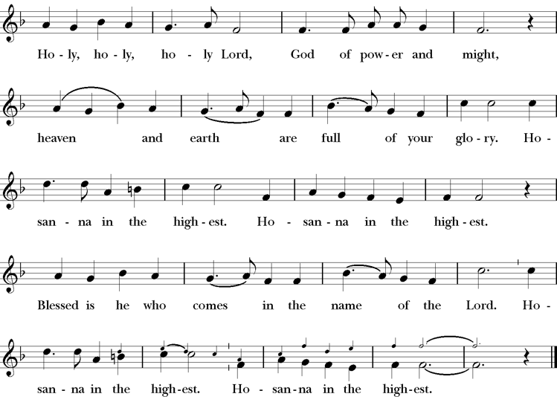
Words of Institution BCP 368
The Lord’s Prayer 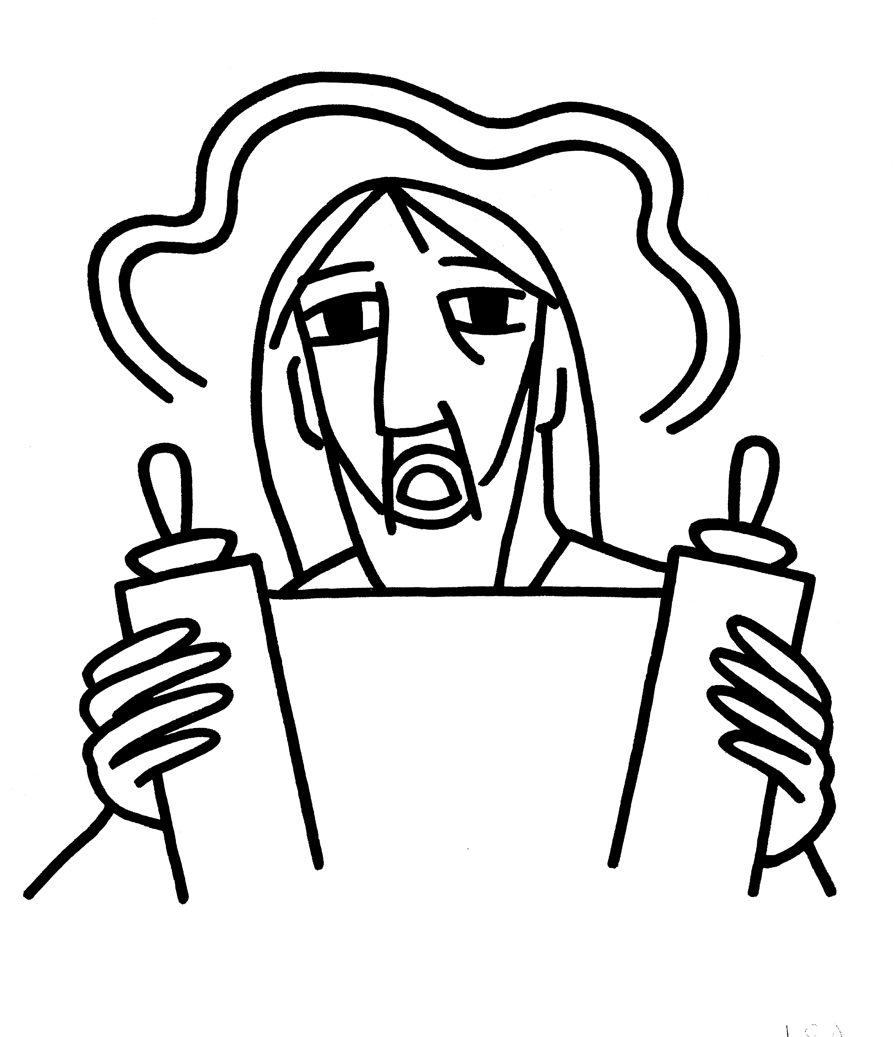 BCP 364
The Breaking of the Bread  BCP 364
Fraction Anthem S-154
All are welcome at the Lord’s table to receive Holy Communion or a blessing. To receive Communion in your pew, please ask an usher to notify the ministers on your behalf. If you require a gluten-free wafer, please ask at the altar rail.
Communion Music Steve Rubardt & Choir
One Bread One Body LEVAS 151
Post-Communion Prayer
Eternal God, heavenly Father,
you have graciously accepted us as living members
of your Son our Savior Jesus Christ,
and you have fed us with spiritual food
in the Sacrament of his Body and Blood.
Send us now into the world in peace,
and grant us strength and courage
to love and serve you
with gladness and singleness of heart;
through Christ our Lord. Amen.
Amen.
Blessing (BCP p. 366)
The blessing of God Almighty, the Father, the Son, and the Holy Spirit, be upon you and remain with you for ever.
Amen.
The Recessional Hymn A Mighty Fortress is Our God H 688
Dismissal (BCP p. 366)
 | Let us go forth in the name of Christ.
People | Thanks be to God.
Postlude Steve Rubardt
Please remain seated
SERVING TODAY
Celebrant and Preacher: Pastor Cindy Beck
Acolyte: Susie Hand
Lector: Barbara Feduska , Gerrilee Fisher
Intercessor: Claire Ginesi
Worship Musician: Steve Rubardt
Choir Leader: Steve Rubardt
Choir: Liz Carpenter, Heather Dahlberg, Scott Sherman, Lucy Maushardt, Patsy Gralow, Laurell Meredith, Mary Omodt, Barbara Feduska, Tara Anderson
Sunday School - Child Care: Wendy Aguilar Appt Only
Ushers: John Addeo
Tech Chaplain: Marcos Rendon
Altar Guild: Laurell Meredith , Liz Carpenter
Hospitality: Barbara Feduska

Prayers requested for these on Trinity’s long-term prayer list: Baby Walker David, Armando P, Laura Basett, , Georgia Bostedt, Muff Davey, John Eiler, Gerrilee Fisher, Claire Ginesi, Mary Griffin, David & Christine Hilt, Dr. Tamer Keshen, Marie Lambert, Mark Mezzetta, Kelcey Omodt, Grizelda Ponce, Barry Reap, Blake W, Robert R, Ann Loveland Sherman, John Spooner, James Thomas, Rose Burns, Jennifer Gralow, Patsy Gralow, Steve Antenen, Sandra Leland, John Forester, Stuart , Melissa White.
Prayers for the Repose of soul: Tim Dowd , Susan Bassett, Joan Biersch, Mere Nagasau, Christina Van Krugel, Linda Dowd, Peggy and John Bell, Denny Hoelter, Van Z
Contact Pastoral Care Chair, Lorena lorena.m.reinhardt@gmail.com to make any additions or to remove names from our Long-Term Prayer list.

Calendar of the Church Year
The calendar (BCP, pp. 15-33) orders the liturgical year of the Episcopal Church by identifying two cycles of feasts and holy days-one dependent upon the movable date of Easter Day and the other dependent upon the fixed date of Christmas, Dec. 25. Easter Day is the first Sunday after the full moon that falls on or after Mar. 21. The sequence of all Sundays in the church year is based on the date of Easter. Tables and rules for finding the date of Easter Day, and other movable feasts and holy days are provided by the BCP, pp. 880-885. The date of Easter determines the beginning of the season of Lent on Ash Wednesday and the date of Pentecost on the fiftieth day of the Easter season. The Sundays of Advent are always the four Sundays before Christmas Day. The church year begins on the first Sunday of Advent. The calendar also identifies and provides directions concerning the precedence and observance of principal feasts, Sundays, holy days (including Feasts of our Lord, other major feasts, and fasts), Days of Special Devotion, and Days of Optional Observance. The calendar lists dates for celebration of major feasts and lesser feasts by month and date. Appropriate Sunday Letters and Golden Numbers are also provided. (see BCP, pp. 880-881). The calendar also lists the titles of the seasons, Sundays, and major holy days observed in the Episcopal Church throughout the church year, including Advent season, Christmas season, Epiphany season, Lenten season, Holy Week, Easter season, the season after Pentecost, holy days, and National Days.
Notes on the Epiphany Season Liturgy
In the weeks after Epiphany, other events in Jesus’ ministry are celebrated, events such as his first miracle, changing water into wine; his first healing; his calling of the disciples; his first preaching. These events reveal him as God’s Son and help us explore more deeply the unlimited extent of his love and our role—as the members of his Body—in revealing him to the world.
The liturgical texts for this period are very expressive of its meaning and embody many of the symbols, both biblical and cultural, which came to be part of the season:
Trinity Liturgical Ministry ROTA Next two weeks
Date | Celebrant | Ushers | Acolyte / EM | Lector (s) | Intercessor | Altar Guild
Feb 1 | Cindy Beck | John Addeo | Susie Hand | Lorena Reinhardt , Ann Kyser | Barbara Feduska | Ann Kyser
Feb 8 | Cindy Beck | Marcia Derby | Arminda Eiler | Gerrilee Fisher , John Eiler | Alfred Escoffier | Marcia Derby Mary Omodt

Schedule of Weekly Meetings and Services at Trinity Episcopal Sonoma
Day | Date | Time | Occasion | Location
Wednesday | January 28 | 10:30 AM | Bible Study | Library
Thursday | January 29 | 10:30 AM  5:30 PM | Mindfulness & Well Being  Alcoholics Anonymous | Library  Buttrum Hall
Saturday | Jan 31 | 8 AM | Centering Prayer | St. Luke’s Chapel
Sunday | Feb 1 | 10:15 AM | Holy Eucharist II | Sanctuary
Mon-Fri | Weekdays | 7AM-1PM | Sonoma Home Meals | Kitchen &Buttrum Hall
Mon-Fri | Weekdays | 9-2 | Sonoma Preschool Academy – School
Monthly Meetings at Trinity Episcopal Sonoma
Day | Date | Time | Meeting | Location | Contact
Tuesday | TBD | 11 AM | Prayer Shawl Ministry | Library | Norah Collins 28norahe@gmail.com
Thursday | TBD | 4:30 PM | Vestry | Library | Claire Ginesi cfgsonoma@gmail.com
PRAYERS and BLESSINGS
For a Birthday
Watch over your child, O Lord as his/her days increase; bless and guide him/her wherever s/he may be. Strengthen them when s/he stands; comfort him/her when discouraged or sorrowful; raise him/her up if s/he fall; and in his/her heart may your peace which passes understanding abide all the days of his/her life; through Jesus Christ our Lord. Amen.
For an Anniversary
O God, you have so consecrated the covenant of marriage that it represents the spiritual unity between Christ and his Church: Send your blessing upon these your servants as they celebrate their anniversary, that they may continue to love, honor and cherish each other in faithfulness and patience, in wisdom and true godliness, that their home may be a haven of blessing and peace; through Jesus Christ our Lord, who lives and reigns with you and the Holy Spirit, one God, now and forever. Amen.
For Travelers
O God, our heavenly Father, whose glory fills the whole creation, and whose presence we find wherever we go; preserve those who travel; surround them with your loving care; protect them from every danger, and bring them in safety to their journey’s end; through Jesus Christ our Lord. Amen.
Sending our Eucharistic Visitors
Priest: In the name of this congregation, I send you forth bearing these holy gifts, the those to whom you go may share with us in the communion of Christ’s body and blood.
People: We who are many are one body, because we all share on bread, and one cup. Amen

Trinity Episcopal Church
In Sonoma for over 170 years
275 East Spain Street
Sonoma, CA 95476
The Rt. Rev. Megan M. Traquair, Bishop
Diocese of Northern California
Pastor Cindy Beck, Interim
Steve Rubardt, Worship Music
Vestry
Bill Doyle, Junior Warden (Buildings, Grounds)
Bill Doyle (Stewardship)
Susie Hand
Heather Dahlberg
Lorena Reinhardt (Pastoral Care)
Ministries
Prayer Shawl ,Norah Collins
Outreach, Jane Hernandez
Youth – Academic Tutoring, Karen Randall
Mindfulness & Well Being, Mary Omodt
Sunday School, Children, Wendy Aguilar

The Members of the Congregation are The Ministers of the Church

Administrative Office Hrs.
Monday Wednesday 9 A.M. – 2 PM; Thursday 10A.M.-2 P.M0
Sunday 9:30-11:30
Clergy Office Hours Wednesdays, Thursdays, by appointment

Emergency, sickness, please contact office: 707-938-4846

