Trinity Episcopal Church
In Sonoma for over 170 years
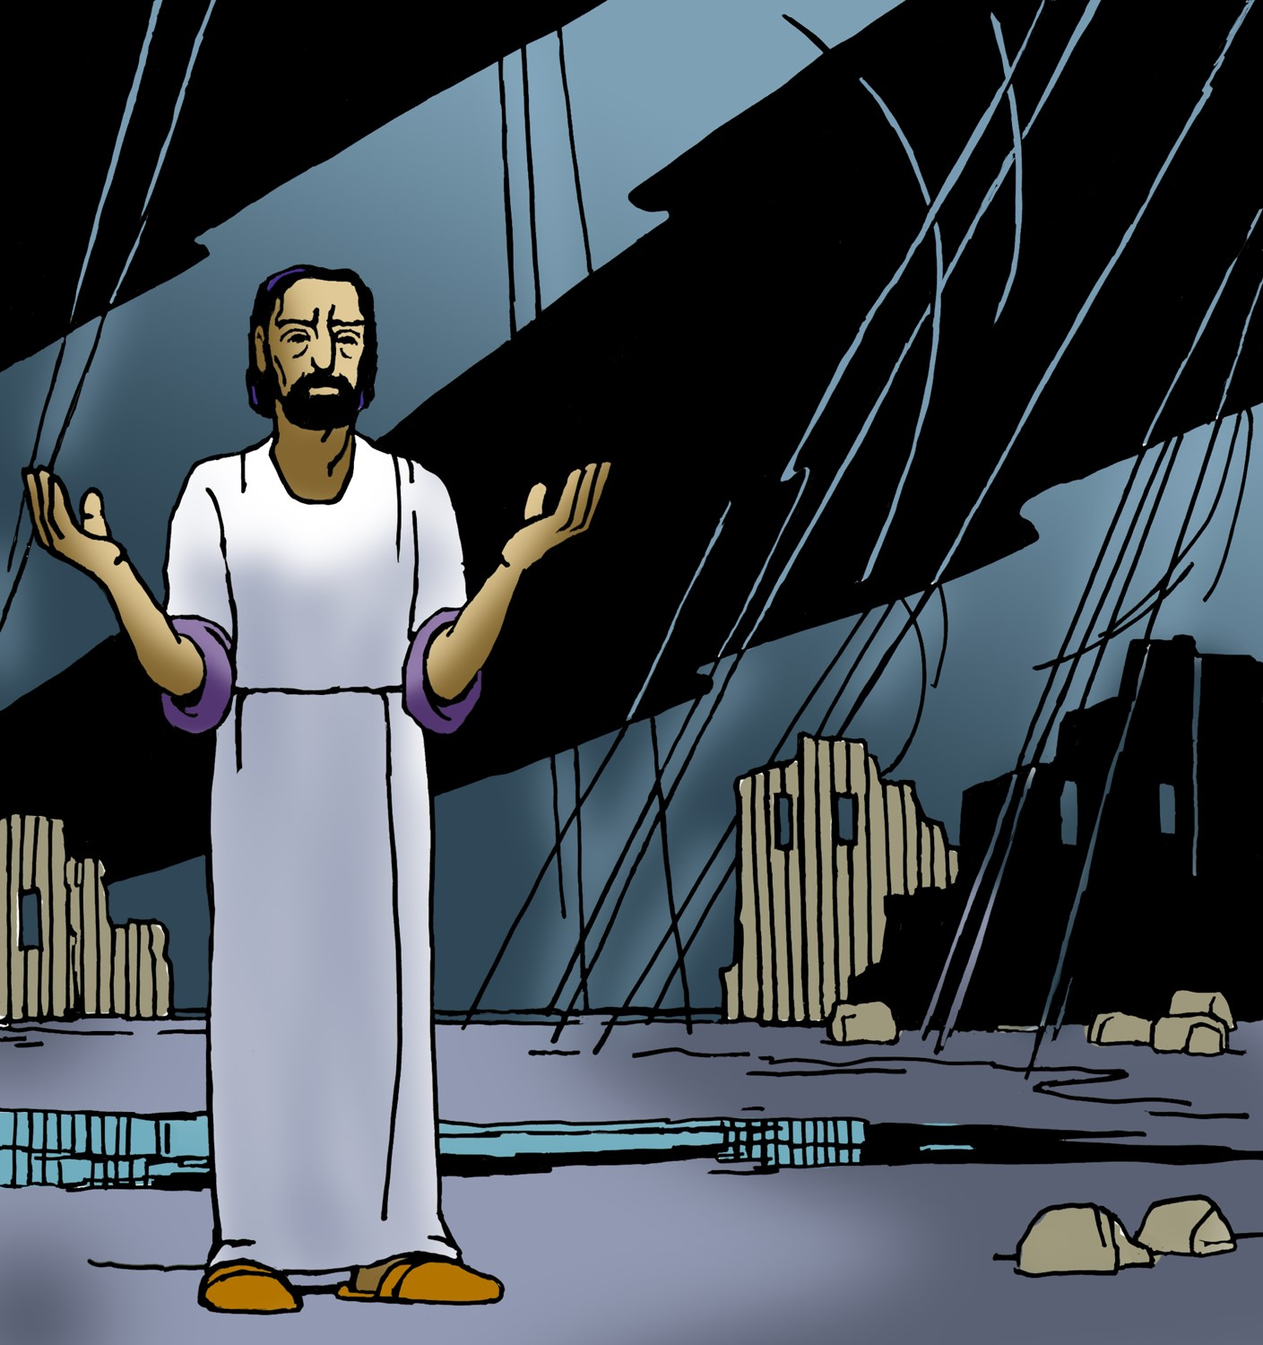
Twenty Third Sunday After Pentecost
Proper 28 (Year C)
Holy Eucharist II
November 16 , 2025
10:00 AM In person and Online
Welcome to Trinity Episcopal, Sonoma!
Whether you have wandered in, are wondering about God or grew up in the church, or wherever you are in your journey...you are welcome here... We are blessed by your presence.
For Visitors and Newcomers:
Everyone is welcome to receive communion at the Lord’s table. Jesus gave this tangible reminder of God’s presence, love, and forgiveness for all. If you are interested in a visit or call from the Priest-in-Charge , please sign our guest book on the table at the entrance of the church, including an email or phone number.
Restrooms
A restroom is located outside the entrance of Buttrum Hall (the building across the courtyard) and another is located inside the hall to the right.
Coffee and Treats:
Following worship we have coffee and treats after service in Buttrum Hall. We hope it is a time to get to know you better.
To access Trinity’s Guest WIFI: Password Rosepettal441 (case sensitive).
We are glad you are here, and we invite you to enter fully into worship this morning.
November Announcements
Pastor Cindy would like to know if there is interest in an Adult Education time either following Sunday worship or an early evening time. If you have suggestions on a class you’d like Pastor Cindy to lead next, please contact the office 707-938-4846 or speak with her directly.
The Free Movie night series hosted by Trinity Episcopal in Sonoma, will be continuing this December, Wednesday 10th with “It’s a Wonderful Life”. Please join us at 6PM for the movie and engage in a conversation about the film afterward.
Fellowship Coffee Hour Sign up - We encourage members to sign up to make coffee. Pastor Cindy is happy to demonstrate how easy this is. Please help us provide this hospitality for guests and members.
This month’s vestry meeting will be on Thursday the 20th instead of the 27th due to the Thanksgiving.
Sonoma Valley Interfaith Ministry will be having a Thanksgiving Eve Interfaith Service on November 26th at 6:30pm. The service will be at St Andrews Presbyterian Church, 16290 Arnold Dr, Sonoma.
The November, December, January Forward Day by Day , a booklet of daily inspirational meditations is now available in the Church and the Office. We ask for a $2 donation.
Potluck immediately following the December 7th service. Join us for a meal and conversation. Be prepared to give Trinity your feedback and questions as we discuss this period of transition.
Christmas Eve Service will be at 3PM on December 24! Come celebrate the birth of our Lord!
This Advent 2025, starting on Sunday November 30th, join us on Sunday as Pastor Cindy breaks down the season of advent in a series of custom lessons crafted for our Parish
All are welcome to make a gift and offering in thanksgiving to God;
for the many blessings we have received. To take advantage of our electronic giving options, please follow the QR code with your capable electronic device, or visit https://onrealm.org/trinitysonoma/-/form/give/default Help us to make this a place where God’s grace is freely shared by all.


Prelude Steve Rubardt
Please stand for the Entrance Hymn.
At the sound of the bell, please stand as you are able. The People respond when bold text appears.
The Word of God
Entrance Hymn All Creatures of Our God and King H 400
Opening Acclamation BCP 319
Celebrant | Blessed be God: Father, Son, and Holy Spirit.
People | And blessed be his kingdom, now and for ever. Amen.
Collect for Purity
All Almighty God, to you all hearts are open, all desires known, and from you no secrets are hid: Cleanse the thoughts of our hearts by the inspiration of your Holy Spirit, that we may perfectly love you, and worthily magnify your holy Name; through Christ our Lord. Amen.
Song of Praise Gloria BCP 356/Hymnal S-280
All Glory to God in the highest,
and peace to his people on earth.
Lord God, heavenly King,
almighty God and Father,
we worship you, we give you thanks,
we praise you for your glory.
Lord Jesus Christ, only Son of the Father,
Lord God, Lamb of God,
you take away the sin of the world:
have mercy on us;
you are seated at the right hand of the Father:
receive our prayer.
For you alone are the Holy One,
you alone are the Lord,
you alone are the Most High,
Jesus Christ,
with the Holy Spirit,
in the glory of God the Father. Amen.
The Collect of the Day BCP 357
Celebrant | The Lord be with you.
People | And also with you.
Celebrant | Let us pray.
Blessed Lord, who caused all holy Scriptures to be written for our learning: Grant us so to hear them, read, mark, learn, and inwardly digest them, that we may embrace and ever hold fast the blessed hope of everlasting life, which you have given us in our Savior Jesus Christ; who lives and reigns with you and the Holy Spirit, one God, for ever and ever. All Amen.
The Lessons
First Reading: Malachi 4:1-2a
Reader A Reading from the book of the prophet Malachi.
¹See, the day is coming, burning like an oven, when all the arrogant and all evildoers will be stubble; the day that comes shall burn them up, says the Lord of hosts, so that it will leave them neither root nor branch. ^{2a}But for you who revere my name the sun of righteousness shall rise, with healing in its wings.

Reader | The Word of the Lord.
People | Thanks be to God.


The Psalm: Psalm 98
Reader Our response to the reading is Psalm 98 which we will read responsively by half verse.
¹Sing to the Lord a new song, *
for he has done marvelous things.
²With his right hand and his holy arm *
has he won for himself the victory.
³The Lord has made known his victory; *
his righteousness has he openly shown in the sight of the nations.
⁴He remembers his mercy and faithfulness to the house of Israel, *
and all the ends of the earth have seen the victory of our God.
⁵Shout with joy to the Lord, all you lands; *
lift up your voice, rejoice, and sing.
⁶Sing to the Lord with the harp, *
with the harp and the voice of song.
⁷With trumpets and the sound of the horn *
shout with joy before the king, the Lord.
⁸Let the sea make a noise and all that is in it, *
the lands and those who dwell therein.
⁹Let the rivers clap their hands, *
and let the hills ring out with joy before the Lord,
when he comes to judge the earth.
¹⁰In righteousness shall he judge the world *
and the peoples with equity.


Second Reading: 2 Thessalonians 3:6-13
Reader A Reading from Paul's Second letter to the Church in Thessalonika.
⁶Now we command you, beloved, in the name of our Lord Jesus Christ, to keep away from believers who are living in idleness and not according to the tradition that they received from us. ⁷For you yourselves know how you ought to imitate us; we were not idle when we were with you, ⁸and we did not eat anyone’s bread without paying for it; but with toil and labor we worked night and day, so that we might not burden any of you. ⁹This was not because we do not have that right, but in order to give you an example to imitate. ¹⁰For even when we were with you, we gave you this command: Anyone unwilling to work should not eat. ¹¹For we hear that some of you are living in idleness, mere busybodies, not doing any work. ¹²Now such persons we command and exhort in the Lord Jesus Christ to do their work quietly and to earn their own living. ¹³Brothers and sisters, do not be weary in doing what is right.

Reader | The Word of the Lord.
People | Thanks be to God.
Sequence Hymn Awake, My Soul, and with the Sun H11 v 1 & 2

The Holy Gospel: Luke 21:5-19
Celebrant | The Holy Gospel of our Lord Jesus Christ according to Luke.
People | Glory to you, Lord Christ.
⁵When some were speaking about the temple, how it was adorned with beautiful stones and gifts dedicated to God, [Jesus] said, ⁶“As for these things that you see, the days will come when not one stone will be left upon another; all will be thrown down.”
⁷They asked him, “Teacher, when will this be, and what will be the sign that this is about to take place?” ⁸And he said, “Beware that you are not led astray; for many will come in my name and say, ‘I am he!’ and, ‘The time is near!’ Do not go after them.
⁹“When you hear of wars and insurrections, do not be terrified; for these things must take place first, but the end will not follow immediately.” ¹⁰Then he said to them, “Nation will rise against nation, and kingdom against kingdom; ¹¹there will be great earthquakes, and in various places famines and plagues; and there will be dreadful portents and great signs from heaven.
¹²“But before all this occurs, they will arrest you and persecute you; they will hand you over to synagogues and prisons, and you will be brought before kings and governors because of my name. ¹³This will give you an opportunity to testify. ¹⁴So make up your minds not to prepare your defense in advance; ¹⁵for I will give you words and a wisdom that none of your opponents will be able to withstand or contradict. ¹⁶You will be betrayed even by parents and brothers, by relatives and friends; and they will put some of you to death. ¹⁷You will be hated by all because of my name. ¹⁸But not a hair of your head will perish. ¹⁹By your endurance you will gain your souls.”
Celebrant | The Gospel of the Lord.
People | Praise to you, Lord Christ.
Sequence Hymn Awake, My Soul, and with the Sun H 11 v 3 & 4
The Sermon Pastor Cindy Beck
The Nicene Creed (BCP p. 358)
The Prayers of the People
Celebrant: Believers, do not be weary in doing what is right. It is right to give God thanks and praise; therefore, let us say, “Sing to the Lord a new song: O God, you have done marvelous things!”
Intercessor: O God, remember your mercy and faithfulness to your Church. Give us your words and your wisdom. May we have the strength to bear the name of Jesus in all circumstances.
In the Diocesan Cycle of Prayer, we pray for St. John’s in Marysville.
In the Anglican Cycle of Prayer, we pray for The Episcopal / Anglican Province of Alexandria.
Silence
Sing to the Lord a new song:
O God, you have done marvelous things!
O God, remember your mercy and faithfulness to this nation. Save us from arrogance and self-reliance. Grant us to be a nation that favors peace over war, life rather than death.
Silence
Sing to the Lord a new song:
O God, you have done marvelous things!
O God, remember your mercy and faithfulness to all of creation. May the seas and their creatures noisily praise you; may the rivers clap their hands and the hills ring out with joy before you, their Creator.
Invite the congregation to add their petitions and thanksgivings, followed by silence
Sing to the Lord a new song:
O God, you have done marvelous things!
O God, remember your mercy and faithfulness to our city. We pray that there may be work enough for all our citizens, that they might earn a living that promotes dignity and health.
Silence
Sing to the Lord a new song:
O God, you have done marvelous things!
O God, remember your mercy and faithfulness to all your children, especially those who are sick and suffering. Come to them, Lover of Souls, with healing in your wings.
Invite the congregation to add their petitions, followed by silence
Sing to the Lord a new song:
O God, you have done marvelous things!
O God, remember your mercy and faithfulness to all who have died. Bless them for their endurance. May they forever rest in that land where the sound of weeping is heard no more.
Invite the congregation to add their petitions, followed by silence
Sing to the Lord a new song:
O God, you have done marvelous things!
The Confession of Sin BCP 359
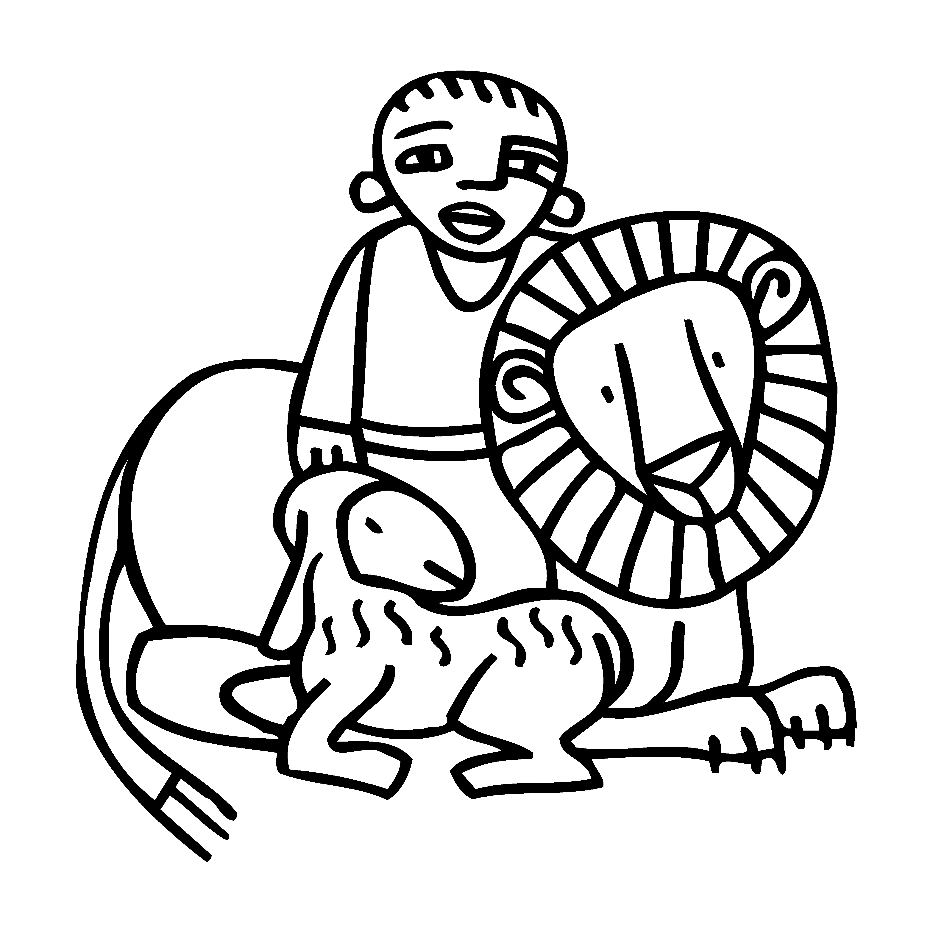
The Peace
Celebrant The peace of the Lord be always with you.
People And also with you.
Announcements
Birthdays, Anniversaries, Travelers (prayers found at back of bulletin)

The Holy Communion
The Offertory At the Offering, you’ll find a Pledge card in the Pew Rack for those who’d like to designate their financial donations to Trinity’s Pledging Income. For others, or a one-time gift, envelopes are in the pew racks as well as on the Narthex table or text TRINITYSONOMA" to 73256. Thank you!
Offertory Music
Steve Rubardt and Choir You who Dwell in the Shelter of the Lord WLP810
Doxology
The people stand while the offerings are presented and placed on the Altar.
Presider: Gracious God, as an offering of our thanksgiving and gratitude, we return to you a portion of what you have gifted us.
The Great Thanksgiving
Eucharistic Prayer B BCP 367
Celebrant | The Lord be with you.
People | And also with you.
Celebrant | Lift up your hearts.
People | We lift them to the Lord.
Celebrant | Let us give thanks to the Lord our God.
People | It is right to give him thanks and praise.
Proper Preface (BCP p. 367)
It is right, and a good and joyful thing, always and everywhere to give thanks to you, Father Almighty, Creator of heaven and earth.
For you are the source of light and life; you made us in your image, and called us to new life in Jesus Christ our Lord.
Therefore we praise you, joining our voices with Angels and Archangels and with all the company of heaven, who for ever sing this hymn to proclaim the glory of your Name:

Sanctus Holy Holy, Holy (Proulx) Hymnal S-125
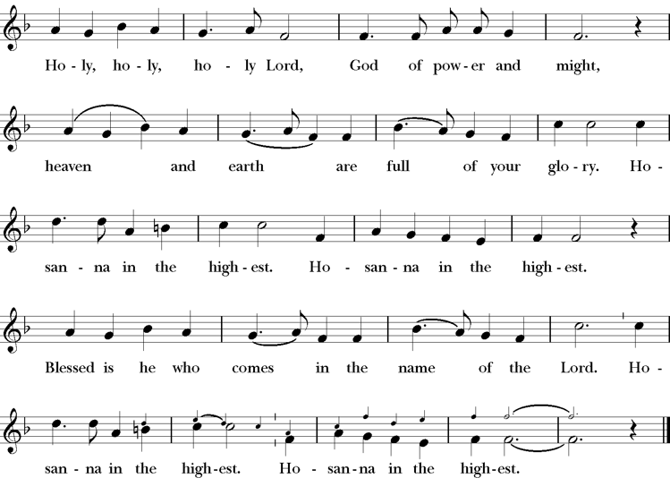
Words of Institution BCP 368
The Lord’s Prayer 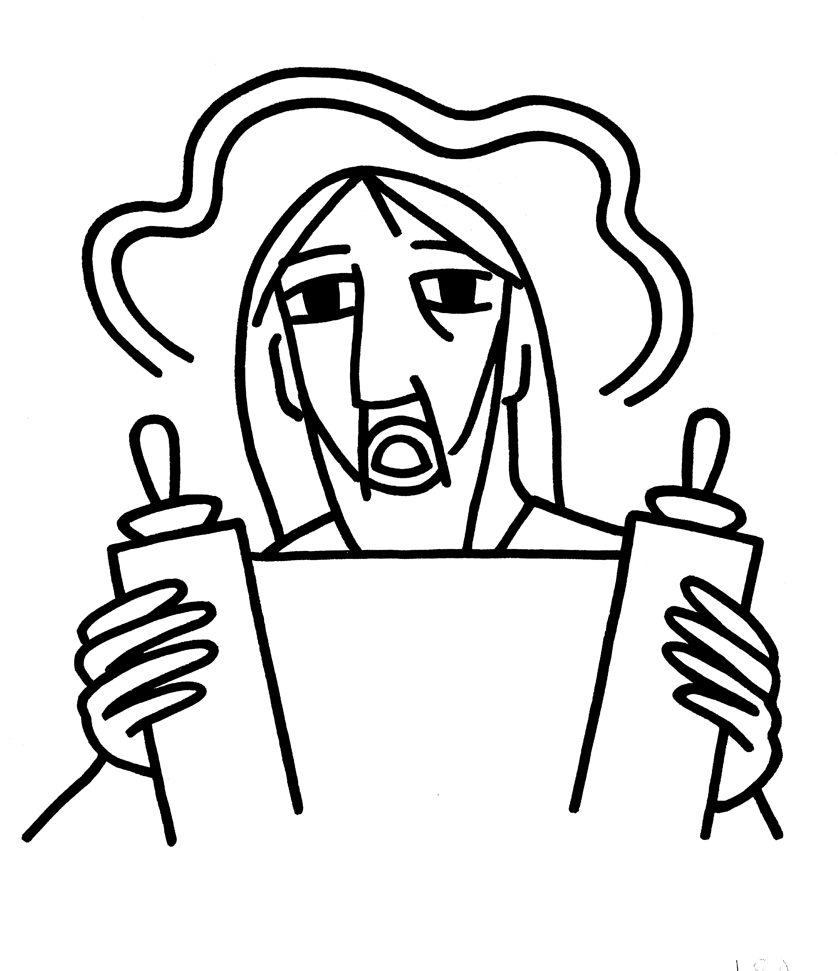 BCP 364
The Breaking of the Bread  BCP 364

Fraction Anthem S-154
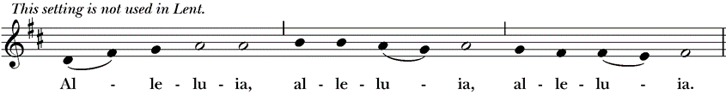
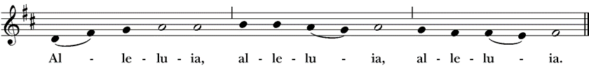
All are welcome at the Lord’s table to receive Holy Communion or a blessing. To receive Communion in your pew, please ask an usher to notify the ministers on your behalf. If you require a gluten-free wafer, please ask at the altar rail.

Communion Music Steve Rubardt & Choir
If thou but Trust In God to Guide You H 635
Post-Communion Prayer BCP 365
The Blessing
The Recessional Hymn Down by the Riverside LEVAS 210
The Dismissal*
Celebrant | Let us go forth in the name of Christ.
People | Thanks be to God.
Postlude Steve Rubardt
Please remain seated

SERVING TODAY
Celebrant and Preacher: Pastor Cindy Beck
Eucharistic Minister: Bill Bonnet
Acolyte: Arminda Eiler
Lector: Bill Doyle , Douglas Griffin
Intercessor: Ann Kyser
Worship Musician: Steve Rubardt
Choir Leader: Steve Rubardt
Choir: Liz Carpenter, Heather Dahlberg, Scott Sherman, Lucy Maushardt, Patsy Gralow, Laurell Meredith, Mary Omodt, Barbara Feduska, Tara Anderson
Sunday School - Child Care: Wendy Aguilar Appt Only
Ushers: John Eiler
Tech Chaplain: Marcos Rendon
Altar Guild: Ann Kyser
Hospitality: Dale Stokes
Flowers: Marianne Uhl
In Honor of Carlo Cestaroll
Altar Flowers are given to the glory of God by Altar Guild.

Prayers requested for these on Trinity’s long-term prayer list: Baby Walker David, Armando P, Laura Basett, , Georgia Bostedt, Muff Davey, John Eiler, Gerrilee Fisher, Claire Ginesi, Mary Griffin, David & Christine Hilt, Dr. Tamer Keshen, Marie Lambert, Mark Mezzetta, Kelcey Omodt, Grizelda Ponce, Barry Reap, Blake W, Robert R, Ann Loveland Sherman, John Spooner, James Thomas, Rose Burns, Jennifer Gralow, Patsy Gralow, Denny Hoelter, Steve Antenen, Van Z, Sandra Leland, John Forester, Stuart , Melissa White.
Prayers for the Repose of soul: Tim Dowd , Susan Bassett, Joan Biersch, Mere Nagasau, Christina Van Krugel, Linda Dowd, Peggy and John Bell
Contact Pastoral Care Chair, Lorena lorena.m.reinhardt@gmail.com to make any additions or to remove names from our Long-Term Prayer list.

About this Service: Year C
Calendar of the Church Year
The calendar (BCP, pp. 15-33) orders the liturgical year of the Episcopal Church by identifying two cycles of feasts and holy days-one dependent upon the movable date of Easter Day and the other dependent upon the fixed date of Christmas, Dec. 25. Easter Day is the first Sunday after the full moon that falls on or after Mar. 21. The sequence of all Sundays in the church year is based on the date of Easter. Tables and rules for finding the date of Easter Day, and other movable feasts and holy days are provided by the BCP, pp. 880-885. The date of Easter determines the beginning of the season of Lent on Ash Wednesday and the date of Pentecost on the fiftieth day of the Easter season. The Sundays of Advent are always the four Sundays before Christmas Day. The church year begins on the first Sunday of Advent. The calendar also identifies and provides directions concerning the precedence and observance of principal feasts, Sundays, holy days (including Feasts of our Lord, other major feasts, and fasts), Days of Special Devotion, and Days of Optional Observance. The calendar lists dates for celebration of major feasts and lesser feasts by month and date. Appropriate Sunday Letters and Golden Numbers are also provided. (see BCP, pp. 880-881). The calendar also lists the titles of the seasons, Sundays, and major holy days observed in the Episcopal Church throughout the church year, including Advent season, Christmas season, Epiphany season, Lenten season, Holy Week, Easter season, the season after Pentecost, holy days, and National Days.
About this Service: The Season after Pentecost
Our current liturgical season, the Season after Pentecost, is by far the longest of the Episcopal church year. It begins the day after Pentecost and ends the day before the First Sunday of Advent. Since the date of Easter changes every year—and the Day of Pentecost is always 50 days after Easter—the length of the season varies as well, ranging from 24-29 weeks in length. This season is sometimes called Ordinary Time, a phrase borrowed from the Roman Catholic Church. A common practice among Episcopal churches is to change the appropriate liturgical elements at the start of each new season. Often these changes are directed by the Book of Common Prayer, such as the acclamations named for use in the Lenten and Easter seasons. However, liturgical leaders also decide which Prayers of the People, Eucharistic Prayer, blessing, and dismissal are used in services.


Trinity Liturgical Ministry ROTA Next two weeks

Date | Celebrant | Ushers | Euch Min | Acolyte | Lector (s) | Intercessor | Altar Guild
Nov 23 | Cindy Beck | Jane Hernandez |  | Susie Hand | Douglas Griffin Jane Hernandez | Lorena Reinhardt | Susie Hand
Nov 30 | Cindy Beck | John Eiler |  | Arminda Eiler | Bill Doyle Gerrilee FIsher | Jane Hernandez | Laurell Meredith Elizabeth Carpenter

Schedule of Weekly Meetings and Services at Trinity Episcopal Sonoma

Day | Date | Time | Occasion | Location
Wednesday | November 19 | 11 AM | Bible Study | Library
Thursday | November 20 | 10:30 AM  5:30 PM | Mindfulness & Well Being  Alcoholics Anonymous | Library  Buttrum Hall
Saturday | November 22 | 8 AM | Centering Prayer | St. Luke’s Chapel
Sunday | November 23 | 10:15 AM | Holy Eucharist II | Sanctuary
Mon-Fri | Weekdays | 7AM-1PM | Sonoma Home Meals | Kitchen &Buttrum Hall
Mon-Fri | Weekdays | 9-2 | Sonoma Preschool Academy – School

Monthly Meetings at Trinity Episcopal Sonoma

Day | Date | Time | Meeting | Location | Contact
Tuesday | November 4 | 11 AM | Prayer Shawl Ministry | Library | Norah Collins 28norahe@gmail.com
Thursday | November 20 | 4:30 PM | Vestry | Library | Claire Ginesi cfgsonoma@gmail.com

PRAYERS and BLESSINGS

For a Birthday
Watch over your child, O Lord as his/her days increase; bless and guide him/her wherever s/he may be. Strengthen them when s/he stands; comfort him/her when discouraged or sorrowful; raise him/her up if s/he fall; and in his/her heart may your peace which passes understanding abide all the days of his/her life; through Jesus Christ our Lord. Amen.
For an Anniversary
O God, you have so consecrated the covenant of marriage that it represents the spiritual unity between Christ and his Church: Send your blessing upon these your servants as they celebrate their anniversary, that they may continue to love, honor and cherish each other in faithfulness and patience, in wisdom and true godliness, that their home may be a haven of blessing and peace; through Jesus Christ our Lord, who lives and reigns with you and the Holy Spirit, one God, now and forever. Amen.
For Travelers
O God, our heavenly Father, whose glory fills the whole creation, and whose presence we find wherever we go; preserve those who travel; surround them with your loving care; protect them from every danger, and bring them in safety to their journey’s end; through Jesus Christ our Lord. Amen.
Sending our Eucharistic Visitors
Priest: In the name of this congregation, I send you forth bearing these holy gifts, the those to whom you go may share with us in the communion of Christ’s body and blood.
People: We who are many are one body, because we all share on bread, and one cup. Amen

Trinity Episcopal Church
In Sonoma for over 170 years
275 East Spain Street
Sonoma, CA 95476
The Rt. Rev. Megan M. Traquair, Bishop
Diocese of Northern California
Pastor Cindy Beck, Interim
Steve Rubardt, Worship Music
Vestry
Claire Ginesi, Senior Warden
Bill Doyle, Junior Warden (Buildings, Grounds)
Bill Doyle (Stewardship)
Susie Hand
Heather Dahlberg
Sally Thornhill
Lorena Reinhardt (Pastoral Care)
Ministries
Prayer Shawl ,Norah Collins
Outreach, Jane Hernandez
Youth – Academic Tutoring, Karen Randall
Mindfulness & Well Being, Mary Omodt
Sunday School, Children, Wendy Aguilar

The Members of the Congregation are The Ministers of the Church

Administrative Office Hrs.
Monday Wednesday 9 A.M. – 2 PM; Thursday 10A.M.-2 P.M0
Sunday 9:30-11:30
Clergy Office Hours Wednesdays, Thursdays, by appointment

Emergency, sickness, please contact office: 707-938-4846

