Trinity Episcopal Church
Cultivating God’s Loving Spirit in each of us
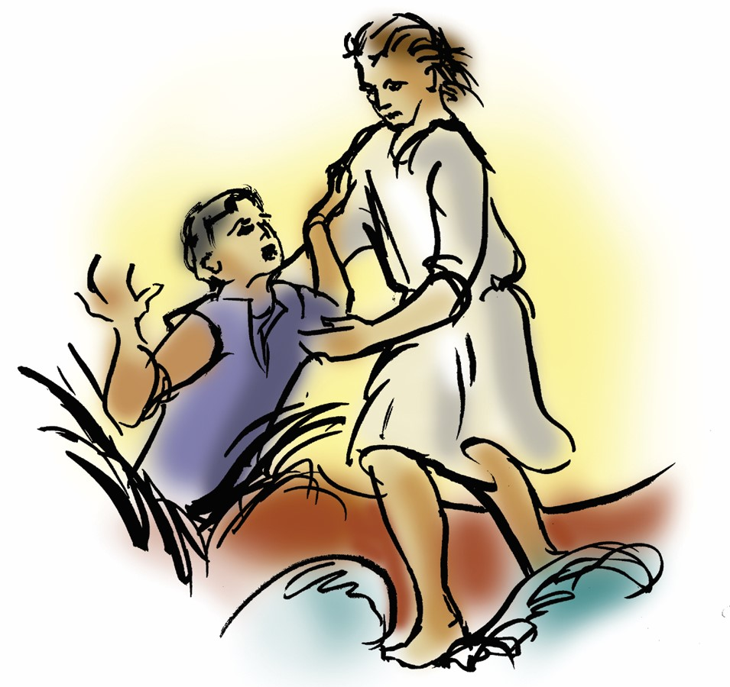
Proper 14
Year A
Holy Eucharist II
August 9th, 2026
10:00 AM In person and Online

Welcome to Trinity Episcopal, Sonoma. Whether you are passing through or looking for a church home, we are blessed by your presence and we invite you to worship with us fully – singing, praying and receiving communion- with your voice and heart. Please sign our guestbook at the back of the church, including your email.
If you would like to learn more about The Episcopal Church, please send us an email trinityepiscopalsonoma@comcast.net. We look forward to meeting you after the service where coffee and treats are served.
Did you know that....
…As part of our Spirituality Outreach:
1. A Little Library has been purchased for the community to borrow (or keep) spiritual books? If you have books to donate, please let Mary Omodt know. We'll provide Mary's contact information for you by calling the Office at (______ fill in the number)
2. We are exploring setting up a Prayer Wall in front for people to leave prayer requests?
...In response to our Senior Isolation Outreach
1. Pastor Cindy contacted the Council on Aging to learn more about their visitation program to seniors? When she receives information, she will pass it on.
2. A Senior Resource booklet can be found in the back of the church along with a flyer providing information about Free Rides for Seniors.

All are welcome to make a gift and offering in thanksgiving to God; for the many blessings we have received. To take advantage of our electronic giving options, please follow the QR code with your capable electronic device, or visit https://onrealm.org/trinitysonoma/-/form/give/default
July Announcements
Fellowship Coffee Hour Sign up – Fellowship follows the service! We meet in the hall or courtyard. We’d love to visit with you.
Thank you to everyone who donated food for A Simple Gesture, your gift helps people have a meal!
BRIEF Congregational Meeting after worship on Sunday, August 23rd. The only agenda item is to elect Doug Griffin to Vestry. He is serving as Trinity’s Treasurer.

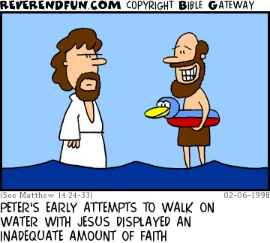

Prelude Steve Rubardt
Please stand for the Entrance Hymn.
At the sound of the bell, please stand as you are able. The People respond when bold text appears.
The Word of God
Entrance Hymn Commit Thou All That Grieves Thee H 669
Opening Acclamation BCP 319
Celebrant | Blessed be God: Father, Son, and Holy Spirit.
People | And blessed be his kingdom, now and for ever. Amen.
Collect for Purity
All Almighty God, to you all hearts are open, all desires known, and from you no secrets are hid: Cleanse the thoughts of our hearts by the inspiration of your Holy Spirit, that we may perfectly love you, and worthily magnify your holy Name; through Christ our Lord. Amen.
Song of Praise Glory to God Hymn S-280 is sung, all standing
Glory to God in the highest,
and peace to his people on earth.
Lord God, heavenly King,
almighty God and Father,
we worship you, we give you thanks,
we praise you for your glory.
Lord Jesus Christ, only Son of the Father,
Lord God, Lamb of God,
you take away the sin of the world:
have mercy on us;
you are seated at the right hand of the Father:
receive our prayer.
For you alone are the Holy One,
you alone are the Lord,
you alone are the Most High,
Jesus Christ,
with the Holy Spirit,
in the glory of God the Father. Amen.
The Collect of the Day BCP 357
Celebrant | The Lord be with you.
People | And also with you.
Celebrant | Let us pray.
Grant to us, Lord, we pray, the spirit to think and do always those things that are right, that we, who cannot exist without you, may by you be enabled to live according to your will; through Jesus Christ our Lord, who lives and reigns with you and the Holy Spirit, one God, for ever and ever. All Amen.
The Lessons
First Reading: 1 Kings 19:9-18
Reader A Reading from the First book of Kings.
⁹[Elijah] came to a cave, and spent the night there.
Then the word of the Lord came to him, saying, “What are you doing here, Elijah?”¹⁰He answered, “I have been very zealous for the Lord, the God of hosts; for the Israelites have forsaken your covenant, thrown down your altars, and killed your prophets with the sword. I alone am left, and they are seeking my life, to take it away.”
¹¹He said, “Go out and stand on the mountain before the Lord, for the Lord is about to pass by.” Now there was a great wind, so strong that it was splitting mountains and breaking rocks in pieces before the Lord, but the Lord was not in the wind; and after the wind an earthquake, but the Lord was not in the earthquake; ¹²and after the earthquake a fire, but the Lord was not in the fire; and after the fire a sound of sheer silence. ¹³When Elijah heard it, he wrapped his face in his mantle and went out and stood at the entrance of the cave. Then there came a voice to him that said, “What are you doing here, Elijah?” ¹⁴He answered, “I have been very zealous for the Lord, the God of hosts; for the Israelites have forsaken your covenant, thrown down your altars, and killed your prophets with the sword. I alone am left, and they are seeking my life, to take it away.” ¹⁵Then the Lord said to him, “Go, return on your way to the wilderness of Damascus; when you arrive, you shall anoint Hazael as king over Aram. ¹⁶Also you shall anoint Jehu son of Nimshi as king over Israel; and you shall anoint Elisha son of Shaphat of Abel-meholah as prophet in your place. ¹⁷Whoever escapes from the sword of Hazael, Jehu shall kill; and whoever escapes from the sword of Jehu, Elisha shall kill. ¹⁸Yet I will leave seven thousand in Israel, all the knees that have not bowed to Baal, and every mouth that has not kissed him.”
Reader | The Word of the Lord.
People | Thanks be to God.
The Psalm: Psalm 85:8-13
Reader Our response to the reading is Psalm 85:8-13, which we will read responsively by half verse.
⁸I will listen to what the Lord God is saying, *
for he is speaking peace to his faithful people
and to those who turn their hearts to him.
⁹Truly, his salvation is very near to those who fear him, *
that his glory may dwell in our land.
¹⁰Mercy and truth have met together; *
righteousness and peace have kissed each other.
¹¹Truth shall spring up from the earth, *
and righteousness shall look down from heaven.
¹²The Lord will indeed grant prosperity, *
and our land will yield its increase.
¹³Righteousness shall go before him, *
and peace shall be a pathway for his feet.

Second Reading: Romans 10:5-15
Reader A Reading from Paul's letter to the Church in Rome.
⁵Moses writes concerning the righteousness that comes from the law, that “the person who does these things will live by them.” ⁶But the righteousness that comes from faith says, “Do not say in your heart, ‘Who will ascend into heaven?’ ” (that is, to bring Christ down) ⁷“or ‘Who will descend into the abyss?’ ” (that is, to bring Christ up from the dead). ⁸But what does it say?
“The word is near you,
on your lips and in your heart”
(that is, the word of faith that we proclaim); ⁹because if you confess with your lips that Jesus is Lord and believe in your heart that God raised him from the dead, you will be saved. ¹⁰For one believes with the heart and so is justified, and one confesses with the mouth and so is saved. ¹¹The scripture says, “No one who believes in him will be put to shame.” ¹²For there is no distinction between Jew and Greek; the same Lord is Lord of all and is generous to all who call on him. ¹³For, “Everyone who calls on the name of the Lord shall be saved.”
¹⁴But how are they to call on one in whom they have not believed? And how are they to believe in one of whom they have never heard? And how are they to hear without someone to proclaim him? ¹⁵And how are they to proclaim him unless they are sent? As it is written, “How beautiful are the feet of those who bring good news!”
Reader | The Word of the Lord.
People | Thanks be to God.

Sequence Hymn We Walk by Faith H 209 v 1 & 2
The Holy Gospel: Matthew 14:22-33
Celebrant | The Holy Gospel of our Lord Jesus Christ according to Matthew.
People | Glory to you, Lord Christ.
²²[Jesus] made the disciples get into the boat and go on ahead to the other side, while he dismissed the crowds.²³And after he had dismissed the crowds, he went up the mountain by himself to pray. When evening came, he was there alone, ²⁴but by this time the boat, battered by the waves, was far from the land, for the wind was against them. ²⁵And early in the morning he came walking toward them on the sea. ²⁶But when the disciples saw him walking on the sea, they were terrified, saying, “It is a ghost!” And they cried out in fear. ²⁷But immediately Jesus spoke to them and said, “Take heart, it is I; do not be afraid.”
²⁸Peter answered him, “Lord, if it is you, command me to come to you on the water.” ²⁹He said, “Come.” So Peter got out of the boat, started walking on the water, and came toward Jesus. ³⁰But when he noticed the strong wind, he became frightened, and beginning to sink, he cried out, “Lord, save me!” ³¹Jesus immediately reached out his hand and caught him, saying to him, “You of little faith, why did you doubt?” ³²When they got into the boat, the wind ceased. ³³And those in the boat worshiped him, saying, “Truly you are the Son of God.”
Celebrant | The Gospel of the Lord.
People | Praise to you, Lord Christ.
Sequence Hymn We Walk by Faith H 209 v 3 & 4
Sermon Pastor Cindy Beck
The Nicene Creed (BCP p. 358)
We believe in one God, the Father, the Almighty, maker of heaven and earth, of all that is, seen and unseen.
We believe in one Lord, Jesus Christ, the only Son of God, eternally begotten of the Father, God from God, Light from Light, true God from true God, begotten, not made, of one Being with the Father. Through him all things were made. For us and for our salvation he came down from heaven: by the Power of the Holy Spirit he became incarnate from the Virgin Mary, and was made man. For our sake he was crucified under Pontius Pilate; he suffered death and was buried. On the third day he rose again in accordance with the Scriptures; he ascended into heaven and is seated at the right hand of the Father. He will come again in glory to judge the living and the dead, and his kingdom will have no end.
We believe in the Holy Spirit, the Lord, the giver of life, who proceeds from the Father and the Son. With the Father and the Son he is worshipped and glorified. He has spoken through the Prophets. We believe in one holy catholic and apostolic Church. We acknowledge one baptism for the forgiveness of sins. We look for the resurrection of the dead, and the life of the world to come. Amen.
The Prayers of the People
Celebrant: As Peter cried out from the waves, let us cry to the Lord our God, who hears our voice from the heart of the flood.
Intercessor: For this holy gathering, for our parish clergy, for N. our bishop and N. our Presiding Bishop, and for the people of God in every place.
In the Diocesan Cycle of Prayer, we pray for Trinity Cathedral in Sacramento.
In the Anglican Cycle of Prayer, we pray for The Episcopal Church.
Christ, have mercy.
For N. our President, N. our Governor, N. our Mayor; for all nations and their leaders, and for mercy, justice, and peace in the world.
Silence
Christ, have mercy.
For farmers and a good harvest, for sailors and all who work at sea, for travelers and those on vacation, for students and faculty returning to classes, and for safety from violent storms, +_________________
Invite the congregation to add their thanksgivings, followed by silence
Christ, have mercy.
For our city and every community, and for our families, companions, and all we love.
Silence
Christ, have mercy.
For all those in danger and need: the sick and the dying, the poor and the oppressed, prisoners and their families, victims of terror, and those who commit violence, +________________.
Invite the congregation to add their petitions, followed by silence
Christ, have mercy.
For those who rest in Christ and for all the dead, +___________________.
Invite the congregation to add their petitions, followed by silence
Christ, have mercy.
Lifting our voices with all creation, with the blessed Virgin Mary and all the saints, let us offer ourselves and one another to the living God through Christ.
To you, Creator God.
Celebrant Lord of wind and water, hear the prayers we offer this day for all battered by the waves of this world and bring them in safety to your harbor; through Jesus Christ our Lord.
Amen.
The Peace
Celebrant The peace of the Lord be always with you.
People And also with you.
Announcements
Birthdays, Anniversaries, Travelers (prayers found at back of bulletin)

The Holy Communion
The Offertory At the Offering, you’ll find a Pledge card in the Pew Rack for those who’d like to designate their financial donations to Trinity’s Pledging Income. For others, or a one-time gift, envelopes are in the pew racks as well as on the Narthex table or text TRINITYSONOMA" to 73256. Thank you!
Offertory Music
Steve Rubardt and Choir Wayfaring Stranger LEVAS 19
Doxology
Praise God, from whom all blessings flow;
Praise Him, all creatures here below;
Praise Him above, ye heav'nly host;
Praise Father, Son, and Holy Ghost.
Amen.
The people stand while the offerings are presented and placed on the Altar.
Presider: Gracious God, as an offering of our thanksgiving and gratitude, we return to you a portion of what you have gifted us.
The Great Thanksgiving
Eucharistic Prayer B BCP 367
Celebrant | The Lord be with you.
People | And also with you.
Celebrant | Lift up your hearts.
People | We lift them to the Lord.
Celebrant | Let us give thanks to the Lord our God.
People | It is right to give him thanks and praise.
Proper Preface (BCP p. 367)
It is right, and a good and joyful thing, always and everywhere to give thanks to you, Father Almighty, Creator of heaven and earth.
For you are the source of light and life; you made us in your image, and called us to new life in Jesus Christ our Lord.
Therefore we praise you, joining our voices with Angels and Archangels and with all the company of heaven, who for ever sing this hymn to proclaim the glory of your Name:
Sanctus Holy Holy, Holy (Proulx) Hymnal S-125
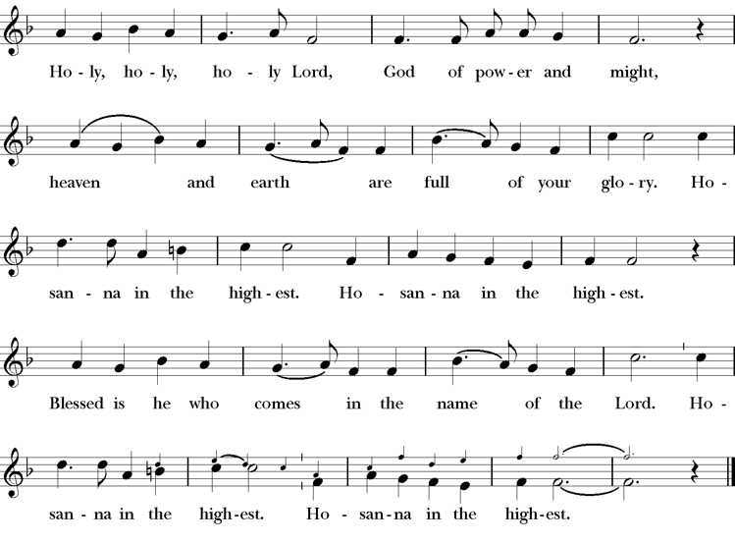
Presider Holy and gracious Father: In your infinite love you made us for yourself; and, when we had fallen into sin and become subject to evil and death, you, in your mercy, sent Jesus Christ, your only and eternal Son, to share our human nature, to live and die as one of us, to reconcile us to you, the God and Father of all.
He stretched out his arms upon the cross, and offered himself, in obedience to your will, a perfect sacrifice for the whole world.
On the night he was handed over to suffering and death, our Lord Jesus Christ took bread; and when he had given thanks to you, he broke it, and gave it to his disciples, and said, “Take, eat: This is my Body, which is given for you. Do this for the remembrance of me”
After supper he took the cup of wine; and when he had given thanks, he gave it to them, saying, “Drink this, all of you: this is my blood of the new covenant which is shed for you and for many for the forgiveness of sins. Whenever you drink it, do this for the remembrance of me.”
Presider Therefore we proclaim the mystery of faith:.
People Christ has died; Christ is risen; Christ will come again.
Presider We celebrate the memorial of our redemption, O Father, in this sacrifice of praise and thanksgiving. Recalling his death, resurrection, and ascension, we offer you these gifts.
Sanctify them by your Holy Spirit to be for your people the Body and Blood of your Son, the holy food and drink of new and unending life in him. Sanctify us also that we may faithfully receive this holy Sacrament, and serve you in unity, constancy, and peace; and at last day bring us with all your saints into the joy of your eternal kingdom.
All this we ask through your Son Jesus Christ. By him, and with him, and in him, in the unity of the Holy Spirit all honor and glory is yours, Almighty Father, now and for ever.
Amen.
The Lord’s Prayer
Presider As our Savior has taught us, we are bold to pray.
People Our Father, who art in heaven, hallowed be thy name. Thy Kingdom come, thy will be done, on earth as it is in heaven. Give us this day our daily bread. And forgive us our trespasses, as we forgive those who trespass against us. And lead us not into temptation, but deliver us from evil. For thine is the kingdom, the power and the glory, for ever and ever. Amen.

The Breaking of the Bread
The Presider breaks the consecrated bread in view of the assembly.
Presider The Gifts of God for the people of God.
People Therefore let us keep the feast. Alleluia

Invitation to Communion
Presider Come to this table you who have been here often and you who have not been here in a long time. Come, you who have tried to follow Jesus and you who have failed. You who are full of faith and full of doubt. Come, it is Christ himself who invites you to meet him here.
Sharing the Sacred Meal
This is Christ’s table and all are welcome and all are fed.
Communion Music Precious Lord LEVAS 106
Post-Communion Prayer BCP 365
The Blessing
The Recessional Hymn Come Thou Font of Every Blessing H 686
The Dismissal*
Celebrant | Let us go forth in the name of Christ.
People | Thanks be to God.
Postlude Steve Rubardt Please remain seated

SERVING TODAY
Celebrant & Preacher: Pastor Cindy Beck
Acolyte: Susie Hand
Lector: Barbara Feduska , Claire Ginesi
Intercessor: Jane Hernandez
Worship Musician: Steve Rubardt
Choir Leader: Steve Rubardt
Choir: Liz Carpenter, Heather Dahlberg, Scott Sherman,
Patsy Gralow, Laurell Meredith, Mary Omodt, Barbara Feduska, Tara Anderson
Sunday School - Child Care: Wendy Aguilar Appt Only
Ushers: Marcia Derby
Tech Chaplain: Marcos Rendon
Altar Guild: Marcia Derby , Mary Omodt
Hospitality : Sally Zimmerman , Lucy Maushardt
Altar Flowers are given to the glory of God by Altar Guild.

Prayers requested for these on Trinity’s long-term prayer list: Armando P, Georgia Bostedt, John Eiler, Gerrilee Fisher, Claire Ginesi, Mary Griffin, David & Christine Hilt, Mark Mezzetta, Kelcey Omodt, Grizelda Ponce, Barry Reap, Blake W, Robert R, Melissa White, Ann Loveland Sherman, James Thomas, Rose Burns, Jennifer Gralow, Patsy Gralow, Steve Antenen, Sandra Leland, Karl, Michael Hardy, Michael Bean Land, Polly Moore, Sinat Liv, Will Maushardt, Sophia Piconi, Mike Smith, Jean Maffoli.
Prayers for the Repose of soul: Tim Dowd , Susan Bassett, Joan Biersch, Linda Dowd, Christina Van Krugel, Mere Nagasau, Mary Goshert, Peggy Bell, Carolyn Caldwell, Van Z, Dolores Mae Seaberg Cole, Muff Davey.
Contact Pastoral Care Chair, Lorena lorena.m.reinhardt@gmail.com to make any additions or to remove names from our Long-Term Prayer list.
Notes on the Service Bulletin This service bulletin is a guide to the service. We use a variety of printed materials for the prayers, the scriptural readings and the hymns. The Readings for the week, including the Collect and Readings are found in this Bulletin. The service follows the liturgies that are found in the Book of Common Prayer (BCP). The BCP is the blue book found in the pew in front of you. The hymns come primarily from The 1982 Hymnal, also in the pew – the red book. Lift Every Voice and Sing (LEVAS) is another hymnal located in the pew rack. VF stands for Voices Found, another authorized hymnal. Sound Mate Assisted Hearing devices available at the back of the church on the Narthex Table.
Trinity Liturgical Ministry ROTA Next two weeks
Date | Celebrant | Ushers | Acolyte | Lector (s) | Intercessor | Altar Guild
8/16 | TBD | Alfred Escoffier | Susie Hand | Claire Ginesi , Lorena Reinhardt | Bill Doyle | Susie Hand
8/23 | Cindy Beck | John Addeo | Arminda Eiler | Jane Hernandez , John Eiler | Barbara Feduska | Laurell Meredith , Liz Carpenter
Schedule of Weekly Meetings and Services at Trinity Episcopal Sonoma
Day | Date | Time | Occasion | Location
Wednesday | August 12 | 11 AM | Bible Study | Library
Thursday | August 13 | 10:30 AM  5:30 PM | Mindfulness & Well Being  Alcoholics Anonymous | Library  Buttrum Hall
Saturday | August 15 | 8 AM | Centering Prayer | St. Luke’s Chapel
Sunday | August 16 | 10:00 AM | Holy Eucharist II | Sanctuary
Mon-Fri | Weekdays | 7AM-1PM | Sonoma Home Meals | Kitchen &Buttrum Hall
Mon-Fri | Weekdays | 9-2 | Sonoma Preschool Academy – School

Monthly Meetings at Trinity Episcopal Sonoma
Day | Date | Time | Meeting | Location | Contact
Tuesday | August 4 | 11 AM | Prayer Shawl Ministry | Library | Lorena Reinhardt lorena.m.reinhardt@gmail.com
Thursday | TBD | TBD | Vestry | Library | Cindy Beck 916-955-9861

PRAYERS and BLESSINGS
For a Birthday
Watch over your child, O Lord as his/her days increase; bless and guide him/her wherever s/he may be. Strengthen them when s/he stands; comfort him/her when discouraged or sorrowful; raise him/her up if s/he fall; and in his/her heart may your peace which passes understanding abide all the days of his/her life; through Jesus Christ our Lord. Amen.
For an Anniversary
O God, you have so consecrated the covenant of marriage that it represents the spiritual unity between Christ and his Church: Send your blessing upon these your servants as they celebrate their anniversary, that they may continue to love, honor and cherish each other in faithfulness and patience, in wisdom and true godliness, that their home may be a haven of blessing and peace; through Jesus Christ our Lord, who lives and reigns with you and the Holy Spirit, one God, now and forever. Amen.
For Travelers
O God, our heavenly Father, whose glory fills the whole creation, and whose presence we find wherever we go; preserve those who travel; surround them with your loving care; protect them from every danger, and bring them in safety to their journey’s end; through Jesus Christ our Lord. Amen.
Sending our Eucharistic Visitors
Priest: In the name of this congregation, I send you forth bearing these holy gifts, the those to whom you go may share with us in the communion of Christ’s body and blood.
People: We who are many are one body, because we all share on bread, and one cup. Amen.
Trinity Episcopal Church
In Sonoma for over 170 years
275 East Spain Street
Sonoma, CA 95476
The Rt. Rev. Megan M. Traquair, Bishop
Diocese of Northern California
Pastor Cindy Beck, Interim
Steve Rubardt, Worship Music
Vestry
Bill Doyle, Senior Warden & Stewardship
Susie Hand
Heather Dahlberg
Sally Zimmerman
Lorena Reinhardt (Pastoral Care)
Luke Bohanan
Mandy Birkbeck
Ministries
Prayer Shawl, Lorena Reinhardt
Outreach, Jane Hernandez
Mindfulness & Well Being, Mary Omodt
Sunday School, Children, Wendy Aguilar

The Members of the Congregation are The Ministers of the Church

Administrative Office Hrs.
Monday Wednesday 9 A.M. – 2 PM; Thursday 10A.M.-2 P.M0
Sunday 9:30-11:30
Clergy Office Hours Wednesdays, Thursdays, by appointment

Emergency, sickness, please contact office: 707-938-4846

