**Trinity Episcopal Church**

In Sonoma for over 170 years

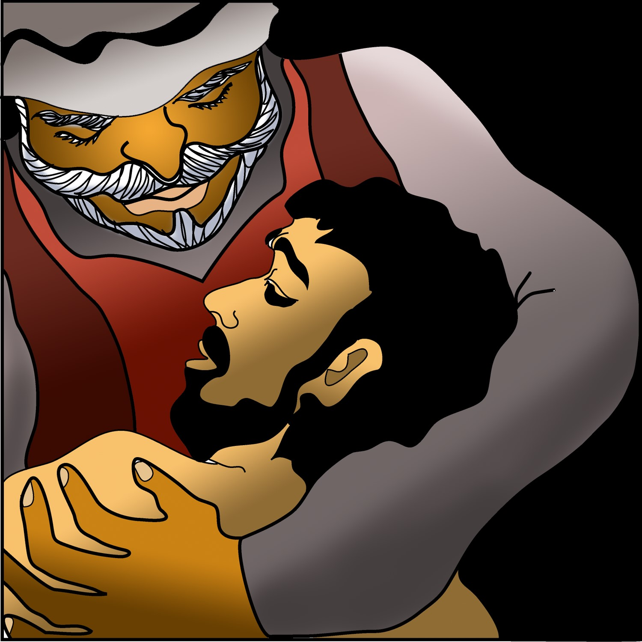

**The Fifth Sunday After Pentecost**

Proper 10 (Year C) **Holy Eucharist II**

July 13 , 2025

10:15 AM *In person and* [*Online*](https://www.youtube.com/@trinityepiscopalchurchsono8741)

***Welcome to Trinity Episcopal, Sonoma!***

Whether you have wandered in, are wondering about God or grew up in the church, or wherever you are in your journey...you are welcome here... We are blessed by your presence.

***For Visitors and Newcomers:***

Everyone is welcome to receive communion at the Lord’s table. Jesus gave this tangible reminder of God’s presence, love, and forgiveness for all. If you are interested in a visit or call from the Priest-in-Charge , please sign our guest book on the table at the entrance of the church, including an email or phone number.

***Restrooms***

A restroom is located outside the entrance of Buttrum Hall (the building across the courtyard) and another is located inside the hall to the right.

***Coffee and Treats:***

Following worship we have coffee and treats after service in Buttrum Hall. We hope it is a time to get to know you better.

***To access Trinity’s Guest WIFI: Password Rosepettal441 (case sensitive).***

We are glad you are here, and we invite you to enter fully into worship this morning.

**July Announcements**

***!!!NEW WORSHIP TIME!!!***

Beginning August 3rd our worship time is 10 AM.

***ROAD CLOSURE JULY 20TH!***

July 20th, Sonoma is hosting the Napa to Sonoma Wine Run, areas of the plaza and downtown Sonoma will be closed off to accommodate the runners. Please plan ahead and give yourself 10-15 minutes extra considering traffic.

***Sunday, July 20***

During worship we will remember Christina Van Krugel’s death and new life in Christ. After worship we will celebrate her life with food, pictures and stories.

***Mark your calendar for August 17 as Trinity observes Heritage Day,***

a time of remembering our past as a congregation, look at where we are now, and begin to consider how God is calling us to serve our community in this time and place. This is an important part of the transition process. Please plan to participate.

***Beginning Wednesday, August 6th 11:00 am,***

Pastor Cindy will facilitate an 8 week bible study called "Together by Grace: Bible Conversations in Matthew." With guided conversations and open-ended questions, participants are invited to share thoughts, experiences and similarities with the biblical stories. Ten participant books have been ordered. If there is interest in an evening group, please let Pastor Cindy know.

***Heads Up! On July 23rd and 24th,***

the parking lot and the Sunday School room has been rented out by a video production company. There is an estimate of 30-40 cars that will be using the parking lot on that Wednesday and Thursday.

***Fellowship Coffee Hour Sign up***

We encourage members to sign up to make coffee. Pastor Cindy is happy to demonstrate how easy this is. Please help us provide this hospitality for guests and members.

***The May, June, July Forward Day by Day ,***

a booklet of daily inspirational meditations is now available in the Church and the Office. We ask for a $2 donation.

***All are welcome to make a gift and offering in thanksgiving to God*;**

for the many blessings we have received. To take advantage of our electronic giving options, please follow the QR code with your capable electronic device, or visit <https://onrealm.org/trinitysonoma/-/form/give/default> Help us to make this a place where God’s grace is freely shared by all.





**Prelude** Steve Rubardt

*Please stand for the Entrance Hymn.*

*At the sound of the bell, please stand as you are able. The People respond when bold text appears.*

The Word of God

**Entrance Hymn *Love Divine , All Loves Excelling*** H 657

**Opening Acclamation** BCP 319

|  |  |
| --- | --- |
| *Celebrant* | Blessed be God: Father, Son, and Holy Spirit. |
| ***People*** | **And blessed be his kingdom, now and for ever. Amen.** |

**Collect for Purity**

***All* Almighty God, to you all hearts are open, all desires known, and from you no secrets are hid: Cleanse the thoughts of our hearts by the inspiration of your Holy Spirit, that we may perfectly love you, and worthily magnify your holy Name; through Christ our Lord. *Amen.***

**Song of Praise Gloria BCP 356/Hymnal S-280**

***All*** Glory to God in the highest,

and peace to his people on earth.

Lord God, heavenly King,

almighty God and Father,

we worship you, we give you thanks,

we praise you for your glory.

Lord Jesus Christ, only Son of the Father,

Lord God, Lamb of God,

you take away the sin of the world:

have mercy on us;

you are seated at the right hand of the Father:

receive our prayer.

For you alone are the Holy One,

you alone are the Lord,

you alone are the Most High,

Jesus Christ,

with the Holy Spirit,

in the glory of God the Father. Amen.

**The Collect of the Day** BCP 357

|  |  |
| --- | --- |
| Celebrant | The Lord be with you. |
| ***People*** | **And also with you.** |
| Celebrant | Let us pray. |

O Lord, mercifully receive the prayers of your people who call upon you, and grant that they may know and understand what things they ought to do, and also may have grace and power faithfully to accomplish them; through Jesus Christ our Lord, who lives and reigns with you and the Holy Spirit, one God, now and for ever.

***All* Amen.**

**The Lessons**

**First Reading:  Deuteronomy 30:9-14**

*Reader* A Reading from the book of Deuteronomy.

[Moses said to the people of Israel,] 9“The Lord your God will make you abundantly prosperous in all your undertakings, in the fruit of your body, in the fruit of your livestock, and in the fruit of your soil. For the Lord will again take delight in prospering you, just as he delighted in prospering your ancestors, 10when you obey the Lord your God by observing his commandments and decrees that are written in this book of the law, because you turn to the Lord your God with all your heart and with all your soul.  
  11Surely, this commandment that I am commanding you today is not too hard for you, nor is it too far away. 12It is not in heaven, that you should say, ‘Who will go up to heaven for us, and get it for us so that we may hear it and observe it?’ 13Neither is it beyond the sea, that you should say, ‘Who will cross to the other side of the sea for us, and get it for us so that we may hear it and observe it?’ 14No, the word is very near to you; it is in your mouth and in your heart for you to observe.”

|  |  |
| --- | --- |
| *Reader* | The Word of the Lord. |
| ***People*** | **Thanks be to God.** |



**The Psalm:  Psalm 25:1-9**

*Reader* Our response to the reading is Psalm 25:1-9 which we will read responsively by half verse.

 1To you, O Lord, I lift up my soul;  
 my God, I put my trust in you; *  
**let me not be humiliated,  
  nor let my enemies triumph over me.**  
 2Let none who look to you be put to shame; *  
**let the treacherous be disappointed in their schemes.**  
 3Show me your ways, O Lord, *  
**and teach me your paths.**  
 4Lead me in your truth and teach me, *  
**for you are the God of my salvation;  
  in you have I trusted all the day long.**  
 5Remember, O Lord, your compassion and love, *  
**for they are from everlasting.**  
 6Remember not the sins of my youth and my transgressions; *  
**remember me according to your love  
  and for the sake of your goodness, O Lord.**  
 7Gracious and upright is the Lord; *  
**therefore he teaches sinners in his way.**  
 8He guides the humble in doing right *  
**and teaches his way to the lowly.**  
 9All the paths of the Lord are love and faithfulness *  
**to those who keep his covenant and his testimonies.**

**Second Reading:  Colossians 1:1-14**

*Reader*A Reading from Paul's letter to the Church in Colossus.

1Paul, an apostle of Christ Jesus by the will of God, and Timothy our brother,  
  2To the saints and faithful brothers and sisters in Christ in Colossae:   
  Grace to you and peace from God our Father.  
  
  3In our prayers for you we always thank God, the Father of our Lord Jesus Christ, 4for we have heard of your faith in Christ Jesus and of the love that you have for all the saints, 5because of the hope laid up for you in heaven. You have heard of this hope before in the word of the truth, the gospel 6that has come to you. Just as it is bearing fruit and growing in the whole world, so it has been bearing fruit among yourselves from the day you heard it and truly comprehended the grace of God. 7This you learned from Epaphras, our beloved fellow servant. He is a faithful minister of Christ on your behalf, 8and he has made known to us your love in the Spirit.  
  9For this reason, since the day we heard it, we have not ceased praying for you and asking that you may be filled with the knowledge of God’s will in all spiritual wisdom and understanding, 10so that you may lead lives worthy of the Lord, fully pleasing to him, as you bear fruit in every good work and as you grow in the knowledge of God. 11May you be made strong with all the strength that comes from his glorious power, and may you be prepared to endure everything with patience, while joyfully 12giving thanks to the Father, who has enabled you to share in the inheritance of the saints in the light. 13He has rescued us from the power of darkness and transferred us into the kingdom of his beloved Son, 14in whom we have redemption, the forgiveness of sins.

|  |  |
| --- | --- |
| *Reader* | The Word of the Lord. |
| ***People*** | **Thanks be to God.** |

**Sequence Hymn**  ***O, Master let me Walk, with Thee*** H660 V 1 & 2

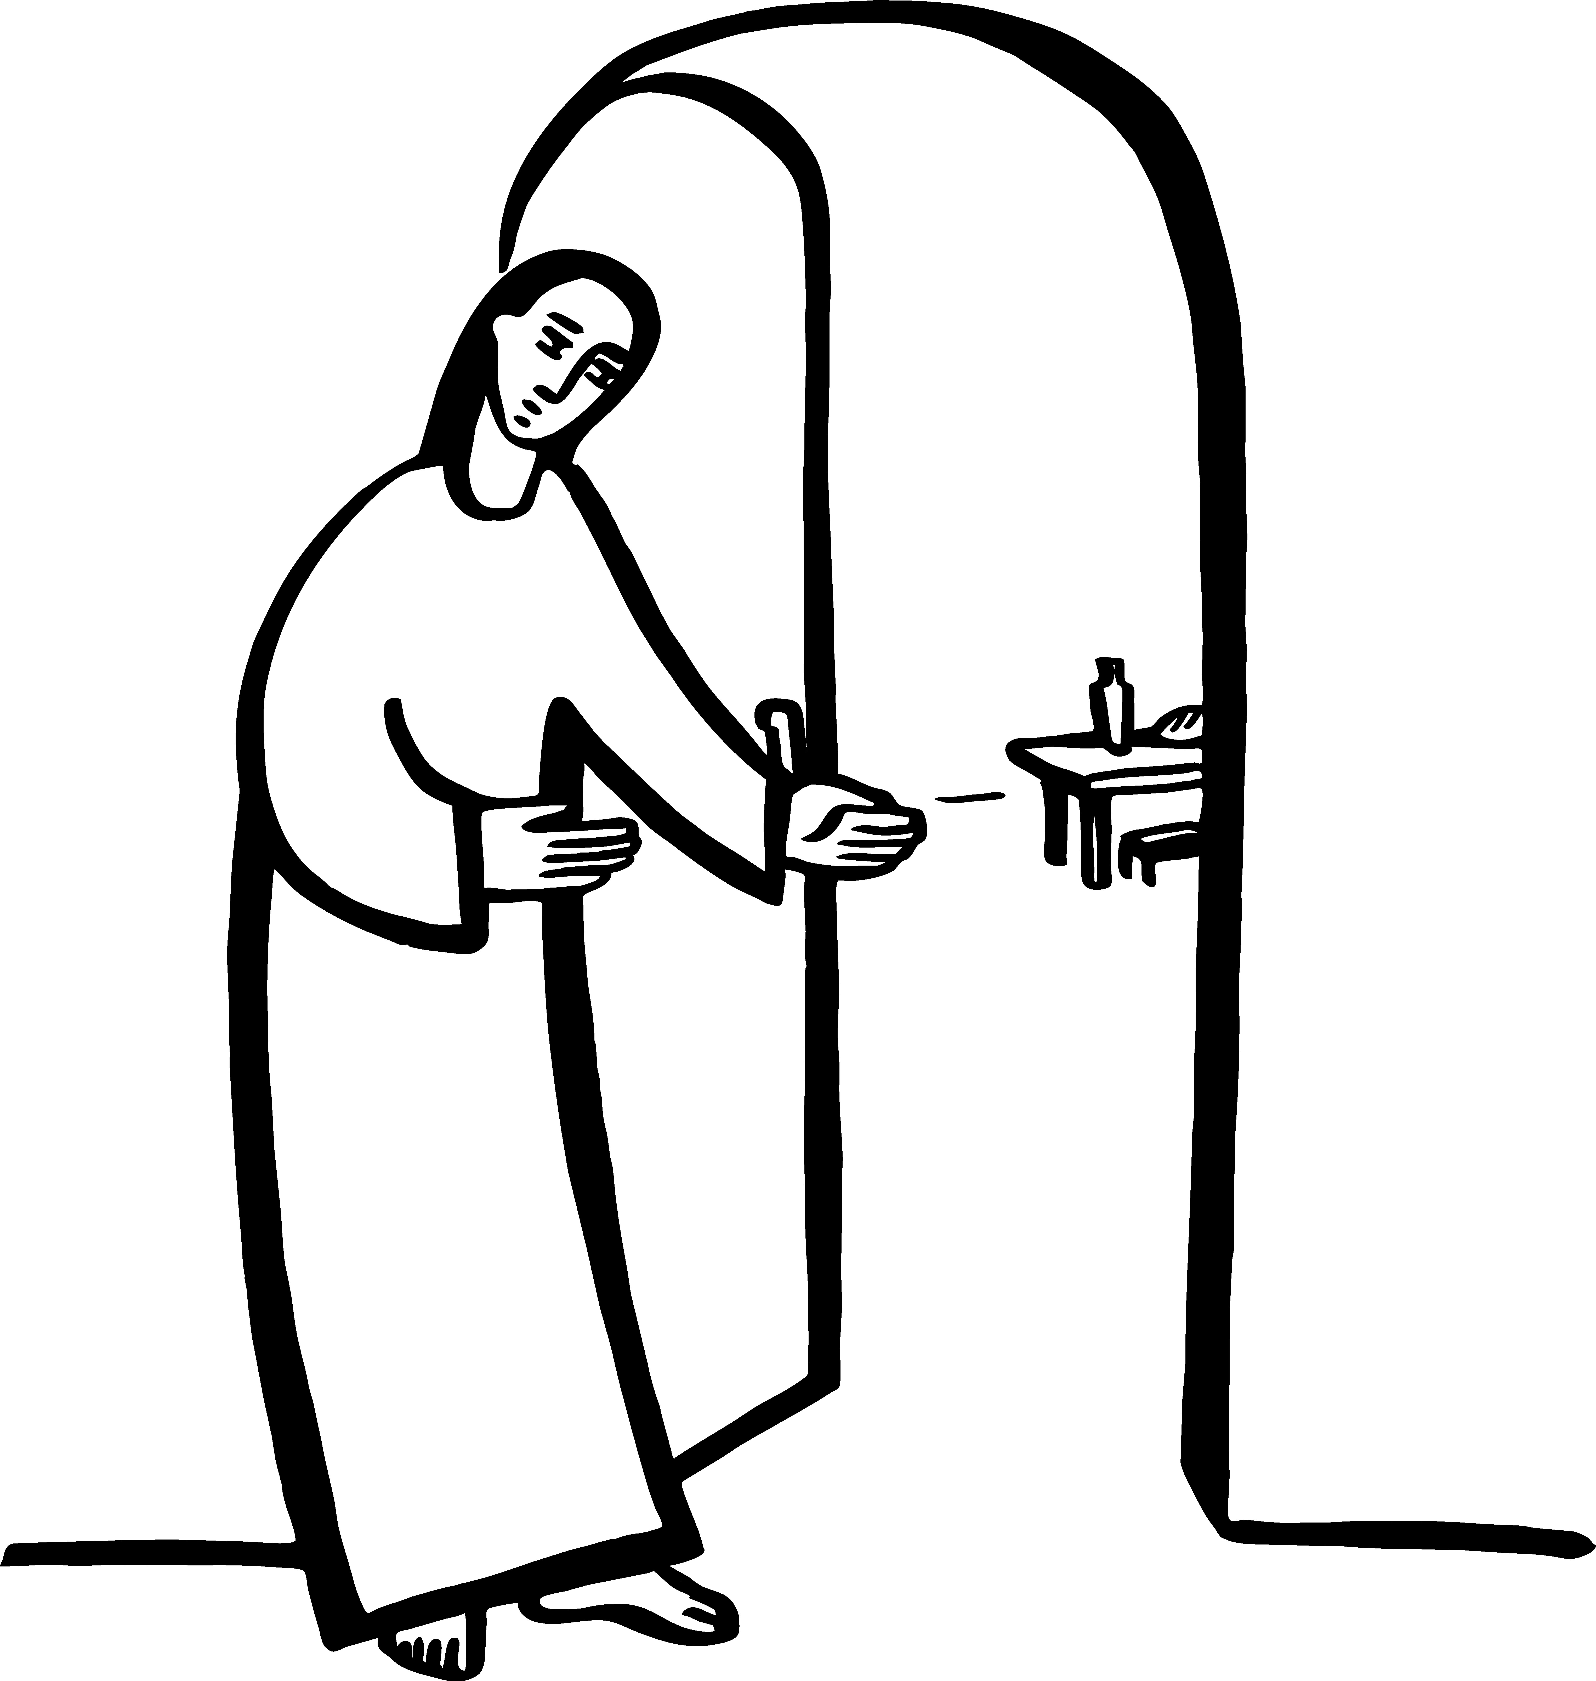

**The Holy Gospel:  Luke 10:25-37**

|  |  |
| --- | --- |
| Celebrant | The Holy Gospel of our Lord Jesus Christ according to Luke. |
| ***People*** | **Glory to you, Lord Christ.** |

25Just then a lawyer stood up to test Jesus. “Teacher,” he said, “what must I do to inherit eternal life?” 26He said to him, “What is written in the law? What do you read there?” 27He answered, “You shall love the Lord your God with all your heart, and with all your soul, and with all your strength, and with all your mind; and your neighbor as yourself.” 28And he said to him, “You have given the right answer; do this, and you will live.”  
  29But wanting to justify himself, he asked Jesus, “And who is my neighbor?” 30Jesus replied, “A man was going down from Jerusalem to Jericho, and fell into the hands of robbers, who stripped him, beat him, and went away, leaving him half dead. 31Now by chance a priest was going down that road; and when he saw him, he passed by on the other side. 32So likewise a Levite, when he came to the place and saw him, passed by on the other side. 33But a Samaritan while traveling came near him; and when he saw him, he was moved with pity. 34He went to him and bandaged his wounds, having poured oil and wine on them. Then he put him on his own animal, brought him to an inn, and took care of him. 35The next day he took out two denarii, gave them to the innkeeper, and said, ‘Take care of him; and when I come back, I will repay you whatever more you spend.’ 36Which of these three, do you think, was a neighbor to the man who fell into the hands of the robbers?” 37He said, “The one who showed him mercy.” Jesus said to him, “Go and do likewise.”

|  |  |
| --- | --- |
| *Celebrant* | The Gospel of the Lord. |
| ***People*** | **Praise to you, Lord Christ.** |

**Sequence Hymn  *O, Master let me Walk, with Thee*** H660 V 3 & 4

**The Sermon**  Pastor Cindy Beck

**The Nicene Creed** (BCP p. 358)

**The Prayers of the People**

Celebrant: Commanded to love our neighbor as ourselves, let us offer prayers for all peoples in every place.

Intercessor: For this holy gathering and for those God loves in every place.

**Christ, have mercy.**

For all nations, peoples, tribes, clans, and families,

In the Diocesan Cycle of Prayer, we pray for St. Peter’s in Red Bluff.

In the Anglican Cycle of Prayer, we pray for The Church of North India.

**Christ, have mercy.**

For mercy, justice, and peace in the world.

**Christ, have mercy.**

For farmers and a good harvest, for those on vacation, and for safety from violent storms.

**Christ, have mercy.**

For those who travel roads of danger, for the sick, the poor, and the oppressed, and for all in peril and great need, ___________________________________

**Christ, have mercy.**

For those who rest in Christ and for all the dead, _____________________

**Christ, have mercy.**

For ourselves, our families and companions, and all those we love, _________

**Christ, have mercy.**

Lifting our voices with all creation, let us offer ourselves and one another to the living God through Christ.

**To you, O Gracious God.**

*Celebrant:* God of mercy and kindness, who gave us the great commandment of love, hear the prayers we offer this day and write your word in our mouth and in our heart; through Jesus Christ our Lord. **Amen.**

**The Confession of Sin**  BCP 359

**The Peace**

Celebrant The peace of the Lord be always with you.

***People* And also with you.**

**Announcements**

Birthdays, Anniversaries, Travelers (prayers found at back of bulletin)



The Holy Communion

**The Offertory** *At the Offering, you’ll find a Pledge card in the Pew Rack for those who’d like to designate their financial donations to Trinity’s Pledging Income. For others, or a one-time gift, envelopes are in the pew racks as well as on the Narthex table or text TRINITYSONOMA" to 73256. Thank you!*

**Offertory Music**

Steve Rubardt and Choir ***Great Thou Art*** LEVAS 60

**Doxology**

The people stand while the offerings are presented and placed on the Altar.

Presider: Gracious God, as an offering of our thanksgiving and gratitude, we return to you a portion of what you have gifted us.

**The Great Thanksgiving**

Eucharistic Prayer B BCP 367

|  |  |
| --- | --- |
| Celebrant | The Lord be with you. |
| **People** | **And also with you.** |
| Celebrant | Lift up your hearts. |
| **People** | **We lift them to the Lord.** |
| Celebrant | Let us give thanks to the Lord our God. |
| **People** | **It is right to give him thanks and praise.** |

**Proper Preface (BCP p. 367)**

It is right, and a good and joyful thing, always and everywhere to give thanks to you, Father Almighty, Creator of heaven and earth.

For you are the source of light and life; you made us in your image, and called us to new life in Jesus Christ our Lord.

Therefore we praise you, joining our voices with Angels and Archangels and with all the company of heaven, who for ever sing this hymn to proclaim the glory of your Name:



**Sanctus Holy Holy, Holy (Proulx)**  Hymnal S-125

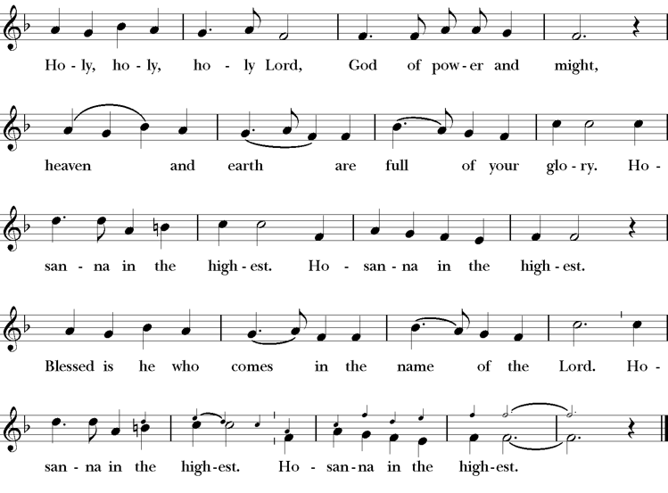



**The Lord’s Prayer** BCP 336

**The Breaking of the Bread** BCP 364



**Fraction Anthem** S-154

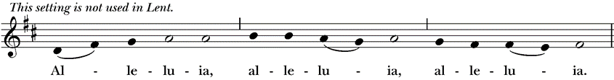

Click to get the full file (S 154 Christ our Passover (Hurd) 2 (Staff).tif):  (Staff)Click to get the full file (S 154 Christ our Passover (Hurd) 3 (Staff).tif):  (Staff)

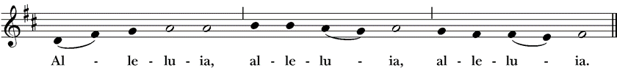

*All are welcome at the Lord’s table to receive Holy Communion or a blessing. To receive Communion in your pew, please ask an usher to notify the ministers on your behalf. If you require a gluten-free wafer, please ask at the altar rail.*

**Communion Music Steve Rubardt & Choir**

***Let All Mortal Flesh Keep Silent*** H 324

**Post-Communion Prayer** BCP 365

**The Blessing**

**The Recessional Hymn *Faith of our Fathers*** H 558

**The Dismissal\***

|  |  |
| --- | --- |
| *Celebrant* | Let us go forth in the name of Christ. |
| ***People*** | **Thanks be to God.** |

**Postlude** Steve Rubardt

*Please remain seated*

**SERVING TODAY**

**Celebrant and Preacher:** Pastor Cindy Beck

**Eucharistic Minister:** Susie Hand

**Acolyte:** Arminda Eiler

**Lector:**  Bill Doyle , Jane Hernandez

**Intercessor:** Ann Kyser

**Worship Musician**: Steve Rubardt

**Choir Leader:** Steve Rubardt

**Choir**: Liz Carpenter, Heather Dahlberg, Scott Sherman, Lucy Maushardt, Patsy Gralow, Laurell Meredith, Mary Omodt, Barbara Feduska, Tara Anderson

**Sunday School - Child Care:**Wendy Aguilar Appt Only

**Ushers**: Jane Hernandez , Barbara Feduska

**Tech Chaplain**: Marcos Rendon

**Altar Guild**: Ann Kyser

**Counters:** Claire Ginesi , Lorena Reinhardt

Altar Flowers are given to the glory of God by Altar Guild.

*\*Why no ‘Alleluias” printed in the bulletin? There are two different rubrics (or rules) that govern the use of Alleluia in worship, set by the Canons. One set of rubrics govern the use of Alleluia in music and in all of the liturgy except for the Dismissal. This rule says that we use Alleluia all the time except during the season of Lent. The other set of rubrics covers just the Dismissal and it says that we only use Alleluia in the Dismissal during the period from Easter Sunday through Pentecost, but not at any other time.*

**Prayers requested for these on Trinity’s long-term prayer list**: Baby Walker David, Armando P, Laura Basett, Peggy & John Bell, Georgia Bostedt, Muff Davey, Linda Dowd, John Eiler, Gerrilee Fisher, Claire Ginesi, Mary Griffin, David & Christine Hilt, Dr. Tamer Keshen, Christina Van Krugel, Marie Lambert, Mark Mezzetta, Kelcey Omodt, Grizelda Ponce, Barry Reap, Blake W, Robert R, Ann Loveland Sherman, John Spooner, James Thomas, Rose Burns, Jennifer Gralow, Patsy Gralow, Denny Hoelter, Steve Antenen, Van Z, Sandra Leland, John Forester, Stuart , Melissa White.

**Prayers for the Repose of soul:** Tim Dowd , Susan Bassett, Joan Biersch, Mere Nagasau, Christina Van Krugel

Contact Pastoral Care Chair, Lorena [lorena.m.reinhardt@gmail.com](mailto:lorena.m.reinhardt@gmail.com) to make any additions or to remove names from our Long-Term Prayer list.

**About this Service**: **Year C**

**Calendar of the Church Year**

The calendar (BCP, pp. 15-33) orders the liturgical year of the Episcopal Church by identifying two cycles of feasts and holy days-one dependent upon the movable date of Easter Day and the other dependent upon the fixed date of Christmas, Dec. 25. Easter Day is the first Sunday after the full moon that falls on or after Mar. 21. The sequence of all Sundays in the church year is based on the date of Easter. Tables and rules for finding the date of Easter Day, and other movable feasts and holy days are provided by the BCP, pp. 880-885. The date of Easter determines the beginning of the season of Lent on Ash Wednesday and the date of Pentecost on the fiftieth day of the Easter season. The Sundays of Advent are always the four Sundays before Christmas Day. The church year begins on the first Sunday of Advent. The calendar also identifies and provides directions concerning the precedence and observance of principal feasts, Sundays, holy days (including Feasts of our Lord, other major feasts, and fasts), Days of Special Devotion, and Days of Optional Observance. The calendar lists dates for celebration of major feasts and lesser feasts by month and date. Appropriate Sunday Letters and Golden Numbers are also provided. (see BCP, pp. 880-881). The calendar also lists the titles of the seasons, Sundays, and major holy days observed in the Episcopal Church throughout the church year, including Advent season, Christmas season, Epiphany season, Lenten season, Holy Week, Easter season, the season after Pentecost, holy days, and National Days.

**About this Service: The Season after Pentecost**

Our current liturgical season, the Season after Pentecost, is by far the longest of the Episcopal church year. It begins the day after Pentecost and ends the day before the First Sunday of Advent. Since the date of Easter changes every year—and the Day of Pentecost is always 50 days after Easter—the length of the season varies as well, ranging from 24-29 weeks in length. This season is sometimes called Ordinary Time, a phrase borrowed from the Roman Catholic Church. A common practice among Episcopal churches is to change the appropriate liturgical elements at the start of each new season. Often these changes are directed by the Book of Common Prayer, such as the acclamations named for use in the Lenten and Easter seasons. However, liturgical leaders also decide which Prayers of the People, Eucharistic Prayer, blessing, and dismissal are used in services.



**Trinity Liturgical Ministry ROTA Next two weeks**

|  |  |  |  |  |  |  |  |
| --- | --- | --- | --- | --- | --- | --- | --- |
| **Date** | **Celebrant** | **Ushers** | **Euch Min** | **Acolyte** | **Lector (s)** | **Intercessor** | **Altar Guild** |
| July 20 | Cindy Beck | John Eiler Alfred Escoffier | Arminda Eiler | Susie Hand | Alfred Escoffier John Eiler | Barbara Feduska | Susie Hand |
| July 27 | LA KING | John Eiler John Addeo | Susie Hand | Arminda Eiler | Barbara Feduska Ann Kyser | Lorena Reinhardt | Ann Kyser |

**Schedule of Weekly Meetings and Services at Trinity Episcopal Sonoma**

|  |  |  |  |  |
| --- | --- | --- | --- | --- |
| **Day** | **Date** | **Time** | **Occasion** | **Location** |
| Wednesday | July 16 | 11 AM | Bible Study | Library |
| Thursday | July 17 | 10:30 AM  5:30 PM | Mindfulness & Well Being  Alcoholics Anonymous | Library  Buttrum Hall |
| Saturday | July 19 | 8 AM | Centering Prayer | St. Luke’s Chapel |
| Sunday | July 20 | 10:15 AM | Holy Eucharist II | Sanctuary |
| Mon-Fri | Weekdays | 7AM-1PM | Sonoma Home Meals | Kitchen &Buttrum Hall |
| 9-2 | **Sonoma Preschool Academy – School** | |

**Monthly Meetings at Trinity Episcopal Sonoma**

|  |  |  |  |  |  |
| --- | --- | --- | --- | --- | --- |
| Day | Date | Time | Meeting | Location | Contact |
| Tuesday | July 1 | 11 AM | Prayer Shawl Ministry | Library | Norah Collins [28norahe@gmail.com](mailto:28norahe@gmail.com) |
| Thursday | July 31 | 4:30 PM | Vestry | Library | Claire Ginesi [cfgsonoma@gmail.com](mailto:cfgsonoma@gmail.com) |

**PRAYERS and BLESSINGS**

**For a Birthday**

Watch over your child, O Lord as his/her days increase; bless and guide him/her wherever s/he may be. Strengthen them when s/he stands; comfort him/her when discouraged or sorrowful; raise him/her up if s/he fall; and in his/her heart may your peace which passes understanding abide all the days of his/her life; through Jesus Christ our Lord. ***Amen.***

**For an Anniversary**

O God, you have so consecrated the covenant of marriage that it represents the spiritual unity between Christ and his Church: Send your blessing upon these your servants as they celebrate their anniversary, that they may continue to love, honor and cherish each other in faithfulness and patience, in wisdom and true godliness, that their home may be a haven of blessing and peace; through Jesus Christ our Lord, who lives and reigns with you and the Holy Spirit, one God, now and forever. ***Amen.***

**For Travelers**

O God, our heavenly Father, whose glory fills the whole creation, and whose presence we find wherever we go; preserve those who travel; surround them with your loving care; protect them from every danger, and bring them in safety to their journey’s end; through Jesus Christ our Lord. ***Amen***.

**Sending our Eucharistic Visitors**

**Priest**: In the name of this congregation, I send you forth bearing these holy gifts, the those to whom you go may share with us in the communion of Christ’s body and blood.

**People**: *We who are many are one body, because we all share on bread, and one cup.* ***Amen***

|  |
| --- |
|   *In Sonoma for over 170 years*  275 East Spain Street  Sonoma, CA 95476 |
| The Rt. Rev. Megan M. Traquair, Bishop  Diocese of Northern California  Pastor Cindy Beck, Interim  Steve Rubardt, Worship Music  **Vestry**  Claire Ginesi, Senior Warden  Bill Doyle, Junior Warden (Buildings, Grounds)  Bill Doyle (Stewardship)  Susie Hand  Heather Dahlberg  Sally Thornhill  Lorena Reinhardt (Pastoral Care)  **Ministries**  Prayer Shawl ,Norah Collins  Outreach, Jane Hernandez  Youth – Academic Tutoring, Karen Randall  Mindfulness & Well Being, Mary Omodt  Sunday School, Children, Wendy Aguilar  The Members of the Congregation are The Ministers of the Church  Administrative Office Hrs.  Monday Wednesday 9 A.M. – 2 PM; Thursday 10A.M.-2 P.M0  Sunday 9:30-11:30  Clergy Office Hours Wednesdays, Thursdays, by appointment  Emergency, sickness, please contact office: 707-938-4846 |