Trinity Episcopal Church
Cultivating God’s Loving Spirit in each of us
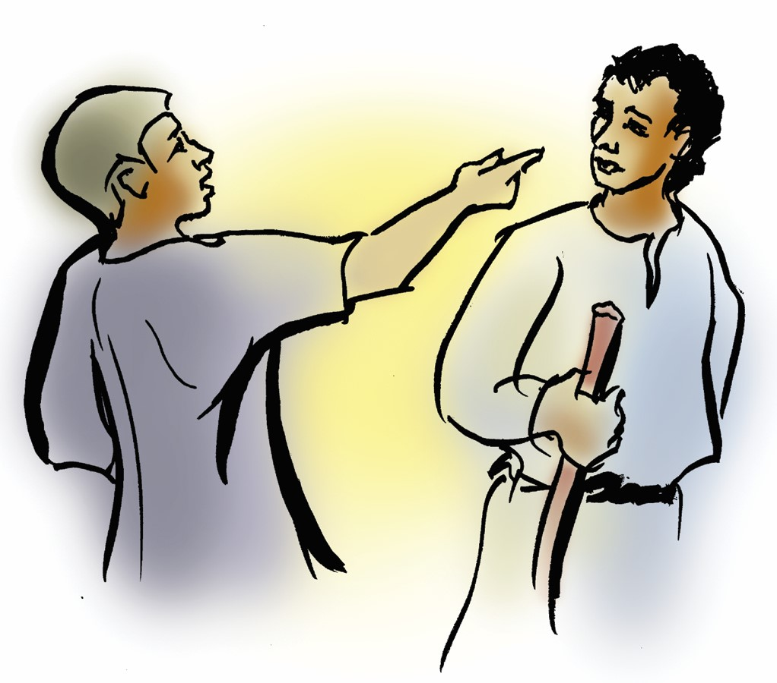
Proper 16
Year A
Holy Eucharist II
August 23rd, 2026
10:00 AM In person and Online

Welcome to Trinity Episcopal, Sonoma. Whether you are passing through or looking for a church home, we are blessed by your presence and we invite you to worship with us fully – singing, praying and receiving communion- with your voice and heart. Please sign our guestbook at the back of the church, including your email.
If you would like to learn more about The Episcopal Church, please send us an email trinityepiscopalsonoma@comcast.net. We look forward to meeting you after the service where coffee and treats are served.
Did you know that....
…As part of our Spirituality Outreach:
1. A Little Library has been purchased for the community to borrow (or keep) spiritual books? If you have books to donate, please let Mary Omodt know. We'll provide Mary's contact information for you by calling the Office at 707-938-4846.
2. We are exploring setting up a Prayer Wall in front for people to leave prayer requests?
...In response to our Senior Isolation Outreach
1. Pastor Cindy contacted the Council on Aging to learn more about their visitation program to seniors? When she receives information, she will pass it on.
2. A Senior Resource booklet can be found in the back of the church along with a flyer providing information about Free Rides for Seniors.

All are welcome to make a gift and offering in thanksgiving to God; for the many blessings we have received. To take advantage of our electronic giving options, please follow the QR code with your capable electronic device, or visit https://onrealm.org/trinitysonoma/-/form/give/default
August Announcements
Fellowship Coffee Hour Sign up – Fellowship follows the service! We meet in the hall or courtyard. We’d love to visit with you.
Thank you to everyone who donated food for A Simple Gesture, your gift helps people have a meal!
BRIEF Congregational Meeting after worship today!. The only agenda item is to elect Doug Griffin to Vestry. He is serving as Trinity’s Treasurer.
Movie Night at Trinity will continue on Wednesday Sept 16th. Join us for “Legally Blonde”, at 6PM in Buttram Hall. Stay for the snacks and post film discussion.
Prelude Steve Rubardt
Please stand for the Entrance Hymn.
At the sound of the bell, please stand as you are able. The People respond when bold text appears.
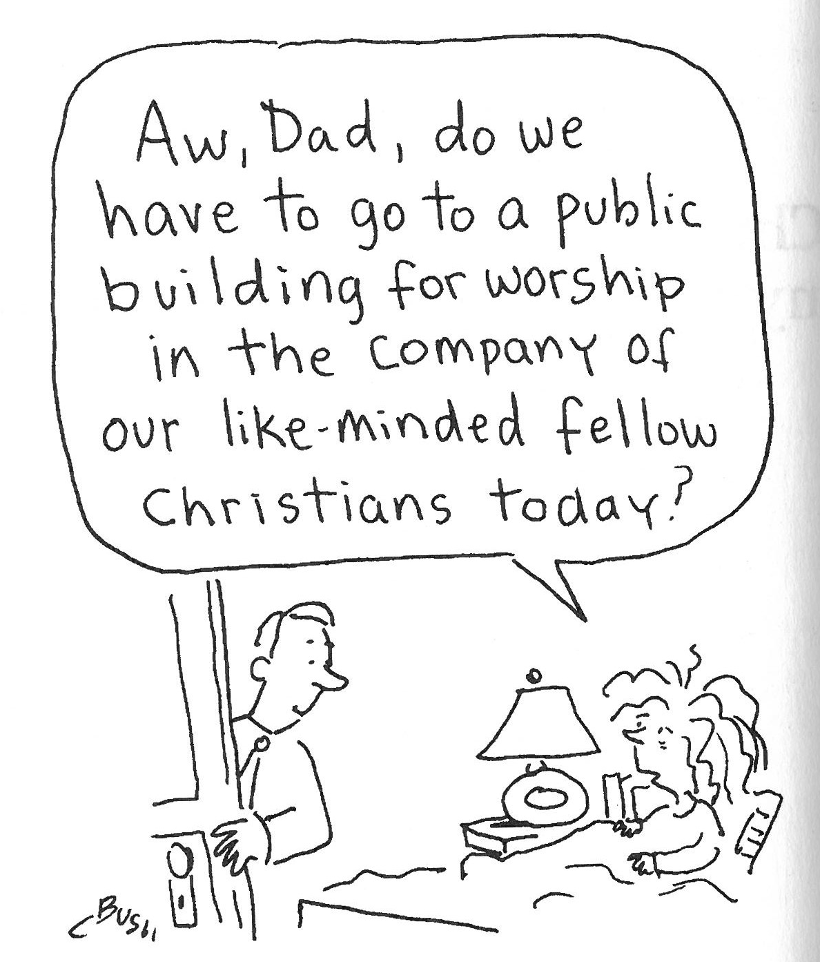
The Word of God
Entrance Hymn Christ Whose Glory Fills the Skies H7
Opening Acclamation BCP 319
Celebrant | Blessed be God: Father, Son, and Holy Spirit.
People | And blessed be his kingdom, now and for ever. Amen.
Collect for Purity
All Almighty God, to you all hearts are open, all desires known, and from you no secrets are hid: Cleanse the thoughts of our hearts by the inspiration of your Holy Spirit, that we may perfectly love you, and worthily magnify your holy Name; through Christ our Lord. Amen.
Song of Praise Glory to God Hymn S-280 is sung, all standing
Glory to God in the highest,
and peace to his people on earth.
Lord God, heavenly King,
almighty God and Father,
we worship you, we give you thanks,
we praise you for your glory.
Lord Jesus Christ, only Son of the Father,
Lord God, Lamb of God,
you take away the sin of the world:
have mercy on us;
you are seated at the right hand of the Father:
receive our prayer.
For you alone are the Holy One,
you alone are the Lord,
you alone are the Most High,
Jesus Christ,
with the Holy Spirit,
in the glory of God the Father. Amen.
The Collect of the Day BCP 357
Celebrant | The Lord be with you.
People | And also with you.
Celebrant | Let us pray.
Grant, O merciful God, that your Church, being gathered together in unity by your Holy Spirit, may show forth your power among all peoples, to the glory of your Name; through Jesus Christ our Lord, who lives and reigns with you and the Holy Spirit, one God, for ever and ever.
All Amen.
The Lessons
First Reading: Isaiah 51:1-6
Reader A Reading from the book of the prophet Isaiah.
¹Listen to me, you that pursue righteousness,
you that seek the Lord.
Look to the rock from which you were hewn,
and to the quarry from which you were dug.
²Look to Abraham your father
and to Sarah who bore you;
for he was but one when I called him,
but I blessed him and made him many.
³For the Lord will comfort Zion;
he will comfort all her waste places,
and will make her wilderness like Eden,
her desert like the garden of the Lord;
joy and gladness will be found in her,
thanksgiving and the voice of song.
⁴Listen to me, my people,
and give heed to me, my nation;
for a teaching will go out from me,
and my justice for a light to the peoples.
⁵I will bring near my deliverance swiftly,
my salvation has gone out
and my arms will rule the peoples;
the coastlands wait for me,
and for my arm they hope.
⁶Lift up your eyes to the heavens,
and look at the earth beneath;
for the heavens will vanish like smoke,
the earth will wear out like a garment,
and those who live on it will die like gnats;
but my salvation will be forever,
and my deliverance will never be ended.
Reader | The Word of the Lord.
People | Thanks be to God.
The Psalm: Psalm 138
Reader We will read Psalm 138, which we will read responsively by half verse.
¹I will give thanks to you, O Lord, with my whole heart; *
before the gods I will sing your praise.
²I will bow down toward your holy temple
and praise your Name, *
because of your love and faithfulness;
³for you have glorified your Name *
and your word above all things.
⁴When I called, you answered me; *
you increased my strength within me.
⁵All the kings of the earth will praise you, O Lord, *
when they have heard the words of your mouth.
⁶They will sing of the ways of the Lord, *
that great is the glory of the Lord.
⁷Though the Lord be high, he cares for the lowly; *
he perceives the haughty from afar.
⁸Though I walk in the midst of trouble, you keep me safe; *
you stretch forth your hand against the fury of my enemies;
your right hand shall save me.
⁹The Lord will make good his purpose for me; *
O Lord, your love endures for ever;
do not abandon the works of your hands.
Second Reading: Romans 12:1-8
Reader A Reading from Paul's letter to the Church in Rome.
¹I appeal to you therefore, brothers and sisters, by the mercies of God, to present your bodies as a living sacrifice, holy and acceptable to God, which is your spiritual worship. ²Do not be conformed to this world, but be transformed by the renewing of your minds, so that you may discern what is the will of God—what is good and acceptable and perfect.
³For by the grace given to me I say to everyone among you not to think of yourself more highly than you ought to think, but to think with sober judgment, each according to the measure of faith that God has assigned. ⁴For as in one body we have many members, and not all the members have the same function, ⁵so we, who are many, are one body in Christ, and individually we are members one of another. ⁶We have gifts that differ according to the grace given to us: prophecy, in proportion to faith; ⁷ministry, in ministering; the teacher, in teaching; ⁸the exhorter, in exhortation; the giver, in generosity; the leader, in diligence; the compassionate, in cheerfulness.
Reader | The Word of the Lord.
People | Thanks be to God.

Sequence Hymn From God Christ’s Deity came Forth H 443 v 1 , 2 & 3
The Holy Gospel: Matthew 16:13-20
Celebrant | The Holy Gospel of our Lord Jesus Christ according to Matthew.
People | Glory to you, Lord Christ.
¹³Now when Jesus came into the district of Caesarea Philippi, he asked his disciples, “Who do people say that the Son of Man is?” ¹⁴And they said, “Some say John the Baptist, but others Elijah, and still others Jeremiah or one of the prophets.” ¹⁵He said to them, “But who do you say that I am?” ¹⁶Simon Peter answered, “You are the Messiah, the Son of the living God.” ¹⁷And Jesus answered him, “Blessed are you, Simon son of Jonah! For flesh and blood has not revealed this to you, but my Father in heaven. ¹⁸And I tell you, you are Peter, and on this rock I will build my church, and the gates of Hades will not prevail against it. ¹⁹I will give you the keys of the kingdom of heaven, and whatever you bind on earth will be bound in heaven, and whatever you loose on earth will be loosed in heaven.” ²⁰Then he sternly ordered the disciples not to tell anyone that he was the Messiah.
Celebrant | The Gospel of the Lord.
People | Praise to you, Lord Christ.
Sequence Hymn From God Christ’s Deity came Forth H 443 v 4 & 5
Sermon Pastor Cindy Beck
The Nicene Creed (BCP p. 358)
We believe in one God, the Father, the Almighty, maker of heaven and earth, of all that is, seen and unseen.
We believe in one Lord, Jesus Christ, the only Son of God, eternally begotten of the Father, God from God, Light from Light, true God from true God, begotten, not made, of one Being with the Father. Through him all things were made. For us and for our salvation he came down from heaven: by the Power of the Holy Spirit he became incarnate from the Virgin Mary, and was made man. For our sake he was crucified under Pontius Pilate; he suffered death and was buried. On the third day he rose again in accordance with the Scriptures; he ascended into heaven and is seated at the right hand of the Father. He will come again in glory to judge the living and the dead, and his kingdom will have no end.
We believe in the Holy Spirit, the Lord, the giver of life, who proceeds from the Father and the Son. With the Father and the Son he is worshipped and glorified. He has spoken through the Prophets. We believe in one holy catholic and apostolic Church. We acknowledge one baptism for the forgiveness of sins. We look for the resurrection of the dead, and the life of the world to come. Amen.
The Prayers of the People
Celebrant: Let us offer prayers to God who builds the church of Christ on the rock of faith and shares with us the keys of the kingdom.
Intercessor: For this holy gathering, for our parish clergy, for N. our bishop, and N. our Presiding Bishop for the people of God in every place, and for all who seek the Lord.
In the Diocesan Cycle of Prayer, we pray for St. Barnabas’ in Mount Shasta.
In the Anglican Cycle of Prayer, we pray for The Church of the Province of West Africa.
O Christ, hear us.
For those in authority, for N. our President, for N. our Governor, for the Courts, for Congress and all legislatures, for the light of justice among all peoples.
Silence
O Christ, hear us.
In thanksgiving for the ministry of children, youth, and college students, for the opportunities we have for formation and fellowship together For those who are new to our community and those who are visiting today, +_________________.
Invite the congregation to add their thanksgivings, followed by silence
O Christ, hear us.
For our city and those who live in it, for N. our Mayor and the City Council, and for our families, companions, and all those we love.
Silence
O Christ, hear us
For the sick and the suffering, travelers and those on vacation, prisoners, captives, and their families, and all those in danger and need, +______________.
Invite the congregation to add their petitions, followed by silence
O Christ, hear us.
For those who rest in Christ and for all the dead, +___________________.
Invite the congregation to add their petitions, followed by silence
O Christ, hear us.
At this time, I invite any additional prayers of intercession or thanksgiving. To you, Creator God.
Celebrant O God who restores and makes whole, hear the prayers we offer today and make the wilderness of this world a garden of salvation; through Jesus Christ our Lord.
Amen.
Confession of Sin BCP 359
Most merciful God, we confess that we have sinned against you in thought, word and deed, by what we have done, and by what we have left undone.
We have not loved you with our whole heart; we have not loved our neighbors as ourselves. We are truly sorry and we humbly repent.
For the sake of your Son Jesus Christ, have mercy on us and forgive us; that we may delight in your will, and walk in your ways, to the glory of your Name. Amen.
The Peace
Celebrant The peace of the Lord be always with you.
People And also with you.
Announcements
Birthdays, Anniversaries, Travelers (prayers found at back of bulletin)
The Holy Communion
The Offertory At the Offering, you’ll find a Pledge card in the Pew Rack for those who’d like to designate their financial donations to Trinity’s Pledging Income. For others, or a one-time gift, envelopes are in the pew racks as well as on the Narthex table or text TRINITYSONOMA" to 73256. Thank you!
Offertory Music
Steve Rubardt and Choir There is a Balm in Gilead LEVAS 203
Doxology
Praise God, from whom all blessings flow;
Praise Him, all creatures here below;
Praise Him above, ye heav'nly host;
Praise Father, Son, and Holy Ghost.
Amen.
The people stand while the offerings are presented and placed on the Altar.
Presider: Gracious God, as an offering of our thanksgiving and gratitude, we return to you a portion of what you have gifted us.
The Great Thanksgiving
Eucharistic Prayer B BCP 367
Celebrant | The Lord be with you.
People | And also with you.
Celebrant | Lift up your hearts.
People | We lift them to the Lord.
Celebrant | Let us give thanks to the Lord our God.
People | It is right to give him thanks and praise.
Proper Preface (BCP p. 367)
It is right, and a good and joyful thing, always and everywhere to give thanks to you, Father Almighty, Creator of heaven and earth.
For you are the source of light and life; you made us in your image, and called us to new life in Jesus Christ our Lord.
Therefore we praise you, joining our voices with Angels and Archangels and with all the company of heaven, who for ever sing this hymn to proclaim the glory of your Name:
Sanctus Holy Holy, Holy (Proulx) Hymnal S-125
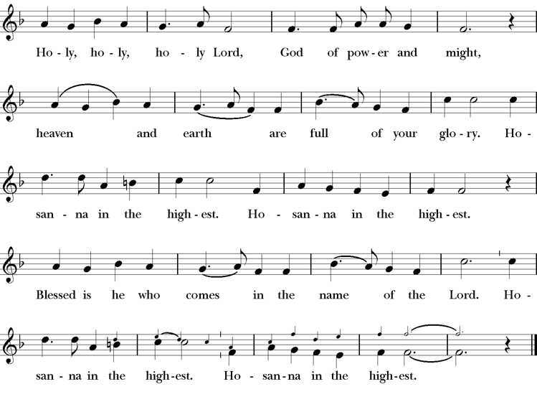
Presider Holy and gracious Father: In your infinite love you made us for yourself; and, when we had fallen into sin and become subject to evil and death, you, in your mercy, sent Jesus Christ, your only and eternal Son, to share our human nature, to live and die as one of us, to reconcile us to you, the God and Father of all.
He stretched out his arms upon the cross, and offered himself, in obedience to your will, a perfect sacrifice for the whole world.
On the night he was handed over to suffering and death, our Lord Jesus Christ took bread; and when he had given thanks to you, he broke it, and gave it to his disciples, and said, “Take, eat: This is my Body, which is given for you. Do this for the remembrance of me”
After supper he took the cup of wine; and when he had given thanks, he gave it to them, saying, “Drink this, all of you: this is my blood of the new covenant which is shed for you and for many for the forgiveness of sins. Whenever you drink it, do this for the remembrance of me.”
Presider Therefore we proclaim the mystery of faith:.
People Christ has died; Christ is risen; Christ will come again.
Presider We celebrate the memorial of our redemption, O Father, in this sacrifice of praise and thanksgiving. Recalling his death, resurrection, and ascension, we offer you these gifts.
Sanctify them by your Holy Spirit to be for your people the Body and Blood of your Son, the holy food and drink of new and unending life in him. Sanctify us also that we may faithfully receive this holy Sacrament, and serve you in unity, constancy, and peace; and at last day bring us with all your saints into the joy of your eternal kingdom.
All this we ask through your Son Jesus Christ. By him, and with him, and in him, in the unity of the Holy Spirit all honor and glory is yours, Almighty Father, now and for ever.
Amen.
The Lord’s Prayer
Presider As our Savior has taught us, we are bold to pray.
People Our Father, who art in heaven, hallowed be thy name. Thy Kingdom come, thy will be done, on earth as it is in heaven. Give us this day our daily bread. And forgive us our trespasses, as we forgive those who trespass against us. And lead us not into temptation, but deliver us from evil. For thine is the kingdom, the power and the glory, for ever and ever. Amen.

The Breaking of the Bread
The Presider breaks the consecrated bread in view of the assembly.
Presider The Gifts of God for the people of God.
People Therefore let us keep the feast. Alleluia

Invitation to Communion
Presider Come to this table you who have been here often and you who have not been here in a long time. Come, you who have tried to follow Jesus and you who have failed. You who are full of faith and full of doubt. Come, it is Christ himself who invites you to meet him here.
Sharing the Sacred Meal
This is Christ’s table and all are welcome and all are fed.
Communion Music One Bread , One Body LEVAS 151
Post-Communion Prayer BCP 365
The Blessing
The Recessional Hymn Take my Life H 707
The Dismissal*
Celebrant | Let us go forth in the name of Christ.
People | Thanks be to God.
Postlude Steve Rubardt Please remain seated

SERVING TODAY
Celebrant & Preacher: Pastor Cindy Beck
Acolyte: Arminda Eiler
Lector: Jane Hernandez , John Eiler
Intercessor: Barbara Feduska
Worship Musician: Steve Rubardt
Choir Leader: Steve Rubardt
Choir: Liz Carpenter, Heather Dahlberg, Scott Sherman,
Patsy Gralow, Laurell Meredith, Mary Omodt, Barbara Feduska, Tara Anderson
Sunday School - Child Care: Wendy Aguilar Appt Only
Ushers: John Addeo
Tech Chaplain: Marcos Rendon
Altar Guild: Laurell Meredith , Liz Carpenter
Hospitality : Lisa Coleman , Matt Dahlberg
Altar Flowers are given to the glory of God by Altar Guild.
Prayers requested for these on Trinity’s long-term prayer list: Armando P, Georgia Bostedt, John Eiler, Gerrilee Fisher, Claire Ginesi, Mary Griffin, David & Christine Hilt, Mark Mezzetta, Kelcey Omodt, Grizelda Ponce, Barry Reap, Blake W, Robert R, Melissa White, Ann Loveland Sherman, James Thomas, Rose Burns, Jennifer Gralow, Patsy Gralow, Steve Antenen, Sandra Leland, Karl, Michael Hardy, Michael Bean Land, Polly Moore, Sinat Liv, Will Maushardt, Sophia Piconi, Mike Smith, Jean Maffoli.
Prayers for the Repose of soul: Tim Dowd , Susan Bassett, Joan Biersch, Linda Dowd, Christina Van Krugel, Mere Nagasau, Mary Goshert, Peggy Bell, Carolyn Caldwell, Van Z, Dolores Mae Seaberg Cole, Muff Davey.
Contact Pastoral Care Chair, Lorena lorena.m.reinhardt@gmail.com to make any additions or to remove names from our Long-Term Prayer list.
Notes on the Service Bulletin This service bulletin is a guide to the service. We use a variety of printed materials for the prayers, the scriptural readings and the hymns. The Readings for the week, including the Collect and Readings are found in this Bulletin. The service follows the liturgies that are found in the Book of Common Prayer (BCP). The BCP is the blue book found in the pew in front of you. The hymns come primarily from The 1982 Hymnal, also in the pew – the red book. Lift Every Voice and Sing (LEVAS) is another hymnal located in the pew rack. VF stands for Voices Found, another authorized hymnal. Sound Mate Assisted Hearing devices available at the back of the church on the Narthex Table.
Trinity Liturgical Ministry ROTA Next two weeks
Date | Celebrant | Ushers | Acolyte | Lector (s) | Intercessor | Altar Guild
8/30 | Cindy Beck | John Addeo | Claire Ginesi | Lorena Reinhardt , Bill Doyle | Ann Kyser | Ann Kyser
9/6 | Cindy Beck
Schedule of Weekly Meetings and Services at Trinity Episcopal Sonoma
Day | Date | Time | Occasion | Location
Wednesday | August 26 | 11 AM | Bible Study | Library
Thursday | August 27 | 10:30 AM  5:30 PM | Mindfulness & Well Being  Alcoholics Anonymous | Library  Buttrum Hall
Saturday | August 29 | 8 AM | Centering Prayer | St. Luke’s Chapel
Sunday | August 30 | 10:00 AM | Holy Eucharist II | Sanctuary
Mon-Fri | Weekdays | 7AM-1PM | Sonoma Home Meals | Kitchen &Buttrum Hall
Mon-Fri | Weekdays | 9-2 | Sonoma Preschool Academy – School

Monthly Meetings at Trinity Episcopal Sonoma
Day | Date | Time | Meeting | Location | Contact
Tuesday | August 4 | 11 AM | Prayer Shawl Ministry | Library | Lorena Reinhardt lorena.m.reinhardt@gmail.com
Thursday | TBD | TBD | Vestry | Library | Cindy Beck 916-955-9861

PRAYERS and BLESSINGS
For a Birthday
Watch over your child, O Lord as his/her days increase; bless and guide him/her wherever s/he may be. Strengthen them when s/he stands; comfort him/her when discouraged or sorrowful; raise him/her up if s/he fall; and in his/her heart may your peace which passes understanding abide all the days of his/her life; through Jesus Christ our Lord. Amen.
For an Anniversary
O God, you have so consecrated the covenant of marriage that it represents the spiritual unity between Christ and his Church: Send your blessing upon these your servants as they celebrate their anniversary, that they may continue to love, honor and cherish each other in faithfulness and patience, in wisdom and true godliness, that their home may be a haven of blessing and peace; through Jesus Christ our Lord, who lives and reigns with you and the Holy Spirit, one God, now and forever. Amen.
For Travelers
O God, our heavenly Father, whose glory fills the whole creation, and whose presence we find wherever we go; preserve those who travel; surround them with your loving care; protect them from every danger, and bring them in safety to their journey’s end; through Jesus Christ our Lord. Amen.
Sending our Eucharistic Visitors
Priest: In the name of this congregation, I send you forth bearing these holy gifts, the those to whom you go may share with us in the communion of Christ’s body and blood.
People: We who are many are one body, because we all share on bread, and one cup. Amen.
Trinity Episcopal Church
In Sonoma for over 170 years
275 East Spain Street
Sonoma, CA 95476
The Rt. Rev. Megan M. Traquair, Bishop
Diocese of Northern California
Pastor Cindy Beck, Interim
Steve Rubardt, Worship Music
Vestry
Bill Doyle, Senior Warden & Stewardship
Susie Hand
Heather Dahlberg
Sally Zimmerman
Lorena Reinhardt (Pastoral Care)
Luke Bohanan
Mandy Birkbeck
Ministries
Prayer Shawl, Lorena Reinhardt
Outreach, Jane Hernandez
Mindfulness & Well Being, Mary Omodt
Sunday School, Children, Wendy Aguilar

The Members of the Congregation are The Ministers of the Church

Administrative Office Hrs.
Monday Wednesday 9 A.M. – 2 PM; Thursday 10A.M.-2 P.M0
Sunday 9:30-11:30
Clergy Office Hours Wednesdays, Thursdays, by appointment

Emergency, sickness, please contact office: 707-938-4846

