Trinity Episcopal Church
In Sonoma for over 170 years
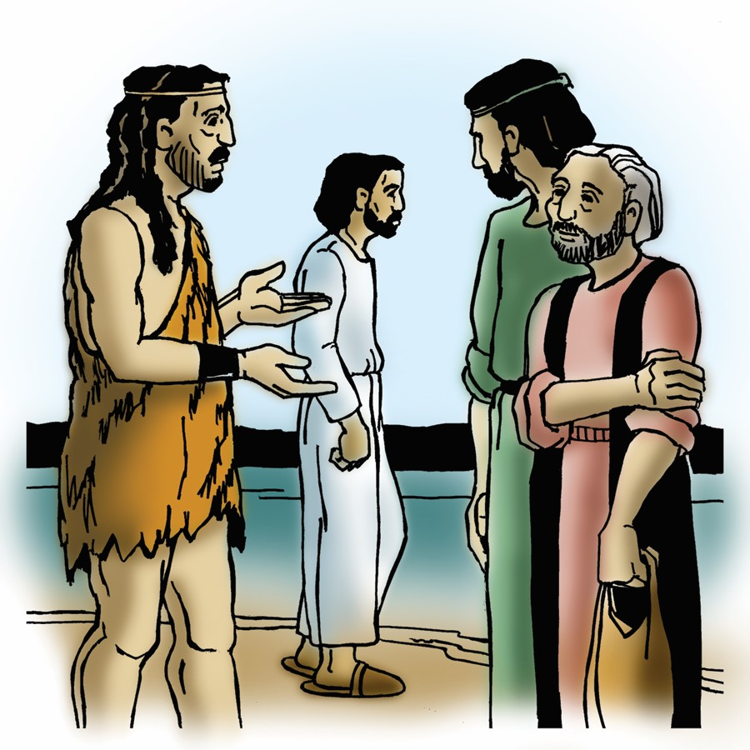
The Second Sunday after the Epiphany
Epiphany 2 (Year A)
Holy Eucharist II
January 18, 2026
10:00 AM In person and Online
Welcome to Trinity Episcopal, Sonoma!
Whether you have wandered in, are wondering about God or grew up in the church, or wherever you are in your journey...you are welcome here... We are blessed by your presence.
For Visitors and Newcomers:
Everyone is welcome to receive communion at the Lord’s table. Jesus gave this tangible reminder of God’s presence, love, and forgiveness for all. If you are interested in a visit or call from the Priest-in-Charge , please sign our guest book on the table at the entrance of the church, including an email or phone number.
Restrooms
A restroom is located outside the entrance of Buttrum Hall (the building across the courtyard) and another is located inside the hall to the right.
Coffee and Treats:
Following worship we have coffee and treats after service in Buttrum Hall. We hope it is a time to get to know you better.
To access Trinity’s Guest WIFI: Password Rosepettal441 (case sensitive).
We are glad you are here, and we invite you to enter fully into worship this morning.
January Announcements
St Paul’s in Healdsburg organ concert series will feature Max Polanek who is a Stanford Engineering Doctoral student studying with the University’s organist, Robert Hugh Morgan. Max will play pieces by Bach, Pachelbel, and Muffat.
The performance will be held in the church on Sunday, January 18 at 5:00 pm. Admission is free.
Fellowship Coffee Hour Sign up - We encourage members to sign up to make coffee. Pastor Cindy is happy to demonstrate how easy this is. Please help us provide this hospitality for guests and members.
Trinity’s annual meeting will be January 25th after Sunday’s Service.
The November, December, January Forward Day by Day , a booklet of daily inspirational meditations is now available in the Church and the Office. We ask for a $2 donation.
Congregational Vitality Assessment (CVA): This online tool is designed to help a congregation diagnose its 1) Vitality and Sustainability 2) Identify its strengths and weaknesses and 3) Develop/Prioritize strategies to address them. It does this by measuring how effectively a congregation is carrying out 11 vital areas of congregational functioning such as: Vision, Mission, & Discernment; Lay Engagement & Empowerment; Change Readiness; Spiritual Life; Outreach; and Stewardship. Once we receive the link from the Diocese, we will provide you with the information on how to fill out the survey.
Prayer Shawl Ministry: When Norah Collins came to Trinity Episcopal, she introduced us to the gift of Prayer Shawl Ministry. Norah was recognized for this effort by the City of Sonoma who named September 9, 2020, Norah Collins Day. Prayer Shawls are handmade by members of Trinity Episcopal to be given to someone to whom you want to give comfort, warmth, blessings and more. Wearing them, the recipients are surrounded by the blessings of Trinity Episcopal. Request forms for a shawl can be found in the purple folder in the library. Please fill one out and someone will get back to you with a shawl. Written requests allow us to follow up with recipients on their needs. Thank you.
Pastor Cindy will be starting a Lectio Divino style study beginning February 4. We will be looking at the gospel reading for the Sunday two weeks from that Wednesday. The gospel is read and a time of silent reflection occurs. The gospel is read a second time and participants share a word or phrase that jumped out at them. The gospel is read a third time followed by a time of silent reflection and/or study. After a time the participants share with one another their thoughts, feelings, or questions that arose in their reflection. We will meet at 10:30 AM on Wednesdays in the library.
Pastor Cindy is considering another study to be held either after worship or early evening based on the book "The Bible With and Without Jesus." Amy-Jill Levine and Marc Zvi Brettler take readers on a guided tour of the most popular Hebrew Bible passages quoted in the New Testament to show what the texts meant in their original contexts and then how Jews and Christians, over time, understood those same texts. More information to come as to time and location.
All are welcome to make a gift and offering in thanksgiving to God;
for the many blessings we have received. To take advantage of our electronic giving options, please follow the QR code with your capable electronic device, or visit https://onrealm.org/trinitysonoma/-/form/give/default Help us to make this a place where God’s grace is freely shared by all.


Prelude Steve Rubardt
Please stand for the Entrance Hymn.
At the sound of the bell, please stand as you are able. The People respond when bold text appears.
The Word of God
Entrance Hymn Christ is the World’s True Light H 542
Opening Acclamation (BCP p. 355)
The people standing, the Celebrant says
 | Blessed be God: Father, Son, and Holy Spirit.
People | And blessed be his kingdom, now and for ever. Amen.
Collect for Purity
All Almighty God, to you all hearts are open, all desires known, and from you no secrets are hid: Cleanse the thoughts of our hearts by the inspiration of your Holy Spirit, that we may perfectly love you, and worthily magnify your holy Name; through Christ our Lord. Amen.
Song of Praise Gloria BCP 356/Hymnal S-280
All Glory to God in the highest,
and peace to his people on earth.
Lord God, heavenly King,
almighty God and Father,
we worship you, we give you thanks,
we praise you for your glory.
Lord Jesus Christ, only Son of the Father,
Lord God, Lamb of God,
you take away the sin of the world:
have mercy on us;
you are seated at the right hand of the Father:
receive our prayer.
For you alone are the Holy One,
you alone are the Lord,
you alone are the Most High,
Jesus Christ,
with the Holy Spirit,
in the glory of God the Father. Amen.
The Collect of the Day BCP 357
Celebrant | The Lord be with you.
People | And also with you.
Celebrant | Let us pray.
Almighty God, whose Son our Savior Jesus Christ is the light of the world: Grant that your people, illumined by your Word and Sacraments, may shine with the radiance of Christ’s glory, that he may be known, worshiped, and obeyed to the ends of the earth; through Jesus Christ our Lord, who with you and the Holy Spirit lives and reigns, one God, now and for ever.
All Amen.
The Lessons
First Reading: Isaiah 49:1-7
Reader A Reading from the book of the prophet Isaiah.
¹Listen to me, O coastlands,
pay attention, you peoples from far away!
The Lord called me before I was born,
while I was in my mother’s womb he named me.
²He made my mouth like a sharp sword,
in the shadow of his hand he hid me;
he made me a polished arrow,
in his quiver he hid me away.
³And he said to me, “You are my servant,
Israel, in whom I will be glorified.”
⁴But I said, “I have labored in vain,
I have spent my strength for nothing and vanity;
yet surely my cause is with the Lord,
and my reward with my God.”
⁵And now the Lord says,
who formed me in the womb to be his servant,
to bring Jacob back to him,
and that Israel might be gathered to him,
for I am honored in the sight of the Lord,
and my God has become my strength—
⁶he says,
“It is too light a thing that you should be my servant
to raise up the tribes of Jacob
and to restore the survivors of Israel;
I will give you as a light to the nations,
that my salvation may reach to the end of the earth.”
⁷Thus says the Lord,
the Redeemer of Israel and his Holy One,
to one deeply despised, abhorred by the nations,
the slave of rulers,
“Kings shall see and stand up,
princes, and they shall prostrate themselves,
because of the Lord, who is faithful,
the Holy One of Israel, who has chosen you.”
Reader | The Word of the Lord.
People | Thanks be to God.
The Psalm: Psalm 40:1-12
Reader We will read Psalm 40:1-12 responsively by half verse.
¹I waited patiently upon the Lord; *
he stooped to me and heard my cry.
²He lifted me out of the desolate pit, out of the mire and clay; *
he set my feet upon a high cliff and made my footing sure.
³He put a new song in my mouth,
a song of praise to our God; *
many shall see, and stand in awe,
and put their trust in the Lord.
⁴Happy are they who trust in the Lord! *
they do not resort to evil spirits or turn to false gods.
⁵Great things are they that you have done, O Lord my God!
how great your wonders and your plans for us! *
there is none who can be compared with you.
⁶Oh, that I could make them known and tell them! *
but they are more than I can count.
⁷In sacrifice and offering you take no pleasure; *
(you have given me ears to hear you);
⁸Burnt-offering and sin-offering you have not required, *
and so I said, “Behold, I come.
⁹In the roll of the book it is written concerning me: *
‘I love to do your will, O my God;
your law is deep in my heart.’ ”
¹⁰I proclaimed righteousness in the great congregation; *
behold, I did not restrain my lips;
and that, O Lord, you know.
¹¹Your righteousness have I not hidden in my heart;
I have spoken of your faithfulness and your deliverance; *
I have not concealed your love and faithfulness from the great congregation.
¹²You are the Lord;
do not withhold your compassion from me; *
let your love and your faithfulness keep me safe for ever.
The Second Reading 1 Corinthians 1:1-9
Reader A Reading from Paul's First letter to the Church in Corinth.
¹Paul, called to be an apostle of Christ Jesus by the will of God, and our brother Sosthenes,
²To the church of God that is in Corinth, to those who are sanctified in Christ Jesus, called to be saints, together with all those who in every place call on the name of our Lord Jesus Christ, both their Lord and ours:
³Grace to you and peace from God our Father and the Lord Jesus Christ.
⁴I give thanks to my God always for you because of the grace of God that has been given you in Christ Jesus, ⁵for in every way you have been enriched in him, in speech and knowledge of every kind—⁶just as the testimony of Christ has been strengthened among you—⁷so that you are not lacking in any spiritual gift as you wait for the revealing of our Lord Jesus Christ. ⁸He will also strengthen you to the end, so that you may be blameless on the day of our Lord Jesus Christ. ⁹God is faithful; by him you were called into the fellowship of his Son, Jesus Christ our Lord.
Reader | The Word of the Lord.
People | Thanks be to God.
Sequence Hymn God of Mercy, God of Grace H 538 v 1
The Holy Gospel: John 1:29-42
Celebrant | The Holy Gospel of our Lord Jesus Christ according to John.
People | Glory to you, Lord Christ.
²⁹[John] saw Jesus coming toward him and declared, “Here is the Lamb of God who takes away the sin of the world!³⁰This is he of whom I said, ‘After me comes a man who ranks ahead of me because he was before me.’ ³¹I myself did not know him; but I came baptizing with water for this reason, that he might be revealed to Israel.” ³²And John testified, “I saw the Spirit descending from heaven like a dove, and it remained on him. ³³I myself did not know him, but the one who sent me to baptize with water said to me, ‘He on whom you see the Spirit descend and remain is the one who baptizes with the Holy Spirit.’ ³⁴And I myself have seen and have testified that this is the Son of God.”
³⁵The next day John again was standing with two of his disciples, ³⁶and as he watched Jesus walk by, he exclaimed, “Look, here is the Lamb of God!” ³⁷The two disciples heard him say this, and they followed Jesus. ³⁸When Jesus turned and saw them following, he said to them, “What are you looking for?” They said to him, “Rabbi” (which translated means Teacher), “where are you staying?” ³⁹He said to them, “Come and see.” They came and saw where he was staying, and they remained with him that day. It was about four o’clock in the afternoon. ⁴⁰One of the two who heard John speak and followed him was Andrew, Simon Peter’s brother. ⁴¹He first found his brother Simon and said to him, “We have found the Messiah” (which is translated Anointed). ⁴²He brought Simon to Jesus, who looked at him and said, “You are Simon son of John. You are to be called Cephas” (which is translated Peter).
Celebrant | The Gospel of the Lord.
People | Praise to you, Lord Christ.
Sequence Hymn God of Mercy, God of Grace H 538 v 2
The Sermon Pastor Cindy Beck
The Nicene Creed (BCP p. 358)
The Prayers of the People
Celebrant: Brothers and sisters, grace to you and peace from God our Father and the Lord Jesus Christ. I bid you to, “Come and see the great things God has done. Behold, we come.”
Intercessor: We pray for your Church. Give us as a light to the nations. Sanctify us in Christ Jesus, call us to be saints and strengthen us to follow Jesus to the end.
In the Diocesan Cycle of Prayer, we pray for Belfry Episcopal & Lutheran Campus Ministry in Davis.
In the Anglican Cycle of Prayer, we pray for The Province de L’Eglise Angelicane Du Congo.
Silence
Come and see the great things God has done.
Behold, we come.
We pray for this nation and the world. May your salvation, O God, reach to the ends of the earth. May all the peoples know of your faithfulness and your deliverance.
Silence
Come and see the great things God has done.
Behold, we come.
We pray for all of creation. Give us a sense of awe as we consider all of the works of your hands. +___________________________
Invite the congregation to add their thanksgivings, followed by silence
Come and see the great things God has done.
Behold, we come.
We pray for our local community. Make our footing sure. May our future be secured by your love and faithfulness.
Silence
Come and see the great things God has done.
Behold, we come.
We pray for all those in need of your healing and strength, +__________ Lift them out of the desolate pit. Put in their mouths a new song, a song of praise. May they know just how great for them are your wonders and your plans.
Invite the congregation to add their petitions, followed by silence
Come and see the great things God has done.
Behold, we come.
We pray for those who have died, +_____ In your great faithfulness, keep them blameless for the day of our Lord Jesus Christ. Honor them in your sight forever.
Invite the congregation to add their petitions, followed by silence
Come and see the great things God has done.
Behold, we come.
The Confession of Sin
Most merciful God,
we confess that we have sinned against you
in thought, word, and deed,
by what we have done,
and by what we have left undone.
We have not loved you with our whole heart;
we have not loved our neighbors as ourselves.
We are truly sorry and we humbly repent.
For the sake of your Son Jesus Christ,
have mercy on us and forgive us;
that we may delight in your will,
and walk in your ways,
to the glory of your Name. Amen.
The Peace
Celebrant The peace of the Lord be always with you.
People And also with you.
Announcements
Birthdays, Anniversaries, Travelers (prayers found at back of bulletin)
The Holy Communion
The Offertory At the Offering, you’ll find a Pledge card in the Pew Rack for those who’d like to designate their financial donations to Trinity’s Pledging Income. For others, or a one-time gift, envelopes are in the pew racks as well as on the Narthex table or text TRINITYSONOMA" to 73256. Thank you!
Offertory Music Steve Rubardt & Choir
I have Decided to Follow Jesus LEVAS 136
Doxology
The people stand while the offerings are presented and placed on the Altar.
Presider: Gracious God, as an offering of our thanksgiving and gratitude, we return to you a portion of what you have gifted us.
The Great Thanksgiving
Eucharistic Prayer B BCP 367
Celebrant | The Lord be with you.
People | And also with you.
Celebrant | Lift up your hearts.
People | We lift them to the Lord.
Celebrant | Let us give thanks to the Lord our God.
People | It is right to give him thanks and praise.
Proper Preface (BCP p. 367)
It is right, and a good and joyful thing, always and everywhere to give thanks to you, Father Almighty, Creator of heaven and earth.
Because you gave Jesus Christ, your only Son, to be born for us; who, by the mighty power of the Holy Spirit, was made perfect Man of the flesh of the Virgin Mary his mother; so that we might be delivered from the bondage of sin, and receive power to become your children.
Therefore we praise you, joining our voices with Angels and Archangels and with all the company of heaven, who for ever sing this hymn to proclaim the glory of your Name:
Sanctus Holy Holy, Holy (Proulx) Hymnal S-125
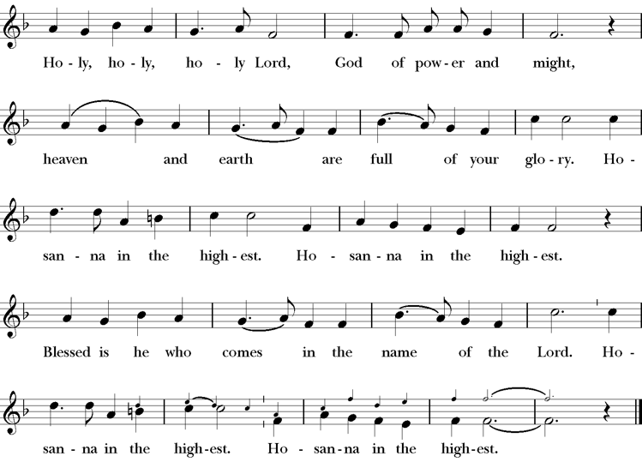
Words of Institution BCP 368
The Lord’s Prayer 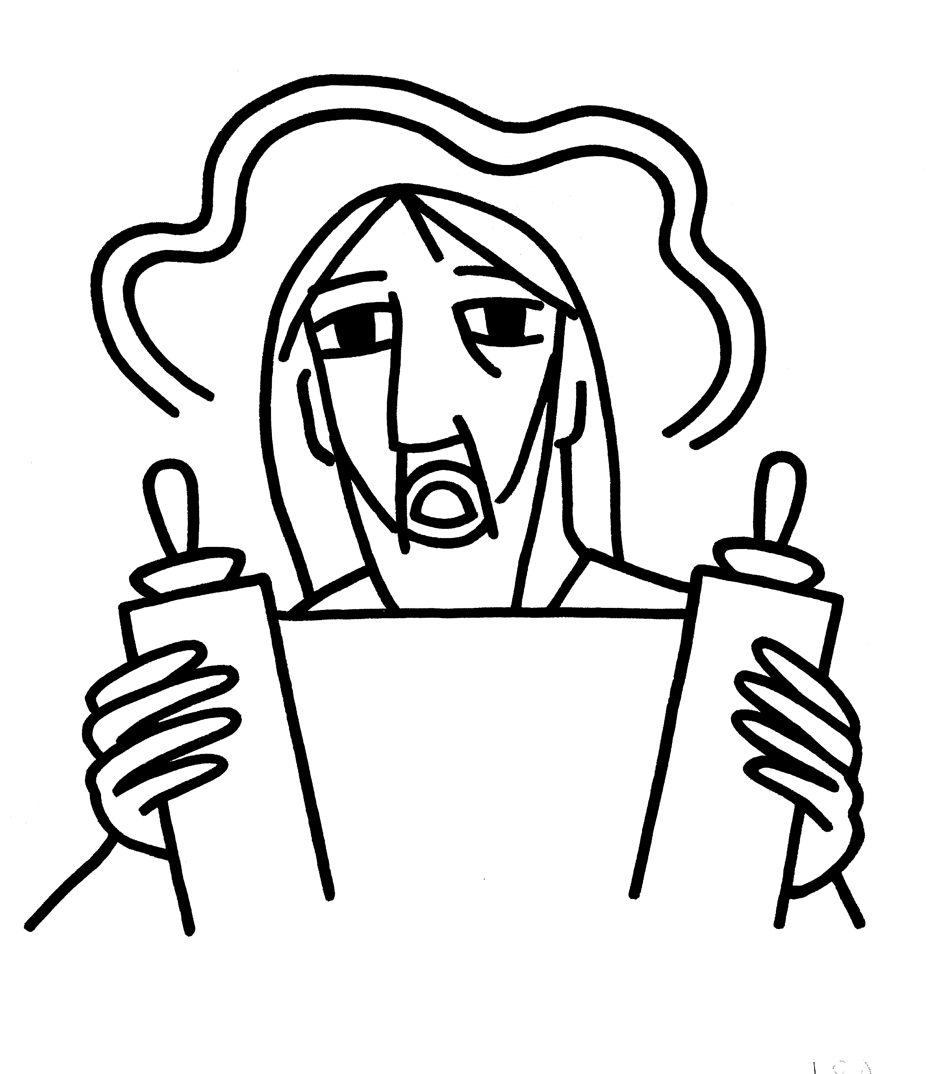 BCP 364
The Breaking of the Bread  BCP 364
Fraction Anthem S-154
All are welcome at the Lord’s table to receive Holy Communion or a blessing. To receive Communion in your pew, please ask an usher to notify the ministers on your behalf. If you require a gluten-free wafer, please ask at the altar rail.
Communion Music Steve Rubardt & Choir
Ave Maria
Post-Communion Prayer
Eternal God, heavenly Father,
you have graciously accepted us as living members
of your Son our Savior Jesus Christ,
and you have fed us with spiritual food
in the Sacrament of his Body and Blood.
Send us now into the world in peace,
and grant us strength and courage
to love and serve you
with gladness and singleness of heart;
through Christ our Lord. Amen.
Amen.
Blessing (BCP p. 366)
The blessing of God Almighty, the Father, the Son, and the Holy Spirit, be upon you and remain with you for ever.
Amen.
The Recessional Hymn Rock of Ages H 685
Dismissal (BCP p. 366)
 | Let us go forth in the name of Christ.
People | Thanks be to God.
Postlude Steve Rubardt
Please remain seated
SERVING TODAY
Celebrant and Preacher: Pastor Cindy Beck
Acolyte: Arminda Eiler
Lector: Ann Kyser , Barbara Feduska
Intercessor: Alfred Escoffier
Worship Musician: Steve Rubardt
Choir Leader: Steve Rubardt
Choir: Liz Carpenter, Heather Dahlberg, Scott Sherman, Lucy Maushardt, Patsy Gralow, Laurell Meredith, Mary Omodt, Barbara Feduska, Tara Anderson
Sunday School - Child Care: Wendy Aguilar Appt Only
Ushers: John Eiler
Tech Chaplain: Marcos Rendon
Altar Guild: Ann Kyser
Hospitality: Susie Hand

Prayers requested for these on Trinity’s long-term prayer list: Baby Walker David, Armando P, Laura Basett, , Georgia Bostedt, Muff Davey, John Eiler, Gerrilee Fisher, Claire Ginesi, Mary Griffin, David & Christine Hilt, Dr. Tamer Keshen, Marie Lambert, Mark Mezzetta, Kelcey Omodt, Grizelda Ponce, Barry Reap, Blake W, Robert R, Ann Loveland Sherman, John Spooner, James Thomas, Rose Burns, Jennifer Gralow, Patsy Gralow, Steve Antenen, Sandra Leland, John Forester, Stuart , Melissa White.
Prayers for the Repose of soul: Tim Dowd , Susan Bassett, Joan Biersch, Mere Nagasau, Christina Van Krugel, Linda Dowd, Peggy and John Bell, Denny Hoelter, Van Z
Contact Pastoral Care Chair, Lorena lorena.m.reinhardt@gmail.com to make any additions or to remove names from our Long-Term Prayer list.

Calendar of the Church Year
The calendar (BCP, pp. 15-33) orders the liturgical year of the Episcopal Church by identifying two cycles of feasts and holy days-one dependent upon the movable date of Easter Day and the other dependent upon the fixed date of Christmas, Dec. 25. Easter Day is the first Sunday after the full moon that falls on or after Mar. 21. The sequence of all Sundays in the church year is based on the date of Easter. Tables and rules for finding the date of Easter Day, and other movable feasts and holy days are provided by the BCP, pp. 880-885. The date of Easter determines the beginning of the season of Lent on Ash Wednesday and the date of Pentecost on the fiftieth day of the Easter season. The Sundays of Advent are always the four Sundays before Christmas Day. The church year begins on the first Sunday of Advent. The calendar also identifies and provides directions concerning the precedence and observance of principal feasts, Sundays, holy days (including Feasts of our Lord, other major feasts, and fasts), Days of Special Devotion, and Days of Optional Observance. The calendar lists dates for celebration of major feasts and lesser feasts by month and date. Appropriate Sunday Letters and Golden Numbers are also provided. (see BCP, pp. 880-881). The calendar also lists the titles of the seasons, Sundays, and major holy days observed in the Episcopal Church throughout the church year, including Advent season, Christmas season, Epiphany season, Lenten season, Holy Week, Easter season, the season after Pentecost, holy days, and National Days.
Notes on the Epiphany Season Liturgy
In the weeks after Epiphany, other events in Jesus’ ministry are celebrated, events such as his first miracle, changing water into wine; his first healing; his calling of the disciples; his first preaching. These events reveal him as God’s Son and help us explore more deeply the unlimited extent of his love and our role—as the members of his Body—in revealing him to the world.
The liturgical texts for this period are very expressive of its meaning and embody many of the symbols, both biblical and cultural, which came to be part of the season:
Trinity Liturgical Ministry ROTA Next two weeks
Date | Celebrant | Ushers | Acolyte / EM | Lector (s) | Intercessor | Altar Guild
Jan 25 | Cindy Beck | John Addeo | Susie Hand | Barbara Feduska , Gerrilee FIsher | Claire Ginesi | Ann Kyser
Feb 1 | Cindy Beck | TBD | TBD | TBD | TBD | TBD

Schedule of Weekly Meetings and Services at Trinity Episcopal Sonoma
Day | Date | Time | Occasion | Location
Wednesday | January 21 | 10:30 AM | Bible Study | Library
Thursday | January 22 | 10:30 AM  5:30 PM | Mindfulness & Well Being  Alcoholics Anonymous | Library  Buttrum Hall
Saturday | Jan 24 | 8 AM | Centering Prayer | St. Luke’s Chapel
Sunday | Jan 25 | 10:15 AM | Holy Eucharist II | Sanctuary
Mon-Fri | Weekdays | 7AM-1PM | Sonoma Home Meals | Kitchen &Buttrum Hall
Mon-Fri | Weekdays | 9-2 | Sonoma Preschool Academy – School
Monthly Meetings at Trinity Episcopal Sonoma
Day | Date | Time | Meeting | Location | Contact
Tuesday | January 6 | 11 AM | Prayer Shawl Ministry | Library | Norah Collins 28norahe@gmail.com
Thursday | January 15 | 4:30 PM | Vestry | Library | Claire Ginesi cfgsonoma@gmail.com
PRAYERS and BLESSINGS
For a Birthday
Watch over your child, O Lord as his/her days increase; bless and guide him/her wherever s/he may be. Strengthen them when s/he stands; comfort him/her when discouraged or sorrowful; raise him/her up if s/he fall; and in his/her heart may your peace which passes understanding abide all the days of his/her life; through Jesus Christ our Lord. Amen.
For an Anniversary
O God, you have so consecrated the covenant of marriage that it represents the spiritual unity between Christ and his Church: Send your blessing upon these your servants as they celebrate their anniversary, that they may continue to love, honor and cherish each other in faithfulness and patience, in wisdom and true godliness, that their home may be a haven of blessing and peace; through Jesus Christ our Lord, who lives and reigns with you and the Holy Spirit, one God, now and forever. Amen.
For Travelers
O God, our heavenly Father, whose glory fills the whole creation, and whose presence we find wherever we go; preserve those who travel; surround them with your loving care; protect them from every danger, and bring them in safety to their journey’s end; through Jesus Christ our Lord. Amen.
Sending our Eucharistic Visitors
Priest: In the name of this congregation, I send you forth bearing these holy gifts, the those to whom you go may share with us in the communion of Christ’s body and blood.
People: We who are many are one body, because we all share on bread, and one cup. Amen

Trinity Episcopal Church
In Sonoma for over 170 years
275 East Spain Street
Sonoma, CA 95476
The Rt. Rev. Megan M. Traquair, Bishop
Diocese of Northern California
Pastor Cindy Beck, Interim
Steve Rubardt, Worship Music
Vestry
Bill Doyle, Junior Warden (Buildings, Grounds)
Bill Doyle (Stewardship)
Susie Hand
Heather Dahlberg
Lorena Reinhardt (Pastoral Care)
Ministries
Prayer Shawl ,Norah Collins
Outreach, Jane Hernandez
Youth – Academic Tutoring, Karen Randall
Mindfulness & Well Being, Mary Omodt
Sunday School, Children, Wendy Aguilar

The Members of the Congregation are The Ministers of the Church

Administrative Office Hrs.
Monday Wednesday 9 A.M. – 2 PM; Thursday 10A.M.-2 P.M0
Sunday 9:30-11:30
Clergy Office Hours Wednesdays, Thursdays, by appointment

Emergency, sickness, please contact office: 707-938-4846

