Trinity Episcopal Church
Cultivating God’s Loving Spirit in each of us
Proper 22
Year A
Holy Eucharist II
October 4, 2026
10:00 AM In person and Online
Welcome to Trinity Episcopal, Sonoma. Whether you are passing through or looking for a church home, we are blessed by your presence and we invite you to worship with us fully – singing, praying and receiving communion- with your voice and heart. Please sign our guestbook at the back of the church, including your email.
If you would like to learn more about The Episcopal Church, please send us an email trinityepiscopalsonoma@comcast.net. We look forward to meeting you after the service where coffee and treats are served.

All are welcome to make a gift and offering in thanksgiving to God; for the many blessings we have received. To take advantage of our electronic giving options, please follow the QR code with your capable electronic device, or visit https://onrealm.org/trinitysonoma/-/form/give/default
October Announcements
Fellowship Coffee Hour Sign up – Fellowship follows the service! We meet in the hall or courtyard. We’d love to visit with you.
Thank you to everyone who donated food for A Simple Gesture, your gift helps people have a meal! Our next pick up will be in November!
Movie Night at Trinity will continue on October 21st, at 6PM in Buttram Hall. We will be showing “The Intern” with Robert Deniro. There will be snacks and refreshements during the post film discussion.

Prelude Steve Rubardt
Please stand for the Entrance Hymn.
At the sound of the bell, please stand as you are able. The People respond when bold text appears.
The Word of God
Entrance Hymn Be thou my Vision H 488
Opening Acclamation BCP 319
Celebrant | Blessed be God: Father, Son, and Holy Spirit.
People | And blessed be his kingdom, now and for ever. Amen.
Collect for Purity
All Almighty God, to you all hearts are open, all desires known, and from you no secrets are hid: Cleanse the thoughts of our hearts by the inspiration of your Holy Spirit, that we may perfectly love you, and worthily magnify your holy Name; through Christ our Lord. Amen.
Song of Praise Glory to God Hymn S-280 is sung, all standing
Glory to God in the highest,
and peace to his people on earth.
Lord God, heavenly King,
almighty God and Father,
we worship you, we give you thanks,
we praise you for your glory.
Lord Jesus Christ, only Son of the Father,
Lord God, Lamb of God,
you take away the sin of the world:
have mercy on us;
you are seated at the right hand of the Father:
receive our prayer.
For you alone are the Holy One,
you alone are the Lord,
you alone are the Most High,
Jesus Christ,
with the Holy Spirit,
in the glory of God the Father. Amen.
The Collect of the Day BCP 357
Celebrant | The Lord be with you.
People | And also with you.
Celebrant | Let us pray.
Almighty and everlasting God, you are always more ready to hear than we to pray, and to give more than we either desire or deserve: Pour upon us the abundance of your mercy, forgiving us those things of which our conscience is afraid, and giving us those good things for which we are not worthy to ask, except through the merits and mediation of Jesus Christ our Savior; who lives and reigns with you and the Holy Spirit, one God, for ever and ever.
All Amen.

The Lessons
First Reading: Isaiah 5:1-7
Reader A Reading from the book of the prophet Isaiah.
¹Let me sing for my beloved
my love-song concerning his vineyard:
My beloved had a vineyard
on a very fertile hill.
²He dug it and cleared it of stones,
and planted it with choice vines;
he built a watchtower in the midst of it,
and hewed out a wine vat in it;
he expected it to yield grapes,
but it yielded wild grapes.
³And now, inhabitants of Jerusalem
and people of Judah,
judge between me
and my vineyard.
⁴What more was there to do for my vineyard
that I have not done in it?
When I expected it to yield grapes,
why did it yield wild grapes?
⁵And now I will tell you
what I will do to my vineyard.
I will remove its hedge,
and it shall be devoured;
I will break down its wall,
and it shall be trampled down.
⁶I will make it a waste;
it shall not be pruned or hoed,
and it shall be overgrown with briers and thorns;
I will also command the clouds
that they rain no rain upon it.
⁷For the vineyard of the Lord of hosts
is the house of Israel,
and the people of Judah
are his pleasant planting;
he expected justice,
but saw bloodshed;
righteousness,
but heard a cry!
Reader | The Word of the Lord.
People | Thanks be to God.
The Psalm: Psalm 80:7-14
Reader We will read Psalm 80:7-14, responsively by half verse.
⁷Restore us, O God of hosts; *
show the light of your countenance, and we shall be saved.
⁸You have brought a vine out of Egypt; *
you cast out the nations and planted it.
⁹You prepared the ground for it; *
it took root and filled the land.
¹⁰The mountains were covered by its shadow *
and the towering cedar trees by its boughs.
¹¹You stretched out its tendrils to the Sea *
and its branches to the River.
¹²Why have you broken down its wall, *
so that all who pass by pluck off its grapes?
¹³The wild boar of the forest has ravaged it, *
and the beasts of the field have grazed upon it.
¹⁴Turn now, O God of hosts, look down from heaven;
behold and tend this vine; *
preserve what your right hand has planted.
Second Reading: Philippians 3:4b-14
Reader A Reading from Paul's letter to the Church in Philippi.
^{4b}If anyone else has reason to be confident in the flesh, I have more: ⁵circumcised on the eighth day, a member of the people of Israel, of the tribe of Benjamin, a Hebrew born of Hebrews; as to the law, a Pharisee; ⁶as to zeal, a persecutor of the church; as to righteousness under the law, blameless.
⁷Yet whatever gains I had, these I have come to regard as loss because of Christ. ⁸More than that, I regard everything as loss because of the surpassing value of knowing Christ Jesus my Lord. For his sake I have suffered the loss of all things, and I regard them as rubbish, in order that I may gain Christ ⁹and be found in him, not having a righteousness of my own that comes from the law, but one that comes through faith in Christ, the righteousness from God based on faith. ¹⁰I want to know Christ and the power of his resurrection and the sharing of his sufferings by becoming like him in his death, ¹¹if somehow I may attain the resurrection from the dead.
¹²Not that I have already obtained this or have already reached the goal; but I press on to make it my own, because Christ Jesus has made me his own. ¹³Beloved, I do not consider that I have made it my own; but this one thing I do: forgetting what lies behind and straining forward to what lies ahead, ¹⁴I press on toward the goal for the prize of the heavenly call of God in Christ Jesus.
Reader | The Word of the Lord.
People | Thanks be to God.
Sequence Hymn We the Lord’s People H 51 v 1 & 2
The Holy Gospel: Matthew 21:33-46
Celebrant | The Holy Gospel of our Lord Jesus Christ according to Matthew.
People | Glory to you, Lord Christ.
[Jesus said,] ³³“Listen to another parable. There was a landowner who planted a vineyard, put a fence around it, dug a wine press in it, and built a watchtower. Then he leased it to tenants and went to another country. ³⁴When the harvest time had come, he sent his slaves to the tenants to collect his produce. ³⁵But the tenants seized his slaves and beat one, killed another, and stoned another. ³⁶Again he sent other slaves, more than the first; and they treated them in the same way. ³⁷Finally he sent his son to them, saying, ‘They will respect my son.’ ³⁸But when the tenants saw the son, they said to themselves, ‘This is the heir; come, let us kill him and get his inheritance.’ ³⁹So they seized him, threw him out of the vineyard, and killed him. ⁴⁰Now when the owner of the vineyard comes, what will he do to those tenants?” ⁴¹They said to him, “He will put those wretches to a miserable death, and lease the vineyard to other tenants who will give him the produce at the harvest time.”
⁴²Jesus said to them, “Have you never read in the scriptures:
‘The stone that the builders rejected
has become the cornerstone;
this was the Lord’s doing,
and it is amazing in our eyes’?
⁴³Therefore I tell you, the kingdom of God will be taken away from you and given to a people that produces the fruits of the kingdom. ⁴⁴The one who falls on this stone will be broken to pieces; and it will crush anyone on whom it falls.”
⁴⁵When the chief priests and the Pharisees heard his parables, they realized that he was speaking about them. ⁴⁶They wanted to arrest him, but they feared the crowds, because they regarded him as a prophet.
Celebrant | The Gospel of the Lord.
People | Praise to you, Lord Christ.
Sequence Hymn We the Lord’s People H 51 v 3 & 4
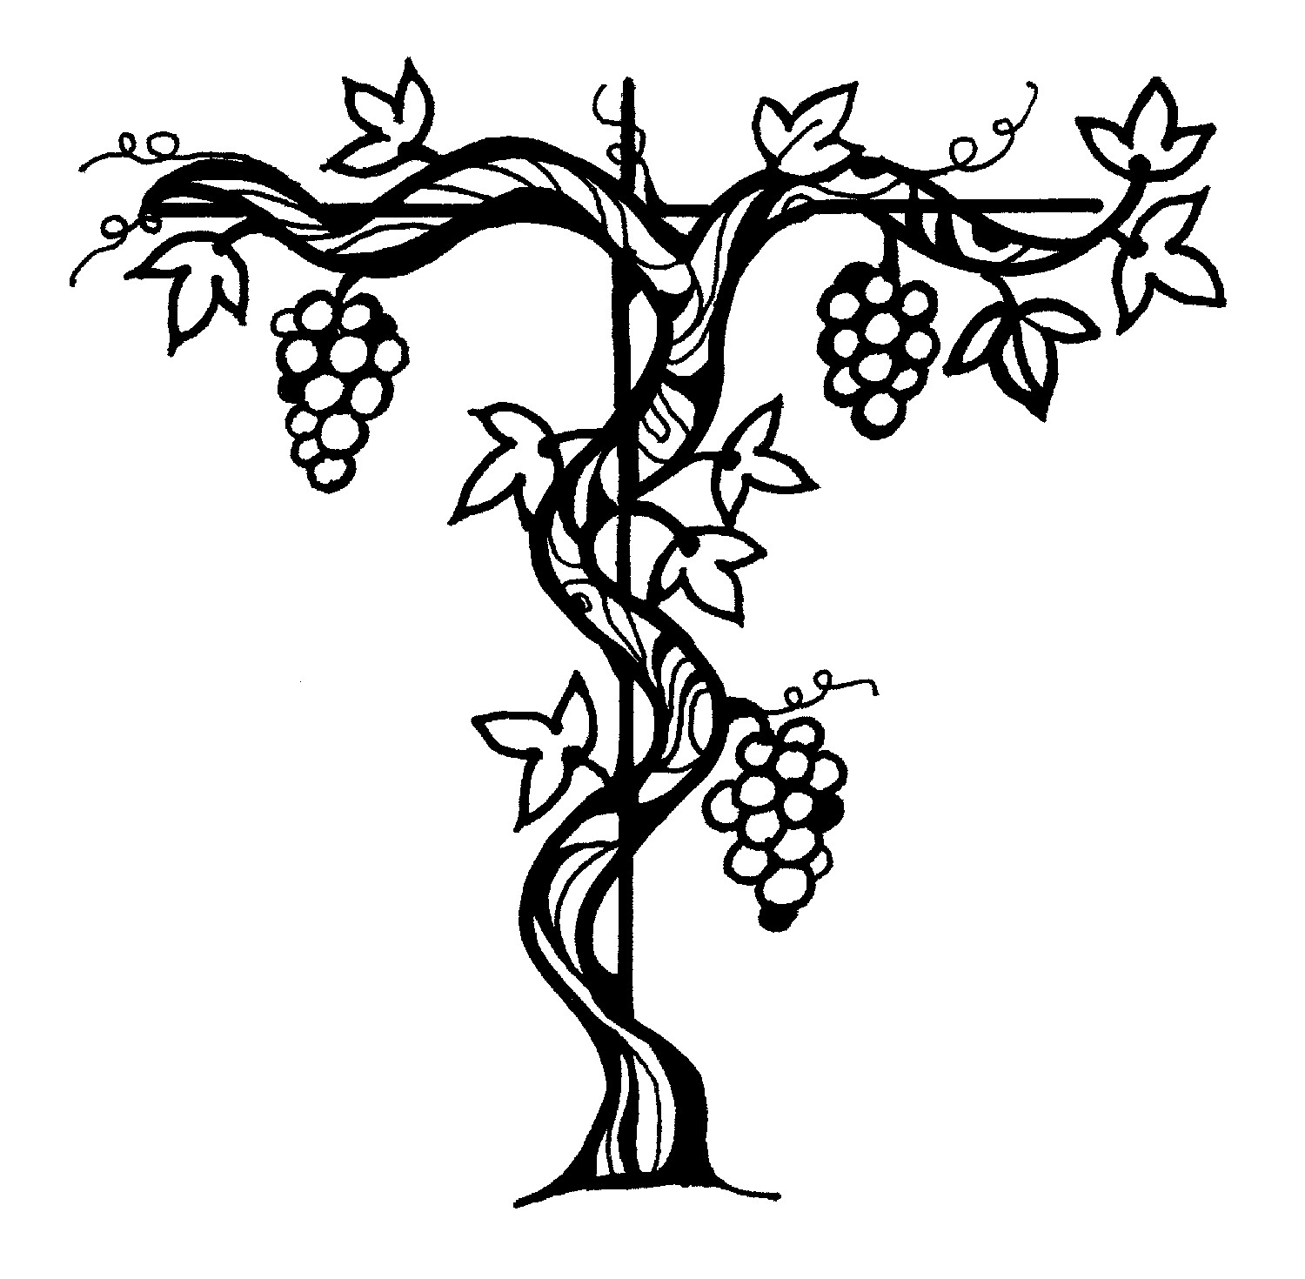
Sermon Pastor Cindy Beck
The Nicene Creed (BCP p. 358)
We believe in one God, the Father, the Almighty, maker of heaven and earth, of all that is, seen and unseen.
We believe in one Lord, Jesus Christ, the only Son of God, eternally begotten of the Father, God from God, Light from Light, true God from true God, begotten, not made, of one Being with the Father. Through him all things were made. For us and for our salvation he came down from heaven: by the Power of the Holy Spirit he became incarnate from the Virgin Mary, and was made man. For our sake he was crucified under Pontius Pilate; he suffered death and was buried. On the third day he rose again in accordance with the Scriptures; he ascended into heaven and is seated at the right hand of the Father. He will come again in glory to judge the living and the dead, and his kingdom will have no end.
We believe in the Holy Spirit, the Lord, the giver of life, who proceeds from the Father and the Son. With the Father and the Son he is worshipped and glorified. He has spoken through the Prophets. We believe in one holy catholic and apostolic Church. We acknowledge one baptism for the forgiveness of sins. We look for the resurrection of the dead, and the life of the world to come. Amen.

The Prayers of the People
Celebrant: Dear Household of God, the law of the Lord is perfect and revives the soul! So let us appeal to our Lord God, saying, “Let the words of our mouths and meditations of our hearts be acceptable in your sight, O Lord, our strength and our redeemer.”
Intercessor: In the Diocesan Cycle of Prayer, we pray for Trinity Church in Sonoma.
In the Anglican Cycle of Prayer, we pray for The Igreja Episcopal Anglicana do Brasil.
Silence
Let the words of our mouths and meditations of our hearts be acceptable in your sight,
O Lord, our strength and our redeemer.
Loving God, you command us to have no other gods before you: give your Church such singleness of mind that we might not be distracted by the rubbish of our lives, but may strive to know Christ and the power of his resurrection.
Silence
Let the words of our mouths and meditations of our hearts be acceptable in your sight,
O Lord, our strength and our redeemer.
Loving God, you command us to keep a holy Sabbath: make us generous stewards of this planet that it may be renewed and refreshed.
Silence
Let the words of our mouths and meditations of our hearts be acceptable in your sight,
O Lord, our strength and our redeemer.
Loving God, you command us to covet nothing that belongs to our neighbor: give us kind and generous hearts for those with whom we share our neighborhoods. May a loving spirit rule this region, +_________________.
Invite the congregation to add their thanksgivings, followed by silence
Let the words of our mouths and meditations of our hearts be acceptable in your sight,
O Lord, our strength and our redeemer.
Loving God, you desire that your people be not afraid: Pour on the sick, suffering, and struggling the abundance of your mercy. Bless them with goodness and healing through Jesus the Christ, +______________.
Invite the congregation to add their petitions, followed by silence
Let the words of our mouths and meditations of our hearts be acceptable in your sight,
O Lord, our strength and our redeemer.
Loving God, you have made us your own: may we, and those who have run the race of faith before us, attain the resurrection from the dead through the abundant mercy of your Son.
Invite the congregation to add their petitions, followed by silence
Let the words of our mouths and meditations of our hearts be acceptable in your sight,
O Lord, our strength and our redeemer.
Celebrant Gracious and merciful God, who honors the last as well as the first, hear the prayers we offer this day and welcome your people into your kingdom; through Jesus Christ our Lord. Amen.
Confession of Sin BCP 359
Most merciful God, we confess that we have sinned against you in thought, word and deed, by what we have done, and by what we have left undone.
We have not loved you with our whole heart; we have not loved our neighbors as ourselves. We are truly sorry and we humbly repent.
For the sake of your Son Jesus Christ, have mercy on us and forgive us; that we may delight in your will, and walk in your ways, to the glory of your Name. Amen.
The Peace
Celebrant The peace of the Lord be always with you.
People And also with you.
Announcements
Birthdays, Anniversaries, Travelers (prayers found at back of bulletin)
The Holy Communion
The Offertory At the Offering, you’ll find a Pledge card in the Pew Rack for those who’d like to designate their financial donations to Trinity’s Pledging Income. For others, or a one-time gift, envelopes are in the pew racks as well as on the Narthex table or text TRINITYSONOMA" to 73256. Thank you!
Offertory Music
Steve Rubardt and Choir Somewhere
Doxology
Praise God, from whom all blessings flow;
Praise Him, all creatures here below;
Praise Him above, ye heav'nly host;
Praise Father, Son, and Holy Ghost.
Amen.
The people stand while the offerings are presented and placed on the Altar.
Presider: Gracious God, as an offering of our thanksgiving and gratitude, we return to you a portion of what you have gifted us.
The Great Thanksgiving
Eucharistic Prayer B BCP 367
Celebrant | The Lord be with you.
People | And also with you.
Celebrant | Lift up your hearts.
People | We lift them to the Lord.
Celebrant | Let us give thanks to the Lord our God.
People | It is right to give him thanks and praise.
Proper Preface (BCP p. 367)
It is right, and a good and joyful thing, always and everywhere to give thanks to you, Father Almighty, Creator of heaven and earth.
For you are the source of light and life; you made us in your image, and called us to new life in Jesus Christ our Lord.
Therefore we praise you, joining our voices with Angels and Archangels and with all the company of heaven, who for ever sing this hymn to proclaim the glory of your Name:
Sanctus Holy Holy, Holy (Proulx) Hymnal S-125
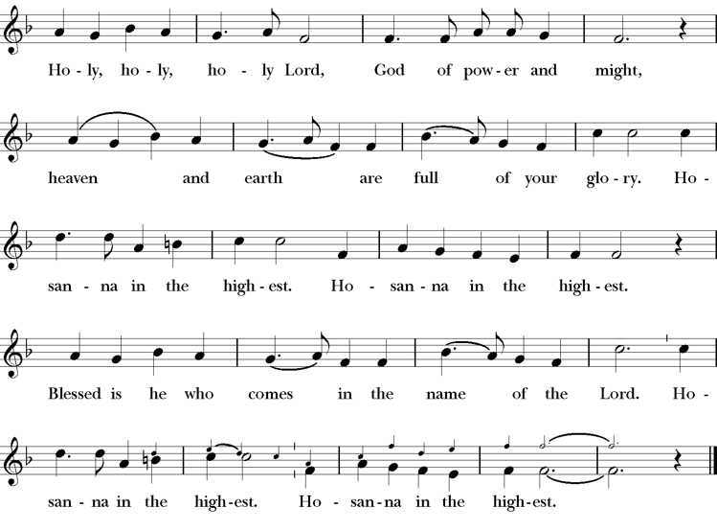
Presider Holy and gracious Father: In your infinite love you made us for yourself; and, when we had fallen into sin and become subject to evil and death, you, in your mercy, sent Jesus Christ, your only and eternal Son, to share our human nature, to live and die as one of us, to reconcile us to you, the God and Father of all.
He stretched out his arms upon the cross, and offered himself, in obedience to your will, a perfect sacrifice for the whole world.
On the night he was handed over to suffering and death, our Lord Jesus Christ took bread; and when he had given thanks to you, he broke it, and gave it to his disciples, and said, “Take, eat: This is my Body, which is given for you. Do this for the remembrance of me”
After supper he took the cup of wine; and when he had given thanks, he gave it to them, saying, “Drink this, all of you: this is my blood of the new covenant which is shed for you and for many for the forgiveness of sins. Whenever you drink it, do this for the remembrance of me.”
Presider Therefore we proclaim the mystery of faith.
People Christ has died; Christ is risen; Christ will come again.
Presider We celebrate the memorial of our redemption, O Father, in this sacrifice of praise and thanksgiving. Recalling his death, resurrection, and ascension, we offer you these gifts.
Sanctify them by your Holy Spirit to be for your people the Body and Blood of your Son, the holy food and drink of new and unending life in him. Sanctify us also that we may faithfully receive this holy Sacrament, and serve you in unity, constancy, and peace; and at last day bring us with all your saints into the joy of your eternal kingdom.
All this we ask through your Son Jesus Christ. By him, and with him, and in him, in the unity of the Holy Spirit all honor and glory is yours, Almighty Father, now and for ever.
Amen.
The Lord’s Prayer
Presider As our Savior has taught us, we are bold to pray.
People Our Father, who art in heaven, hallowed be thy name. Thy Kingdom come, thy will be done, on earth as it is in heaven. Give us this day our daily bread. And forgive us our trespasses, as we forgive those who trespass against us. And lead us not into temptation, but deliver us from evil. For thine is the kingdom, the power and the glory, for ever and ever. Amen.

The Breaking of the Bread
The Presider breaks the consecrated bread in view of the assembly.
Presider The Gifts of God for the people of God.
People Therefore let us keep the feast. Alleluia

Invitation to Communion
Presider This is the Lord’s table. The Lord Jesus invites us to share this joyful feast.
Sharing the Sacred Meal
This is Christ’s table and all are welcome and all are fed.
Communion Music Now the Silence H 333
Post-Communion Prayer BCP 365
The Blessing
The Recessional Hymn Ev’ry Time I feel the Spirit LEVAS 114
The Dismissal*
Celebrant | Let us go forth in the name of Christ.
People | Thanks be to God.
Postlude Steve Rubardt Please remain seated

SERVING TODAY
Celebrant & Preacher: Pastor Cindy Beck
Acolyte: Susie Hand
Lector: Lorena Reinhardt , Jane Hernandez
Intercessor: Barbara Feduska
Worship Musician: Steve Rubardt
Choir Leader: Steve Rubardt
Choir: Liz Carpenter, Heather Dahlberg, Scott Sherman, Patsy Gralow, Laurell Meredith, Mary Omodt, Barbara Feduska, Tara Anderson, Carol Heffler, Don McMahon
Sunday School - Child Care: Wendy Aguilar
Ushers: John Addeo
Tech Chaplain: Marcos Rendon
Altar Guild: Laurell Meredith , Liz Carpenter
Hospitality : Scott Sherman , Bill Doyle
Altar Flowers today are arranged by Liz Carpenter

Prayers requested for these on Trinity’s long-term prayer list: Armando P, Georgia Bostedt, John Eiler, Gerrilee Fisher, Claire Ginesi, Mary Griffin, David & Christine Hilt, Mark Mezzetta, Kelcey Omodt, Grizelda Ponce, Barry Reap, Blake W, Robert R, Melissa White, Ann Loveland Sherman, James Thomas, Rose Burns, Jennifer Gralow, Patsy Gralow, Steve Antenen, Sandra Leland, Karl, Michael Hardy, Michael Bean Land, Polly Moore, Sinat Liv, Will Maushardt, Sophia Piconi, Mike Smith, Jean Maffoli.
Prayers for the Repose of soul: Tim Dowd , Susan Bassett, Joan Biersch, Linda Dowd, Christina Van Krugel, Mere Nagasau, Mary Goshert, Peggy Bell, Carolyn Caldwell, Van Z, Dolores Mae Seaberg Cole, Muff Davey, Giancarlo Cestarollo.
Contact Pastoral Care Chair, Lorena lorena.m.reinhardt@gmail.com to make any additions or to remove names from our Long-Term Prayer list.
Notes on the Service Bulletin This service bulletin is a guide to the service. We use a variety of printed materials for the prayers, the scriptural readings and the hymns. The Readings for the week, including the Collect and Readings are found in this Bulletin. The service follows the liturgies that are found in the Book of Common Prayer (BCP). The BCP is the blue book found in the pew in front of you. The hymns come primarily from The 1982 Hymnal, also in the pew – the red book. Lift Every Voice and Sing (LEVAS) is another hymnal located in the pew rack. VF stands for Voices Found, another authorized hymnal. Sound Mate Assisted Hearing devices available at the back of the church on the Narthex Table.
Trinity Liturgical Ministry ROTA Next two weeks
Date | Celebrant | Ushers | Acolyte | Lector (s) | Intercessor | Altar Guild
10/11 | Cindy Beck | Marcia Derby | Claire Ginesi | Barbara Feduska , Gerrilee Fischer | Alfred Escoffier | Marcia Derby , Mary Omodt
10/18 | Cindy Beck | John Addeo | Susie Hand | Claire Ginesi , Lorena Reinhardt | Bill Doyle | Susie Hand
Schedule of Weekly Meetings and Services at Trinity Episcopal Sonoma
Day | Date | Time | Occasion | Location
Wednesday | October 7 | 11 AM | Bible Study | Library
Thursday | October 8 | 10:30 AM  5:30 PM | Mindfulness & Well Being  Alcoholics Anonymous | Library  Buttrum Hall
Saturday | October 10 | 8 AM | Centering Prayer | St. Luke’s Chapel
Sunday | October 11 | 10:00 AM | Holy Eucharist II | Sanctuary
Mon-Fri | Weekdays | 7AM-1PM | Sonoma Home Meals | Kitchen &Buttrum Hall
Mon-Fri | Weekdays | 9-2 | Sonoma Preschool Academy – School

Monthly Meetings at Trinity Episcopal Sonoma
Day | Date | Time | Meeting | Location | Contact
Tuesday | October 6 | 11 AM | Prayer Shawl Ministry | Library | Lorena Reinhardt lorena.m.reinhardt@gmail.com
Thursday | TBD | TBD | Vestry | Library | Cindy Beck 916-955-9861

PRAYERS and BLESSINGS
For a Birthday
Watch over your child, O Lord as his/her days increase; bless and guide him/her wherever s/he may be. Strengthen them when s/he stands; comfort him/her when discouraged or sorrowful; raise him/her up if s/he fall; and in his/her heart may your peace which passes understanding abide all the days of his/her life; through Jesus Christ our Lord. Amen.
For an Anniversary
O God, you have so consecrated the covenant of marriage that it represents the spiritual unity between Christ and his Church: Send your blessing upon these your servants as they celebrate their anniversary, that they may continue to love, honor and cherish each other in faithfulness and patience, in wisdom and true godliness, that their home may be a haven of blessing and peace; through Jesus Christ our Lord, who lives and reigns with you and the Holy Spirit, one God, now and forever. Amen.
For Travelers
O God, our heavenly Father, whose glory fills the whole creation, and whose presence we find wherever we go; preserve those who travel; surround them with your loving care; protect them from every danger, and bring them in safety to their journey’s end; through Jesus Christ our Lord. Amen.
Sending our Eucharistic Visitors
Priest: In the name of this congregation, I send you forth bearing these holy gifts, the those to whom you go may share with us in the communion of Christ’s body and blood.
People: We who are many are one body, because we all share on bread, and one cup. Amen.

Trinity Episcopal Church
In Sonoma for over 170 years
275 East Spain Street
Sonoma, CA 95476
The Rt. Rev. Megan M. Traquair, Bishop
Diocese of Northern California
Pastor Cindy Beck, Interim
Steve Rubardt, Worship Music
Vestry
Bill Doyle, Senior Warden & Stewardship
Susie Hand
Heather Dahlberg
Sally Zimmerman
Lorena Reinhardt (Pastoral Care)
Luke Bohanan
Mandy Birkbeck
Ministries
Prayer Shawl, Lorena Reinhardt
Outreach, Jane Hernandez
Mindfulness & Well Being, Mary Omodt
Sunday School, Children, Wendy Aguilar

The Members of the Congregation are The Ministers of the Church

Administrative Office Hrs.
Monday Wednesday 9 A.M. – 2 PM; Thursday 10A.M.-2 P.M0
Sunday 9:30-11:30
Clergy Office Hours Wednesdays, Thursdays, by appointment

Emergency, sickness, please contact office: 707-938-4846

