Trinity Episcopal Church
In Sonoma for over 170 years
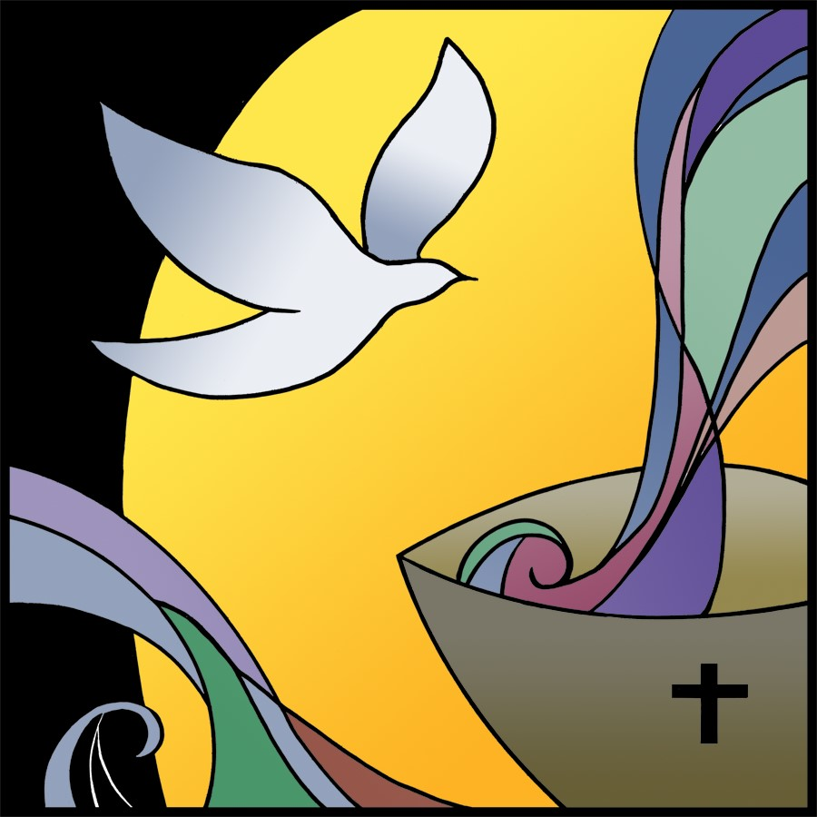
First Sunday after Pentecost
Year A
Holy Eucharist II
May 31, 2026
10:00 AM In person and Online

May Announcements
Fellowship Coffee Hour Sign up - We encourage members to sign up to make coffee. Pastor Cindy is happy to demonstrate how easy this is. Please help us provide this hospitality for guests and members.
Movie Night at Trinity will continue on Wednesday June 17th. Join us for “Inside Out” at 6PM in Buttrum Hall. Stay for the snacks and post film discussion.
The May, June, July Forward Day by Day , a booklet of daily inspirational meditations is now available in the Church and the Office.
Lectio Divina Bible Study is on Wednesday, at 11AM in the library. Lectio Divina, Latin for "divine reading," is a contemplative practice of scriptural reading, meditation, and prayer intended to promote communion with God. Unlike traditional Bible study that focuses on intellectual information, Lectio Divina emphasizes spiritual formation and personal intimacy with God.
A simple Gesture next pick up date will be on July 11th. Check expiration dates on your items and please no glass containers!!
St. Paul’s organ concert series for the 2025-26 season concludes with a recital put together by organists of the Redwood Empire Chapter of the American Guild of Organists. The performance will be held in the church on Sunday, June 7 at 5:00 pm. Admission is free.
St. Stephen's Episcopal, Sebastopol invites us to participate in a Gay Pride March on Saturday, June 6, 2026. Those who’d like to walk in the Parade need to be in place at 10:30 a.m. at the intersection of 4th Street and Brookwood in Santa Rosa; look for the Episcopal Church banner. All the Episcopal parishes together will have a booth at the festival, with the opportunity to engage with festival goers and share that all are welcome in the Episcopal Church. The festival will be in Courthouse Square in downtown Santa Rosa from 12:00 pm to 5:00 pm, welcoming everyone and supporting the LGBTQIA+ community. For more information, contact Deacon Kate at deacon@ststephenssebastopol.org

Prelude Steve Rubardt
Please stand for the Entrance Hymn.
At the sound of the bell, please stand as you are able. The People respond when bold text appears.
The Word of God
Entrance Hymn All Creatures of our God and King H 400
Opening Acclamation BCP 319
Celebrant | Alleluia. Christ is risen.
People | The Lord is risen indeed. Alleluia.
Collect for Purity
All Almighty God, to you all hearts are open, all desires known, and from you no secrets are hid: Cleanse the thoughts of our hearts by the inspiration of your Holy Spirit, that we may perfectly love you, and worthily magnify your holy Name; through Christ our Lord. Amen.
Song of Praise Glory to God Hymn S-280 is sung, all standing
Glory to God in the highest,
and peace to his people on earth.
Lord God, heavenly King,
almighty God and Father,
we worship you, we give you thanks,
we praise you for your glory.
Lord Jesus Christ, only Son of the Father,
Lord God, Lamb of God,
you take away the sin of the world:
have mercy on us;
you are seated at the right hand of the Father:
receive our prayer.
For you alone are the Holy One,
you alone are the Lord,
you alone are the Most High,
Jesus Christ,
with the Holy Spirit,
in the glory of God the Father. Amen.
The Collect of the Day BCP 357
Celebrant | The Lord be with you.
People | And also with you.
Celebrant | Let us pray.
Almighty and everlasting God, you have given to us your servants grace, by the confession of a true faith, to acknowledge the glory of the eternal Trinity, and in the power of your divine Majesty to worship the Unity: Keep us steadfast in this faith and worship, and bring us at last to see you in your one and eternal glory, O Father; who with the Son and the Holy Spirit live and reign, one God, for ever and ever.
All Amen.
The Lessons
First Reading: Genesis 1:1--2:4a
Reader A Reading from the book of Genesis.
¹In the beginning when God created the heavens and the earth, ²the earth was a formless void and darkness covered the face of the deep, while a wind from God swept over the face of the waters. ³Then God said, “Let there be light”; and there was light. ⁴And God saw that the light was good; and God separated the light from the darkness. ⁵God called the light Day, and the darkness he called Night. And there was evening and there was morning, the first day.
⁶And God said, “Let there be a dome in the midst of the waters, and let it separate the waters from the waters.” ⁷So God made the dome and separated the waters that were under the dome from the waters that were above the dome. And it was so. ⁸God called the dome Sky. And there was evening and there was morning, the second day.
⁹And God said, “Let the waters under the sky be gathered together into one place, and let the dry land appear.” And it was so. ¹⁰God called the dry land Earth, and the waters that were gathered together he called Seas. And God saw that it was good. ¹¹Then God said, “Let the earth put forth vegetation: plants yielding seed, and fruit trees of every kind on earth that bear fruit with the seed in it.” And it was so. ¹²The earth brought forth vegetation: plants yielding seed of every kind, and trees of every kind bearing fruit with the seed in it. And God saw that it was good. ¹³And there was evening and there was morning, the third day.
¹⁴And God said, “Let there be lights in the dome of the sky to separate the day from the night; and let them be for signs and for seasons and for days and years, ¹⁵and let them be lights in the dome of the sky to give light upon the earth.” And it was so. ¹⁶God made the two great lights—the greater light to rule the day and the lesser light to rule the night—and the stars. ¹⁷God set them in the dome of the sky to give light upon the earth, ¹⁸to rule over the day and over the night, and to separate the light from the darkness. And God saw that it was good. ¹⁹And there was evening and there was morning, the fourth day.
²⁰And God said, “Let the waters bring forth swarms of living creatures, and let birds fly above the earth across the dome of the sky.” ²¹So God created the great sea monsters and every living creature that moves, of every kind, with which the waters swarm, and every winged bird of every kind. And God saw that it was good. ²²God blessed them, saying, “Be fruitful and multiply and fill the waters in the seas, and let birds multiply on the earth.” ²³And there was evening and there was morning, the fifth day.
²⁴And God said, “Let the earth bring forth living creatures of every kind: cattle and creeping things and wild animals of the earth of every kind.” And it was so. ²⁵God made the wild animals of the earth of every kind, and the cattle of every kind, and everything that creeps upon the ground of every kind. And God saw that it was good.
²⁶Then God said, “Let us make humankind in our image, according to our likeness; and let them have dominion over the fish of the sea, and over the birds of the air, and over the cattle, and over all the wild animals of the earth, and over every creeping thing that creeps upon the earth.”
²⁷So God created humankind in his image,
in the image of God he created them;
male and female he created them.
²⁸God blessed them, and God said to them, “Be fruitful and multiply, and fill the earth and subdue it; and have dominion over the fish of the sea and over the birds of the air and over every living thing that moves upon the earth.” ²⁹God said, “See, I have given you every plant yielding seed that is upon the face of all the earth, and every tree with seed in its fruit; you shall have them for food. ³⁰And to every beast of the earth, and to every bird of the air, and to everything that creeps on the earth, everything that has the breath of life, I have given every green plant for food.” And it was so. ³¹God saw everything that he had made, and indeed, it was very good. And there was evening and there was morning, the sixth day.
^{2:1}Thus the heavens and the earth were finished, and all their multitude. ²And on the seventh day God finished the work that he had done, and he rested on the seventh day from all the work that he had done. ³So God blessed the seventh day and hallowed it, because on it God rested from all the work that he had done in creation.
^{4a}These are the generations of the heavens and the earth when they were created.
Reader | The Word of the Lord.
People | Thanks be to God.
The Psalm: Psalm 8
Reader Our response to the reading is Psalm 8, which we will read responsively by half verse.
¹O Lord our Governor, *
how exalted is your Name in all the world!
²Out of the mouths of infants and children *
your majesty is praised above the heavens.
³You have set up a stronghold against your adversaries, *
to quell the enemy and the avenger.
⁴When I consider your heavens, the work of your fingers, *
the moon and the stars you have set in their courses,
⁵What is man that you should be mindful of him? *
the son of man that you should seek him out?
⁶You have made him but little lower than the angels; *
you adorn him with glory and honor;
⁷You give him mastery over the works of your hands; *
you put all things under his feet:
⁸All sheep and oxen, *
even the wild beasts of the field,
⁹The birds of the air, the fish of the sea, *
and whatsoever walks in the paths of the sea.
¹⁰O Lord our Governor, *
how exalted is your Name in all the world!
Second Reading: 2 Corinthians 13:11-13
Reader A Reading from Paul's Second letter to the Church in Corinth.
¹¹Finally, brothers and sisters, farewell. Put things in order, listen to my appeal, agree with one another, live in peace; and the God of love and peace will be with you. ¹²Greet one another with a holy kiss. All the saints greet you.
¹³The grace of the Lord Jesus Christ, the love of God, and the communion of the Holy Spirit be with all of you.
Reader | The Word of the Lord.
People | Thanks be to God.

Sequence Hymn Awake my Soul H 11 v 1 & 2
The Holy Gospel: Matthew 28:16-20
Celebrant | The Holy Gospel of our Lord Jesus Christ according to Matthew.
People | Glory to you, Lord Christ.
¹⁶Now the eleven disciples went to Galilee, to the mountain to which Jesus had directed them. ¹⁷When they saw him, they worshiped him; but some doubted. ¹⁸And Jesus came and said to them, “All authority in heaven and on earth has been given to me. ¹⁹Go therefore and make disciples of all nations, baptizing them in the name of the Father and of the Son and of the Holy Spirit, ²⁰and teaching them to obey everything that I have commanded you. And remember, I am with you always, to the end of the age.”
Celebrant | The Gospel of the Lord.
People | Praise to you, Lord Christ.
Sequence Hymn Awake my Soul H 11 v 3 & 4
Sermon Pastor Cindy Beck
The Nicene Creed (BCP p. 358)
The Prayers of the People
Celebrant: Brothers and sisters, live in peace. With gracious hearts appeal to the Lord, saying, “Glory to you, Holy Trinity; we will praise you and highly exalt you forever.”
Intercessor: Holy Trinity, you separated the light from the darkness: may your Church ever dwell in your radiance and walk in the light of your love.
In the Diocesan Cycle of Prayer, we pray for St. Paul’s in Oroville and St. Stephen’s in Colusa.
In the Anglican Cycle of Prayer, we pray for The Eglise Anglicane du Rwanda;
Glory to you, Holy Trinity;
We will praise you and highly exalt you forever.
Holy Trinity, you placed the same sky above all people: may people all over the world live in peace with one another.
Silence
Glory to you, Holy Trinity;
We will praise you and highly exalt you forever.
Holy Trinity, you created all things good: give us the will to respect and preserve your creation, that future generations may experience the goodness of all you have made, +_________________.
Invite the congregation to add their thanksgivings, followed by silence
Glory to you, Holy Trinity;
We will praise you and highly exalt you forever.
Holy Trinity, you created the sun to give us light: shine your light on our city, that the shadow places may be exposed. May your justice and peace reign in our neighborhoods.
Silence
Glory to you, Holy Trinity;
We will praise you and highly exalt you forever.
Holy Trinity, from your hand comes forth creatures great and small: as you care for even the smallest creature, show your loving-kindness to all who call out to you for help. Grace the lives of your children with healing and strength,+___________________.
Invite the congregation to add their petitions, followed by silence
Glory to you, Holy Trinity;
We will praise you and highly exalt you forever.
Holy Trinity, you created humankind in your image and you promised to be with us always: may those who have died take comfort in your eternal presence,+___________________.
Invite the congregation to add their petitions, followed by silence
Glory to you, Holy Trinity;
We will praise you and highly exalt you forever.
Celebrant With the freedom of an enlightened heart, we join in the inheritance of the saints as we continue our prayers and thanksgivings.
Amen.
The Peace
Celebrant The peace of the Lord be always with you.
People And also with you.
Announcements
Birthdays, Anniversaries, Travelers (prayers found at back of bulletin)
The Holy Communion
The Offertory At the Offering, you’ll find a Pledge card in the Pew Rack for those who’d like to designate their financial donations to Trinity’s Pledging Income. For others, or a one-time gift, envelopes are in the pew racks as well as on the Narthex table or text TRINITYSONOMA" to 73256. Thank you!
Offertory Music
Steve Rubardt and Choir Come Sunday
Doxology
Praise God, from whom all blessings flow;
Praise Him, all creatures here below;
Praise Him above, ye heav'nly host;
Praise Father, Son, and Holy Ghost.
Amen.
The people stand while the offerings are presented and placed on the Altar.
Presider: Gracious God, as an offering of our thanksgiving and gratitude, we return to you a portion of what you have gifted us.
The Great Thanksgiving
Eucharistic Prayer B BCP 367
Celebrant | The Lord be with you.
People | And also with you.
Celebrant | Lift up your hearts.
People | We lift them to the Lord.
Celebrant | Let us give thanks to the Lord our God.
People | It is right to give him thanks and praise.
Proper Preface (BCP p. 367)
It is right, and a good and joyful thing, always and everywhere to give thanks to you, Father Almighty, Creator of heaven and earth, through Jesus Christ our Lord. In fulfillment of his true promise, the Holy Spirit came down on this day from heaven, lighting upon the disciples, to teach them and to lead them into all truth; uniting peoples of many tongues in the confession of one faith, and giving to your Church the power to serve you as a royal priesthood, and to preach the Gospel to all nations. Therefore we praise you, joining our voices with Angels and Archangels and with all the company of heaven, who for ever sing this hymn to proclaim the glory of your Name:
Sanctus Holy Holy, Holy (Proulx) Hymnal S-125
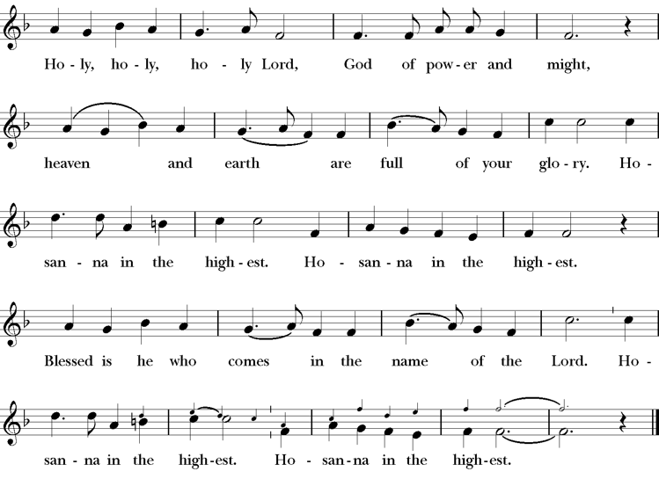
Presider Holy and gracious Father: In your infinite love you made us for yourself; and, when we had fallen into sin and become subject to evil and death, you, in your mercy, sent Jesus Christ, your only and eternal Son, to share our human nature, to live and die as one of us, to reconcile us to you, the God and Father of all.
He stretched out his arms upon the cross, and offered himself, in obedience to your will, a perfect sacrifice for the whole world.
On the night he was handed over to suffering and death, our Lord Jesus Christ took bread; and when he had given thanks to you, he broke it, and gave it to his disciples, and said, “Take, eat: This is my Body, which is given for you. Do this for the remembrance of me”
After supper he took the cup of wine; and when he had given thanks, he gave it to them, saying, “Drink this, all of you: this is my blood of the new covenant which is shed for you and for many for the forgiveness of sins. Whenever you drink it, do this for the remembrance of me.”
Presider Therefore we proclaim the mystery of faith:.
People Christ has died; Christ is risen; Christ will come again.
Presider We celebrate the memorial of our redemption, O Father, in this sacrifice of praise and thanksgiving. Recalling his death, resurrection, and ascension, we offer you these gifts.
Sanctify them by your Holy Spirit to be for your people the Body and Blood of your Son, the holy food and drink of new and unending life in him. Sanctify us also that we may faithfully receive this holy Sacrament, and serve you in unity, constancy, and peace; and at last day bring us with all your saints into the joy of your eternal kingdom.
All this we ask through your Son Jesus Christ. By him, and with him, and in him, in the unity of the Holy Spirit all honor and glory is yours, Almighty Father, now and for ever.
Amen.
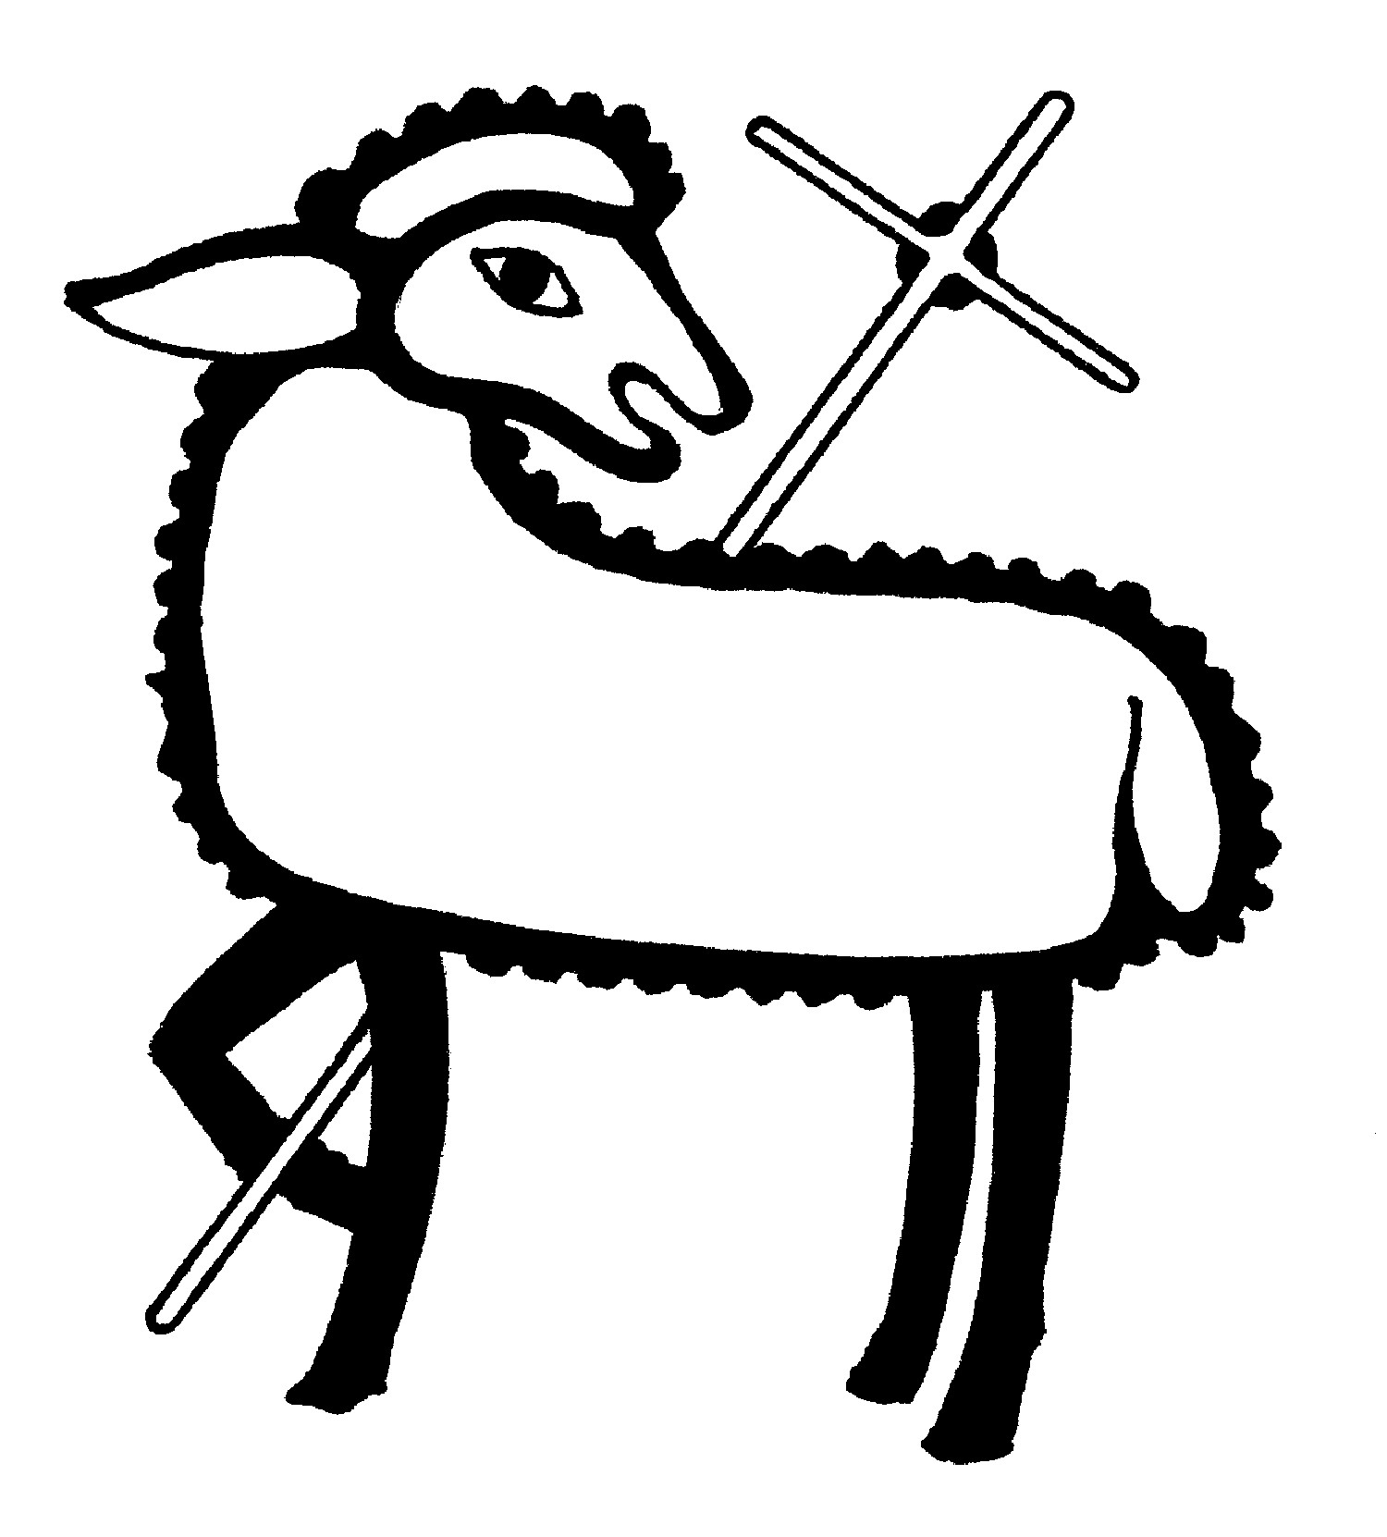
The Lord’s Prayer
Presider As our Savior has taught us, we are bold to pray.
People Our Father, who art in heaven, hallowed be thy name. Thy Kingdom come, thy will be done, on earth as it is in heaven. Give us this day our daily bread. And forgive us our trespasses, as we forgive those who trespass against us. And lead us not into temptation, but deliver us from evil. For thine is the kingdom, the power and the glory, for ever and ever. Amen.
The Breaking of the Bread
The Presider breaks the consecrated bread in view of the assembly.
Presider The Gifts of God for the people of God.
People Therefore let us keep the feast. Alleluia
Invitation to Communion
Presider Come to this table you who have been here often and you who have not been here in a long time. Come, you who have tried to follow Jesus and you who have failed. You who are full of faith and full of doubt. Come, it is Christ himself who invites you to meet him here.
Sharing the Sacred Meal
This is Christ’s table and all are welcome and all are fed.
Communion Music Now the Silence H 333
Post-Communion Prayer BCP 365
The Blessing
The Recessional Hymn I sing a Song of the Saints of God H 293
The Dismissal*
Celebrant | Let us go forth in the name of Christ.
People | Thanks be to God.
Postlude Steve Rubardt Please remain seated
SERVING TODAY
Celebrant & Preacher: Pastor Cindy Beck
Acolyte:
Lector: Bill Doyle , Gerrilee Fisher
Intercessor: Jane Hernandez
Worship Musician: Steve Rubardt
Choir Leader: Steve Rubardt
Choir: Liz Carpenter, Heather Dahlberg, Scott Sherman,
Patsy Gralow, Laurell Meredith, Mary Omodt, Barbara Feduska, Tara Anderson
Sunday School - Child Care: Wendy Aguilar Appt Only
Ushers: John Addeo
Tech Chaplain: Marcos Rendon
Altar Guild: Liz Carpenter , Laurell Meredith
Hospitality :
Altar Flowers are given to the glory of God by Altar Guild.
*Why no ‘Alleluias” printed in the bulletin? There are two different rubrics (or rules) that govern the use of Alleluia in worship, set by the Canons. One set of rubrics govern the use of Alleluia in music and in all of the liturgy except for the Dismissal. This rule says that we use Alleluia all the time except during the season of Lent. The other set of rubrics covers just the Dismissal and it says that we only use Alleluia in the Dismissal during the period from Easter Sunday through Pentecost, but not at any other time.

Prayers requested for these on Trinity’s long-term prayer list: Armando P, Georgia Bostedt, Muff Davey, John Eiler, Gerrilee Fisher, Claire Ginesi, Mary Griffin, David & Christine Hilt, Marie Lambert, Mark Mezzetta, Kelcey Omodt, Grizelda Ponce, Barry Reap, Blake W, Robert R, Melissa White, Ann Loveland Sherman, James Thomas, Rose Burns, Jennifer Gralow, Patsy Gralow, Steve Antenen, Sandra Leland, Karl, Michael Hardy, Michael Bean Land, Polly Moore, Sinat Liv, Will Maushardt, Sophia Piconi, Mike Smith.
Prayers for the Repose of soul: Tim Dowd , Susan Bassett, Joan Biersch, Linda Dowd, Christina Van Krugel, Mere Nagasau, Mary Goshert, Peggy Bell, Carolyn Caldwell, Van Z, Dolores Mae Seaberg Cole.
Contact Pastoral Care Chair, Lorena lorena.m.reinhardt@gmail.com to make any additions or to remove names from our Long-Term Prayer list.
Welcome to Trinity Episcopal, Sonoma. Whether you are passing through or looking for a church home, we are blessed by your presence and we invite you to worship with us fully – singing, praying and receiving communion- with your voice and heart. Everyone is welcome at Jesus’ Table, and everyone’s voice is needed to tell the Good News of God’s love in Christ. If you would like to learn more about The Episcopal Church, or how you can become a member of Trinity Church, please send us an email trinityepiscopalsonoma@comcast.net. We look forward to meeting you after the service where coffee and treats are served.
Notes on the Service Bulletin This service bulletin is a guide to the service. We use a variety of printed materials for the prayers, the scriptural readings and the hymns. The Readings for the week, including the Collect and Readings are found in this Bulletin. The service follows the liturgies that are found in the Book of Common Prayer (BCP). The BCP is the blue book found in the pew in front of you. The hymns come primarily from The 1982 Hymnal, also in the pew – the red book. Lift Every Voice and Sing (LEVAS) is another hymnal located in the pew rack. VF stands for Voices Found, another authorized hymnal. Sound Mate Assisted Hearing devices available at the back of the church on the Narthex Table.
For Visitors and Newcomers | Welcome! We are glad you have joined us today. If you are interested in a visit or call from the Priest-in-Charge, please sign our guest book on the Narthex* table to let her know you are visiting. Include your phone or email address. Narthex = wonderful old Latin word Episcopalians use for the entrance hall, traditionally at the western end of our churches.
Nursery Care | Children | Available during the 10:00 worship service by request. The nursery is located through the breezeway to the Education wing of the campus. Please ask an usher to show the way.
Sunday School available by appointment, Please contact Trinity Office at least one week in advance.
Coffee Hour Fellowship | Buttrum Hall or Courtyard, weather depending | Join us following the 10:00 AM worship service.
To access Trinity’s Guest WIFI: Password Rosepettal441 (case sensitive). We are glad you are here, and we invite you to enter fully into worship this morning.
All are welcome to make a gift and offering in thanksgiving to God; for the many blessings we have received. To take advantage of our electronic giving options, please follow the QR code with your capable electronic device, or visit https://onrealm.org/trinitysonoma/-/form/give/default Help us to make this a place where God’s grace is freely shared by all.


About this Service: Calendar of the Church (Year A)
The calendar (BCP, pp. 15-33) orders the liturgical year of the Episcopal Church by identifying two cycles of feasts and holy days-one dependent upon the movable date of Easter Day and the other dependent upon the fixed date of Christmas, Dec. 25. Easter Day is the first Sunday after the full moon that falls on or after Mar. 21. The sequence of all Sundays in the church year is based on the date of Easter. Tables and rules for finding the date of Easter Day, and other movable feasts and holy days are provided by the BCP, pp. 880-885. The date of Easter determines the beginning of the season of Lent on Ash Wednesday and the date of Pentecost on the fiftieth day of the Easter season. The Sundays of Advent are always the four Sundays before Christmas Day. The church year begins on the first Sunday of Advent. The calendar also identifies and provides directions concerning the precedence and observance of principal feasts, Sundays, holy days (including Feasts of our Lord, other major feasts, and fasts), Days of Special Devotion, and Days of Optional Observance. The calendar lists dates for celebration of major feasts and lesser feasts by month and date. Appropriate Sunday Letters and Golden Numbers are also provided. (see BCP, pp. 880-881). The calendar also lists the titles of the seasons, Sundays, and major holy days observed in the Episcopal Church throughout the church year, including Advent season, Christmas season, Epiphany season, Lenten season, Holy Week, Easter season, the season after Pentecost, holy days, and National Days.
About this Service: Season of Pentecost
The season of Pentecost is the longest of the Church Year. It begins on the Day of Pentecost when the promised Holy Spirit (Counselor, Advocate) of God fell upon the disciples and those gathered with them in the upper room and runs until the Sunday before Advent. The color of the season is green to symbolize growth and new life. This season is often called “The work of the Church.” The lessons focus on Jesus’ teaching encouraging personal growth and transformation in the Spirit. The teachings also call believers to spread the Gospel to those in the world who have not encountered Jesus. Believers are called to live lives in service of others.
Trinity Liturgical Ministry ROTA Next two weeks
Date | Celebrant | Ushers | Acolyte | Lector (s) | Intercessor | Altar Guild
June 7th | Cindy Beck | John Addeo | Susie Hand | Bill Doyle , Douglas Griffin | Lorena Reinhardt | Susie Hand
June 14th | Cindy Beck | Alfred Escoffier | TBD | Barbara Feduska , Jane Hernandez | Ann Kyser | Ann Kyser

Schedule of Weekly Meetings and Services at Trinity Episcopal Sonoma
Day | Date | Time | Occasion | Location
Wednesday | June 3 | 11 AM | Bible Study | Library
Thursday | June 4 | 10:30 AM  5:30 PM | Mindfulness & Well Being  Alcoholics Anonymous | Library  Buttrum Hall
Saturday | June 6 | 8 AM | Centering Prayer | St. Luke’s Chapel
Saturday | June 6 | 2pm | Drawing Class | in Library
Sunday | June 7 | 10:15 AM | Holy Eucharist II | Sanctuary
Mon-Fri | Weekdays | 7AM-1PM | Sonoma Home Meals | Kitchen &Buttrum Hall
Mon-Fri | Weekdays | 9-2 | Sonoma Preschool Academy – School

Monthly Meetings at Trinity Episcopal Sonoma
Day | Date | Time | Meeting | Location | Contact
Tuesday | June 2 | 11 AM | Prayer Shawl Ministry | Library | Lorena Reinhardt lorena.m.reinhardt@gmail.com
Thursday | TBD | TBD | Vestry | Library | Cindy Beck 916-955-9861

PRAYERS and BLESSINGS
For a Birthday
Watch over your child, O Lord as his/her days increase; bless and guide him/her wherever s/he may be. Strengthen them when s/he stands; comfort him/her when discouraged or sorrowful; raise him/her up if s/he fall; and in his/her heart may your peace which passes understanding abide all the days of his/her life; through Jesus Christ our Lord. Amen.
For an Anniversary
O God, you have so consecrated the covenant of marriage that it represents the spiritual unity between Christ and his Church: Send your blessing upon these your servants as they celebrate their anniversary, that they may continue to love, honor and cherish each other in faithfulness and patience, in wisdom and true godliness, that their home may be a haven of blessing and peace; through Jesus Christ our Lord, who lives and reigns with you and the Holy Spirit, one God, now and forever. Amen.
For Travelers
O God, our heavenly Father, whose glory fills the whole creation, and whose presence we find wherever we go; preserve those who travel; surround them with your loving care; protect them from every danger, and bring them in safety to their journey’s end; through Jesus Christ our Lord. Amen.
Sending our Eucharistic Visitors
Priest: In the name of this congregation, I send you forth bearing these holy gifts, the those to whom you go may share with us in the communion of Christ’s body and blood.
People: We who are many are one body, because we all share on bread, and one cup. Amen

