Trinity Episcopal Church
In Sonoma for over 170 years
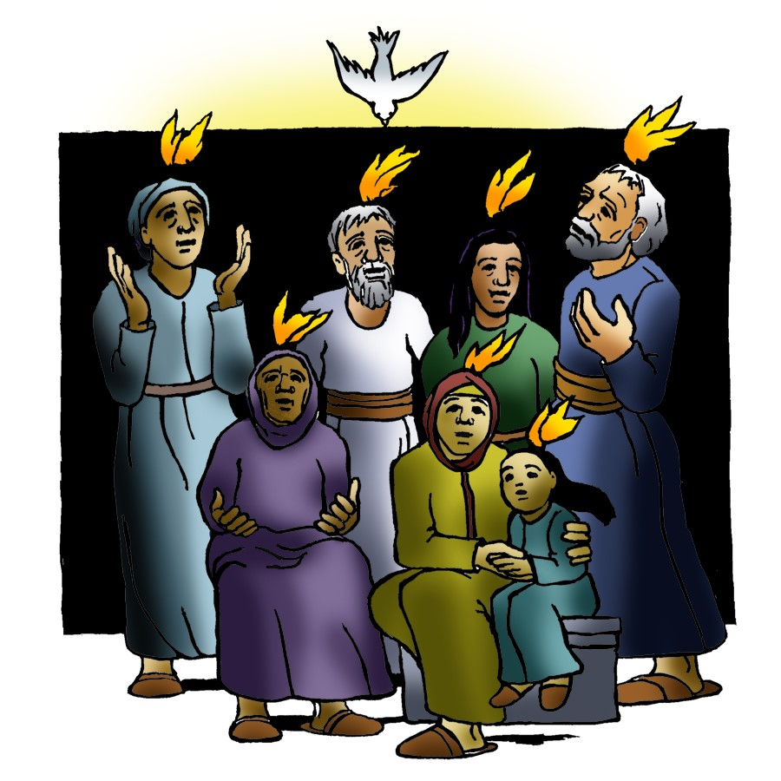
Day of Pentecost
Year A
Holy Eucharist II
May 24, 2026
10:00 AM In person and Online

May Announcements
Fellowship Coffee Hour Sign up - We encourage members to sign up to make coffee. Pastor Cindy is happy to demonstrate how easy this is. Please help us provide this hospitality for guests and members.
Movie Night at Trinity will continue on Wednesday June 17th. Join us for “Inside Out” at 6PM in Buttrum Hall. Stay for the snacks and post film discussion.
The May, June, July Forward Day by Day , a booklet of daily inspirational meditations is now available in the Church and the Office.
Lectio Divina Bible Study is on Wednesday, at 11AM in the library. Lectio Divina, Latin for "divine reading," is a contemplative practice of scriptural reading, meditation, and prayer intended to promote communion with God. Unlike traditional Bible study that focuses on intellectual information, Lectio Divina emphasizes spiritual formation and personal intimacy with God.
Trinity Episcopal donated 8 full bags to A simple Gesture this month! It was picked up on Saturday May 2nd. The next pick up date will be on July 11th. Check expiration dates on your items and please no glass containers!!
St. Paul’s organ concert series for the 2025-26 season concludes with a recital put together by organists of the Redwood Empire Chapter of the American Guild of Organists. This is a great opportunity to hear many local organists all in one place! The performance will be held in the church on Sunday, June 7 at 5:00 pm. (please note the date as it is the 1st Sunday in the month). Admission is free.
St. Stephen's Episcopal, Sebastopol invites us to participate in a Gay Pride March on Saturday, June 6, 2026. They are registered as part of a contingent called Episcopal Churches of Sonoma County. Those who’d like to walk in the Parade need to be in place at 10:30 a.m. at the intersection of 4th Street and Brookwood in Santa Rosa; look for the Episcopal Church banner. All the Episcopal parishes together will have a booth at the festival, with the opportunity to engage with festival goers and share that all are welcome in the Episcopal Church. The festival will be in Courthouse Square in downtown Santa Rosa from 12:00 pm to 5:00 pm, welcoming everyone and supporting the LGBTQIA+ community. Attending this joyful and peaceful parade is one way to let others know that they are welcome in the congregations of the local Episcopal Church. For more information, contact Deacon Kate at at deacon@ststephenssebastopol.org
Thank you to everyone who participated in the congregational retreat, either in person or having handed in their "homework." It is not easy to condense our understanding of the mission of Trinity Episcopal. I appreciate all the input and think we accomplished much in the process.

Prelude Steve Rubardt
Please stand for the Entrance Hymn.
At the sound of the bell, please stand as you are able. The People respond when bold text appears.
The Word of God
Entrance Hymn Come Thou font of Every Blessing H 686
Opening Acclamation BCP 319
Celebrant | Alleluia. Christ is risen.
People | The Lord is risen indeed. Alleluia.
Collect for Purity
All Almighty God, to you all hearts are open, all desires known, and from you no secrets are hid: Cleanse the thoughts of our hearts by the inspiration of your Holy Spirit, that we may perfectly love you, and worthily magnify your holy Name; through Christ our Lord. Amen.
Song of Praise Glory to God Hymn S-280 is sung, all standing
Glory to God in the highest,
and peace to his people on earth.
Lord God, heavenly King,
almighty God and Father,
we worship you, we give you thanks,
we praise you for your glory.
Lord Jesus Christ, only Son of the Father,
Lord God, Lamb of God,
you take away the sin of the world:
have mercy on us;
you are seated at the right hand of the Father:
receive our prayer.
For you alone are the Holy One,
you alone are the Lord,
you alone are the Most High,
Jesus Christ,
with the Holy Spirit,
in the glory of God the Father. Amen.
The Collect of the Day BCP 357
Celebrant | The Lord be with you.
People | And also with you.
Celebrant | Let us pray.
Almighty God, on this day you opened the way of eternal life to every race and nation by the promised gift of your Holy Spirit: Shed abroad this gift throughout the world by the preaching of the Gospel, that it may reach to the ends of the earth; through Jesus Christ our Lord, who lives and reigns with you, in the unity of the Holy Spirit, one God, for ever and ever.
All Amen.
The Lessons
First Reading: Acts 2:1-21
Reader A Reading from the Acts of the Apostles.
¹When the day of Pentecost had come, they were all together in one place. ²And suddenly from heaven there came a sound like the rush of a violent wind, and it filled the entire house where they were sitting. ³Divided tongues, as of fire, appeared among them, and a tongue rested on each of them. ⁴All of them were filled with the Holy Spirit and began to speak in other languages, as the Spirit gave them ability.
⁵Now there were devout Jews from every nation under heaven living in Jerusalem. ⁶And at this sound the crowd gathered and was bewildered, because each one heard them speaking in the native language of each. ⁷Amazed and astonished, they asked, “Are not all these who are speaking Galileans? ⁸And how is it that we hear, each of us, in our own native language? ⁹Parthians, Medes, Elamites, and residents of Mesopotamia, Judea and Cappadocia, Pontus and Asia, ¹⁰Phrygia and Pamphylia, Egypt and the parts of Libya belonging to Cyrene, and visitors from Rome, both Jews and proselytes, ¹¹Cretans and Arabs—in our own languages we hear them speaking about God’s deeds of power.” ¹²All were amazed and perplexed, saying to one another, “What does this mean?” ¹³But others sneered and said, “They are filled with new wine.”
¹⁴But Peter, standing with the eleven, raised his voice and addressed them, “Men of Judea and all who live in Jerusalem, let this be known to you, and listen to what I say. ¹⁵Indeed, these are not drunk, as you suppose, for it is only nine o’clock in the morning. ¹⁶No, this is what was spoken through the prophet Joel:
¹⁷‘In the last days it will be, God declares,
that I will pour out my Spirit upon all flesh,
and your sons and your daughters shall prophesy,
and your young men shall see visions,
and your old men shall dream dreams.
¹⁸Even upon my slaves, both men and women,
in those days I will pour out my Spirit;
and they shall prophesy.
¹⁹And I will show portents in the heaven above
and signs on the earth below,
blood, and fire, and smoky mist.
²⁰The sun shall be turned to darkness
and the moon to blood,
before the coming of the Lord’s great and glorious day.
²¹Then everyone who calls on the name of the Lord shall be saved.’ ”
Reader | The Word of the Lord.
People | Thanks be to God.
The Psalm: Psalm 104:25-35, 37
Reader Our response to the reading is Psalm 104:25-35, 37, which we will read responsively by half verse.
²⁵O Lord, how manifold are your works! *
In wisdom you have made them all;
the earth is full of your creatures.
²⁶Yonder is the great and wide sea
with its living things too many to number, *
creatures both small and great.
²⁷There move the ships,
and there is that Leviathan, *
which you have made for the sport of it.
²⁸All of them look to you *
to give them their food in due season.
²⁹You give it to them; they gather it; *
you open your hand, and they are filled with good things.
³⁰You hide your face, and they are terrified; *
you take away their breath,
and they die and return to their dust.
³¹You send forth your Spirit, and they are created; *
and so you renew the face of the earth.
³²May the glory of the Lord endure forever; *
may the Lord rejoice in all his works.
³³He looks at the earth and it trembles; *
he touches the mountains and they smoke.
³⁴I will sing to the Lord as long as I live; *
I will praise my God while I have my being.
³⁵May these words of mine please him; *
I will rejoice in the Lord.
³⁷Bless the Lord, O my soul. *
Hallelujah!
Second Reading: 1 Corinthians 12:3b-13
Reader A Reading from Paul's First letter to the Church in Corinth.
^{3b}No one can say “Jesus is Lord” except by the Holy Spirit.
⁴Now there are varieties of gifts, but the same Spirit; ⁵and there are varieties of services, but the same Lord; ⁶and there are varieties of activities, but it is the same God who activates all of them in everyone. ⁷To each is given the manifestation of the Spirit for the common good. ⁸To one is given through the Spirit the utterance of wisdom, and to another the utterance of knowledge according to the same Spirit, ⁹to another faith by the same Spirit, to another gifts of healing by the one Spirit, ¹⁰to another the working of miracles, to another prophecy, to another the discernment of spirits, to another various kinds of tongues, to another the interpretation of tongues. ¹¹All these are activated by one and the same Spirit, who allots to each one individually just as the Spirit chooses.
¹²For just as the body is one and has many members, and all the members of the body, though many, are one body, so it is with Christ. ¹³For in the one Spirit we were all baptized into one body—Jews or Greeks, slaves or free—and we were all made to drink of one Spirit.
Reader | The Word of the Lord.
People | Thanks be to God.

Sequence Hymn We the Lord’s People H 51 v 1 & 2
The Holy Gospel: John 20:19-23
Celebrant | The Holy Gospel of our Lord Jesus Christ according to John.
People | Glory to you, Lord Christ.
¹⁹When it was evening on that day, the first day of the week, and the doors of the house where the disciples had met were locked for fear of the Jews, Jesus came and stood among them and said, “Peace be with you.” ²⁰After he said this, he showed them his hands and his side. Then the disciples rejoiced when they saw the Lord. ²¹Jesus said to them again, “Peace be with you. As the Father has sent me, so I send you.” ²²When he had said this, he breathed on them and said to them, “Receive the Holy Spirit. ²³If you forgive the sins of any, they are forgiven them; if you retain the sins of any, they are retained.”
Celebrant | The Gospel of the Lord.
People | Praise to you, Lord Christ.
Sequence Hymn We the Lord’s People H 51 3 & 4
Sermon Pastor Cindy Beck
The Nicene Creed (BCP p. 358)
The Prayers of the People
Celebrant: Peace be with you, brothers and sisters. In wonder and gratitude, let us pray, saying, “You send forth your Spirit: Come, Holy Spirit.”
Intercessor: Holy God, by your Spirit you gave birth to your Church: may our many members be the one Body of Christ in this world. Give to each member of your Church the manifestation of the Spirit for the common good.
In the Diocesan Cycle of Prayer, we pray for Incarnation Church in Santa Rosa.
In the Anglican Cycle of Prayer, we pray for The Episcopal Church in the Phillipines.
You send forth your spirit;
Come, Holy Spirit.
Holy God, you gave your disciples the ability to speak in the languages of the people: may we also speak about your deeds of power throughout the world, that all may know of your salvation.
Silence
You send forth your spirit;
Come, Holy Spirit.
Holy God, the earth is full of your creatures: may all who look to you be given food in due season. Open your hand in desolate places and fill the hungry with good things, +_________________.
Invite the congregation to add their thanksgivings, followed by silence
You send forth your spirit;
Come, Holy Spirit.
Holy God, you poured out your Holy Spirit in your Holy City Jerusalem: pour out your Spirit in our own city. Raise up prophets and dreamers; give us vision.
Silence
You send forth your spirit;
Come, Holy Spirit.
Holy God, you give the gift of healing by your Spirit: bring healing and wholeness to all those on our hearts and minds this day. You renew the face of the earth; bring renewal to those in need,+___________________.
Invite the congregation to add their petitions, followed by silence
You send forth your spirit;
Come, Holy Spirit.
Holy God, we pray for our sisters and brothers who were baptized into the one body, who were made to drink of the one Spirit, and who now have died in Christ. May those who have called upon your name, O Lord, be saved forever,+___________________.
Invite the congregation to add their petitions, followed by silence
You send forth your Spirit;
Come, Holy Spirit.
Celebrant With the freedom of an enlightened heart, we join in the inheritance of the saints as we continue our prayers and thanksgivings.
Amen.
The Peace
Celebrant The peace of the Lord be always with you.
People And also with you.
Announcements
Birthdays, Anniversaries, Travelers (prayers found at back of bulletin)
The Holy Communion
The Offertory At the Offering, you’ll find a Pledge card in the Pew Rack for those who’d like to designate their financial donations to Trinity’s Pledging Income. For others, or a one-time gift, envelopes are in the pew racks as well as on the Narthex table or text TRINITYSONOMA" to 73256. Thank you!
Offertory Music
Steve Rubardt and Choir Wayfaring Stranger LEVAS 19
Doxology
The people stand while the offerings are presented and placed on the Altar.
Presider: Gracious God, as an offering of our thanksgiving and gratitude, we return to you a portion of what you have gifted us.
The Great Thanksgiving
Eucharistic Prayer B BCP 367
Celebrant | The Lord be with you.
People | And also with you.
Celebrant | Lift up your hearts.
People | We lift them to the Lord.
Celebrant | Let us give thanks to the Lord our God.
People | It is right to give him thanks and praise.
Proper Preface (BCP p. 367)
It is right, and a good and joyful thing, always and everywhere to give thanks to you, Father Almighty, Creator of heaven and earth, through Jesus Christ our Lord. In fulfillment of his true promise, the Holy Spirit came down on this day from heaven, lighting upon the disciples, to teach them and to lead them into all truth; uniting peoples of many tongues in the confession of one faith, and giving to your Church the power to serve you as a royal priesthood, and to preach the Gospel to all nations. Therefore we praise you, joining our voices with Angels and Archangels and with all the company of heaven, who for ever sing this hymn to proclaim the glory of your Name:
Sanctus Holy Holy, Holy (Proulx) Hymnal S-125
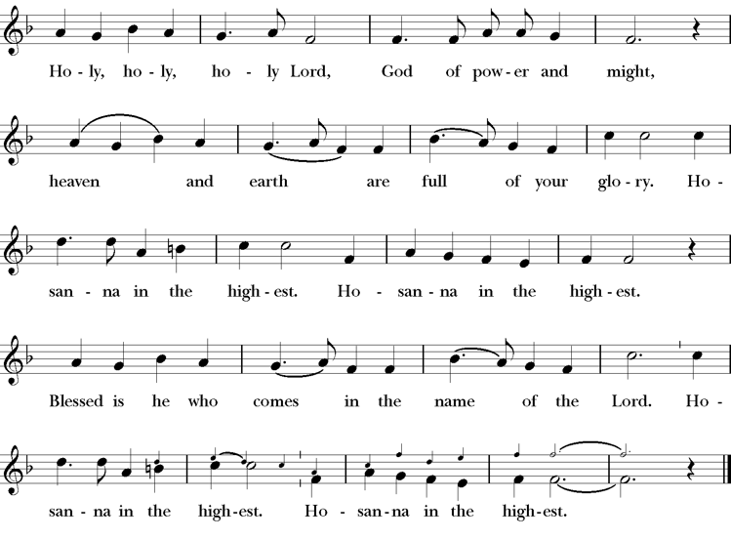
Presider Holy and gracious Father: In your infinite love you made us for yourself; and, when we had fallen into sin and become subject to evil and death, you, in your mercy, sent Jesus Christ, your only and eternal Son, to share our human nature, to live and die as one of us, to reconcile us to you, the God and Father of all.
He stretched out his arms upon the cross, and offered himself, in obedience to your will, a perfect sacrifice for the whole world.
On the night he was handed over to suffering and death, our Lord Jesus Christ took bread; and when he had given thanks to you, he broke it, and gave it to his disciples, and said, “Take, eat: This is my Body, which is given for you. Do this for the remembrance of me”
After supper he took the cup of wine; and when he had given thanks, he gave it to them, saying, “Drink this, all of you: this is my blood of the new covenant which is shed for you and for many for the forgiveness of sins. Whenever you drink it, do this for the remembrance of me.”
Presider Therefore we proclaim the mystery of faith:.
People Christ has died; Christ is risen; Christ will come again.
Presider We celebrate the memorial of our redemption, O Father, in this sacrifice of praise and thanksgiving. Recalling his death, resurrection, and ascension, we offer you these gifts.
Sanctify them by your Holy Spirit to be for your people the Body and Blood of your Son, the holy food and drink of new and unending life in him. Sanctify us also that we may faithfully receive this holy Sacrament, and serve you in unity, constancy, and peace; and at last day bring us with all your saints into the joy of your eternal kingdom.
All this we ask through your Son Jesus Christ. By him, and with him, and in him, in the unity of the Holy Spirit all honor and glory is yours, Almighty Father, now and for ever.
Amen.

The Lord’s Prayer
Presider As our Savior has taught us, we are bold to pray.
People Our Father, who art in heaven, hallowed be thy name. Thy Kingdom come, thy will be done, on earth as it is in heaven. Give us this day our daily bread. And forgive us our trespasses, as we forgive those who trespass against us. And lead us not into temptation, but deliver us from evil. For thine is the kingdom, the power and the glory, for ever and ever. Amen.
The Breaking of the Bread
The Presider breaks the consecrated bread in view of the assembly.
Presider The Gifts of God for the people of God.
People Therefore let us keep the feast. Alleluia
Invitation to Communion
Presider Come to this table you who have been here often and you who have not been here in a long time. Come, you who have tried to follow Jesus and you who have failed. You who are full of faith and full of doubt. Come, it is Christ himself who invites you to meet him here.
Sharing the Sacred Meal
This is Christ’s table and all are welcome and all are fed.
Communion Music Shepherd of Souls H 343
Post-Communion Prayer BCP 365
The Blessing
The Recessional Hymn God is Love , Let Heaven H 379
The Dismissal*
Celebrant | Let us go forth in the name of Christ.
People | Thanks be to God.
Postlude Steve Rubardt Please remain seated



SERVING TODAY
Celebrant & Preacher: Pastor Cindy Beck
Acolyte: Susie Hand
Lector: Lorena Reinhardt
Intercessor: Claire Ginesi
Worship Musician: Steve Rubardt
Choir Leader: Steve Rubardt
Choir: Liz Carpenter, Heather Dahlberg, Scott Sherman,
Patsy Gralow, Laurell Meredith, Mary Omodt, Barbara Feduska, Tara Anderson
Sunday School - Child Care: Wendy Aguilar Appt Only
Ushers: Marcia Derby
Tech Chaplain: Marcos Rendon
Altar Guild: Marcia Derby , Mary Omodt
Hospitality :
Altar Flowers are given to the glory of God by Altar Guild.
*Why no ‘Alleluias” printed in the bulletin? There are two different rubrics (or rules) that govern the use of Alleluia in worship, set by the Canons. One set of rubrics govern the use of Alleluia in music and in all of the liturgy except for the Dismissal. This rule says that we use Alleluia all the time except during the season of Lent. The other set of rubrics covers just the Dismissal and it says that we only use Alleluia in the Dismissal during the period from Easter Sunday through Pentecost, but not at any other time.

Prayers requested for these on Trinity’s long-term prayer list: Armando P, Georgia Bostedt, Muff Davey, John Eiler, Gerrilee Fisher, Claire Ginesi, Mary Griffin, David & Christine Hilt, Marie Lambert, Mark Mezzetta, Kelcey Omodt, Grizelda Ponce, Barry Reap, Blake W, Robert R, Melissa White, Ann Loveland Sherman, James Thomas, Rose Burns, Jennifer Gralow, Patsy Gralow, Steve Antenen, Sandra Leland, Karl, Michael Hardy, Michael Bean Land, Polly Moore, Sinat Liv, Will Maushardt, Sophia Piconi, Mike Smith.
Prayers for the Repose of soul: Tim Dowd , Susan Bassett, Joan Biersch, Linda Dowd, Christina Van Krugel, Mere Nagasau, Mary Goshert, Peggy Bell, Carolyn Caldwell, Van Z, Dolores Mae Seaberg Cole.
Contact Pastoral Care Chair, Lorena lorena.m.reinhardt@gmail.com to make any additions or to remove names from our Long-Term Prayer list.
Welcome to Trinity Episcopal, Sonoma. Whether you are passing through or looking for a church home, we are blessed by your presence and we invite you to worship with us fully – singing, praying and receiving communion- with your voice and heart. Everyone is welcome at Jesus’ Table, and everyone’s voice is needed to tell the Good News of God’s love in Christ. If you would like to learn more about The Episcopal Church, or how you can become a member of Trinity Church, please send us an email trinityepiscopalsonoma@comcast.net. We look forward to meeting you after the service where coffee and treats are served.
Notes on the Service Bulletin This service bulletin is a guide to the service. We use a variety of printed materials for the prayers, the scriptural readings and the hymns. The Readings for the week, including the Collect and Readings are found in this Bulletin. The service follows the liturgies that are found in the Book of Common Prayer (BCP). The BCP is the blue book found in the pew in front of you. The hymns come primarily from The 1982 Hymnal, also in the pew – the red book. Lift Every Voice and Sing (LEVAS) is another hymnal located in the pew rack. VF stands for Voices Found, another authorized hymnal. Sound Mate Assisted Hearing devices available at the back of the church on the Narthex Table.
For Visitors and Newcomers | Welcome! We are glad you have joined us today. If you are interested in a visit or call from the Priest-in-Charge, please sign our guest book on the Narthex* table to let her know you are visiting. Include your phone or email address. Narthex = wonderful old Latin word Episcopalians use for the entrance hall, traditionally at the western end of our churches.
Nursery Care | Children | Available during the 10:00 worship service by request. The nursery is located through the breezeway to the Education wing of the campus. Please ask an usher to show the way.
Sunday School available by appointment, Please contact Trinity Office at least one week in advance.
Coffee Hour Fellowship | Buttrum Hall or Courtyard, weather depending | Join us following the 10:00 AM worship service.
To access Trinity’s Guest WIFI: Password Rosepettal441 (case sensitive). We are glad you are here, and we invite you to enter fully into worship this morning.
All are welcome to make a gift and offering in thanksgiving to God; for the many blessings we have received. To take advantage of our electronic giving options, please follow the QR code with your capable electronic device, or visit https://onrealm.org/trinitysonoma/-/form/give/default Help us to make this a place where God’s grace is freely shared by all.

About this Service: Year A
Calendar of the Church Year
The calendar (BCP, pp. 15-33) orders the liturgical year of the Episcopal Church by identifying two cycles of feasts and holy days-one dependent upon the movable date of Easter Day and the other dependent upon the fixed date of Christmas, Dec. 25. Easter Day is the first Sunday after the full moon that falls on or after Mar. 21. The sequence of all Sundays in the church year is based on the date of Easter. Tables and rules for finding the date of Easter Day, and other movable feasts and holy days are provided by the BCP, pp. 880-885. The date of Easter determines the beginning of the season of Lent on Ash Wednesday and the date of Pentecost on the fiftieth day of the Easter season. The Sundays of Advent are always the four Sundays before Christmas Day. The church year begins on the first Sunday of Advent. The calendar also identifies and provides directions concerning the precedence and observance of principal feasts, Sundays, holy days (including Feasts of our Lord, other major feasts, and fasts), Days of Special Devotion, and Days of Optional Observance. The calendar lists dates for celebration of major feasts and lesser feasts by month and date. Appropriate Sunday Letters and Golden Numbers are also provided. (see BCP, pp. 880-881). The calendar also lists the titles of the seasons, Sundays, and major holy days observed in the Episcopal Church throughout the church year, including Advent season, Christmas season, Epiphany season, Lenten season, Holy Week, Easter season, the season after Pentecost, holy days, and National Days.
About this Service: Day of Pentecost
Today is the day we celebrate the arrival of the Advocate that Jesus promised to send us - the outpouring of the Holy Spirit upon the disciples and spread through their witness, teaching, and baptism of those who followed.

Trinity Liturgical Ministry ROTA Next two weeks
Date | Celebrant | Ushers | Acolyte | Lector (s) | Intercessor | Altar Guild
May 31 | Cindy Beck | John Addeo |  | Bill Doyle , Gerrilee Fisher | Jane Hernandez | Liz Carpenter
June 7th | TBD | TBD | TBD | TBD | TBD | TBD

Schedule of Weekly Meetings and Services at Trinity Episcopal Sonoma
Day | Date | Time | Occasion | Location
Wednesday | May 27 | 11 AM | Bible Study | Library
Thursday | May 28 | 10:30 AM  5:30 PM | Mindfulness & Well Being  Alcoholics Anonymous | Library  Buttrum Hall
Saturday | May 30 | 8 AM | Centering Prayer | St. Luke’s Chapel
Saturday | May 30 | 2pm | Drawing Class | in Library
Sunday | May 31 | 10:15 AM | Holy Eucharist II | Sanctuary
Mon-Fri | Weekdays | 7AM-1PM | Sonoma Home Meals | Kitchen &Buttrum Hall
Mon-Fri | Weekdays | 9-2 | Sonoma Preschool Academy – School

Monthly Meetings at Trinity Episcopal Sonoma
Day | Date | Time | Meeting | Location | Contact
Tuesday | May 5 | 11 AM | Prayer Shawl Ministry | Library | Lorena Reinhardt lorena.m.reinhardt@gmail.com
Thursday | May 7 | 4:30 PM | Vestry | Library | Cindy Beck 916-955-9861

PRAYERS and BLESSINGS
For a Birthday
Watch over your child, O Lord as his/her days increase; bless and guide him/her wherever s/he may be. Strengthen them when s/he stands; comfort him/her when discouraged or sorrowful; raise him/her up if s/he fall; and in his/her heart may your peace which passes understanding abide all the days of his/her life; through Jesus Christ our Lord. Amen.
For an Anniversary
O God, you have so consecrated the covenant of marriage that it represents the spiritual unity between Christ and his Church: Send your blessing upon these your servants as they celebrate their anniversary, that they may continue to love, honor and cherish each other in faithfulness and patience, in wisdom and true godliness, that their home may be a haven of blessing and peace; through Jesus Christ our Lord, who lives and reigns with you and the Holy Spirit, one God, now and forever. Amen.
For Travelers
O God, our heavenly Father, whose glory fills the whole creation, and whose presence we find wherever we go; preserve those who travel; surround them with your loving care; protect them from every danger, and bring them in safety to their journey’s end; through Jesus Christ our Lord. Amen.
Sending our Eucharistic Visitors
Priest: In the name of this congregation, I send you forth bearing these holy gifts, the those to whom you go may share with us in the communion of Christ’s body and blood.
People: We who are many are one body, because we all share on bread, and one cup. Amen

