Trinity Episcopal Church
Cultivating God’s Loving Spirit in Each of Us

Proper 23
Year A
Holy Eucharist II
October 11, 2026
10:00 AM In person and Online
Welcome to Trinity Episcopal, Sonoma. Whether you are passing through or looking for a church home, we are blessed by your presence and we invite you to worship with us fully – singing, praying and receiving communion- with your voice and heart. Please sign our guestbook at the back of the church, including your email.
If you would like to learn more about The Episcopal Church, please send us an email trinityepiscopalsonoma@comcast.net. We look forward to meeting you after the service where coffee and treats are served.

All are welcome to make a gift and offering in thanksgiving to God; for the many blessings we have received. To take advantage of our electronic giving options, please follow the QR code with your capable electronic device, or visit https://onrealm.org/trinitysonoma/-/form/give/default
October Announcements
Fellowship Coffee Hour Sign up – Fellowship follows the service! We meet in the hall or courtyard. We’d love to visit with you.
Thank you to everyone who donated food for A Simple Gesture, your gift helps people have a meal! Our next pick up will be in November!
Movie Night at Trinity will continue on October 21st, at 6PM in Buttram Hall. We will be showing “The Intern” with Robert Deniro. There will be snacks and refreshements during the post film discussion.

Prelude Steve Rubardt
Please stand for the Entrance Hymn.
At the sound of the bell, please stand as you are able. The People respond when bold text appears.
The Word of God
Entrance Hymn My Shepherd will supply my Need H 664
Opening Acclamation BCP 319
Celebrant | Blessed be God: Father, Son, and Holy Spirit.
People | And blessed be his kingdom, now and for ever. Amen.
Collect for Purity
All Almighty God, to you all hearts are open, all desires known, and from you no secrets are hid: Cleanse the thoughts of our hearts by the inspiration of your Holy Spirit, that we may perfectly love you, and worthily magnify your holy Name; through Christ our Lord. Amen.
Song of Praise Glory to God Hymn S-280 is sung, all standing
Glory to God in the highest,
and peace to his people on earth.
Lord God, heavenly King,
almighty God and Father,
we worship you, we give you thanks,
we praise you for your glory.
Lord Jesus Christ, only Son of the Father,
Lord God, Lamb of God,
you take away the sin of the world:
have mercy on us;
you are seated at the right hand of the Father:
receive our prayer.
For you alone are the Holy One,
you alone are the Lord,
you alone are the Most High,
Jesus Christ,
with the Holy Spirit,
in the glory of God the Father. Amen.
The Collect of the Day BCP 357
Celebrant | The Lord be with you.
People | And also with you.
Celebrant | Let us pray.
Lord, we pray that your grace may always precede and follow us, that we may continually be given to good works; through Jesus Christ our Lord, who lives and reigns with you and the Holy Spirit, one God, now and for ever.
All Amen.
The Lessons
First Reading: Isaiah 25:1-9
Reader A Reading from the book of the prophet Isaiah.
¹O Lord, you are my God;
I will exalt you, I will praise your name;
for you have done wonderful things,
plans formed of old, faithful and sure.
²For you have made the city a heap,
the fortified city a ruin;
the palace of aliens is a city no more,
it will never be rebuilt.
³Therefore strong peoples will glorify you;
cities of ruthless nations will fear you.
⁴For you have been a refuge to the poor,
a refuge to the needy in their distress,
a shelter from the rainstorm and a shade from the heat.
When the blast of the ruthless was like a winter rainstorm,
⁵the noise of aliens like heat in a dry place,
you subdued the heat with the shade of clouds;
the song of the ruthless was stilled.
⁶On this mountain the Lord of hosts will make for all peoples
a feast of rich food, a feast of well-aged wines,
of rich food filled with marrow, of well-aged wines strained clear.
⁷And he will destroy on this mountain
the shroud that is cast over all peoples,
the sheet that is spread over all nations;
⁸he will swallow up death forever.
Then the Lord God will wipe away the tears from all faces,
and the disgrace of his people he will take away from all the earth,
for the Lord has spoken.
⁹It will be said on that day,
Lo, this is our God; we have waited for him, so that he might save us.
This is the Lord for whom we have waited;
let us be glad and rejoice in his salvation.
Reader | The Word of the Lord.
People | Thanks be to God.
The Psalm: Psalm 23
Reader We will read Psalm 23, responsively by half verse.
¹The Lord is my shepherd; *
I shall not be in want.
²He makes me lie down in green pastures *
and leads me beside still waters.
³He revives my soul *
and guides me along right pathways for his Name’s sake.
⁴Though I walk through the valley of the shadow of death,
I shall fear no evil; *
for you are with me;
your rod and your staff, they comfort me.
⁵You spread a table before me in the presence of those who trouble me; *
you have anointed my head with oil,
and my cup is running over.
⁶Surely your goodness and mercy shall follow me all the days of my life, *
and I will dwell in the house of the Lord for ever.
Second Reading: Philippians 4:1-9
Reader A Reading from Paul's letter to the Church in Philippi.
¹My brothers and sisters, whom I love and long for, my joy and crown, stand firm in the Lord in this way, my beloved.
²I urge Euodia and I urge Syntyche to be of the same mind in the Lord. ³Yes, and I ask you also, my loyal companion, help these women, for they have struggled beside me in the work of the gospel, together with Clement and the rest of my co-workers, whose names are in the book of life.
⁴Rejoice in the Lord always; again I will say, Rejoice. ⁵Let your gentleness be known to everyone. The Lord is near. ⁶Do not worry about anything, but in everything by prayer and supplication with thanksgiving let your requests be made known to God. ⁷And the peace of God, which surpasses all understanding, will guard your hearts and your minds in Christ Jesus.
⁸Finally, beloved, whatever is true, whatever is honorable, whatever is just, whatever is pure, whatever is pleasing, whatever is commendable, if there is any excellence and if there is anything worthy of praise, think about these things. ⁹Keep on doing the things that you have learned and received and heard and seen in me, and the God of peace will be with you.
Reader | The Word of the Lord.
People | Thanks be to God.
Sequence Hymn Come down, O Love Divine H 516 v 1 & 2
The Holy Gospel: Matthew 22:1-14
Celebrant | The Holy Gospel of our Lord Jesus Christ according to Matthew.
People | Glory to you, Lord Christ.
¹Once more Jesus spoke to them in parables, saying: ²“The kingdom of heaven may be compared to a king who gave a wedding banquet for his son. ³He sent his slaves to call those who had been invited to the wedding banquet, but they would not come. ⁴Again he sent other slaves, saying, ‘Tell those who have been invited: Look, I have prepared my dinner, my oxen and my fat calves have been slaughtered, and everything is ready; come to the wedding banquet.’ ⁵But they made light of it and went away, one to his farm, another to his business, ⁶while the rest seized his slaves, mistreated them, and killed them. ⁷The king was enraged. He sent his troops, destroyed those murderers, and burned their city. ⁸Then he said to his slaves, ‘The wedding is ready, but those invited were not worthy. ⁹Go therefore into the main streets, and invite everyone you find to the wedding banquet.’ ¹⁰Those slaves went out into the streets and gathered all whom they found, both good and bad; so the wedding hall was filled with guests.
¹¹“But when the king came in to see the guests, he noticed a man there who was not wearing a wedding robe, ¹²and he said to him, ‘Friend, how did you get in here without a wedding robe?’ And he was speechless. ¹³Then the king said to the attendants, ‘Bind him hand and foot, and throw him into the outer darkness, where there will be weeping and gnashing of teeth.’ ¹⁴For many are called, but few are chosen.”
Celebrant | The Gospel of the Lord.
People | Praise to you, Lord Christ.
Sequence Hymn Come down. O Love Divine H 516 v 3
Sermon Pastor Cindy Beck
The Nicene Creed (BCP p. 358)
We believe in one God, the Father, the Almighty, maker of heaven and earth, of all that is, seen and unseen.
We believe in one Lord, Jesus Christ, the only Son of God, eternally begotten of the Father, God from God, Light from Light, true God from true God, begotten, not made, of one Being with the Father. Through him all things were made. For us and for our salvation he came down from heaven: by the Power of the Holy Spirit he became incarnate from the Virgin Mary, and was made man. For our sake he was crucified under Pontius Pilate; he suffered death and was buried. On the third day he rose again in accordance with the Scriptures; he ascended into heaven and is seated at the right hand of the Father. He will come again in glory to judge the living and the dead, and his kingdom will have no end.
We believe in the Holy Spirit, the Lord, the giver of life, who proceeds from the Father and the Son. With the Father and the Son he is worshipped and glorified. He has spoken through the Prophets. We believe in one holy catholic and apostolic Church. We acknowledge one baptism for the forgiveness of sins. We look for the resurrection of the dead, and the life of the world to come. Amen.

The Prayers of the People
Celebrant: Rejoice in the Lord always; again, I will say, Rejoice. Let us humbly approach our God, saying, “Remember us with favor, O Lord; visit us with your saving help.”
Intercessor: In the Diocesan Cycle of Prayer, we pray for St. George’s in Carmichael.
In the Anglican Cycle of Prayer, we pray for The Anglican Church of Burundi.
Remember us with favor, O Lord;
Visit us with your saving help.
God our Savior, strengthen your Church to stand firm in your love. May we struggle not with one another, but instead struggle beside one another in the work of the gospel.
Silence
Remember us with favor, O Lord;
Visit us with your saving help.
God our Savior, you make happy those who act with justice. May the leaders and people of the nations dedicate themselves to pure and honorable dealings. Let your justice reign on this earth.
Silence
Remember us with favor, O Lord;,
Visit us with your saving help.
God our Savior, you are good to us. You have blessed us with a rich creation and a beautiful planet for our home. May we cherish the gifts you have given us, +_________________.
Invite the congregation to add their thanksgivings, followed by silence
Remember us with favor, O Lord;
Visit us with your saving help.
God our Savior, deliver our community from worry. Make us a people of prayer, a congregation who intercedes for our neighbors.
Silence
Remember us with favor, O Lord;
Visit us with your saving help.
God our Savior, you are always near. Assure the lonely; heal the sick; do mighty acts in the lives of the downcast. With thankful hearts, trusting in your mercy, we make our requests known to you, +______________.
Invite the congregation to add their petitions, followed by silence
Remember us with favor, O Lord;
Visit us with your saving help.
God our Savior, your mercy endures forever. May those who have died glory in your inheritance and feast at your heavenly banquet for all eternity, +__________.
Invite the congregation to add their petitions, followed by silence
Remember us with favor, O Lord;
O Lord, our strength and our redeemer.
Celebrant Gracious and merciful God, who honors the last as well as the first, hear the prayers we offer this day and welcome your people into your kingdom; through Jesus Christ our Lord. Amen.
Confession of Sin BCP 359
Most merciful God, we confess that we have sinned against you in thought, word and deed, by what we have done, and by what we have left undone.
We have not loved you with our whole heart; we have not loved our neighbors as ourselves. We are truly sorry and we humbly repent.
For the sake of your Son Jesus Christ, have mercy on us and forgive us; that we may delight in your will, and walk in your ways, to the glory of your Name. Amen.
The Peace
Celebrant The peace of the Lord be always with you.
People And also with you.
Announcements
Birthdays, Anniversaries, Travelers (prayers found at back of bulletin)
The Holy Communion
The Offertory At the Offering, you’ll find a Pledge card in the Pew Rack for those who’d like to designate their financial donations to Trinity’s Pledging Income. For others, or a one-time gift, envelopes are in the pew racks as well as on the Narthex table or text TRINITYSONOMA" to 73256. Thank you!
Offertory Music
Steve Rubardt and Choir Morning has Broken H 8
Doxology
Praise God, from whom all blessings flow;
Praise Him, all creatures here below;
Praise Him above, ye heav'nly host;
Praise Father, Son, and Holy Ghost.
Amen.
The people stand while the offerings are presented and placed on the Altar.
Presider: Gracious God, as an offering of our thanksgiving and gratitude, we return to you a portion of what you have gifted us.
The Great Thanksgiving
Eucharistic Prayer B BCP 367
Celebrant | The Lord be with you.
People | And also with you.
Celebrant | Lift up your hearts.
People | We lift them to the Lord.
Celebrant | Let us give thanks to the Lord our God.
People | It is right to give him thanks and praise.
Proper Preface (BCP p. 367)
It is right, and a good and joyful thing, always and everywhere to give thanks to you, Father Almighty, Creator of heaven and earth.
For you are the source of light and life; you made us in your image, and called us to new life in Jesus Christ our Lord.
Therefore we praise you, joining our voices with Angels and Archangels and with all the company of heaven, who for ever sing this hymn to proclaim the glory of your Name:
Sanctus Holy Holy, Holy (Proulx) Hymnal S-125
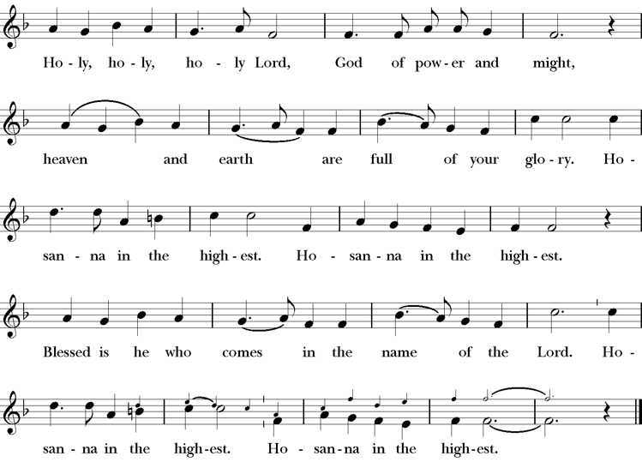
Presider Holy and gracious Father: In your infinite love you made us for yourself; and, when we had fallen into sin and become subject to evil and death, you, in your mercy, sent Jesus Christ, your only and eternal Son, to share our human nature, to live and die as one of us, to reconcile us to you, the God and Father of all.
He stretched out his arms upon the cross, and offered himself, in obedience to your will, a perfect sacrifice for the whole world.
On the night he was handed over to suffering and death, our Lord Jesus Christ took bread; and when he had given thanks to you, he broke it, and gave it to his disciples, and said, “Take, eat: This is my Body, which is given for you. Do this for the remembrance of me”
After supper he took the cup of wine; and when he had given thanks, he gave it to them, saying, “Drink this, all of you: this is my blood of the new covenant which is shed for you and for many for the forgiveness of sins. Whenever you drink it, do this for the remembrance of me.”
Presider Therefore we proclaim the mystery of faith.
People Christ has died; Christ is risen; Christ will come again.
Presider We celebrate the memorial of our redemption, O Father, in this sacrifice of praise and thanksgiving. Recalling his death, resurrection, and ascension, we offer you these gifts.
Sanctify them by your Holy Spirit to be for your people the Body and Blood of your Son, the holy food and drink of new and unending life in him. Sanctify us also that we may faithfully receive this holy Sacrament, and serve you in unity, constancy, and peace; and at last day bring us with all your saints into the joy of your eternal kingdom.
All this we ask through your Son Jesus Christ. By him, and with him, and in him, in the unity of the Holy Spirit all honor and glory is yours, Almighty Father, now and for ever.
Amen.

The Lord’s Prayer
Presider As our Savior has taught us, we are bold to pray.
People Our Father, who art in heaven, hallowed be thy name. Thy Kingdom come, thy will be done, on earth as it is in heaven. Give us this day our daily bread. And forgive us our trespasses, as we forgive those who trespass against us. And lead us not into temptation, but deliver us from evil. For thine is the kingdom, the power and the glory, for ever and ever. Amen.

The Breaking of the Bread
The Presider breaks the consecrated bread in view of the assembly.
Presider The Gifts of God for the people of God.
People Therefore let us keep the feast. Alleluia

Invitation to Communion
Presider This is the Lord’s table. The Lord Jesus invites us to share this joyful feast.
Sharing the Sacred Meal
This is Christ’s table and all are welcome and all are fed.
Communion Music Let all Mortal Flesh keep Silence H 324
Post-Communion Prayer BCP 365
The Blessing
The Recessional Hymn This is the Day LEVAS 219
The Dismissal*
Celebrant | Let us go forth in the name of Christ.
People | Thanks be to God.
Postlude Steve Rubardt Please remain seated

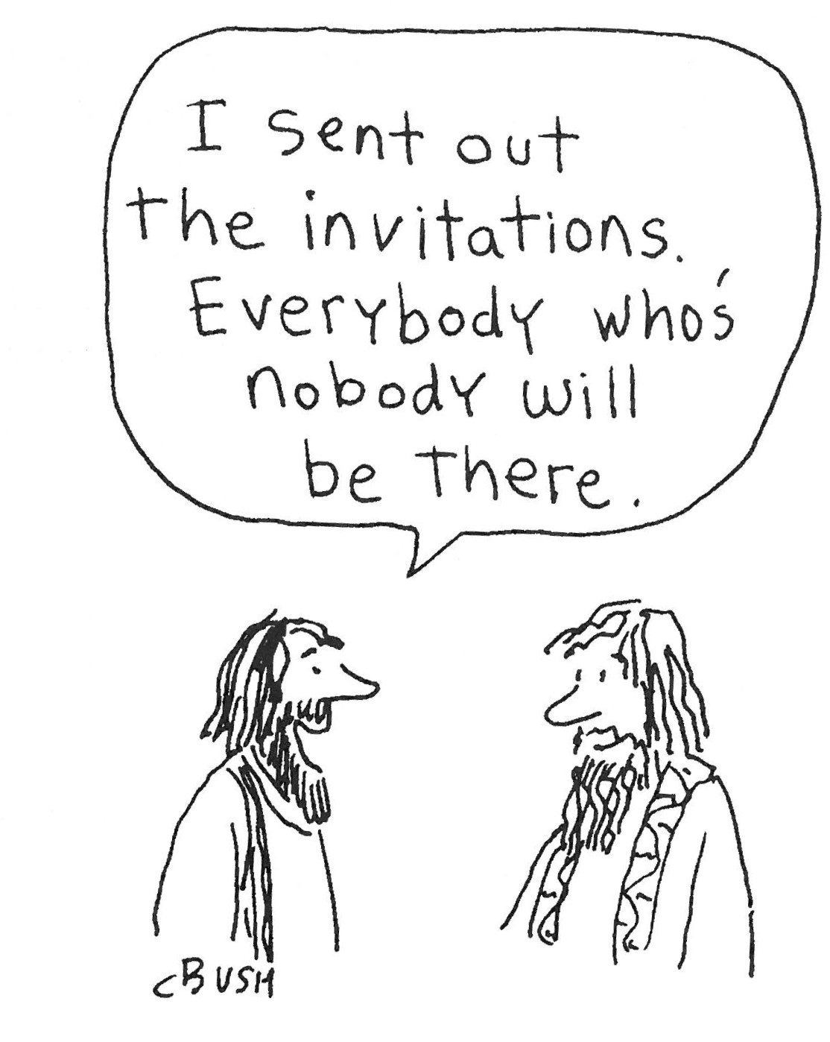
SERVING TODAY
Celebrant & Preacher: Pastor Cindy Beck
Acolyte: Claire Ginesi
Lector: Barbara Feduska , Gerrilee Fischer
Intercessor: Alfred Escoffier
Worship Musician: Steve Rubardt
Choir Leader: Steve Rubardt
Choir: Liz Carpenter, Heather Dahlberg, Scott Sherman, Patsy Gralow, Laurell Meredith, Mary Omodt, Barbara Feduska, Tara Anderson, Carol Heffler, Don McMahon
Sunday School - Child Care: Claire Ginesi
Ushers: Marcia Derby
Tech Chaplain: Marcos Rendon
Altar Guild: Marcia Derby , Mary Omodt
Hospitality : Sophie Popenoe , Arminda Eiler
Altar Flowers today are arranged by Marianne Uhl
Prayers requested for these on Trinity’s long-term prayer list: Armando P, Georgia Bostedt, John Eiler, Gerrilee Fisher, Claire Ginesi, Mary Griffin, David & Christine Hilt, Mark Mezzetta, Kelcey Omodt, Grizelda Ponce, Barry Reap, Blake W, Robert R, Melissa White, Ann Loveland Sherman, James Thomas, Rose Burns, Jennifer Gralow, Patsy Gralow, Steve Antenen, Sandra Leland, Karl, Michael Hardy, Michael Bean Land, Polly Moore, Sinat Liv, Will Maushardt, Sophia Piconi, Mike Smith, Jean Maffoli.
Prayers for the Repose of soul: Tim Dowd , Susan Bassett, Joan Biersch, Linda Dowd, Christina Van Krugel, Mere Nagasau, Mary Goshert, Peggy Bell, Carolyn Caldwell, Van Z, Dolores Mae Seaberg Cole, Muff Davey, Giancarlo Cestarollo.
Contact Pastoral Care Chair, Lorena lorena.m.reinhardt@gmail.com to make any additions or to remove names from our Long-Term Prayer list.
Notes on the Service Bulletin This service bulletin is a guide to the service. We use a variety of printed materials for the prayers, the scriptural readings and the hymns. The Readings for the week, including the Collect and Readings are found in this Bulletin. The service follows the liturgies that are found in the Book of Common Prayer (BCP). The BCP is the blue book found in the pew in front of you. The hymns come primarily from The 1982 Hymnal, also in the pew – the red book. Lift Every Voice and Sing (LEVAS) is another hymnal located in the pew rack. VF stands for Voices Found, another authorized hymnal. Sound Mate Assisted Hearing devices available at the back of the church on the Narthex Table.

Trinity Liturgical Ministry ROTA Next two weeks
Date | Celebrant | Ushers | Acolyte | Lector (s) | Intercessor | Altar Guild
10/18 | Cindy Beck | John Addeo | Susie Hand | Alfred Escoffier , Lorena Reinhardt | Bill Doyle | Susie Hand
10/25 | LA KING | Alfred Escoffier | Arminda Eiler | Jane Hernandez , John Eiler | Barbara Feduska | Susie Hand
Schedule of Weekly Meetings and Services at Trinity Episcopal Sonoma
Day | Date | Time | Occasion | Location
Wednesday | October 14 | 11 AM | Bible Study | Library
Thursday | October 15 | 10:30 AM  5:30 PM | Mindfulness & Well Being  Alcoholics Anonymous | Library  Buttrum Hall
Saturday | October 17 | 8 AM | Centering Prayer | St. Luke’s Chapel
Sunday | October 18 | 10:00 AM | Holy Eucharist II | Sanctuary
Mon-Fri | Weekdays | 7AM-1PM | Sonoma Home Meals | Kitchen &Buttrum Hall
Mon-Fri | Weekdays | 9-2 | Sonoma Preschool Academy – School

Monthly Meetings at Trinity Episcopal Sonoma
Day | Date | Time | Meeting | Location | Contact
Tuesday | October 6 | 11 AM | Prayer Shawl Ministry | Library | Lorena Reinhardt lorena.m.reinhardt@gmail.com
Thursday | TBD | TBD | Vestry | Library | Cindy Beck 916-955-9861



PRAYERS and BLESSINGS
For a Birthday
Watch over your child, O Lord as his/her days increase; bless and guide him/her wherever s/he may be. Strengthen them when s/he stands; comfort him/her when discouraged or sorrowful; raise him/her up if s/he fall; and in his/her heart may your peace which passes understanding abide all the days of his/her life; through Jesus Christ our Lord. Amen.
For an Anniversary
O God, you have so consecrated the covenant of marriage that it represents the spiritual unity between Christ and his Church: Send your blessing upon these your servants as they celebrate their anniversary, that they may continue to love, honor and cherish each other in faithfulness and patience, in wisdom and true godliness, that their home may be a haven of blessing and peace; through Jesus Christ our Lord, who lives and reigns with you and the Holy Spirit, one God, now and forever. Amen.
For Travelers
O God, our heavenly Father, whose glory fills the whole creation, and whose presence we find wherever we go; preserve those who travel; surround them with your loving care; protect them from every danger, and bring them in safety to their journey’s end; through Jesus Christ our Lord. Amen.
Sending our Eucharistic Visitors
Priest: In the name of this congregation, I send you forth bearing these holy gifts, the those to whom you go may share with us in the communion of Christ’s body and blood.
People: We who are many are one body, because we all share on bread, and one cup. Amen.

Trinity Episcopal Church
In Sonoma for over 170 years
275 East Spain Street
Sonoma, CA 95476
The Rt. Rev. Megan M. Traquair, Bishop
Diocese of Northern California
Pastor Cindy Beck, Interim
Steve Rubardt, Worship Music
Vestry
Bill Doyle, Senior Warden & Stewardship
Susie Hand
Heather Dahlberg
Sally Zimmerman
Lorena Reinhardt (Pastoral Care)
Luke Bohanan
Mandy Birkbeck
Ministries
Prayer Shawl, Lorena Reinhardt
Outreach, Jane Hernandez
Mindfulness & Well Being, Mary Omodt
Sunday School, Children, Wendy Aguilar

The Members of the Congregation are The Ministers of the Church

Administrative Office Hrs.
Monday Wednesday 9 A.M. – 2 PM; Thursday 10A.M.-2 P.M0
Sunday 9:30-11:30
Clergy Office Hours Wednesdays, Thursdays, by appointment

Emergency, sickness, please contact office: 707-938-4846

