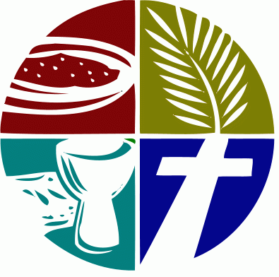

An Order for
the Celebration of
The Holy Eucharist
For the 5th Sunday of Lent
March 22, 2026
Welcome! Beinvenido! Karibu!
Scattered in the world we gather together as God's people in worship. We bring the fragments of our lives to be healed and made whole in Christ as we gather in community.
Worship lies at the heart of the Christian life. It is in worship that we express our theology and define our identity. It is through encountering God within worship that we are formed and transformed as God’s people. One of the glories of the Episcopal/Anglican Church is its liturgical worship. Liturgy refers to the patterns, forms, words and actions through which public worship is conducted.
As we gather, we bring our diverse gifts: gifts of music, dance, prophecy, teaching, preaching, and friendship. We present these gifts in the form of our most precious offering to God, our very selves, that all that we do may be for God’s glory in the unity of Christ’s church.
See end of bulletin for information and announcements for Trinity Episcopal Sonoma.
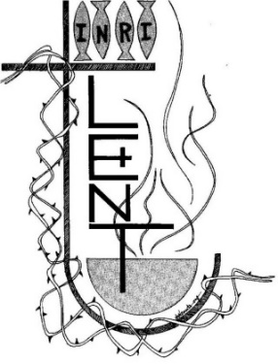
About the Season of Lent

Early Christians observed “a season of penitence and fasting” in preparation for the Paschal feast, or Pascha (Easter). The season now known as Lent, from an Old English word meaning “spring,” the time of lengthening days, has a long history. Lent was especially important for converts to the faith who were preparing for baptism, and for those guilty of notorious sins who were being restored to the Christian assembly. In the western church, the forty days of Lent extend from Ash Wednesday through Holy Saturday, omitting Sundays. The last three days of Lent are the sacred Triduum of Maundy Thursday, Good Friday, and Holy Saturday. Today, Lent has reacquired its significance as the final preparation of adult candidates for baptism. Joining with them, all Christians are invited “to the observance of a holy Lent, by self-examination and repentance; by prayer, fasting, and self-denial; and by reading and meditating on God’s holy Word.”

About the Holy Eucharist
“When God finds us, there is always a celebration. In the Eucharist, we gather to celebrate God finding us in Jesus Christ. If you’re feeling lost, when you come to receive Jesus in bread and wine, ask to be found. If you know what it is to have been found by God, when you come to receive Jesus in bread and wine, give thanks – thanks to the one who came looking for you, and found you.”
-Br. Geoffrey Tristram Society of Saint John the Evangelist
In the Episcopal Church the Holy Eucharist is the sacrament of Christ's body and blood, and the principal act of Christian worship. The term is from the Greek, "thanksgiving." Jesus instituted the Eucharist "on the night when he was betrayed." At the Last Supper he shared the Bread and cup of Wine at a sacred meal with his disciples. He identified the Bread with his body and the Wine with his blood of the new covenant. Jesus commanded his disciples to "do this" in remembrance of Jesus.
For Episcopalians, the Holy Eucharist becomes the very Real Presence of Christ, his Body and Blood, the ordinary made also extraordinary, sacred by Jesus' own words and by the Holy Spirit.
In the Episcopal Church, we seek to adapt ancient liturgy for today. If you grew up in a less formal church, worship may feel pretty traditional. If you grew up in a formal church, our worship may deconstruct that formality, and ask you to pray using more modern words, or sing new songs. We seek to balance tradition and culture in our worship. When we hold the tension well between the ancient and the modern, the Holy Eucharist comes alive.
Opening Hymn
We begin by praising God through song and prayer.
Glorious Things of Thee are Spoken H 523
The Penitential Rite
Our worship begins with the Acclamation and Penitential Rite.
Presider Blessed be the God of our salvation.
People Who bears our burdens and forgives our sin.
Presider Jesus said, "The first commandment is this: Hear, O Israel: The Lord our God is the only Lord. Love the Lord your God with all your heart, with all your soul, with all your mind, and with all your strength. The second is this: Love your neighbor as yourself. There is no other commandment greater than these." -Mark 12:29-31

The Confession
As we enter in to worship we ask God’s forgiveness for things done and things left undone and things done on our behalf so that we may be reconciled to each other and to God.
Presider Let us confess our sins against God and our neighbor.
Silence is kept for a time.
Presider Most holy and merciful God: We confess to you and to one another, and to the whole communion of saints in heaven and on earth, that we have sinned by our own fault in thought, word, and deed; by what we have done, and by what we have left undone.
People We have not loved you with our whole heart, and mind, and strength. We have not loved our neighbors as ourselves. We have not forgiven others, as we have been forgiven.

Presider Our past unfaithfulness: the pride, hypocrisy, and impatience of our lives,
People We confess to you, O God.
Presider Our self-indulgence, and our exploitation of other people, our anger at our own frustration, and our envy of those more fortunate than ourselves,
People We confess to you, O God.
Presider For all false judgments, for uncharitable thoughts toward our neighbors, and for our prejudice and contempt toward those who differ from us,
People Accept our repentance, O God.
Presider For our waste and pollution of your creation, and our lack of concern for those who come after us,
People Accept our repentance, O God.
Presider Restore us, good Lord, and let your anger depart from us;
People Favorably hear us, for your mercy is great.

declaration of pardon & forgiveness
Presider The Eternal God forgives you and frees you from your sins, heals and strengthens you by the Holy Spirit, and raises you to new life in Christ Jesus our Lord. Amen

Song of Penance: Trisagion (Sung)
When the Trisagion is sung, it is repeated three times.
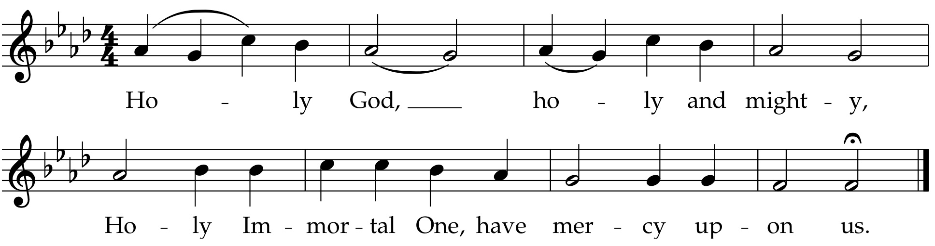
Collect of the Day
The collect is written to go along with both the season of the church year and the readings for the day. It summarizes the attributes of God as revealed in the scripture for the day.
Presider The Lord be with you.
People And also with you.
Presider Let us pray.
Lord Jesus, you taught your disciples that unless a grain of wheat falls
into the earth and dies it remains just a single grain, but if it dies it
bears much fruit; as we prepare our hearts to remember your death
and resurrection, grant us the strength and wisdom to serve and follow
you, this day and always.
Amen.
We hear the sacred stories
We hear the stories of the experience of God from our spiritual ancestors. Reading and commenting on scripture goes back to the earliest services of Christianity. Following the pattern of Jewish synagogue worship, readings follow a set pattern for what will be read when.
The First Reading Ezekiel 37:1-14
The people sit.
A Reading from the book of Ezekiel.
¹The hand of the Lord came upon me, and he brought me out by the spirit of the Lord and set me down in the middle of a valley; it was full of bones. ²He led me all around them; there were very many lying in the valley, and they were very dry. ³He said to me, “Mortal, can these bones live?” I answered, “O Lord God, you know.” ⁴Then he said to me, “Prophesy to these bones, and say to them: O dry bones, hear the word of the Lord. ⁵Thus says the Lord God to these bones: I will cause breath to enter you, and you shall live. ⁶I will lay sinews on you, and will cause flesh to come upon you, and cover you with skin, and put breath in you, and you shall live; and you shall know that I am the Lord.”
⁷So I prophesied as I had been commanded; and as I prophesied, suddenly there was a noise, a rattling, and the bones came together, bone to its bone. ⁸I looked, and there were sinews on them, and flesh had come upon them, and skin had covered them; but there was no breath in them. ⁹Then he said to me, “Prophesy to the breath, prophesy, mortal, and say to the breath: Thus says the Lord God: Come from the four winds, O breath, and breathe upon these slain, that they may live.” ¹⁰I prophesied as he commanded me, and the breath came into them, and they lived, and stood on their feet, a vast multitude.
¹¹Then he said to me, “Mortal, these bones are the whole house of Israel. They say, ‘Our bones are dried up, and our hope is lost; we are cut off completely.’ ¹²Therefore prophesy, and say to them, Thus says the Lord God: I am going to open your graves, and bring you up from your graves, O my people; and I will bring you back to the land of Israel. ¹³And you shall know that I am the Lord, when I open your graves, and bring you up from your graves, O my people. ¹⁴I will put my spirit within you, and you shall live, and I will place you on your own soil; then you shall know that I, the Lord, have spoken and will act, says the Lord.”
Reader Hear what the Holy Spirit is saying to God’s people.
People Thanks be to God.

The Psalm of the Day Psalm 130
The psalms are a part of the poetry of the Hebrew people. They express joy and sadness, loneliness and thanksgiving as part of the human longing to be united with God.
Reader We will read Psalm 130, responsively by half verse.
¹Out of the depths have I called to you, O Lord;
Lord, hear my voice; *
let your ears consider well the voice of my supplication.
²If you, Lord, were to note what is done amiss, *
O Lord, who could stand?
³For there is forgiveness with you; *
therefore you shall be feared.
⁴I wait for the Lord; my soul waits for him; *
in his word is my hope.
⁵My soul waits for the Lord,
more than watchmen for the morning, *
more than watchmen for the morning.
⁶O Israel, wait for the Lord, *
for with the Lord there is mercy;
⁷with him there is plenteous redemption, *
and he shall redeem Israel from all their sins.

The Second Reading Romans 8:6-11
A Reading from Paul's letter to the Church in Rome.
⁶To set the mind on the flesh is death, but to set the mind on the Spirit is life and peace. ⁷For this reason the mind that is set on the flesh is hostile to God; it does not submit to God’s law—indeed it cannot, ⁸and those who are in the flesh cannot please God.
⁹But you are not in the flesh; you are in the Spirit, since the Spirit of God dwells in you. Anyone who does not have the Spirit of Christ does not belong to him. ¹⁰But if Christ is in you, though the body is dead because of sin, the Spirit is life because of righteousness. ¹¹If the Spirit of him who raised Jesus from the dead dwells in you, he who raised Christ from the dead will give life to your mortal bodies also through his Spirit that dwells in you.
Reader Hear what the Holy Spirit is saying to the church.
People Thanks be to God.
Preparing to Hear the Gospel
We rise in body or in spirit for the Gospel reading to show the particular importance we place on Jesus’ words and actions.
Sequence Hymn
Come, gracious Spirit, heavenly dove H 512 v 1 & 2
The Proclamation of the Gospel John 11:1-45
Presider The Holy Gospel of our Savior Jesus Christ according to John.
People Glory to you, O Christ.
¹Now a certain man was ill, Lazarus of Bethany, the village of Mary and her sister Martha. ²Mary was the one who anointed the Lord with perfume and wiped his feet with her hair; her brother Lazarus was ill. ³So the sisters sent a message to Jesus, “Lord, he whom you love is ill.” ⁴But when Jesus heard it, he said, “This illness does not lead to death; rather it is for God’s glory, so that the Son of God may be glorified through it.” ⁵Accordingly, though Jesus loved Martha and her sister and Lazarus, ⁶after having heard that Lazarus was ill, he stayed two days longer in the place where he was.
⁷Then after this he said to the disciples, “Let us go to Judea again.” ⁸The disciples said to him, “Rabbi, the Jews were just now trying to stone you, and are you going there again?” ⁹Jesus answered, “Are there not twelve hours of daylight? Those who walk during the day do not stumble, because they see the light of this world. ¹⁰But those who walk at night stumble, because the light is not in them.” ¹¹After saying this, he told them, “Our friend Lazarus has fallen asleep, but I am going there to awaken him.” ¹²The disciples said to him, “Lord, if he has fallen asleep, he will be all right.” ¹³Jesus, however, had been speaking about his death, but they thought that he was referring merely to sleep. ¹⁴Then Jesus told them plainly, “Lazarus is dead. ¹⁵For your sake I am glad I was not there, so that you may believe. But let us go to him.” ¹⁶Thomas, who was called the Twin, said to his fellow disciples, “Let us also go, that we may die with him.”
¹⁷When Jesus arrived, he found that Lazarus had already been in the tomb four days. ¹⁸Now Bethany was near Jerusalem, some two miles away, ¹⁹and many of the Jews had come to Martha and Mary to console them about their brother. ²⁰When Martha heard that Jesus was coming, she went and met him, while Mary stayed at home. ²¹Martha said to Jesus, “Lord, if you had been here, my brother would not have died. ²²But even now I know that God will give you whatever you ask of him.” ²³Jesus said to her, “Your brother will rise again.” ²⁴Martha said to him, “I know that he will rise again in the resurrection on the last day.” ²⁵Jesus said to her, “I am the resurrection and the life. Those who believe in me, even though they die, will live, ²⁶and everyone who lives and believes in me will never die. Do you believe this?” ²⁷She said to him, “Yes, Lord, I believe that you are the Messiah, the Son of God, the one coming into the world.”
²⁸When she had said this, she went back and called her sister Mary, and told her privately, “The Teacher is here and is calling for you.” ²⁹And when she heard it, she got up quickly and went to him. ³⁰Now Jesus had not yet come to the village, but was still at the place where Martha had met him. ³¹The Jews who were with her in the house, consoling her, saw Mary get up quickly and go out. They followed her because they thought that she was going to the tomb to weep there. ³²When Mary came where Jesus was and saw him, she knelt at his feet and said to him, “Lord, if you had been here, my brother would not have died.” ³³When Jesus saw her weeping, and the Jews who came with her also weeping, he was greatly disturbed in spirit and deeply moved. ³⁴He said, “Where have you laid him?” They said to him, “Lord, come and see.” ³⁵Jesus began to weep. ³⁶So the Jews said, “See how he loved him!” ³⁷But some of them said, “Could not he who opened the eyes of the blind man have kept this man from dying?”
³⁸Then Jesus, again greatly disturbed, came to the tomb. It was a cave, and a stone was lying against it. ³⁹Jesus said, “Take away the stone.” Martha, the sister of the dead man, said to him, “Lord, already there is a stench because he has been dead four days.” ⁴⁰Jesus said to her, “Did I not tell you that if you believed, you would see the glory of God?” ⁴¹So they took away the stone. And Jesus looked upward and said, “Father, I thank you for having heard me. ⁴²I knew that you always hear me, but I have said this for the sake of the crowd standing here, so that they may believe that you sent me.” ⁴³When he had said this, he cried with a loud voice, “Lazarus, come out!” ⁴⁴The dead man came out, his hands and feet bound with strips of cloth, and his face wrapped in a cloth. Jesus said to them, “Unbind him, and let him go.”
⁴⁵Many of the Jews therefore, who had come with Mary and had seen what Jesus did, believed in him.
Presider The Gospel of the Lord.
People Praise to you, O Christ.
Sequence Hymn
Come, gracious spirit, heavenly dove H 512 v 3 & 4
The Sermon
We remain seated for the sermon. Having someone comment on the scriptures read goes back to the earliest days of Christianity and to the Jewish Synagogue worship which preceded it.
The Affirmation of Faith
Since the Sixth Century, the Church has recited either the Nicene Creed or the Apostle’s Creed at the Eucharist. The word creed comes from the Latin credo for “I believe” or “I lend my heart to.”
The Nicene Creed
Presider We affirm our faith in the One, Holy and Living God.
People We believe in one God, the Father, the Almighty, maker of heaven and earth, of all that is, seen and unseen.
People We believe in one Lord, Jesus Christ, the only Son of God, eternally begotten of the Father, God from God, Light from Light, true God from true God, begotten, not made, of one Being with the Father. Through him all things were made. For us and for our salvation he came down from heaven: by the power of the Holy Spirit he became incarnate from the Virgin Mary, and was made man. For our sake he was crucified under Pontius Pilate; he suffered death and was buried. On the third day he rose again in accordance with the Scriptures; he ascended into heaven and is seated at the right hand of the Father. He will come again in glory to judge the living and the dead, and his kingdom will have no end.
People We believe in the Holy Spirit, the Lord, the giver of life, who proceeds from the Father and the Son. With the Father and the Son he is worshiped and glorified. He has spoken through the Prophets. We believe in one holy catholic and apostolic Church. We acknowledge one baptism for the forgiveness of sins. We look for the resurrection of the dead, and the life of the world to come. Amen.

The Prayers of the People
Prayer changes people. Prayer is not about changing God, but about changing us more into the likeness of God. Collectively and individually we offer the hopes and desires of our hearts to God.
Presider: Brothers and sisters, the Spirit of God dwells in you. Let us appeal to our God, saying, “We call to you, O Lord; Lord, hear our voice.”
Intercessor: Breathe new life into your Church, O Lord. Where our bones are dried up, where our hope is lost, cause your life-giving breath to enter. Give us confidence in the truth that the same Spirit that raised Jesus from the dead dwells in us, +___________
Invite the congregation to add their thanksgivings, followed by silence
We call to you, O Lord;
People: Lord, hear our voice.
Intercessor: Many are they who wait for you, O Lord. Speak into the souls of those suffering throughout the world, a word of hope.
Silence
We call to you, O Lord;
People: Lord, hear our voice.
Intercessor: Creating God, it is the wind of your Spirit that sweeps across this planet. Renew and refresh your creation; bring forth newness in dead places.
Silence
We call to you, O Lord;
People: Lord, hear our voice.
Intercessor: With you, O Lord, there is plenteous redemption. Restore the hope of this city. Renew our trust that you have a life-giving future in mind for us.
Silence
We call to you, O Lord;
People: Lord, hear our voice.
Intercessor: With you, O Lord, there is mercy. Consider well the voice of those who call out from their depths. As they wait for you in their pain and sorrow, give life to their mortal bodies by your healing Spirit, +_____________
Invite the congregation to add their petitions, followed by silence
We call to you, O Lord;
People: Lord, hear our voice.
Intercessor: God, we trust your Son Jesus to be for us resurrection and life. Give to the dead your life. Assure the living with the promise of resurrection,+_____________________
Invite the congregation to add their petitions, followed by silence
We call to you, O Lord;
People: Lord, hear our voice.
Presider: Look down in mercy, Lord, on your people who kneel before you;
and, grant that those whom you have nourished by your Word
and Sacraments may bring forth fruit worthy of repentance;
through Christ our Lord.
People: Amen.

The Exchange of the Peace
As we enter the most sacred portion of our worship, we exchange a sign of God’s promised peace. There are no set words to use in greeting each other, but “Peace be with you,” “God’s peace,” and “Shalom” are all commonly used.
Presider The Peace of Christ be always with you.
People And also with you.
Presider Let us offer each other a sign of Christ's peace.
We are a community of reconciliation and peace; therefore, we greet each other with a sign of our desire for peace.
Welcome & Announcements
Community announcements, notices, prayers, and celebrations may be offered at this time.
Gathering at Christ's Table
Having been nourished from the richness of God's love in sacred story and reconciled to each other through prayer and peace, we gather at Christ's table to offer ourselves to be transformed for service in the world.
The Offertory
The gifts of bread, wine, money and other gifts are brought to the Presider as an offering to God as a reminder of Christ's sacrificial love and life. Once the Holy Table or Altar is prepared the Presider and people give thanks to God for the many gifts we have been given.
Offertory Hymn:
Lift every voice and sing LEVAS 1
Doxology
The people stand while the offerings are presented and placed on the Altar.
Presider: Gracious God, as an offering of our thanksgiving and gratitude, we return to you a portion of what you have gifted us.
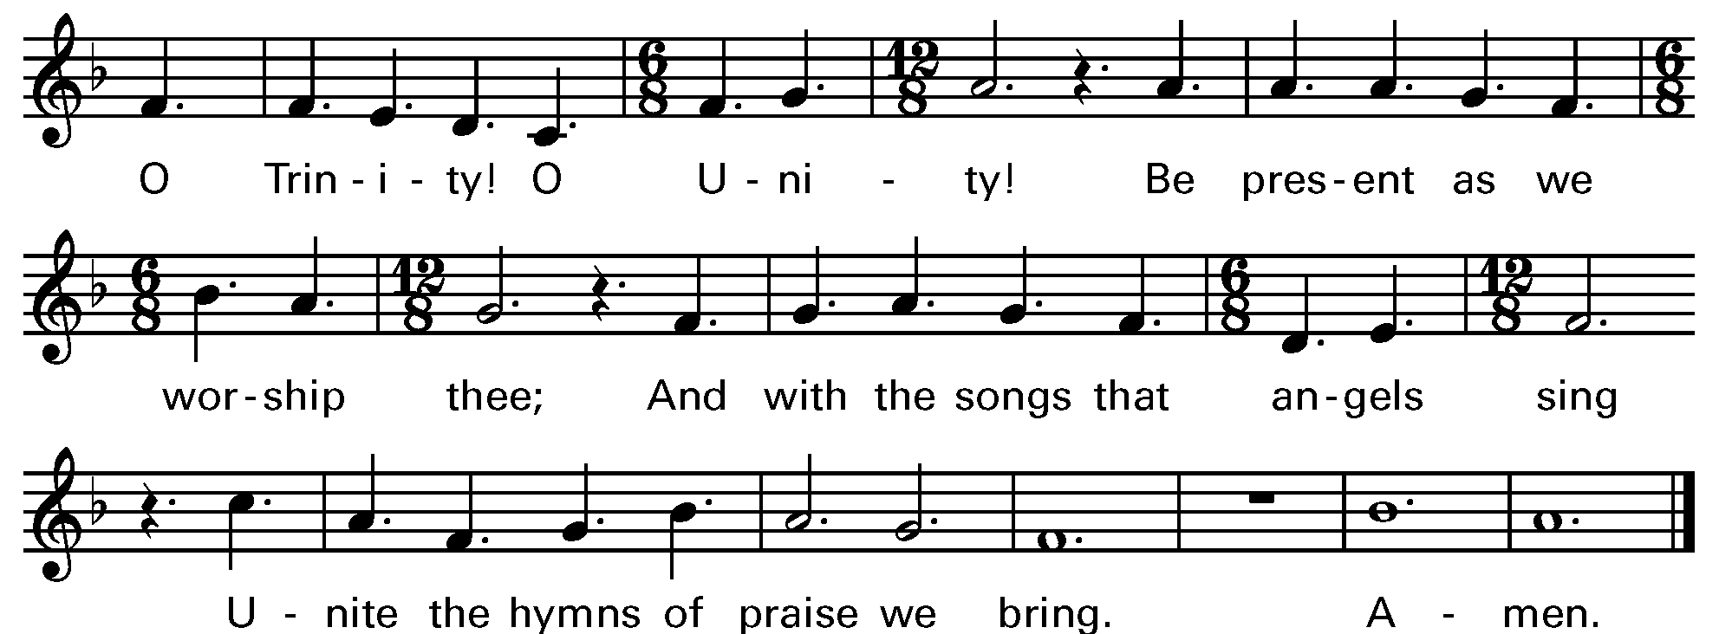

Music: OLD HUNDREDTH

The Great Thanksgiving
The Eucharistic Prayer, or Great Thanksgiving, is the prayer of the Church to invite Christ to be present in the elements of bread and wine. Now we come to the second act in the drama with the Liturgy of the Table. It is based on Jewish Fellowship meals, particularly the Passover observance. But this second half of the service is not communion in and of itself. It is the whole service, both acts of the drama, that make up the Eucharist.
Eucharistic Prayer for Lent
Presider The Lord be with you.
People And also with you.
Presider Lift up your hearts.
People We lift them to the Lord.
Presider Let us give thanks to the Lord our God.
People It is right to give thanks and praise.
Presider Blessed are you, God of everlasting covenant, for your promises are steadfast and your provision is sure. Through the forty years of your people’s desert wanderings you were constant in fire and cloud; with manna and mercy you sustained every step. You made Jesus’ temptation of forty days a theater of truth where your Word stood strong.
In every age you have shaped your people through times of wilderness and wandering, of temptation and trial, and brought them into the land of promise and the life of covenant.
And so we give you humble thanks for your forgiveness and our new life, with angels and archangels and the company of heaven, singing your unending praise.

Sanctus Holy Holy, Holy (Proulx) Hymnal S-125
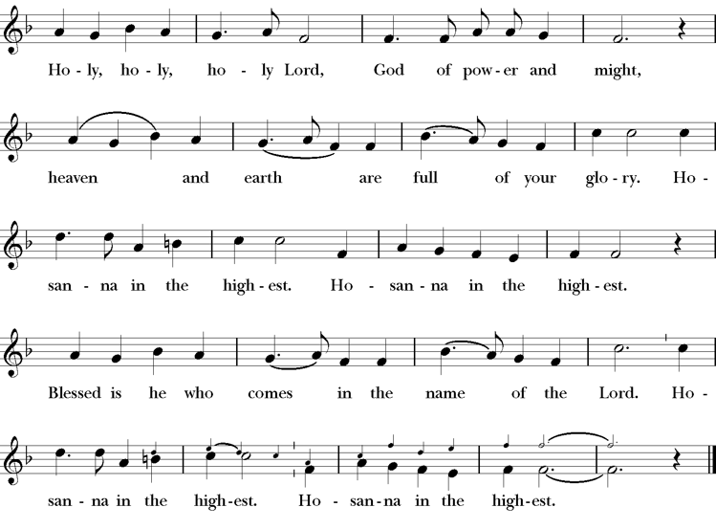
Presider Enduring God, as you sustained Jesus in hunger and thirst; through this meal strengthen us to keep our Lenten fast. Send your Holy Spirit upon us as we remember Jesus’ saving passion; transform our insatiable desires into hunger for the feast of this table. Send your Holy Spirit upon this bread and wine that they may be for us the body and blood of Christ;
Who at supper with his disciples, took bread, gave you thanks, broke the bread, and gave it to them, saying “Take, eat: this is my body which is given for you; do this in remembrance of me.”
Presider After supper he took the cup of wine. Again he gave you thanks, and gave it to his disciples, saying, “Drink this, all of you: this is my blood of the new covenant which is shed for you and for many for the forgiveness of sins. Do this, as often as you drink it, in remembrance of me.”
Presider Great is the mystery of faith.
People Christ has died; Christ is risen; Christ will come again.
Presider Forgiving God, in this season of repentance, make your mercy sufficient for every need. Come to your children who are in their own wilderness and make their wanderings holy paths of learning your truth.
Presider Come alongside your children who suffer in sin and give them the power to live as your beloved sons and daughters. Renew your church from the depths of your heart, where justice and mercy meet.
Presider Infuse your church with Spirit and truth, walk with your beloved people as they seek security, companionship and freedom in your world, and fill your saints with the hope of eternal life, that all may come to praise your name, that all creation be stirred with the wonders of your grace.
Presider Through Christ, with Christ, in Christ, in the unity of the Holy Spirit, all glory and honor are yours, almighty God, now and forever. AMEN.
The Lord’s Prayer
The link between our daily bread and the spiritual food we receive in the Eucharist is an ancient connection. In the Lord’s Prayer we ask for daily bread, meaning the things we need to get through each day. But as a part of that, the bread also symbolizes God’s presence.
Presider As our Savior has taught us, we are bold to pray.
People Our Father, who art in heaven, hallowed be thy name. Thy Kingdom come, thy will be done, on earth as it is in heaven. Give us this day our daily bread. And forgive us our trespasses, as we forgive those who trespass against us. And lead us not into temptation, but deliver us from evil. For thine is the kingdom, the power and the glory, for ever and ever. Amen.
The Breaking of the Bread
The Presider breaks the consecrated bread in view of the assembly.
Presider Christ our Passover is sacrificed for us.
People Therefore let us keep the feast.
Invitation to Communion
We partake in the Eucharist and are spiritually nourished, but it is not for our benefit alone. Communion enables us to return to the world with renewed vigor for proclaiming the Gospel in our words and in our lives. In the Eucharist, Christ’s presence both nourishes us and challenges us.
Presider The gifts of God for the people of God. So come to this table you who have been here often and you who have not been here in a long time. Come, you who have tried to follow Jesus and you who have failed. You who are full of faith and full of doubt. Come, it is Christ himself who invites you to meet him here.
Sharing the Sacred Meal
This is Christ’s table and all are welcome and all are fed.
Communion Hymn: Come, My way H 487
Post Communion Prayer
Presider God is with you.
People And also with you.
Presider Together, let us pray.
People Eternal God, you have renewed us with the living bread from heaven; by it you nourish our faith, increase our hope, and strengthen our love: teach us always to hunger for him who is the true and living bread, and enable us to live lives grounded in service to you and to one another; through Jesus Christ our Lord. Amen.
The Lenten Prayer over the People
The Presider prays over the people as a reminder of God’s extravagant love and invites us to go into the world to be God’s blessing.
Presider Bow down your hearts before the Lord our God. Grant, most merciful Lord, to your faithful people pardon and peace, that they may be cleansed from all their sins, and serve you with a quiet mind; through Christ our Lord. Amen.
Closing Hymn
We begin and end our time of worship by praising God through song and prayer.
The spacious firmament on high H 409
Dismissal
As the celebration ends, we are charged to “Go in Peace to love and serve the Lord.” The Eucharist is therefore not an exclusive gathering that separates us from the world, but a challenge to reach out beyond our own church to the world around us.
Presider Our worship is ended. Our service in the world begins. Go into the world to love what God loves. Go in Peace to love and serve the Lord.
People Thanks be to God.

Thank you for worshiping with us today.
We hope to see you again soon
as we offer Christ’s unfenced love to the world.
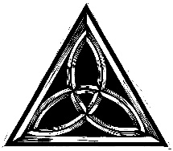
SERVING TODAY
Celebrant and Preacher: Cindy Beck
Acolyte: Arminda Eiler
Lector: Ann Kyser , Lorena Reinhardt
Intercessor: Claire Ginesi
Worship Musician: Steve Rubardt
Choir Leader: Steve Rubardt
Choir: Liz Carpenter, Heather Dahlberg, Scott Sherman, Lucy Maushardt, Patsy Gralow, Laurell Meredith, Mary Omodt, Barbara Feduska, Tara Anderson
Sunday School - Child Care: Wendy Aguilar Appt Only
Ushers: John Eiler
Tech Chaplain: Marcos Rendon
Altar Guild: Ann Kyser
Hospitality: Susie Hand , Barbara Addeo

Trinity Liturgical Ministry ROTA Next two weeks
Date | Celebrant | Ushers | Acolyte / EM | Lector (s) | Intercessor | Altar Guild
March 22 | Cindy Beck | John Eiler | Arminda Eiler | Ann Kyser, Bill Doyle | Claire Ginesi | Ann Kyser
March 29 | Cindy Beck | John Addeo | Susie Hand | Barbara Feduska , Gerrilee Fisher | Alfred Escoffier | Laurell Meredith Mary Omodt

Schedule of Weekly Meetings and Services at Trinity Episcopal Sonoma
Day | Date | Time | Occasion | Location
Wednesday | March 18 | 11 AM | Bible Study | Library
Thursday | March 19 | 10:30 AM  5:30 PM | Mindfulness & Well Being  Alcoholics Anonymous | Library  Buttrum Hall
Saturday | March 21 | 8 AM | Centering Prayer | St. Luke’s Chapel
Sunday | March 22 | 10:15 AM | Holy Eucharist II | Sanctuary
Mon-Fri | Weekdays | 7AM-1PM | Sonoma Home Meals | Kitchen &Buttrum Hall
Mon-Fri | Weekdays | 9-2 | Sonoma Preschool Academy – School

Monthly Meetings at Trinity Episcopal Sonoma
Day | Date | Time | Meeting | Location | Contact
Tuesday | March 3 | 11 AM | Prayer Shawl Ministry | TBD | Lorena Reinhardt (415)488-3674
Thursday | TBD | 4:30 PM | Vestry | Library | Cindy Beck cbeck6012@gmail.com

PRAYERS and BLESSINGS
For a Birthday
Watch over your child, O Lord as his/her days increase; bless and guide him/her wherever s/he may be. Strengthen them when s/he stands; comfort him/her when discouraged or sorrowful; raise him/her up if s/he fall; and in his/her heart may your peace which passes understanding abide all the days of his/her life; through Jesus Christ our Lord. Amen.
For an Anniversary
O God, you have so consecrated the covenant of marriage that it represents the spiritual unity between Christ and his Church: Send your blessing upon these your servants as they celebrate their anniversary, that they may continue to love, honor and cherish each other in faithfulness and patience, in wisdom and true godliness, that their home may be a haven of blessing and peace; through Jesus Christ our Lord, who lives and reigns with you and the Holy Spirit, one God, now and forever. Amen.
For Travelers
O God, our heavenly Father, whose glory fills the whole creation, and whose presence we find wherever we go; preserve those who travel; surround them with your loving care; protect them from every danger, and bring them in safety to their journey’s end; through Jesus Christ our Lord. Amen.
Sending our Eucharistic Visitors
Priest: In the name of this congregation, I send you forth bearing these holy gifts, the those to whom you go may share with us in the communion of Christ’s body and blood.
People: We who are many are one body, because we all share on bread, and one cup. Amen

March Announcements
Holy Week begins next Sunday, March 29, with Palm/Passion Sunday. Good Friday service is April 3rd at 5PM with The Seven Last Words from the Cross. Easter Sunday is April 5th at 10AM.
Easter Flower Donations: Easter flower offering envelopes are now available in the narthex.
Envelopes may be placed in the collection plate, or you may mail them or drop them off at the parish office. Please make your donation by Sunday, April 5th, and we’ll include the names of your loved ones you wish to remember or honor in our Easter Sunday bulletin.
Fellowship Coffee Hour Sign up - We encourage members to sign up to make coffee. Pastor Cindy is happy to demonstrate how easy this is. Please help us provide this hospitality for guests and members.
The February, March, April Forward Day by Day , a booklet of daily inspirational meditations is now available in the Church and the Office. We ask for a $2 donation.
Soup Suppers conclude this Wednesday, the 25th at 5:30PM in Buttram Hall. Please sign up for either soup or bread during fellowship hour!
Lectio Divina Bible Study is on Wednesday, at 11AM in the library. Lectio Divina, Latin for "divine reading," is a contemplative practice of scriptural reading, meditation, and prayer intended to promote communion with God. Unlike traditional Bible study that focuses on intellectual information, Lectio Divina emphasizes spiritual formation and personal intimacy with God.
All are welcome to make a gift and offering in thanksgiving to God; for the many blessings we have received. To take advantage of our electronic giving options, please follow the QR code with your capable electronic device, or visit https://onrealm.org/trinitysonoma/-/form/give/default Help us to make this a place where God’s grace is freely shared by all.

