Trinity Episcopal Church
Cultivating God’s Loving Spirit in each of us

Proper 17
Year A
Holy Eucharist II
August 30th, 2026
10:00 AM In person and Online

Welcome to Trinity Episcopal, Sonoma. Whether you are passing through or looking for a church home, we are blessed by your presence and we invite you to worship with us fully – singing, praying and receiving communion- with your voice and heart. Please sign our guestbook at the back of the church, including your email.
If you would like to learn more about The Episcopal Church, please send us an email trinityepiscopalsonoma@comcast.net. We look forward to meeting you after the service where coffee and treats are served.
Did you know that....
...24% of Seniors 65+ in Sonoma County live alone?
...That the Council on Aging has a Senior Peer Support program that matches volunteers to do home visits with Srs?
...That you can be one of the volunteers that visits older adults? Ask Pastor Cindy about it.

All are welcome to make a gift and offering in thanksgiving to God; for the many blessings we have received. To take advantage of our electronic giving options, please follow the QR code with your capable electronic device, or visit https://onrealm.org/trinitysonoma/-/form/give/default
August Announcements
Fellowship Coffee Hour Sign up – Fellowship follows the service! We meet in the hall or courtyard. We’d love to visit with you.
Thank you to everyone who donated food for A Simple Gesture, your gift helps people have a meal! Our next pick up will be on September!
Movie Night at Trinity will continue on Wednesday Sept 16th. Join us for “Legally Blonde”, at 6PM in Buttram Hall. Stay for the snacks and post film discussion.
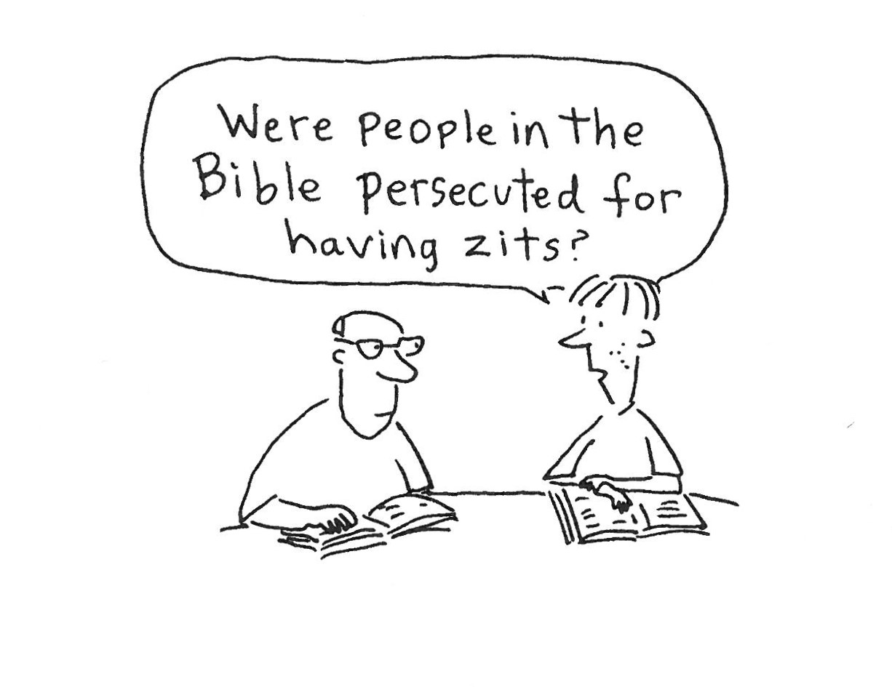
Prelude Steve Rubardt
Please stand for the Entrance Hymn.
At the sound of the bell, please stand as you are able. The People respond when bold text appears.
The Word of God
Entrance Hymn All Praise to Thee, for Thou, O King Divine H 477
Opening Acclamation BCP 319
Celebrant | Blessed be God: Father, Son, and Holy Spirit.
People | And blessed be his kingdom, now and for ever. Amen.
Collect for Purity
All Almighty God, to you all hearts are open, all desires known, and from you no secrets are hid: Cleanse the thoughts of our hearts by the inspiration of your Holy Spirit, that we may perfectly love you, and worthily magnify your holy Name; through Christ our Lord. Amen.
Song of Praise Glory to God Hymn S-280 is sung, all standing
Glory to God in the highest,
and peace to his people on earth.
Lord God, heavenly King,
almighty God and Father,
we worship you, we give you thanks,
we praise you for your glory.
Lord Jesus Christ, only Son of the Father,
Lord God, Lamb of God,
you take away the sin of the world:
have mercy on us;
you are seated at the right hand of the Father:
receive our prayer.
For you alone are the Holy One,
you alone are the Lord,
you alone are the Most High,
Jesus Christ,
with the Holy Spirit,
in the glory of God the Father. Amen.
The Collect of the Day BCP 357
Celebrant | The Lord be with you.
People | And also with you.
Celebrant | Let us pray.
Lord of all power and might, the author and giver of all good things: Graft in our hearts the love of your Name; increase in us true religion; nourish us with all goodness; and bring forth in us the fruit of good works; through Jesus Christ our Lord, who lives and reigns with you and the Holy Spirit, one God for ever and ever.
All Amen.

The Lessons
First Reading: Jeremiah 15:15-21
Reader A Reading from the book of the prophet Jeremiah.
¹⁵O Lord, you know;
remember me and visit me,
and bring down retribution for me on my persecutors.
In your forbearance do not take me away;
know that on your account I suffer insult.
¹⁶Your words were found, and I ate them,
and your words became to me a joy
and the delight of my heart;
for I am called by your name,
O Lord, God of hosts.
¹⁷I did not sit in the company of merrymakers,
nor did I rejoice;
under the weight of your hand I sat alone,
for you had filled me with indignation.
¹⁸Why is my pain unceasing,
my wound incurable,
refusing to be healed?
Truly, you are to me like a deceitful brook,
like waters that fail.
¹⁹Therefore thus says the Lord:
If you turn back, I will take you back,
and you shall stand before me.
If you utter what is precious, and not what is worthless,
you shall serve as my mouth.
It is they who will turn to you,
not you who will turn to them.
²⁰And I will make you to this people
a fortified wall of bronze;
they will fight against you,
but they shall not prevail over you,
for I am with you
to save you and deliver you,
says the Lord.
²¹I will deliver you out of the hand of the wicked,
and redeem you from the grasp of the ruthless.
Reader | The Word of the Lord.
People | Thanks be to God.
The Psalm: Psalm 26:1-8
Reader We will read Psalm 26:1-8, which we will read responsively by half verse.
¹Give judgment for me, O Lord,
for I have lived with integrity; *
I have trusted in the Lord and have not faltered.
²Test me, O Lord, and try me; *
examine my heart and my mind.
³For your love is before my eyes; *
I have walked faithfully with you.
⁴I have not sat with the worthless, *
nor do I consort with the deceitful.
⁵I have hated the company of evildoers; *
I will not sit down with the wicked.
⁶I will wash my hands in innocence, O Lord, *
that I may go in procession round your altar,
⁷Singing aloud a song of thanksgiving *
and recounting all your wonderful deeds.
⁸Lord, I love the house in which you dwell *
and the place where your glory abides.
Second Reading: Romans 12:9-21
Reader A Reading from Paul's letter to the Church in Rome.
⁹Let love be genuine; hate what is evil, hold fast to what is good; ¹⁰love one another with mutual affection; outdo one another in showing honor. ¹¹Do not lag in zeal, be ardent in spirit, serve the Lord. ¹²Rejoice in hope, be patient in suffering, persevere in prayer. ¹³Contribute to the needs of the saints; extend hospitality to strangers.
¹⁴Bless those who persecute you; bless and do not curse them. ¹⁵Rejoice with those who rejoice, weep with those who weep. ¹⁶Live in harmony with one another; do not be haughty, but associate with the lowly; do not claim to be wiser than you are. ¹⁷Do not repay anyone evil for evil, but take thought for what is noble in the sight of all. ¹⁸If it is possible, so far as it depends on you, live peaceably with all. ¹⁹Beloved, never avenge yourselves, but leave room for the wrath of God; for it is written, “Vengeance is mine, I will repay, says the Lord.” ²⁰No, “if your enemies are hungry, feed them; if they are thirsty, give them something to drink; for by doing this you will heap burning coals on their heads.” ²¹Do not be overcome by evil, but overcome evil with good.
Reader | The Word of the Lord.
People | Thanks be to God.

Sequence Hymn Like the Murmur of a Dove’s Song H 513 v 1 & 2
The Holy Gospel: Matthew 16:21-28
Celebrant | The Holy Gospel of our Lord Jesus Christ according to Matthew.
People | Glory to you, Lord Christ.
²¹Jesus began to show his disciples that he must go to Jerusalem and undergo great suffering at the hands of the elders and chief priests and scribes, and be killed, and on the third day be raised. ²²And Peter took him aside and began to rebuke him, saying, “God forbid it, Lord! This must never happen to you.” ²³But he turned and said to Peter, “Get behind me, Satan! You are a stumbling block to me; for you are setting your mind not on divine things but on human things.”
²⁴Then Jesus told his disciples, “If any want to become my followers, let them deny themselves and take up their cross and follow me. ²⁵For those who want to save their life will lose it, and those who lose their life for my sake will find it. ²⁶For what will it profit them if they gain the whole world but forfeit their life? Or what will they give in return for their life?
²⁷“For the Son of Man is to come with his angels in the glory of his Father, and then he will repay everyone for what has been done. ²⁸Truly I tell you, there are some standing here who will not taste death before they see the Son of Man coming in his kingdom.”
Celebrant | The Gospel of the Lord.
People | Praise to you, Lord Christ.
Sequence Hymn Like the Murmur of a Dove’s Song H 513 v 3
Sermon Pastor Cindy Beck
The Nicene Creed (BCP p. 358)
We believe in one God, the Father, the Almighty, maker of heaven and earth, of all that is, seen and unseen.
We believe in one Lord, Jesus Christ, the only Son of God, eternally begotten of the Father, God from God, Light from Light, true God from true God, begotten, not made, of one Being with the Father. Through him all things were made. For us and for our salvation he came down from heaven: by the Power of the Holy Spirit he became incarnate from the Virgin Mary, and was made man. For our sake he was crucified under Pontius Pilate; he suffered death and was buried. On the third day he rose again in accordance with the Scriptures; he ascended into heaven and is seated at the right hand of the Father. He will come again in glory to judge the living and the dead, and his kingdom will have no end.
We believe in the Holy Spirit, the Lord, the giver of life, who proceeds from the Father and the Son. With the Father and the Son he is worshipped and glorified. He has spoken through the Prophets. We believe in one holy catholic and apostolic Church. We acknowledge one baptism for the forgiveness of sins. We look for the resurrection of the dead, and the life of the world to come. Amen.
The Prayers of the People
Celebrant: Let us pray for the Church and the world, saying “Kyrie eleison.”
Intercessor: Heavenly Father, we ask your blessing upon the Universal Church, its members and our mission in the world; we pray for this congregation, for our parish clergy, for our bishop, N., and for N., our Presiding Bishop.
In the Diocesan Cycle of Prayer, we pray for Trinity Church in Folsom.
In the Anglican Cycle of Prayer, we pray for The Church in the Province of the West Indies.
Kyrie eleison.
God of wisdom and truth, guide our nation and the decision-making of those whose authority governs her future; bless all communities throughout the world with wise and reflective leaders; we pray for N., our President, N., our Governor, and N., our Mayor.
Silence
Kyrie eleison.
God of all creation, guarding the welfare of our world and your entire creation, nourish us in all manner of goodness, giving us the benefit of loving one another, +_________________.
Invite the congregation to add their thanksgivings, followed by silence
Kyrie eleison.
Loving God, bless this community, our goals, and our desire to reach out to others in need of your grace.
Silence
Kyrie eleison.
Merciful God, alleviate the suffering of all in your divine care; we pray for those affected by natural disasters and inclement weather, for those who are sick, those who suffer, those who are impoverished or hungry, those oppressed and those in despair, especially all who are exposed to violence, insult and rejection, +______________.
Invite the congregation to add their petitions, followed by silence
Kyrie eleison.
Father of all, welcoming the souls of the departed and comforting those who mourn their loss, keep us in your steadfast care, +___________________.
Invite the congregation to add their petitions, followed by silence
Kyrie eleison.
Gracious God, help us to become reflections of Christ’s most holy life, enabling us to live according to your will.
Kyrie eleison.
Celebrant Holy God, listen as we pray; adding our own prayers and thanksgivings, in silence or aloud.
Amen.
Confession of Sin BCP 359
Most merciful God, we confess that we have sinned against you in thought, word and deed, by what we have done, and by what we have left undone.
We have not loved you with our whole heart; we have not loved our neighbors as ourselves. We are truly sorry and we humbly repent.
For the sake of your Son Jesus Christ, have mercy on us and forgive us; that we may delight in your will, and walk in your ways, to the glory of your Name. Amen.
The Peace
Celebrant The peace of the Lord be always with you.
People And also with you.
Announcements
Birthdays, Anniversaries, Travelers (prayers found at back of bulletin)
The Holy Communion
The Offertory At the Offering, you’ll find a Pledge card in the Pew Rack for those who’d like to designate their financial donations to Trinity’s Pledging Income. For others, or a one-time gift, envelopes are in the pew racks as well as on the Narthex table or text TRINITYSONOMA" to 73256. Thank you!
Offertory Music
Steve Rubardt and Choir Deep River LEVAS 8
Doxology
Praise God, from whom all blessings flow;
Praise Him, all creatures here below;
Praise Him above, ye heav'nly host;
Praise Father, Son, and Holy Ghost.
Amen.
The people stand while the offerings are presented and placed on the Altar.
Presider: Gracious God, as an offering of our thanksgiving and gratitude, we return to you a portion of what you have gifted us.
The Great Thanksgiving
Eucharistic Prayer B BCP 367
Celebrant | The Lord be with you.
People | And also with you.
Celebrant | Lift up your hearts.
People | We lift them to the Lord.
Celebrant | Let us give thanks to the Lord our God.
People | It is right to give him thanks and praise.
Proper Preface (BCP p. 367)
It is right, and a good and joyful thing, always and everywhere to give thanks to you, Father Almighty, Creator of heaven and earth.
For you are the source of light and life; you made us in your image, and called us to new life in Jesus Christ our Lord.
Therefore we praise you, joining our voices with Angels and Archangels and with all the company of heaven, who for ever sing this hymn to proclaim the glory of your Name:
Sanctus Holy Holy, Holy (Proulx) Hymnal S-125
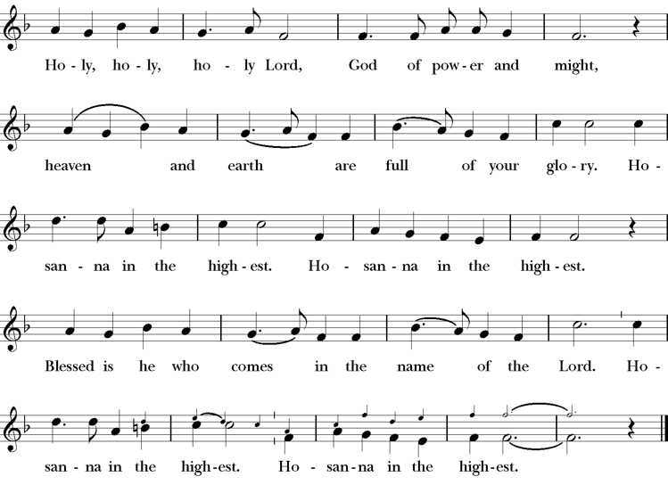
Presider Holy and gracious Father: In your infinite love you made us for yourself; and, when we had fallen into sin and become subject to evil and death, you, in your mercy, sent Jesus Christ, your only and eternal Son, to share our human nature, to live and die as one of us, to reconcile us to you, the God and Father of all.
He stretched out his arms upon the cross, and offered himself, in obedience to your will, a perfect sacrifice for the whole world.
On the night he was handed over to suffering and death, our Lord Jesus Christ took bread; and when he had given thanks to you, he broke it, and gave it to his disciples, and said, “Take, eat: This is my Body, which is given for you. Do this for the remembrance of me”
After supper he took the cup of wine; and when he had given thanks, he gave it to them, saying, “Drink this, all of you: this is my blood of the new covenant which is shed for you and for many for the forgiveness of sins. Whenever you drink it, do this for the remembrance of me.”
Presider Therefore we proclaim the mystery of faith:.
People Christ has died; Christ is risen; Christ will come again.
Presider We celebrate the memorial of our redemption, O Father, in this sacrifice of praise and thanksgiving. Recalling his death, resurrection, and ascension, we offer you these gifts.
Sanctify them by your Holy Spirit to be for your people the Body and Blood of your Son, the holy food and drink of new and unending life in him. Sanctify us also that we may faithfully receive this holy Sacrament, and serve you in unity, constancy, and peace; and at last day bring us with all your saints into the joy of your eternal kingdom.
All this we ask through your Son Jesus Christ. By him, and with him, and in him, in the unity of the Holy Spirit all honor and glory is yours, Almighty Father, now and for ever.
Amen.
The Lord’s Prayer
Presider As our Savior has taught us, we are bold to pray.
People Our Father, who art in heaven, hallowed be thy name. Thy Kingdom come, thy will be done, on earth as it is in heaven. Give us this day our daily bread. And forgive us our trespasses, as we forgive those who trespass against us. And lead us not into temptation, but deliver us from evil. For thine is the kingdom, the power and the glory, for ever and ever. Amen.

The Breaking of the Bread
The Presider breaks the consecrated bread in view of the assembly.
Presider The Gifts of God for the people of God.
People Therefore let us keep the feast. Alleluia

Invitation to Communion
Presider Come to this table you who have been here often and you who have not been here in a long time. Come, you who have tried to follow Jesus and you who have failed. You who are full of faith and full of doubt. Come, it is Christ himself who invites you to meet him here.
Sharing the Sacred Meal
This is Christ’s table and all are welcome and all are fed.
Communion Music Now the Silence H 333
Post-Communion Prayer BCP 365
The Blessing
The Recessional Hymn All Creatures of our God and King H 400
The Dismissal*
Celebrant | Let us go forth in the name of Christ.
People | Thanks be to God.
Postlude Steve Rubardt Please remain seated


SERVING TODAY
Celebrant & Preacher: Pastor Cindy Beck
Acolyte: Claire Ginesi
Lector: Lorena Reinhardt , Bill Doyle
Intercessor: Ann Kyser
Worship Musician: Steve Rubardt
Choir Leader: Steve Rubardt
Choir: Liz Carpenter, Heather Dahlberg, Scott Sherman, Patsy Gralow, Laurell Meredith, Mary Omodt, Barbara Feduska, Tara Anderson, Carol Heffer, Don McMahon
Sunday School - Child Care: Wendy Aguilar Appt Only
Ushers: John Addeo
Tech Chaplain: Marcos Rendon
Altar Guild: Ann Kyser
Hospitality : Tara Anderson , Matt Dahlberg
Altar Flowers are given to the glory of God by Altar Guild.
Prayers requested for these on Trinity’s long-term prayer list: Armando P, Georgia Bostedt, John Eiler, Gerrilee Fisher, Claire Ginesi, Mary Griffin, David & Christine Hilt, Mark Mezzetta, Kelcey Omodt, Grizelda Ponce, Barry Reap, Blake W, Robert R, Melissa White, Ann Loveland Sherman, James Thomas, Rose Burns, Jennifer Gralow, Patsy Gralow, Steve Antenen, Sandra Leland, Karl, Michael Hardy, Michael Bean Land, Polly Moore, Sinat Liv, Will Maushardt, Sophia Piconi, Mike Smith, Jean Maffoli.
Prayers for the Repose of soul: Tim Dowd , Susan Bassett, Joan Biersch, Linda Dowd, Christina Van Krugel, Mere Nagasau, Mary Goshert, Peggy Bell, Carolyn Caldwell, Van Z, Dolores Mae Seaberg Cole, Muff Davey.
Contact Pastoral Care Chair, Lorena lorena.m.reinhardt@gmail.com to make any additions or to remove names from our Long-Term Prayer list.
Notes on the Service Bulletin This service bulletin is a guide to the service. We use a variety of printed materials for the prayers, the scriptural readings and the hymns. The Readings for the week, including the Collect and Readings are found in this Bulletin. The service follows the liturgies that are found in the Book of Common Prayer (BCP). The BCP is the blue book found in the pew in front of you. The hymns come primarily from The 1982 Hymnal, also in the pew – the red book. Lift Every Voice and Sing (LEVAS) is another hymnal located in the pew rack. VF stands for Voices Found, another authorized hymnal. Sound Mate Assisted Hearing devices available at the back of the church on the Narthex Table.
Trinity Liturgical Ministry ROTA Next two weeks
Date | Celebrant | Ushers | Acolyte | Lector (s) | Intercessor | Altar Guild
9/6 | Cindy Beck | John Addeo | Susie Hand | Lorena Reinhardt , Bill Doyle | Alfred Escoffier | Susie Hand
9/13 | Cindy Beck | Marcia Derby | Claire Ginesi | Barbara Feduska , Gerrilee Fischer | Jane Hernandez | Marcia Derby , Mary Omodt
Schedule of Weekly Meetings and Services at Trinity Episcopal Sonoma
Day | Date | Time | Occasion | Location
Wednesday | August 26 | 11 AM | Bible Study | Library
Thursday | August 27 | 10:30 AM  5:30 PM | Mindfulness & Well Being  Alcoholics Anonymous | Library  Buttrum Hall
Saturday | August 29 | 8 AM | Centering Prayer | St. Luke’s Chapel
Sunday | August 30 | 10:00 AM | Holy Eucharist II | Sanctuary
Mon-Fri | Weekdays | 7AM-1PM | Sonoma Home Meals | Kitchen &Buttrum Hall
Mon-Fri | Weekdays | 9-2 | Sonoma Preschool Academy – School

Monthly Meetings at Trinity Episcopal Sonoma
Day | Date | Time | Meeting | Location | Contact
Tuesday | August 4 | 11 AM | Prayer Shawl Ministry | Library | Lorena Reinhardt lorena.m.reinhardt@gmail.com
Thursday | TBD | TBD | Vestry | Library | Cindy Beck 916-955-9861

PRAYERS and BLESSINGS
For a Birthday
Watch over your child, O Lord as his/her days increase; bless and guide him/her wherever s/he may be. Strengthen them when s/he stands; comfort him/her when discouraged or sorrowful; raise him/her up if s/he fall; and in his/her heart may your peace which passes understanding abide all the days of his/her life; through Jesus Christ our Lord. Amen.
For an Anniversary
O God, you have so consecrated the covenant of marriage that it represents the spiritual unity between Christ and his Church: Send your blessing upon these your servants as they celebrate their anniversary, that they may continue to love, honor and cherish each other in faithfulness and patience, in wisdom and true godliness, that their home may be a haven of blessing and peace; through Jesus Christ our Lord, who lives and reigns with you and the Holy Spirit, one God, now and forever. Amen.
For Travelers
O God, our heavenly Father, whose glory fills the whole creation, and whose presence we find wherever we go; preserve those who travel; surround them with your loving care; protect them from every danger, and bring them in safety to their journey’s end; through Jesus Christ our Lord. Amen.
Sending our Eucharistic Visitors
Priest: In the name of this congregation, I send you forth bearing these holy gifts, the those to whom you go may share with us in the communion of Christ’s body and blood.
People: We who are many are one body, because we all share on bread, and one cup. Amen.
Trinity Episcopal Church
In Sonoma for over 170 years
275 East Spain Street
Sonoma, CA 95476
The Rt. Rev. Megan M. Traquair, Bishop
Diocese of Northern California
Pastor Cindy Beck, Interim
Steve Rubardt, Worship Music
Vestry
Bill Doyle, Senior Warden & Stewardship
Susie Hand
Heather Dahlberg
Sally Zimmerman
Lorena Reinhardt (Pastoral Care)
Luke Bohanan
Mandy Birkbeck
Ministries
Prayer Shawl, Lorena Reinhardt
Outreach, Jane Hernandez
Mindfulness & Well Being, Mary Omodt
Sunday School, Children, Wendy Aguilar

The Members of the Congregation are The Ministers of the Church

Administrative Office Hrs.
Monday Wednesday 9 A.M. – 2 PM; Thursday 10A.M.-2 P.M0
Sunday 9:30-11:30
Clergy Office Hours Wednesdays, Thursdays, by appointment

Emergency, sickness, please contact office: 707-938-4846

