Trinity Episcopal Church
Cultivating God’s Loving Spirit in each of us
Proper 18
Year A
Holy Eucharist II
September 6, 2026
10:00 AM In person and Online

Welcome to Trinity Episcopal, Sonoma. Whether you are passing through or looking for a church home, we are blessed by your presence and we invite you to worship with us fully – singing, praying and receiving communion- with your voice and heart. Please sign our guestbook at the back of the church, including your email.
If you would like to learn more about The Episcopal Church, please send us an email trinityepiscopalsonoma@comcast.net. We look forward to meeting you after the service where coffee and treats are served.
Did you know that....
...24% of Seniors 65+ in Sonoma County live alone?
...That the Council on Aging has a Senior Peer Support program that matches volunteers to do home visits with Srs?
...That you can be one of the volunteers that visits older adults? Ask Pastor Cindy about it.

All are welcome to make a gift and offering in thanksgiving to God; for the many blessings we have received. To take advantage of our electronic giving options, please follow the QR code with your capable electronic device, or visit https://onrealm.org/trinitysonoma/-/form/give/default
September Announcements
Fellowship Coffee Hour Sign up – Fellowship follows the service! We meet in the hall or courtyard. We’d love to visit with you.
Thank you to everyone who donated food for A Simple Gesture, your gift helps people have a meal! Our next pick up will be on September 12th!
Movie Night at Trinity will continue on Wednesday Sept 16th. Join us for “Legally Blonde”, at 6PM in Buttram Hall. Stay for the snacks and post film discussion.
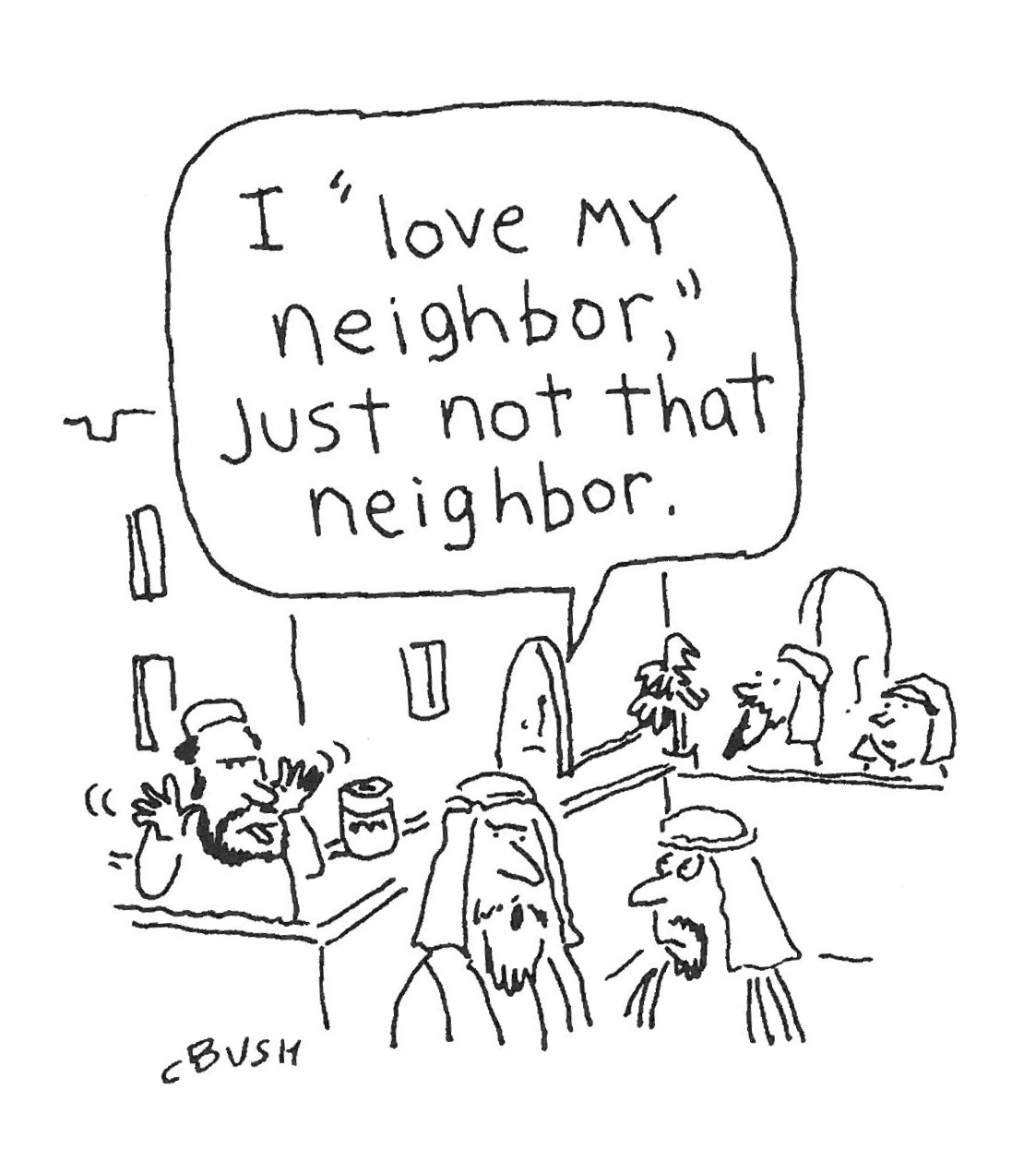
Prelude Steve Rubardt
Please stand for the Entrance Hymn.
At the sound of the bell, please stand as you are able. The People respond when bold text appears.
The Word of God
Entrance Hymn Come with us, O Bless’d Jesus H 336
Opening Acclamation BCP 319
Celebrant | Blessed be God: Father, Son, and Holy Spirit.
People | And blessed be his kingdom, now and for ever. Amen.
Collect for Purity
All Almighty God, to you all hearts are open, all desires known, and from you no secrets are hid: Cleanse the thoughts of our hearts by the inspiration of your Holy Spirit, that we may perfectly love you, and worthily magnify your holy Name; through Christ our Lord. Amen.
Song of Praise Glory to God Hymn S-280 is sung, all standing
Glory to God in the highest,
and peace to his people on earth.
Lord God, heavenly King,
almighty God and Father,
we worship you, we give you thanks,
we praise you for your glory.
Lord Jesus Christ, only Son of the Father,
Lord God, Lamb of God,
you take away the sin of the world:
have mercy on us;
you are seated at the right hand of the Father:
receive our prayer.
For you alone are the Holy One,
you alone are the Lord,
you alone are the Most High,
Jesus Christ,
with the Holy Spirit,
in the glory of God the Father. Amen.
The Collect of the Day BCP 357
Celebrant | The Lord be with you.
People | And also with you.
Celebrant | Let us pray.
Grant us, O Lord, to trust in you with all our hearts; for, as you always resist the proud who confide in their own strength, so you never forsake those who make their boast of your mercy; through Jesus Christ our Lord, who lives and reigns with you and the Holy Spirit, one God, now and for ever.
All Amen.
The Lessons
First Reading: Ezekiel 33:7-11
Reader A Reading from the book of Ezekiel.
⁷So you, mortal, I have made a sentinel for the house of Israel; whenever you hear a word from my mouth, you shall give them warning from me. ⁸If I say to the wicked, “O wicked ones, you shall surely die,” and you do not speak to warn the wicked to turn from their ways, the wicked shall die in their iniquity, but their blood I will require at your hand. ⁹But if you warn the wicked to turn from their ways, and they do not turn from their ways, the wicked shall die in their iniquity, but you will have saved your life.
¹⁰Now you, mortal, say to the house of Israel, Thus you have said: “Our transgressions and our sins weigh upon us, and we waste away because of them; how then can we live?” ¹¹Say to them, “As I live, says the Lord God, I have no pleasure in the death of the wicked, but that the wicked turn from their ways and live; turn back, turn back from your evil ways; for why will you die, O house of Israel?”

Reader | The Word of the Lord.
People | Thanks be to God.
The Psalm: Psalm 119:33-40
Reader We will read Psalm 119:33-40, which we will read responsively by half verse.
³³Teach me, O Lord, the way of your statutes, *
and I shall keep it to the end.
³⁴Give me understanding, and I shall keep your law; *
I shall keep it with all my heart.
³⁵Make me go in the path of your commandments, *
for that is my desire.
³⁶Incline my heart to your decrees *
and not to unjust gain.
³⁷Turn my eyes from watching what is worthless; *
give me life in your ways.
³⁸Fulfill your promise to your servant, *
which you make to those who fear you.
³⁹Turn away the reproach which I dread, *
because your judgments are good.
⁴⁰Behold, I long for your commandments; *
in your righteousness preserve my life.
Second Reading: Romans 13:8-14
Reader A Reading from Paul's letter to the Church in Rome.
⁸Owe no one anything, except to love one another; for the one who loves another has fulfilled the law. ⁹The commandments, “You shall not commit adultery; You shall not murder; You shall not steal; You shall not covet”; and any other commandment, are summed up in this word, “Love your neighbor as yourself.” ¹⁰Love does no wrong to a neighbor; therefore, love is the fulfilling of the law.
¹¹Besides this, you know what time it is, how it is now the moment for you to wake from sleep. For salvation is nearer to us now than when we became believers; ¹²the night is far gone, the day is near. Let us then lay aside the works of darkness and put on the armor of light; ¹³let us live honorably as in the day, not in reveling and drunkenness, not in debauchery and licentiousness, not in quarreling and jealousy. ¹⁴Instead, put on the Lord Jesus Christ, and make no provision for the flesh, to gratify its desires.
Reader | The Word of the Lord.
People | Thanks be to God.

Sequence Hymn What Wondrous Love Is This H 439 v 1 & 2
The Holy Gospel: Matthew 18:15-20
Celebrant | The Holy Gospel of our Lord Jesus Christ according to Matthew.
People | Glory to you, Lord Christ.
[Jesus said,] ¹⁵“If another member of the church sins against you, go and point out the fault when the two of you are alone. If the member listens to you, you have regained that one. ¹⁶But if you are not listened to, take one or two others along with you, so that every word may be confirmed by the evidence of two or three witnesses. ¹⁷If the member refuses to listen to them, tell it to the church; and if the offender refuses to listen even to the church, let such a one be to you as a Gentile and a tax collector. ¹⁸Truly I tell you, whatever you bind on earth will be bound in heaven, and whatever you loose on earth will be loosed in heaven. ¹⁹Again, truly I tell you, if two of you agree on earth about anything you ask, it will be done for you by my Father in heaven. ²⁰For where two or three are gathered in my name, I am there among them.”
Celebrant | The Gospel of the Lord.
People | Praise to you, Lord Christ.
Sequence Hymn What Wondrous Love Is This H 439 v 3
Sermon Pastor Cindy Beck
The Nicene Creed (BCP p. 358)
We believe in one God, the Father, the Almighty, maker of heaven and earth, of all that is, seen and unseen.
We believe in one Lord, Jesus Christ, the only Son of God, eternally begotten of the Father, God from God, Light from Light, true God from true God, begotten, not made, of one Being with the Father. Through him all things were made. For us and for our salvation he came down from heaven: by the Power of the Holy Spirit he became incarnate from the Virgin Mary, and was made man. For our sake he was crucified under Pontius Pilate; he suffered death and was buried. On the third day he rose again in accordance with the Scriptures; he ascended into heaven and is seated at the right hand of the Father. He will come again in glory to judge the living and the dead, and his kingdom will have no end.
We believe in the Holy Spirit, the Lord, the giver of life, who proceeds from the Father and the Son. With the Father and the Son he is worshipped and glorified. He has spoken through the Prophets. We believe in one holy catholic and apostolic Church. We acknowledge one baptism for the forgiveness of sins. We look for the resurrection of the dead, and the life of the world to come. Amen.

The Prayers of the People
Celebrant: Let us pray for the Church and the world, saying “Hear our prayer.”
Intercessor: At this time of changing seasons, we thank you, O Lord, for the beauty of our earth.
Hear our prayer.
We pray for the Church in all times and places. Strengthen our faith as we seek to do your will and become more and more your people.
In the Diocesan Cycle of Prayer, we pray for St Clément’s in Rancho Cordova.
In the Anglican Cycle of Prayer, we pray for The Episcopal Province of Alexandria.
Hear our prayer.
Guide the leaders of our land: N., our President, N., our Governor, N., our Mayor, that we may be a people at peace among ourselves and a blessing to other nations of the earth.
Silence
Hear our prayer.
Guide the people of this land so to use our public and private wealth that all may find suitable and fulfilling employment, and receive just payment for their labor, +_________________.
Invite the congregation to add their thanksgivings, followed by silence
Hear our prayer.
Grant that barriers which divide us may crumble, suspicions disappear, and hatreds cease; that we may live in justice and peace.
Silence
Hear our prayer.
O God, the strength of those who labor, grant that we may never forget that our common life depends upon each other’s toil.
Silence
Hear our prayer.
Remember, O Lord, in mercy all those who suffer or are in any trouble, knowing that you do not willingly afflict or grieve us, +______________.
Invite the congregation to add their petitions, followed by silence
Hear our prayer.
Grant your blessing to all who have died in the hope of resurrection; grant them rest from their labors, +___________________.
Invite the congregation to add their petitions, followed by silence
Hear our prayer.
I invite any other prayers of intercession or thanksgiving, silently or aloud.
Hear our prayer.
Celebrant Almighty and eternal God, ruler of all things in heaven and earth: Mercifully accept the prayers of your people, and strengthen us to do your will; through Jesus Christ our Lord.
Amen.
Confession of Sin BCP 359
Most merciful God, we confess that we have sinned against you in thought, word and deed, by what we have done, and by what we have left undone.
We have not loved you with our whole heart; we have not loved our neighbors as ourselves. We are truly sorry and we humbly repent.
For the sake of your Son Jesus Christ, have mercy on us and forgive us; that we may delight in your will, and walk in your ways, to the glory of your Name. Amen.
The Peace
Celebrant The peace of the Lord be always with you.
People And also with you.
Announcements
Birthdays, Anniversaries, Travelers (prayers found at back of bulletin)
The Holy Communion
The Offertory At the Offering, you’ll find a Pledge card in the Pew Rack for those who’d like to designate their financial donations to Trinity’s Pledging Income. For others, or a one-time gift, envelopes are in the pew racks as well as on the Narthex table or text TRINITYSONOMA" to 73256. Thank you!
Offertory Music
Steve Rubardt and Choir Lift Every Voice LEVAS 1
Doxology
Praise God, from whom all blessings flow;
Praise Him, all creatures here below;
Praise Him above, ye heav'nly host;
Praise Father, Son, and Holy Ghost.
Amen.
The people stand while the offerings are presented and placed on the Altar.
Presider: Gracious God, as an offering of our thanksgiving and gratitude, we return to you a portion of what you have gifted us.
The Great Thanksgiving
Eucharistic Prayer B BCP 367
Celebrant | The Lord be with you.
People | And also with you.
Celebrant | Lift up your hearts.
People | We lift them to the Lord.
Celebrant | Let us give thanks to the Lord our God.
People | It is right to give him thanks and praise.
Proper Preface (BCP p. 367)
It is right, and a good and joyful thing, always and everywhere to give thanks to you, Father Almighty, Creator of heaven and earth.
For you are the source of light and life; you made us in your image, and called us to new life in Jesus Christ our Lord.
Therefore we praise you, joining our voices with Angels and Archangels and with all the company of heaven, who for ever sing this hymn to proclaim the glory of your Name:
Sanctus Holy Holy, Holy (Proulx) Hymnal S-125
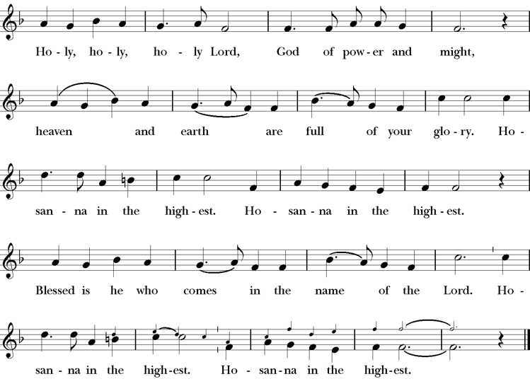
Presider Holy and gracious Father: In your infinite love you made us for yourself; and, when we had fallen into sin and become subject to evil and death, you, in your mercy, sent Jesus Christ, your only and eternal Son, to share our human nature, to live and die as one of us, to reconcile us to you, the God and Father of all.
He stretched out his arms upon the cross, and offered himself, in obedience to your will, a perfect sacrifice for the whole world.
On the night he was handed over to suffering and death, our Lord Jesus Christ took bread; and when he had given thanks to you, he broke it, and gave it to his disciples, and said, “Take, eat: This is my Body, which is given for you. Do this for the remembrance of me”
After supper he took the cup of wine; and when he had given thanks, he gave it to them, saying, “Drink this, all of you: this is my blood of the new covenant which is shed for you and for many for the forgiveness of sins. Whenever you drink it, do this for the remembrance of me.”
Presider Therefore we proclaim the mystery of faith:.
People Christ has died; Christ is risen; Christ will come again.
Presider We celebrate the memorial of our redemption, O Father, in this sacrifice of praise and thanksgiving. Recalling his death, resurrection, and ascension, we offer you these gifts.
Sanctify them by your Holy Spirit to be for your people the Body and Blood of your Son, the holy food and drink of new and unending life in him. Sanctify us also that we may faithfully receive this holy Sacrament, and serve you in unity, constancy, and peace; and at last day bring us with all your saints into the joy of your eternal kingdom.
All this we ask through your Son Jesus Christ. By him, and with him, and in him, in the unity of the Holy Spirit all honor and glory is yours, Almighty Father, now and for ever.
Amen.
The Lord’s Prayer
Presider As our Savior has taught us, we are bold to pray.
People Our Father, who art in heaven, hallowed be thy name. Thy Kingdom come, thy will be done, on earth as it is in heaven. Give us this day our daily bread. And forgive us our trespasses, as we forgive those who trespass against us. And lead us not into temptation, but deliver us from evil. For thine is the kingdom, the power and the glory, for ever and ever. Amen.

The Breaking of the Bread
The Presider breaks the consecrated bread in view of the assembly.
Presider The Gifts of God for the people of God.
People Therefore let us keep the feast. Alleluia

Invitation to Communion
Presider Come to this table you who have been here often and you who have not been here in a long time. Come, you who have tried to follow Jesus and you who have failed. You who are full of faith and full of doubt. Come, it is Christ himself who invites you to meet him here.
Sharing the Sacred Meal
This is Christ’s table and all are welcome and all are fed.
Communion Music Ave Verum
Post-Communion Prayer BCP 365
The Blessing
The Recessional Hymn Great is Thy Faithfulness LEVAS 189
The Dismissal*
Celebrant | Let us go forth in the name of Christ.
People | Thanks be to God.
Postlude Steve Rubardt Please remain seated

SERVING TODAY
Celebrant & Preacher: Pastor Cindy Beck
Acolyte: Susie Hand
Lector: Lorena Reinhardt , Jane Hernandez
Intercessor: Alfred Escoffier
Worship Musician: Steve Rubardt
Choir Leader: Steve Rubardt
Choir: Liz Carpenter, Heather Dahlberg, Scott Sherman, Patsy Gralow, Laurell Meredith, Mary Omodt, Barbara Feduska, Tara Anderson, Carol Heffer, Don McMahon
Sunday School - Child Care: Wendy Aguilar Appt Only
Ushers: John Addeo
Tech Chaplain: Marcos Rendon
Altar Guild: Susie Hand
Hospitality : Alfred Escoffier , Patsy Gralow
Altar Flowers are given to the glory of God by Altar Guild.

Prayers requested for these on Trinity’s long-term prayer list: Armando P, Georgia Bostedt, John Eiler, Gerrilee Fisher, Claire Ginesi, Mary Griffin, David & Christine Hilt, Mark Mezzetta, Kelcey Omodt, Grizelda Ponce, Barry Reap, Blake W, Robert R, Melissa White, Ann Loveland Sherman, James Thomas, Rose Burns, Jennifer Gralow, Patsy Gralow, Steve Antenen, Sandra Leland, Karl, Michael Hardy, Michael Bean Land, Polly Moore, Sinat Liv, Will Maushardt, Sophia Piconi, Mike Smith, Jean Maffoli.
Prayers for the Repose of soul: Tim Dowd , Susan Bassett, Joan Biersch, Linda Dowd, Christina Van Krugel, Mere Nagasau, Mary Goshert, Peggy Bell, Carolyn Caldwell, Van Z, Dolores Mae Seaberg Cole, Muff Davey.
Contact Pastoral Care Chair, Lorena lorena.m.reinhardt@gmail.com to make any additions or to remove names from our Long-Term Prayer list.
Notes on the Service Bulletin This service bulletin is a guide to the service. We use a variety of printed materials for the prayers, the scriptural readings and the hymns. The Readings for the week, including the Collect and Readings are found in this Bulletin. The service follows the liturgies that are found in the Book of Common Prayer (BCP). The BCP is the blue book found in the pew in front of you. The hymns come primarily from The 1982 Hymnal, also in the pew – the red book. Lift Every Voice and Sing (LEVAS) is another hymnal located in the pew rack. VF stands for Voices Found, another authorized hymnal. Sound Mate Assisted Hearing devices available at the back of the church on the Narthex Table.

Trinity Liturgical Ministry ROTA Next two weeks
Date | Celebrant | Ushers | Acolyte | Lector (s) | Intercessor | Altar Guild
9/13 | Cindy Beck | Marcia Derby | Claire Ginesi | Barbara Feduska , Gerrilee Fischer | Alfred Escoffier | Marcia Derby , Mary Omodt
9/20 | TBD | Alfred Escoffier | Susie Hand | Claire Ginesi , Lorena Reinhardt | Bill Doyle | Laurell Meredith , Liz Carpenter
Schedule of Weekly Meetings and Services at Trinity Episcopal Sonoma
Day | Date | Time | Occasion | Location
Wednesday | September 9 | 11 AM | Bible Study | Library
Thursday | September 10 | 10:30 AM  5:30 PM | Mindfulness & Well Being  Alcoholics Anonymous | Library  Buttrum Hall
Saturday | September 12 | 8 AM | Centering Prayer | St. Luke’s Chapel
Sunday | September 13 | 10:00 AM | Holy Eucharist II | Sanctuary
Mon-Fri | Weekdays | 7AM-1PM | Sonoma Home Meals | Kitchen &Buttrum Hall
Mon-Fri | Weekdays | 9-2 | Sonoma Preschool Academy – School

Monthly Meetings at Trinity Episcopal Sonoma
Day | Date | Time | Meeting | Location | Contact
Tuesday | September 1 | 11 AM | Prayer Shawl Ministry | Library | Lorena Reinhardt lorena.m.reinhardt@gmail.com
Thursday | TBD | TBD | Vestry | Library | Cindy Beck 916-955-9861



PRAYERS and BLESSINGS
For a Birthday
Watch over your child, O Lord as his/her days increase; bless and guide him/her wherever s/he may be. Strengthen them when s/he stands; comfort him/her when discouraged or sorrowful; raise him/her up if s/he fall; and in his/her heart may your peace which passes understanding abide all the days of his/her life; through Jesus Christ our Lord. Amen.
For an Anniversary
O God, you have so consecrated the covenant of marriage that it represents the spiritual unity between Christ and his Church: Send your blessing upon these your servants as they celebrate their anniversary, that they may continue to love, honor and cherish each other in faithfulness and patience, in wisdom and true godliness, that their home may be a haven of blessing and peace; through Jesus Christ our Lord, who lives and reigns with you and the Holy Spirit, one God, now and forever. Amen.
For Travelers
O God, our heavenly Father, whose glory fills the whole creation, and whose presence we find wherever we go; preserve those who travel; surround them with your loving care; protect them from every danger, and bring them in safety to their journey’s end; through Jesus Christ our Lord. Amen.
Sending our Eucharistic Visitors
Priest: In the name of this congregation, I send you forth bearing these holy gifts, the those to whom you go may share with us in the communion of Christ’s body and blood.
People: We who are many are one body, because we all share on bread, and one cup. Amen.
Trinity Episcopal Church
In Sonoma for over 170 years
275 East Spain Street
Sonoma, CA 95476
The Rt. Rev. Megan M. Traquair, Bishop
Diocese of Northern California
Pastor Cindy Beck, Interim
Steve Rubardt, Worship Music
Vestry
Bill Doyle, Senior Warden & Stewardship
Susie Hand
Heather Dahlberg
Sally Zimmerman
Lorena Reinhardt (Pastoral Care)
Luke Bohanan
Mandy Birkbeck
Ministries
Prayer Shawl, Lorena Reinhardt
Outreach, Jane Hernandez
Mindfulness & Well Being, Mary Omodt
Sunday School, Children, Wendy Aguilar

The Members of the Congregation are The Ministers of the Church

Administrative Office Hrs.
Monday Wednesday 9 A.M. – 2 PM; Thursday 10A.M.-2 P.M0
Sunday 9:30-11:30
Clergy Office Hours Wednesdays, Thursdays, by appointment

Emergency, sickness, please contact office: 707-938-4846

