Trinity Episcopal Church
In Sonoma for over 170 years

Proper 7
Year A
Holy Eucharist II
June 21, 2026
10:00 AM In person and Online
Welcome to Trinity Episcopal, Sonoma. Whether you are passing through or looking for a church home, we are blessed by your presence and we invite you to worship with us fully – singing, praying and receiving communion- with your voice and heart. Please sign our guestbook at the back of the church, including your email.
If you would like to learn more about The Episcopal Church, please send us an email trinityepiscopalsonoma@comcast.net. We look forward to meeting you after the service where coffee and treats are served.
Did you know that...
...our worship space is open Monday, Wednesday and Thursdays from 10 - 3 for the public to pray, rest, contemplate, or whatever spiritual needs they have?
...Centering Prayer is an ancient Christian contemplative practice designed to deepen one's relationship with God. Practitioners quietly focus on God's presence within and surrounding them and with an open receptivity to the activity of the Holy Spirit. Explore this spiritual discipline Saturday mornings at 8AM in the chapel within the church.
…That the benches around the labyrinth intended for visitors to enjoy relaxing and meditating have been secured by John Addeo to avoid tipping. Thank you!
…We have children’s bags at the back of the church for parents to use with their children during worship?
To access Trinity’s Guest WIFI: Password Rosepettal441 (case sensitive). We are glad you are here, and we invite you to enter fully into worship this morning. 
All are welcome to make a gift and offering in thanksgiving to God; for the many blessings we have received. To take advantage of our electronic giving options, please follow the QR code with your capable electronic device, or visit https://onrealm.org/trinitysonoma/-/form/give/default
June Announcements
Fellowship Coffee Hour Sign up – Fellowship follows the service! We meet in the hall or courtyard. We’d love to visit with you.
Movie Night at Trinity will be postponed for two months due to summer, it will return in September with Legally Blonde.
The May, June, July Forward Day by Day , a booklet of daily inspirational meditations is available in the Church and the Office.
Lectio Divina Bible Study is on Wednesday, at 11AM in the library. Lectio Divina, is a contemplative practice of scriptural reading, meditation, and prayer. intended to promote communion with God. This type of study emphasizes spiritual formation and personal intimacy with God.
Saturday July 18th, there will be a Congregational Conversation in Buttram Hall at 10AM. This conversation will be used to help move the Congregation forward in discussing current events.
A simple Gesture next pick up date will be on July 11th. Check expiration dates on your items and please no glass containers!!
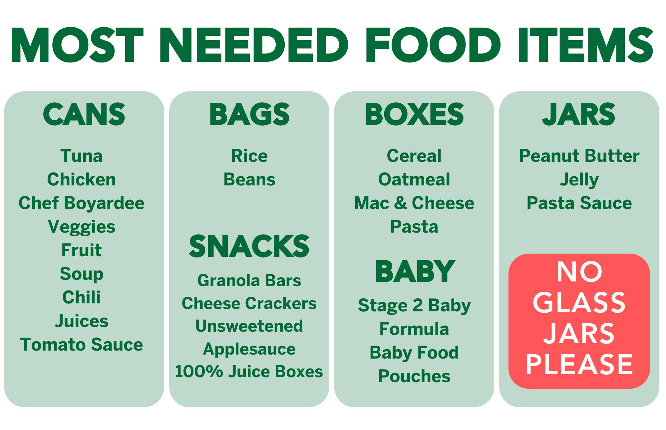
Prelude Steve Rubardt
Please stand for the Entrance Hymn.
At the sound of the bell, please stand as you are able. The People respond when bold text appears.
The Word of God
Entrance Hymn Christ For The World We Sing H 537
Opening Acclamation BCP 319
Celebrant | Blessed be God: Father, Son, and Holy Spirit.
People | And blessed be his kingdom, now and for ever. Amen.
Collect for Purity
All Almighty God, to you all hearts are open, all desires known, and from you no secrets are hid: Cleanse the thoughts of our hearts by the inspiration of your Holy Spirit, that we may perfectly love you, and worthily magnify your holy Name; through Christ our Lord. Amen.
Song of Praise Glory to God Hymn S-280 is sung, all standing
Glory to God in the highest,
and peace to his people on earth.
Lord God, heavenly King,
almighty God and Father,
we worship you, we give you thanks,
we praise you for your glory.
Lord Jesus Christ, only Son of the Father,
Lord God, Lamb of God,
you take away the sin of the world:
have mercy on us;
you are seated at the right hand of the Father:
receive our prayer.
For you alone are the Holy One,
you alone are the Lord,
you alone are the Most High,
Jesus Christ,
with the Holy Spirit,
in the glory of God the Father. Amen.
The Collect of the Day BCP 357
Celebrant | The Lord be with you.
People | And also with you.
Celebrant | Let us pray.
O Lord, make us have perpetual love and reverence for your holy Name, for you never fail to help and govern those whom you have set upon the sure foundation of your loving-kindness; through Jesus Christ our Lord, who lives and reigns with you and the Holy Spirit, one God, for ever and ever.
All Amen.
The Lessons
First Reading: Jeremiah 20:7-13
Reader A Reading from the book of Jeremiah.
⁷O Lord, you have enticed me,
and I was enticed;
you have overpowered me,
and you have prevailed.
I have become a laughingstock all day long;
everyone mocks me.
⁸For whenever I speak, I must cry out,
I must shout, “Violence and destruction!”
For the word of the Lord has become for me
a reproach and derision all day long.
⁹If I say, “I will not mention him,
or speak any more in his name,”
then within me there is something like a burning fire
shut up in my bones;
I am weary with holding it in,
and I cannot.
¹⁰For I hear many whispering:
“Terror is all around!
Denounce him! Let us denounce him!”
All my close friends
are watching for me to stumble.
“Perhaps he can be enticed,
and we can prevail against him,
and take our revenge on him.”
¹¹But the Lord is with me like a dread warrior;
therefore my persecutors will stumble,
and they will not prevail.
They will be greatly shamed,
for they will not succeed.
Their eternal dishonor
will never be forgotten.
¹²O Lord of hosts, you test the righteous,
you see the heart and the mind;
let me see your retribution upon them,
for to you I have committed my cause.
¹³Sing to the Lord;
praise the Lord!
For he has delivered the life of the needy
from the hands of evildoers.
Reader | The Word of the Lord.
People | Thanks be to God.
The Psalm: Psalm 69:8-11 [12-17] 18-20
Reader Our response to the reading is Psalm 69:8-11 [12-17] 18-20, which we will read responsively by half verse.
⁸Surely, for your sake have I suffered reproach, *
and shame has covered my face.
⁹I have become a stranger to my own kindred, *
an alien to my mother’s children.
¹⁰Zeal for your house has eaten me up; *
the scorn of those who scorn you has fallen upon me.
¹¹I humbled myself with fasting, *
but that was turned to my reproach.
[ ¹²I put on sack-cloth also, *
and became a byword among them.
¹³Those who sit at the gate murmur against me, *
and the drunkards make songs about me.
¹⁴But as for me, this is my prayer to you, *
at the time you have set, O Lord:
¹⁵“In your great mercy, O God, *
answer me with your unfailing help.
¹⁶Save me from the mire; do not let me sink; *
let me be rescued from those who hate me
and out of the deep waters.
¹⁷Let not the torrent of waters wash over me,
neither let the deep swallow me up; *
do not let the Pit shut its mouth upon me.
] ¹⁸Answer me, O Lord, for your love is kind; *
in your great compassion, turn to me.”
¹⁹Hide not your face from your servant; *
be swift and answer me, for I am in distress.
²⁰Draw near to me and redeem me; *
because of my enemies deliver me.”
Second Reading: Romans 6:1b-11
Reader A Reading from Paul's letter to the Church in Rome.
^{1b}Should we continue in sin in order that grace may abound? ²By no means! How can we who died to sin go on living in it? ³Do you not know that all of us who have been baptized into Christ Jesus were baptized into his death? ⁴Therefore we have been buried with him by baptism into death, so that, just as Christ was raised from the dead by the glory of the Father, so we too might walk in newness of life.
⁵For if we have been united with him in a death like his, we will certainly be united with him in a resurrection like his. ⁶We know that our old self was crucified with him so that the body of sin might be destroyed, and we might no longer be enslaved to sin. ⁷For whoever has died is freed from sin. ⁸But if we have died with Christ, we believe that we will also live with him. ⁹We know that Christ, being raised from the dead, will never die again; death no longer has dominion over him. ¹⁰The death he died, he died to sin, once for all; but the life he lives, he lives to God. ¹¹So you also must consider yourselves dead to sin and alive to God in Christ Jesus.
Reader | The Word of the Lord.
People | Thanks be to God.

Sequence Hymn If Thou But Trust H 635 v 1
The Holy Gospel: Matthew 10:24-39
Celebrant | The Holy Gospel of our Lord Jesus Christ according to Matthew.
People | Glory to you, Lord Christ.
[Jesus said to the twelve apostles,] ²⁴“A disciple is not above the teacher, nor a slave above the master; ²⁵it is enough for the disciple to be like the teacher, and the slave like the master. If they have called the master of the house Beelzebul, how much more will they malign those of his household!
²⁶“So have no fear of them; for nothing is covered up that will not be uncovered, and nothing secret that will not become known. ²⁷What I say to you in the dark, tell in the light; and what you hear whispered, proclaim from the housetops. ²⁸Do not fear those who kill the body but cannot kill the soul; rather fear him who can destroy both soul and body in hell. ²⁹Are not two sparrows sold for a penny? Yet not one of them will fall to the ground apart from your Father. ³⁰And even the hairs of your head are all counted. ³¹So do not be afraid; you are of more value than many sparrows.
³²“Everyone therefore who acknowledges me before others, I also will acknowledge before my Father in heaven; ³³but whoever denies me before others, I also will deny before my Father in heaven.
³⁴“Do not think that I have come to bring peace to the earth; I have not come to bring peace, but a sword.
³⁵For I have come to set a man against his father,
and a daughter against her mother,
and a daughter-in-law against her mother-in-law;
³⁶and one’s foes will be members of one’s own household.
³⁷Whoever loves father or mother more than me is not worthy of me; and whoever loves son or daughter more than me is not worthy of me; ³⁸and whoever does not take up the cross and follow me is not worthy of me. ³⁹Those who find their life will lose it, and those who lose their life for my sake will find it.”
Celebrant | The Gospel of the Lord.
People | Praise to you, Lord Christ.
Sequence Hymn If Thou But Trust H 635 v 2
Sermon REV LA KING
The Nicene Creed (BCP p. 358)
The Prayers of the People
Celebrant: Children of God, praise the Lord! Our God is faithful and hears our prayers, so let us pray, “In your great mercy, O God, answer us with your unfailing help.”
Intercessor: To the baptized, O God, grant newness of life. Strengthen us to follow in the footsteps of your Son.
In the Diocesan Cycle of Prayer, we pray for St. Paul’s in Benicia.
In the Anglican Cycle of Prayer, we pray for The Church of South India.
Silence
In your great mercy, O God.
Answer us with your unfailing help.
To the nations of earth, O God of hosts, grant freedom and peace. Deliver the lives of the needy from the hands of evildoers.
Silence
In your great mercy, O God.
Answer us with your unfailing help.
To your created order, O God, grant your help. May the waters, soil, and air be made clean and healthy again, +_________________
Invite the congregation to add their thanksgivings, followed by silence
In your great mercy, O God.
Answer us with your unfailing help.
To this city, O God, grant your deliverance. Set us free from violence and destruction. Make safe our streets.
Silence
In your great mercy, O God.
Answer us with your unfailing help.
To those who feel the deep about to swallow them, O God, grant your salvation. In your great compassion, turn to all those in need, +___________________.
Invite the congregation to add their petitions, followed by silence
In your great mercy, O God.
Answer us with your unfailing help.
To the dead, O God, grant life eternal with Christ. May all those who have been baptized into the death of Christ be united with him in his resurrection, +______.
Invite the congregation to add their petitions, followed by silence
In your great mercy, O God!
Answer us with your unfailing help.
Celebrant With the freedom of an enlightened heart, we join in the inheritance of the saints as we continue our prayers and thanksgivings.
Amen.
Confession of Sin
Celebrant: Let us confess our sins against God and our neighbor.
People Most merciful God,
we confess that we have sinned against you
in thought, word, and deed,
by what we have done,
and by what we have left undone.
We have not loved you with our whole heart;
we have not loved our neighbors as ourselves.
We are truly sorry and we humbly repent.
For the sake of your Son Jesus Christ,
have mercy on us and forgive us;
that we may delight in your will,
and walk in your ways,
to the glory of your Name.
Amen.
Celebrant: Almighty God have mercy on you, forgive you all your sins through our Lord Jesus Christ, strengthen you in all goodness, and by the power of the Holy Spirit keep you in eternal life. Amen.
The Peace
Celebrant The peace of the Lord be always with you.
People And also with you.
Announcements
Birthdays, Anniversaries, Travelers (prayers found at back of bulletin)
The Holy Communion
The Offertory At the Offering, you’ll find a Pledge card in the Pew Rack for those who’d like to designate their financial donations to Trinity’s Pledging Income. For others, or a one-time gift, envelopes are in the pew racks as well as on the Narthex table or text TRINITYSONOMA" to 73256. Thank you!
Offertory Music
Steve Rubardt and Choir Teach Your Children Well
Doxology
Praise God, from whom all blessings flow;
Praise Him, all creatures here below;
Praise Him above, ye heav'nly host;
Praise Father, Son, and Holy Ghost.
Amen.
The people stand while the offerings are presented and placed on the Altar.
Presider: Gracious God, as an offering of our thanksgiving and gratitude, we return to you a portion of what you have gifted us.
The Great Thanksgiving
Eucharistic Prayer B BCP 367
Celebrant | The Lord be with you.
People | And also with you.
Celebrant | Lift up your hearts.
People | We lift them to the Lord.
Celebrant | Let us give thanks to the Lord our God.
People | It is right to give him thanks and praise.
Proper Preface (BCP p. 367)
It is right, and a good and joyful thing, always and everywhere to give thanks to you, Father Almighty, Creator of heaven and earth.
For you are the source of light and life; you made us in your image, and called us to new life in Jesus Christ our Lord.
Therefore we praise you, joining our voices with Angels and Archangels and with all the company of heaven, who for ever sing this hymn to proclaim the glory of your Name:
Sanctus Holy Holy, Holy (Proulx) Hymnal S-125
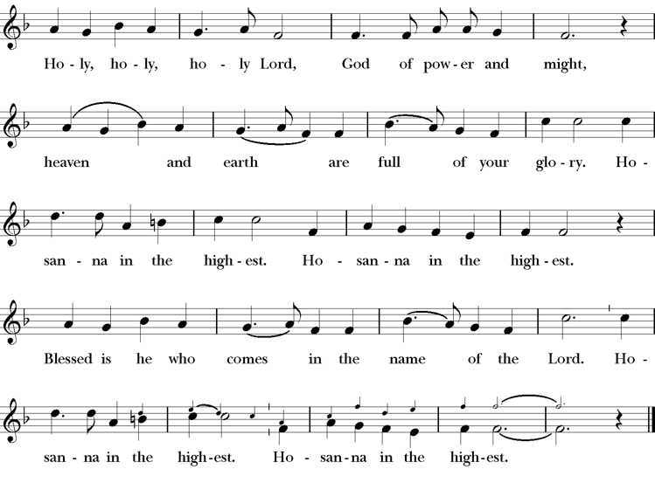
Presider: We give thanks to you, O God, for the goodness and love which you have made known to us in creation; in the calling of Israel to be your people; in your Word spoken through the prophets; and above all in the Word made flesh, Jesus, your Son. For in these last days you sent him to be incarnate from the Virgin Mary, to be the Savior and Redeemer of the world. In him, you have delivered us from evil, and made us worthy to stand before you. In him, you have brought us out of error into truth, out of sin into righteousness, out of death into life.
On the night before he died for us, our Lord Jesus Christ took bread; and when he had given thanks to you, he broke it, and gave it to his disciples, and said, “Take, eat: This is my Body, which is given for you. Do this for the remembrance of me.”
After supper he took the cup of wine; and when he had given thanks, he gave it to them, and said, “Drink this, all of you: This is my Blood of the new Covenant, which is shed for you and for many for the forgiveness of sins. Whenever you drink it, do this for the remembrance of me.” Therefore, according to his command, O Father,
Celebrant & People We remember his death,
We proclaim his resurrection,
We await his coming in glory;
Presider And we offer our sacrifice of praise and thanksgiving to you, O Lord of all; presenting to you, from your creation, this bread and this wine.
We pray you, gracious God, to send your Holy Spirit upon these gifts that they may be the Sacrament of the Body of Christ and his Blood of the new Covenant. Unite us to your Son in his sacrifice, that we may be acceptable through him, being sanctified by the Holy Spirit. In the fullness of time, put all things in subjection under your Christ, and bring us to that heavenly country where, with [__________ and] all your saints, we may enter the everlasting heritage of your sons and daughters; through Jesus Christ our Lord, the firstborn of all creation, the head of the Church, and the author of our salvation.
By him, and with him, and in him, in the unity of the Holy Spirit all honor and glory is yours, Almighty Father, now and for ever.
Amen.
The Lord’s Prayer
Presider As our Savior has taught us, we are bold to pray.
People Our Father, who art in heaven, hallowed be thy name. Thy Kingdom come, thy will be done, on earth as it is in heaven. Give us this day our daily bread. And forgive us our trespasses, as we forgive those who trespass against us. And lead us not into temptation, but deliver us from evil. For thine is the kingdom, the power and the glory, for ever and ever. Amen.
The Breaking of the Bread
The Presider breaks the consecrated bread in view of the assembly.
Presider The Gifts of God for the people of God.
People Therefore let us keep the feast. Alleluia
Invitation to Communion
Presider Come to this table you who have been here often and you who have not been here in a long time. Come, you who have tried to follow Jesus and you who have failed. You who are full of faith and full of doubt. Come, it is Christ himself who invites you to meet him here.
Sharing the Sacred Meal
This is Christ’s table and all are welcome and all are fed.
Communion Music Let All Mortal Flesh Keep Silence H 324
Post-Communion Prayer BCP 365
The Blessing
The Recessional Hymn Praise To The Living God H 372
The Dismissal*
Celebrant | Let us go forth in the name of Christ.
People | Thanks be to God.
Postlude Steve Rubardt Please remain seated



SERVING TODAY
Celebrant & Preacher: Rev LA King
Acolyte: Susie Hand
Lector: Gerrilee Fisher , Lorena Reinhardt
Intercessor: Barbara Feduska
Worship Musician: Steve Rubardt
Choir Leader: Steve Rubardt
Choir: Liz Carpenter, Heather Dahlberg, Scott Sherman,
Patsy Gralow, Laurell Meredith, Mary Omodt, Barbara Feduska, Tara Anderson
Sunday School - Child Care: Wendy Aguilar Appt Only
Ushers: Marcia Derby
Tech Chaplain: Marcos Rendon
Altar Guild: Marcia Derby , Mary Omodt
Hospitality : Luke Bohanan , Jane Hernandez
Altar Flowers are given to the glory of God by Altar Guild.
Prayers requested for these on Trinity’s long-term prayer list: Armando P, Georgia Bostedt, Muff Davey, John Eiler, Gerrilee Fisher, Claire Ginesi, Mary Griffin, David & Christine Hilt, Walker David, Mark Mezzetta, Kelcey Omodt, Grizelda Ponce, Barry Reap, Blake W, Robert R, Melissa White, Annie Loveland Sherman, James Thomas, Rose Burns, Jennifer Gralow, Patsy Gralow, Steve Antenen, Sandra Leland, Karl, Michael Hardy, Michael Bean Land, Polly Moore, Sinat Liv, Will Maushardt, Sophia Piconi, Mike Smith, Jean Maffoli
Prayers for the Repose of Soul: Tim Dowd , Susan Bassett, Joan Biersch, Linda Dowd, Christina Van Krugel, Mere Nagasau, Mary Goshert, Peggy Bell, Carolyn Caldwell, Van Z, Dolores Mae Seaberg Cole.
Contact Pastoral Care Chair, Lorena lorena.m.reinhardt@gmail.com to make any additions or to remove names from our Long-Term Prayer list.
Notes on the Service Bulletin This service bulletin is a guide to the service. We use a variety of printed materials for the prayers, the scriptural readings and the hymns. The Readings for the week, including the Collect and Readings are found in this Bulletin. The service follows the liturgies that are found in the Book of Common Prayer (BCP). The BCP is the blue book found in the pew in front of you. The hymns come primarily from The 1982 Hymnal, also in the pew – the red book. Lift Every Voice and Sing (LEVAS) is another hymnal located in the pew rack. VF stands for Voices Found, another authorized hymnal. Sound Mate Assisted Hearing devices available at the back of the church on the Narthex Table.
About this Service: Season of Pentecost
The season of Pentecost is the longest of the Church Year. It begins on the Day of Pentecost when the promised Holy Spirit (Counselor, Advocate) of God fell upon the disciples and those gathered with them in the upper room and runs until the Sunday before Advent. The color of the season is green to symbolize growth and new life. This season is often called “The work of the Church.” The lessons focus on Jesus’ teaching encouraging personal growth and transformation in the Spirit. The teachings also call believers to spread the Gospel to those in the world who have not encountered Jesus. Believers are called to live lives in service of others.
Trinity Liturgical Ministry ROTA Next two weeks
Date | Celebrant | Ushers | Acolyte | Lector (s) | Intercessor | Altar Guild
June 28th | Cindy Beck | Alfred Escoffier | Claire Ginesi | TBD, Bill Doyle | Ann Kyser | Laurell Meredith , Liz Carpenter
July 5th | Cindy Beck | John Addeo | TBD | Bill Doyle, Ann Kyser | Lorena Reinhardt | Ann Kyser
Schedule of Weekly Meetings and Services at Trinity Episcopal Sonoma
Day | Date | Time | Occasion | Location
Wednesday | June 24 | 11 AM | Bible Study | Library
Thursday | June 25 | 10:30 AM  5:30 PM | Mindfulness & Well Being  Alcoholics Anonymous | Library  Buttrum Hall
Saturday | June 27 | 8 AM | Centering Prayer | St. Luke’s Chapel
Saturday | June 27 | 2pm | Drawing Class | in Library
Sunday | June 28 | 10:00 AM | Holy Eucharist II | Sanctuary
Mon-Fri | Weekdays | 7AM-1PM | Sonoma Home Meals | Kitchen &Buttrum Hall
Mon-Fri | Weekdays | 9-2 | Sonoma Preschool Academy – School
Monthly Meetings at Trinity Episcopal Sonoma
Day | Date | Time | Meeting | Location | Contact
Tuesday | July 7 | 11 AM | Prayer Shawl Ministry | Library | Lorena Reinhardt lorena.m.reinhardt@gmail.com
Thursday | TBD | TBD | Vestry | Library | Cindy Beck 916-955-9861

PRAYERS and BLESSINGS
For a Birthday
Watch over your child, O Lord as his/her days increase; bless and guide him/her wherever s/he may be. Strengthen them when s/he stands; comfort him/her when discouraged or sorrowful; raise him/her up if s/he fall; and in his/her heart may your peace which passes understanding abide all the days of his/her life; through Jesus Christ our Lord. Amen.
For an Anniversary
O God, you have so consecrated the covenant of marriage that it represents the spiritual unity between Christ and his Church: Send your blessing upon these your servants as they celebrate their anniversary, that they may continue to love, honor and cherish each other in faithfulness and patience, in wisdom and true godliness, that their home may be a haven of blessing and peace; through Jesus Christ our Lord, who lives and reigns with you and the Holy Spirit, one God, now and forever. Amen.
For Travelers
O God, our heavenly Father, whose glory fills the whole creation, and whose presence we find wherever we go; preserve those who travel; surround them with your loving care; protect them from every danger, and bring them in safety to their journey’s end; through Jesus Christ our Lord. Amen.
Sending our Eucharistic Visitors
Priest: In the name of this congregation, I send you forth bearing these holy gifts, the those to whom you go may share with us in the communion of Christ’s body and blood.
People: We who are many are one body, because we all share on bread, and one cup. Amen.
Trinity Episcopal Church
In Sonoma for over 170 years
275 East Spain Street
Sonoma, CA 95476
The Rt. Rev. Megan M. Traquair, Bishop
Diocese of Northern California
Pastor Cindy Beck, Interim
Steve Rubardt, Worship Music
Vestry
Bill Doyle, Senior Warden & Stewardship
Susie Hand
Heather Dahlberg
Sally Zimmerman
Lorena Reinhardt (Pastoral Care)
Luke Bohanan
Mandy Birkbeck
Ministries
Prayer Shawl, Lorena Reinhardt
Outreach, Jane Hernandez
Mindfulness & Well Being, Mary Omodt
Sunday School, Children, Wendy Aguilar

The Members of the Congregation are The Ministers of the Church

Administrative Office Hrs.
Monday Wednesday 9 A.M. – 2 PM; Thursday 10A.M.-2 P.M0
Sunday 9:30-11:30
Clergy Office Hours Wednesdays, Thursdays, by appointment

Emergency, sickness, please contact office: 707-938-4846

