Trinity Episcopal Church
In SONOMA for over 170 Years
ASH WEDNESDAY
Year A
Wednesday, February 18, 2026
5 PM
In person and Online
Ash Wednesday Service
Welcome to Trinity Episcopal, Sonoma on this first day of Lent. Today’s liturgy presents a challenge to Christian people. It confronts us with the radical change in living which is the Way of Christ.
On Ash Wednesday we begin our forty-day journey toward Easter with a day of fasting and repentance. Marking our foreheads with dust, we acknowledge that we die and return to the earth. At the same time, the dust traces the life-giving cross indelibly marked on our foreheads at baptism. While we journey through Lent to return to God, we have already been reconciled to God through Christ. We humbly pray for God to make our hearts clean while we rejoice that “now is the day of salvation.” Returning to our baptismal call, we more intentionally bear the fruits of mercy and justice in the world.
Note on Today’s Readings
During the Lenten season it is our custom to take a more contemplative and somber posture in our worship. The color is purple, a more penitential color.
The Altar flowers are removed. We omit the “Gloria” and refrain from using “alleluia”.
All these changes are meant to focus our worship, to reflect the season and to prepare us for the coming resurrection of our Lord Jesus Christ.

Prelude Steve Rubardt
The Word of God
Celebrant The Lord be with you.
People And also with you.
Celebrant Let us pray.
The Collect of the Day BCP 264
Almighty and everlasting God, you hate nothing you have made and forgive the sins of all who are penitent: Create and make in us new and contrite hearts, that we, worthily lamenting our sins and acknowledging our wretchedness, may obtain of you, the God of all mercy, perfect remission and forgiveness; through Jesus Christ our Lord, who lives and reigns with you and the Holy Spirit, one God, for ever and ever.
All Amen.
First Reading Joel 2:1-2, 12-17
Lector: A Reading from the book if the prophet Joel.
¹Blow the trumpet in Zion;
sound the alarm on my holy mountain!
Let all the inhabitants of the land tremble,
for the day of the Lord is coming, it is near—
²a day of darkness and gloom,
a day of clouds and thick darkness!
Like blackness spread upon the mountains
a great and powerful army comes;
their like has never been from of old,
nor will be again after them
in ages to come.
¹²Yet even now, says the Lord,
return to me with all your heart,
with fasting, with weeping, and with mourning;
¹³rend your hearts and not your clothing.
Return to the Lord, your God,
for he is gracious and merciful,
slow to anger, and abounding in steadfast love,
and relents from punishing.
¹⁴Who knows whether he will not turn and relent,
and leave a blessing behind him,
a grain offering and a drink offering
for the Lord, your God?
¹⁵Blow the trumpet in Zion;
sanctify a fast;
call a solemn assembly;
¹⁶gather the people.
Sanctify the congregation;
assemble the aged;
gather the children,
even infants at the breast.
Let the bridegroom leave his room,
and the bride her canopy.
¹⁷Between the vestibule and the altar
let the priests, the ministers of the Lord, weep.
Let them say, “Spare your people, O Lord,
and do not make your heritage a mockery,
a byword among the nations.
Why should it be said among the peoples,
‘Where is their God?’ ”
Reader The Word of the Lord.
People Thanks be to God.
Psalm Psalm 103
¹Bless the Lord, O my soul, *
and all that is within me, bless his holy Name.
²Bless the Lord, O my soul, *
and forget not all his benefits.
³He forgives all your sins *
and heals all your infirmities;
⁴He redeems your life from the grave *
and crowns you with mercy and loving-kindness;
⁵He satisfies you with good things, *
and your youth is renewed like an eagle’s.
⁶The Lord executes righteousness *
and judgment for all who are oppressed.
⁷He made his ways known to Moses *
and his works to the children of Israel.
⁸The Lord is full of compassion and mercy, *
slow to anger and of great kindness.
⁹He will not always accuse us, *
nor will he keep his anger for ever.
¹⁰He has not dealt with us according to our sins, *
nor rewarded us according to our wickedness.
¹¹For as the heavens are high above the earth, *
so is his mercy great upon those who fear him.
¹²As far as the east is from the west, *
so far has he removed our sins from us.
¹³As a father cares for his children, *
so does the Lord care for those who fear him.
¹⁴For he himself knows whereof we are made; *
he remembers that we are but dust.
¹⁵Our days are like the grass; *
we flourish like a flower of the field;
¹⁶When the wind goes over it, it is gone, *
and its place shall know it no more.
¹⁷But the merciful goodness of the Lord endures for ever on those who fear him, *
and his righteousness on children’s children;
¹⁸On those who keep his covenant *
and remember his commandments and do them.
¹⁹The Lord has set his throne in heaven, *
and his kingship has dominion over all.
²⁰Bless the Lord, you angels of his,
you mighty ones who do his bidding, *
and hearken to the voice of his word.
²¹Bless the Lord, all you his hosts, *
you ministers of his who do his will.
²²Bless the Lord, all you works of his,
in all places of his dominion; *
bless the Lord, O my soul.
Second Reading 2 Corinthians 5:20b-6:10
Lector: A Reading from Paul's Second letter to the Church in Corinth.
^{20b}We entreat you on behalf of Christ, be reconciled to God. ²¹For our sake he made him to be sin who knew no sin, so that in him we might become the righteousness of God.
^{6:1}As we work together with him, we urge you also not to accept the grace of God in vain. ²For he says,
“At an acceptable time I have listened to you,
and on a day of salvation I have helped you.”
See, now is the acceptable time; see, now is the day of salvation! ³We are putting no obstacle in anyone’s way, so that no fault may be found with our ministry, ⁴but as servants of God we have commended ourselves in every way: through great endurance, in afflictions, hardships, calamities, ⁵beatings, imprisonments, riots, labors, sleepless nights, hunger; ⁶by purity, knowledge, patience, kindness, holiness of spirit, genuine love, ⁷truthful speech, and the power of God; with the weapons of righteousness for the right hand and for the left; ⁸in honor and dishonor, in ill repute and good repute. We are treated as impostors, and yet are true; ⁹as unknown, and yet are well known; as dying, and see—we are alive; as punished, and yet not killed; ¹⁰as sorrowful, yet always rejoicing; as poor, yet making many rich; as having nothing, and yet possessing everything.
Reader The Word of the Lord.
People Thanks be to God.
Sequence Hymn The Glory of these Forty Days Hymnal #143
The Gospel Matthew 6:1-6, 16-21
Celebrant The Holy Gospel of our Lord Jesus Christ according to Matthew. People Glory to you, Lord Christ.
[Jesus said,] ¹“Beware of practicing your piety before others in order to be seen by them; for then you have no reward from your Father in heaven.
²“So whenever you give alms, do not sound a trumpet before you, as the hypocrites do in the synagogues and in the streets, so that they may be praised by others. Truly I tell you, they have received their reward. ³But when you give alms, do not let your left hand know what your right hand is doing, ⁴so that your alms may be done in secret; and your Father who sees in secret will reward you.
⁵“And whenever you pray, do not be like the hypocrites; for they love to stand and pray in the synagogues and at the street corners, so that they may be seen by others. Truly I tell you, they have received their reward. ⁶But whenever you pray, go into your room and shut the door and pray to your Father who is in secret; and your Father who sees in secret will reward you.
¹⁶“And whenever you fast, do not look dismal, like the hypocrites, for they disfigure their faces so as to show others that they are fasting. Truly I tell you, they have received their reward. ¹⁷But when you fast, put oil on your head and wash your face, ¹⁸so that your fasting may be seen not by others but by your Father who is in secret; and your Father who sees in secret will reward you.
¹⁹“Do not store up for yourselves treasures on earth, where moth and rust consume and where thieves break in and steal; ²⁰but store up for yourselves treasures in heaven, where neither moth nor rust consumes and where thieves do not break in and steal. ²¹For where your treasure is, there your heart will be also.”
The Gospel of the Lord.
People Praise to your Lord Christ
The Sermon The Pastor Cindy Beck

Lenten Invitation BCP 264
After the Sermon, all stand, and the Celebrant or Minister appointed invites the people to the observance of a holy Lent, saying
Dear People of God: The first Christians observed with great devotion the days of our Lord’s passion and resurrection, and it became the custom of the Church to prepare for them by a season of penitence and fasting. This season of Lent provided a time in which converts to the faith were prepared for Holy Baptism. It was also a time when those who, because of notorious sins, had been separated from the body of the faithful were reconciled by penitence and forgiveness, and restored to the fellowship of the Church. Thereby, the whole congregation was put in mind of the message of pardon and absolution set forth in the Gospel of our Savior, and of the need which all Christians continually have to renew their repentance and faith.
I invite you, therefore, in the name of the Church, to the observance of a holy Lent, by self-examination and repentance; by prayer, fasting, and self-denial; and by reading and meditating on God’s holy Word. And, to make a right beginning of repentance, and as a mark of our mortal nature, let us now kneel before the Lord, our maker and redeemer.
Silence is then kept for a time, all kneeling.
Blessing of the Ashes  BCP 264
If ashes are to be imposed, the Celebrant says the following prayer
Almighty God, you have created us out of the dust of the earth: Grant that these ashes may be to us a sign of our mortality and penitence, that we may remember that it is only by your gracious gift that we are given everlasting life; through Jesus Christ our Savior. Amen.
Imposition of Ashes BCP 265
The ashes are imposed with the following words
Remember that you are dust, and to dust you shall return.
Psalm 51 BCP 266
¹Have mercy on me, O God, according to your loving-kindness; *
in your great compassion blot out my offenses.
²Wash me through and through from my wickedness *
and cleanse me from my sin.
³For I know my transgressions, *
and my sin is ever before me.
⁴Against you only have I sinned *
and done what is evil in your sight.
⁵And so you are justified when you speak *
and upright in your judgment.
⁶Indeed, I have been wicked from my birth, *
a sinner from my mother’s womb.
⁷For behold, you look for truth deep within me, *
and will make me understand wisdom secretly.
⁸Purge me from my sin, and I shall be pure; *
wash me, and I shall be clean indeed.
⁹Make me hear of joy and gladness, *
that the body you have broken may rejoice.
¹⁰Hide your face from my sins *
and blot out all my iniquities.
¹¹Create in me a clean heart, O God, *
and renew a right spirit within me.
¹²Cast me not away from your presence *
and take not your holy Spirit from me.
¹³Give me the joy of your saving help again *
and sustain me with your bountiful Spirit.
¹⁴I shall teach your ways to the wicked, *
and sinners shall return to you.
¹⁵Deliver me from death, O God, *
and my tongue shall sing of your righteousness,
O God of my salvation.
¹⁶Open my lips, O Lord, *
and my mouth shall proclaim your praise.
¹⁷Had you desired it, I would have offered sacrifice, *
but you take no delight in burnt-offerings.
¹⁸The sacrifice of God is a troubled spirit; *
a broken and contrite heart, O God, you will not despise.
Litany of Penitence 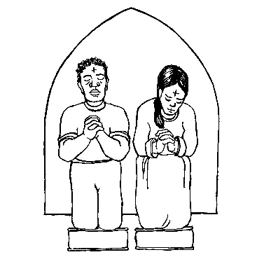BCP 267
The Celebrant and People together, all kneeling
Most holy and merciful Father: We confess to you and to one another, and to the whole communion of saints in heaven and on earth, that we have sinned by our own fault in thought, word, and deed; by what we have done, and by what we have left undone.
The Celebrant continues
We have not loved you with our whole heart, and mind, and strength. We have not loved our neighbors as ourselves. We have not forgiven others, as we have been forgiven.
Have mercy on us, Lord.
We have been deaf to your call to serve, as Christ served us. We have not been true to the mind of Christ. We have grieved your Holy Spirit.
Have mercy on us, Lord.
We confess to you, Lord, all our past unfaithfulness: the pride, hypocrisy, and impatience of our lives,
We confess to you, Lord.
Our self-indulgent appetites and ways, and our exploitation of other people,
We confess to you, Lord.
Our anger at our own frustration, and our envy of those more fortunate than ourselves,
We confess to you, Lord.
Our intemperate love of worldly goods and comforts, and our dishonesty in daily life and work,
We confess to you, Lord.
Our negligence in prayer and worship, and our failure to commend the faith that is in us,
We confess to you, Lord.
Accept our repentance, Lord, for the wrongs we have done: for our blindness to human need and suffering, and our indifference to injustice and cruelty,
Accept our repentance, Lord.
For all false judgments, for uncharitable thoughts toward our neighbors, and for our prejudice and contempt toward those who differ from us,
Accept our repentance, Lord.
For our waste and pollution of your creation, and our lack of concern for those who come after us,
Accept our repentance, Lord.
Restore us, good Lord, and let your anger depart from us;
Favorably hear us, for your mercy is great.
Accomplish in us the work of your salvation,
That we may show forth your glory in the world.
By the cross and passion of your Son our Lord,
Bring us with all your saints to the joy of his resurrection.
A deacon or lay reader leading the service remains kneeling and says
Almighty God have mercy on us, forgive us all our sins through our Lord Jesus Christ, strengthen us in all goodness, and by the power of the Holy Spirit keep us in eternal life. Amen.
THE Peace BCP 269
The Peace is now exchanged
Celebrant | The peace of the Lord be always with you.
People | And also with you.
THE Blessing BCP 366
The Priest blesses the people, saying
The blessing of God Almighty, the Father, the Son, and the Holy Spirit, be upon you and remain with you for ever. Amen.
Recessional Hymn Jesus, all my Gladness Hymn #701
Dismissal
Celebrant: | Let us bless the Lord.
People | Thanks be to God.
Postlude Steve Rubardt
SERVING TODAY
Celebrant: The Pastor Cindy Beck
Acolyte: Arminda Eiler
Lectors: John Eiler
Worship Musician: Steve Rubardt
Tech Chaplain: Marcos Rendon
Altar Guild: Susie Hand
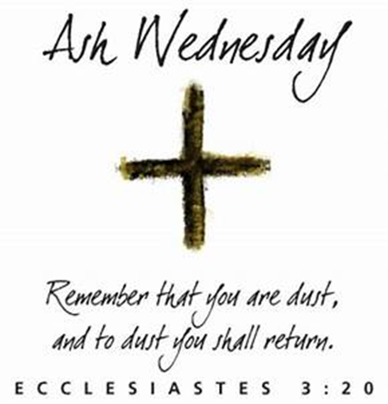
Why “Ashes”
Ashes are an ancient sign of penitence. From the Middle Ages it became the custom to begin Lent by being marked in ash with the sign of the cross. The reminder that we are dust turns our attention to the creative power of God, and God’s ability to heal the brokenness in our lives when we offer that brokenness to God. That turning to God is the work of Lent, preparation for the celebration of Easter. We’re offering ashes on the front steps of our sanctuary today because that reminder of need, humility, and healing shouldn’t be confined to inside our church building and just to those who worship with us on Sundays. Many walk through and by our campus – neighbors, visitors, others who are working on our campus but are not parishioners.
The ashes we receive here are to remind us throughout the day of our need for God, and of God’s call to us. There is much more to the beginning of Lent than ashes alone, and we encourage you to make time for worship with a community of faith, for the support of others and of the great traditions of faith in our work of repentance and renewal. But God meets us not just in worship, but in the midst of life, and we offer the opportunity to remember our faith to those whose schedules make it hard to stop and pray with others today.
The Reason behind Lenten Discipline
Lent has long been the primary time for renewing our discipleship by adopting some more rigorous discipline to heighten our spiritual awareness. The idea of discipline relates to the experience of being a disciple. The disciple is a learner, and discipline is the way of learning. It includes instruction for the mind and exercises for the body.
No matter what we decide to do for Lent, the important thing is our inner motive. As Jesus so often warned us, the outward action can be done for a wide variety of reasons. If we are going to fast merely to look good, then we are committing what the poet T. S. Eliot called “the greatest treason, to do the right thing for the wrong reason.” The importance of discipline cannot be overestimated. Only through discipline can we achieve genuine freedom. Discipline indicates a regular pattern of training for any activity. If we wish to play the piano, for example, we must submit to the discipline of learning the finger movements to produce the correct notes. Just as many want freedom to play anything on the piano, virtuosos know that freedom only comes after long hours of disciplined practice. So likewise, we who want freedom to live a deeper spiritual life, must remember that freedom only comes if we are willing to pay the price of learning to discipline ourselves. Fasting, abstinence and other practices that we might wish to adopt for our Lenten observance can help us to achieve our spiritual goal—freedom in Christ.
Some Lenten Practices
The Church has always had times of fasting, penitence and preparation. In the early Church, the custom of fasting before Easter was practiced, initially for only a few days at a time. It also became the tradition to set aside a time of preparation for catechumens, who would undergo a rigorous period of instruction, reflection, self- denial, scrutiny, prayer and exorcism in order to become candidates for baptism. The Church eventually decided on a 40-day period for Lent as a reminder of the 40-day period of Jesus’ fast in the desert. The length of time also recalls other 40-day or 40-year times of great significance in Jewish history:
- Noah and 40 days of rain
- Moses’ fasting for 40 days before receiving the Ten Commandments
- The Israelites’ wandering for 40 years
- Elijah’s traveling for 40 days to reach God’s holy mountain
These experiences were occasions of great spiritual cleansing and preparation to encounter God in a new way, and serve as excellent models for our Lenten disciplines and expectations. The 40-day period of Lent does not include Sundays, which are considered little Easters, feast days that celebrate Jesus’ resurrection on the first day of the week.
Prayers for keeping Lent
O God whose glory it is always to have mercy: Be gracious to all who have gone astray from your ways, and bring us again with penitent hearts and steadfast faith to embrace and hold fast the unchangeable truth of your Word, Jesus Christ your Son. Amen. (BCP Lent 2)
Almighty God, you know that we have no power in ourselves to help ourselves: Keep us both outwardly in our bodies and inwardly in our souls, that we may be defended from all adversities which may happen to the body and from all evil thoughts which may assault and hurt the soul; through Jesus Christ our Savior. Amen. (BCP Lent 3)
God our Creator, the strength of all who put their trust in you, mercifully accept our prayers; and because, in our weakness, we can do nothing good without you, grant us the help of your grace, that in keeping your commandments we may please you, both in will and deed; through Jesus Christ our Lord. Amen.
(adapted from the collect for 6 Epiphany in the Book of Common Prayer, but appropriate to keeping Lent)

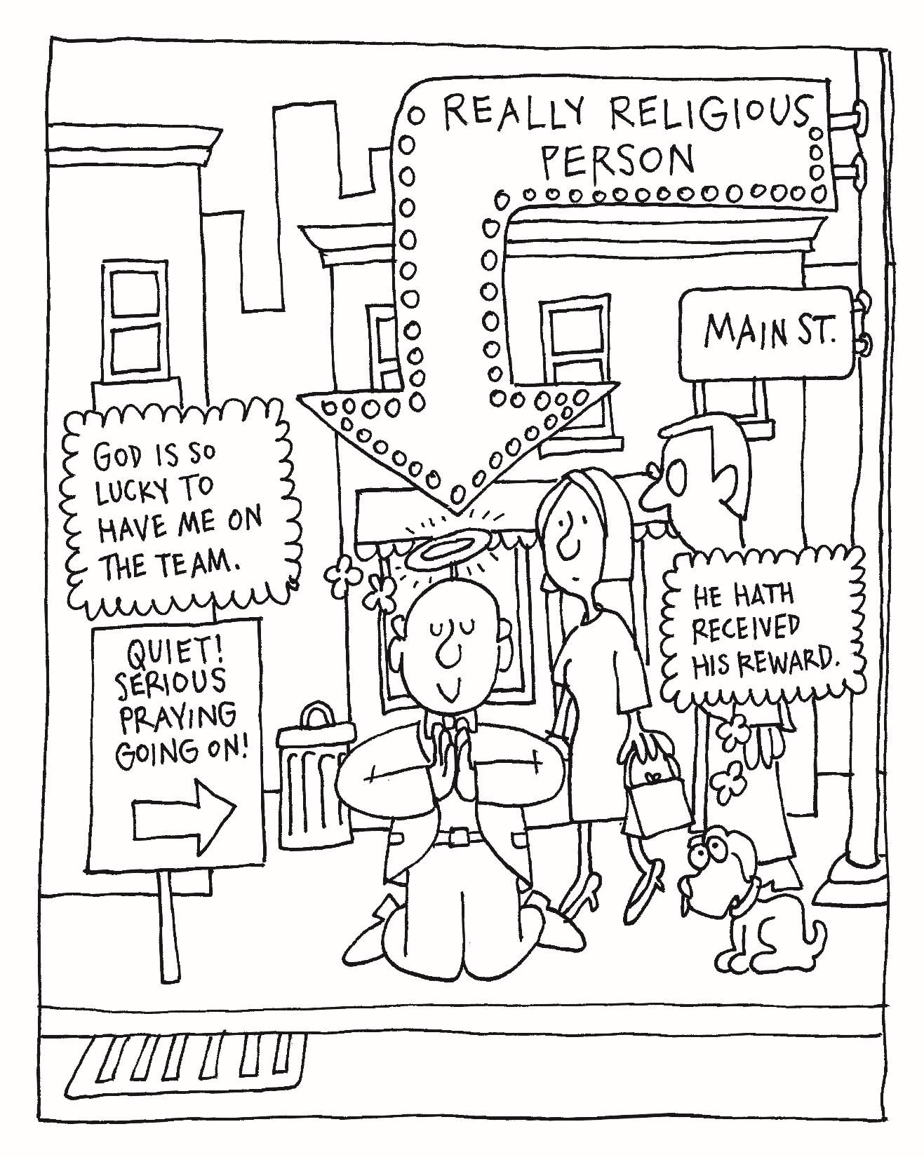
Trinity Episcopal Church
In Sonoma for over 170 years
275 East Spain Street
Sonoma, CA 95476
The Rt. Rev. Megan M. Traquair, Bishop
Diocese of Northern California
Pastor Cindy Beck, Interim
Steve Rubardt, Worship Music
Vestry
TBD, Junior Warden (Buildings, Grounds)
Bill Doyle (Stewardship)
Heather Dahlberg
Lorena Reinhardt (Pastoral Care Chair Person)
Ministries
TBD ,Acting Treasurer
Outreach, Jane Hernandez
Youth – Academic Tutoring, Karen Randall
Mindfulness & Well Being, Mary Omodt
Sunday School, Children, Wendy Aguilar

The Members of the Congregation are The Ministers of the Church

Administrative Office Hrs.
Monday Wednesday 9 A.M. – 2 PM; Thursday 10A.M.-2 P.M0
Sunday 9:30-11:30
Clergy Office Hours Wednesdays, Thursdays, by appointment

Emergency, sickness, please contact office: 707-938-4846

