Trinity Episcopal Church
In Sonoma for over 170 years
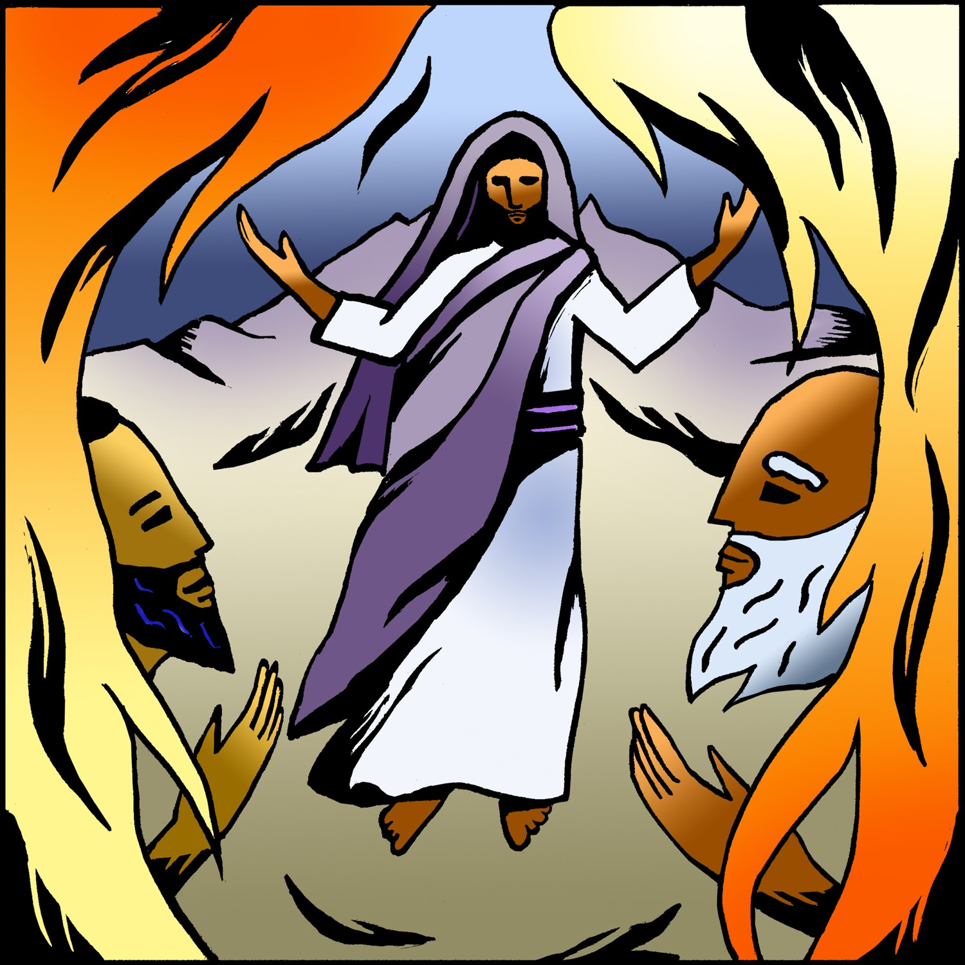
The Last Sunday after the Epiphany
Epiphany 6 (Year A)
Holy Eucharist II
February 15, 2026
10:00 AM In person and Online
Welcome to Trinity Episcopal, Sonoma!
Whether you have wandered in, are wondering about God or grew up in the church, or wherever you are in your journey...you are welcome here... We are blessed by your presence.
For Visitors and Newcomers:
Everyone is welcome to receive communion at the Lord’s table. Jesus gave this tangible reminder of God’s presence, love, and forgiveness for all. If you are interested in a visit or call from the Priest-in-Charge , please sign our guest book on the table at the entrance of the church, including an email or phone number.
Restrooms
A restroom is located outside the entrance of Buttrum Hall (the building across the courtyard) and another is located inside the hall to the right.
Coffee and Treats:
Following worship we have coffee and treats after service in Buttrum Hall. We hope it is a time to get to know you better.
To access Trinity’s Guest WIFI: Password Rosepettal441 (case sensitive).
We are glad you are here, and we invite you to enter fully into worship this morning.
February Announcements
2025 End of Year Giving Statements have been generated and will begin to be sent out.
Fellowship Coffee Hour Sign up - We encourage members to sign up to make coffee. Pastor Cindy is happy to demonstrate how easy this is. Please help us provide this hospitality for guests and members.
The February, March, April Forward Day by Day , a booklet of daily inspirational meditations is now available in the Church and the Office. We ask for a $2 donation.
This month, St. Pauls in Healdsburg organ concert series will feature John Karl Hirten, Director of Music at St. John's Episcopal in Ross, CA. John will play pieces by J. S. Bach, Milhaud, Bruhns, Hewitt as well as one of his own compositions! The performance will be held in the church on Sunday, February 15 at 5:00 pm. Admission is free.
Lectio Divina Bible Study is on Wednesday, at 11AM in the library. Lectio Divina, Latin for "divine reading," is a contemplative practice of scriptural reading, meditation, and prayer intended to promote communion with God. Unlike traditional Bible study that focuses on intellectual information, Lectio Divina emphasizes spiritual formation and personal intimacy with God.
Welcome to our new Vestry members! Mandy Birkbeck, Susie Hand, Sally Zimmerman and Luke Bohanan; prayerfully let their names go forward and were elected to Trinity's Vestry. Keep them and the vestry in prayer as we begin a new year of serving God through leadership at Trinity.
Ash Wednesday is Wednesday, Feb 18th. This begins our journey through Lent, a time of intentional reflection of our life in Christ. A Service will be held at 5pm with imposition of ashes.
All are welcome to make a gift and offering in thanksgiving to God;
for the many blessings we have received. To take advantage of our electronic giving options, please follow the QR code with your capable electronic device, or visit https://onrealm.org/trinitysonoma/-/form/give/default Help us to make this a place where God’s grace is freely shared by all.

Prelude Steve Rubardt
Please stand for the Entrance Hymn.
At the sound of the bell, please stand as you are able. The People respond when bold text appears.
The Word of God
Entrance Hymn As with Gladness Men of Old H 119
Opening Acclamation (BCP p. 355)
The people standing, the Celebrant says
 | Blessed be God: Father, Son, and Holy Spirit.
People | And blessed be his kingdom, now and for ever. Amen.
Collect for Purity
All Almighty God, to you all hearts are open, all desires known, and from you no secrets are hid: Cleanse the thoughts of our hearts by the inspiration of your Holy Spirit, that we may perfectly love you, and worthily magnify your holy Name; through Christ our Lord. Amen.
Song of Praise Gloria BCP 356/Hymnal S-280
All Glory to God in the highest,
and peace to his people on earth.
Lord God, heavenly King,
almighty God and Father,
we worship you, we give you thanks,
we praise you for your glory.
Lord Jesus Christ, only Son of the Father,
Lord God, Lamb of God,
you take away the sin of the world:
have mercy on us;
you are seated at the right hand of the Father:
receive our prayer.
For you alone are the Holy One,
you alone are the Lord,
you alone are the Most High,
Jesus Christ,
with the Holy Spirit,
in the glory of God the Father. Amen.
The Collect of the Day BCP 357
Celebrant | The Lord be with you.
People | And also with you.
Celebrant | Let us pray.
Set us free, O God, from the bondage of our sins, and give us the liberty of that abundant life which you have made known to us in your Son our Savior Jesus Christ; who lives and reigns with you, in the unity of the Holy Spirit, one God, now and for ever.
All Amen.
The Lessons
First Reading: Exodus 24:12-18
Reader A Reading from the book of Exodus.
¹²The Lord said to Moses, “Come up to me on the mountain, and wait there; and I will give you the tablets of stone, with the law and the commandment, which I have written for their instruction.” ¹³So Moses set out with his assistant Joshua, and Moses went up into the mountain of God. ¹⁴To the elders he had said, “Wait here for us, until we come to you again; for Aaron and Hur are with you; whoever has a dispute may go to them.”
¹⁵Then Moses went up on the mountain, and the cloud covered the mountain. ¹⁶The glory of the Lord settled on Mount Sinai, and the cloud covered it for six days; on the seventh day he called to Moses out of the cloud. ¹⁷Now the appearance of the glory of the Lord was like a devouring fire on the top of the mountain in the sight of the people of Israel. ¹⁸Moses entered the cloud, and went up on the mountain. Moses was on the mountain for forty days and forty nights.
Reader | The Word of the Lord.
People | Thanks be to God.
The Psalm: Psalm 2
Reader We will read Psalm 2, responsively by half verse.
¹Why are the nations in an uproar? *
Why do the peoples mutter empty threats?
²Why do the kings of the earth rise up in revolt,
and the princes plot together, *
against the Lord and against his Anointed?
³“Let us break their yoke,” they say; *
“let us cast off their bonds from us.”
⁴He whose throne is in heaven is laughing; *
the Lord has them in derision.
⁵Then he speaks to them in his wrath, *
and his rage fills them with terror.
⁶“I myself have set my king *
upon my holy hill of Zion.”
⁷Let me announce the decree of the Lord: *
he said to me, “You are my son;
this day have I begotten you.
⁸Ask of me, and I will give you the nations for your inheritance *
and the ends of the earth for your possession.
⁹You shall crush them with an iron rod *
and shatter them like a piece of pottery.”
¹⁰And now, you kings, be wise; *
be warned, you rulers of the earth.
¹¹Submit to the Lord with fear, *
and with trembling bow before him;
¹²lest he be angry, and you perish; *
for his wrath is quickly kindled.
¹³Happy are they all *
who take refuge in him!

The Second Reading: 2 Peter 1:16-21
Reader A Reading from the Second letter of Peter.
¹⁶We did not follow cleverly devised myths when we made known to you the power and coming of our Lord Jesus Christ, but we had been eyewitnesses of his majesty. ¹⁷For he received honor and glory from God the Father when that voice was conveyed to him by the Majestic Glory, saying, “This is my Son, my Beloved, with whom I am well pleased.” ¹⁸We ourselves heard this voice come from heaven, while we were with him on the holy mountain.
¹⁹So we have the prophetic message more fully confirmed. You will do well to be attentive to this as to a lamp shining in a dark place, until the day dawns and the morning star rises in your hearts. ²⁰First of all you must understand this, that no prophecy of scripture is a matter of one’s own interpretation, ²¹because no prophecy ever came by human will, but men and women moved by the Holy Spirit spoke from God.
Reader | The Word of the Lord.
People | Thanks be to God.
Sequence Hymn What a Wondrous Love is This H 439 v 1 & 2

The Holy Gospel: Matthew 5:13-20
Celebrant | The Holy Gospel of our Lord Jesus Christ according to Matthew.
People | Glory to you, Lord Christ.
¹Six days [after Peter had acknowledged Jesus as the Christ, the Son of the living God], Jesus took with him Peter and James and his brother John and led them up a high mountain, by themselves. ²And he was transfigured before them, and his face shone like the sun, and his clothes became dazzling white. ³Suddenly there appeared to them Moses and Elijah, talking with him. ⁴Then Peter said to Jesus, “Lord, it is good for us to be here; if you wish, I will make three dwellings here, one for you, one for Moses, and one for Elijah.” ⁵While he was still speaking, suddenly a bright cloud overshadowed them, and from the cloud a voice said, “This is my Son, the Beloved; with him I am well pleased; listen to him!” ⁶When the disciples heard this, they fell to the ground and were overcome by fear. ⁷But Jesus came and touched them, saying, “Get up and do not be afraid.” ⁸And when they looked up, they saw no one except Jesus himself alone.
⁹As they were coming down the mountain, Jesus ordered them, “Tell no one about the vision until after the Son of Man has been raised from the dead.”
Celebrant | The Gospel of the Lord.
People | Praise to you, Lord Christ.
Sequence Hymn What a Wondrous Love is This H 439 v 3
The Sermon Pastor Cindy Beck
The Nicene Creed (BCP p. 358)

The Prayers of the People
Celebrant: When we call upon the Lord, God will answer us. So let us come before the Lord in prayer, saying, “Majestic God, show us your glory.”
Intercessor: Lord our God, move your Church by your Holy Spirit. May we proclaim your greatness in the world. Inspire in us a prophetic message and let us not be overcome by fear.
In the Diocesan Cycle of Prayer, we pray for the Church of The Ascension in Vallejo.
In the Anglican Cycle of Prayer, we pray for The Church of the Province of the Indian Ocean.
Silence
Majestic God,
Show us your glory.
We pray especially today for our Bishop, _____. May (s)he, like your servant Moses, lead your people into a deeper experience of you.
Silence
Majestic God,
Show us your glory.
O mighty King, lover of justice, may this and every nation, strive for justice and peace. We pray that the leaders of the nations trust and care for those in their charge.
Silence
Majestic God,
Show us your glory.
Holy One, you have chosen to wear the clouds and meet our forebears on the mountains. In doing so, you remind us that you created all things good and continue to manifest your glory through those things you have created. Remind us to also honor your creation, +______________________________
Invite the congregation to add their thanksgivings, followed by silence
Majestic God,
Show us your glory.
O Lord, after they witnessed your majesty, Jesus led his disciples back down the mountain to minister to the people. Lead us to proclaim the Good News of God in Christ to our neighbors—to be your lamps shining in dark places.
Silence
Majestic God,
Show us your glory.
God our Father, touch those who are overcome by fear, sickness or any other adversity, +_________ Overshadow them with the healing power of your love.
Invite the congregation to add their petitions, followed by silence
Majestic God,
Show us your glory.
God of Light, we pray for the dying and the dead, +______________ May all those who experience death also come to know the new day of resurrection that comes through your Risen Son.
Invite the congregation to add their petitions, followed by silence
Majestic God,
Show us your glory.
The Confession of Sin
Most merciful God,
we confess that we have sinned against you
in thought, word, and deed,
by what we have done,
and by what we have left undone.
We have not loved you with our whole heart;
we have not loved our neighbors as ourselves.
We are truly sorry and we humbly repent.
For the sake of your Son Jesus Christ,
have mercy on us and forgive us;
that we may delight in your will,
and walk in your ways,
to the glory of your Name. Amen.
The Peace
Celebrant The peace of the Lord be always with you.
People And also with you.
Announcements
Birthdays, Anniversaries, Travelers (prayers found at back of bulletin)
The Holy Communion
The Offertory At the Offering, you’ll find a Pledge card in the Pew Rack for those who’d like to designate their financial donations to Trinity’s Pledging Income. For others, or a one-time gift, envelopes are in the pew racks as well as on the Narthex table or text TRINITYSONOMA" to 73256. Thank you!
Offertory Music
There’s a Sweet, Sweet Spirit in this Place LEVAS 120
Doxology
The people stand while the offerings are presented and placed on the Altar.
Presider: Gracious God, as an offering of our thanksgiving and gratitude, we return to you a portion of what you have gifted us.
The Great Thanksgiving
Eucharistic Prayer B BCP 367
Celebrant | The Lord be with you.
People | And also with you.
Celebrant | Lift up your hearts.
People | We lift them to the Lord.
Celebrant | Let us give thanks to the Lord our God.
People | It is right to give him thanks and praise.
Proper Preface (BCP p. 367)
It is right, and a good and joyful thing, always and everywhere to give thanks to you, Father Almighty, Creator of heaven and earth.
Because in the mystery of the Word made flesh, you have caused a new light to shine in our hearts, to give the knowledge of your glory in the face of your Son Jesus Christ our Lord.
Therefore we praise you, joining our voices with Angels and Archangels and with all the company of heaven, who for ever sing this hymn to proclaim the glory of your Name:
Sanctus Holy Holy, Holy (Proulx) Hymnal S-125
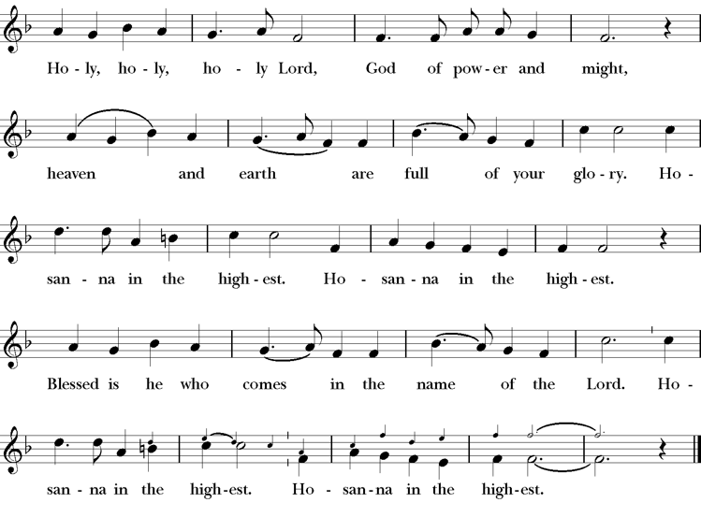
Words of Institution BCP 368
The Lord’s Prayer 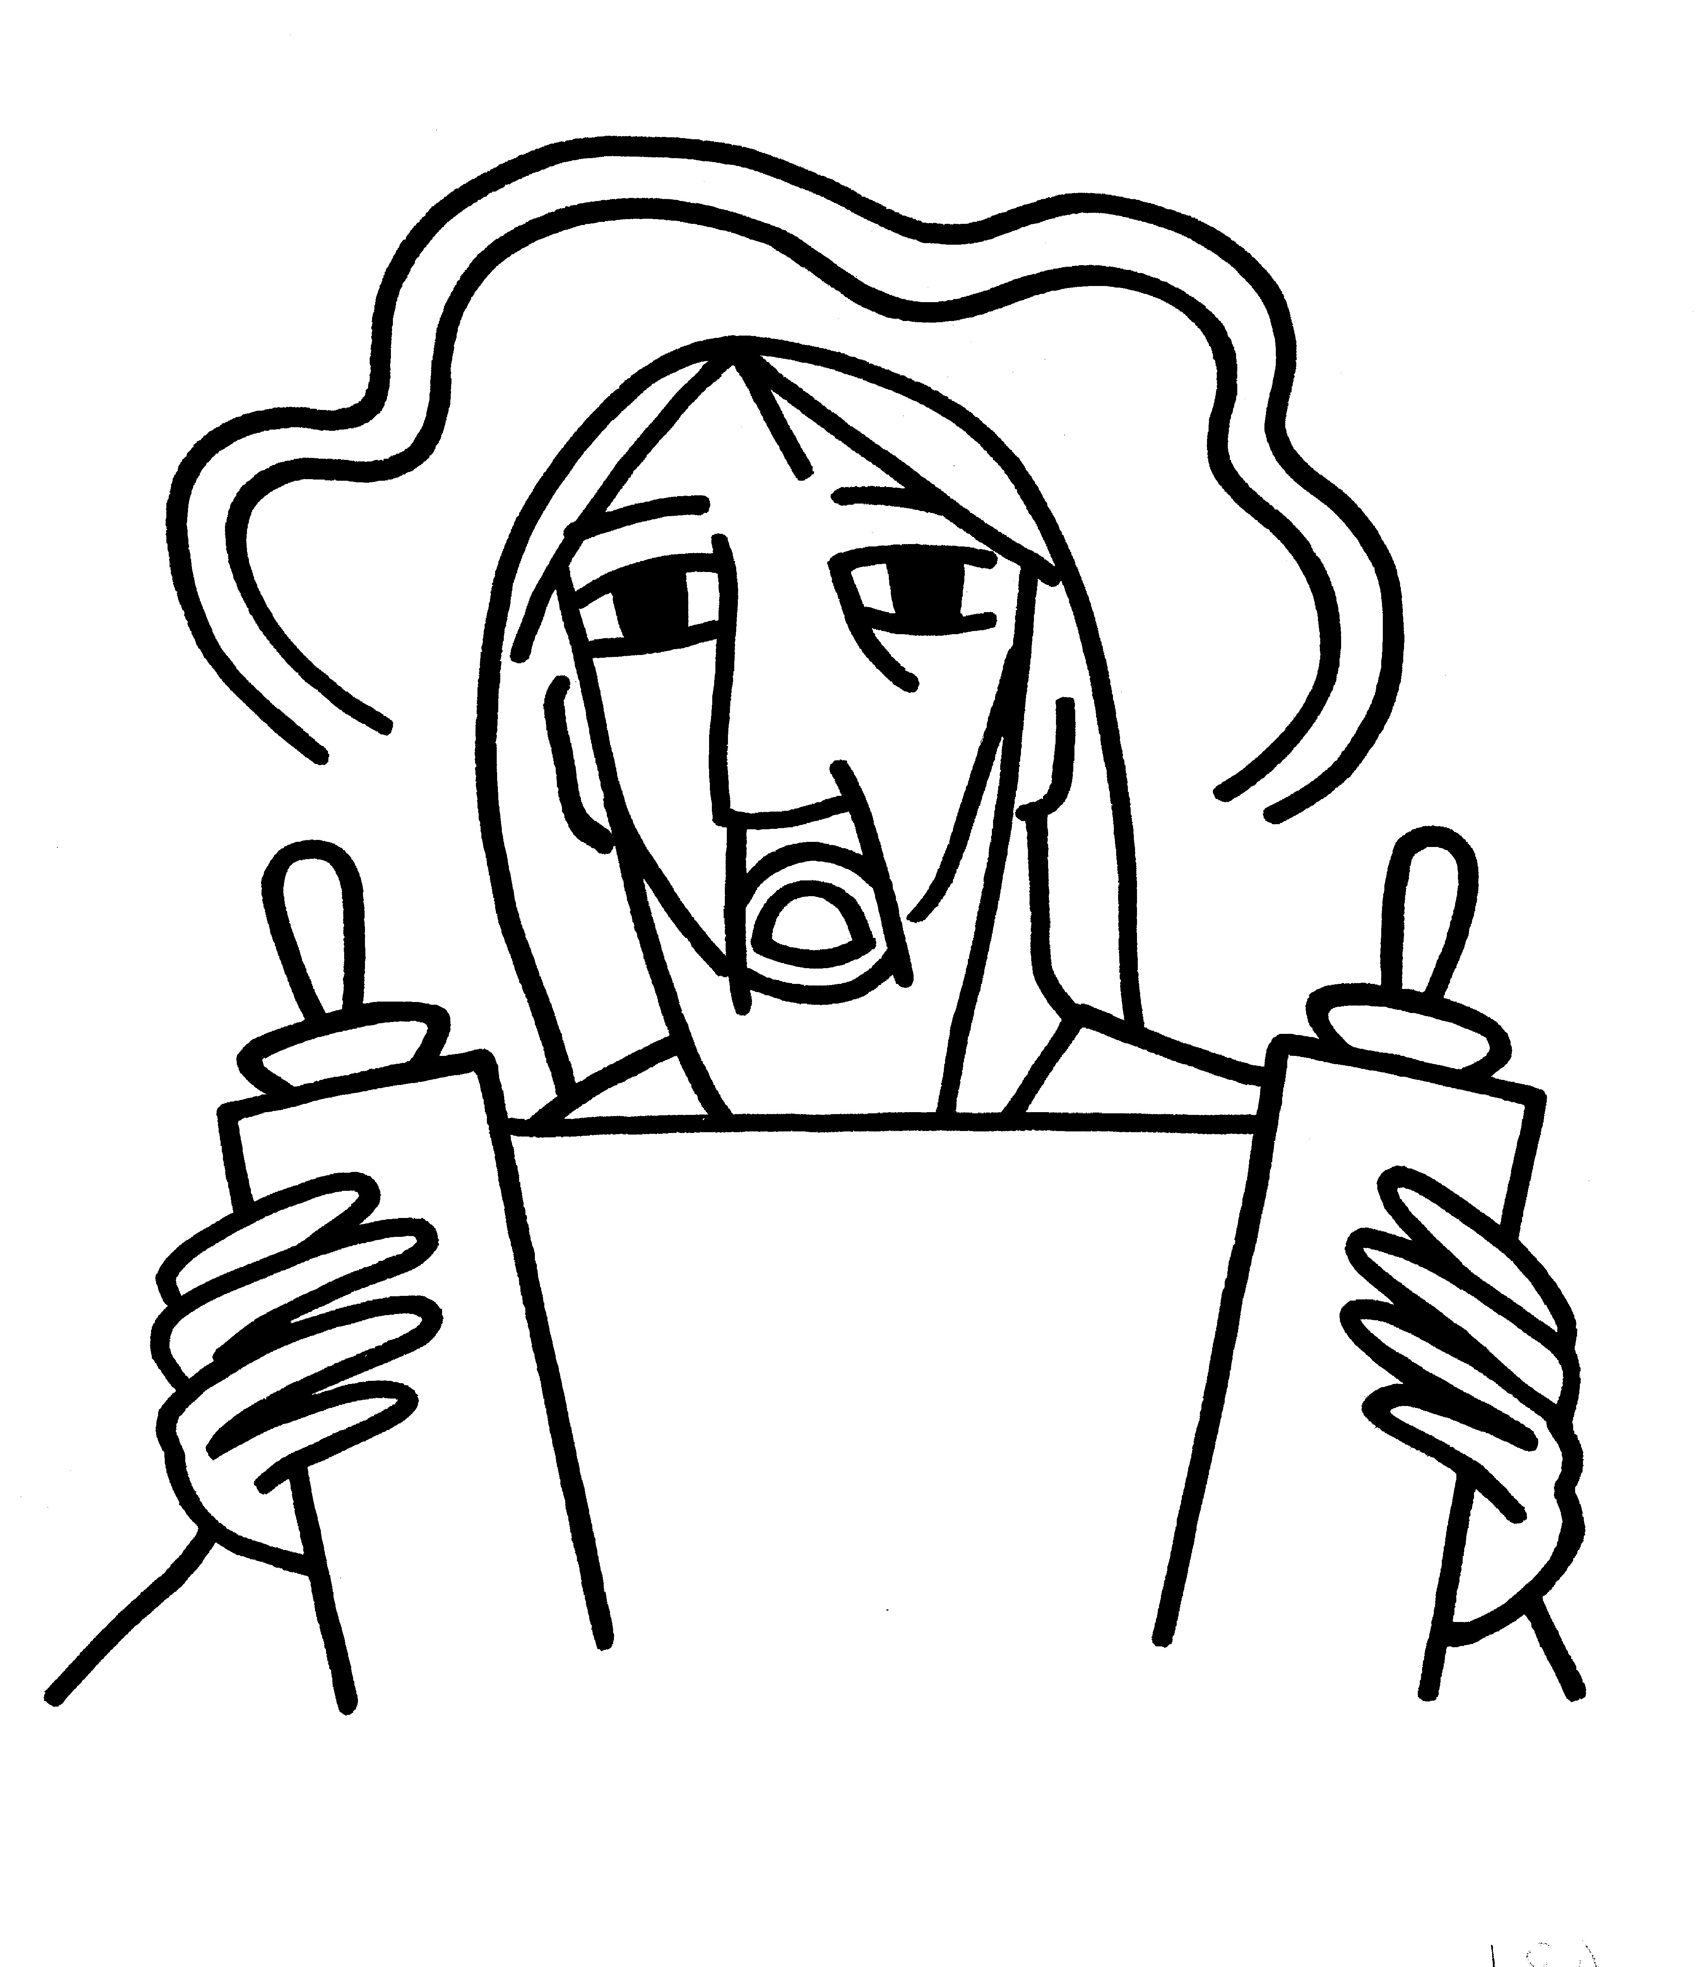 BCP 364
The Breaking of the Bread  BCP 364
Fraction Anthem S-154
All are welcome at the Lord’s table to receive Holy Communion or a blessing. To receive Communion in your pew, please ask an usher to notify the ministers on your behalf. If you require a gluten-free wafer, please ask at the altar rail.
Communion Music Steve Rubardt & Choir
Let us Break Bread Together H 325
Post-Communion Prayer
Eternal God, heavenly Father,
you have graciously accepted us as living members
of your Son our Savior Jesus Christ,
and you have fed us with spiritual food
in the Sacrament of his Body and Blood.
Send us now into the world in peace,
and grant us strength and courage
to love and serve you
with gladness and singleness of heart;
through Christ our Lord. Amen.
Amen.
Blessing (BCP p. 366)
The blessing of God Almighty, the Father, the Son, and the Holy Spirit, be upon you and remain with you for ever.
Amen.
The Recessional Hymn For All the Saints H 287
Dismissal (BCP p. 366)
 | Let us go forth in the name of Christ.
People | Thanks be to God.
Postlude Steve Rubardt
Please remain seated
SERVING TODAY
Celebrant and Preacher: Pastor Cindy Beck
Acolyte: Susie Hand
Lector: Ann Kyser , Lorena Reinhardt
Intercessor: Alfred Escoffier
Worship Musician: Steve Rubardt
Choir Leader: Steve Rubardt
Choir: Liz Carpenter, Heather Dahlberg, Scott Sherman, Lucy Maushardt, Patsy Gralow, Laurell Meredith, Mary Omodt, Barbara Feduska, Tara Anderson
Sunday School - Child Care: Wendy Aguilar Appt Only
Ushers: John Eiler
Tech Chaplain: Marcos Rendon
Altar Guild: Susie Hand
AG Flowers: Marianne Uhl
Hospitality: Lucy Maushardt , Arminda Eiler

Prayers requested for these on Trinity’s long-term prayer list: Baby Walker David, Armando P, Laura Basett, , Georgia Bostedt, Muff Davey, John Eiler, Gerrilee Fisher, Claire Ginesi, Mary Griffin, David & Christine Hilt, Dr. Tamer Keshen, Marie Lambert, Mark Mezzetta, Kelcey Omodt, Grizelda Ponce, Barry Reap, Blake W, Robert R, Ann Loveland Sherman, John Spooner, James Thomas, Rose Burns, Jennifer Gralow, Patsy Gralow, Steve Antenen, Sandra Leland, John Forester, Stuart , Melissa White.
Prayers for the Repose of soul: Tim Dowd , Susan Bassett, Joan Biersch, Mere Nagasau, Christina Van Krugel, Linda Dowd, Peggy and John Bell, Denny Hoelter, Van Z
Contact Pastoral Care Chair, Lorena lorena.m.reinhardt@gmail.com to make any additions or to remove names from our Long-Term Prayer list.

Calendar of the Church Year
The calendar (BCP, pp. 15-33) orders the liturgical year of the Episcopal Church by identifying two cycles of feasts and holy days-one dependent upon the movable date of Easter Day and the other dependent upon the fixed date of Christmas, Dec. 25. Easter Day is the first Sunday after the full moon that falls on or after Mar. 21. The sequence of all Sundays in the church year is based on the date of Easter. Tables and rules for finding the date of Easter Day, and other movable feasts and holy days are provided by the BCP, pp. 880-885. The date of Easter determines the beginning of the season of Lent on Ash Wednesday and the date of Pentecost on the fiftieth day of the Easter season. The Sundays of Advent are always the four Sundays before Christmas Day. The church year begins on the first Sunday of Advent. The calendar also identifies and provides directions concerning the precedence and observance of principal feasts, Sundays, holy days (including Feasts of our Lord, other major feasts, and fasts), Days of Special Devotion, and Days of Optional Observance. The calendar lists dates for celebration of major feasts and lesser feasts by month and date. Appropriate Sunday Letters and Golden Numbers are also provided. (see BCP, pp. 880-881). The calendar also lists the titles of the seasons, Sundays, and major holy days observed in the Episcopal Church throughout the church year, including Advent season, Christmas season, Epiphany season, Lenten season, Holy Week, Easter season, the season after Pentecost, holy days, and National Days.
Notes on the Epiphany Season Liturgy
In the weeks after Epiphany, other events in Jesus’ ministry are celebrated, events such as his first miracle, changing water into wine; his first healing; his calling of the disciples; his first preaching. These events reveal him as God’s Son and help us explore more deeply the unlimited extent of his love and our role—as the members of his Body—in revealing him to the world.
The liturgical texts for this period are very expressive of its meaning and embody many of the symbols, both biblical and cultural, which came to be part of the season:
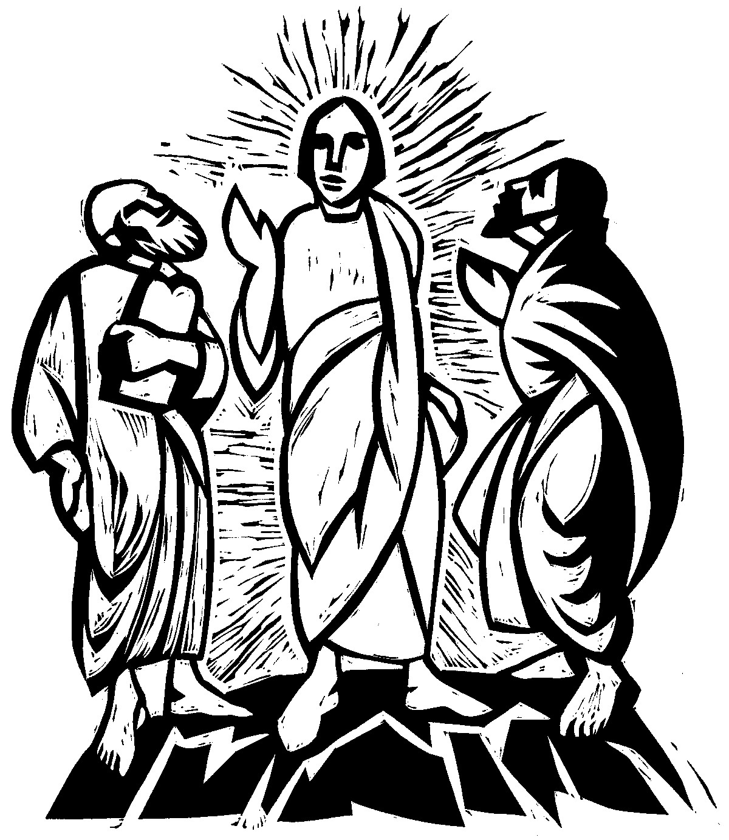
Trinity Liturgical Ministry ROTA Next two weeks
Date | Celebrant | Ushers | Acolyte / EM | Lector (s) | Intercessor | Altar Guild | Altar Flowers
Feb 22 | Cindy Beck | John Eiler | Arminda Eiler | Gerrilee Fisher , John Eiler | Claire Ginesi | Laurell Meredith , Liz Carpenter | Marianne Uhl
March 1 | Cindy Beck | TBD | TBD | TBD | TBD | TBD | N/a

Schedule of Weekly Meetings and Services at Trinity Episcopal Sonoma
Day | Date | Time | Occasion | Location
Wednesday | February 18 | 11 AM | Bible Study | Library
Thursday | February 19 | 10:30 AM  5:30 PM | Mindfulness & Well Being  Alcoholics Anonymous | Library  Buttrum Hall
Saturday | February 21 | 8 AM | Centering Prayer | St. Luke’s Chapel
Sunday | Feb 22 | 10:15 AM | Holy Eucharist II | Sanctuary
Mon-Fri | Weekdays | 7AM-1PM | Sonoma Home Meals | Kitchen &Buttrum Hall
Mon-Fri | Weekdays | 9-2 | Sonoma Preschool Academy – School

Monthly Meetings at Trinity Episcopal Sonoma
Day | Date | Time | Meeting | Location | Contact
Tuesday | TBD | 11 AM | Prayer Shawl Ministry | Library | Norah Collins 28norahe@gmail.com
Thursday | TBD | 4:30 PM | Vestry | Library | Claire Ginesi cfgsonoma@gmail.com
PRAYERS and BLESSINGS
For a Birthday
Watch over your child, O Lord as his/her days increase; bless and guide him/her wherever s/he may be. Strengthen them when s/he stands; comfort him/her when discouraged or sorrowful; raise him/her up if s/he fall; and in his/her heart may your peace which passes understanding abide all the days of his/her life; through Jesus Christ our Lord. Amen.
For an Anniversary
O God, you have so consecrated the covenant of marriage that it represents the spiritual unity between Christ and his Church: Send your blessing upon these your servants as they celebrate their anniversary, that they may continue to love, honor and cherish each other in faithfulness and patience, in wisdom and true godliness, that their home may be a haven of blessing and peace; through Jesus Christ our Lord, who lives and reigns with you and the Holy Spirit, one God, now and forever. Amen.
For Travelers
O God, our heavenly Father, whose glory fills the whole creation, and whose presence we find wherever we go; preserve those who travel; surround them with your loving care; protect them from every danger, and bring them in safety to their journey’s end; through Jesus Christ our Lord. Amen.
Sending our Eucharistic Visitors
Priest: In the name of this congregation, I send you forth bearing these holy gifts, the those to whom you go may share with us in the communion of Christ’s body and blood.
People: We who are many are one body, because we all share on bread, and one cup. Amen

Trinity Episcopal Church
In Sonoma for over 170 years
275 East Spain Street
Sonoma, CA 95476
The Rt. Rev. Megan M. Traquair, Bishop
Diocese of Northern California
Pastor Cindy Beck, Interim
Steve Rubardt, Worship Music
Vestry
Bill Doyle, Junior Warden (Buildings, Grounds)
Bill Doyle (Stewardship)
Susie Hand
Heather Dahlberg
Lorena Reinhardt (Pastoral Care)
Ministries
Prayer Shawl ,Norah Collins
Outreach, Jane Hernandez
Youth – Academic Tutoring, Karen Randall
Mindfulness & Well Being, Mary Omodt
Sunday School, Children, Wendy Aguilar

The Members of the Congregation are The Ministers of the Church

Administrative Office Hrs.
Monday Wednesday 9 A.M. – 2 PM; Thursday 10A.M.-2 P.M0
Sunday 9:30-11:30
Clergy Office Hours Wednesdays, Thursdays, by appointment

Emergency, sickness, please contact office: 707-938-4846

