Trinity Episcopal Church
Cultivating God’s Loving Spirit in Each of Us
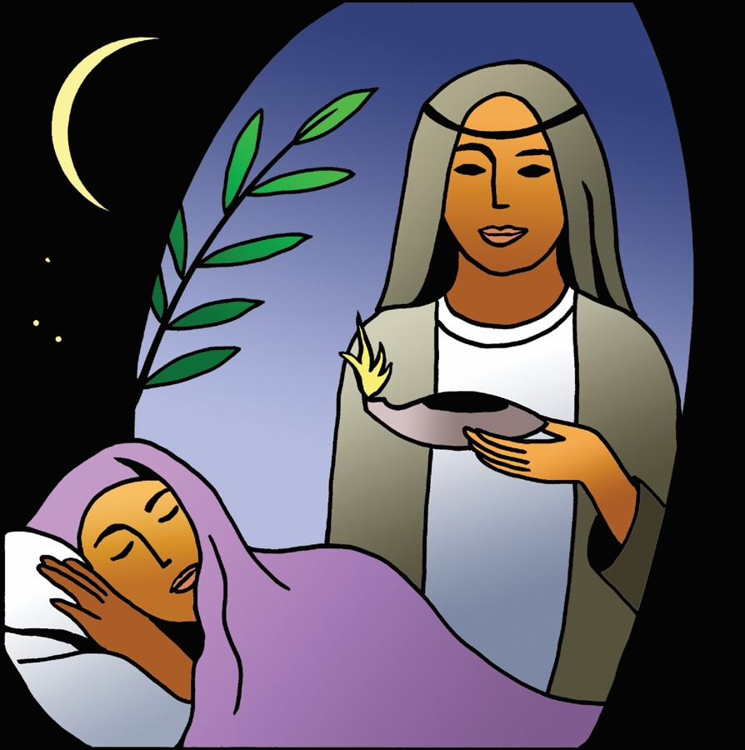
(Proper 27)
Year A
Holy Eucharist II
November 8, 2026
10:00 AM In person and Online

Welcome to Trinity Episcopal, Sonoma. Whether you are passing through or looking for a church home, we are blessed by your presence and we invite you to worship with us fully – singing, praying and receiving communion- with your voice and heart. Please sign our guestbook at the back of the church, including your email.
If you would like to learn more about The Episcopal Church, please send us an email trinityepiscopalsonoma@comcast.net. We look forward to meeting you after the service where coffee and treats are served.

All are welcome to make a gift and offering in thanksgiving to God; for the many blessings we have received. To take advantage of our electronic giving options, please follow the QR code with your capable electronic device, or visit https://onrealm.org/trinitysonoma/-/form/give/default
November Announcements
Fellowship Coffee Hour Sign up – Fellowship follows the service! We meet in the hall or courtyard. We’d love to visit with you.
Thank you to everyone who donated food for A Simple Gesture, your gift helps people have a meal! Our pick up was this November 10th! Stay tuned for information on the next pick up!
Movie Night at Trinity will continue on Novmeber 18th, at 6PM in Buttram Hall. We will be showing “Paper Moon”. There will be snacks and refreshements during the post film discussion.
Prelude Steve Rubardt
Please stand for the Entrance Hymn.
At the sound of the bell, please stand as you are able. The People respond when bold text appears.
The Word of God
Entrance Hymn Jerusalem my Happy Home H 620
Opening Acclamation BCP 319
Celebrant | Blessed be God: Father, Son, and Holy Spirit.
People | And blessed be his kingdom, now and for ever. Amen.
Collect for Purity
Almighty God, to you all hearts are open, all desires known, and from you no secrets are hid: Cleanse the thoughts of our hearts by the inspiration of your Holy Spirit, that we may perfectly love you, and worthily magnify your holy Name; through Christ our Lord. Amen.
Opening Anthem or Song of Praise (BCP p. 356)
Glory to God in the highest,
and peace to his people on earth.
Lord God, heavenly King,
almighty God and Father,
we worship you, we give you thanks,
we praise you for your glory.
Lord Jesus Christ, only Son of the Father,
Lord God, Lamb of God,
you take away the sin of the world:
have mercy on us;
you are seated at the right hand of the Father:
receive our prayer.
For you alone are the Holy One,
you alone are the Lord,
you alone are the Most High,
Jesus Christ,
with the Holy Spirit,
in the glory of God the Father. Amen.
The Collect of the Day BCP 357
Celebrant | The Lord be with you.
People | And also with you.
Celebrant | Let us pray.
Almighty God, you have knit together your elect in one communion and fellowship in the mystical body of your Son Christ our Lord: Give us grace so to follow your blessed saints in all virtuous and godly living, that we may come to those ineffable joys that you have prepared for those who truly love you; through Jesus Christ our Lord, who with you and the Holy Spirit lives and reigns, one God, in glory everlasting.
All Amen.

The Lessons
First Reading: Wisdom of Solomon 6:12-16
Reader A Reading from the book of Wisdom.
¹²Wisdom is radiant and unfading,
and she is easily discerned by those who love her,
and is found by those who seek her.
¹³She hastens to make herself known to those who desire her.
¹⁴One who rises early to seek her will have no difficulty,
for she will be found sitting at the gate.
¹⁵To fix one’s thought on her is perfect understanding,
and one who is vigilant on her account will soon be free from care,
¹⁶because she goes about seeking those worthy of her,
and she graciously appears to them in their paths,
and meets them in every thought.
Reader | The Word of the Lord.
People | Thanks be to God.
The Psalm: A Song of the Love of Wisdom
Reader We will read A Song of the Love of Wisdom, responsively by half verse.
The beginning of wisdom *
is the true desire to receive teaching,
and a longing to be taught *
comes from a love of her;
the one who loves her *
will keep her laws.
Observing the laws of wisdom *
assures immortality,
and immortality brings one *
nearer still to God;
so the desire for wisdom *
leads to the authority of one who rules.

Second Reading: 1 Thessalonians 4:13-18
Reader A Reading from Paul's First letter to the Church in Thessalonika.
¹³We do not want you to be uninformed, brothers and sisters, about those who have died, so that you may not grieve as others do who have no hope. ¹⁴For since we believe that Jesus died and rose again, even so, through Jesus, God will bring with him those who have died. ¹⁵For this we declare to you by the word of the Lord, that we who are alive, who are left until the coming of the Lord, will by no means precede those who have died. ¹⁶For the Lord himself, with a cry of command, with the archangel’s call and with the sound of God’s trumpet, will descend from heaven, and the dead in Christ will rise first. ¹⁷Then we who are alive, who are left, will be caught up in the clouds together with them to meet the Lord in the air; and so we will be with the Lord forever. ¹⁸Therefore encourage one another with these words.
Reader | The Word of the Lord.
People | Thanks be to God.
Sequence Hymn O Love of God, How Strong and True H 455 v 1 & 2
The Holy Gospel: Matthew 25:1-13
Celebrant | The Holy Gospel of our Lord Jesus Christ according to Matthew.
People | Glory to you, Lord Christ.
[Jesus said,] ¹“Then the kingdom of heaven will be like this. Ten bridesmaids took their lamps and went to meet the bridegroom. ²Five of them were foolish, and five were wise. ³When the foolish took their lamps, they took no oil with them; ⁴but the wise took flasks of oil with their lamps. ⁵As the bridegroom was delayed, all of them became drowsy and slept. ⁶But at midnight there was a shout, ‘Look! Here is the bridegroom! Come out to meet him.’ ⁷Then all those bridesmaids got up and trimmed their lamps. ⁸The foolish said to the wise, ‘Give us some of your oil, for our lamps are going out.’ ⁹But the wise replied, ‘No! there will not be enough for you and for us; you had better go to the dealers and buy some for yourselves.’ ¹⁰And while they went to buy it, the bridegroom came, and those who were ready went with him into the wedding banquet; and the door was shut. ¹¹Later the other bridesmaids came also, saying, ‘Lord, lord, open to us.’ ¹²But he replied, ‘Truly I tell you, I do not know you.’ ¹³Keep awake therefore, for you know neither the day nor the hour.”
Celebrant | The Gospel of the Lord.
People | Praise to you, Lord Christ.
Sequence Hymn O Love of God, How Strong and True H 455 v 3 & 4


Sermon Pastor Cindy Beck
The Nicene Creed (BCP p. 358)
We believe in one God, the Father, the Almighty, maker of heaven and earth, of all that is, seen and unseen.
We believe in one Lord, Jesus Christ, the only Son of God, eternally begotten of the Father, God from God, Light from Light, true God from true God, begotten, not made, of one Being with the Father. Through him all things were made. For us and for our salvation he came down from heaven: by the Power of the Holy Spirit he became incarnate from the Virgin Mary, and was made man. For our sake he was crucified under Pontius Pilate; he suffered death and was buried. On the third day he rose again in accordance with the Scriptures; he ascended into heaven and is seated at the right hand of the Father. He will come again in glory to judge the living and the dead, and his kingdom will have no end.
We believe in the Holy Spirit, the Lord, the giver of life, who proceeds from the Father and the Son. With the Father and the Son he is worshipped and glorified. He has spoken through the Prophets. We believe in one holy catholic and apostolic Church. We acknowledge one baptism for the forgiveness of sins. We look for the resurrection of the dead, and the life of the world to come. Amen.

The Prayers of the People
Celebrant: Alleluia! Let us join the countless throngs who sing God’s praises, praying, “We bless you, O Lord; your praise is ever in our mouth.”
Intercessor: In the Diocesan Cycle of Prayer, we pray for St. John’s in Petaluma.
In the Anglican Cycle of Prayer, we pray for The Province de L’eglise Anglicane du Congo.
We bless you, O Lord;
Your praise is ever in our mouths.
God of all people, you love us and call us your children: In a world of violence and war, you bless the peacemakers. Make us instruments of healing and peace.
Silence
We bless you, O Lord;
Your praise is ever in our mouths.
God of creation, you love us and call us your children: you have given this earth to the meek. May our steps be gentle and leave a small footprint on our earth. As it has been handed on to us, may we carefully preserve this creation for future generations, +_____________.
Invite the congregation to add their thanksgivings, followed by silence
We bless you, O Lord;
Your praise is ever in our mouths.
God of the city, you love us and call us your children: bless the poor with good things. Visit our impoverished neighborhoods with hope, mercy, and relief. Give us hearts for the poor in our region.
Silence
We bless you, O Lord;
Your praise is ever in our mouths.
God of the mournful and suffering, you love us and call us your children: comfort and heal those in need. Hear them in their affliction and save them from their troubles, +______________.
Invite the congregation to add their petitions, followed by silence
We bless you, O Lord;
Your praise is ever in our mouths.
God of the Church at rest, you love us and call us your children: we praise you for the faith and witness of all the saints. May their prayers and presence continue to strengthen us. It is with their triumphant voices that we join our own prayers and praises. Alleluia! +__________.
Invite the congregation to add their petitions, followed by silence
We bless you, O Lord;
Your praise is ever in our mouths.
Celebrant Almighty God, whose gifts of blessing and grace have no end, write in our hearts your joy and zeal to tell the story of our faith by our words, by our deeds, and by offering all that you have given us: our lives, our gifts, our resources. Grant us also a portion of your never-ending generosity, that we may proclaim your love and mercy to the world around us through our parish community; through Jesus Christ our Lord and Savior.
Amen.
Confession of Sin BCP 359
Most merciful God, we confess that we have sinned against you in thought, word and deed, by what we have done, and by what we have left undone.
We have not loved you with our whole heart; we have not loved our neighbors as ourselves. We are truly sorry and we humbly repent.
For the sake of your Son Jesus Christ, have mercy on us and forgive us; that we may delight in your will, and walk in your ways, to the glory of your Name. Amen.

The Peace
Celebrant The peace of the Lord be always with you.
People And also with you.

Announcements
Birthdays, Anniversaries, Travelers (prayers found at back of bulletin)
The Holy Communion
The Offertory At the Offering, you’ll find a Pledge card in the Pew Rack for those who’d like to designate their financial donations to Trinity’s Pledging Income. For others, or a one-time gift, envelopes are in the pew racks as well as on the Narthex table or text TRINITYSONOMA" to 73256. Thank you!
Offertory Music
Steve Rubardt and Choir I’m Just a Poor Wayfaring Stranger LEVAS 19
Doxology
Praise God, from whom all blessings flow;
Praise Him, all creatures here below;
Praise Him above, ye heav'nly host;
Praise Father, Son, and Holy Ghost.
Amen.
The people stand while the offerings are presented and placed on the Altar.
Presider: Gracious God, as an offering of our thanksgiving and gratitude, we return to you a portion of what you have gifted us.
The Great Thanksgiving
Eucharistic Prayer B BCP 367
Celebrant | The Lord be with you.
People | And also with you.
Celebrant | Lift up your hearts.
People | We lift them to the Lord.
Celebrant | Let us give thanks to the Lord our God.
People | It is right to give him thanks and praise.
Proper Preface (BCP p. 367)
It is right, and a good and joyful thing, always and everywhere to give thanks to you, Father Almighty, Creator of heaven and earth.
For you are the source of light and life; you made us in your image, and called us to new life in Jesus Christ our Lord.
Therefore we praise you, joining our voices with Angels and Archangels and with all the company of heaven, who for ever sing this hymn to proclaim the glory of your Name:
Sanctus Holy Holy, Holy (Proulx) Hymnal S-125

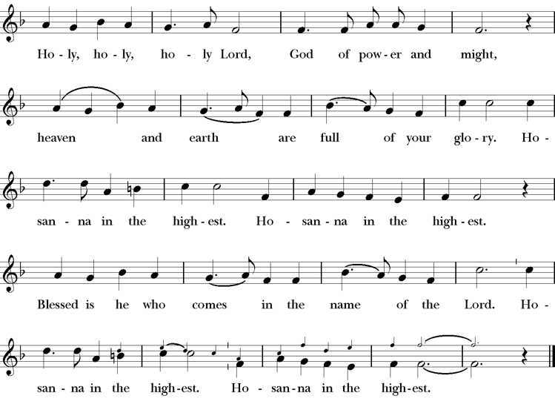

Presider Holy and gracious Father: In your infinite love you made us for yourself; and, when we had fallen into sin and become subject to evil and death, you, in your mercy, sent Jesus Christ, your only and eternal Son, to share our human nature, to live and die as one of us, to reconcile us to you, the God and Father of all.
He stretched out his arms upon the cross, and offered himself, in obedience to your will, a perfect sacrifice for the whole world.
On the night he was handed over to suffering and death, our Lord Jesus Christ took bread; and when he had given thanks to you, he broke it, and gave it to his disciples, and said, “Take, eat: This is my Body, which is given for you. Do this for the remembrance of me”
After supper he took the cup of wine; and when he had given thanks, he gave it to them, saying, “Drink this, all of you: this is my blood of the new covenant which is shed for you and for many for the forgiveness of sins. Whenever you drink it, do this for the remembrance of me.”
Presider Therefore we proclaim the mystery of faith.
People Christ has died; Christ is risen; Christ will come again.
Presider We celebrate the memorial of our redemption, O Father, in this sacrifice of praise and thanksgiving. Recalling his death, resurrection, and ascension, we offer you these gifts.
Sanctify them by your Holy Spirit to be for your people the Body and Blood of your Son, the holy food and drink of new and unending life in him. Sanctify us also that we may faithfully receive this holy Sacrament, and serve you in unity, constancy, and peace; and at last day bring us with all your saints into the joy of your eternal kingdom.
All this we ask through your Son Jesus Christ. By him, and with him, and in him, in the unity of the Holy Spirit all honor and glory is yours, Almighty Father, now and for ever.
Amen.

The Lord’s Prayer
Presider As our Savior has taught us, we are bold to pray.
People Our Father, who art in heaven, hallowed be thy name. Thy Kingdom come, thy will be done, on earth as it is in heaven. Give us this day our daily bread. And forgive us our trespasses, as we forgive those who trespass against us. And lead us not into temptation, but deliver us from evil. For thine is the kingdom, the power and the glory, for ever and ever. Amen.

The Breaking of the Bread
The Presider breaks the consecrated bread in view of the assembly.
Presider The Gifts of God for the people of God.
People Therefore let us keep the feast. Alleluia

Invitation to Communion
Presider This is the Lord’s table. The Lord Jesus invites us to share this joyful feast.
Sharing the Sacred Meal
This is Christ’s table and all are welcome and all are fed.
Communion Music The Lord’s Prayer LEVAS 264
Post-Communion Prayer BCP 365
The Blessing
The Recessional Hymn Come Thou Font of Every Blessing H 686
The Dismissal*
Celebrant | Let us go forth in the name of Christ.
People | Thanks be to God.
Postlude Steve Rubardt Please remain seated

SERVING TODAY
Celebrant & Preacher: Pastor Cindy Beck
Acolyte: Claire Ginesi
Lector: Barbara Feduska , Gerrilee Fisher
Intercessor: Jane Hernandez
Worship Musician: Steve Rubardt
Choir Leader: Steve Rubardt
Choir: Liz Carpenter, Heather Dahlberg, Scott Sherman, Patsy Gralow, Laurell Meredith, Mary Omodt, Barbara Feduska, Tara Anderson, Carol Heffler, Don McMahon
Sunday School - Child Care: Wendy Aguilar
Ushers: Alfred Escoffier
Tech Chaplain: Marcos Rendon
Altar Guild: Mary Omodt
Hospitality : Tara Anderson

Prayers requested for these on Trinity’s long-term prayer list: Armando P, Georgia Bostedt, John Eiler, Gerrilee Fisher, Claire Ginesi, Mary Griffin, David & Christine Hilt, Mark Mezzetta, Kelcey Omodt, Grizelda Ponce, Barry Reap, Blake W, Robert R, Melissa White, Ann Loveland Sherman, James Thomas, Rose Burns, Jennifer Gralow, Patsy Gralow, Steve Antenen, Sandra Leland, Karl, Michael Hardy, Michael Bean Land, Polly Moore, Sinat Liv, Will Maushardt, Sophia Piconi, Mike Smith, Jean Maffoli.
Prayers for the Repose of soul: Tim Dowd , Susan Bassett, Joan Biersch, Linda Dowd, Christina Van Krugel, Mere Nagasau, Mary Goshert, Peggy Bell, Carolyn Caldwell, Van Z, Dolores Mae Seaberg Cole, Muff Davey, Giancarlo Cestarollo.
Contact Pastoral Care Chair, Lorena lorena.m.reinhardt@gmail.com to make any additions or to remove names from our Long-Term Prayer list.
Notes on the Service Bulletin This service bulletin is a guide to the service. We use a variety of printed materials for the prayers, the scriptural readings and the hymns. The Readings for the week, including the Collect and Readings are found in this Bulletin. The service follows the liturgies that are found in the Book of Common Prayer (BCP). The BCP is the blue book found in the pew in front of you. The hymns come primarily from The 1982 Hymnal, also in the pew – the red book. Lift Every Voice and Sing (LEVAS) is another hymnal located in the pew rack. VF stands for Voices Found, another authorized hymnal. Sound Mate Assisted Hearing devices available at the back of the church on the Narthex Table.


Trinity Liturgical Ministry ROTA Next two weeks
Date | Celebrant | Ushers | Acolyte | Lector (s) | Intercessor | Altar Guild
11/15 | Cindy Beck | Alfred Escoffier | Susie Hand | Ann Kyser , Lorena Reinhardt | Douglas Griffin | Ann Kyser
11/22 | Cindy Beck | Marcia Derby | Arminda Eiler | Lorena Reinhardt , John Eiler | Ann Kyser | Ann Kyser

Schedule of Weekly Meetings and Services at Trinity Episcopal Sonoma
Day | Date | Time | Occasion | Location
Wednesday | November 11 | 11 AM | Bible Study | Library
Thursday | November 12 | 10:30 AM  5:30 PM | Mindfulness & Well Being  Alcoholics Anonymous | Library  Buttrum Hall
Saturday | November 14 | 8 AM | Centering Prayer | St. Luke’s Chapel
Sunday | November 15 | 10:00 AM | Holy Eucharist II | Sanctuary
Mon-Fri | Weekdays | 7AM-1PM | Sonoma Home Meals | Kitchen &Buttrum Hall
Mon-Fri | Weekdays | 9-2 | Sonoma Preschool Academy – School

Monthly Meetings at Trinity Episcopal Sonoma
Day | Date | Time | Meeting | Location | Contact
Tuesday | November 3 | 11 AM | Prayer Shawl Ministry | Library | Lorena Reinhardt lorena.m.reinhardt@gmail.com
Thursday | TBD | TBD | Vestry | Library | Cindy Beck 916-955-9861
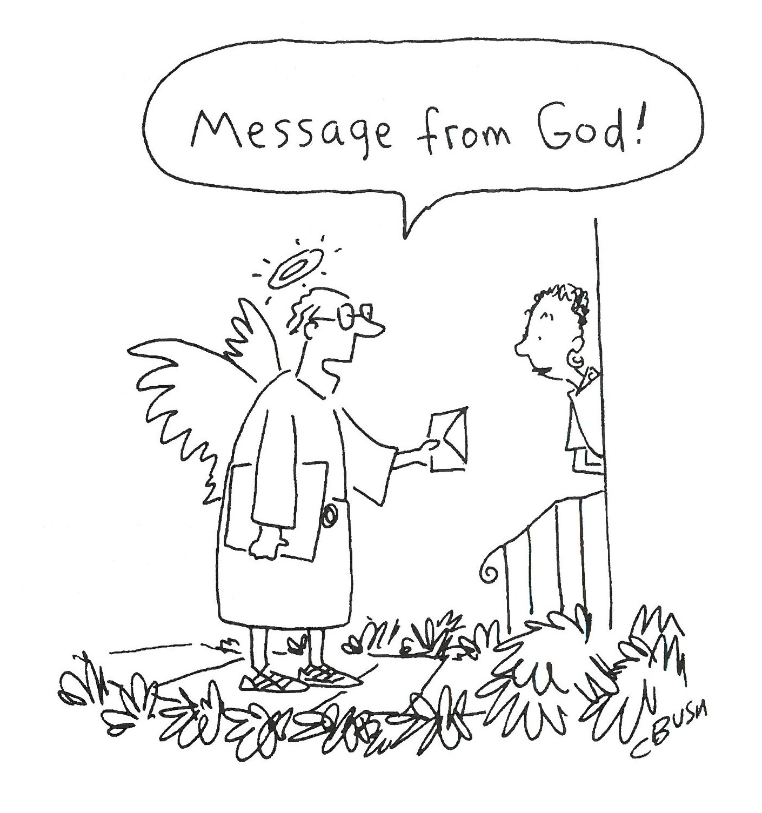

PRAYERS and BLESSINGS
For a Birthday
Watch over your child, O Lord as his/her days increase; bless and guide him/her wherever s/he may be. Strengthen them when s/he stands; comfort him/her when discouraged or sorrowful; raise him/her up if s/he fall; and in his/her heart may your peace which passes understanding abide all the days of his/her life; through Jesus Christ our Lord. Amen.
For an Anniversary
O God, you have so consecrated the covenant of marriage that it represents the spiritual unity between Christ and his Church: Send your blessing upon these your servants as they celebrate their anniversary, that they may continue to love, honor and cherish each other in faithfulness and patience, in wisdom and true godliness, that their home may be a haven of blessing and peace; through Jesus Christ our Lord, who lives and reigns with you and the Holy Spirit, one God, now and forever. Amen.
For Travelers
O God, our heavenly Father, whose glory fills the whole creation, and whose presence we find wherever we go; preserve those who travel; surround them with your loving care; protect them from every danger, and bring them in safety to their journey’s end; through Jesus Christ our Lord. Amen.
Sending our Eucharistic Visitors
Priest: In the name of this congregation, I send you forth bearing these holy gifts, the those to whom you go may share with us in the communion of Christ’s body and blood.
People: We who are many are one body, because we all share on bread, and one cup. Amen.

Trinity Episcopal Church
In Sonoma for over 170 years
275 East Spain Street
Sonoma, CA 95476
The Rt. Rev. Megan M. Traquair, Bishop
Diocese of Northern California
Pastor Cindy Beck, Interim
Steve Rubardt, Worship Music
Vestry
Bill Doyle, Senior Warden & Stewardship
Susie Hand
Heather Dahlberg
Sally Zimmerman
Lorena Reinhardt (Pastoral Care)
Luke Bohanan
Mandy Birkbeck
Ministries
Prayer Shawl, Lorena Reinhardt
Outreach, Jane Hernandez
Mindfulness & Well Being, Mary Omodt
Sunday School, Children, Wendy Aguilar

The Members of the Congregation are The Ministers of the Church

Administrative Office Hrs.
Monday Wednesday 9 A.M. – 2 PM; Thursday 10A.M.-2 P.M0
Sunday 9:30-11:30
Clergy Office Hours Wednesdays, Thursdays, by appointment

Emergency, sickness, please contact office: 707-938-4846

