Trinity Episcopal Church
In Sonoma for over 170 years

The Fifth Sunday after the Epiphany
Epiphany 5 (Year A)
Holy Eucharist II
February 8, 2026
10:00 AM In person and Online
Welcome to Trinity Episcopal, Sonoma!
Whether you have wandered in, are wondering about God or grew up in the church, or wherever you are in your journey...you are welcome here... We are blessed by your presence.
For Visitors and Newcomers:
Everyone is welcome to receive communion at the Lord’s table. Jesus gave this tangible reminder of God’s presence, love, and forgiveness for all. If you are interested in a visit or call from the Priest-in-Charge , please sign our guest book on the table at the entrance of the church, including an email or phone number.
Restrooms
A restroom is located outside the entrance of Buttrum Hall (the building across the courtyard) and another is located inside the hall to the right.
Coffee and Treats:
Following worship we have coffee and treats after service in Buttrum Hall. We hope it is a time to get to know you better.
To access Trinity’s Guest WIFI: Password Rosepettal441 (case sensitive).
We are glad you are here, and we invite you to enter fully into worship this morning.
February Announcements
Fellowship Coffee Hour Sign up - We encourage members to sign up to make coffee. Pastor Cindy is happy to demonstrate how easy this is. Please help us provide this hospitality for guests and members.
The February, March, April Forward Day by Day , a booklet of daily inspirational meditations is now available in the Church and the Office. We ask for a $2 donation.
Next month, St. Pauls in Healdsburg organ concert series will feature John Karl Hirten, Director of Music at St. John's Episcopal in Ross, CA. John will play pieces by J. S. Bach, Milhaud, Bruhns, Hewitt as well as one of his own compositions! The performance will be held in the church on Sunday, February 15 at 5:00 pm. Admission is free.
Movie Night Wednesday, February 11 @ 6PM. Our movie is "The Mortal Storm" starring Jimmy Stewart, Margaret Sullivan and Robert Young. The film shows the impact on Germans, focusing on the family and friends of a Non-Aryan Professor, after Hitler becomes chancellor of Germany and gains unlimited power. Discussion and food will follow.
Lectio Divina Bible Study is on Wednesday, at 11AM in the library. Lectio Divina, Latin for "divine reading," is a contemplative practice of scriptural reading, meditation, and prayer intended to promote communion with God. Unlike traditional Bible study that focuses on intellectual information, Lectio Divina emphasizes spiritual formation and personal intimacy with God.
Welcome to our new Vestry members! Mandy Birkbeck, Susie Hand, Sally Zimmerman and Luke Bohanan; prayerfully let their names go forward and were elected to Trinity's Vestry. Keep them and the vestry in prayer as we begin a new year of serving God through leadership at Trinity.
Ash Wednesday is Wednesday, Feb 18th. This begins our journey through Lent, a time of intentional reflection of our life in Christ. A Service will be held at 5pm with imposition of ashes.
All are welcome to make a gift and offering in thanksgiving to God;
for the many blessings we have received. To take advantage of our electronic giving options, please follow the QR code with your capable electronic device, or visit https://onrealm.org/trinitysonoma/-/form/give/default Help us to make this a place where God’s grace is freely shared by all.

Prelude Steve Rubardt
Please stand for the Entrance Hymn.
At the sound of the bell, please stand as you are able. The People respond when bold text appears.
The Word of God
Entrance Hymn Praise to the Living God H 372
Opening Acclamation (BCP p. 355)
The people standing, the Celebrant says
 | Blessed be God: Father, Son, and Holy Spirit.
People | And blessed be his kingdom, now and for ever. Amen.
Collect for Purity
All Almighty God, to you all hearts are open, all desires known, and from you no secrets are hid: Cleanse the thoughts of our hearts by the inspiration of your Holy Spirit, that we may perfectly love you, and worthily magnify your holy Name; through Christ our Lord. Amen.
Song of Praise Gloria BCP 356/Hymnal S-280
All Glory to God in the highest,
and peace to his people on earth.
Lord God, heavenly King,
almighty God and Father,
we worship you, we give you thanks,
we praise you for your glory.
Lord Jesus Christ, only Son of the Father,
Lord God, Lamb of God,
you take away the sin of the world:
have mercy on us;
you are seated at the right hand of the Father:
receive our prayer.
For you alone are the Holy One,
you alone are the Lord,
you alone are the Most High,
Jesus Christ,
with the Holy Spirit,
in the glory of God the Father. Amen.
The Collect of the Day BCP 357
Celebrant | The Lord be with you.
People | And also with you.
Celebrant | Let us pray.
Set us free, O God, from the bondage of our sins, and give us the liberty of that abundant life which you have made known to us in your Son our Savior Jesus Christ; who lives and reigns with you, in the unity of the Holy Spirit, one God, now and for ever.
All Amen.
The Lessons
First Reading: Isaiah 58:1-9a [9b-12]
Reader A Reading from the book of the prophet Isaiah.
¹Shout out, do not hold back!
Lift up your voice like a trumpet!
Announce to my people their rebellion,
to the house of Jacob their sins.
²Yet day after day they seek me
and delight to know my ways,
as if they were a nation that practiced righteousness
and did not forsake the ordinance of their God;
they ask of me righteous judgments,
they delight to draw near to God.
³“Why do we fast, but you do not see?
Why humble ourselves, but you do not notice?”
Look, you serve your own interest on your fast day,
and oppress all your workers.
⁴Look, you fast only to quarrel and to fight
and to strike with a wicked fist.
Such fasting as you do today
will not make your voice heard on high.
⁵Is such the fast that I choose,
a day to humble oneself?
Is it to bow down the head like a bulrush,
and to lie in sackcloth and ashes?
Will you call this a fast,
a day acceptable to the Lord?
⁶Is not this the fast that I choose:
to loose the bonds of injustice,
to undo the thongs of the yoke,
to let the oppressed go free,
and to break every yoke?
⁷Is it not to share your bread with the hungry,
and bring the homeless poor into your house;
when you see the naked, to cover them,
and not to hide yourself from your own kin?
⁸Then your light shall break forth like the dawn,
and your healing shall spring up quickly;
your vindicator shall go before you,
the glory of the Lord shall be your rear guard.
^{9a}Then you shall call, and the Lord will answer;
you shall cry for help, and he will say, Here I am.
[ ^{9b}If you remove the yoke from among you,
the pointing of the finger, the speaking of evil,
¹⁰if you offer your food to the hungry
and satisfy the needs of the afflicted,
then your light shall rise in the darkness
and your gloom be like the noonday.
¹¹The Lord will guide you continually,
and satisfy your needs in parched places,
and make your bones strong;
and you shall be like a watered garden,
like a spring of water,
whose waters never fail.
¹²Your ancient ruins shall be rebuilt;
you shall raise up the foundations of many generations;
you shall be called the repairer of the breach,
the restorer of streets to live in. ]
Reader | The Word of the Lord.
People | Thanks be to God.
The Psalm: Psalm 112:1-9
Reader We will read Psalm 112:1-9, responsively by half verse.
¹Hallelujah!
Happy are they who fear the Lord *
and have great delight in his commandments!
²Their descendants will be mighty in the land; *
the generation of the upright will be blessed.
³Wealth and riches will be in their house, *
and their righteousness will last forever.
⁴Light shines in the darkness for the upright; *
the righteous are merciful and full of compassion.
⁵It is good for them to be generous in lending *
and to manage their affairs with justice.
⁶For they will never be shaken; *
the righteous will be kept in everlasting remembrance.
⁷They will not be afraid of any evil rumors; *
their heart is right;
they put their trust in the Lord.
⁸Their heart is established and will not shrink, *
until they see their desire upon their enemies.
⁹They have given freely to the poor, *
and their righteousness stands fast forever;
they will hold up their head with honor.
The Second Reading 1 Corinthians 2:1-12 [13-16]
Reader A Reading from Paul's First letter to the Church in Corinth.
¹When I came to you, brothers and sisters, I did not come proclaiming the mystery of God to you in lofty words or wisdom. ²For I decided to know nothing among you except Jesus Christ, and him crucified. ³And I came to you in weakness and in fear and in much trembling. ⁴My speech and my proclamation were not with plausible words of wisdom, but with a demonstration of the Spirit and of power, ⁵so that your faith might rest not on human wisdom but on the power of God.
⁶Yet among the mature we do speak wisdom, though it is not a wisdom of this age or of the rulers of this age, who are doomed to perish. ⁷But we speak God’s wisdom, secret and hidden, which God decreed before the ages for our glory. ⁸None of the rulers of this age understood this; for if they had, they would not have crucified the Lord of glory. ⁹But, as it is written,
“What no eye has seen, nor ear heard,
nor the human heart conceived,
what God has prepared for those who love him”—
¹⁰these things God has revealed to us through the Spirit; for the Spirit searches everything, even the depths of God. ¹¹For what human being knows what is truly human except the human spirit that is within? So also no one comprehends what is truly God’s except the Spirit of God. ¹²Now we have received not the spirit of the world, but the Spirit that is from God, so that we may understand the gifts bestowed on us by God. [¹³And we speak of these things in words not taught by human wisdom but taught by the Spirit, interpreting spiritual things to those who are spiritual.
¹⁴Those who are unspiritual do not receive the gifts of God’s Spirit, for they are foolishness to them, and they are unable to understand them because they are spiritually discerned. ¹⁵Those who are spiritual discern all things, and they are themselves subject to no one else’s scrutiny.
¹⁶“For who has known the mind of the Lord
so as to instruct him?”
But we have the mind of Christ.]
Reader | The Word of the Lord.
People | Thanks be to God.
Sequence Hymn O day of God, Draw Nigh H 601 v 1,2 & 3

The Holy Gospel: Matthew 5:13-20
Celebrant | The Holy Gospel of our Lord Jesus Christ according to Matthew.
People | Glory to you, Lord Christ.
[Jesus said:] ¹³“You are the salt of the earth; but if salt has lost its taste, how can its saltiness be restored? It is no longer good for anything, but is thrown out and trampled under foot.
¹⁴“You are the light of the world. A city built on a hill cannot be hid. ¹⁵No one after lighting a lamp puts it under the bushel basket, but on the lampstand, and it gives light to all in the house. ¹⁶In the same way, let your light shine before others, so that they may see your good works and give glory to your Father in heaven.
¹⁷“Do not think that I have come to abolish the law or the prophets; I have come not to abolish but to fulfill. ¹⁸For truly I tell you, until heaven and earth pass away, not one letter, not one stroke of a letter, will pass from the law until all is accomplished. ¹⁹Therefore, whoever breaks one of the least of these commandments, and teaches others to do the same, will be called least in the kingdom of heaven; but whoever does them and teaches them will be called great in the kingdom of heaven. ²⁰For I tell you, unless your righteousness exceeds that of the scribes and Pharisees, you will never enter the kingdom of heaven.”
Celebrant | The Gospel of the Lord.
People | Praise to you, Lord Christ.
Sequence Hymn O day of God, Draw Nigh H 601 v 4 & 5
The Sermon Pastor Cindy Beck
The Nicene Creed (BCP p. 358)
The Prayers of the People
Celebrant: Sisters and brothers, let your light shine before others, so that they may see your good works and give glory to God. Let us pray, “Lord, hear our call, and answer us.”
Intercessor: Establish your Church, O God, as a light to the world. Shine your Holy Spirit through us, and all for your glory and the welfare of your people.
In the Diocesan Cycle of Prayer, we pray for the Church of Our Saviour in Placerville.
In the Anglican Cycle of Prayer, we pray for Hong Kong Sheng Kung Hui.
Silence
Lord, hear our call,
And answer us.
Righteous God, you delight in justice and mercy: Loose the bonds of injustice and let the oppressed go free. Raise up leaders who care for the poor.
Silence
Lord, hear our call,
And answer us.
We thank you, O God, for the gift of light. By it you cause plants to grow; by it you generate warmth; by it you open our eyes to see the beauty of all you have made, +__________________________________
Invite the congregation to add their thanksgivings, followed by silence
Lord, hear our call,
And answer us.
In our own city, Great God, be the restorer of streets. Rebuild our ruined places. May all the people of this community live in security and peace.
Silence
Lord, hear our call,
And answer us.
Be present to all those who cry for help, O Holy One. We pray your healing will spring up quickly for those in need, +________________________
Invite the congregation to add their petitions, followed by silence
Lord, hear our call,
And answer us.
The human heart fails to conceive all the good you have prepared for your beloved ones, Heavenly Parent. We trust to you our dying and our dead, believing that you are good and faithful, +________________________
Invite the congregation to add their petitions, followed by silence
Lord, hear our call,
And answer us.
The Confession of Sin
Most merciful God,
we confess that we have sinned against you
in thought, word, and deed,
by what we have done,
and by what we have left undone.
We have not loved you with our whole heart;
we have not loved our neighbors as ourselves.
We are truly sorry and we humbly repent.
For the sake of your Son Jesus Christ,
have mercy on us and forgive us;
that we may delight in your will,
and walk in your ways,
to the glory of your Name. Amen.
The Peace
Celebrant The peace of the Lord be always with you.
People And also with you.
Announcements
Birthdays, Anniversaries, Travelers (prayers found at back of bulletin)
The Holy Communion
The Offertory At the Offering, you’ll find a Pledge card in the Pew Rack for those who’d like to designate their financial donations to Trinity’s Pledging Income. For others, or a one-time gift, envelopes are in the pew racks as well as on the Narthex table or text TRINITYSONOMA" to 73256. Thank you!
Offertory Music
This Little Light of Mine LEVAS 221
Doxology
The people stand while the offerings are presented and placed on the Altar.
Presider: Gracious God, as an offering of our thanksgiving and gratitude, we return to you a portion of what you have gifted us.
The Great Thanksgiving
Eucharistic Prayer B BCP 367
Celebrant | The Lord be with you.
People | And also with you.
Celebrant | Lift up your hearts.
People | We lift them to the Lord.
Celebrant | Let us give thanks to the Lord our God.
People | It is right to give him thanks and praise.
Proper Preface (BCP p. 367)
It is right, and a good and joyful thing, always and everywhere to give thanks to you, Father Almighty, Creator of heaven and earth.
Because in the mystery of the Word made flesh, you have caused a new light to shine in our hearts, to give the knowledge of your glory in the face of your Son Jesus Christ our Lord.
Therefore we praise you, joining our voices with Angels and Archangels and with all the company of heaven, who for ever sing this hymn to proclaim the glory of your Name:
Sanctus Holy Holy, Holy (Proulx) Hymnal S-125
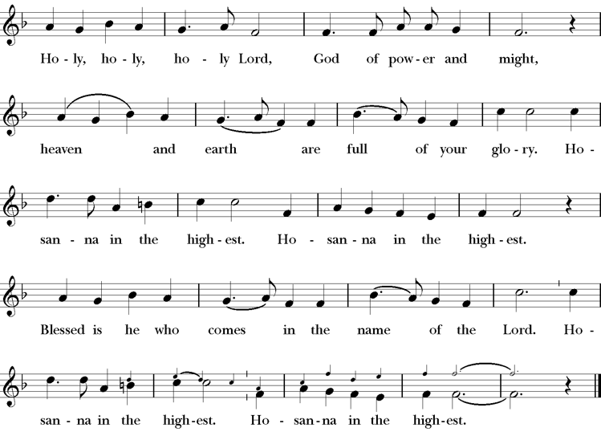
Words of Institution BCP 368
The Lord’s Prayer 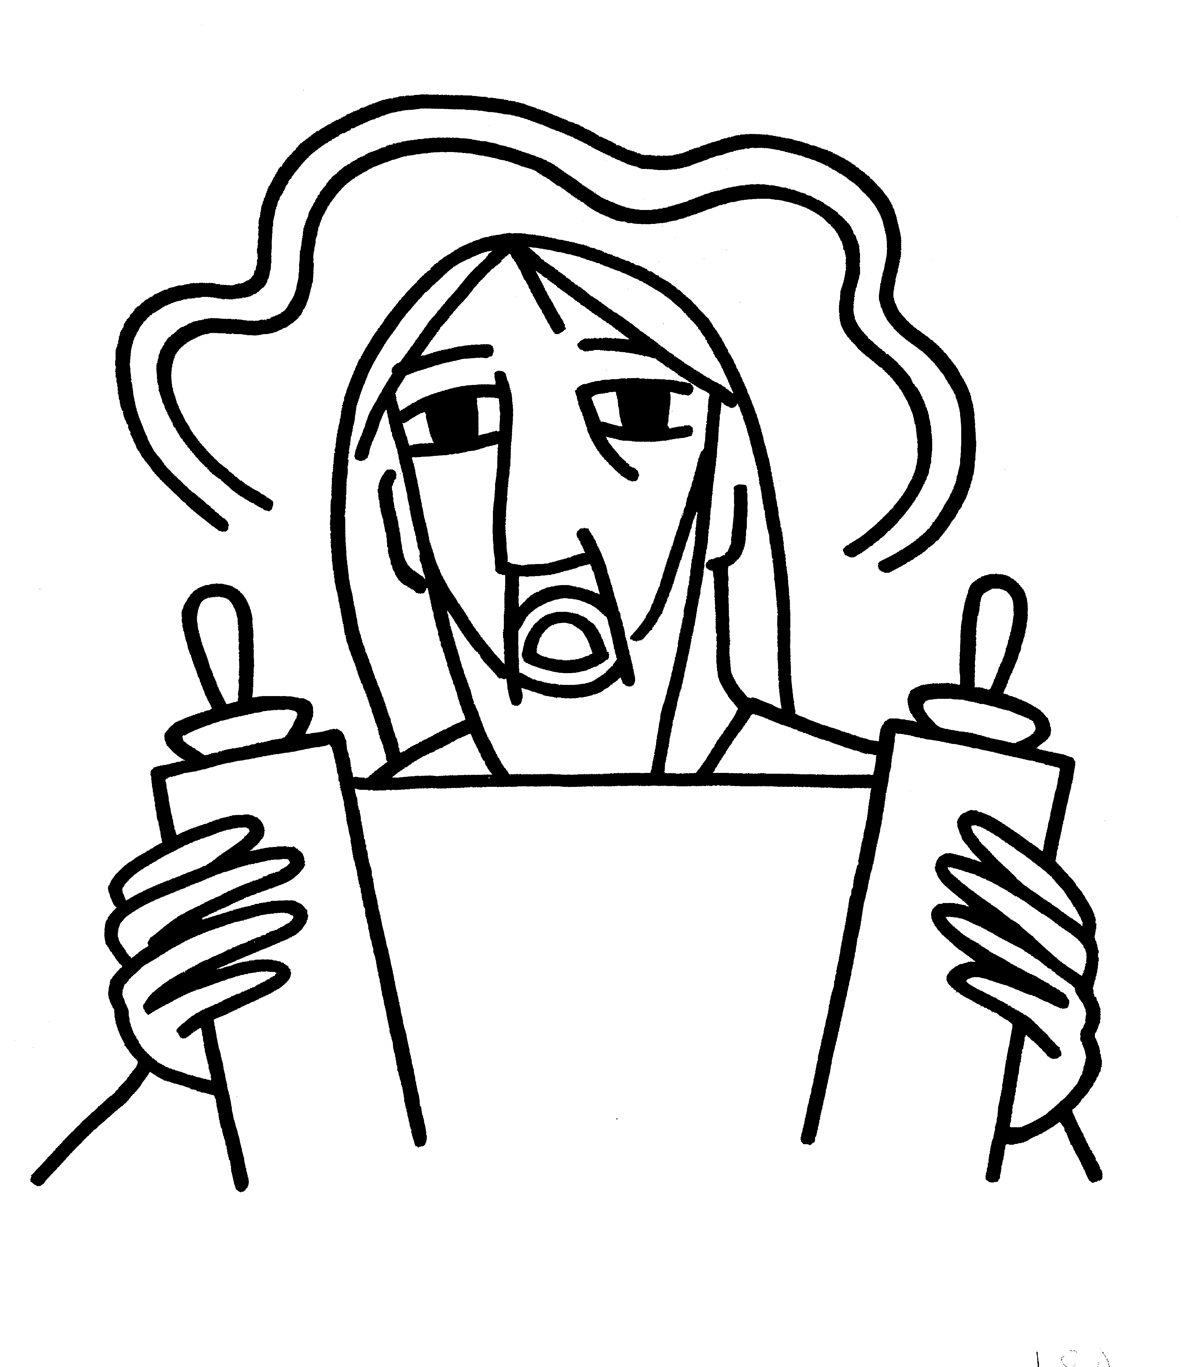 BCP 364
The Breaking of the Bread  BCP 364
Fraction Anthem S-154
All are welcome at the Lord’s table to receive Holy Communion or a blessing. To receive Communion in your pew, please ask an usher to notify the ministers on your behalf. If you require a gluten-free wafer, please ask at the altar rail.
Communion Music Steve Rubardt & Choir
Dona Nobis Pacem H 712
Post-Communion Prayer
Eternal God, heavenly Father,
you have graciously accepted us as living members
of your Son our Savior Jesus Christ,
and you have fed us with spiritual food
in the Sacrament of his Body and Blood.
Send us now into the world in peace,
and grant us strength and courage
to love and serve you
with gladness and singleness of heart;
through Christ our Lord. Amen.
Amen.
Blessing (BCP p. 366)
The blessing of God Almighty, the Father, the Son, and the Holy Spirit, be upon you and remain with you for ever.
Amen.
The Recessional Hymn All thing Bright and Beautiful H 405
Dismissal (BCP p. 366)
 | Let us go forth in the name of Christ.
People | Thanks be to God.
Postlude Steve Rubardt
Please remain seated
SERVING TODAY
Celebrant and Preacher: Pastor Cindy Beck
Acolyte: Arminda Eiler
Lector: Gerrilee Fisher , John Eiler
Intercessor: Alfred Escoffier
Worship Musician: Steve Rubardt
Choir Leader: Steve Rubardt
Choir: Liz Carpenter, Heather Dahlberg, Scott Sherman, Lucy Maushardt, Patsy Gralow, Laurell Meredith, Mary Omodt, Barbara Feduska, Tara Anderson
Sunday School - Child Care: Wendy Aguilar Appt Only
Ushers: Marcia Derby
Tech Chaplain: Marcos Rendon
Altar Guild: Marcia Derby Mary Omodt
Hospitality: Matthew Dahlberg

Prayers requested for these on Trinity’s long-term prayer list: Baby Walker David, Armando P, Laura Basett, , Georgia Bostedt, Muff Davey, John Eiler, Gerrilee Fisher, Claire Ginesi, Mary Griffin, David & Christine Hilt, Dr. Tamer Keshen, Marie Lambert, Mark Mezzetta, Kelcey Omodt, Grizelda Ponce, Barry Reap, Blake W, Robert R, Ann Loveland Sherman, John Spooner, James Thomas, Rose Burns, Jennifer Gralow, Patsy Gralow, Steve Antenen, Sandra Leland, John Forester, Stuart , Melissa White.
Prayers for the Repose of soul: Tim Dowd , Susan Bassett, Joan Biersch, Mere Nagasau, Christina Van Krugel, Linda Dowd, Peggy and John Bell, Denny Hoelter, Van Z
Contact Pastoral Care Chair, Lorena lorena.m.reinhardt@gmail.com to make any additions or to remove names from our Long-Term Prayer list.

Calendar of the Church Year
The calendar (BCP, pp. 15-33) orders the liturgical year of the Episcopal Church by identifying two cycles of feasts and holy days-one dependent upon the movable date of Easter Day and the other dependent upon the fixed date of Christmas, Dec. 25. Easter Day is the first Sunday after the full moon that falls on or after Mar. 21. The sequence of all Sundays in the church year is based on the date of Easter. Tables and rules for finding the date of Easter Day, and other movable feasts and holy days are provided by the BCP, pp. 880-885. The date of Easter determines the beginning of the season of Lent on Ash Wednesday and the date of Pentecost on the fiftieth day of the Easter season. The Sundays of Advent are always the four Sundays before Christmas Day. The church year begins on the first Sunday of Advent. The calendar also identifies and provides directions concerning the precedence and observance of principal feasts, Sundays, holy days (including Feasts of our Lord, other major feasts, and fasts), Days of Special Devotion, and Days of Optional Observance. The calendar lists dates for celebration of major feasts and lesser feasts by month and date. Appropriate Sunday Letters and Golden Numbers are also provided. (see BCP, pp. 880-881). The calendar also lists the titles of the seasons, Sundays, and major holy days observed in the Episcopal Church throughout the church year, including Advent season, Christmas season, Epiphany season, Lenten season, Holy Week, Easter season, the season after Pentecost, holy days, and National Days.
Notes on the Epiphany Season Liturgy
In the weeks after Epiphany, other events in Jesus’ ministry are celebrated, events such as his first miracle, changing water into wine; his first healing; his calling of the disciples; his first preaching. These events reveal him as God’s Son and help us explore more deeply the unlimited extent of his love and our role—as the members of his Body—in revealing him to the world.
The liturgical texts for this period are very expressive of its meaning and embody many of the symbols, both biblical and cultural, which came to be part of the season:
Trinity Liturgical Ministry ROTA Next two weeks
Date | Celebrant | Ushers | Acolyte / EM | Lector (s) | Intercessor | Altar Guild | Altar Flowers
Feb 15 | Cindy Beck | Alfred Escoffier | Susie Hand | Ann Kyser , Lorena Reinhardt | Barbara Feduska | Susie Hand | Barbara Addeo
Feb 22 | Cindy Beck | Barbara Feduska | Arminda Eiler | Gerrilee Fisher , John Eiler | Claire Ginesi | Laurell Meredith Liz Carpenter | N/a

Schedule of Weekly Meetings and Services at Trinity Episcopal Sonoma
Day | Date | Time | Occasion | Location
Wednesday | February 11 | 11 AM | Bible Study | Library
Thursday | February 12 | 10:30 AM  5:30 PM | Mindfulness & Well Being  Alcoholics Anonymous | Library  Buttrum Hall
Saturday | February 14 | 8 AM | Centering Prayer | St. Luke’s Chapel
Sunday | Feb 15 | 10:15 AM | Holy Eucharist II | Sanctuary
Mon-Fri | Weekdays | 7AM-1PM | Sonoma Home Meals | Kitchen &Buttrum Hall
Mon-Fri | Weekdays | 9-2 | Sonoma Preschool Academy – School
Monthly Meetings at Trinity Episcopal Sonoma
Day | Date | Time | Meeting | Location | Contact
Tuesday | TBD | 11 AM | Prayer Shawl Ministry | Library | Norah Collins 28norahe@gmail.com
Thursday | TBD | 4:30 PM | Vestry | Library | Claire Ginesi cfgsonoma@gmail.com
PRAYERS and BLESSINGS
For a Birthday
Watch over your child, O Lord as his/her days increase; bless and guide him/her wherever s/he may be. Strengthen them when s/he stands; comfort him/her when discouraged or sorrowful; raise him/her up if s/he fall; and in his/her heart may your peace which passes understanding abide all the days of his/her life; through Jesus Christ our Lord. Amen.
For an Anniversary
O God, you have so consecrated the covenant of marriage that it represents the spiritual unity between Christ and his Church: Send your blessing upon these your servants as they celebrate their anniversary, that they may continue to love, honor and cherish each other in faithfulness and patience, in wisdom and true godliness, that their home may be a haven of blessing and peace; through Jesus Christ our Lord, who lives and reigns with you and the Holy Spirit, one God, now and forever. Amen.
For Travelers
O God, our heavenly Father, whose glory fills the whole creation, and whose presence we find wherever we go; preserve those who travel; surround them with your loving care; protect them from every danger, and bring them in safety to their journey’s end; through Jesus Christ our Lord. Amen.
Sending our Eucharistic Visitors
Priest: In the name of this congregation, I send you forth bearing these holy gifts, the those to whom you go may share with us in the communion of Christ’s body and blood.
People: We who are many are one body, because we all share on bread, and one cup. Amen

Trinity Episcopal Church
In Sonoma for over 170 years
275 East Spain Street
Sonoma, CA 95476
The Rt. Rev. Megan M. Traquair, Bishop
Diocese of Northern California
Pastor Cindy Beck, Interim
Steve Rubardt, Worship Music
Vestry
Bill Doyle, Junior Warden (Buildings, Grounds)
Bill Doyle (Stewardship)
Susie Hand
Heather Dahlberg
Lorena Reinhardt (Pastoral Care)
Ministries
Prayer Shawl ,Norah Collins
Outreach, Jane Hernandez
Youth – Academic Tutoring, Karen Randall
Mindfulness & Well Being, Mary Omodt
Sunday School, Children, Wendy Aguilar

The Members of the Congregation are The Ministers of the Church

Administrative Office Hrs.
Monday Wednesday 9 A.M. – 2 PM; Thursday 10A.M.-2 P.M0
Sunday 9:30-11:30
Clergy Office Hours Wednesdays, Thursdays, by appointment

Emergency, sickness, please contact office: 707-938-4846

