Trinity Episcopal Church
Cultivating God’s Loving Spirit in Each of Us
All Saints Day (Proper 26)
Year A
Holy Eucharist II
November 1, 2026
10:00 AM In person and Online

Welcome to Trinity Episcopal, Sonoma. Whether you are passing through or looking for a church home, we are blessed by your presence and we invite you to worship with us fully – singing, praying and receiving communion- with your voice and heart. Please sign our guestbook at the back of the church, including your email.
If you would like to learn more about The Episcopal Church, please send us an email trinityepiscopalsonoma@comcast.net. We look forward to meeting you after the service where coffee and treats are served.

All are welcome to make a gift and offering in thanksgiving to God; for the many blessings we have received. To take advantage of our electronic giving options, please follow the QR code with your capable electronic device, or visit https://onrealm.org/trinitysonoma/-/form/give/default
October Announcements
Fellowship Coffee Hour Sign up – Fellowship follows the service! We meet in the hall or courtyard. We’d love to visit with you.
Thank you to everyone who donated food for A Simple Gesture, your gift helps people have a meal! Our next pick up will be in November!
Movie Night at Trinity will continue on Novmeber 18th, at 6PM in Buttram Hall. We will be showing “Paper Moon”. There will be snacks and refreshements during the post film discussion.
The Discernement Capacity Group will be meeting at 4pm this Sunday November 1st.
Prelude Steve Rubardt
Please stand for the Entrance Hymn.
At the sound of the bell, please stand as you are able. The People respond when bold text appears.
The Word of God
Entrance Hymn Faith of our Fathers H 558
Opening Acclamation BCP 319
Celebrant | Blessed be God: Father, Son, and Holy Spirit.
People | And blessed be his kingdom, now and for ever. Amen.
Litany of Remembrance: The Cloud of Witnesses
Celebrant: God of the ages, we give you thanks for the faithful of every time and place who have walked the path of faith before us. We praise you for your enduring grace, which sustains your people in life and in death.
People: For the great cloud of witnesses who surround us, we give you thanks, O God.
Celebrant: We remember today those who first brought us to the waters of baptism, who taught us the stories of faith, and who showed us how to love our neighbors.
People: For their legacy of love and faithfulness, we give you thanks, O God.
Celebrant: We remember today those whose voices once filled this sanctuary, whose hands served this community, and whose witness helped shape this congregation.
People: For their presence among us and the gifts they shared, we give you thanks, O God.
Celebrant: We remember today the loved ones who have been called home to you since we last gathered for this holy day, especially those whom we now name aloud or in the silence of our hearts...
(Here, the names of congregation members and loved ones who died in the past year may be read aloud. A bell or chime may toll after each name.)
Celebrant: Comfort those who mourn, O Lord. Wipe away every tear from their eyes, and wrap them in the assurance of your resurrection promise.
People: Hear our prayer, O God, and grant us your peace.
Celebrant: Keep us united with all your saints in the communion of Christ’s body. Strengthen us for our journey on earth, until that day when you gather us with all the redeemed into the joy of your eternal banquet.
People: To you, O God, be all glory, honor, and praise, now and forever. Amen.
The Collect of the Day BCP 357
Celebrant | The Lord be with you.
People | And also with you.
Celebrant | Let us pray.
Almighty God, you have knit together your elect in one communion and fellowship in the mystical body of your Son Christ our Lord: Give us grace so to follow your blessed saints in all virtuous and godly living, that we may come to those ineffable joys that you have prepared for those who truly love you; through Jesus Christ our Lord, who with you and the Holy Spirit lives and reigns, one God, in glory everlasting.
All Amen.
The Lessons
First Reading: Revelation 7:9-17
Reader A Reading from the Revelation of John.
⁹After this I looked, and there was a great multitude that no one could count, from every nation, from all tribes and peoples and languages, standing before the throne and before the Lamb, robed in white, with palm branches in their hands. ¹⁰They cried out in a loud voice, saying,
“Salvation belongs to our God who is seated on the throne, and to the Lamb!”
¹¹And all the angels stood around the throne and around the elders and the four living creatures, and they fell on their faces before the throne and worshiped God, ¹²singing,
“Amen! Blessing and glory and wisdom
and thanksgiving and honor
and power and might
be to our God forever and ever! Amen.”
¹³Then one of the elders addressed me, saying, “Who are these, robed in white, and where have they come from?” ¹⁴I said to him, “Sir, you are the one that knows.” Then he said to me, “These are they who have come out of the great ordeal; they have washed their robes and made them white in the blood of the Lamb.
¹⁵For this reason they are before the throne of God,
and worship him day and night within his temple,
and the one who is seated on the throne will shelter them.
¹⁶They will hunger no more, and thirst no more;
the sun will not strike them,
nor any scorching heat;
¹⁷for the Lamb at the center of the throne will be their shepherd,
and he will guide them to springs of the water of life,
and God will wipe away every tear from their eyes.”
Reader | The Word of the Lord.
People | Thanks be to God.
The Psalm: Psalm 34:1-10, 22
Reader We will read Psalm 34:1-10, 22, responsively by half verse.
¹I will bless the Lord at all times; *
his praise shall ever be in my mouth.
²I will glory in the Lord; *
let the humble hear and rejoice.
³Proclaim with me the greatness of the Lord; *
let us exalt his Name together.
⁴I sought the Lord, and he answered me *
and delivered me out of all my terror.
⁵Look upon him and be radiant, *
and let not your faces be ashamed.
⁶I called in my affliction, and the Lord heard me *
and saved me from all my troubles.
⁷The angel of the Lord encompasses those who fear him, *
and he will deliver them.
⁸Taste and see that the Lord is good; *
happy are they who trust in him!
⁹Fear the Lord, you that are his saints, *
for those who fear him lack nothing.
¹⁰The young lions lack and suffer hunger, *
but those who seek the Lord lack nothing that is good.
²²The Lord ransoms the life of his servants, *
and none will be punished who trust in him.

Second Reading: 1 John 3:1-3
Reader A Reading from the First letter of John.
¹See what love the Father has given us, that we should be called children of God; and that is what we are. The reason the world does not know us is that it did not know him. ²Beloved, we are God’s children now; what we will be has not yet been revealed. What we do know is this: when he is revealed, we will be like him, for we will see him as he is. ³And all who have this hope in him purify themselves, just as he is pure.
Reader | The Word of the Lord.
People | Thanks be to God.
Sequence Hymn Blest are the Pure in Heart H 656 v 1 & 2
The Holy Gospel: Matthew 5:1-12
Celebrant | The Holy Gospel of our Lord Jesus Christ according to Matthew.
People | Glory to you, Lord Christ.
¹When Jesus saw the crowds, he went up the mountain; and after he sat down, his disciples came to him. ²Then he began to speak, and taught them, saying:
³“Blessed are the poor in spirit, for theirs is the kingdom of heaven.
⁴“Blessed are those who mourn, for they will be comforted.
⁵“Blessed are the meek, for they will inherit the earth.
⁶“Blessed are those who hunger and thirst for righteousness, for they will be filled.
⁷“Blessed are the merciful, for they will receive mercy.
⁸“Blessed are the pure in heart, for they will see God.
⁹“Blessed are the peacemakers, for they will be called children of God.
¹⁰“Blessed are those who are persecuted for righteousness’ sake, for theirs is the kingdom of heaven.
¹¹“Blessed are you when people revile you and persecute you and utter all kinds of evil against you falsely on my account. ¹²Rejoice and be glad, for your reward is great in heaven, for in the same way they persecuted the prophets who were before you.”
Celebrant | The Gospel of the Lord.
People | Praise to you, Lord Christ.
Sequence Hymn Blest are the Pure in Heart H 565 v 3 & 4
Sermon Pastor Cindy Beck
The Nicene Creed (BCP p. 358)
We believe in one God, the Father, the Almighty, maker of heaven and earth, of all that is, seen and unseen.
We believe in one Lord, Jesus Christ, the only Son of God, eternally begotten of the Father, God from God, Light from Light, true God from true God, begotten, not made, of one Being with the Father. Through him all things were made. For us and for our salvation he came down from heaven: by the Power of the Holy Spirit he became incarnate from the Virgin Mary, and was made man. For our sake he was crucified under Pontius Pilate; he suffered death and was buried. On the third day he rose again in accordance with the Scriptures; he ascended into heaven and is seated at the right hand of the Father. He will come again in glory to judge the living and the dead, and his kingdom will have no end.
We believe in the Holy Spirit, the Lord, the giver of life, who proceeds from the Father and the Son. With the Father and the Son he is worshipped and glorified. He has spoken through the Prophets. We believe in one holy catholic and apostolic Church. We acknowledge one baptism for the forgiveness of sins. We look for the resurrection of the dead, and the life of the world to come. Amen.

The Prayers of the People
Celebrant: With clean hearts and a pure faith, let us ascend the hill of the Lord, offering our prayers and thanksgivings to the one who hears our petitions and answers our call, responding, “Hear us, O Host of Heaven.”
Intercessor: In the Diocesan Cycle of Prayer, we pray for St. John the Evangelist in Chico.
In the Anglican Cycle of Prayer, we pray for The Iglesia Anglicana de la Region Central de America.
Let us pray to the Lord,
Hear us, O Host of Heaven.
In thanksgiving for many peoples, languages, tribes and nations, whose diversity of thought and action become blessings to all who seek the fullness of God’s presence in the midst of daily life; let us pray to the Lord.
Silence
Hear us, O Host of Heaven.
In thanksgiving for the Eucharistic Meal in which we are fed by Christ, who reveals his goodness and invites us to trust in his love with our whole heart, and soul, and mind; let us pray to the Lord , +_____________.
Invite the congregation to add their thanksgivings, followed by silence
Hear us, O Host of Heaven.
For the commitment and strength to share God’s blessings throughout the world, honoring those who hunger and thirst, who mourn, and who live in fear and anxiety, giving out of our weaknesses to fill the hopes of others; let us pray to the Lord , +______________.
Invite the congregation to add their petitions, followed by silence
Hear us, O Host of Heaven.
For the peacemakers who proclaim justice in the marketplace, and petition prime ministers, presidents and legislators, to turn the ways of war into the dividends of peace; let us pray to the Lord.
Silence
Hear us, O Host of Heaven.
For those who volunteer their time to enlighten the lives of others, especially those who work in our schools, recreational centers, and wherever young people seek enrichment and encouragement; let us pray to the Lord.
Silence
Hear us, O Host of Heaven.
For holy women and men who have died in the light of Christ, and whose righteousness inspired the faithful of every generation; may their souls and the souls of unsung heroes in every age enter the gates of paradise; let us pray to the Lord , +__________.
Invite the congregation to add their petitions, followed by silence
Hear us, O Host of Heaven.
In companionship with the Blessed Virgin Mary, [blessed N.,] and all the saints, we continue the offering of our prayers.
Silence
Hear us, O Host of Heaven.
Celebrant Almighty God, whose gifts of blessing and grace have no end, write in our hearts your joy and zeal to tell the story of our faith by our words, by our deeds, and by offering all that you have given us: our lives, our gifts, our resources. Grant us also a portion of your never-ending generosity, that we may proclaim your love and mercy to the world around us through our parish community; through Jesus Christ our Lord and Savior. Amen.
Confession of Sin BCP 359
Most merciful God, we confess that we have sinned against you in thought, word and deed, by what we have done, and by what we have left undone.
We have not loved you with our whole heart; we have not loved our neighbors as ourselves. We are truly sorry and we humbly repent.
For the sake of your Son Jesus Christ, have mercy on us and forgive us; that we may delight in your will, and walk in your ways, to the glory of your Name. Amen.

The Peace
Celebrant The peace of the Lord be always with you.
People And also with you.

Announcements
Birthdays, Anniversaries, Travelers (prayers found at back of bulletin)
The Holy Communion
The Offertory At the Offering, you’ll find a Pledge card in the Pew Rack for those who’d like to designate their financial donations to Trinity’s Pledging Income. For others, or a one-time gift, envelopes are in the pew racks as well as on the Narthex table or text TRINITYSONOMA" to 73256. Thank you!
Offertory Music
Steve Rubardt and Choir Sweet, Sweet Spirit LEVAS 120
Doxology
Praise God, from whom all blessings flow;
Praise Him, all creatures here below;
Praise Him above, ye heav'nly host;
Praise Father, Son, and Holy Ghost.
Amen.
The people stand while the offerings are presented and placed on the Altar.
Presider: Gracious God, as an offering of our thanksgiving and gratitude, we return to you a portion of what you have gifted us.
The Great Thanksgiving
Eucharistic Prayer B BCP 367
Celebrant | The Lord be with you.
People | And also with you.
Celebrant | Lift up your hearts.
People | We lift them to the Lord.
Celebrant | Let us give thanks to the Lord our God.
People | It is right to give him thanks and praise.
Proper Preface (BCP p. 367)
It is right, and a good and joyful thing, always and everywhere to give thanks to you, Father Almighty, Creator of heaven and earth.
For you are the source of light and life; you made us in your image, and called us to new life in Jesus Christ our Lord.
Therefore we praise you, joining our voices with Angels and Archangels and with all the company of heaven, who for ever sing this hymn to proclaim the glory of your Name:
Sanctus Holy Holy, Holy (Proulx) Hymnal S-125
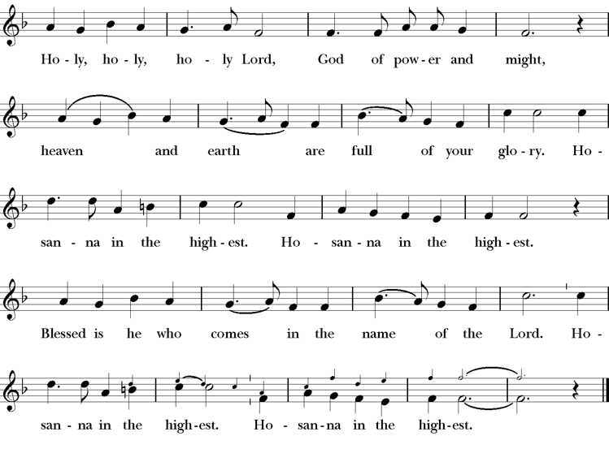
Presider Holy and gracious Father: In your infinite love you made us for yourself; and, when we had fallen into sin and become subject to evil and death, you, in your mercy, sent Jesus Christ, your only and eternal Son, to share our human nature, to live and die as one of us, to reconcile us to you, the God and Father of all.
He stretched out his arms upon the cross, and offered himself, in obedience to your will, a perfect sacrifice for the whole world.
On the night he was handed over to suffering and death, our Lord Jesus Christ took bread; and when he had given thanks to you, he broke it, and gave it to his disciples, and said, “Take, eat: This is my Body, which is given for you. Do this for the remembrance of me”
After supper he took the cup of wine; and when he had given thanks, he gave it to them, saying, “Drink this, all of you: this is my blood of the new covenant which is shed for you and for many for the forgiveness of sins. Whenever you drink it, do this for the remembrance of me.”
Presider Therefore we proclaim the mystery of faith.
People Christ has died; Christ is risen; Christ will come again.
Presider We celebrate the memorial of our redemption, O Father, in this sacrifice of praise and thanksgiving. Recalling his death, resurrection, and ascension, we offer you these gifts.
Sanctify them by your Holy Spirit to be for your people the Body and Blood of your Son, the holy food and drink of new and unending life in him. Sanctify us also that we may faithfully receive this holy Sacrament, and serve you in unity, constancy, and peace; and at last day bring us with all your saints into the joy of your eternal kingdom.
All this we ask through your Son Jesus Christ. By him, and with him, and in him, in the unity of the Holy Spirit all honor and glory is yours, Almighty Father, now and for ever.
Amen.

The Lord’s Prayer
Presider As our Savior has taught us, we are bold to pray.
People Our Father, who art in heaven, hallowed be thy name. Thy Kingdom come, thy will be done, on earth as it is in heaven. Give us this day our daily bread. And forgive us our trespasses, as we forgive those who trespass against us. And lead us not into temptation, but deliver us from evil. For thine is the kingdom, the power and the glory, for ever and ever. Amen.

The Breaking of the Bread
The Presider breaks the consecrated bread in view of the assembly.
Presider The Gifts of God for the people of God.
People Therefore let us keep the feast. Alleluia

Invitation to Communion
Presider This is the Lord’s table. The Lord Jesus invites us to share this joyful feast.
Sharing the Sacred Meal
This is Christ’s table and all are welcome and all are fed.
Communion Music Ave Verum
Post-Communion Prayer BCP 365
The Blessing
The Recessional Hymn Love Divine, All Loves Excelling H 657
The Dismissal*
Celebrant | Let us go forth in the name of Christ.
People | Thanks be to God.
Postlude Steve Rubardt Please remain seated

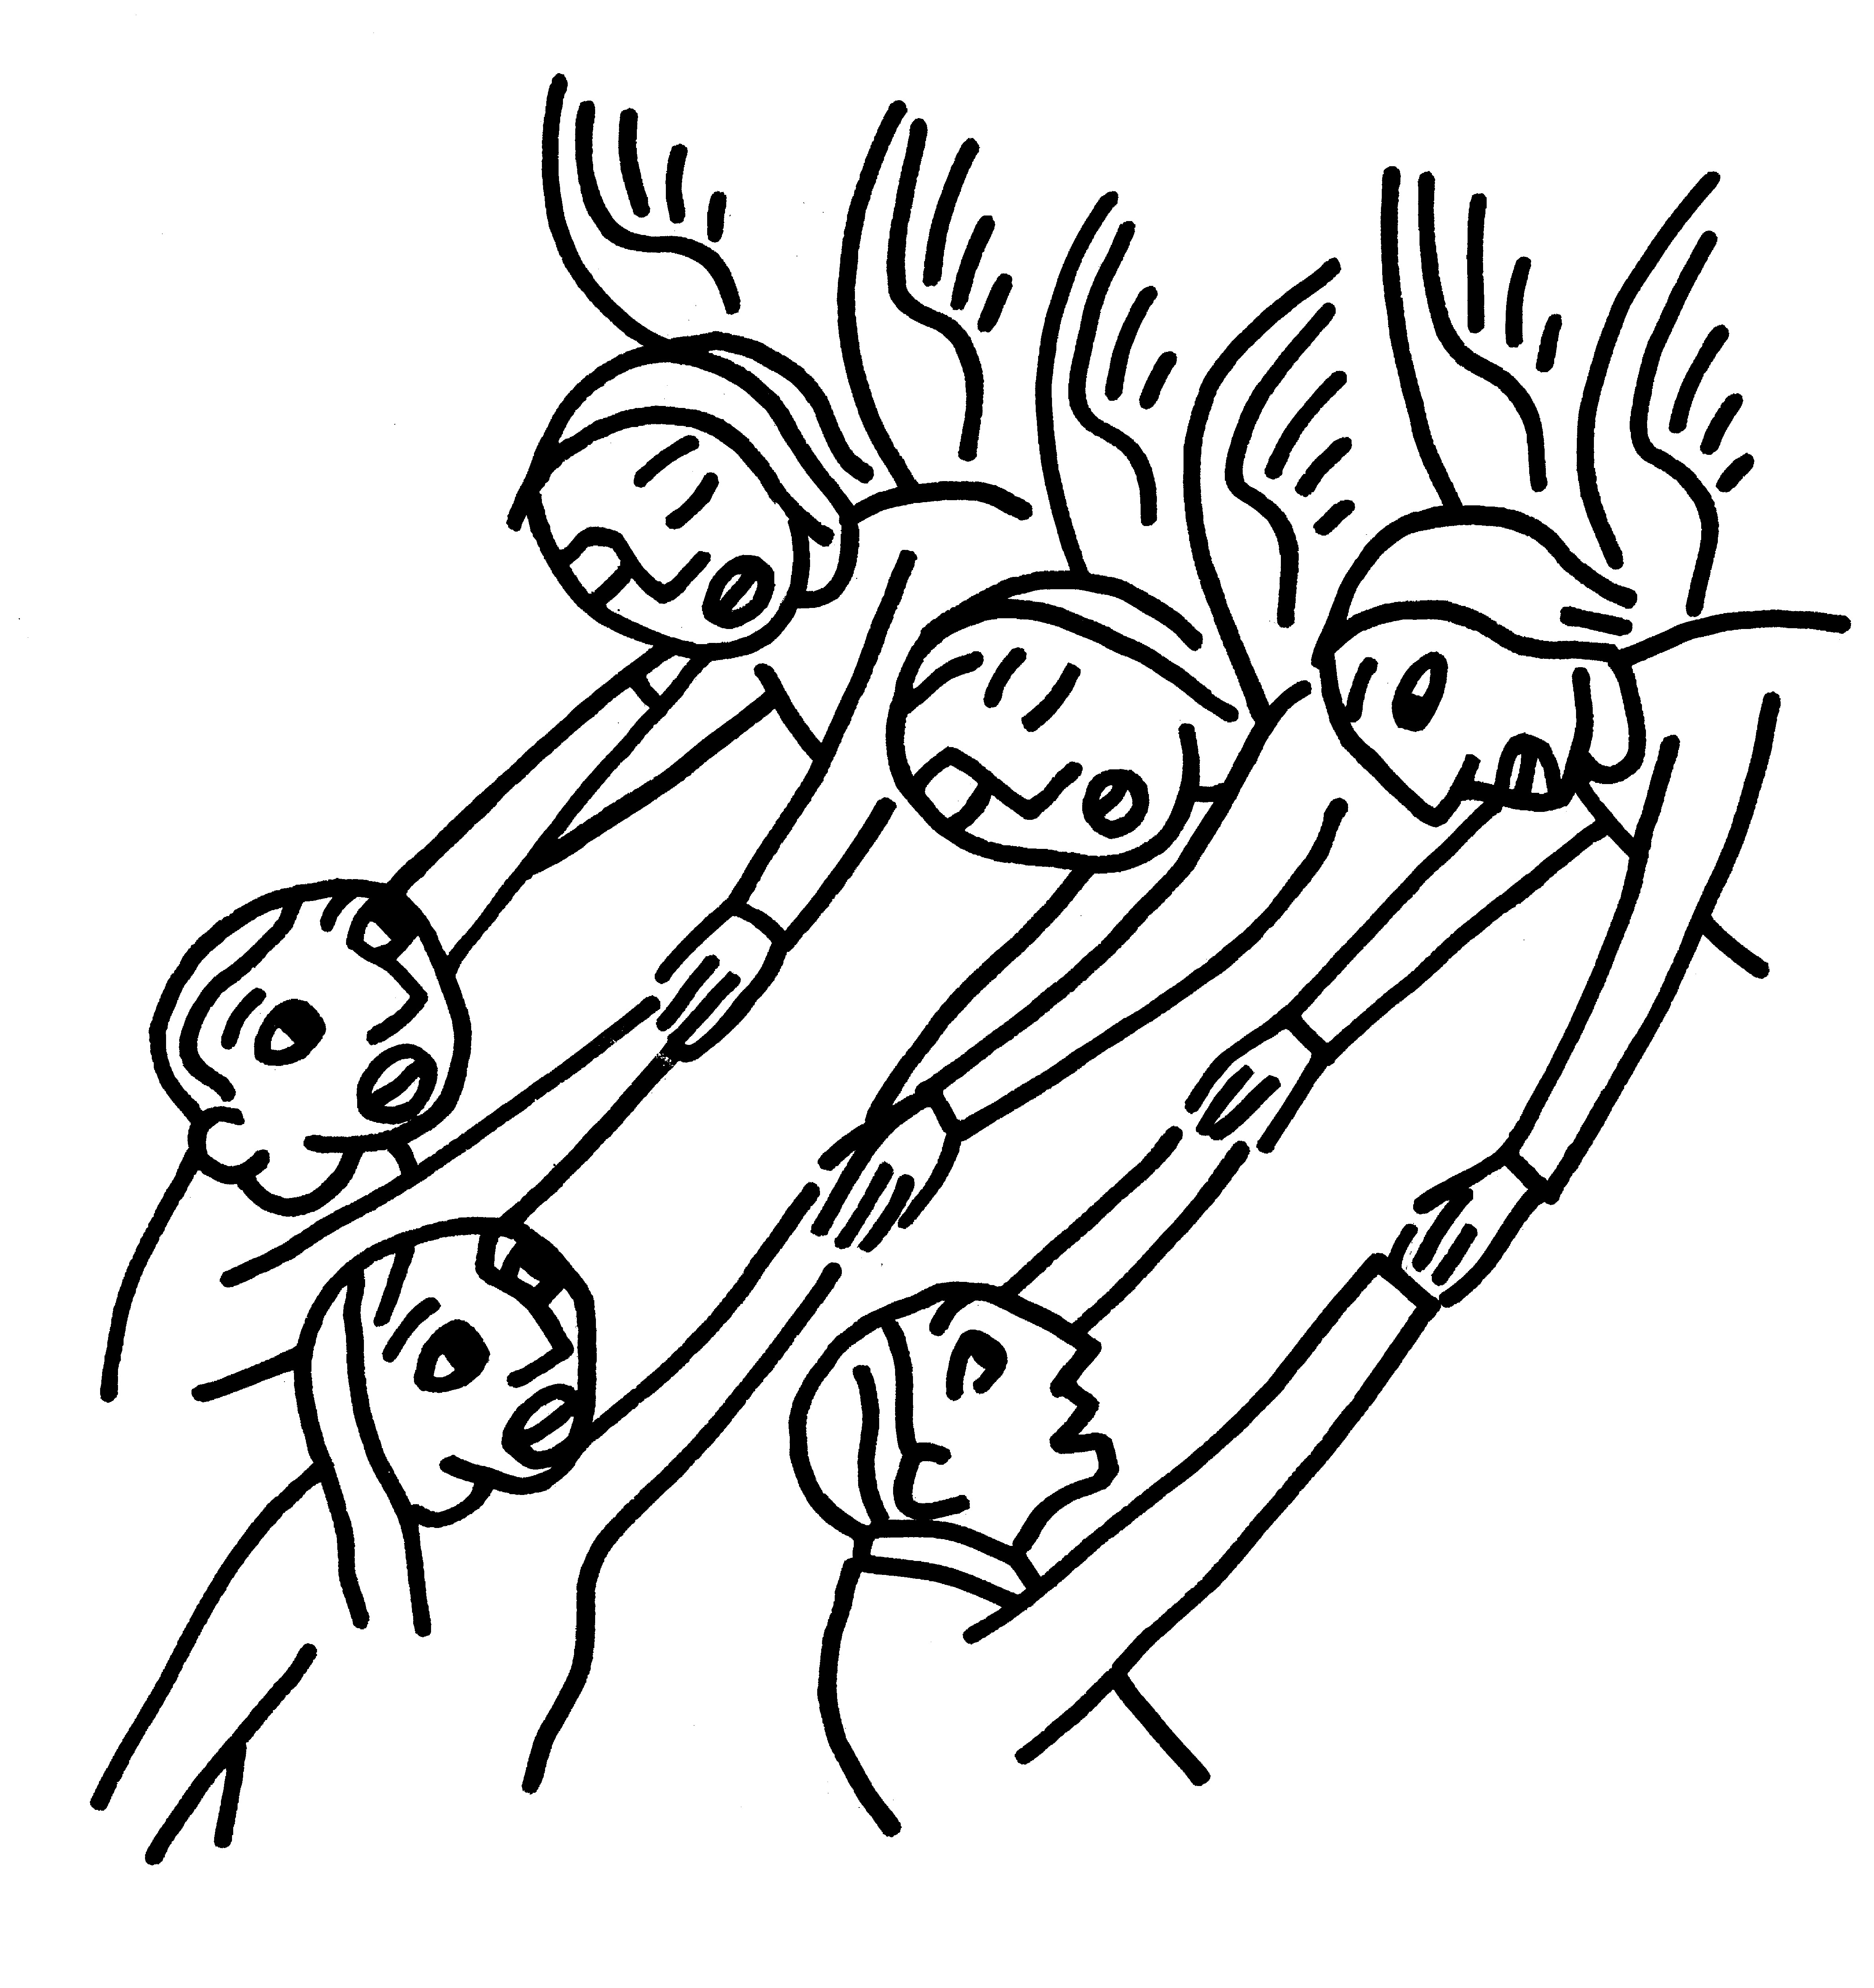

SERVING TODAY
Celebrant & Preacher: Pastor Cindy Beck
Acolyte: Arminda Eiler
Lector: Bill Doyle , John Eiler
Intercessor: Douglas Griffin
Worship Musician: Steve Rubardt
Choir Leader: Steve Rubardt
Choir: Liz Carpenter, Heather Dahlberg, Scott Sherman, Patsy Gralow, Laurell Meredith, Mary Omodt, Barbara Feduska, Tara Anderson, Carol Heffler, Don McMahon
Sunday School - Child Care: Wendy Aguilar
Ushers: John Addeo
Tech Chaplain: Marcos Rendon
Altar Guild: Susie Hand
Hospitality : Hannah and Gabe

Prayers requested for these on Trinity’s long-term prayer list: Armando P, Georgia Bostedt, John Eiler, Gerrilee Fisher, Claire Ginesi, Mary Griffin, David & Christine Hilt, Mark Mezzetta, Kelcey Omodt, Grizelda Ponce, Barry Reap, Blake W, Robert R, Melissa White, Ann Loveland Sherman, James Thomas, Rose Burns, Jennifer Gralow, Patsy Gralow, Steve Antenen, Sandra Leland, Karl, Michael Hardy, Michael Bean Land, Polly Moore, Sinat Liv, Will Maushardt, Sophia Piconi, Mike Smith, Jean Maffoli.
Prayers for the Repose of soul: Tim Dowd , Susan Bassett, Joan Biersch, Linda Dowd, Christina Van Krugel, Mere Nagasau, Mary Goshert, Peggy Bell, Carolyn Caldwell, Van Z, Dolores Mae Seaberg Cole, Muff Davey, Giancarlo Cestarollo.
Contact Pastoral Care Chair, Lorena lorena.m.reinhardt@gmail.com to make any additions or to remove names from our Long-Term Prayer list.
Notes on the Service Bulletin This service bulletin is a guide to the service. We use a variety of printed materials for the prayers, the scriptural readings and the hymns. The Readings for the week, including the Collect and Readings are found in this Bulletin. The service follows the liturgies that are found in the Book of Common Prayer (BCP). The BCP is the blue book found in the pew in front of you. The hymns come primarily from The 1982 Hymnal, also in the pew – the red book. Lift Every Voice and Sing (LEVAS) is another hymnal located in the pew rack. VF stands for Voices Found, another authorized hymnal. Sound Mate Assisted Hearing devices available at the back of the church on the Narthex Table.

Trinity Liturgical Ministry ROTA Next two weeks
Date | Celebrant | Ushers | Acolyte | Lector (s) | Intercessor | Altar Guild
11/8 | Cindy Beck | Alfred Escoffier | Claire Ginesi | Barbara Feduska , Gerrilee Fisher | Jane Hernandez | Mary Omodt
11/15 | Cindy Beck | Alfred Escoffier | Susie Hand | Ann Kyser , Lorena Reinhardt | Douglas Griffin | Ann Kyser

Schedule of Weekly Meetings and Services at Trinity Episcopal Sonoma
Day | Date | Time | Occasion | Location
Wednesday | November 4 | 11 AM | Bible Study | Library
Thursday | November 5 | 10:30 AM  5:30 PM | Mindfulness & Well Being  Alcoholics Anonymous | Library  Buttrum Hall
Saturday | November 7 | 8 AM | Centering Prayer | St. Luke’s Chapel
Sunday | November 8 | 10:00 AM | Holy Eucharist II | Sanctuary
Mon-Fri | Weekdays | 7AM-1PM | Sonoma Home Meals | Kitchen &Buttrum Hall
Mon-Fri | Weekdays | 9-2 | Sonoma Preschool Academy – School

Monthly Meetings at Trinity Episcopal Sonoma
Day | Date | Time | Meeting | Location | Contact
Tuesday | November 3 | 11 AM | Prayer Shawl Ministry | Library | Lorena Reinhardt lorena.m.reinhardt@gmail.com
Thursday | TBD | TBD | Vestry | Library | Cindy Beck 916-955-9861



PRAYERS and BLESSINGS
For a Birthday
Watch over your child, O Lord as his/her days increase; bless and guide him/her wherever s/he may be. Strengthen them when s/he stands; comfort him/her when discouraged or sorrowful; raise him/her up if s/he fall; and in his/her heart may your peace which passes understanding abide all the days of his/her life; through Jesus Christ our Lord. Amen.
For an Anniversary
O God, you have so consecrated the covenant of marriage that it represents the spiritual unity between Christ and his Church: Send your blessing upon these your servants as they celebrate their anniversary, that they may continue to love, honor and cherish each other in faithfulness and patience, in wisdom and true godliness, that their home may be a haven of blessing and peace; through Jesus Christ our Lord, who lives and reigns with you and the Holy Spirit, one God, now and forever. Amen.
For Travelers
O God, our heavenly Father, whose glory fills the whole creation, and whose presence we find wherever we go; preserve those who travel; surround them with your loving care; protect them from every danger, and bring them in safety to their journey’s end; through Jesus Christ our Lord. Amen.
Sending our Eucharistic Visitors
Priest: In the name of this congregation, I send you forth bearing these holy gifts, the those to whom you go may share with us in the communion of Christ’s body and blood.
People: We who are many are one body, because we all share on bread, and one cup. Amen.

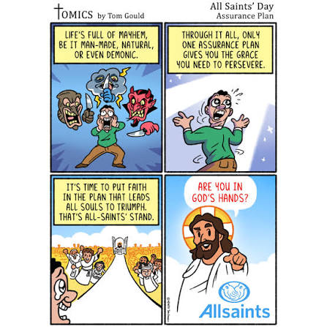

Trinity Episcopal Church
In Sonoma for over 170 years
275 East Spain Street
Sonoma, CA 95476
The Rt. Rev. Megan M. Traquair, Bishop
Diocese of Northern California
Pastor Cindy Beck, Interim
Steve Rubardt, Worship Music
Vestry
Bill Doyle, Senior Warden & Stewardship
Susie Hand
Heather Dahlberg
Sally Zimmerman
Lorena Reinhardt (Pastoral Care)
Luke Bohanan
Mandy Birkbeck
Ministries
Prayer Shawl, Lorena Reinhardt
Outreach, Jane Hernandez
Mindfulness & Well Being, Mary Omodt
Sunday School, Children, Wendy Aguilar

The Members of the Congregation are The Ministers of the Church

Administrative Office Hrs.
Monday Wednesday 9 A.M. – 2 PM; Thursday 10A.M.-2 P.M0
Sunday 9:30-11:30
Clergy Office Hours Wednesdays, Thursdays, by appointment

Emergency, sickness, please contact office: 707-938-4846

