Trinity Episcopal Church
Cultivating God’s Loving Spirit in each of us

Proper 9
Year A
Holy Eucharist II
July 5th, 2026
10:00 AM In person and Online

Welcome to Trinity Episcopal, Sonoma. Whether you are passing through or looking for a church home, we are blessed by your presence and we invite you to worship with us fully – singing, praying and receiving communion- with your voice and heart. Please sign our guestbook at the back of the church, including your email.
If you would like to learn more about The Episcopal Church, please send us an email trinityepiscopalsonoma@comcast.net. We look forward to meeting you after the service where coffee and treats are served.
Did you know that...
...our worship space is open Monday, Wednesday and Thursdays from 10 - 3 for the public to pray, rest, contemplate, or whatever spiritual needs they have?
…Saturday, July 18 is our next congregational conversation? Save the Date! More info to come.
…Every Friday from Noon – 1PM and 5pm – 6 pm grassroots organizations like Indivisible Sonoma County hold an ongoing demonstration and "No Kings" protest at the plaza?
…Mandy Bierbeck is our new Jr. Warden? Thank you, Mandy, for serving in this capacity!
…on the 3rd Monday of every month there is a safe, online space for LGBTQIA+ people in our Diocese to gather, reflect, and share with one another? For more information or for the Zoom link to the support group contact RainbowMinistriesEDNC@gmail.com
…that our property has been refreshed by having the courtyard and all the walk areas power washed?
…We have children’s bags at the back of the church for parents to use with their children during worship?
To access Trinity’s Guest WIFI: Password Rosepettal441 (case sensitive). We are glad you are here, and we invite you to enter fully into worship this morning.

All are welcome to make a gift and offering in thanksgiving to God; for the many blessings we have received. To take advantage of our electronic giving options, please follow the QR code with your capable electronic device, or visit https://onrealm.org/trinitysonoma/-/form/give/default
July Announcements
Fellowship Coffee Hour Sign up – Fellowship follows the service! We meet in the hall or courtyard. We’d love to visit with you.
Movie Night at Trinity will be postponed for two months due to summer, it will return in September with Legally Blonde.
The May, June, July Forward Day by Day , a booklet of daily inspirational meditations is available in the Church and the Office.
Lectio Divina Bible Study is on Wednesday, at 11AM in the library. Lectio Divina, is a contemplative practice of scriptural reading, meditation, and prayer. intended to promote communion with God. This type of study emphasizes spiritual formation and personal intimacy with God.
A simple Gesture next pick up date will be on July 11th. Check expiration dates on your items and please no glass containers!!
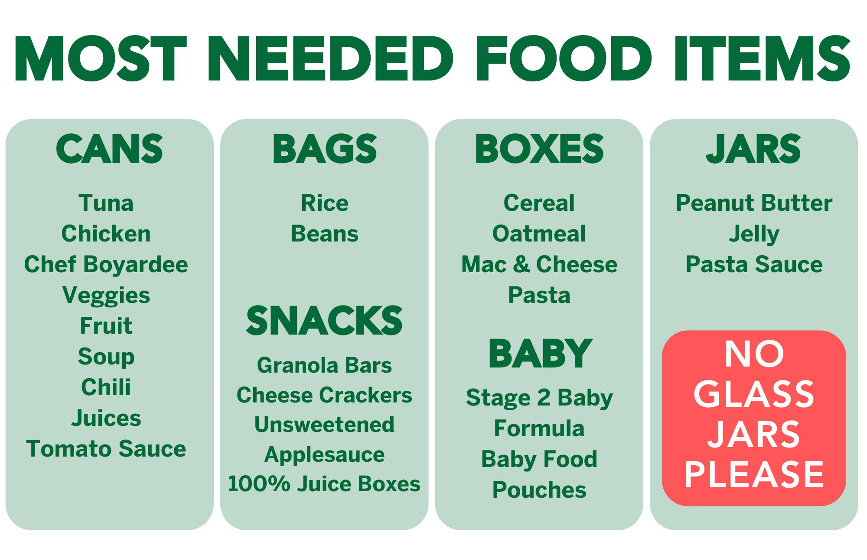
Prelude Steve Rubardt
Please stand for the Entrance Hymn.
At the sound of the bell, please stand as you are able. The People respond when bold text appears.
The Word of God
Entrance Hymn Come away to the Skies H 213
Opening Acclamation BCP 319
Celebrant | Blessed be God: Father, Son, and Holy Spirit.
People | And blessed be his kingdom, now and for ever. Amen.
Collect for Purity
All Almighty God, to you all hearts are open, all desires known, and from you no secrets are hid: Cleanse the thoughts of our hearts by the inspiration of your Holy Spirit, that we may perfectly love you, and worthily magnify your holy Name; through Christ our Lord. Amen.
Song of Praise Glory to God Hymn S-280 is sung, all standing
Glory to God in the highest,
and peace to his people on earth.
Lord God, heavenly King,
almighty God and Father,
we worship you, we give you thanks,
we praise you for your glory.
Lord Jesus Christ, only Son of the Father,
Lord God, Lamb of God,
you take away the sin of the world:
have mercy on us;
you are seated at the right hand of the Father:
receive our prayer.
For you alone are the Holy One,
you alone are the Lord,
you alone are the Most High,
Jesus Christ,
with the Holy Spirit,
in the glory of God the Father. Amen.
The Collect of the Day BCP 357
Celebrant | The Lord be with you.
People | And also with you.
Celebrant | Let us pray.
O God, you have taught us to keep all your commandments by loving you and our neighbor: Grant us the grace of your Holy Spirit, that we may be devoted to you with our whole heart, and united to one another with pure affection; through Jesus Christ our Lord, who lives and reigns with you and the Holy Spirit, one God, for ever and ever.
All Amen.
The Lessons
First Reading: Zechariah 9:9-12
Reader A Reading from the book of the prophet Zechariah.
⁹Rejoice greatly, O daughter Zion!
Shout aloud, O daughter Jerusalem!
Lo, your king comes to you;
triumphant and victorious is he,
humble and riding on a donkey,
on a colt, the foal of a donkey.
¹⁰He will cut off the chariot from Ephraim
and the war-horse from Jerusalem;
and the battle bow shall be cut off,
and he shall command peace to the nations;
his dominion shall be from sea to sea,
and from the River to the ends of the earth.
¹¹As for you also, because of the blood of my covenant with you,
I will set your prisoners free from the waterless pit.
¹²Return to your stronghold, O prisoners of hope;
today I declare that I will restore to you double.
Reader | The Word of the Lord.
People | Thanks be to God.
The Psalm: Psalm 145:8-15
Reader Our response to the reading is Psalm 145:8-15, which we will read responsively by half verse.
⁸The Lord is gracious and full of compassion, *
slow to anger and of great kindness.
⁹The Lord is loving to everyone *
and his compassion is over all his works.
¹⁰All your works praise you, O Lord, *
and your faithful servants bless you.
¹¹They make known the glory of your kingdom *
and speak of your power;
¹²That the peoples may know of your power *
and the glorious splendor of your kingdom.
¹³Your kingdom is an everlasting kingdom; *
your dominion endures throughout all ages.
¹⁴The Lord is faithful in all his words *
and merciful in all his deeds.
¹⁵The Lord upholds all those who fall; *
he lifts up those who are bowed down.
Second Reading: Romans 7:15-25a
Reader A Reading from Paul's letter to the Church in Rome.
¹⁵I do not understand my own actions. For I do not do what I want, but I do the very thing I hate. ¹⁶Now if I do what I do not want, I agree that the law is good. ¹⁷But in fact it is no longer I that do it, but sin that dwells within me. ¹⁸For I know that nothing good dwells within me, that is, in my flesh. I can will what is right, but I cannot do it. ¹⁹For I do not do the good I want, but the evil I do not want is what I do. ²⁰Now if I do what I do not want, it is no longer I that do it, but sin that dwells within me.
²¹So I find it to be a law that when I want to do what is good, evil lies close at hand. ²²For I delight in the law of God in my inmost self, ²³but I see in my members another law at war with the law of my mind, making me captive to the law of sin that dwells in my members. ²⁴Wretched man that I am! Who will rescue me from this body of death? ^{25a}Thanks be to God through Jesus Christ our Lord!
Reader | The Word of the Lord.
People | Thanks be to God.

Sequence Hymn Lord of all Hopefulness, Lord of all Joy H 482 v 1 & 2
The Holy Gospel: Matthew 11:16-19, 25-30
Celebrant | The Holy Gospel of our Lord Jesus Christ according to Matthew.
People | Glory to you, Lord Christ.
[Jesus said,] ¹⁶“To what will I compare this generation? It is like children sitting in the marketplaces and calling to one another,
¹⁷‘We played the flute for you, and you did not dance;
we wailed, and you did not mourn.’
¹⁸For John came neither eating nor drinking, and they say, ‘He has a demon’; ¹⁹the Son of Man came eating and drinking, and they say, ‘Look, a glutton and a drunkard, a friend of tax collectors and sinners!’ Yet wisdom is vindicated by her deeds.”
²⁵At that time Jesus said, “I thank you, Father, Lord of heaven and earth, because you have hidden these things from the wise and the intelligent and have revealed them to infants; ²⁶yes, Father, for such was your gracious will. ²⁷All things have been handed over to me by my Father; and no one knows the Son except the Father, and no one knows the Father except the Son and anyone to whom the Son chooses to reveal him.
²⁸“Come to me, all you that are weary and are carrying heavy burdens, and I will give you rest. ²⁹Take my yoke upon you, and learn from me; for I am gentle and humble in heart, and you will find rest for your souls. ³⁰For my yoke is easy, and my burden is light.”
Celebrant | The Gospel of the Lord.
People | Praise to you, Lord Christ.
Sequence Hymn Lord of all Hopefulness, Lord of all Joy H 482 v 3 & 4
Sermon Pastor Cindy Beck
The Nicene Creed (BCP p. 358)
The Prayers of the People
Celebrant: Thanks be to God through Jesus Christ our Lord! With grateful hearts we pray to our Loving God, saying, “We thank you, Father; you hear the voice of your beloved.”
Intercessor: Loving God, you call your Church “my love” and “my beauty.” Look upon your Church with eyes of great compassion and love. May we generously share the love with which we have been so greatly blessed.
In the Diocesan Cycle of Prayer, we pray for St. Michael’s in Anderson.
In the Anglican Cycle of Prayer, we pray for The Anglican Church of South America.
Silence
We thank you Father;
You hear the voice of your beloved.
Loving God, you have blessed our nation with great freedoms. Grant us, and all the people of this land, the grace to maintain our liberties in righteousness and peace.
Silence
We thank you Father;
You hear the voice of your beloved.
Loving God, all that you have created tells of your love for us. May flowers and birds, but even more so our human relationships, remind us of your great care and presence, +_________________
Invite the congregation to add their thanksgivings, followed by silence
We thank you Father;
You hear the voice of your beloved.
Loving God, you promise to give rest to all those who carry heavy burdens. Lift up those who are weighed down by the burdens of violence, depression, and despair.
Silence
We thank you Father;
You hear the voice of your beloved.
Loving God, your Son Jesus revealed your heart to be gentle and humble. We pray for those who have restless souls. We pray that all the sorrowful and the suffering may find their rest in you, +___________________.
Invite the congregation to add their petitions, followed by silence
We thank you Father;
You hear the voice of your beloved.
Loving God, you rescue us from death. We pray that all who have died, especially those who strived for freedom and peace, may come to know that heavenly comfort you have prepared us, +___________________.
Invite the congregation to add their petitions, followed by silence
We thank you Father;
You hear the voice of your beloved.
Celebrant With the freedom of an enlightened heart, we join in the inheritance of the saints as we continue our prayers and thanksgivings.
Amen.
The Peace
Celebrant The peace of the Lord be always with you.
People And also with you.
Announcements
Birthdays, Anniversaries, Travelers (prayers found at back of bulletin)

The Holy Communion
The Offertory At the Offering, you’ll find a Pledge card in the Pew Rack for those who’d like to designate their financial donations to Trinity’s Pledging Income. For others, or a one-time gift, envelopes are in the pew racks as well as on the Narthex table or text TRINITYSONOMA" to 73256. Thank you!
Offertory Music
Steve Rubardt and Choir Softly and Tenderly LEVAS 101
Doxology
Praise God, from whom all blessings flow;
Praise Him, all creatures here below;
Praise Him above, ye heav'nly host;
Praise Father, Son, and Holy Ghost.
Amen.
The people stand while the offerings are presented and placed on the Altar.
Presider: Gracious God, as an offering of our thanksgiving and gratitude, we return to you a portion of what you have gifted us.
The Great Thanksgiving
Eucharistic Prayer B BCP 367
Celebrant | The Lord be with you.
People | And also with you.
Celebrant | Lift up your hearts.
People | We lift them to the Lord.
Celebrant | Let us give thanks to the Lord our God.
People | It is right to give him thanks and praise.
Proper Preface (BCP p. 367)
It is right, and a good and joyful thing, always and everywhere to give thanks to you, Father Almighty, Creator of heaven and earth.
For you are the source of light and life; you made us in your image, and called us to new life in Jesus Christ our Lord.
Therefore we praise you, joining our voices with Angels and Archangels and with all the company of heaven, who for ever sing this hymn to proclaim the glory of your Name:
Sanctus Holy Holy, Holy (Proulx) Hymnal S-125
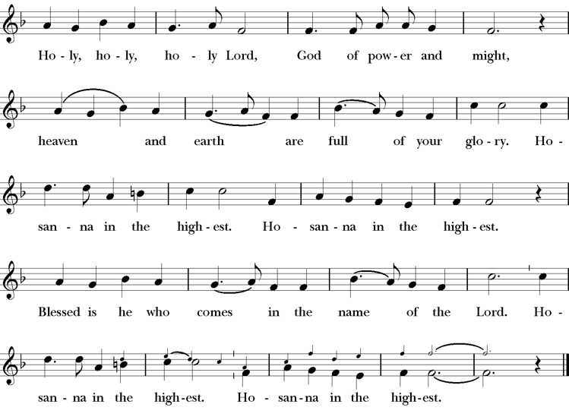
Presider Holy and gracious Father: In your infinite love you made us for yourself; and, when we had fallen into sin and become subject to evil and death, you, in your mercy, sent Jesus Christ, your only and eternal Son, to share our human nature, to live and die as one of us, to reconcile us to you, the God and Father of all.
He stretched out his arms upon the cross, and offered himself, in obedience to your will, a perfect sacrifice for the whole world.
On the night he was handed over to suffering and death, our Lord Jesus Christ took bread; and when he had given thanks to you, he broke it, and gave it to his disciples, and said, “Take, eat: This is my Body, which is given for you. Do this for the remembrance of me”
After supper he took the cup of wine; and when he had given thanks, he gave it to them, saying, “Drink this, all of you: this is my blood of the new covenant which is shed for you and for many for the forgiveness of sins. Whenever you drink it, do this for the remembrance of me.”
Presider Therefore we proclaim the mystery of faith:.
People Christ has died; Christ is risen; Christ will come again.
Presider We celebrate the memorial of our redemption, O Father, in this sacrifice of praise and thanksgiving. Recalling his death, resurrection, and ascension, we offer you these gifts.
Sanctify them by your Holy Spirit to be for your people the Body and Blood of your Son, the holy food and drink of new and unending life in him. Sanctify us also that we may faithfully receive this holy Sacrament, and serve you in unity, constancy, and peace; and at last day bring us with all your saints into the joy of your eternal kingdom.
All this we ask through your Son Jesus Christ. By him, and with him, and in him, in the unity of the Holy Spirit all honor and glory is yours, Almighty Father, now and for ever.
Amen.
The Lord’s Prayer
Presider As our Savior has taught us, we are bold to pray.
People Our Father, who art in heaven, hallowed be thy name. Thy Kingdom come, thy will be done, on earth as it is in heaven. Give us this day our daily bread. And forgive us our trespasses, as we forgive those who trespass against us. And lead us not into temptation, but deliver us from evil. For thine is the kingdom, the power and the glory, for ever and ever. Amen.
The Breaking of the Bread
The Presider breaks the consecrated bread in view of the assembly.
Presider The Gifts of God for the people of God.
People Therefore let us keep the feast. Alleluia
Invitation to Communion
Presider Come to this table you who have been here often and you who have not been here in a long time. Come, you who have tried to follow Jesus and you who have failed. You who are full of faith and full of doubt. Come, it is Christ himself who invites you to meet him here.
Sharing the Sacred Meal
This is Christ’s table and all are welcome and all are fed.
Communion Music Now the Silence H 333
Post-Communion Prayer BCP 365
The Blessing
The Recessional Hymn Alleluia, Sing to Jesus H 460
The Dismissal*
Celebrant | Let us go forth in the name of Christ.
People | Thanks be to God.
Postlude Steve Rubardt Please remain seated

SERVING TODAY
Celebrant & Preacher: Pastor Cindy Beck
Acolyte: Arminda Eiler
Lector: Bill Doyle , Lorena Reinhardt
Intercessor: Ann Kyser
Worship Musician: Steve Rubardt
Choir Leader: Steve Rubardt
Choir: Liz Carpenter, Heather Dahlberg, Scott Sherman,
Patsy Gralow, Laurell Meredith, Mary Omodt, Barbara Feduska, Tara Anderson
Sunday School - Child Care: Wendy Aguilar Appt Only
Ushers: Alfred Escoffier
Tech Chaplain: Marcos Rendon
Altar Guild: Ann Kyser
Hospitality : Bill Doyle
Altar Flowers are given to the glory of God by Altar Guild.
*Why no ‘Alleluias” printed in the bulletin? There are two different rubrics (or rules) that govern the use of Alleluia in worship, set by the Canons. One set of rubrics govern the use of Alleluia in music and in all of the liturgy except for the Dismissal. This rule says that we use Alleluia all the time except during the season of Lent. The other set of rubrics covers just the Dismissal and it says that we only use Alleluia in the Dismissal during the period from Easter Sunday through Pentecost, but not at any other time.
Prayers requested for these on Trinity’s long-term prayer list: Armando P, Georgia Bostedt, John Eiler, Gerrilee Fisher, Claire Ginesi, Mary Griffin, David & Christine Hilt, Mark Mezzetta, Kelcey Omodt, Grizelda Ponce, Barry Reap, Blake W, Robert R, Melissa White, Ann Loveland Sherman, James Thomas, Rose Burns, Jennifer Gralow, Patsy Gralow, Steve Antenen, Sandra Leland, Karl, Michael Hardy, Michael Bean Land, Polly Moore, Sinat Liv, Will Maushardt, Sophia Piconi, Mike Smith, Jean Maffoli.
Prayers for the Repose of soul: Tim Dowd , Susan Bassett, Joan Biersch, Linda Dowd, Christina Van Krugel, Mere Nagasau, Mary Goshert, Peggy Bell, Carolyn Caldwell, Van Z, Dolores Mae Seaberg Cole, Muff Davey.
Contact Pastoral Care Chair, Lorena lorena.m.reinhardt@gmail.com to make any additions or to remove names from our Long-Term Prayer list.
Notes on the Service Bulletin This service bulletin is a guide to the service. We use a variety of printed materials for the prayers, the scriptural readings and the hymns. The Readings for the week, including the Collect and Readings are found in this Bulletin. The service follows the liturgies that are found in the Book of Common Prayer (BCP). The BCP is the blue book found in the pew in front of you. The hymns come primarily from The 1982 Hymnal, also in the pew – the red book. Lift Every Voice and Sing (LEVAS) is another hymnal located in the pew rack. VF stands for Voices Found, another authorized hymnal. Sound Mate Assisted Hearing devices available at the back of the church on the Narthex Table.
About this Service: Season of Pentecost
The season of Pentecost is the longest of the Church Year. It begins on the Day of Pentecost when the promised Holy Spirit (Counselor, Advocate) of God fell upon the disciples and those gathered with them in the upper room and runs until the Sunday before Advent. The color of the season is green to symbolize growth and new life. This season is often called “The work of the Church.” The lessons focus on Jesus’ teaching encouraging personal growth and transformation in the Spirit. The teachings also call believers to spread the Gospel to those in the world who have not encountered Jesus. Believers are called to live lives in service of others.
Trinity Liturgical Ministry ROTA Next two weeks
Date | Celebrant | Ushers | Acolyte | Lector (s) | Intercessor | Altar Guild
7/12 | Cindy Beck | Marcia Derby | Claire Ginesi | Barbara Feduska , Gerrilee Fisher | Jane Hernandez | Marcia Derby , Mary Omodt
7/19 | Cindy Beck | John Addeo | Susie Hand | Scott Sherman, Lorena Reinhardt | Barbara Feduska | Susie Hand

Schedule of Weekly Meetings and Services at Trinity Episcopal Sonoma
Day | Date | Time | Occasion | Location
Wednesday | July 8 | 11 AM | Bible Study | Library
Thursday | July 9 | 10:30 AM  5:30 PM | Mindfulness & Well Being  Alcoholics Anonymous | Library  Buttrum Hall
Saturday | July 11 | 8 AM | Centering Prayer | St. Luke’s Chapel
Saturday | July 11 | 2pm | Drawing Class | in Library
Sunday | July 12 | 10:00 AM | Holy Eucharist II | Sanctuary
Mon-Fri | Weekdays | 7AM-1PM | Sonoma Home Meals | Kitchen &Buttrum Hall
Mon-Fri | Weekdays | 9-2 | Sonoma Preschool Academy – School

Monthly Meetings at Trinity Episcopal Sonoma
Day | Date | Time | Meeting | Location | Contact
Tuesday | July 7 | 11 AM | Prayer Shawl Ministry | Library | Lorena Reinhardt lorena.m.reinhardt@gmail.com
Thursday | TBD | TBD | Vestry | Library | Cindy Beck 916-955-9861

PRAYERS and BLESSINGS
For a Birthday
Watch over your child, O Lord as his/her days increase; bless and guide him/her wherever s/he may be. Strengthen them when s/he stands; comfort him/her when discouraged or sorrowful; raise him/her up if s/he fall; and in his/her heart may your peace which passes understanding abide all the days of his/her life; through Jesus Christ our Lord. Amen.
For an Anniversary
O God, you have so consecrated the covenant of marriage that it represents the spiritual unity between Christ and his Church: Send your blessing upon these your servants as they celebrate their anniversary, that they may continue to love, honor and cherish each other in faithfulness and patience, in wisdom and true godliness, that their home may be a haven of blessing and peace; through Jesus Christ our Lord, who lives and reigns with you and the Holy Spirit, one God, now and forever. Amen.
For Travelers
O God, our heavenly Father, whose glory fills the whole creation, and whose presence we find wherever we go; preserve those who travel; surround them with your loving care; protect them from every danger, and bring them in safety to their journey’s end; through Jesus Christ our Lord. Amen.
Sending our Eucharistic Visitors
Priest: In the name of this congregation, I send you forth bearing these holy gifts, the those to whom you go may share with us in the communion of Christ’s body and blood.
People: We who are many are one body, because we all share on bread, and one cup. Amen.

Trinity Episcopal Church
In Sonoma for over 170 years
275 East Spain Street
Sonoma, CA 95476
The Rt. Rev. Megan M. Traquair, Bishop
Diocese of Northern California
Pastor Cindy Beck, Interim
Steve Rubardt, Worship Music
Vestry
Bill Doyle, Senior Warden & Stewardship
Susie Hand
Heather Dahlberg
Sally Zimmerman
Lorena Reinhardt (Pastoral Care)
Luke Bohanan
Mandy Birkbeck
Ministries
Prayer Shawl, Lorena Reinhardt
Outreach, Jane Hernandez
Mindfulness & Well Being, Mary Omodt
Sunday School, Children, Wendy Aguilar

The Members of the Congregation are The Ministers of the Church

Administrative Office Hrs.
Monday Wednesday 9 A.M. – 2 PM; Thursday 10A.M.-2 P.M0
Sunday 9:30-11:30
Clergy Office Hours Wednesdays, Thursdays, by appointment

Emergency, sickness, please contact office: 707-938-4846

