Trinity Episcopal Church
In Sonoma for over 170 years
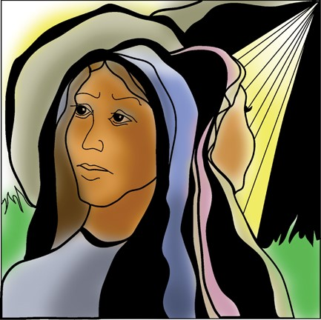
Easter Sunday: Sunday of Resurrection
Year A
Holy Eucharist II
April 5, 2026
10:00 AM In person and Online

April Announcements
Movie Night Wednesday, April 15th @ 6PM. Our movie is "Driving Miss Daisy" starring Jessica Tandy and Morgan Freeman. “The best friendships are the ones we never expected.” Discussion and food will follow.
Fellowship Coffee Hour Sign up - We encourage members to sign up to make coffee. Pastor Cindy is happy to demonstrate how easy this is. Please help us provide this hospitality for guests and members.
This month, St Paul’s in Healdsburg organ concert series will feature St. Paul’s own organist and choir director, Paul Blanchard! Paul’s concert pieces will relate to the Holy Trinity.
- God, the Father, is represented by Marcello’s Psalm 19 and Böhm’s 3 settings of Vater unser in Himmelreich (Lord’s Prayer).
- God, the Son’s, birth is evoked by Bach’s Vom Himmel Hoch and his Ascension by Messiaen’s Priere du Christ (Ascension Suite, No. IV).
- God, The Holy Spirit, is portrayed by Thomas Fielding’s Versets on Veni Creator (w chanted verses).
- God, the Holy Trinity, is depicted by Weckmann’s O Lux Beata Trinitas.
The performance will be held in the church on Sunday, April 19 at 5:00 pm. Admission is free.
The February, March, April Forward Day by Day , a booklet of daily inspirational meditations is now available in the Church and the Office.
Lectio Divina Bible Study is on Wednesday, at 11AM in the library. Lectio Divina, Latin for "divine reading," is a contemplative practice of scriptural reading, meditation, and prayer intended to promote communion with God. Unlike traditional Bible study that focuses on intellectual information, Lectio Divina emphasizes spiritual formation and personal intimacy with God.
Save the date!: Congregational Retreat on May 16, 2026 from 9:30 AM to 12:30!
Prelude Steve Rubardt
Please stand at the entrance of the Church for the procession of the palms.
At the sound of the bell, please stand as you are able. The People respond when bold text appears.
The Word of God
Entrance Hymn At the Lamb’s High Feast we Sing H 174
Opening Acclamation BCP 319
Celebrant | Alleluia. Christ is risen.
People | The Lord is risen indeed. Alleluia.
Collect for Purity All
Almighty God, to you all hearts are open, all desires known, and from you no secrets are hid: Cleanse the thoughts of our hearts by the inspiration of your Holy Spirit, that we may perfectly love you, and worthily magnify your holy Name; through Christ our Lord. Amen.
Song of Praise Glory to God Hymn S-280
The following is sung, all standing
The Collect of the Day BCP 357
Celebrant | The Lord be with you.
People | And also with you.
Celebrant | Let us pray.
O God, who for our redemption gave your only-begotten Son to the death of the cross, and by his glorious resurrection delivered us from the power of our enemy: Grant us so to die daily to sin, that we may evermore live with him in the joy of his resurrection; through Jesus Christ your Son our Lord, who lives and reigns with you and the Holy Spirit, one God, now and for ever.
All Amen.
The Lessons
First Reading: Acts 10:34-43
Reader A Reading from the Acts of the Apostles.
³⁴Peter began to speak to [Cornelius and the other Gentiles]: “I truly understand that God shows no partiality, ³⁵but in every nation anyone who fears him and does what is right is acceptable to him. ³⁶You know the message he sent to the people of Israel, preaching peace by Jesus Christ—he is Lord of all. ³⁷That message spread throughout Judea, beginning in Galilee after the baptism that John announced: ³⁸how God anointed Jesus of Nazareth with the Holy Spirit and with power; how he went about doing good and healing all who were oppressed by the devil, for God was with him. ³⁹We are witnesses to all that he did both in Judea and in Jerusalem. They put him to death by hanging him on a tree; ⁴⁰but God raised him on the third day and allowed him to appear, ⁴¹not to all the people but to us who were chosen by God as witnesses, and who ate and drank with him after he rose from the dead. ⁴²He commanded us to preach to the people and to testify that he is the one ordained by God as judge of the living and the dead. ⁴³All the prophets testify about him that everyone who believes in him receives forgiveness of sins through his name.”
Reader | The Word of the Lord.
People | Thanks be to God.
The Psalm: Psalm 118:1-2, 14-24
Reader Our response to the reading is Psalm 118:1-2, 14-24 which we will read responsively by half verse.
¹Give thanks to the Lord, for he is good; *
his mercy endures for ever.
²Let Israel now proclaim, *
“His mercy endures for ever.”
¹⁴The Lord is my strength and my song, *
and he has become my salvation.
¹⁵There is a sound of exultation and victory *
in the tents of the righteous:
¹⁶“The right hand of the Lord has triumphed! *
the right hand of the Lord is exalted!
the right hand of the Lord has triumphed!”
¹⁷I shall not die, but live, *
and declare the works of the Lord.
¹⁸The Lord has punished me sorely, *
but he did not hand me over to death.
¹⁹Open for me the gates of righteousness; *
I will enter them;
I will offer thanks to the Lord.
²⁰“This is the gate of the Lord; *
he who is righteous may enter.”
²¹I will give thanks to you, for you answered me *
and have become my salvation.
²²The same stone which the builders rejected *
has become the chief cornerstone.
²³This is the Lord’s doing, *
and it is marvelous in our eyes.
²⁴On this day the Lord has acted; *
we will rejoice and be glad in it.
Second Reading: Colossians 3:1-4
Reader A Reading from Paul's letter to the Church in Colossus.
¹[Since] you have been raised with Christ, seek the things that are above, where Christ is, seated at the right hand of God.²Set your minds on things that are above, not on things that are on earth, ³for you have died, and your life is hidden with Christ in God. ⁴When Christ who is your life is revealed, then you also will be revealed with him in glory.
Reader | The Word of the Lord.
People | Thanks be to God.
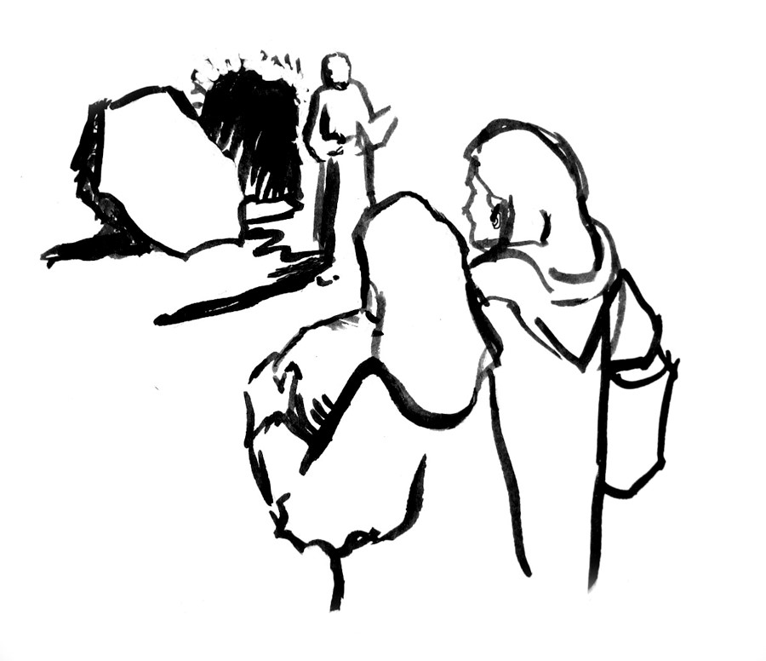
Sequence Hymn We Walk by Faith H 209 v 1 & 2
The Holy Gospel: John 20:1-18
Celebrant | The Holy Gospel of our Lord Jesus Christ according to John.
People | Glory to you, Lord Christ.
¹Early on the first day of the week, while it was still dark, Mary Magdalene came to the tomb and saw that the stone had been removed from the tomb. ²So she ran and went to Simon Peter and the other disciple, the one whom Jesus loved, and said to them, “They have taken the Lord out of the tomb, and we do not know where they have laid him.” ³Then Peter and the other disciple set out and went toward the tomb. ⁴The two were running together, but the other disciple outran Peter and reached the tomb first. ⁵He bent down to look in and saw the linen wrappings lying there, but he did not go in. ⁶Then Simon Peter came, following him, and went into the tomb. He saw the linen wrappings lying there, ⁷and the cloth that had been on Jesus’ head, not lying with the linen wrappings but rolled up in a place by itself. ⁸Then the other disciple, who reached the tomb first, also went in, and he saw and believed; ⁹for as yet they did not understand the scripture, that he must rise from the dead. ¹⁰Then the disciples returned to their homes.
¹¹But Mary stood weeping outside the tomb. As she wept, she bent over to look into the tomb; ¹²and she saw two angels in white, sitting where the body of Jesus had been lying, one at the head and the other at the feet. ¹³They said to her, “Woman, why are you weeping?” She said to them, “They have taken away my Lord, and I do not know where they have laid him.” ¹⁴When she had said this, she turned around and saw Jesus standing there, but she did not know that it was Jesus. ¹⁵Jesus said to her, “Woman, why are you weeping? Whom are you looking for?” Supposing him to be the gardener, she said to him, “Sir, if you have carried him away, tell me where you have laid him, and I will take him away.” ¹⁶Jesus said to her, “Mary!” She turned and said to him in Hebrew, “Rabbouni!” (which means Teacher). ¹⁷Jesus said to her, “Do not hold on to me, because I have not yet ascended to the Father. But go to my brothers and say to them, ‘I am ascending to my Father and your Father, to my God and your God.’ ” ¹⁸Mary Magdalene went and announced to the disciples, “I have seen the Lord”; and she told them that he had said these things to her.
Celebrant | The Gospel of the Lord.
People | Praise to you, Lord Christ.
Sequence Hymn We Walk by Faith H 209 v 3 & 4
The Sermon Pastor Cindy Beck
The Nicene Creed (BCP p. 358)
The Prayers of the People
Celebrant: Jesus Christ is risen today, our triumphant holy day. Alleluia! So let us pray to our Lord, saying, “Risen Christ, to you we give undying praise.”
Intercessor Heavenly King, for us you endured the cross and the grave. When we were yet sinners, you redeemed and saved us. May we sing your eternal praises everywhere we go.
In the Diocesan Cycle of Prayer, we pray for Grace Church in St. Helena.
In the Anglican Cycle of Prayer, we pray for La Iglesia Anglicana de Mexico.
Risen Christ,
To you we give undying praise.
Incarnate Love, where hearts are wintry, grieving or in pain, call forth new life by your touch. Bring forth life in the barren places of your world.
Silence
Risen Christ,
To you we give undying praise.
Author of Life, you are the ruler of creation. All things created on earth sing to your glory. From the death of the winter, raise the fair beauty of earth.
Risen Christ,
To you we give undying praise.
Resurrected One, bring our neighbors from sadness into joy. Where they live in darkness, brighten their lives with a day of splendor and give to all that peace that passes human knowing, +_______________________________
Invite the congregation to add their thanksgivings, followed by silence
Risen Christ,
To you we give undying praise.
Triumphant Lord, gladden the faces of all who are sad and fearful-hearted. May they rejoice in your victory over sin and pain—even as they share in your glorious triumph, +___________________________________
Invite the congregation to add their petitions, followed by silence
Risen Christ,
To you we give undying praise.
Risen Christ, you have opened heaven’s gate. You have freed us from the power of sin and death. Through your resurrection, you give us the promise of resurrection to a holier state. Bless the dying and the dead, +___________
Invite the congregation to add their petitions, followed by silence
Risen Christ,
To you we give undying praise.
Celebrant Grant, we pray, Almighty God, that we who celebrate with awe the Paschal feast may be found worthy to attain to everlasting joys; through Jesus Christ our Lord, who lives and reigns with you and the Holy Spirit, one God, now and for ever.
Amen.
The Peace
Celebrant The peace of the Lord be always with you.
People And also with you.
Announcements
Birthdays, Anniversaries, Travelers (prayers found at back of bulletin)

The Holy Communion
The Offertory At the Offering, you’ll find a Pledge card in the Pew Rack for those who’d like to designate their financial donations to Trinity’s Pledging Income. For others, or a one-time gift, envelopes are in the pew racks as well as on the Narthex table or text TRINITYSONOMA" to 73256. Thank you!
Offertory Music
Steve Rubardt and Choir Now the Green Blade Riseth H 204
Doxology
The people stand while the offerings are presented and placed on the Altar.
Presider: Gracious God, as an offering of our thanksgiving and gratitude, we return to you a portion of what you have gifted us.
The Great Thanksgiving
Eucharistic Prayer B BCP 367
Celebrant | The Lord be with you.
People | And also with you.
Celebrant | Lift up your hearts.
People | We lift them to the Lord.
Celebrant | Let us give thanks to the Lord our God.
People | It is right to give him thanks and praise.
Proper Preface (BCP p. 367)
It is right, and a good and joyful thing, always and everywhere to give thanks to you, Father Almighty, Creator of heaven and earth.
Through Jesus Christ our Lord. For our sins he was lifted high upon the cross, that he might draw the whole world to himself; and, by his suffering and death, he became the source of eternal salvation for all who put their trust in him.
Therefore we praise you, joining our voices with Angels and Archangels and with all the company of heaven, who for ever sing this hymn to proclaim the glory of your Name:

Sanctus Holy Holy, Holy (Proulx) Hymnal S-125
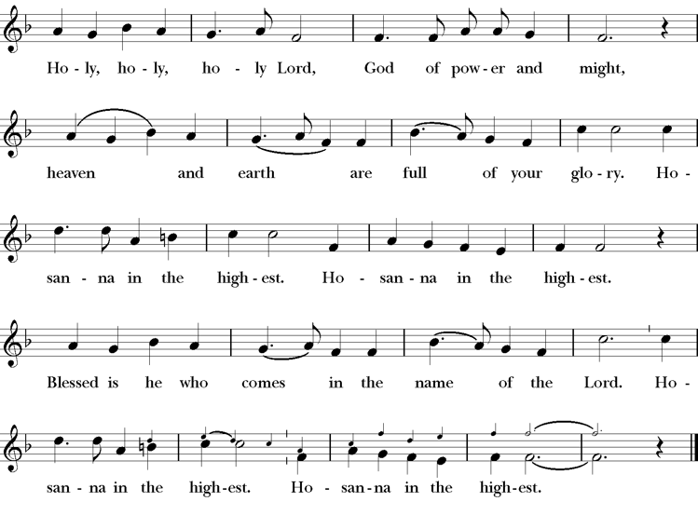
Presider Enduring God, as you sustained Jesus in hunger and thirst; through this meal strengthen us to keep our Lenten fast. Send your Holy Spirit upon us as we remember Jesus’ saving passion; transform our insatiable desires into hunger for the feast of this table. Send your Holy Spirit upon this bread and wine that they may be for us the body and blood of Christ; Who at supper with his disciples, took bread, gave you thanks, broke the bread, and gave it to them, saying “Take, eat: this is my body which is given for you; do this in remembrance of me.”
Presider After supper he took the cup of wine. Again he gave you thanks, and gave it to his disciples, saying, “Drink this, all of you: this is my blood of the new covenant which is shed for you and for many for the forgiveness of sins. Do this, as often as you drink it, in remembrance of me.”
Presider Great is the mystery of faith.
People Christ has died; Christ is risen; Christ will come again.
Presider Forgiving God, in this season of repentance, make your mercy sufficient for every need. Come to your children who are in their own wilderness and make their wanderings holy paths of learning your truth.
Come alongside your children who suffer in sin and give them the power to live as your beloved sons and daughters. Renew your church from the depths of your heart, where justice and mercy meet.
Infuse your church with Spirit and truth, walk with your beloved people as they seek security, companionship and freedom in your world, and fill your saints with the hope of eternal life, that all may come to praise your name, that all creation be stirred with the wonders of your grace.
Through Christ, with Christ, in Christ, in the unity of the Holy Spirit, all glory and honor are yours, almighty God, now and forever. AMEN.
The Lord’s Prayer
Presider As our Savior has taught us, we are bold to pray.
People Our Father, who art in heaven, hallowed be thy name. Thy Kingdom come, thy will be done, on earth as it is in heaven. Give us this day our daily bread. And forgive us our trespasses, as we forgive those who trespass against us. And lead us not into temptation, but deliver us from evil. For thine is the kingdom, the power and the glory, for ever and ever. Amen.
The Breaking of the Bread
The Presider breaks the consecrated bread in view of the assembly.
Presider Christ our Passover is sacrificed for us.
People Therefore let us keep the feast.
Invitation to Communion
Presider The gifts of God for the people of God. So come to this table you who have been here often and you who have not been here in a long time. Come, you who have tried to follow Jesus and you who have failed. You who are full of faith and full of doubt. Come, it is Christ himself who invites you to meet him here.
Sharing the Sacred Meal
This is Christ’s table and all are welcome and all are fed.
Communion Music That Easer Day with Joy was Bright H 193
Post-Communion Prayer BCP 365
The Blessing
The Recessional Hymn Jesus Christ is Risen Today H 207
The Dismissal*
Celebrant | Let us go forth in the name of Christ.
People | Thanks be to God.
Postlude Steve Rubardt Please remain seated

SERVING TODAY
Celebrant and Preacher: Pastor Cindy Beck
Acolyte: Susie Hand
Eucharistic Minister: Bill Bonnet
Lector: Bill Doyle , Bill Bonnet
Intercessor: Ann Kyser
Worship Musician: Steve Rubardt
Choir Leader: Steve Rubardt
Choir: Liz Carpenter, Heather Dahlberg, Scott Sherman,
Patsy Gralow, Laurell Meredith, Mary Omodt, Barbara Feduska, Tara Anderson
Sunday School - Child Care: Wendy Aguilar Appt Only
Ushers: John Addeo , Marcia Derby
Tech Chaplain: Marcos Rendon
Altar Guild: Ann Kyser
Hospitality :
Altar Flowers are given to the glory of God by Altar Guild.
*Why no ‘Alleluias” printed in the bulletin? There are two different rubrics (or rules) that govern the use of Alleluia in worship, set by the Canons. One set of rubrics govern the use of Alleluia in music and in all of the liturgy except for the Dismissal. This rule says that we use Alleluia all the time except during the season of Lent. The other set of rubrics covers just the Dismissal and it says that we only use Alleluia in the Dismissal during the period from Easter Sunday through Pentecost, but not at any other time.
Prayers requested for these on Trinity’s long-term prayer list: Armando P, Georgia Bostedt, Muff Davey, John Eiler, Gerrilee Fisher, Claire Ginesi, Mary Griffin, David & Christine Hilt, Marie Lambert, Mark Mezzetta, Kelcey Omodt, Grizelda Ponce, Barry Reap, Blake W, Robert R, Melissa White, Ann Loveland Sherman, James Thomas, Rose Burns, Jennifer Gralow, Patsy Gralow, Steve Antenen, Sandra Leland, Karl, Michael Hardy, Michael Bean Land, Polly Moore, Sinat Liv, Will Maushardt, Sophia Piconi, Mike Smith.
Prayers for the Repose of soul: Tim Dowd , Susan Bassett, Joan Biersch, Linda Dowd, Christina Van Krugel, Mere Nagasau, Mary Goshert, Peggy Bell, Carolyn Caldwell, Van Z, Dolores Mae Seaberg Cole.
Contact Pastoral Care Chair, Lorena lorena.m.reinhardt@gmail.com to make any additions or to remove names from our Long-Term Prayer list.
Welcome to Trinity Episcopal, Sonoma. Whether you are passing through or looking for a church home, we are blessed by your presence and we invite you to worship with us fully – singing, praying and receiving communion- with your voice and heart. Everyone is welcome at Jesus’ Table, and everyone’s voice is needed to tell the Good News of God’s love in Christ. If you would like to learn more about The Episcopal Church, or how you can become a member of Trinity Church, please send us an email trinityepiscopalsonoma@comcast.net. We look forward to meeting you after the service where coffee and treats are served.
Notes on the Service Bulletin This service bulletin is a guide to the service. We use a variety of printed materials for the prayers, the scriptural readings and the hymns. The Readings for the week, including the Collect and Readings are found in this Bulletin. The service follows the liturgies that are found in the Book of Common Prayer (BCP). The BCP is the blue book found in the pew in front of you. The hymns come primarily from The 1982 Hymnal, also in the pew – the red book. Lift Every Voice and Sing (LEVAS) is another hymnal located in the pew rack. VF stands for Voices Found, another authorized hymnal. Sound Mate Assisted Hearing devices available at the back of the church on the Narthex Table.
For Visitors and Newcomers | Welcome! We are glad you have joined us today. If you are interested in a visit or call from the Priest-in-Charge, please sign our guest book on the Narthex* table to let her know you are visiting. Include your phone or email address. Narthex = wonderful old Latin word Episcopalians use for the entrance hall, traditionally at the western end of our churches.
Nursery Care | Children | Available during the 10:15 worship service by request. The nursery is located through the breezeway to the Education wing of the campus. Please ask an usher to show the way.
Coffee Hour Fellowship | Buttrum Hall or Courtyard, weather depending | Join us following the 10:00 AM worship service.
To access Trinity’s Guest WIFI: Password Rosepettal441 (case sensitive). We are glad you are here, and we invite you to enter fully into worship this morning.
All are welcome to make a gift and offering in thanksgiving to God; for the many blessings we have received. To take advantage of our electronic giving options, please follow the QR code with your capable electronic device, or visit https://onrealm.org/trinitysonoma/-/form/give/default Help us to make this a place where God’s grace is freely shared by all.

About this Service: Year A
Calendar of the Church Year
The calendar (BCP, pp. 15-33) orders the liturgical year of the Episcopal Church by identifying two cycles of feasts and holy days-one dependent upon the movable date of Easter Day and the other dependent upon the fixed date of Christmas, Dec. 25. Easter Day is the first Sunday after the full moon that falls on or after Mar. 21. The sequence of all Sundays in the church year is based on the date of Easter. Tables and rules for finding the date of Easter Day, and other movable feasts and holy days are provided by the BCP, pp. 880-885. The date of Easter determines the beginning of the season of Lent on Ash Wednesday and the date of Pentecost on the fiftieth day of the Easter season. The Sundays of Advent are always the four Sundays before Christmas Day. The church year begins on the first Sunday of Advent. The calendar also identifies and provides directions concerning the precedence and observance of principal feasts, Sundays, holy days (including Feasts of our Lord, other major feasts, and fasts), Days of Special Devotion, and Days of Optional Observance. The calendar lists dates for celebration of major feasts and lesser feasts by month and date. Appropriate Sunday Letters and Golden Numbers are also provided. (see BCP, pp. 880-881). The calendar also lists the titles of the seasons, Sundays, and major holy days observed in the Episcopal Church throughout the church year, including Advent season, Christmas season, Epiphany season, Lenten season, Holy Week, Easter season, the season after Pentecost, holy days, and National Days.
About this Service: Eastertide
Easter is the highest holiday of the Christian year—a celebration of the event that defines our Church: the resurrection of Jesus Christ from the dead, fulfilling the scriptural foretelling of the Messiah. Like spring itself, the Paschal feast brings the promise of new life. After weeks of preparation and reflection, more joyful elements return to the liturgy. A song of praise replaces the Kyrie, a supplication for mercy; and the word alleluia (“Praise the Lord”)—which has not been spoken during the past 40 days of Lent—is proclaimed enthusiastically, and will remain in acclamations, hymns, and dismissals throughout Eastertide.

Trinity Liturgical Ministry ROTA Next two weeks
Date | Celebrant | Ushers | Euch Min | Acolyte | Lector (s) | Intercessor | Altar Guild
April 12 | Cindy Beck | Marcia Derby |  | Arminda Eiler | Barbara Feduska , John Eiler | Jane Hernandez | Marcia Derby , Mary Omodt
April 19 | Cindy Beck | Alfred Escoffier | Bill Bonnet | Susie Hand | Ann Kyser , Lorena Reinhardt | Claire Ginesi | Ann Kyser

Schedule of Weekly Meetings and Services at Trinity Episcopal Sonoma
Day | Date | Time | Occasion | Location
Wednesday | April 8 | 11 AM | Bible Study | Library
Thursday | April 9 | 10:30 AM  5:30 PM | Mindfulness & Well Being  Alcoholics Anonymous | Library  Buttrum Hall
Saturday | April 11 | 8 AM | Centering Prayer | St. Luke’s Chapel
Saturday | April 11 | 2pm | Drawing Class | in Library
Sunday | April 12 | 10:15 AM | Holy Eucharist II | Sanctuary
Mon-Fri | Weekdays | 7AM-1PM | Sonoma Home Meals | Kitchen &Buttrum Hall
Mon-Fri | Weekdays | 9-2 | Sonoma Preschool Academy – School

Monthly Meetings at Trinity Episcopal Sonoma
Day | Date | Time | Meeting | Location | Contact
Tuesday | April 7 | 11 AM | Prayer Shawl Ministry | Library | Lorena Reinhardt lorena.m.reinhardt@gmail.com
TBD | TBD | 4:30 PM | Vestry | Library | Cindy Beck 916-955-9861

PRAYERS and BLESSINGS
For a Birthday
Watch over your child, O Lord as his/her days increase; bless and guide him/her wherever s/he may be. Strengthen them when s/he stands; comfort him/her when discouraged or sorrowful; raise him/her up if s/he fall; and in his/her heart may your peace which passes understanding abide all the days of his/her life; through Jesus Christ our Lord. Amen.
For an Anniversary
O God, you have so consecrated the covenant of marriage that it represents the spiritual unity between Christ and his Church: Send your blessing upon these your servants as they celebrate their anniversary, that they may continue to love, honor and cherish each other in faithfulness and patience, in wisdom and true godliness, that their home may be a haven of blessing and peace; through Jesus Christ our Lord, who lives and reigns with you and the Holy Spirit, one God, now and forever. Amen.
For Travelers
O God, our heavenly Father, whose glory fills the whole creation, and whose presence we find wherever we go; preserve those who travel; surround them with your loving care; protect them from every danger, and bring them in safety to their journey’s end; through Jesus Christ our Lord. Amen.
Sending our Eucharistic Visitors
Priest: In the name of this congregation, I send you forth bearing these holy gifts, the those to whom you go may share with us in the communion of Christ’s body and blood.
People: We who are many are one body, because we all share on bread, and one cup. Amen

